Feature selection results for big_dataset and Nmin = 15

1. result: (pp2, pp4, peak_frequency)
Estimated Epsilon: 0.043803, Picked Epsilon: 0.073803, MinNumPoints: 15
DBCV_single_clust index value: 0.82504
cluster -1 had 0.4918% single peaks
cluster 1 had 99.5082% single peaks
cluster 2 had 0% single peaks
cluster 3 had 0% single peaks
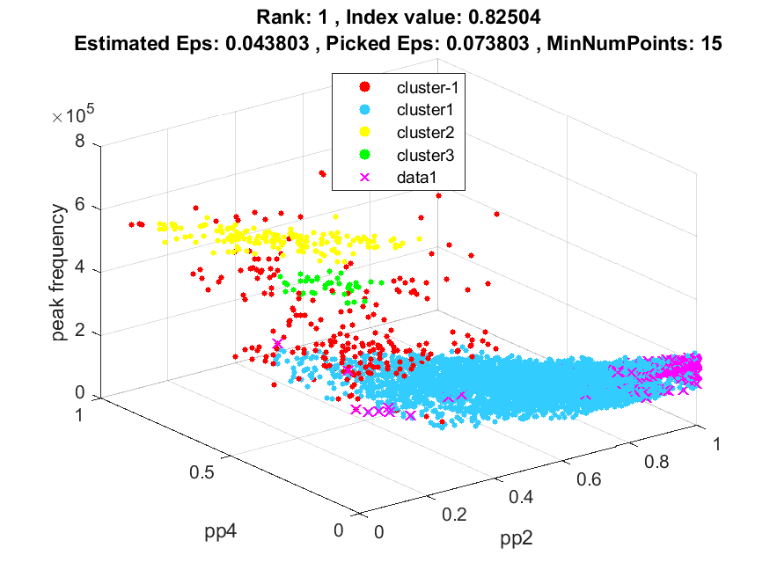
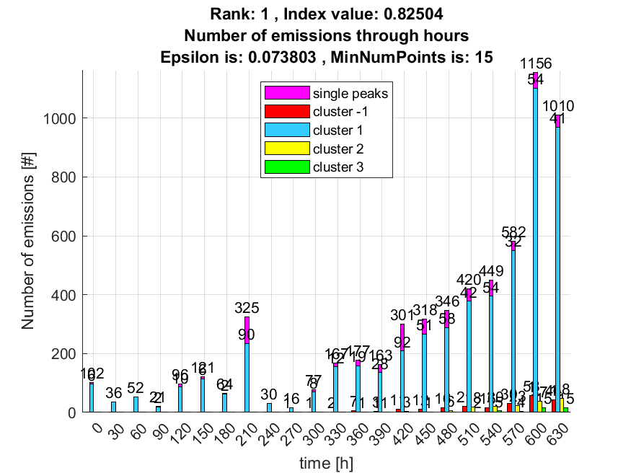

2. result: (pp3, peak_frequency, fall_time)
Estimated Epsilon: 0.027217, Picked Epsilon: 0.077217, MinNumPoints: 15
DBCV_single_clust index value: 0.81761
cluster -1 had 0% single peaks
cluster 1 had 100% single peaks
cluster 2 had 0% single peaks
cluster 3 had 0% single peaks
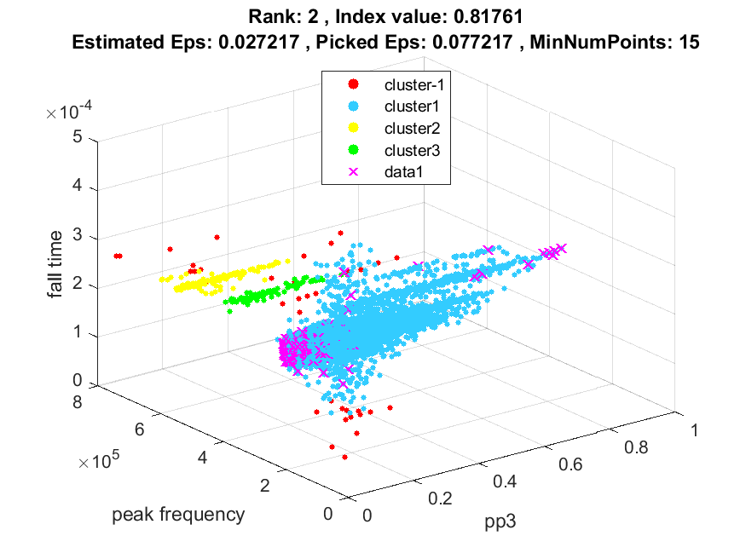
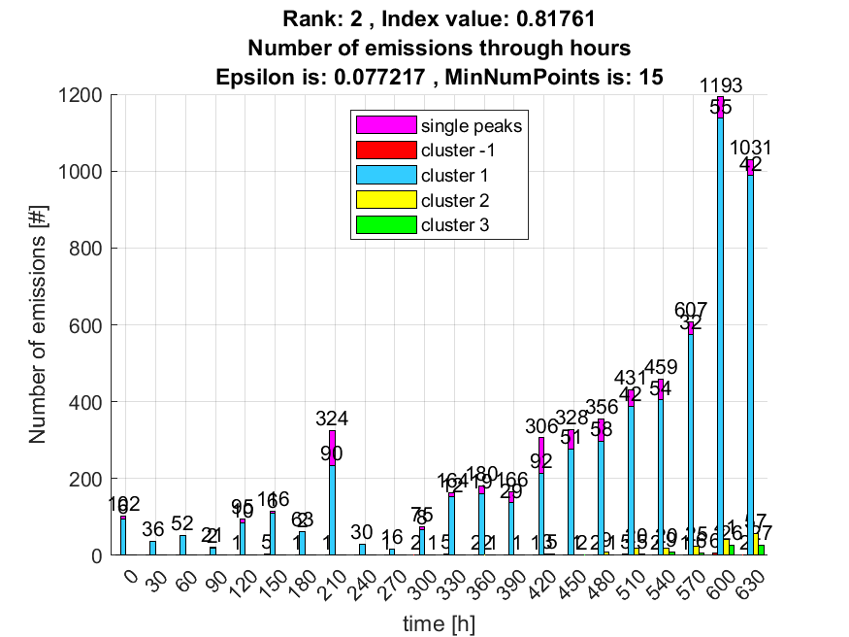

3. result: (pp2, pp3, peak_frequency)
Estimated Epsilon: 0.040714, Picked Epsilon: 0.080714, MinNumPoints: 15
DBCV_single_clust index value: 0.8112
cluster -1 had 0.65574% single peaks
cluster 1 had 99.3443% single peaks
cluster 2 had 0% single peaks
cluster 3 had 0% single peaks
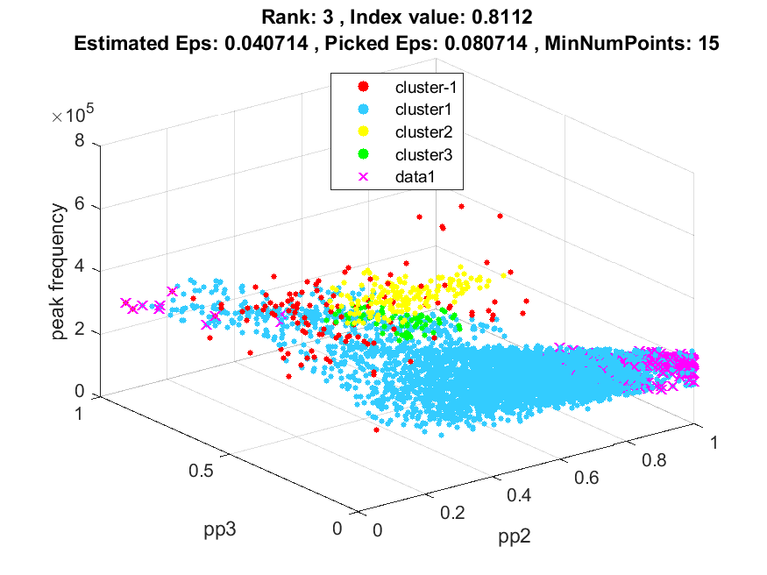
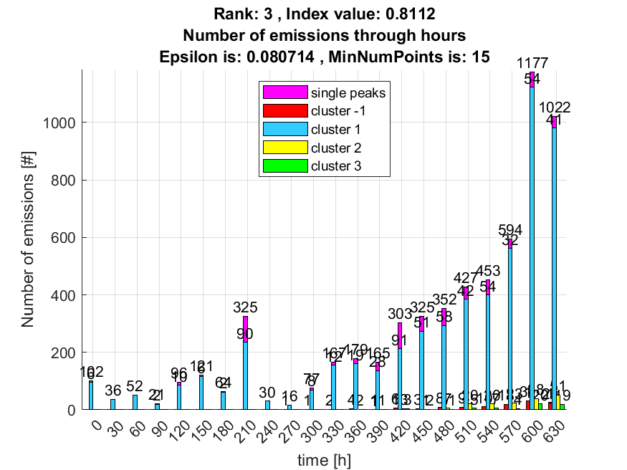

4. result: (pp3, peak_frequency, total_counts)
Estimated Epsilon: 0.045658, Picked Epsilon: 0.035658, MinNumPoints: 15
DBCV_single_clust index value: 0.65579
cluster -1 had 5.2459% single peaks
cluster 1 had 94.5902% single peaks
cluster 2 had 0.16393% single peaks
cluster 3 had 0% single peaks
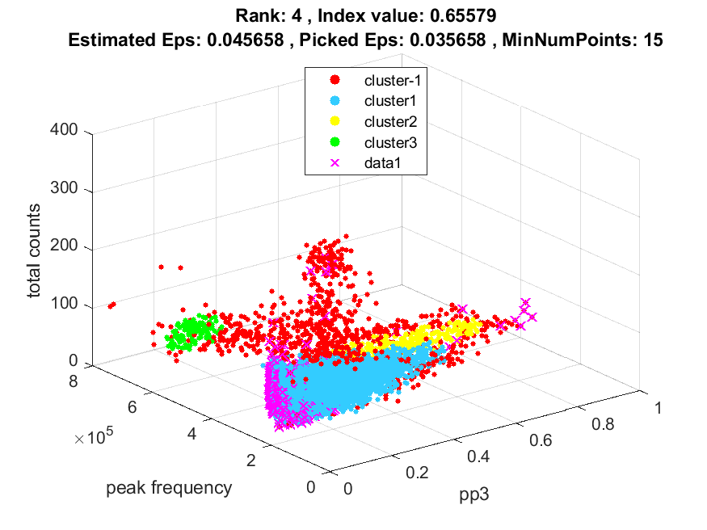
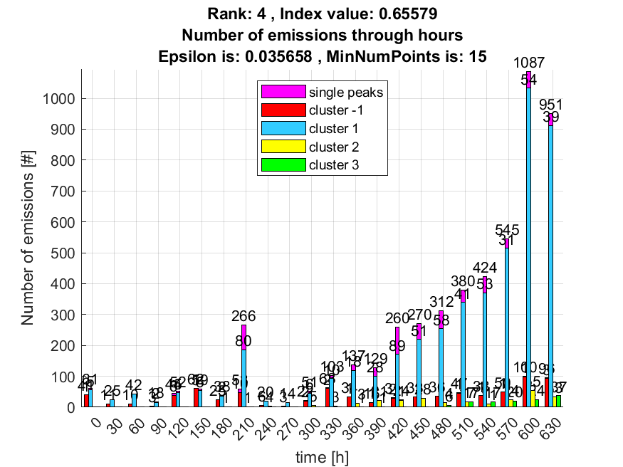

5. result: (counts_from, pp3, peak_frequency)
Estimated Epsilon: 0.038578, Picked Epsilon: 0.078578, MinNumPoints: 15
DBCV_single_clust index value: 0.6283
cluster -1 had 0.32787% single peaks
cluster 1 had 99.6721% single peaks
cluster 2 had 0% single peaks
cluster 3 had 0% single peaks
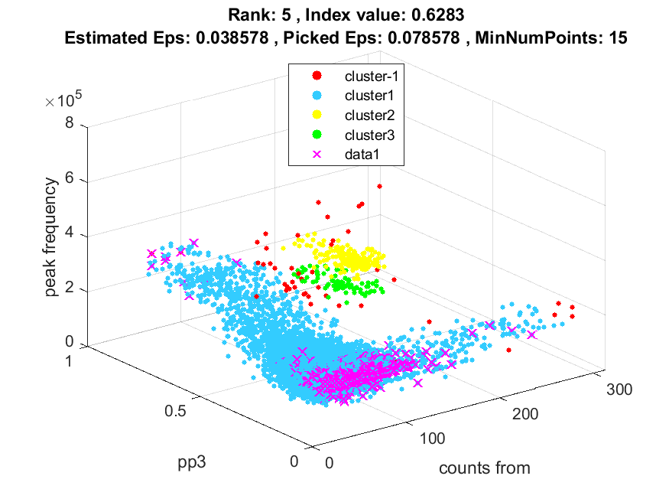
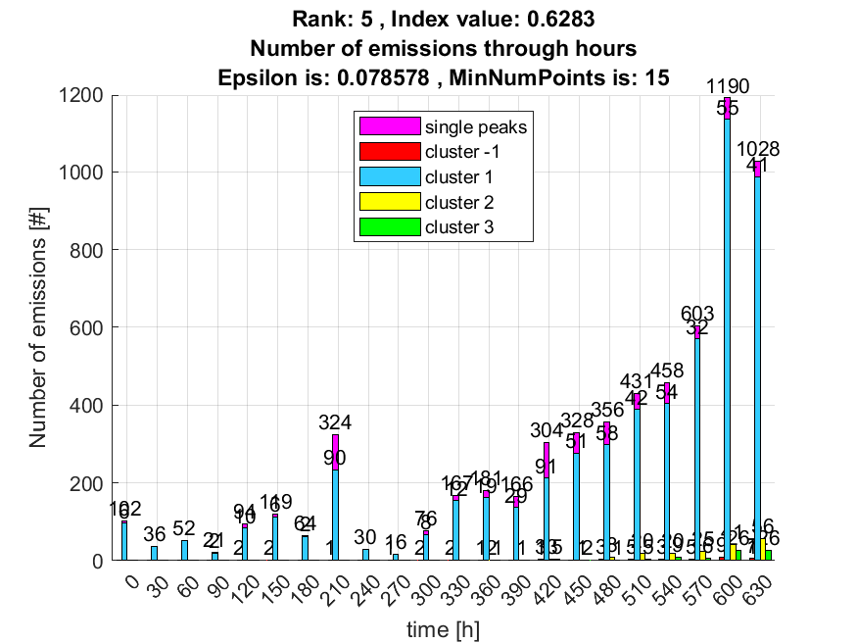

6. result: (rise_time, pp3, peak_frequency)
Estimated Epsilon: 0.030246, Picked Epsilon: 0.080246, MinNumPoints: 15
DBCV_single_clust index value: 0.45286
cluster -1 had 0.32787% single peaks
cluster 1 had 99.6721% single peaks
cluster 2 had 0% single peaks
cluster 3 had 0% single peaks
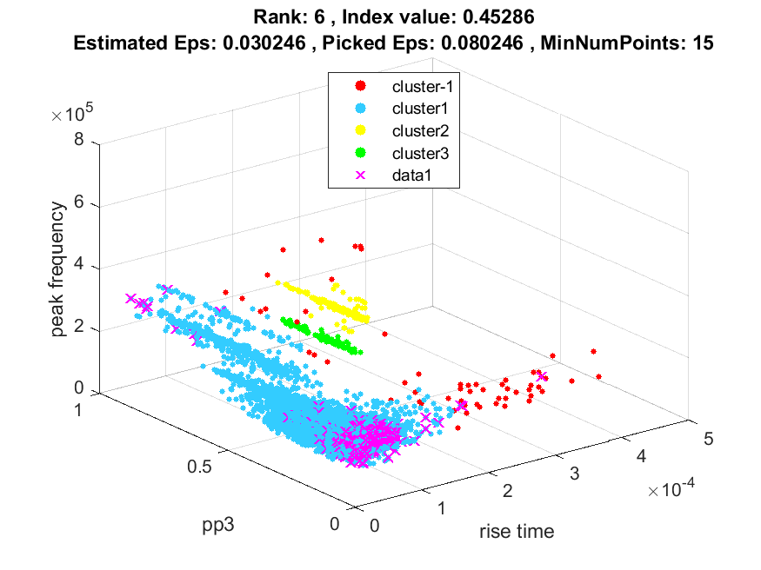
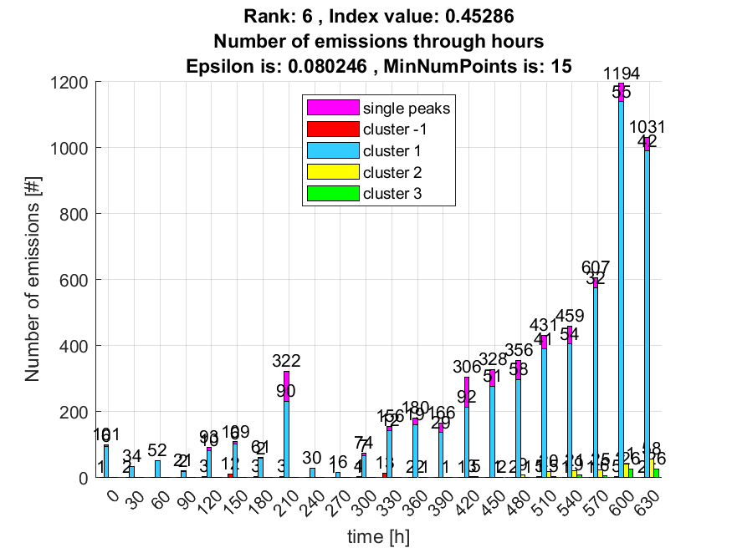

7. result: (pp1, pp4, peak_frequency)
Estimated Epsilon: 0.047144, Picked Epsilon: 0.087144, MinNumPoints: 15
DBCV_single_clust index value: 0.34653
cluster -1 had 0% single peaks
cluster 1 had 100% single peaks
cluster 2 had 0% single peaks
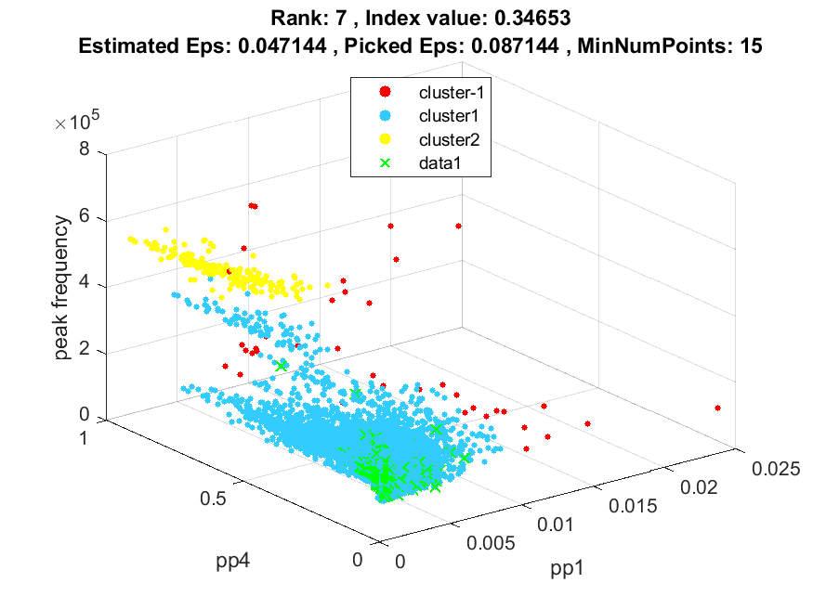
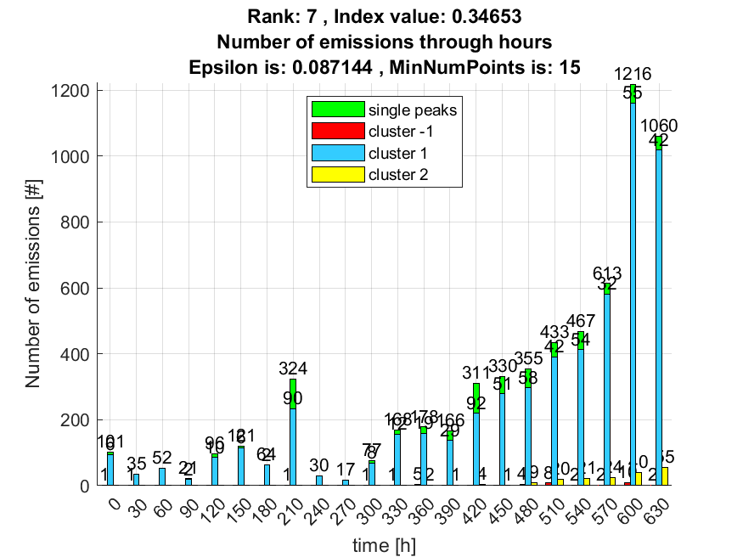

8. result: (counts_from, peak_amplitude, peak_frequency)
Estimated Epsilon: 0.022675, Picked Epsilon: 0.072675, MinNumPoints: 15
DBCV_single_clust index value: 0.28543
cluster -1 had 0.32787% single peaks
cluster 1 had 99.6721% single peaks
cluster 2 had 0% single peaks
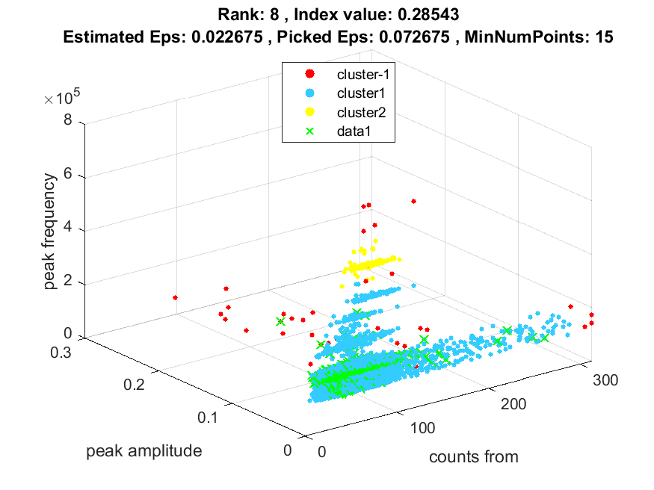
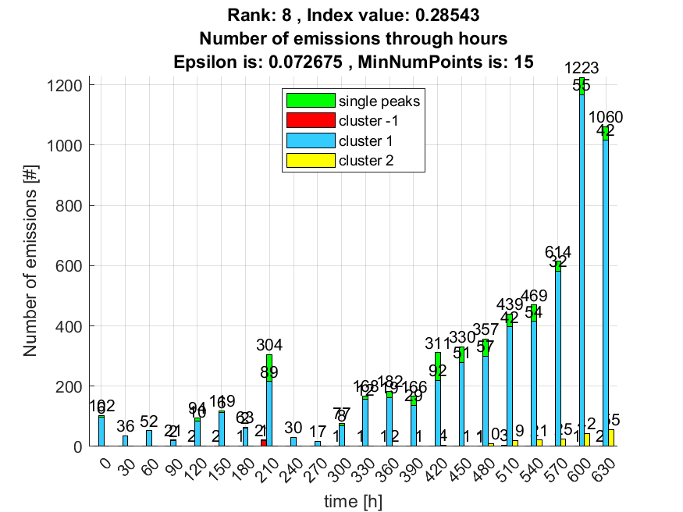

9. result: (pp4, peak_frequency, fall_time)
Estimated Epsilon: 0.03213, Picked Epsilon: 0.08213, MinNumPoints: 15
DBCV_single_clust index value: 0.17453
cluster -1 had 0% single peaks
cluster 1 had 100% single peaks
cluster 2 had 0% single peaks
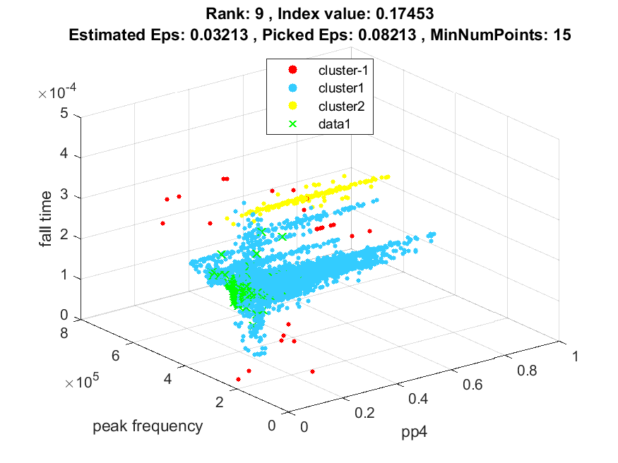
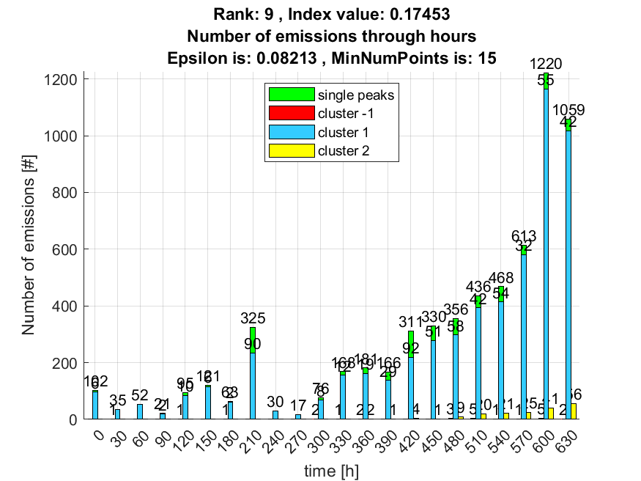

10. result: (pp3, pp4, peak_frequency)
Estimated Epsilon: 0.046333, Picked Epsilon: 0.096333, MinNumPoints: 15
DBCV_single_clust index value: 0.1327
cluster -1 had 0% single peaks
cluster 1 had 100% single peaks
cluster 2 had 0% single peaks
