Feature selection results for exp_10_part_1 and Nmin = 10

1. result: (signal_strength, peak_frequency, amp_of_peak_frequency)
Estimated Epsilon: 0.03791, Picked Epsilon: 0.02041, MinNumPoints: 10
DBCV_single_clust index value: -0.0019974
cluster -1 had 53.1915% single peaks
cluster 1 had 46.8085% single peaks
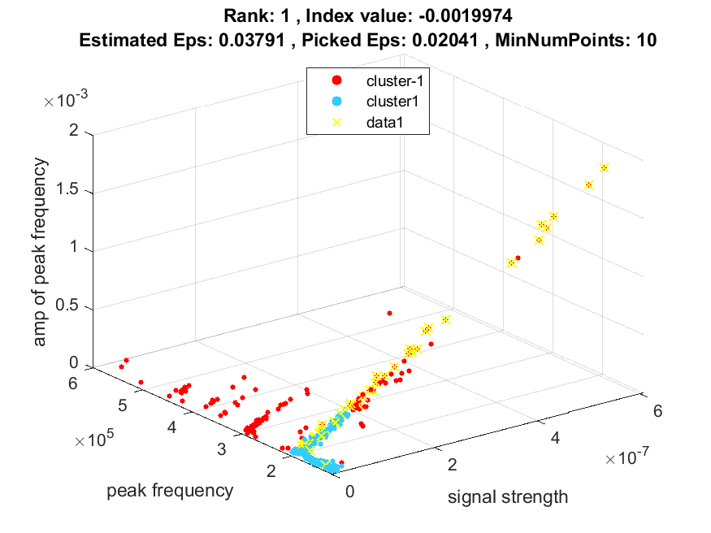
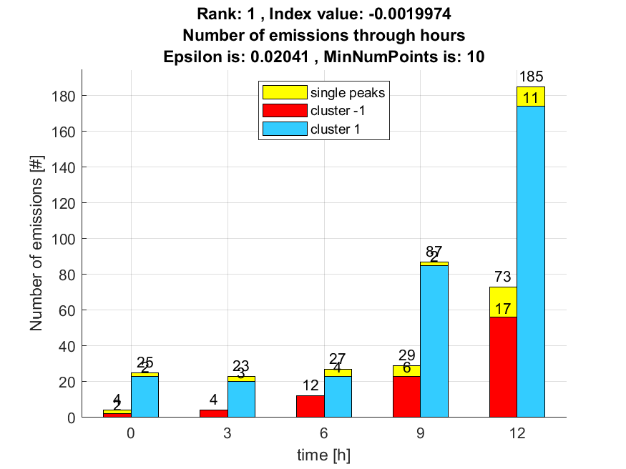

2. result: (peak_amplitude, peak_frequency, amp_of_peak_frequency)
Estimated Epsilon: 0.047284, Picked Epsilon: 0.027284, MinNumPoints: 10
DBCV_single_clust index value: -0.0030255
cluster -1 had 57.4468% single peaks
cluster 1 had 42.5532% single peaks
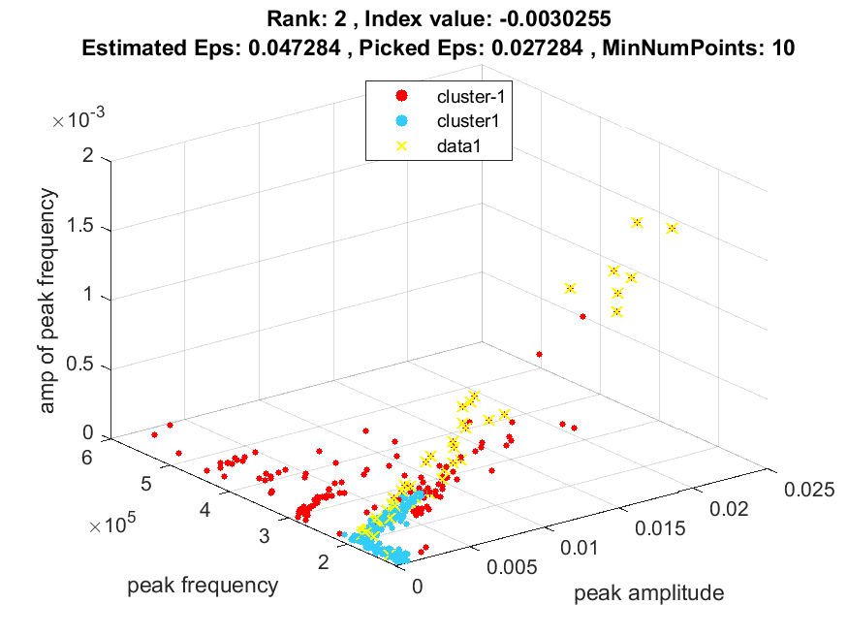
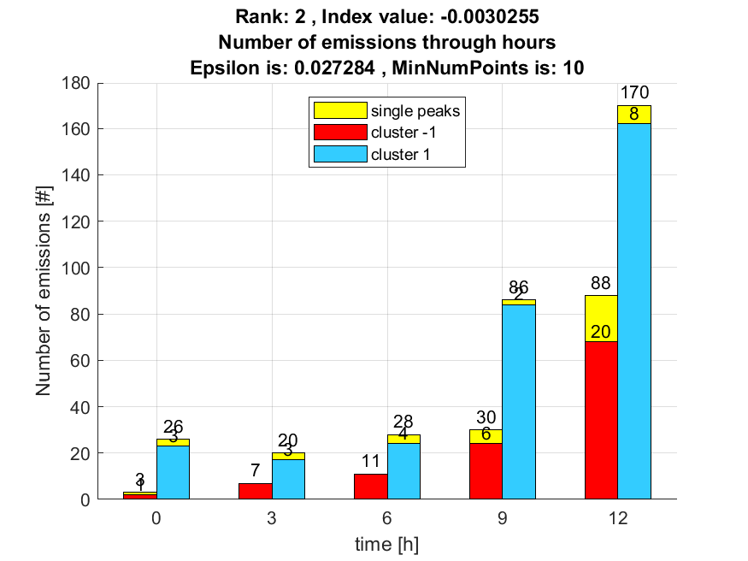

3. result: (pp1, pp3, peak_frequency)
Estimated Epsilon: 0.073028, Picked Epsilon: 0.065528, MinNumPoints: 10
DBCV_single_clust index value: -0.0046307
cluster -1 had 0% single peaks
cluster 1 had 100% single peaks
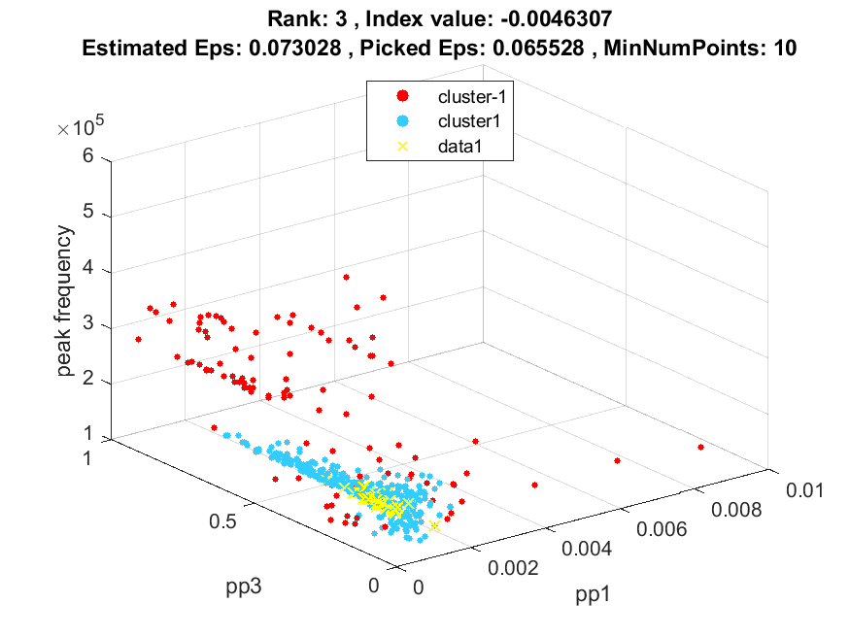
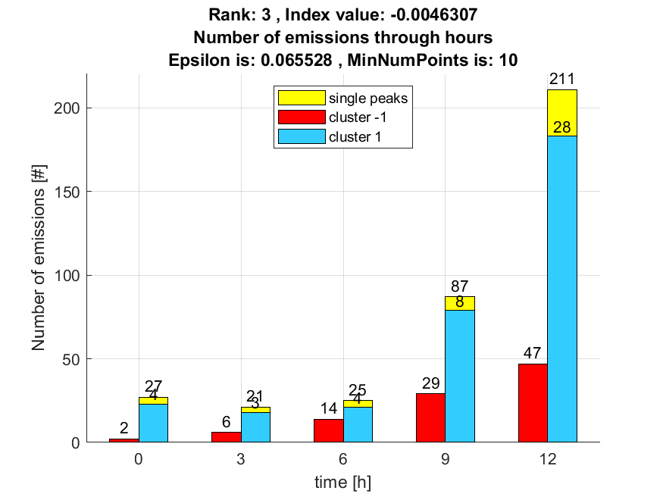

4. result: (pp1, pp2, peak_frequency)
Estimated Epsilon: 0.086017, Picked Epsilon: 0.068517, MinNumPoints: 10
DBCV_single_clust index value: -0.0053469
cluster -1 had 0% single peaks
cluster 1 had 100% single peaks
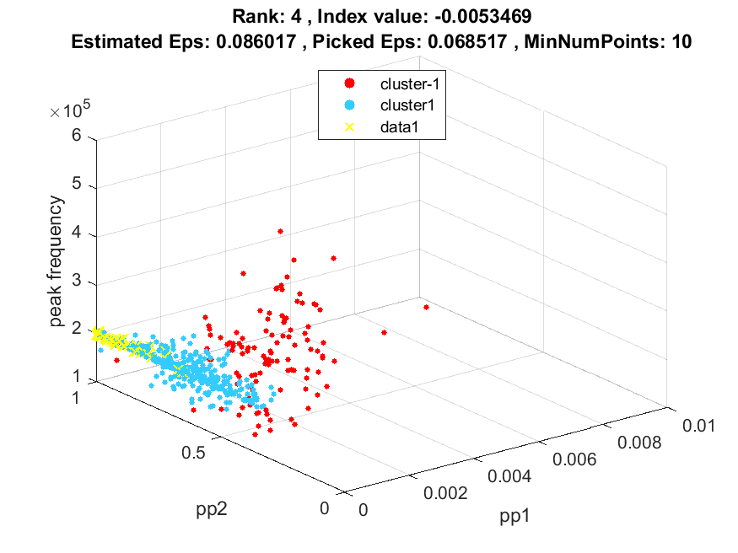
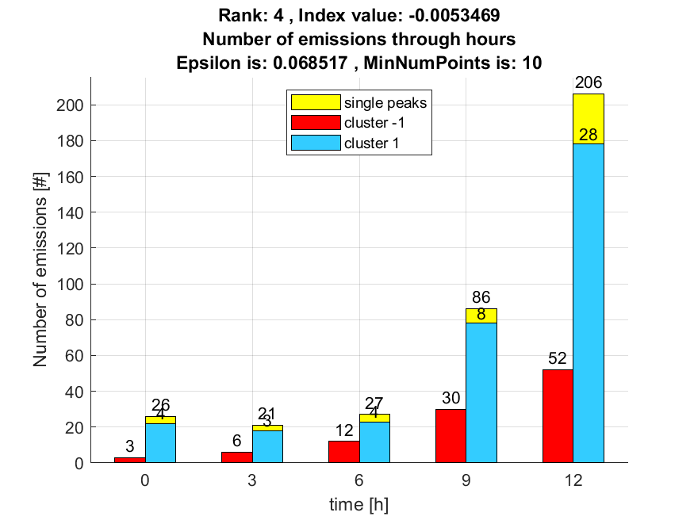

5. result: (pp2, pp3, peak_frequency)
Estimated Epsilon: 0.073991, Picked Epsilon: 0.081491, MinNumPoints: 10
DBCV_single_clust index value: -0.0057889
cluster -1 had 0% single peaks
cluster 1 had 100% single peaks
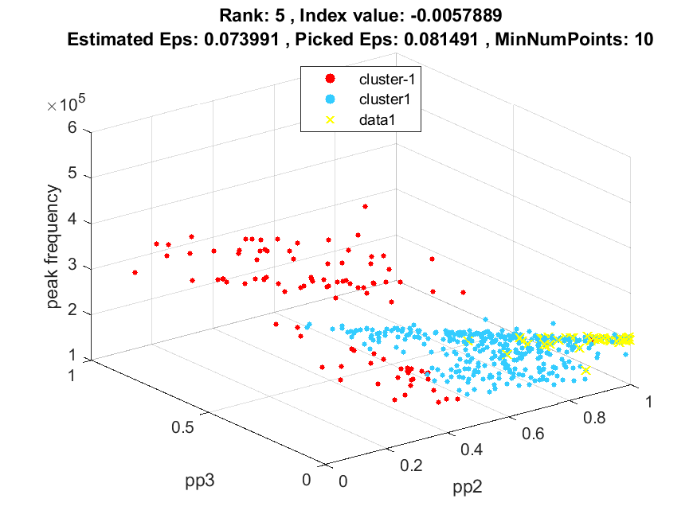
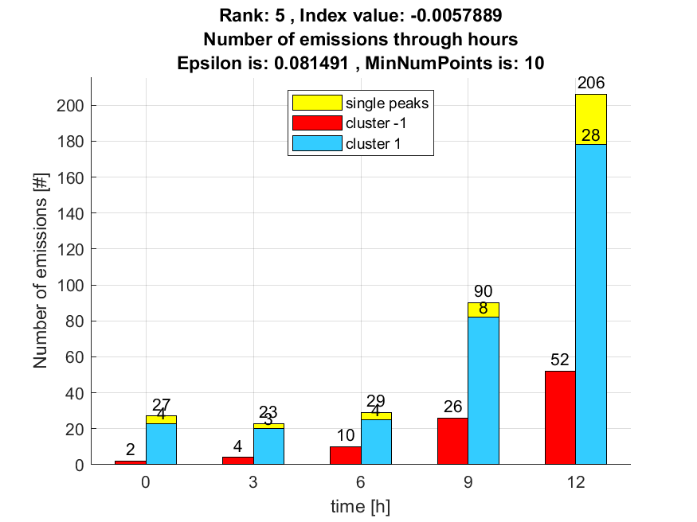

6. result: (pp3, peak_frequency, amp_of_peak_frequency)
Estimated Epsilon: 0.073346, Picked Epsilon: 0.060846, MinNumPoints: 10
DBCV_single_clust index value: -0.005802
cluster -1 had 38.2979% single peaks
cluster 1 had 61.7021% single peaks
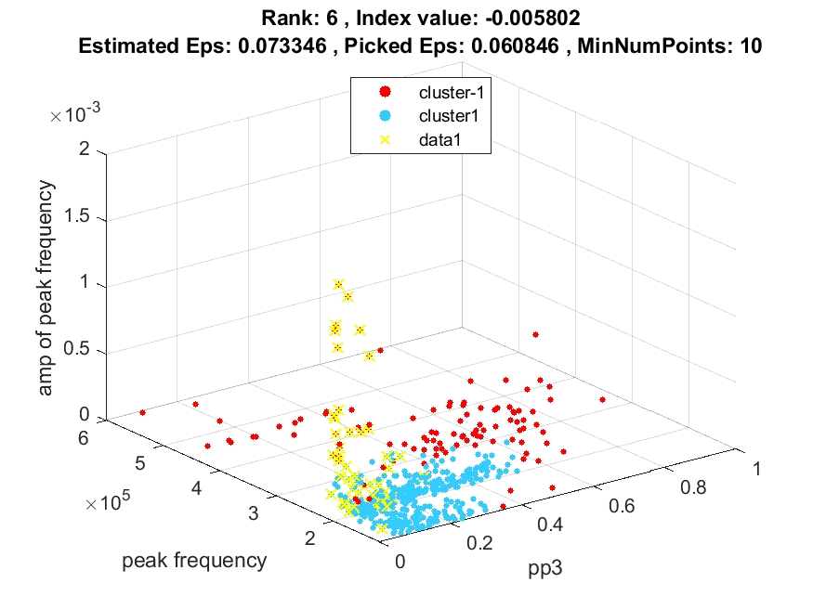
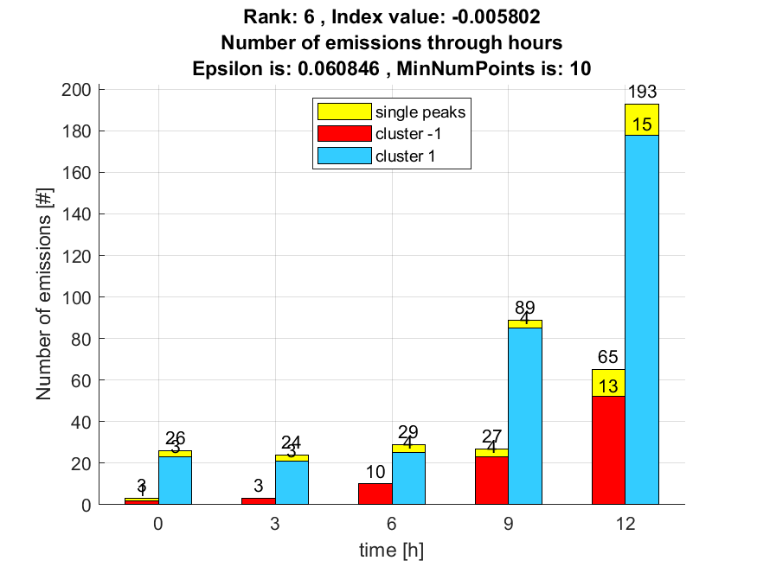

7. result: (peak_frequency, amp_of_peak_frequency, total_counts)
Estimated Epsilon: 0.061617, Picked Epsilon: 0.054117, MinNumPoints: 10
DBCV_single_clust index value: -0.0058314
cluster -1 had 42.5532% single peaks
cluster 1 had 57.4468% single peaks
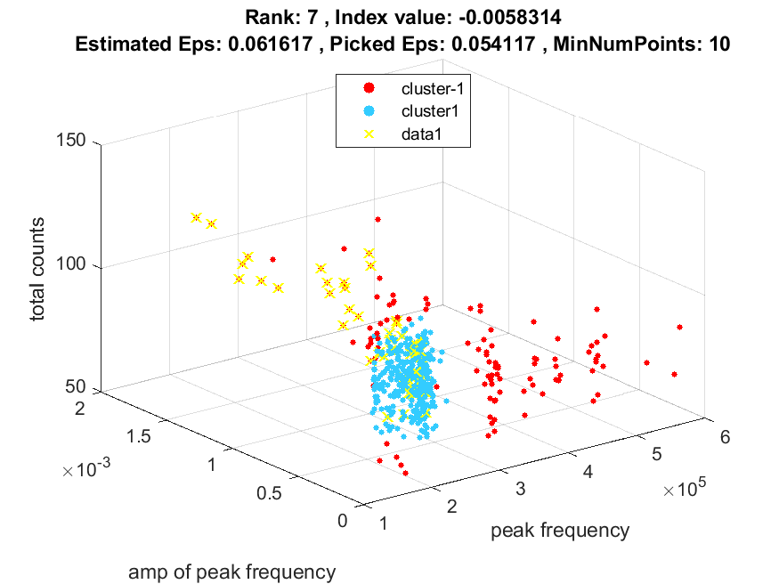
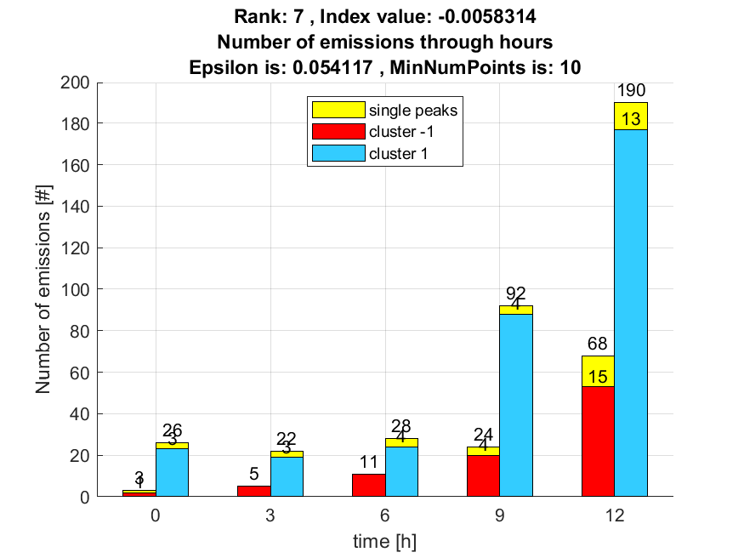

8. result: (signal_strength, pp3, peak_frequency)
Estimated Epsilon: 0.076188, Picked Epsilon: 0.073688, MinNumPoints: 10
DBCV_single_clust index value: -0.0059267
cluster -1 had 31.9149% single peaks
cluster 1 had 68.0851% single peaks
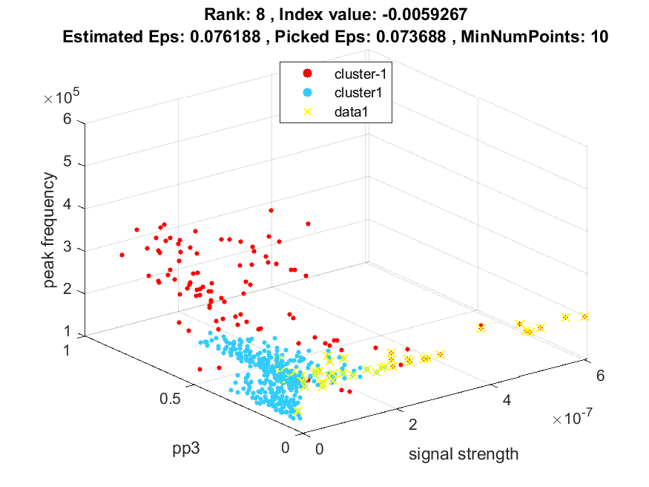
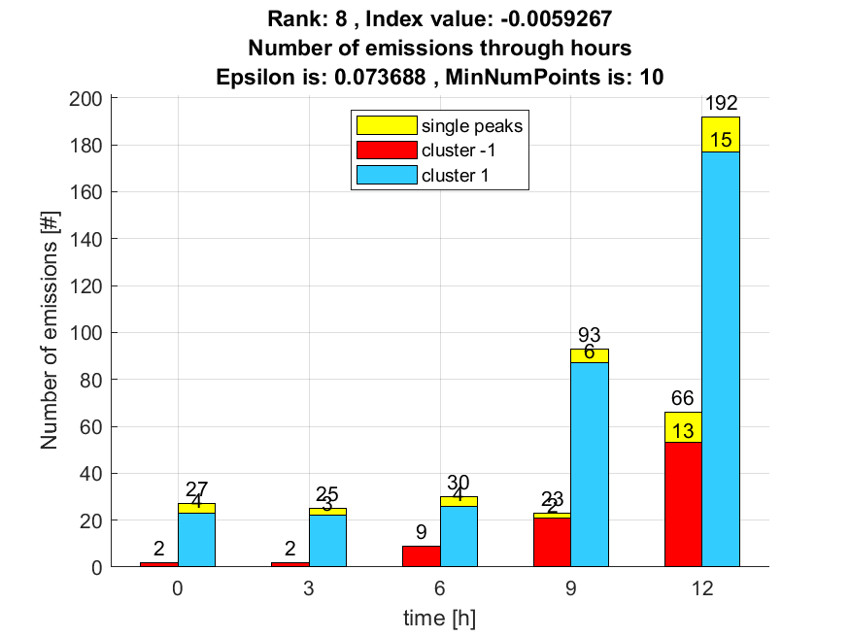

9. result: (pp2, peak_frequency, amp_of_peak_frequency)
Estimated Epsilon: 0.075058, Picked Epsilon: 0.065058, MinNumPoints: 10
DBCV_single_clust index value: -0.0061489
cluster -1 had 38.2979% single peaks
cluster 1 had 61.7021% single peaks
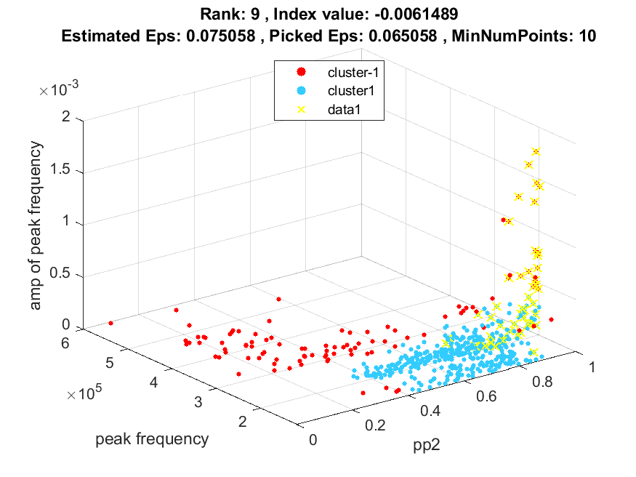
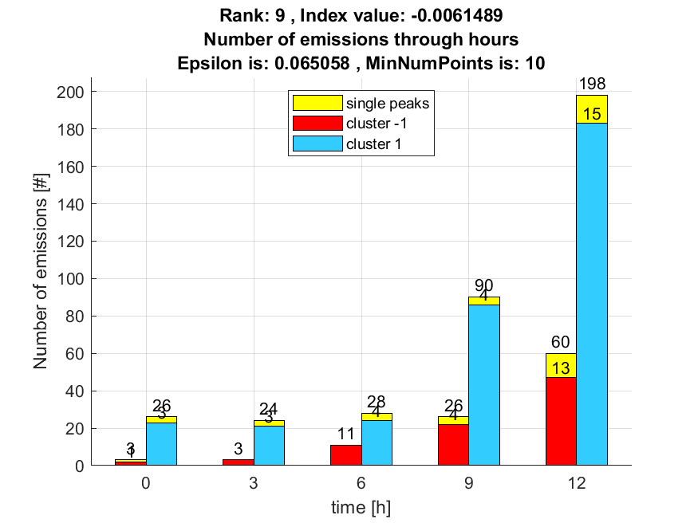

10. result: (rise_time, pp3, peak_frequency)
Estimated Epsilon: 0.093697, Picked Epsilon: 0.1037, MinNumPoints: 10
DBCV_single_clust index value: -0.0062079
cluster -1 had 0% single peaks
cluster 1 had 100% single peaks
