Feature selection results for exp_10_part_2 and Nmin = 10

1. result: (signal_strength, peak_frequency, amp_of_peak_frequency)
Estimated Epsilon: 0.019911, Picked Epsilon: 0.019911, MinNumPoints: 10
DBCV_single_clust index value: 0.92515
cluster -1 had 5.3398% single peaks
cluster 1 had 93.6893% single peaks
cluster 2 had 0.48544% single peaks
cluster 3 had 0% single peaks
cluster 4 had 0.48544% single peaks
cluster 5 had 0% single peaks
cluster 6 had 0% single peaks
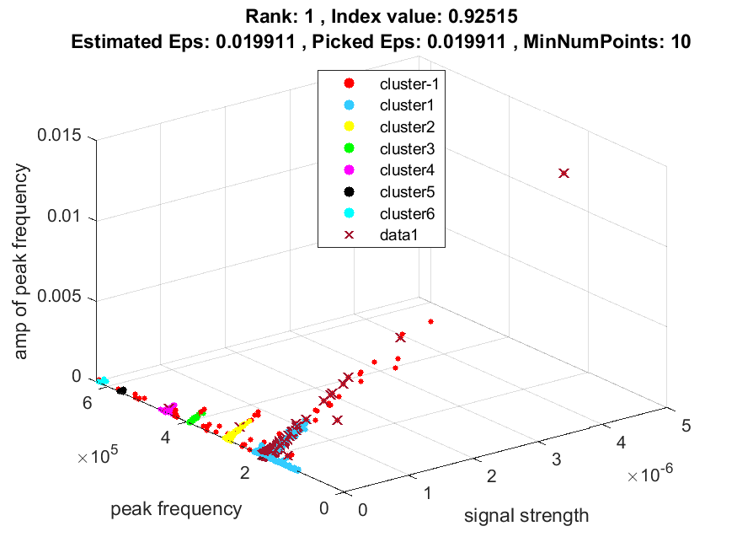
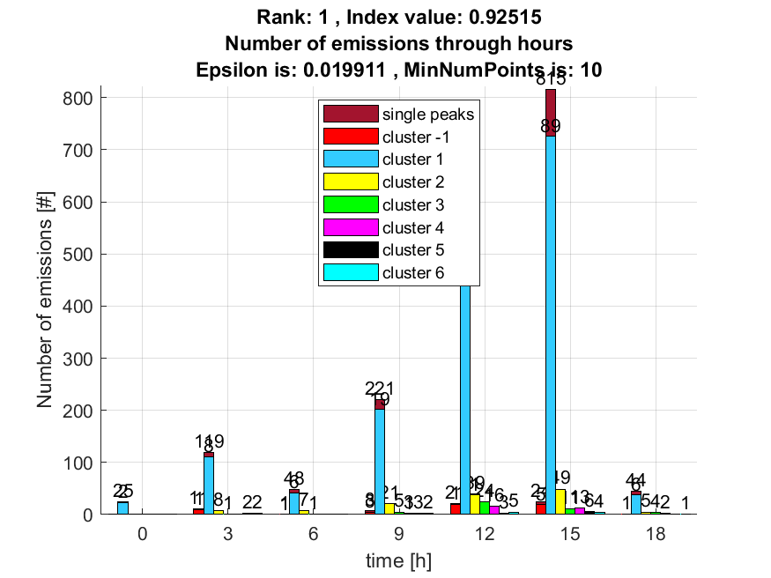

2. result: (peak_amplitude, peak_frequency, amp_of_peak_frequency)
Estimated Epsilon: 0.026244, Picked Epsilon: 0.026244, MinNumPoints: 10
DBCV_single_clust index value: 0.91303
cluster -1 had 4.3689% single peaks
cluster 1 had 94.6602% single peaks
cluster 2 had 0.48544% single peaks
cluster 3 had 0% single peaks
cluster 4 had 0.48544% single peaks
cluster 5 had 0% single peaks
cluster 6 had 0% single peaks
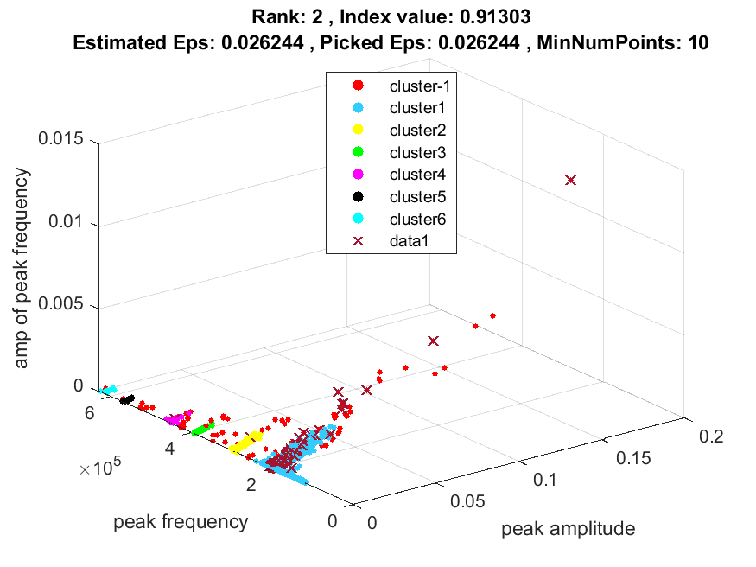
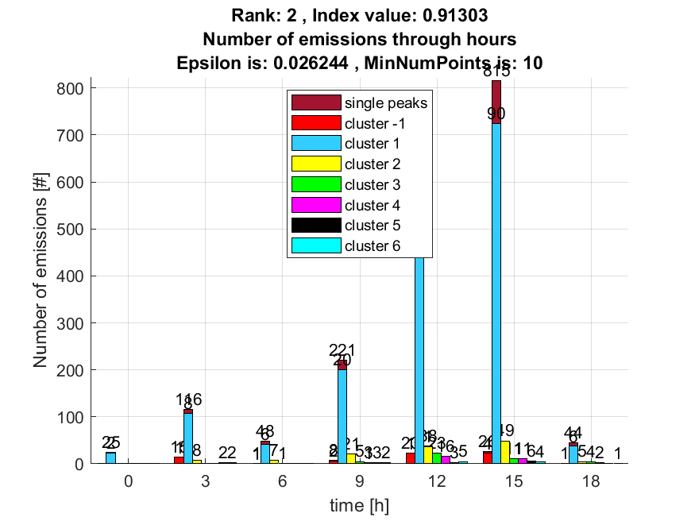

3. result: (rise_time, peak_frequency, total_counts)
Estimated Epsilon: 0.057657, Picked Epsilon: 0.060157, MinNumPoints: 10
DBCV_single_clust index value: 0.88454
cluster -1 had 2.4272% single peaks
cluster 1 had 96.6019% single peaks
cluster 2 had 0.48544% single peaks
cluster 3 had 0.48544% single peaks
cluster 4 had 0% single peaks
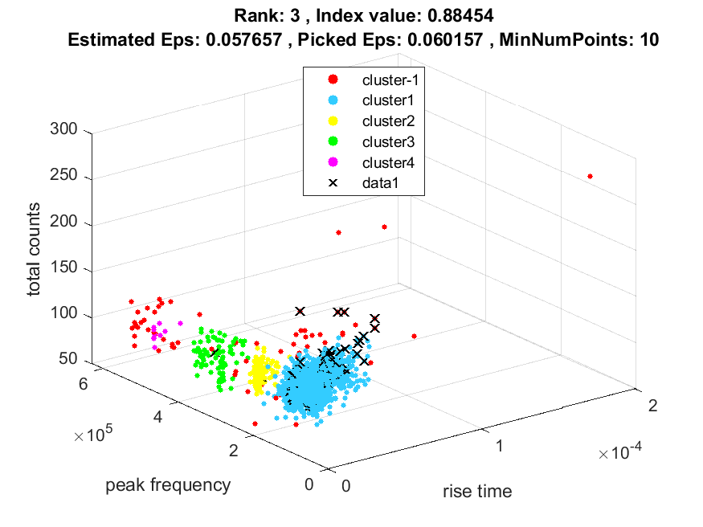
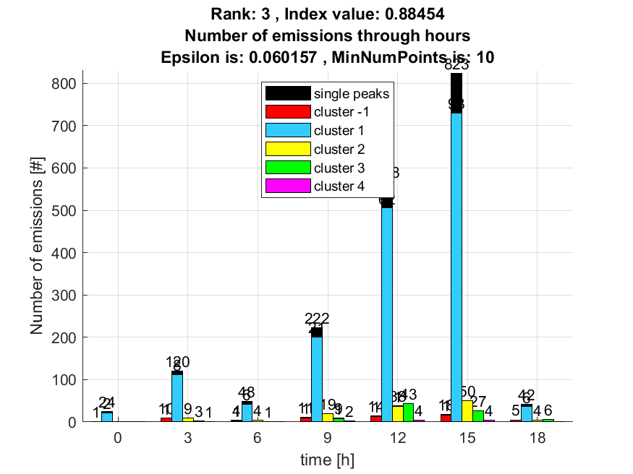

4. result: (rise_time, peak_frequency, amp_of_peak_frequency)
Estimated Epsilon: 0.028289, Picked Epsilon: 0.030789, MinNumPoints: 10
DBCV_single_clust index value: 0.8727
cluster -1 had 6.7961% single peaks
cluster 1 had 92.233% single peaks
cluster 2 had 0.48544% single peaks
cluster 3 had 0% single peaks
cluster 4 had 0.48544% single peaks
cluster 5 had 0% single peaks
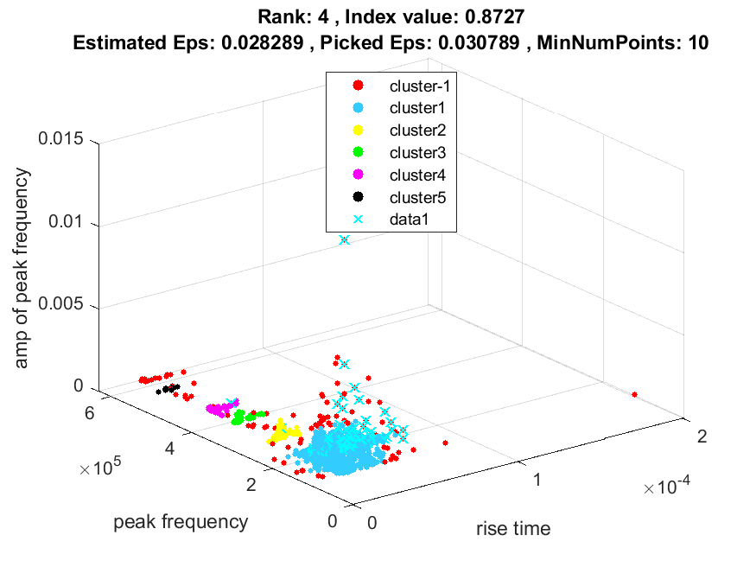
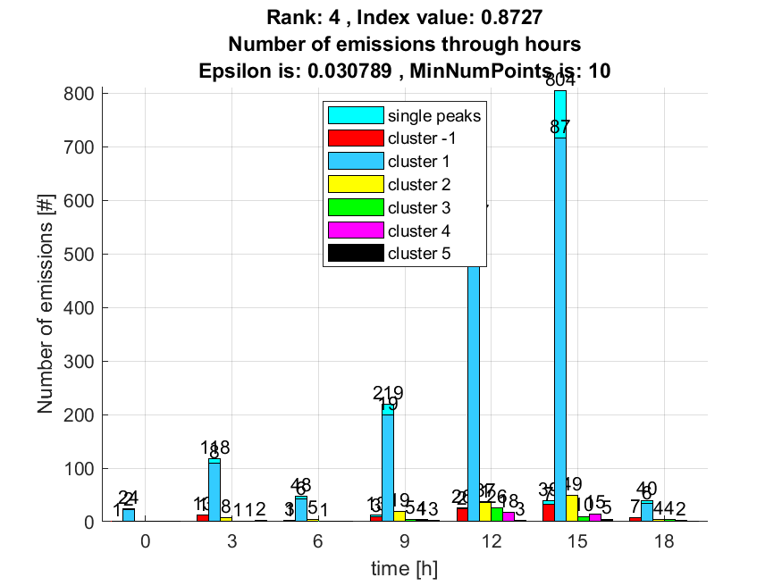

5. result: (peak_frequency, amp_of_peak_frequency, total_counts)
Estimated Epsilon: 0.038793, Picked Epsilon: 0.038793, MinNumPoints: 10
DBCV_single_clust index value: 0.85602
cluster -1 had 7.767% single peaks
cluster 1 had 91.2621% single peaks
cluster 2 had 0.48544% single peaks
cluster 3 had 0% single peaks
cluster 4 had 0.48544% single peaks
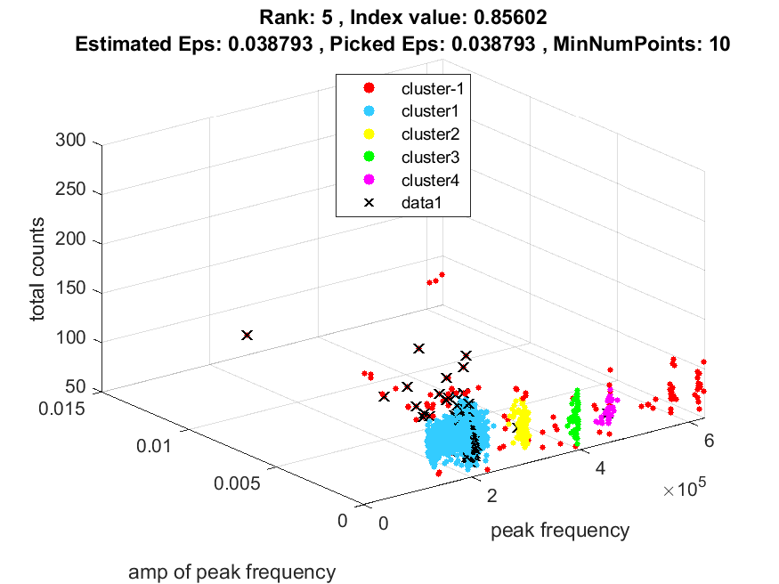
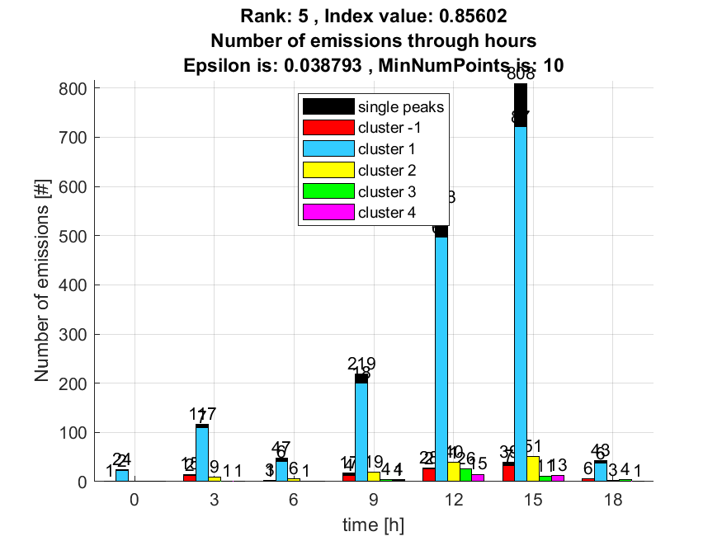

6. result: (signal_strength, pp1, peak_frequency)
Estimated Epsilon: 0.031224, Picked Epsilon: 0.031224, MinNumPoints: 10
DBCV_single_clust index value: 0.82987
cluster -1 had 3.8835% single peaks
cluster 1 had 95.1456% single peaks
cluster 2 had 0.48544% single peaks
cluster 3 had 0% single peaks
cluster 4 had 0.48544% single peaks
cluster 5 had 0% single peaks
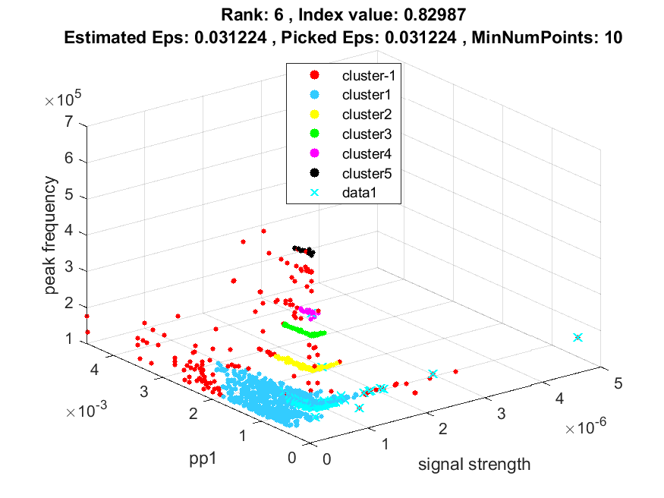
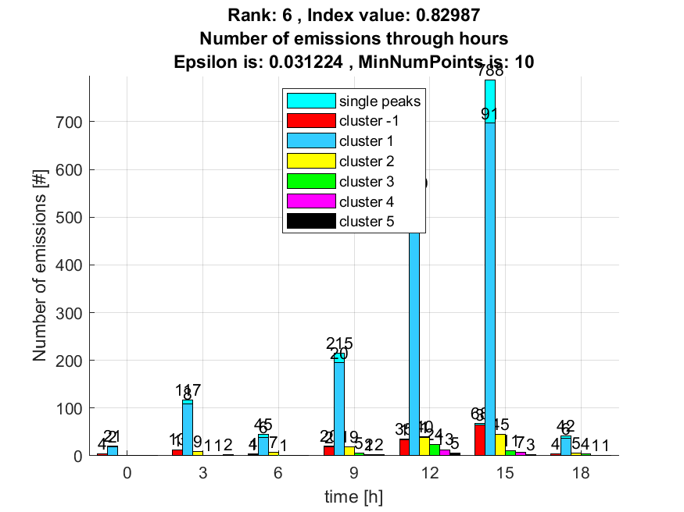

7. result: (rise_time, pp1, peak_frequency)
Estimated Epsilon: 0.047611, Picked Epsilon: 0.050111, MinNumPoints: 10
DBCV_single_clust index value: 0.82498
cluster -1 had 0.97087% single peaks
cluster 1 had 98.0583% single peaks
cluster 2 had 0.48544% single peaks
cluster 3 had 0% single peaks
cluster 4 had 0.48544% single peaks
cluster 5 had 0% single peaks
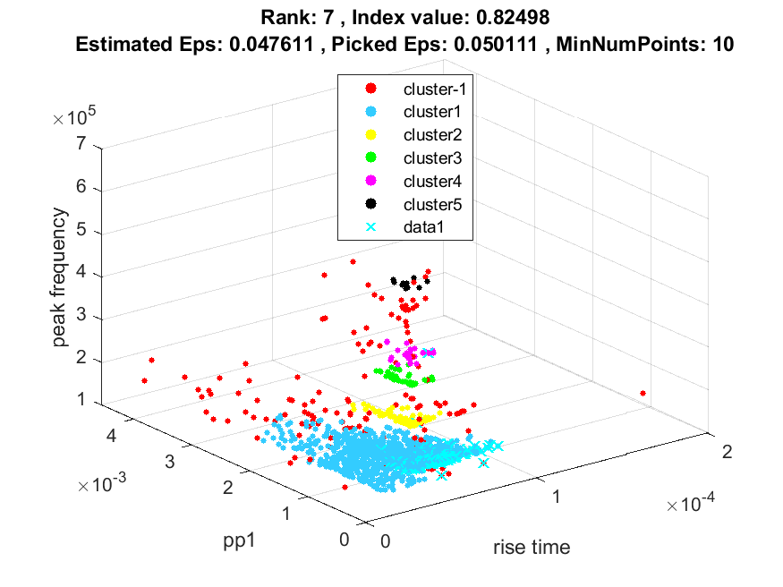
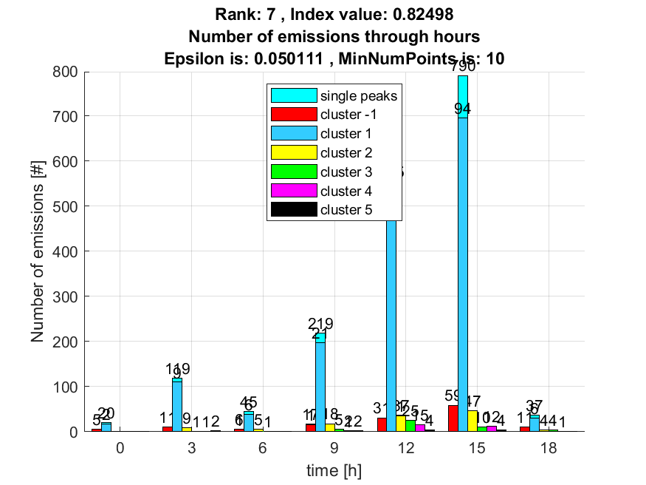

8. result: (pp3, peak_frequency, amp_of_peak_frequency)
Estimated Epsilon: 0.041967, Picked Epsilon: 0.041967, MinNumPoints: 10
DBCV_single_clust index value: 0.81913
cluster -1 had 5.8252% single peaks
cluster 1 had 94.1748% single peaks
cluster 2 had 0% single peaks
cluster 3 had 0% single peaks
cluster 4 had 0% single peaks
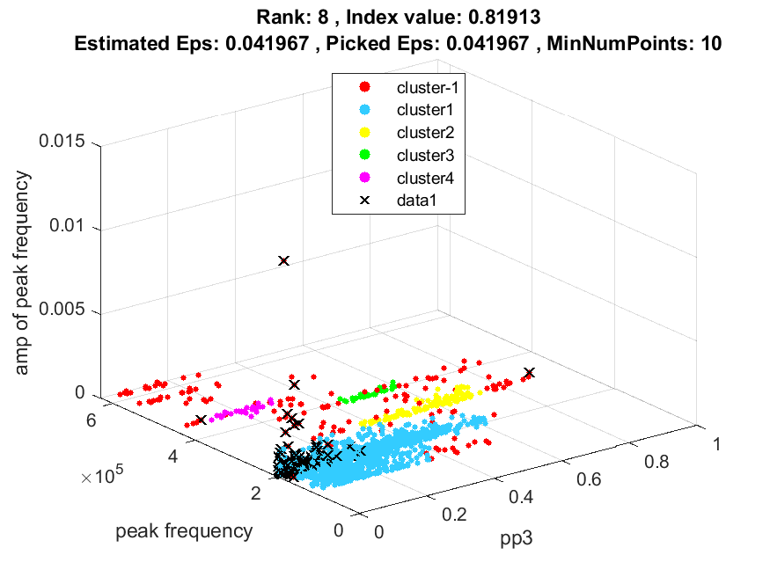
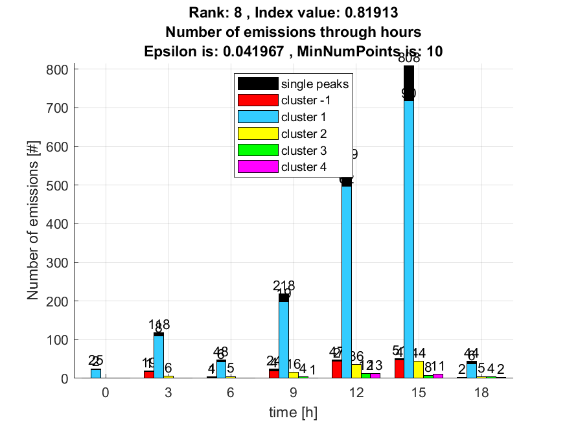

9. result: (peak_amplitude, pp1, peak_frequency)
Estimated Epsilon: 0.029273, Picked Epsilon: 0.029273, MinNumPoints: 10
DBCV_single_clust index value: 0.80733
cluster -1 had 1.9417% single peaks
cluster 1 had 97.0874% single peaks
cluster 2 had 0.48544% single peaks
cluster 3 had 0% single peaks
cluster 4 had 0.48544% single peaks
cluster 5 had 0% single peaks
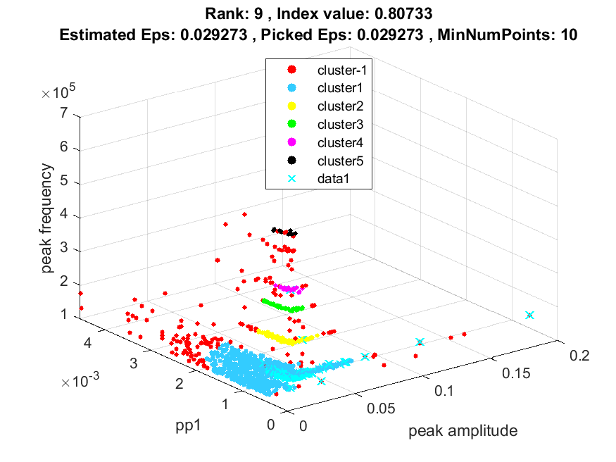
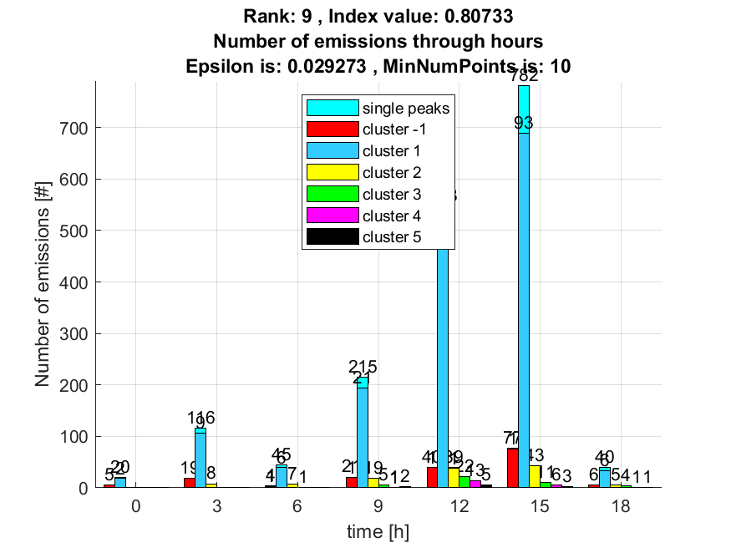

10. result: (rise_time, pp2, peak_frequency)
Estimated Epsilon: 0.053246, Picked Epsilon: 0.055746, MinNumPoints: 10
DBCV_single_clust index value: 0.80552
cluster -1 had 1.4563% single peaks
cluster 1 had 98.0583% single peaks
cluster 2 had 0.48544% single peaks
cluster 3 had 0% single peaks
cluster 4 had 0% single peaks
