Feature selection results for exp_14_part_1 and Nmin = 10

1. result: (peak_amplitude, pp2, peak_frequency)
Estimated Epsilon: 0.089519, Picked Epsilon: 0.099519, MinNumPoints: 10
DBCV index value: 0.79078
cluster -1 had 11.1111% single peaks
cluster 1 had 88.8889% single peaks
cluster 2 had 0% single peaks
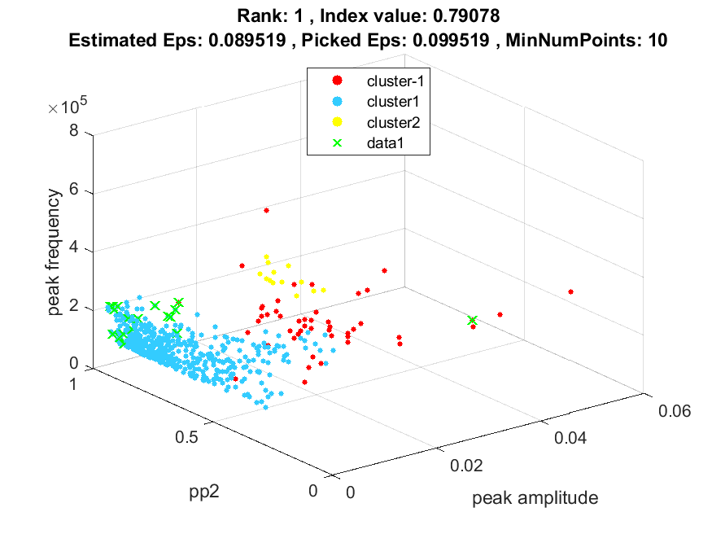
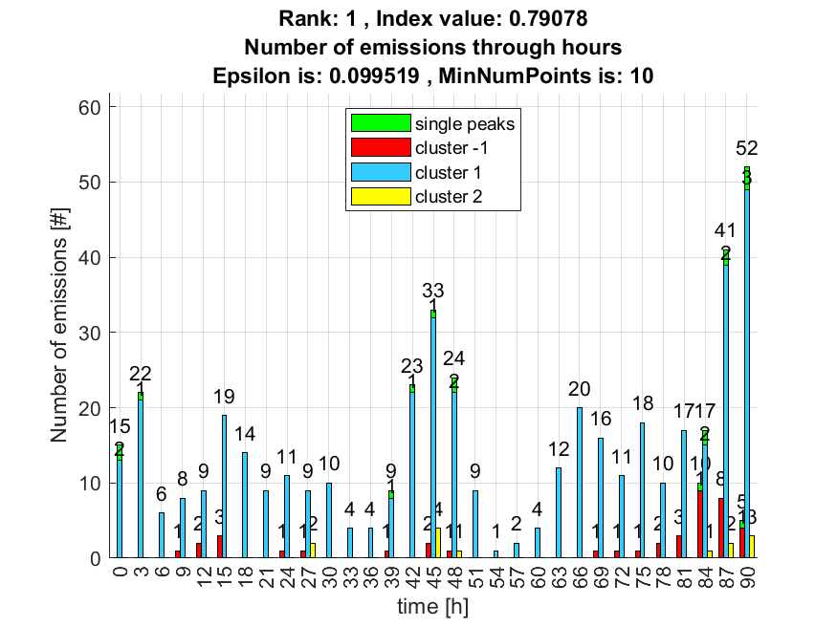

2. result: (rise_time, peak_frequency, amp_of_peak_frequency)
Estimated Epsilon: 0.062363, Picked Epsilon: 0.072363, MinNumPoints: 10
DBCV index value: 0.77246
cluster -1 had 16.6667% single peaks
cluster 1 had 83.3333% single peaks
cluster 2 had 0% single peaks
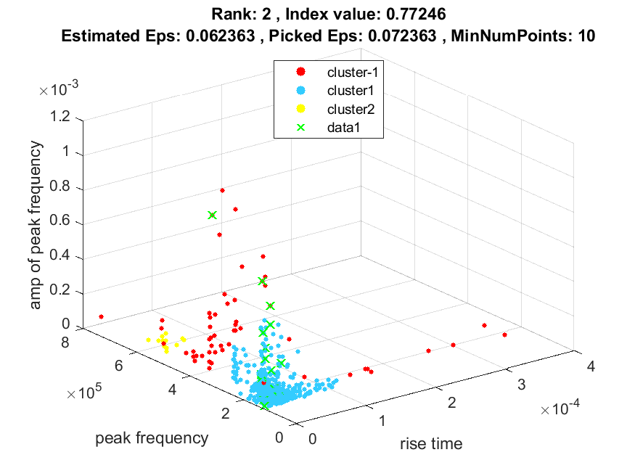
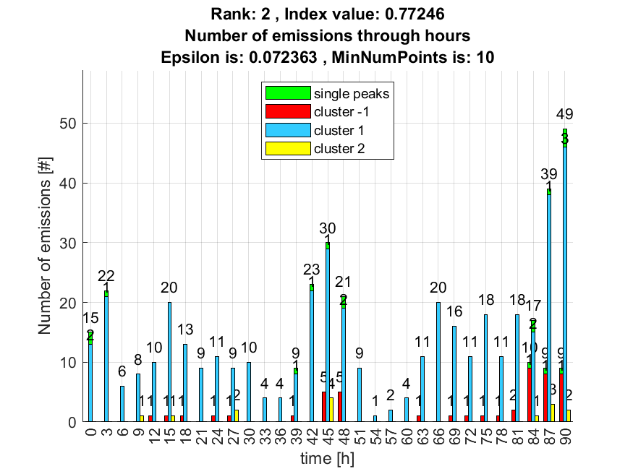

3. result: (rise_time, signal_strength, peak_frequency)
Estimated Epsilon: 0.055678, Picked Epsilon: 0.065678, MinNumPoints: 10
DBCV index value: 0.76223
cluster -1 had 11.1111% single peaks
cluster 1 had 88.8889% single peaks
cluster 2 had 0% single peaks
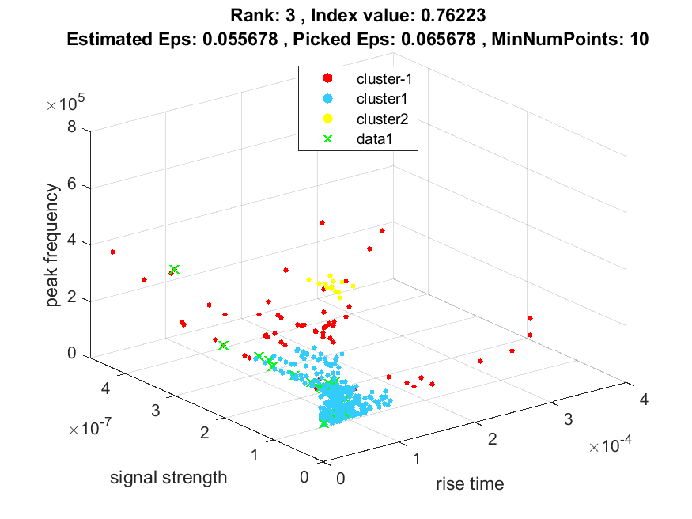
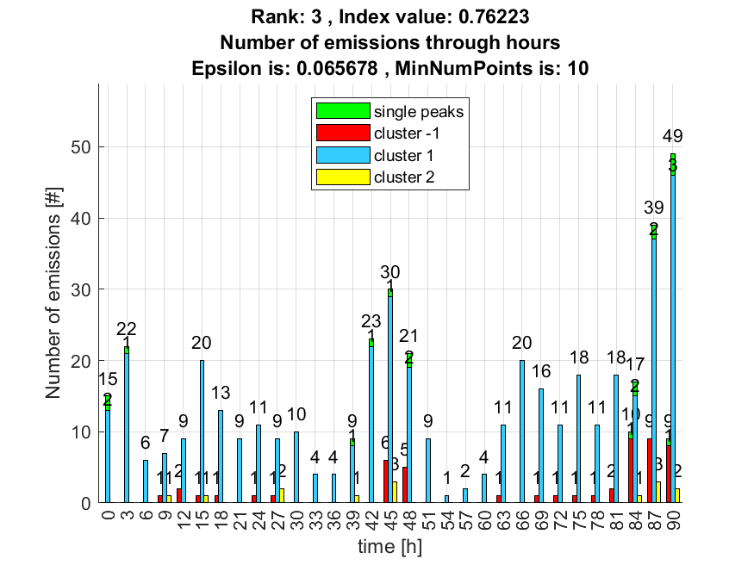

4. result: (signal_strength, pp2, peak_frequency)
Estimated Epsilon: 0.10363, Picked Epsilon: 0.11363, MinNumPoints: 10
DBCV index value: 0.76126
cluster -1 had 22.2222% single peaks
cluster 1 had 77.7778% single peaks
cluster 2 had 0% single peaks
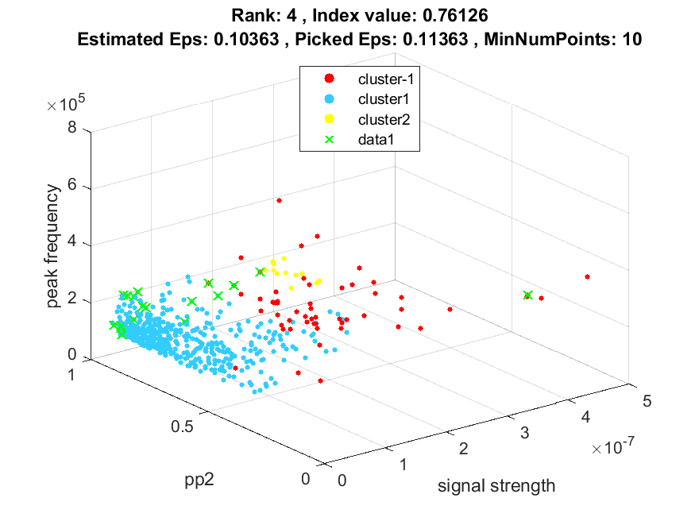
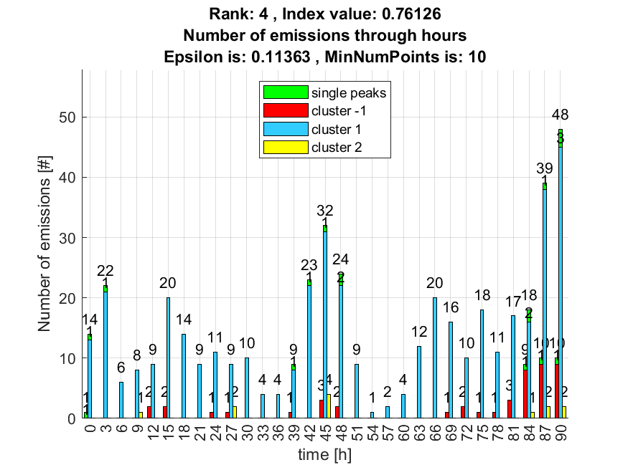

5. result: (signal_strength, pp3, peak_frequency)
Estimated Epsilon: 0.099121, Picked Epsilon: 0.10912, MinNumPoints: 10
DBCV index value: 0.75825
cluster -1 had 11.1111% single peaks
cluster 1 had 88.8889% single peaks
cluster 2 had 0% single peaks
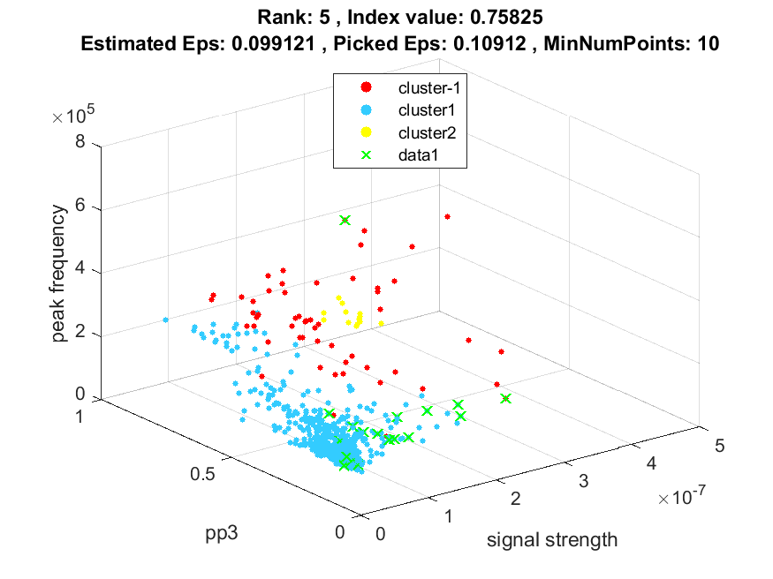
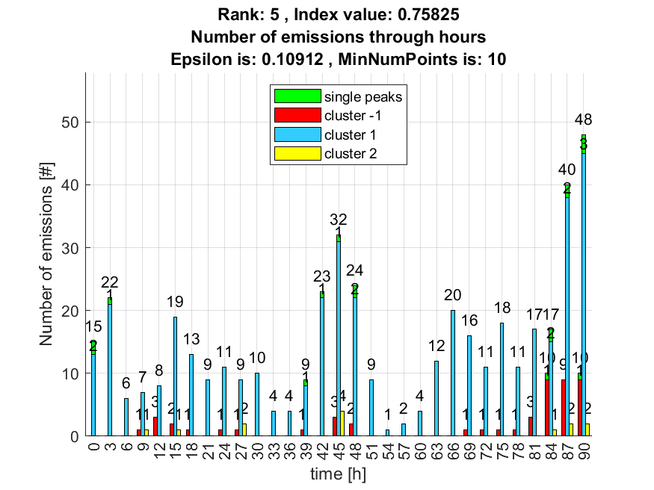

6. result: (peak_amplitude, pp3, peak_frequency)
Estimated Epsilon: 0.078027, Picked Epsilon: 0.088027, MinNumPoints: 10
DBCV index value: 0.75487
cluster -1 had 11.1111% single peaks
cluster 1 had 88.8889% single peaks
cluster 2 had 0% single peaks
cluster 3 had 0% single peaks
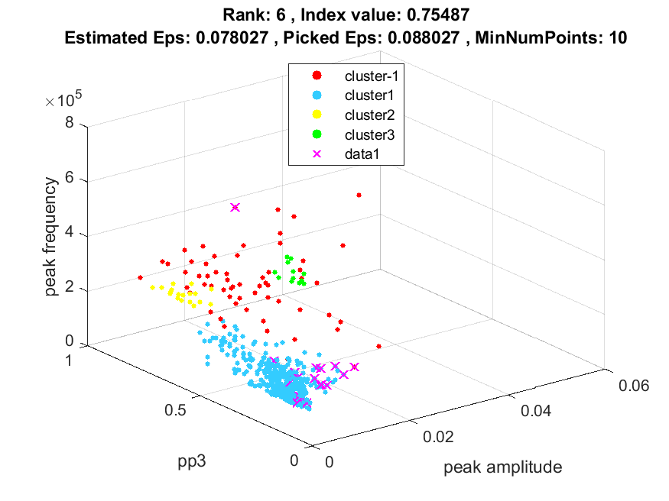
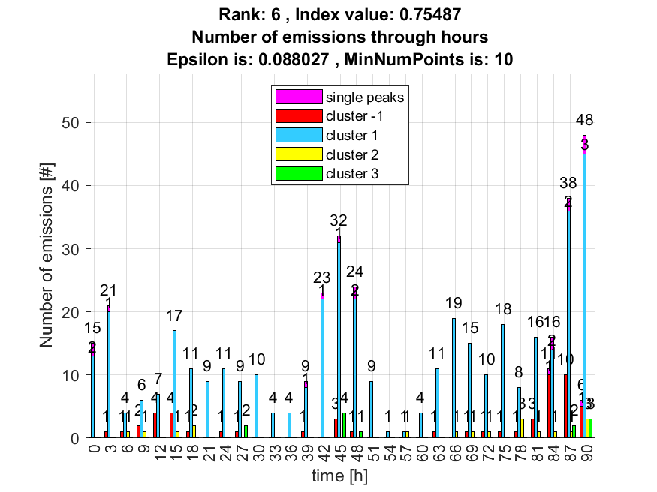

7. result: (pp3, peak_frequency, fall_time)
Estimated Epsilon: 0.068513, Picked Epsilon: 0.078513, MinNumPoints: 10
DBCV index value: 0.75138
cluster -1 had 5.5556% single peaks
cluster 1 had 94.4444% single peaks
cluster 2 had 0% single peaks
cluster 3 had 0% single peaks
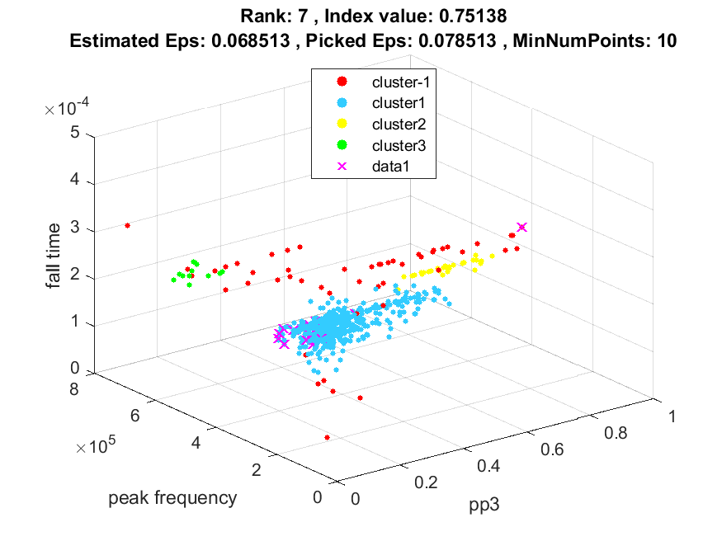
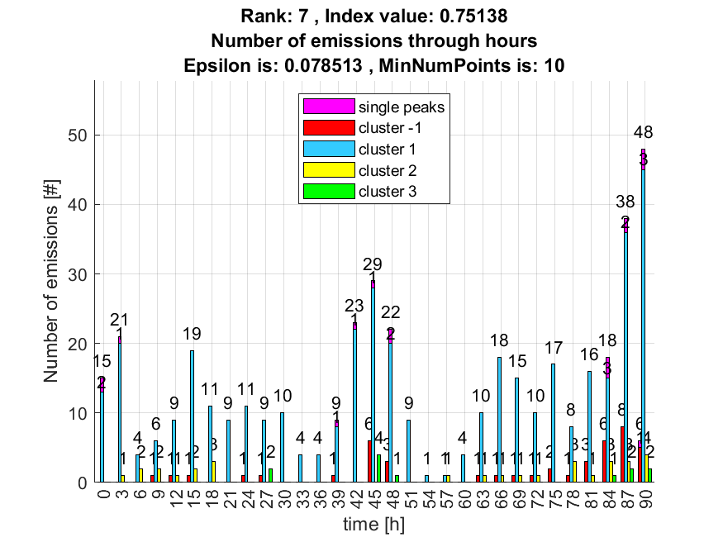

8. result: (peak_amplitude, peak_frequency, total_counts)
Estimated Epsilon: 0.08867, Picked Epsilon: 0.09867, MinNumPoints: 10
DBCV index value: 0.7421
cluster -1 had 5.5556% single peaks
cluster 1 had 94.4444% single peaks
cluster 2 had 0% single peaks
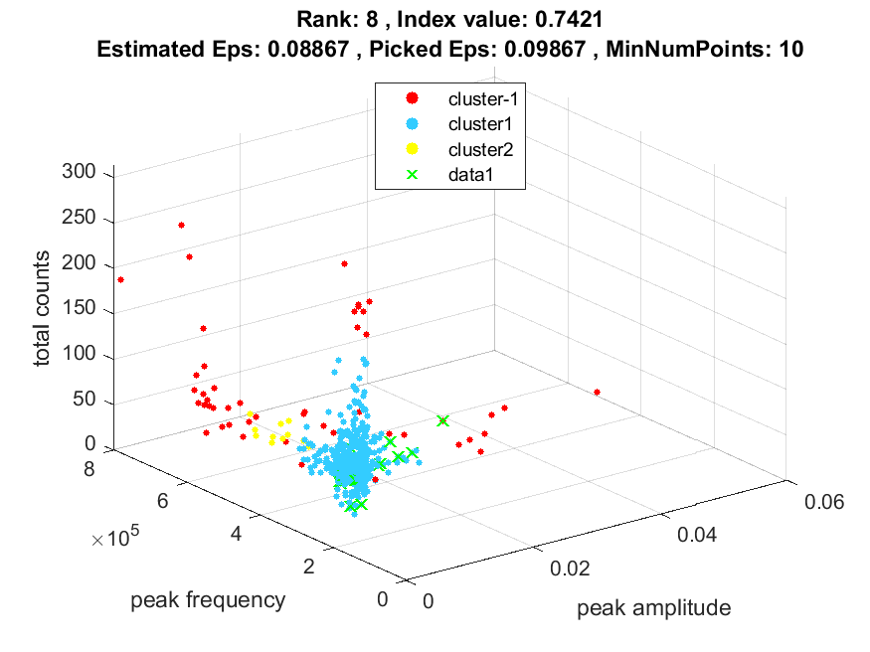
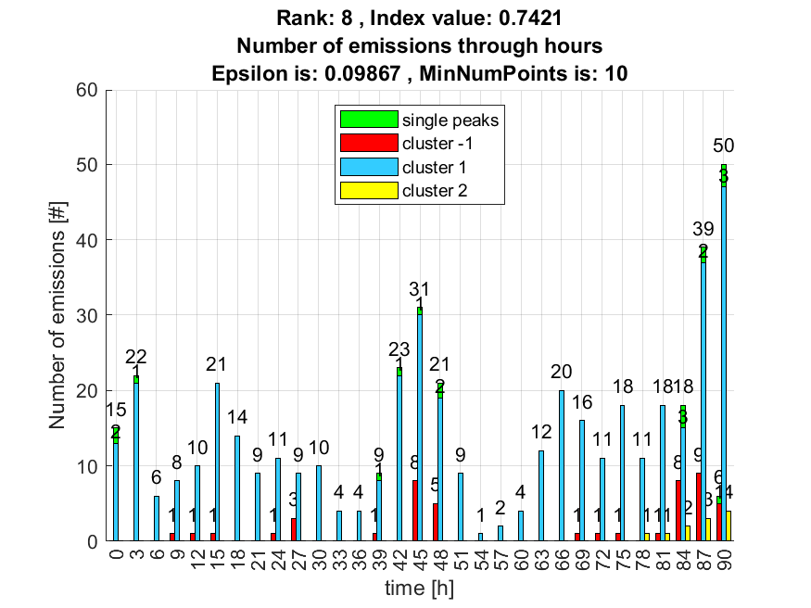

9. result: (counts_from, peak_frequency, amp_of_peak_frequency)
Estimated Epsilon: 0.076984, Picked Epsilon: 0.084484, MinNumPoints: 10
DBCV index value: 0.73413
cluster -1 had 16.6667% single peaks
cluster 1 had 83.3333% single peaks
cluster 2 had 0% single peaks
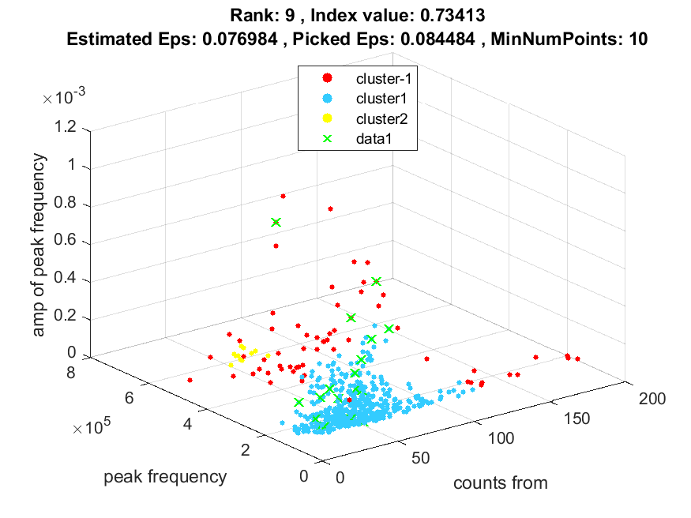
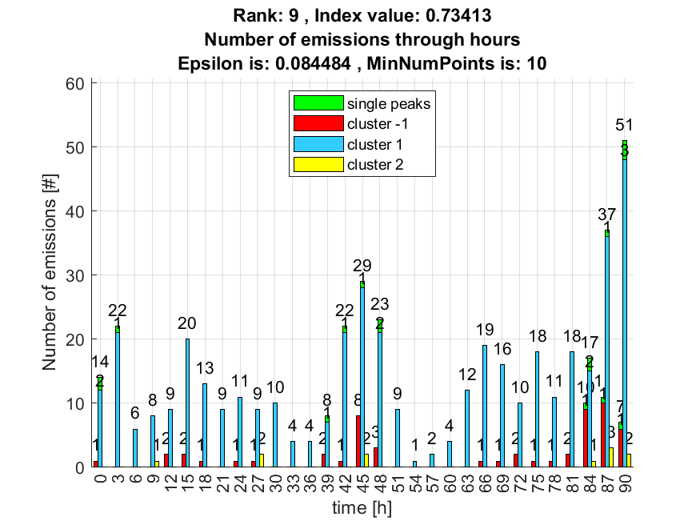

10. result: (pp2, peak_frequency, amp_of_peak_frequency)
Estimated Epsilon: 0.08249, Picked Epsilon: 0.09249, MinNumPoints: 10
DBCV index value: 0.72378
cluster -1 had 27.7778% single peaks
cluster 1 had 72.2222% single peaks
cluster 2 had 0% single peaks
