Feature selection results for exp_14_part_1 and Nmin = 10

1. result: (rise_time, peak_amplitude, peak_frequency)
Estimated Epsilon: 0.062647, Picked Epsilon: 0.052647, MinNumPoints: 10
DBCV_single_clust index value: -0.0020006
cluster -1 had 11.1111% single peaks
cluster 1 had 88.8889% single peaks
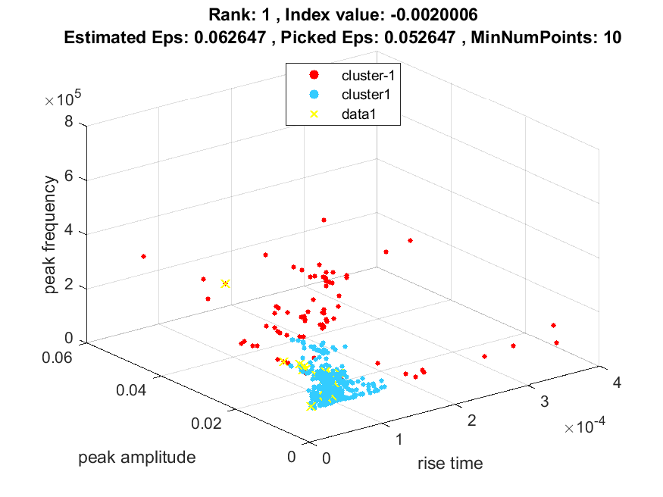
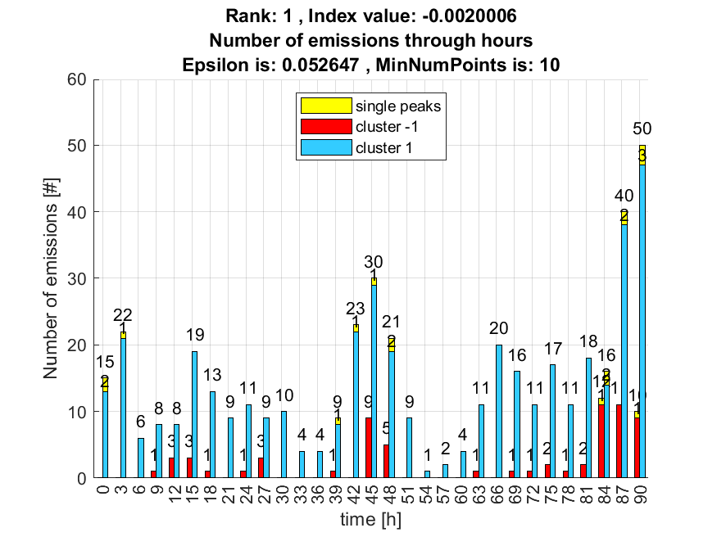

2. result: (peak_amplitude, peak_frequency, total_counts)
Estimated Epsilon: 0.08867, Picked Epsilon: 0.08867, MinNumPoints: 10
DBCV_single_clust index value: -0.0025636
cluster -1 had 5.5556% single peaks
cluster 1 had 94.4444% single peaks
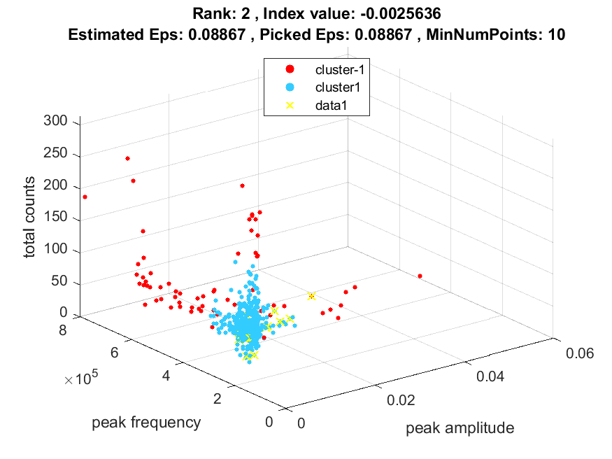
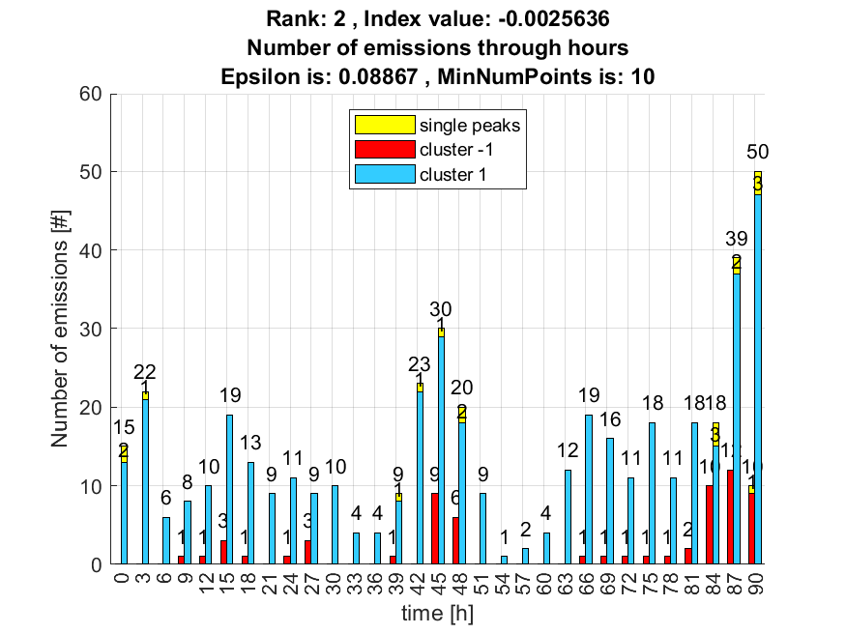

3. result: (rise_time, pp4, peak_frequency)
Estimated Epsilon: 0.07761, Picked Epsilon: 0.08011, MinNumPoints: 10
DBCV_single_clust index value: -0.0026682
cluster -1 had 5.5556% single peaks
cluster 1 had 94.4444% single peaks
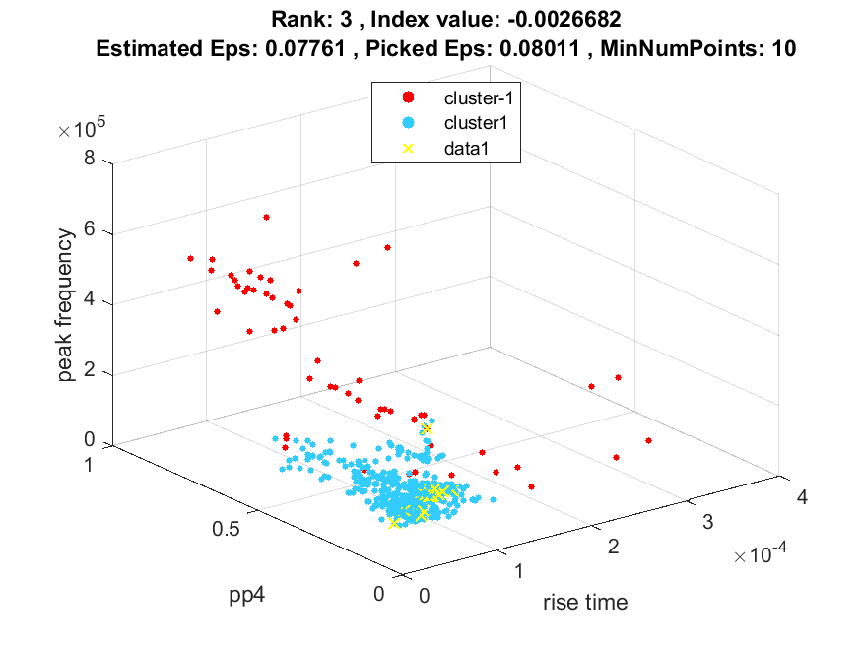
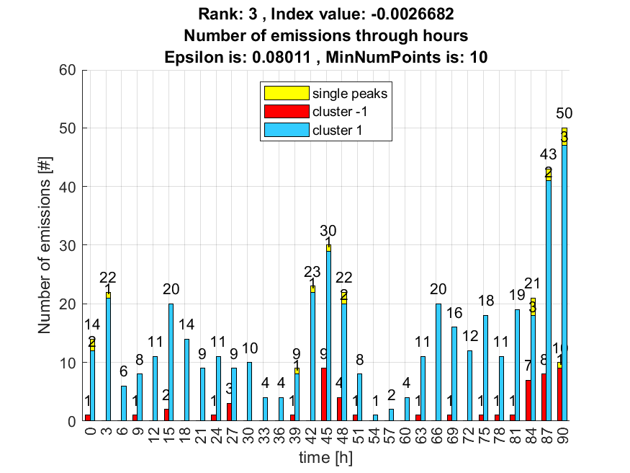

4. result: (peak_frequency, amp_of_peak_frequency, total_counts)
Estimated Epsilon: 0.091155, Picked Epsilon: 0.10115, MinNumPoints: 10
DBCV_single_clust index value: -0.0031199
cluster -1 had 16.6667% single peaks
cluster 1 had 83.3333% single peaks
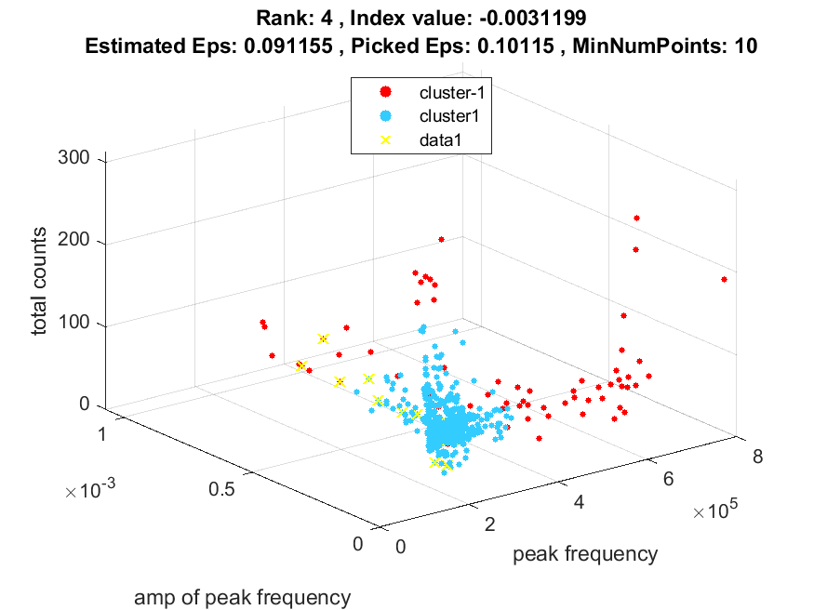
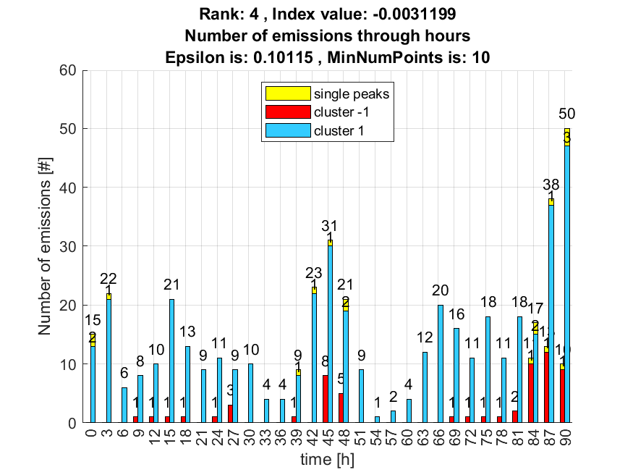

5. result: (signal_strength, peak_frequency, total_counts)
Estimated Epsilon: 0.079507, Picked Epsilon: 0.087007, MinNumPoints: 10
DBCV_single_clust index value: -0.0032375
cluster -1 had 11.1111% single peaks
cluster 1 had 88.8889% single peaks
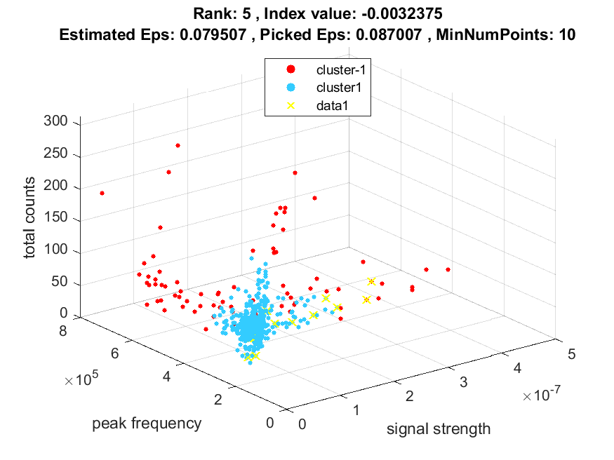
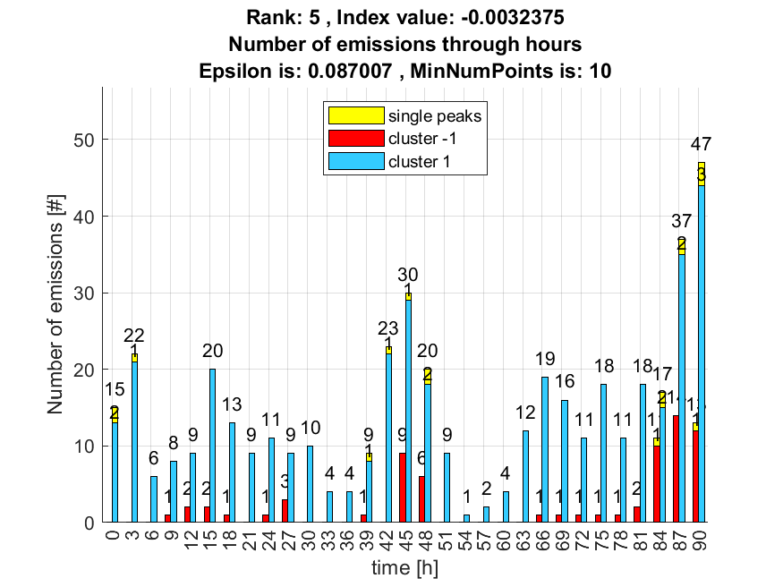

6. result: (peak_amplitude, pp3, peak_frequency)
Estimated Epsilon: 0.078027, Picked Epsilon: 0.073027, MinNumPoints: 10
DBCV_single_clust index value: -0.0032488
cluster -1 had 16.6667% single peaks
cluster 1 had 83.3333% single peaks
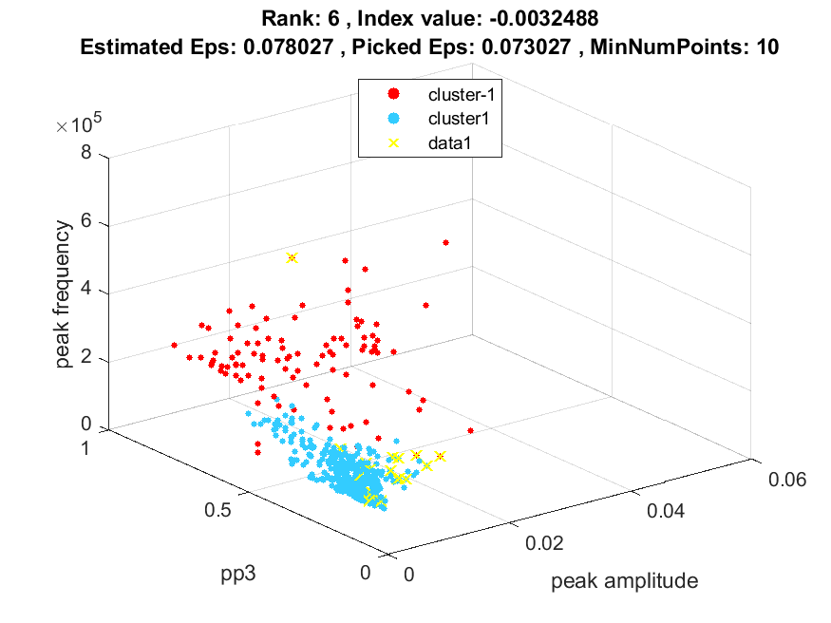
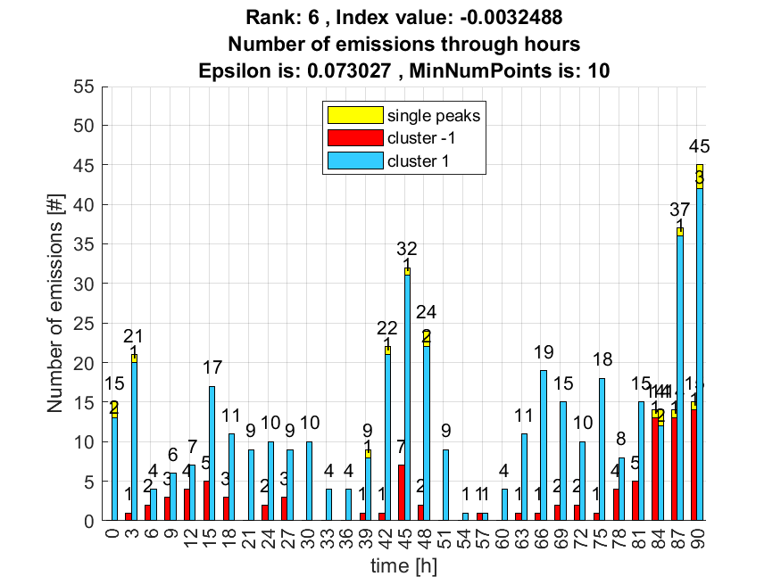

7. result: (centroid_frequency, peak_frequency, fall_time)
Estimated Epsilon: 0.069143, Picked Epsilon: 0.079143, MinNumPoints: 10
DBCV_single_clust index value: -0.0034844
cluster -1 had 5.5556% single peaks
cluster 1 had 94.4444% single peaks
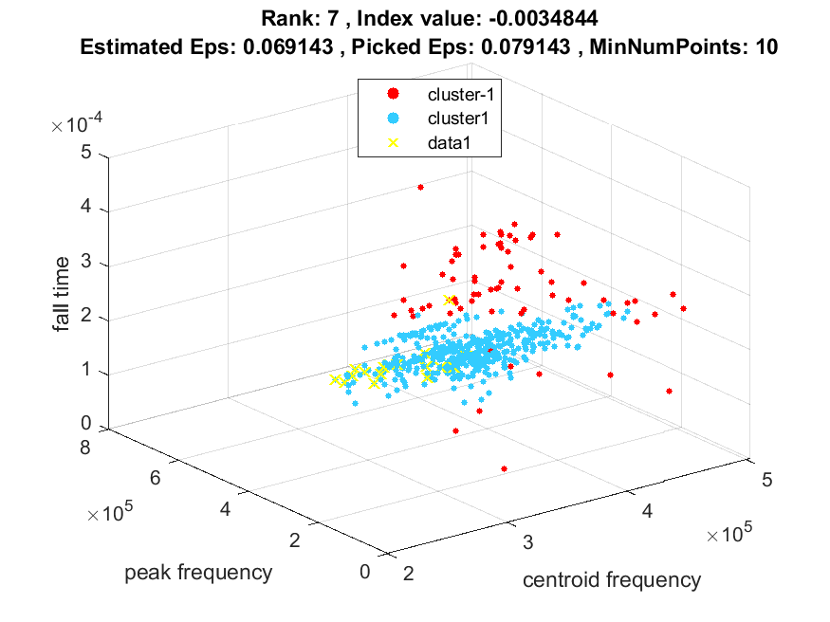
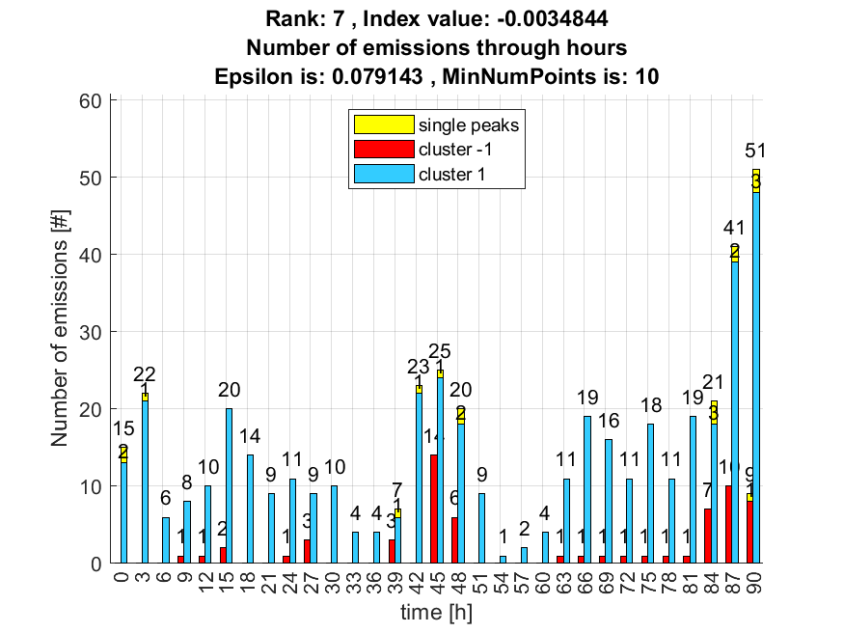

8. result: (counts_from, peak_amplitude, peak_frequency)
Estimated Epsilon: 0.073747, Picked Epsilon: 0.068747, MinNumPoints: 10
DBCV_single_clust index value: -0.0036464
cluster -1 had 22.2222% single peaks
cluster 1 had 77.7778% single peaks
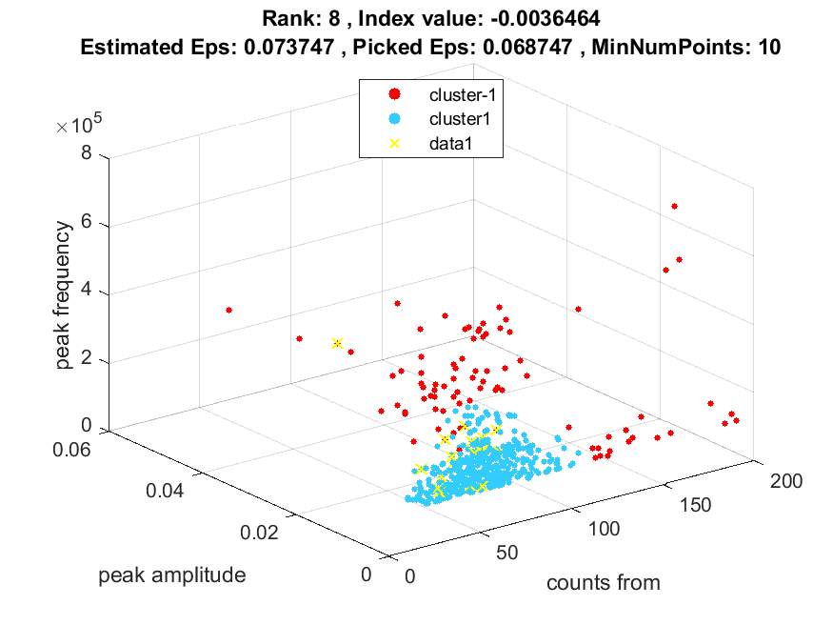
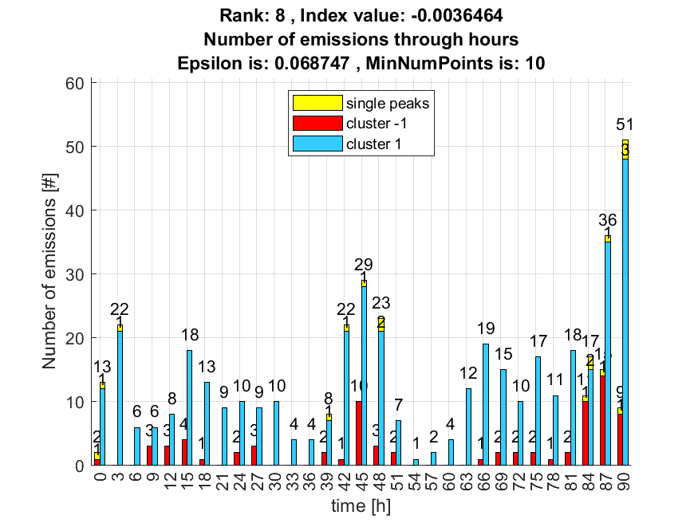

9. result: (pp1, pp4, peak_frequency)
Estimated Epsilon: 0.070187, Picked Epsilon: 0.080187, MinNumPoints: 10
DBCV_single_clust index value: -0.0036479
cluster -1 had 0% single peaks
cluster 1 had 100% single peaks
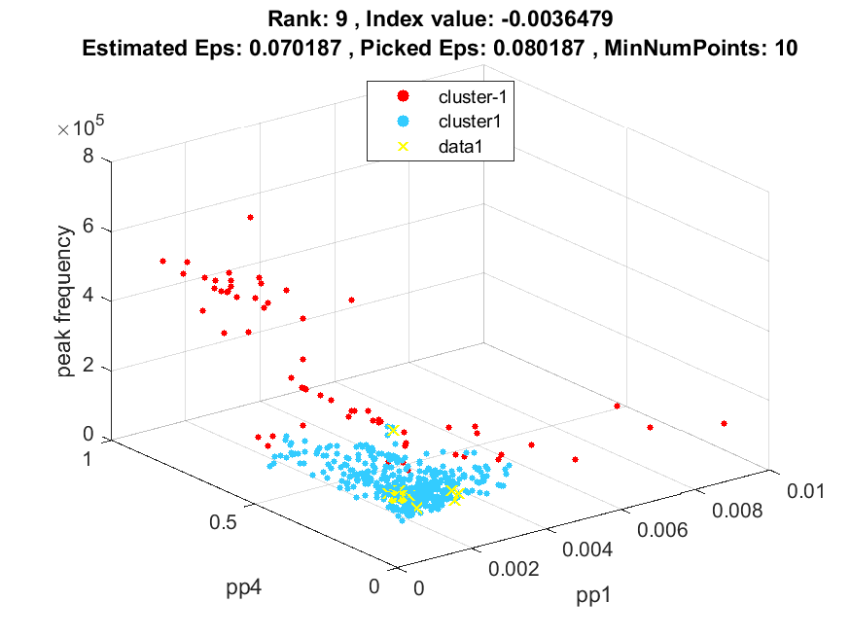
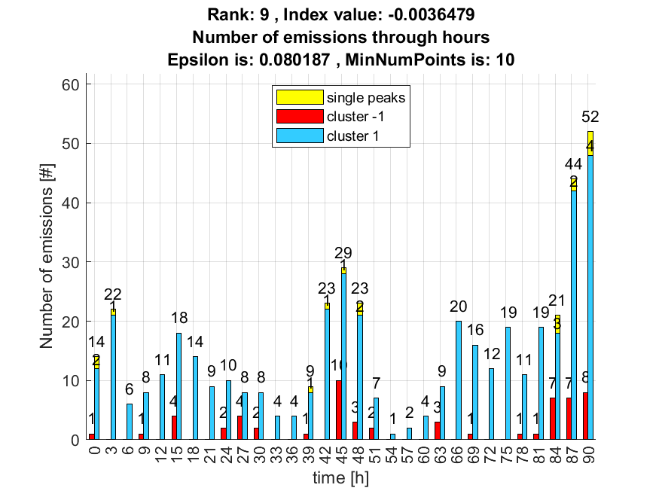

10. result: (counts_from, peak_frequency, amp_of_peak_frequency)
Estimated Epsilon: 0.076984, Picked Epsilon: 0.076984, MinNumPoints: 10
DBCV_single_clust index value: -0.0037488
cluster -1 had 22.2222% single peaks
cluster 1 had 77.7778% single peaks
