Feature selection results for exp_14_part_2 and Nmin = 10

Problem što najveći dataset sadrži rupe u sebi:
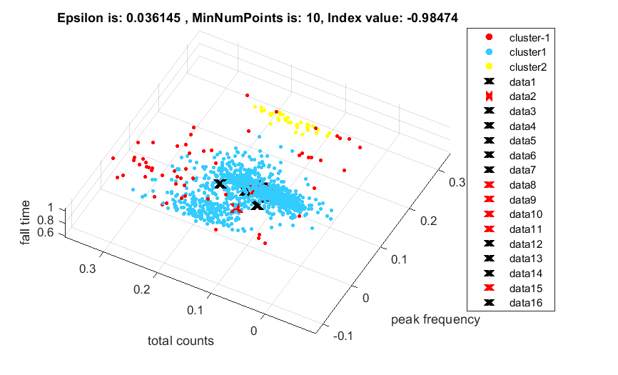
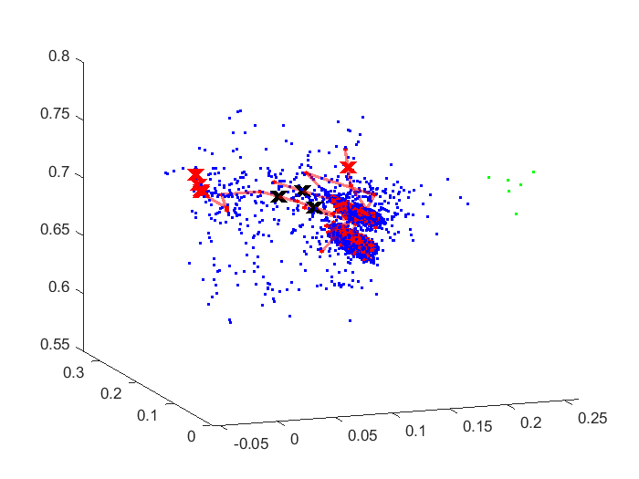

1. result: (peak_amplitude, pp1, peak_frequency)
Estimated Epsilon: 0.017662, Picked Epsilon: 0.012662, MinNumPoints: 10
DBCV index value: 0.86405
cluster -1 had 0.32328% single peaks
cluster 1 had 99.542% single peaks
cluster 2 had 0.10776% single peaks
cluster 3 had 0.02694% single peaks
cluster 4 had 0% single peaks
cluster 5 had 0% single peaks
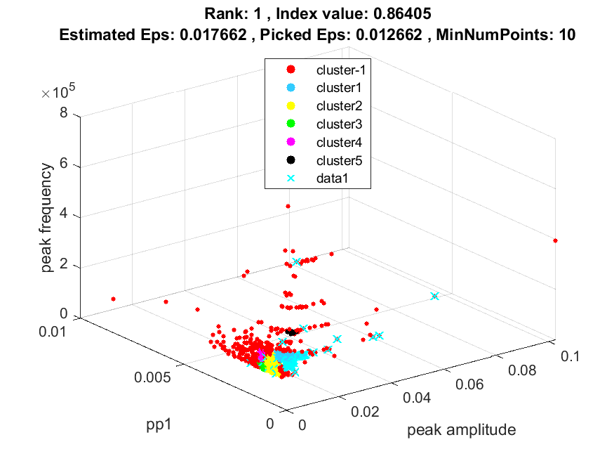
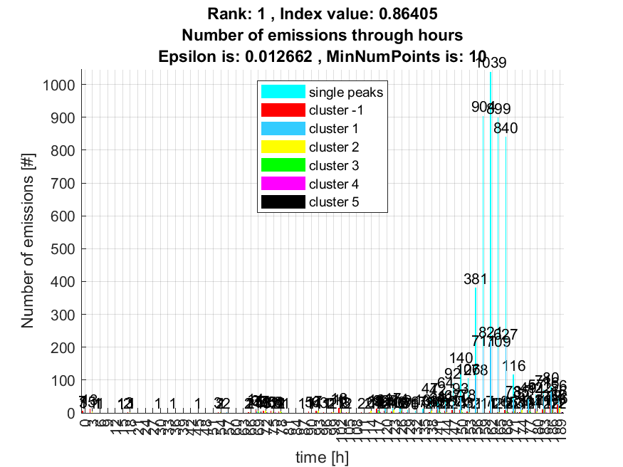

2. result: (pp2, centroid_frequency, peak_frequency)
Estimated Epsilon: 0.03573, Picked Epsilon: 0.04823, MinNumPoints: 10
DBCV index value: 0.85452
cluster -1 had 0.29634% single peaks
cluster 1 had 99.4612% single peaks
cluster 2 had 0.24246% single peaks
cluster 3 had 0% single peaks
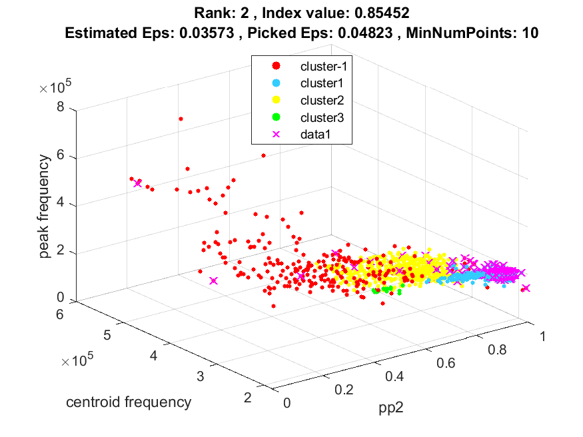
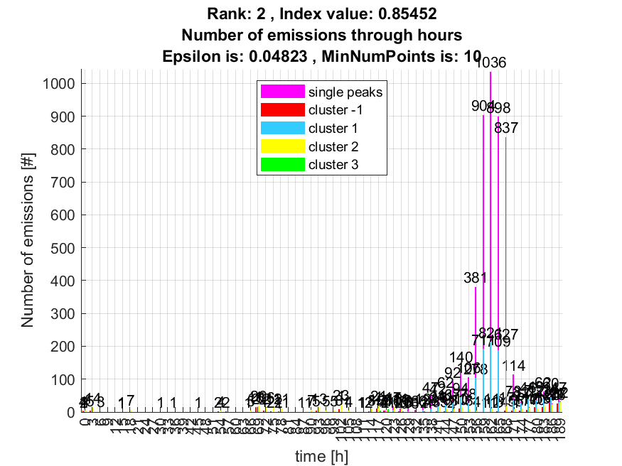

3. result: (pp4, peak_frequency, amp_of_peak_frequency)
Estimated Epsilon: 0.020545, Picked Epsilon: 0.013045, MinNumPoints: 10
DBCV index value: 0.84692
cluster -1 had 0.72737% single peaks
cluster 1 had 99.1379% single peaks
cluster 2 had 0.1347% single peaks
cluster 3 had 0% single peaks
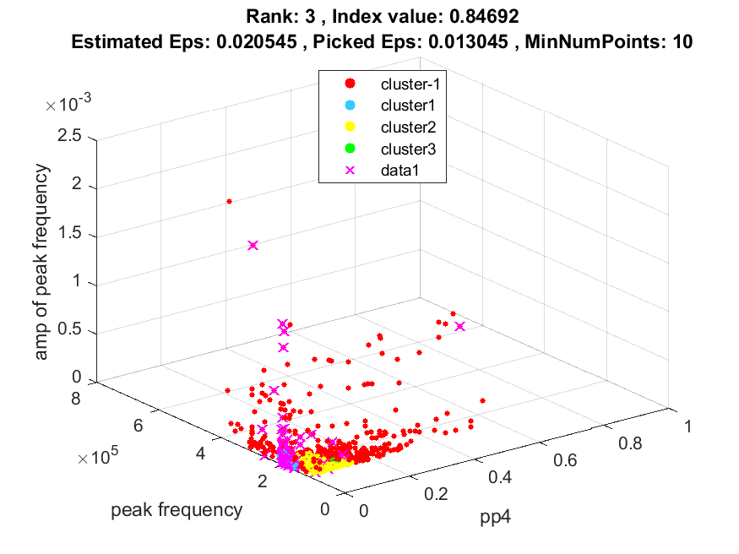
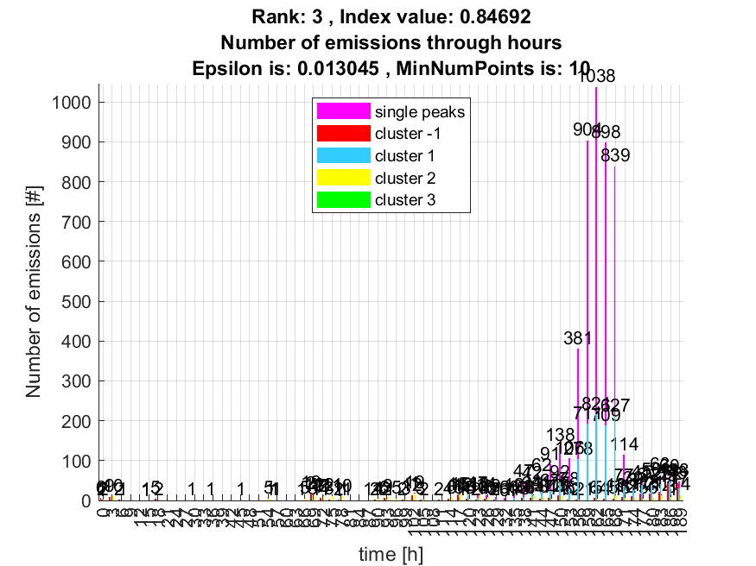

4. result: (peak_amplitude, pp4, peak_frequency)
Estimated Epsilon: 0.019654, Picked Epsilon: 0.012154, MinNumPoints: 10
DBCV index value: 0.8439
cluster -1 had 0.37716% single peaks
cluster 1 had 99.4881% single peaks
cluster 2 had 0.10776% single peaks
cluster 3 had 0% single peaks
cluster 4 had 0.02694% single peaks
cluster 5 had 0% single peaks
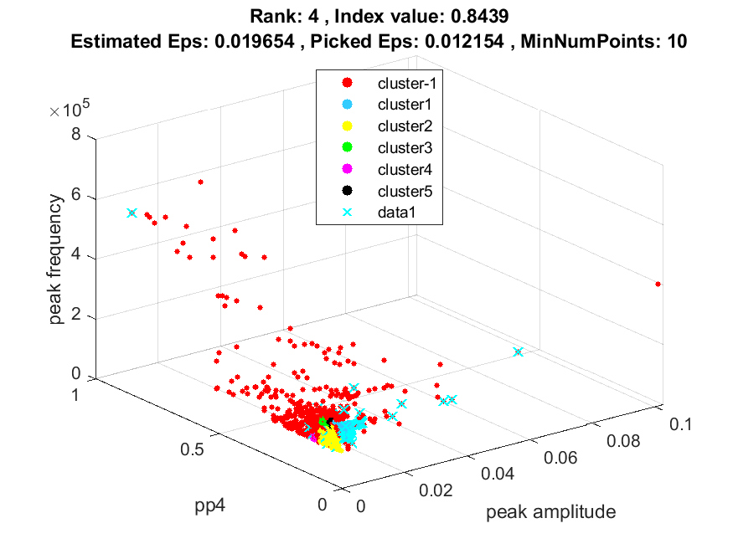
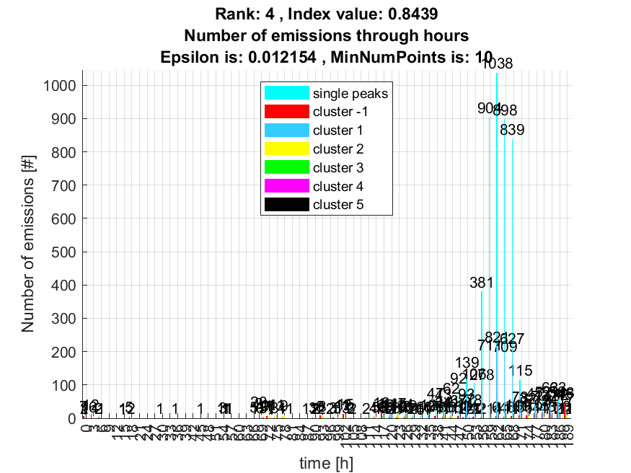

5. result: (pp1, pp3, peak_frequency)
Estimated Epsilon: 0.029715, Picked Epsilon: 0.027215, MinNumPoints: 10
DBCV index value: 0.84
cluster -1 had 0.29634% single peaks
cluster 1 had 99.5959% single peaks
cluster 2 had 0.10776% single peaks
cluster 3 had 0% single peaks
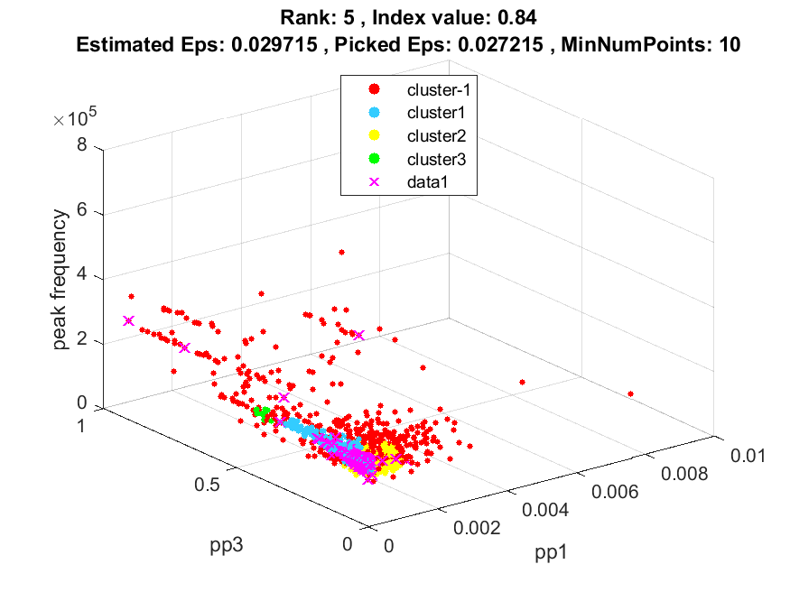
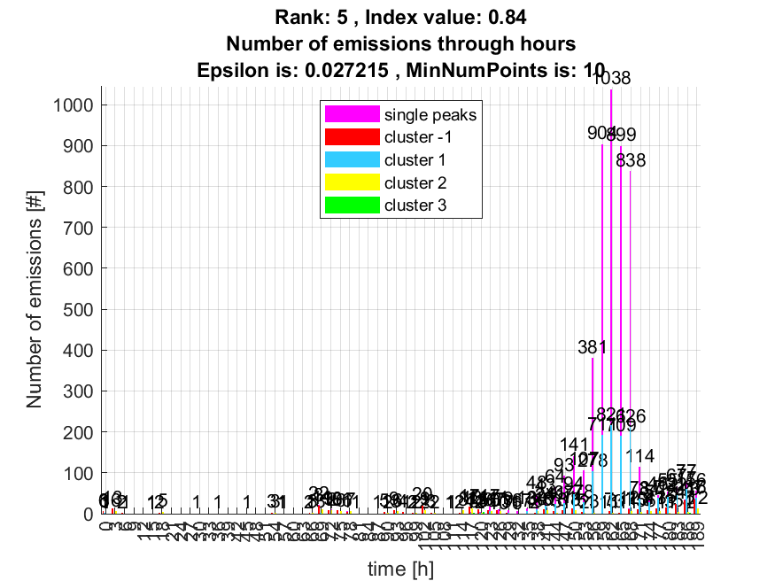

6. result: (signal_strength, pp1, peak_frequency)
Estimated Epsilon: 0.022777, Picked Epsilon: 0.012777, MinNumPoints: 10
DBCV index value: 0.83439
cluster -1 had 0.59267% single peaks
cluster 1 had 99.3804% single peaks
cluster 2 had 0.02694% single peaks
cluster 3 had 0% single peaks
cluster 4 had 0% single peaks
cluster 5 had 0% single peaks
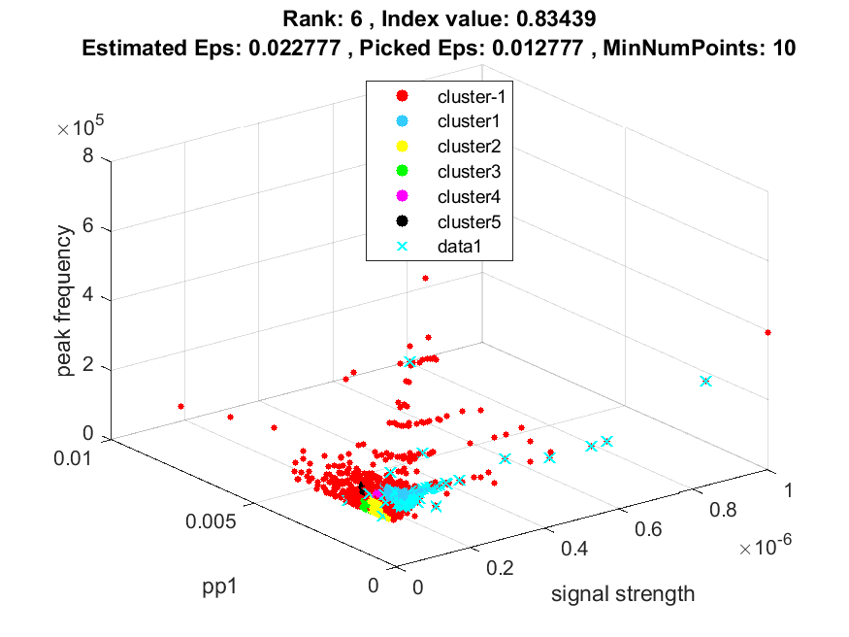
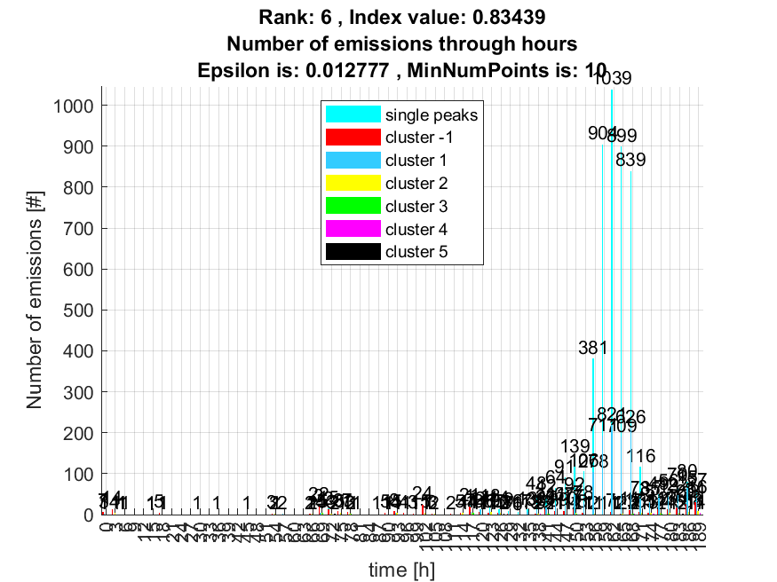

7. result: (pp2, peak_frequency, amp_of_peak_frequency)
Estimated Epsilon: 0.021286, Picked Epsilon: 0.016286, MinNumPoints: 10
DBCV index value: 0.83114
cluster -1 had 0.80819% single peaks
cluster 1 had 99.111% single peaks
cluster 2 had 0.080819% single peaks
cluster 3 had 0% single peaks
cluster 4 had 0% single peaks
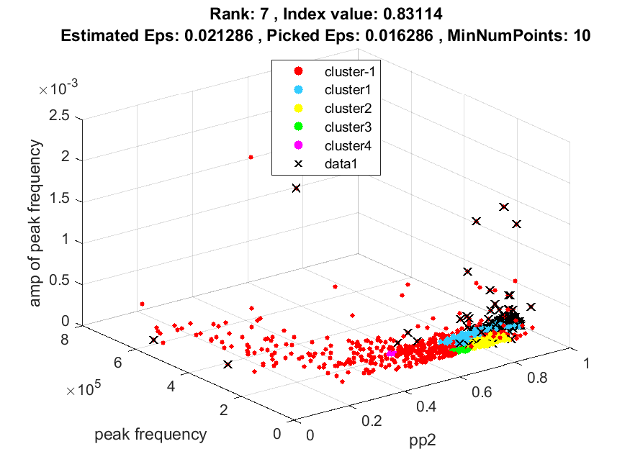
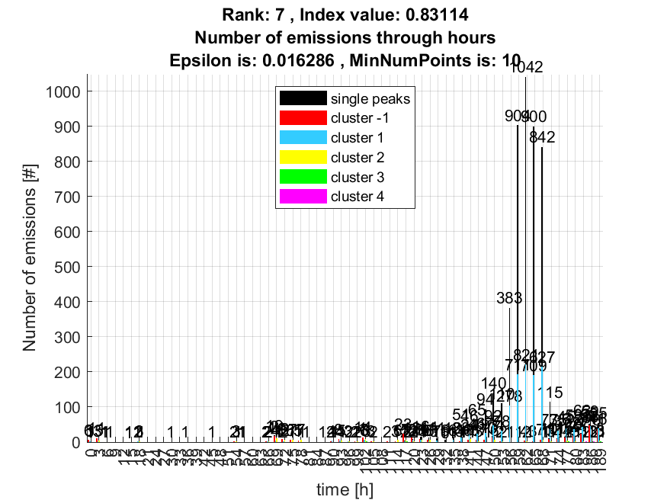

8. result: (pp1, pp4, peak_frequency)
Estimated Epsilon: 0.026035, Picked Epsilon: 0.023535, MinNumPoints: 10
DBCV index value: 0.82503
cluster -1 had 0.2694% single peaks
cluster 1 had 99.6228% single peaks
cluster 2 had 0.053879% single peaks
cluster 3 had 0.02694% single peaks
cluster 4 had 0.02694% single peaks
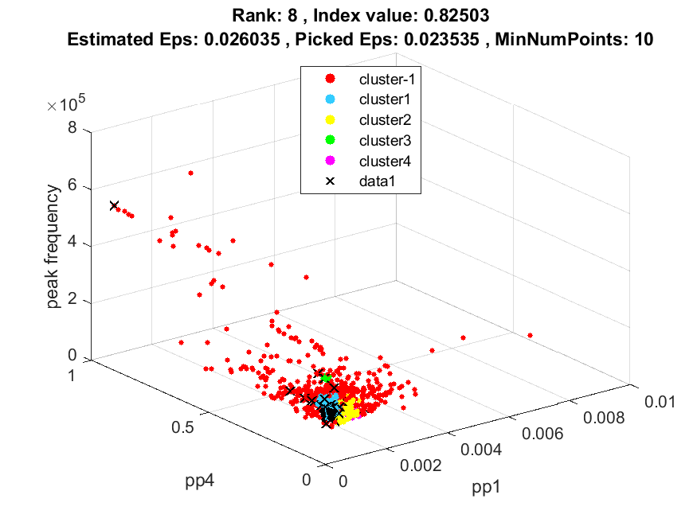
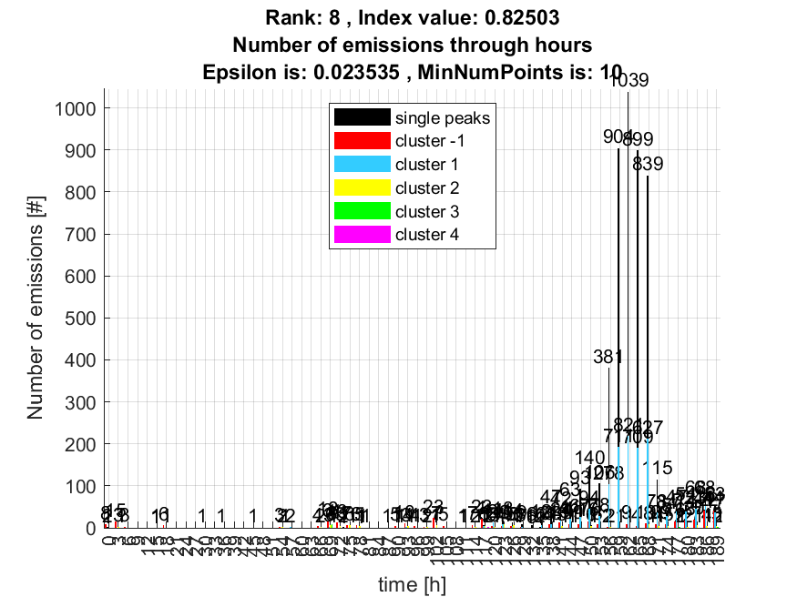

9. result: (rise_time, pp2, peak_frequency)
Estimated Epsilon: 0.038106, Picked Epsilon: 0.023106, MinNumPoints: 10
DBCV index value: 0.81665
cluster -1 had 0.43103% single peaks
cluster 1 had 99.4881% single peaks
cluster 2 had 0.02694% single peaks
cluster 3 had 0.02694% single peaks
cluster 4 had 0% single peaks
cluster 5 had 0.02694% single peaks
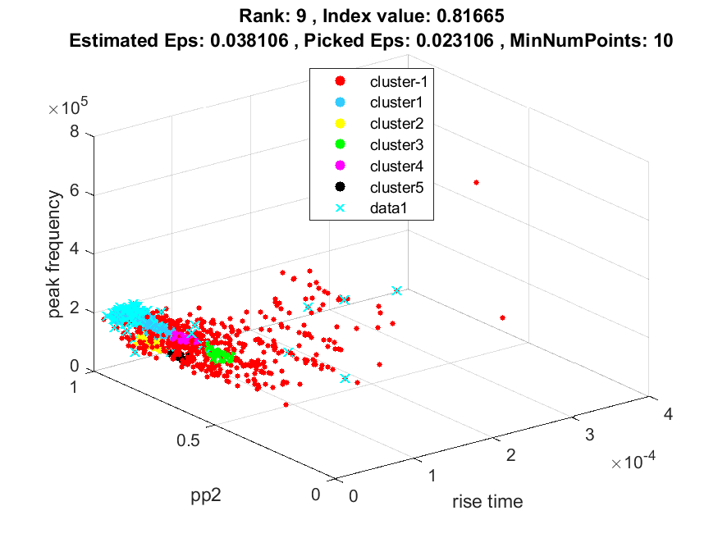
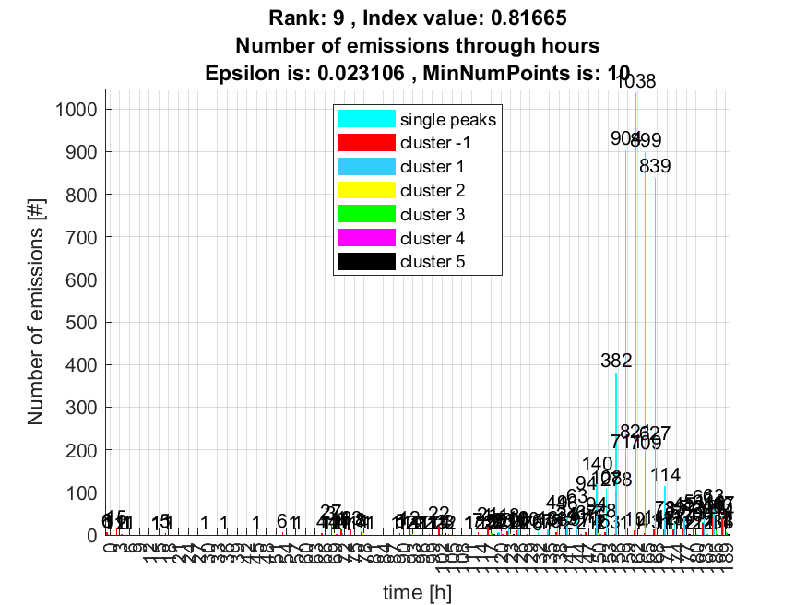

10. result: (counts_from, centroid_frequency, peak_frequency)
Estimated Epsilon: 0.036705, Picked Epsilon: 0.039205, MinNumPoints: 10
DBCV index value: 0.80967
cluster -1 had 0.48491% single peaks
cluster 1 had 99.1379% single peaks
cluster 2 had 0.37716% single peaks
