Feature selection results for exp_14_part_2 and Nmin = 10

1. result: (rise_time, pp1, peak_frequency)
Estimated Epsilon: 0.026618, Picked Epsilon: 0.0066178, MinNumPoints: 10
DBCV_single_clust index value: -5.7352e-05
cluster -1 had 1.7241% single peaks
cluster 1 had 98.2759% single peaks
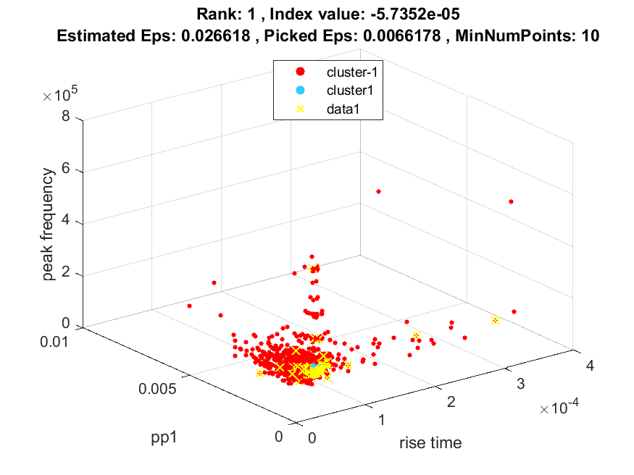
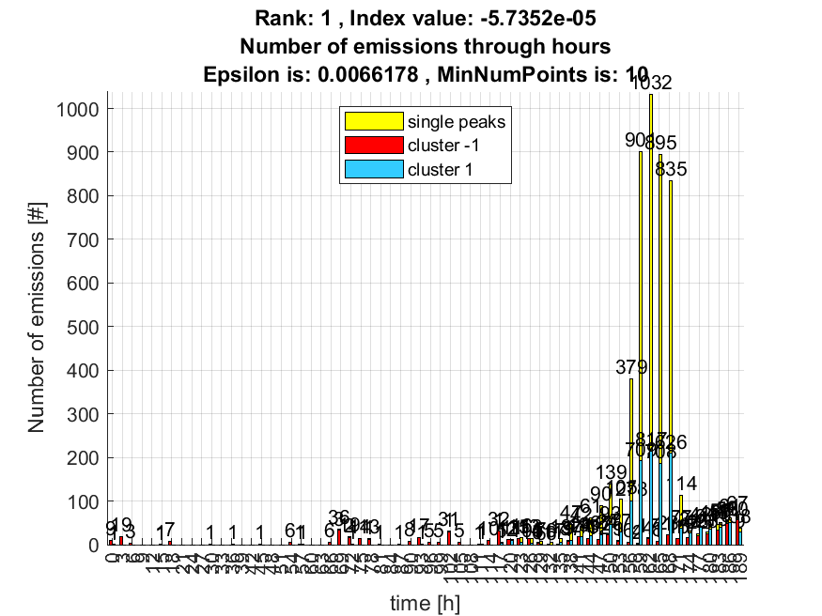

2. result: (counts_from, pp4, peak_frequency)
Estimated Epsilon: 0.029121, Picked Epsilon: 0.0091208, MinNumPoints: 10
DBCV_single_clust index value: -5.8215e-05
cluster -1 had 1.4817% single peaks
cluster 1 had 98.5183% single peaks
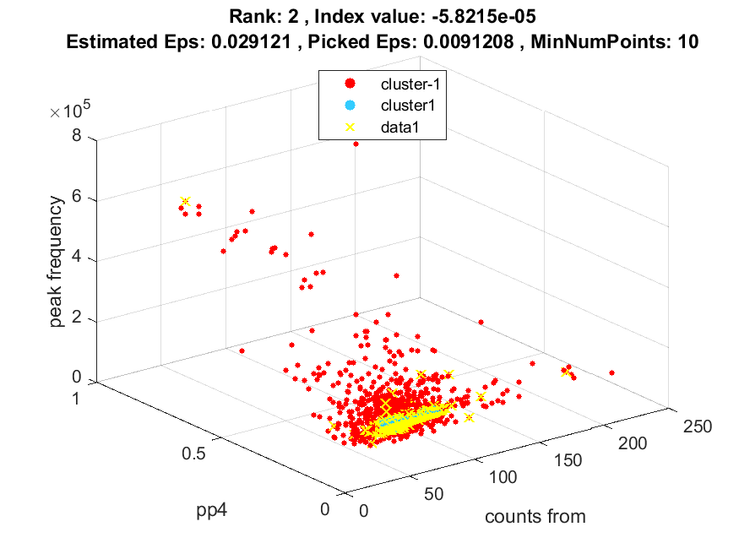
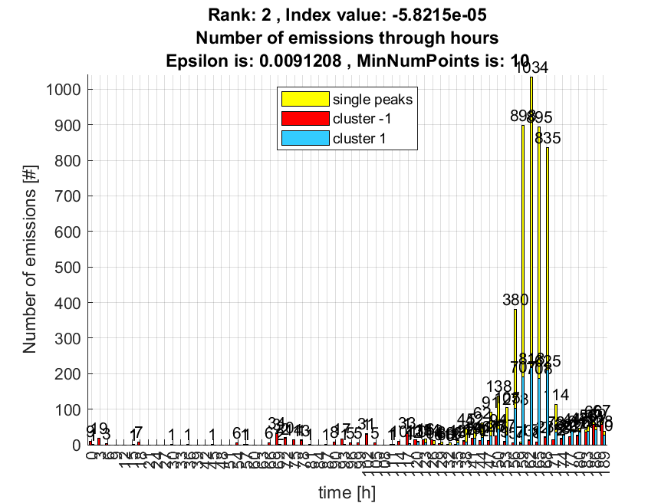

3. result: (pp3, pp4, peak_frequency)
Estimated Epsilon: 0.023763, Picked Epsilon: 0.0087625, MinNumPoints: 10
DBCV_single_clust index value: -8.0519e-05
cluster -1 had 0.78125% single peaks
cluster 1 had 99.2188% single peaks
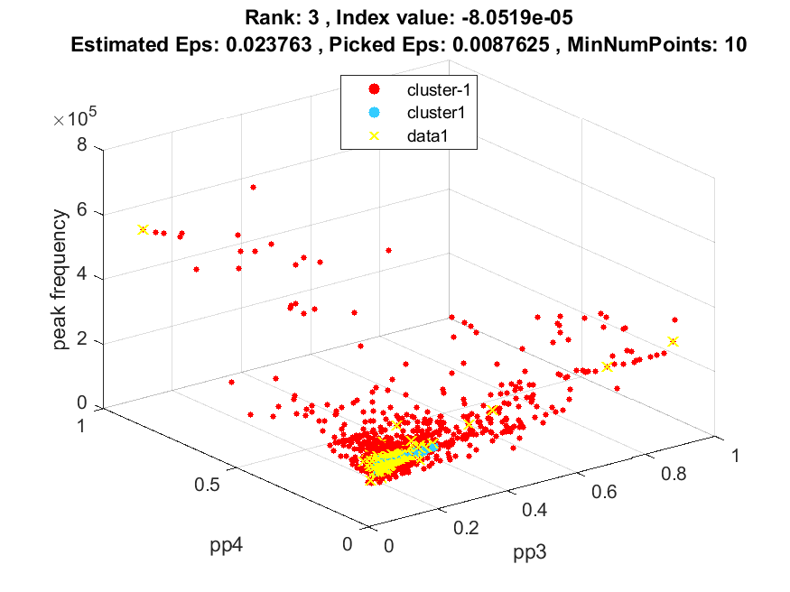
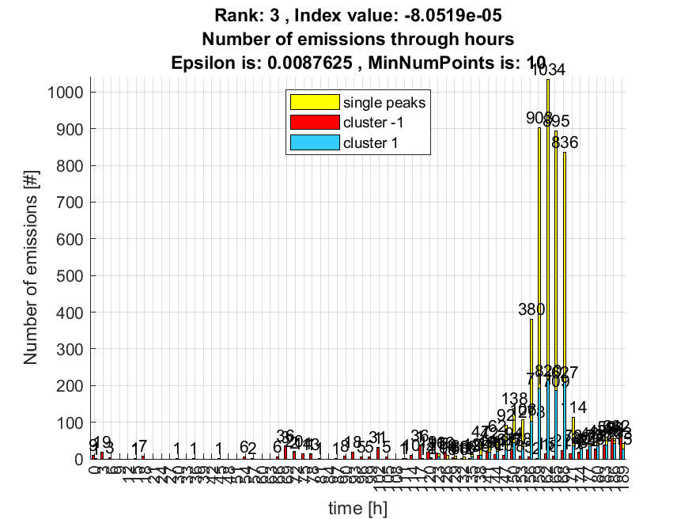

4. result: (pp2, pp4, peak_frequency)
Estimated Epsilon: 0.026647, Picked Epsilon: 0.0066465, MinNumPoints: 10
DBCV_single_clust index value: -8.2483e-05
cluster -1 had 1.3739% single peaks
cluster 1 had 98.6261% single peaks
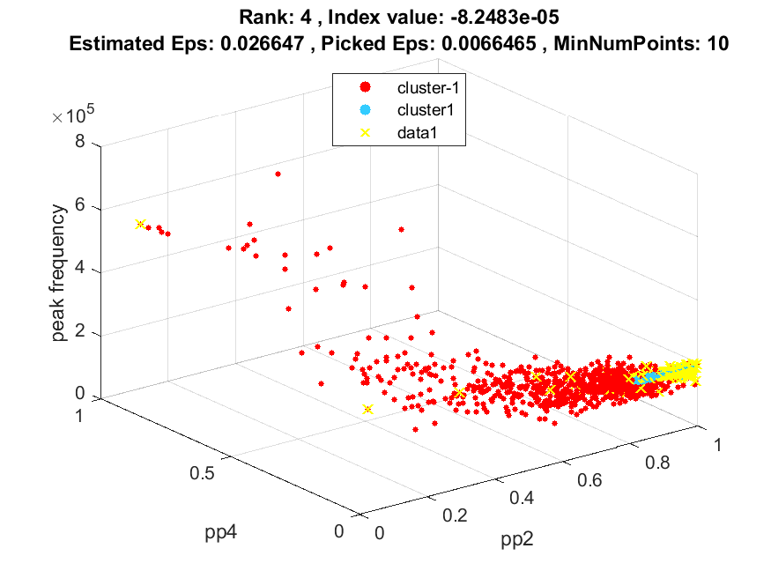
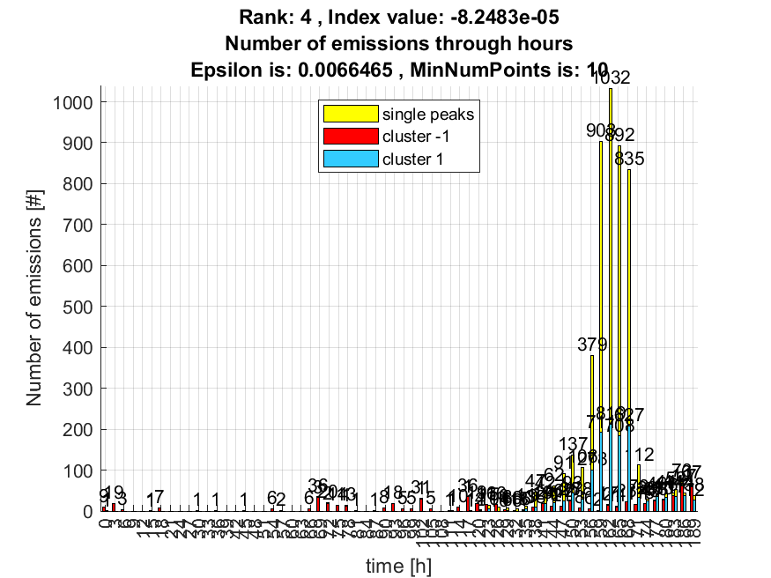

5. result: (counts_from, peak_amplitude, peak_frequency)
Estimated Epsilon: 0.020959, Picked Epsilon: 0.0084587, MinNumPoints: 10
DBCV_single_clust index value: -0.00011133
cluster -1 had 2.0474% single peaks
cluster 1 had 97.9526% single peaks
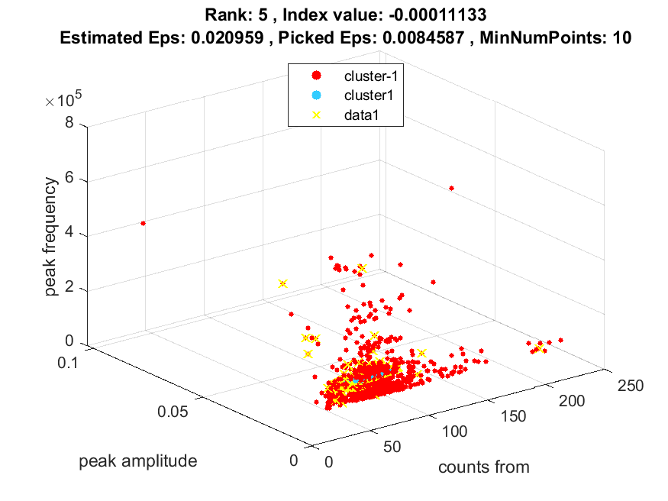
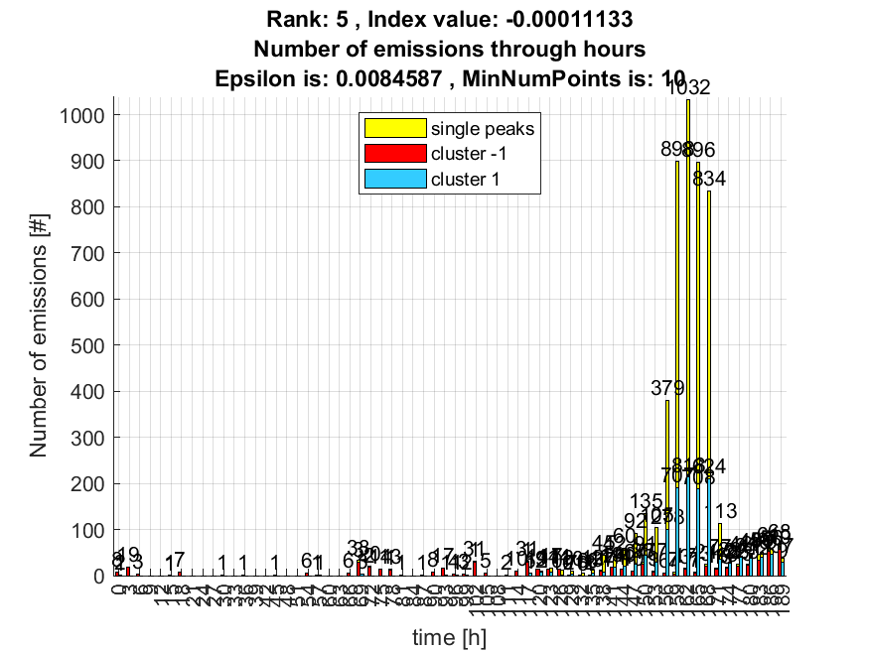

6. result: (pp2, pp3, peak_frequency)
Estimated Epsilon: 0.026933, Picked Epsilon: 0.0069331, MinNumPoints: 10
DBCV_single_clust index value: -0.00011691
cluster -1 had 1.5625% single peaks
cluster 1 had 98.4375% single peaks
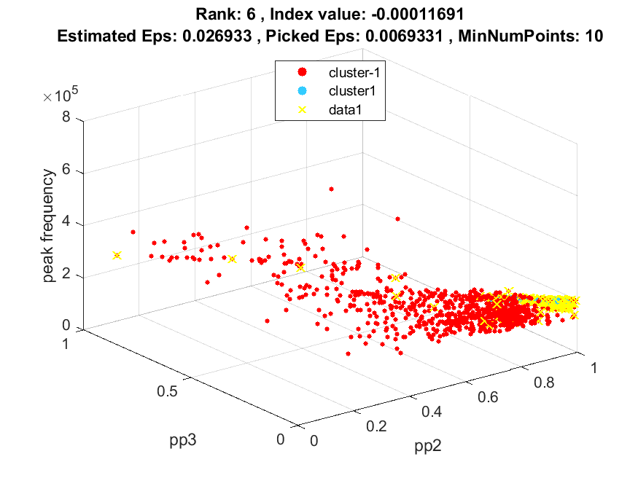
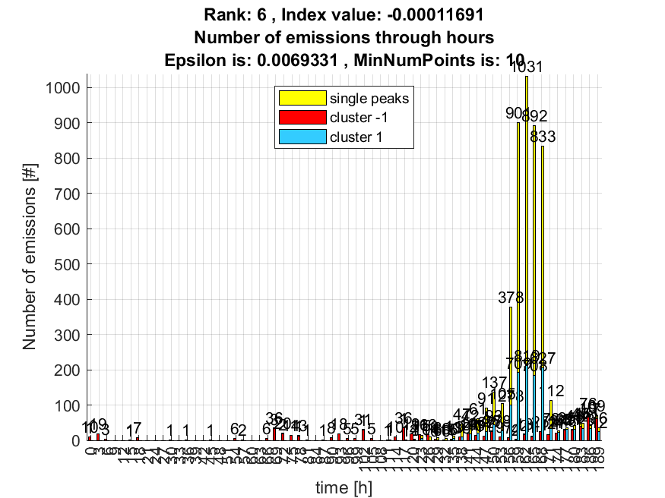

7. result: (pp1, pp2, peak_frequency)
Estimated Epsilon: 0.035, Picked Epsilon: 0.0175, MinNumPoints: 10
DBCV_single_clust index value: -0.00014252
cluster -1 had 0.45797% single peaks
cluster 1 had 99.542% single peaks
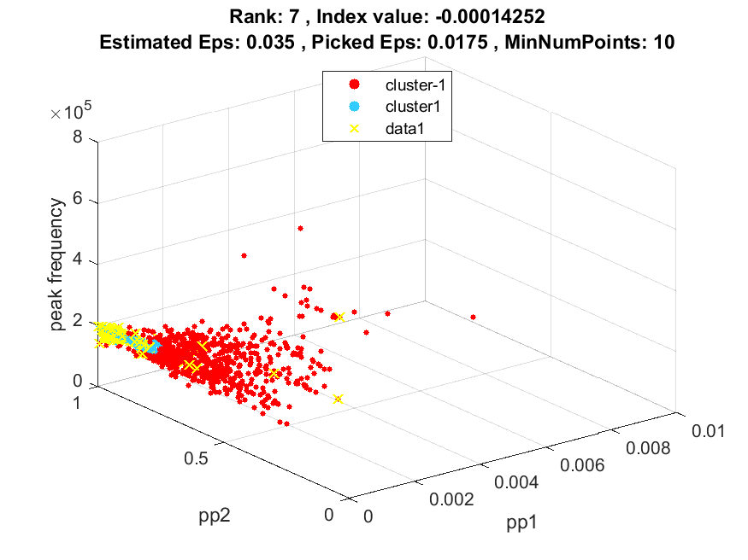
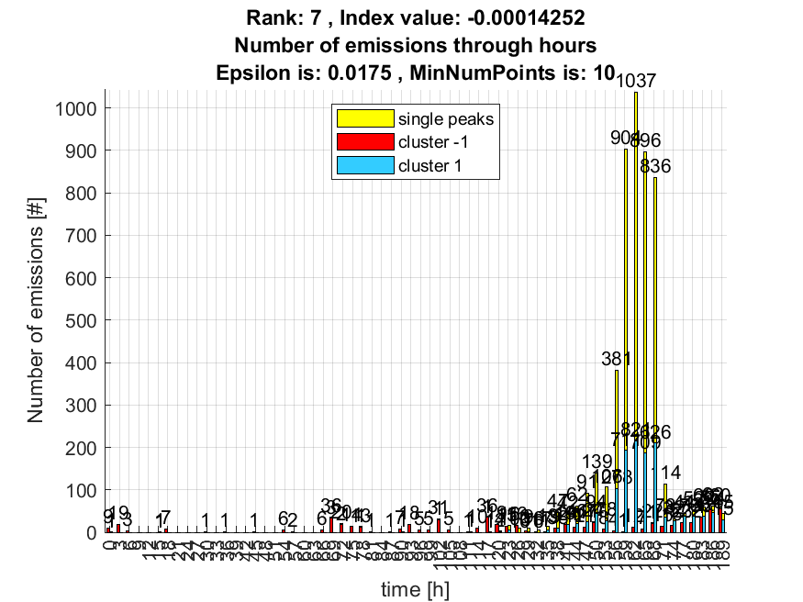

8. result: (signal_strength, peak_frequency, total_counts)
Estimated Epsilon: 0.017954, Picked Epsilon: 0.005454, MinNumPoints: 10
DBCV_single_clust index value: -0.00014554
cluster -1 had 2.7209% single peaks
cluster 1 had 97.2791% single peaks
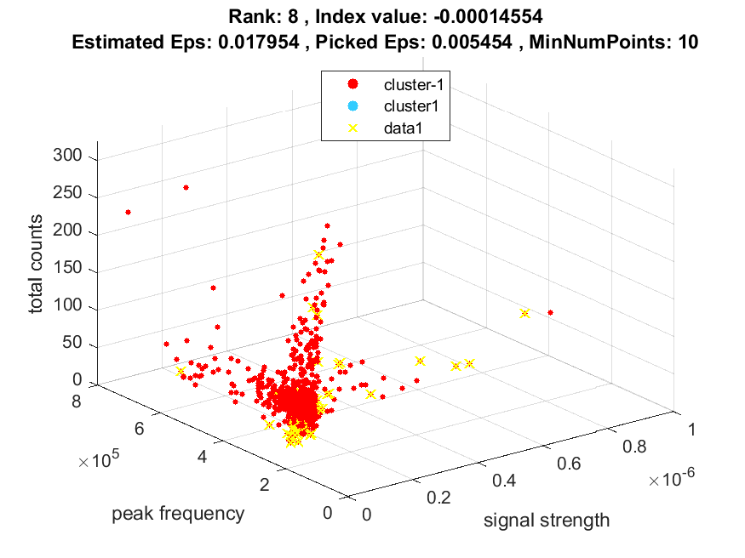
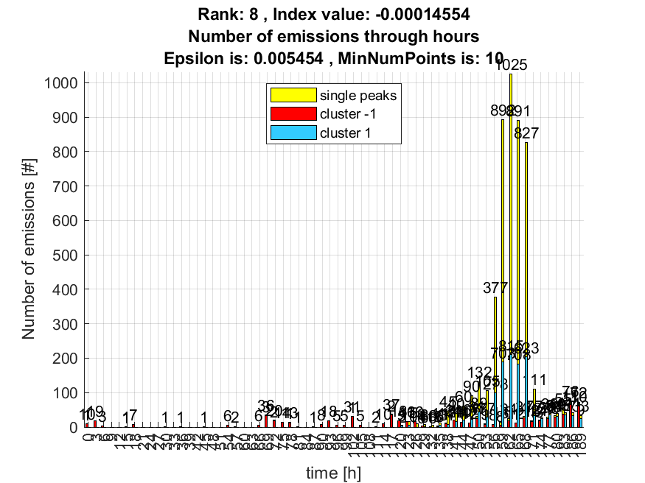

9. result: (signal_strength, pp3, peak_frequency)
Estimated Epsilon: 0.020012, Picked Epsilon: 0.0075122, MinNumPoints: 10
DBCV_single_clust index value: -0.0001508
cluster -1 had 1.9666% single peaks
cluster 1 had 98.0334% single peaks
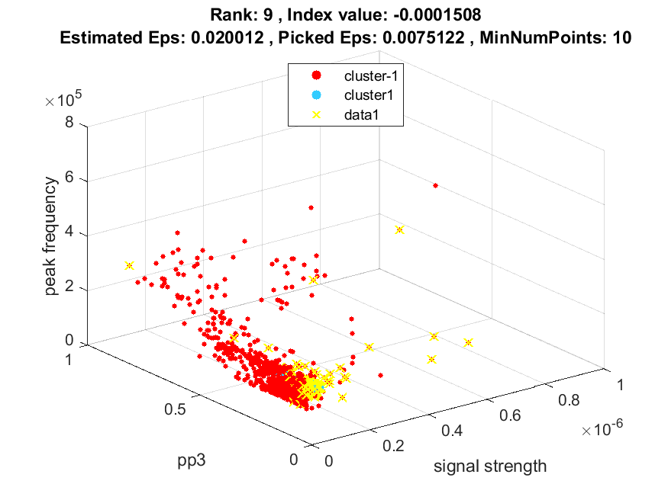
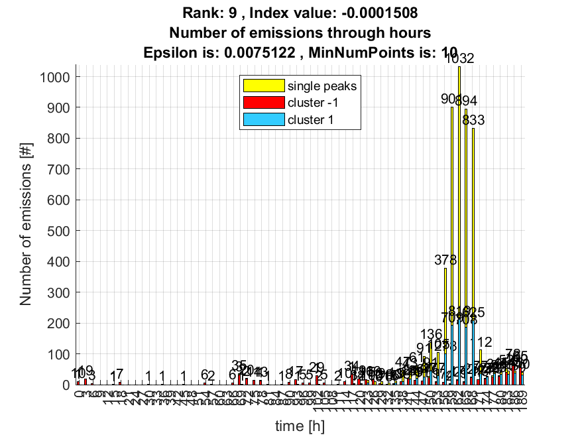

10. result: (counts_from, signal_strength, peak_frequency)
Estimated Epsilon: 0.022241, Picked Epsilon: 0.0097413, MinNumPoints: 10
DBCV_single_clust index value: -0.00015647
cluster -1 had 1.9935% single peaks
cluster 1 had 98.0065% single peaks
