Feature selection results for exp_14_part_3 and Nmin = 10

1. result: (rise_time, pp1, peak_frequency)
Estimated Epsilon: 0.03993, Picked Epsilon: 0.04743, MinNumPoints: 10
DBCV index value: 0.89333
cluster -1 had 0% single peaks
cluster 1 had 83.1325% single peaks
cluster 2 had 6.0241% single peaks
cluster 3 had 8.4337% single peaks
cluster 4 had 2.4096% single peaks
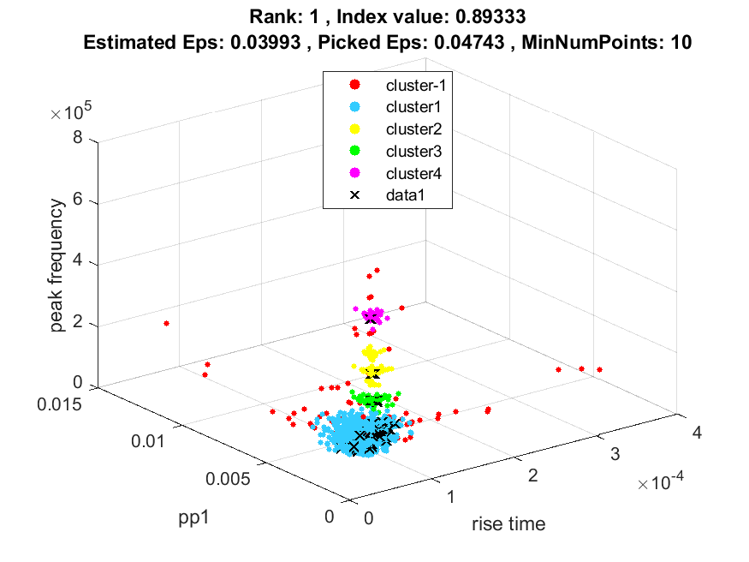
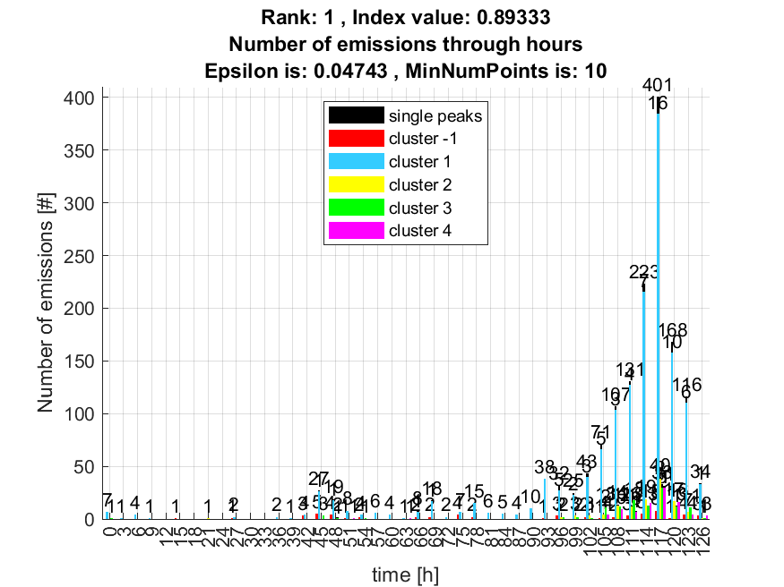

2. result: (rise_time, peak_frequency, fall_time)
Estimated Epsilon: 0.032436, Picked Epsilon: 0.042436, MinNumPoints: 10
DBCV index value: 0.88455
cluster -1 had 0% single peaks
cluster 1 had 83.1325% single peaks
cluster 2 had 6.0241% single peaks
cluster 3 had 8.4337% single peaks
cluster 4 had 2.4096% single peaks
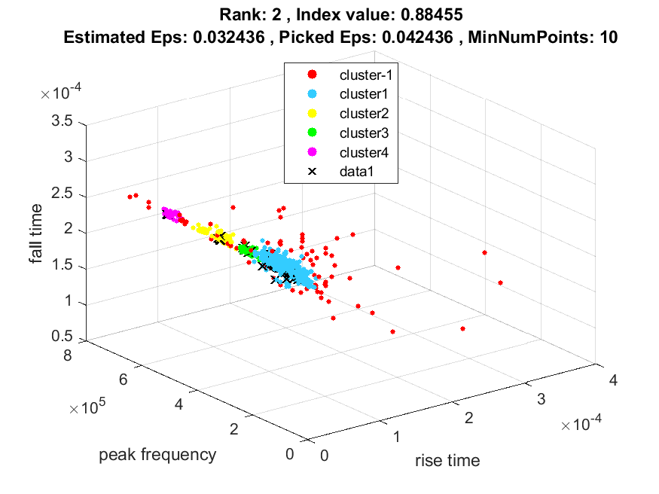
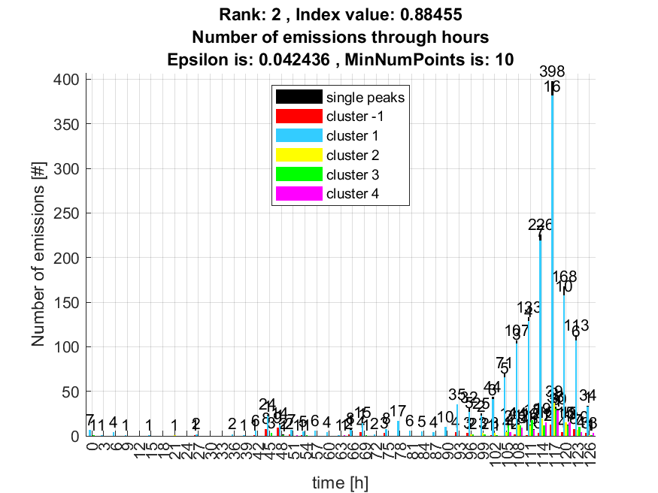

3. result: (rise_time, counts_from, peak_frequency)
Estimated Epsilon: 0.049775, Picked Epsilon: 0.059775, MinNumPoints: 10
DBCV index value: 0.86725
cluster -1 had 0% single peaks
cluster 1 had 83.1325% single peaks
cluster 2 had 6.0241% single peaks
cluster 3 had 8.4337% single peaks
cluster 4 had 2.4096% single peaks
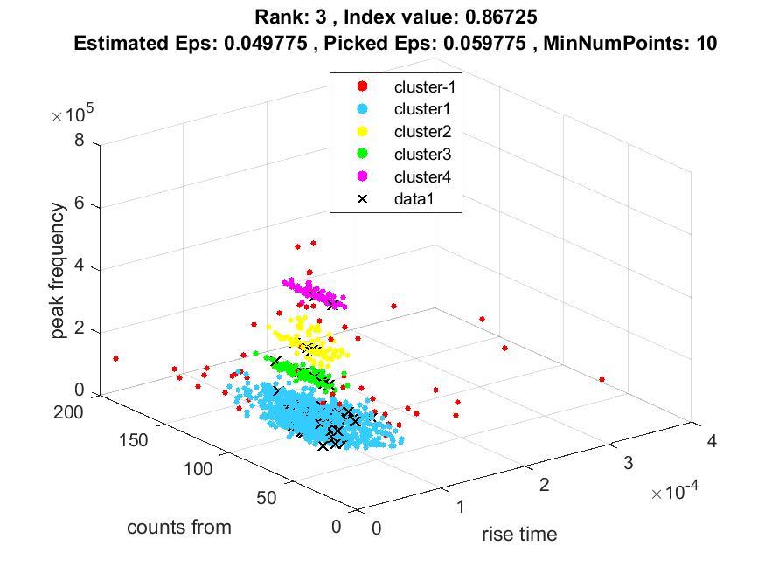
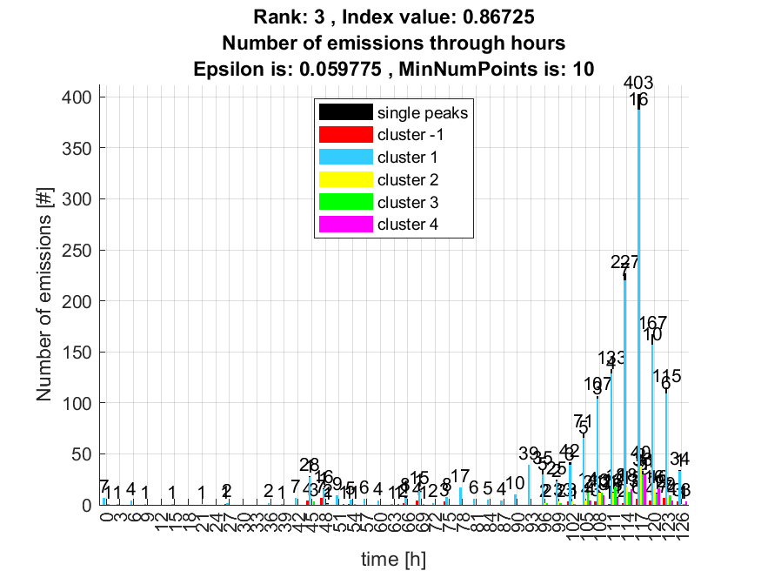

4. result: (counts_from, pp1, peak_frequency)
Estimated Epsilon: 0.047534, Picked Epsilon: 0.057534, MinNumPoints: 10
DBCV index value: 0.86609
cluster -1 had 0% single peaks
cluster 1 had 83.1325% single peaks
cluster 2 had 6.0241% single peaks
cluster 3 had 8.4337% single peaks
cluster 4 had 2.4096% single peaks
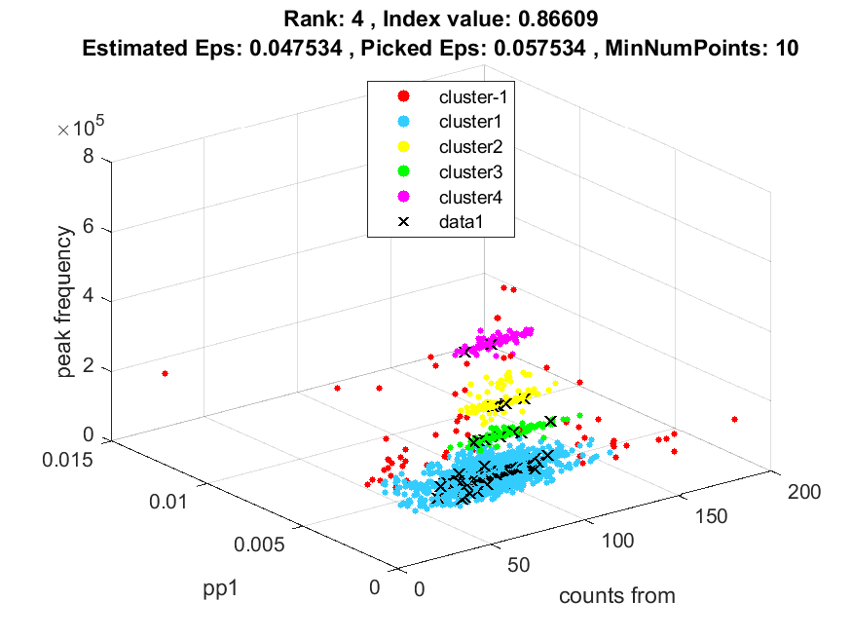
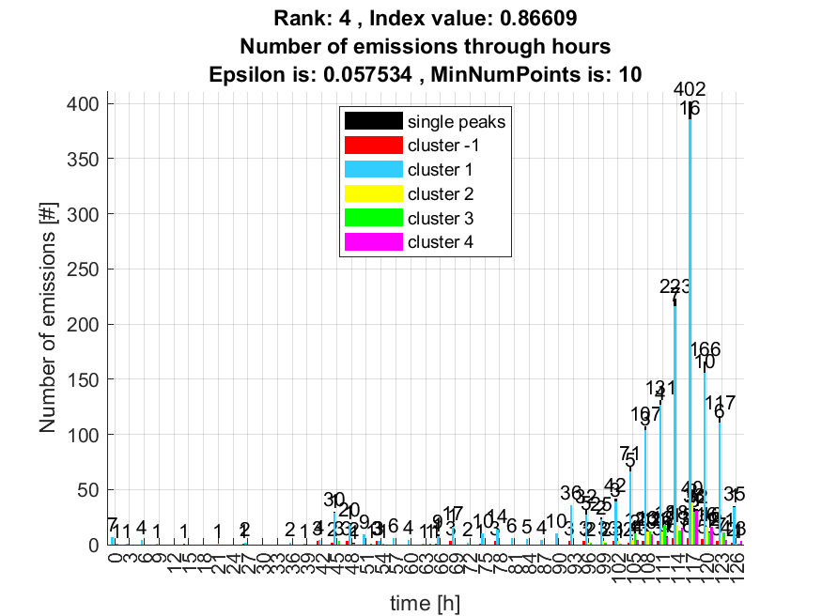

5. result: (pp1, peak_frequency, amp_of_peak_frequency)
Estimated Epsilon: 0.034684, Picked Epsilon: 0.044684, MinNumPoints: 10
DBCV index value: 0.86086
cluster -1 had 9.6386% single peaks
cluster 1 had 78.3133% single peaks
cluster 2 had 7.2289% single peaks
cluster 3 had 2.4096% single peaks
cluster 4 had 2.4096% single peaks
cluster 5 had 0% single peaks
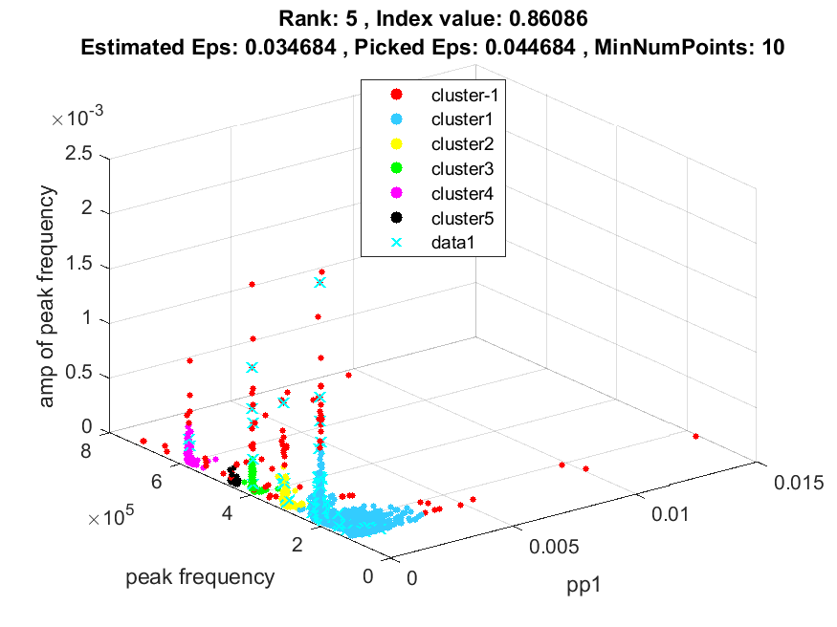
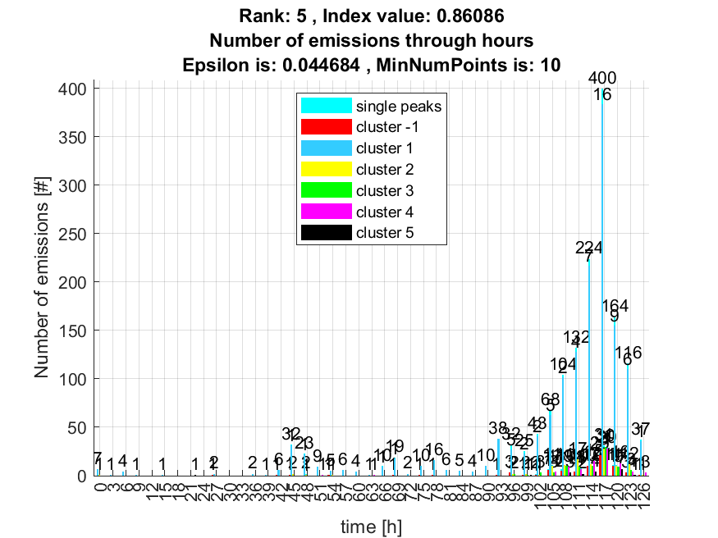

6. result: (rise_time, peak_frequency, amp_of_peak_frequency)
Estimated Epsilon: 0.040394, Picked Epsilon: 0.047894, MinNumPoints: 10
DBCV index value: 0.85888
cluster -1 had 10.8434% single peaks
cluster 1 had 77.1084% single peaks
cluster 2 had 7.2289% single peaks
cluster 3 had 2.4096% single peaks
cluster 4 had 2.4096% single peaks
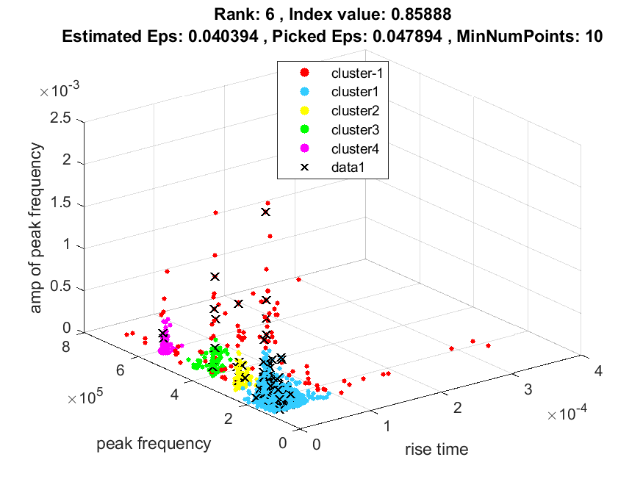
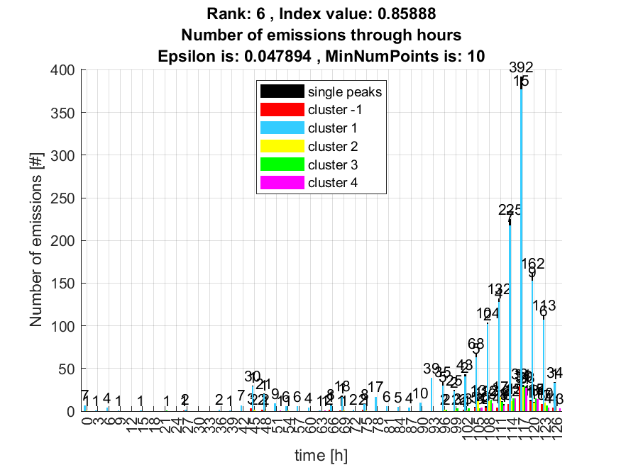

7. result: (rise_time, peak_frequency, total_counts)
Estimated Epsilon: 0.048205, Picked Epsilon: 0.055705, MinNumPoints: 10
DBCV index value: 0.85736
cluster -1 had 0% single peaks
cluster 1 had 83.1325% single peaks
cluster 2 had 8.4337% single peaks
cluster 3 had 6.0241% single peaks
cluster 4 had 2.4096% single peaks
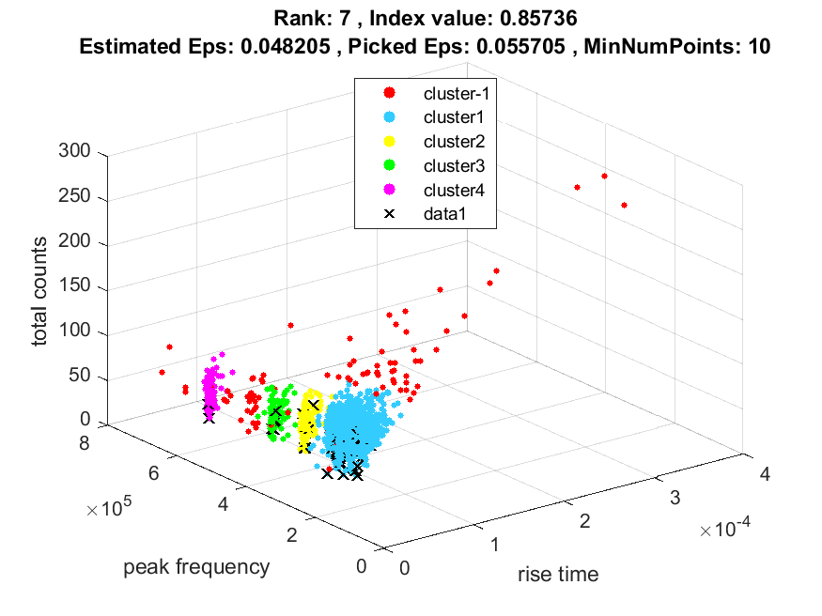
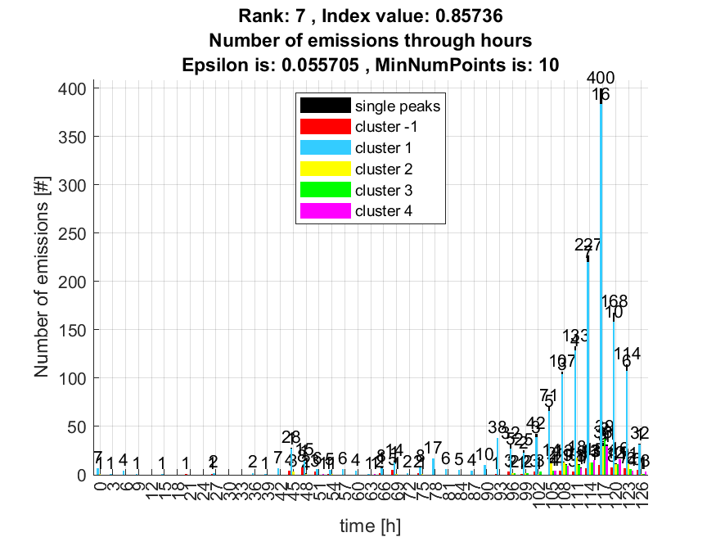

8. result: (signal_strength, pp1, peak_frequency)
Estimated Epsilon: 0.037747, Picked Epsilon: 0.047747, MinNumPoints: 10
DBCV index value: 0.85467
cluster -1 had 10.8434% single peaks
cluster 1 had 77.1084% single peaks
cluster 2 had 7.2289% single peaks
cluster 3 had 2.4096% single peaks
cluster 4 had 2.4096% single peaks
cluster 5 had 0% single peaks
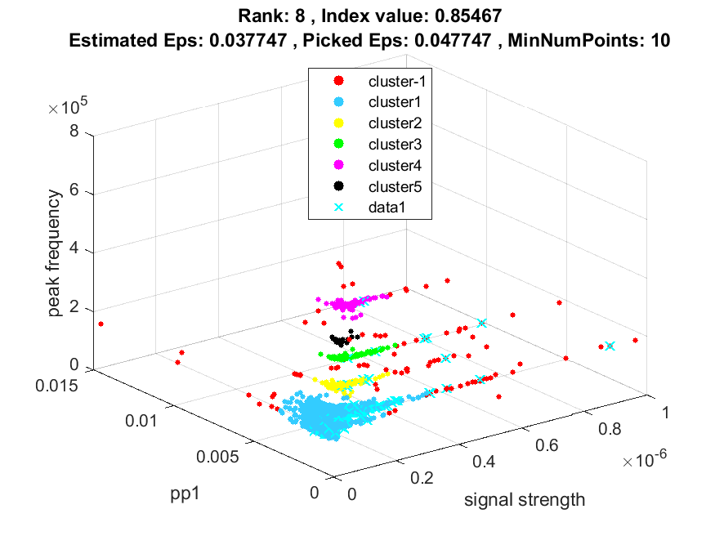
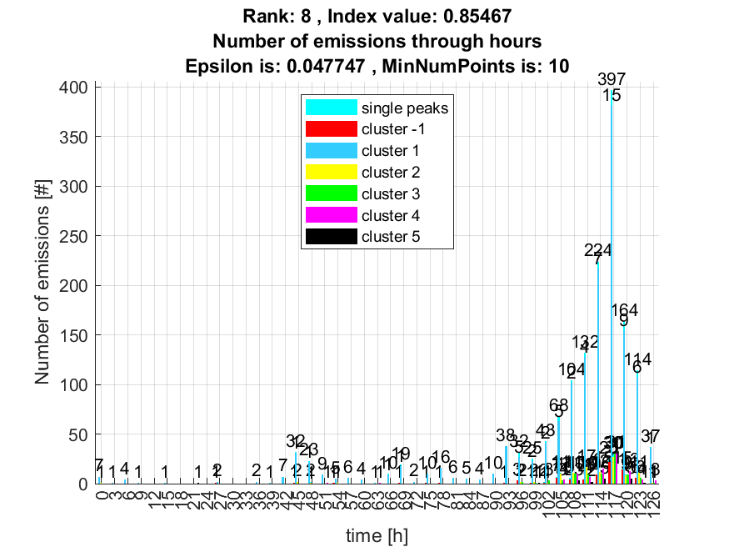

9. result: (peak_amplitude, pp1, peak_frequency)
Estimated Epsilon: 0.030123, Picked Epsilon: 0.040123, MinNumPoints: 10
DBCV index value: 0.85119
cluster -1 had 8.4337% single peaks
cluster 1 had 79.5181% single peaks
cluster 2 had 7.2289% single peaks
cluster 3 had 2.4096% single peaks
cluster 4 had 2.4096% single peaks
cluster 5 had 0% single peaks
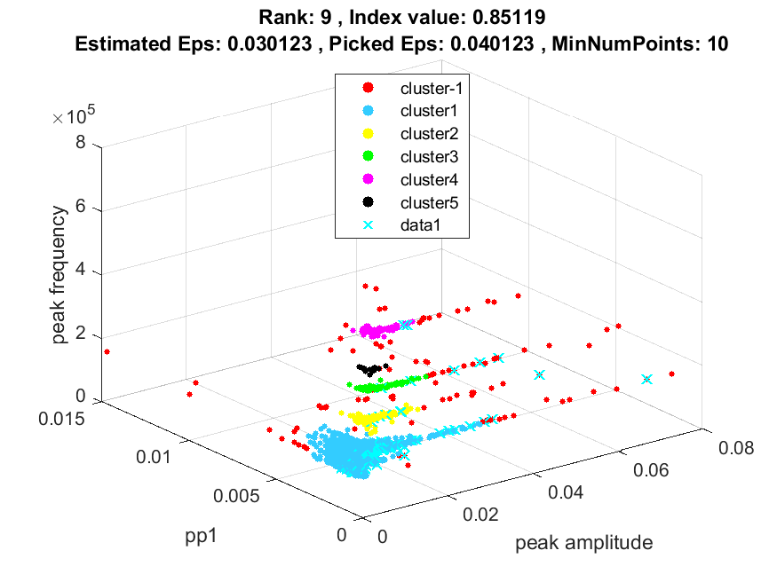
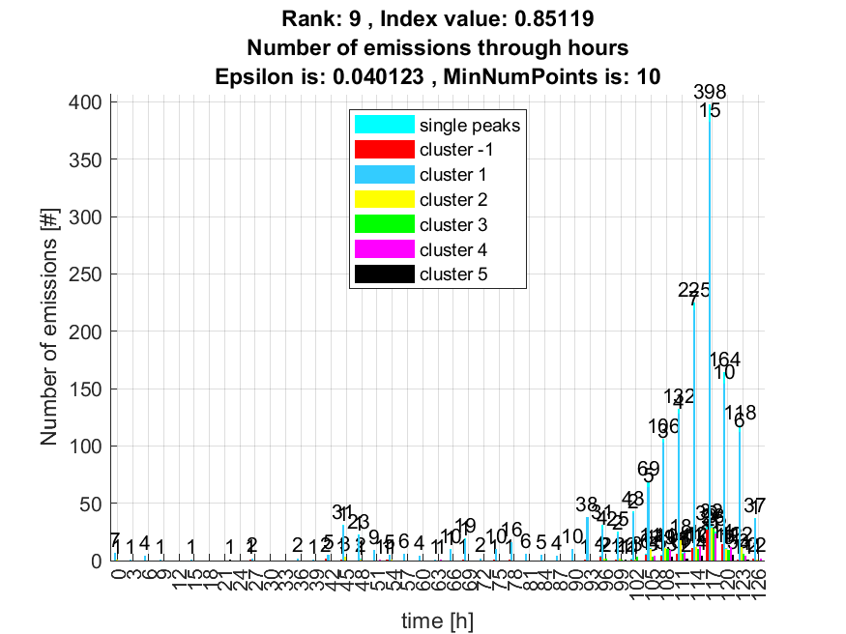

10. result: (peak_frequency, total_counts, fall_time)
Estimated Epsilon: 0.044671, Picked Epsilon: 0.054671, MinNumPoints: 10
DBCV index value: 0.85056
cluster -1 had 1.2048% single peaks
cluster 1 had 81.9277% single peaks
cluster 2 had 8.4337% single peaks
cluster 3 had 6.0241% single peaks
cluster 4 had 2.4096% single peaks
cluster 5 had 0% single peaks
