Feature selection results for exp_7 and Nmin = 10

1. result: (signal_strength, peak_frequency, amp_of_peak_frequency)
Estimated Epsilon: 0.011114, Picked Epsilon: 0.016114, MinNumPoints: 10
DBCV index value: 0.97238
cluster -1 had 0% single peaks
cluster 1 had 94.3548% single peaks
cluster 2 had 4.0323% single peaks
cluster 3 had 0% single peaks
cluster 4 had 1.6129% single peaks
cluster 5 had 0% single peaks
cluster 6 had 0% single peaks
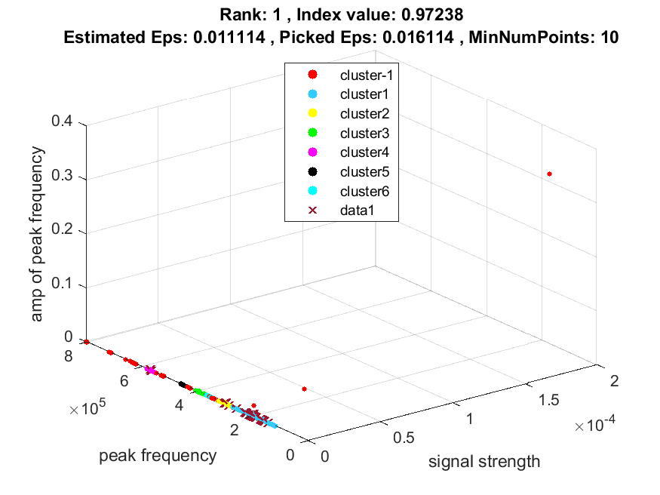
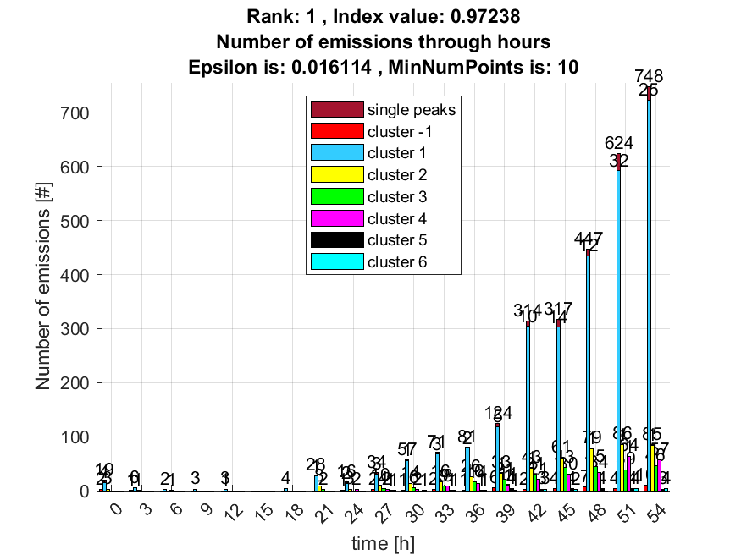

2. result: (peak_amplitude, peak_frequency, amp_of_peak_frequency)
Estimated Epsilon: 0.014274, Picked Epsilon: 0.016774, MinNumPoints: 10
DBCV index value: 0.97157
cluster -1 had 0% single peaks
cluster 1 had 94.3548% single peaks
cluster 2 had 4.0323% single peaks
cluster 3 had 0% single peaks
cluster 4 had 1.6129% single peaks
cluster 5 had 0% single peaks
cluster 6 had 0% single peaks
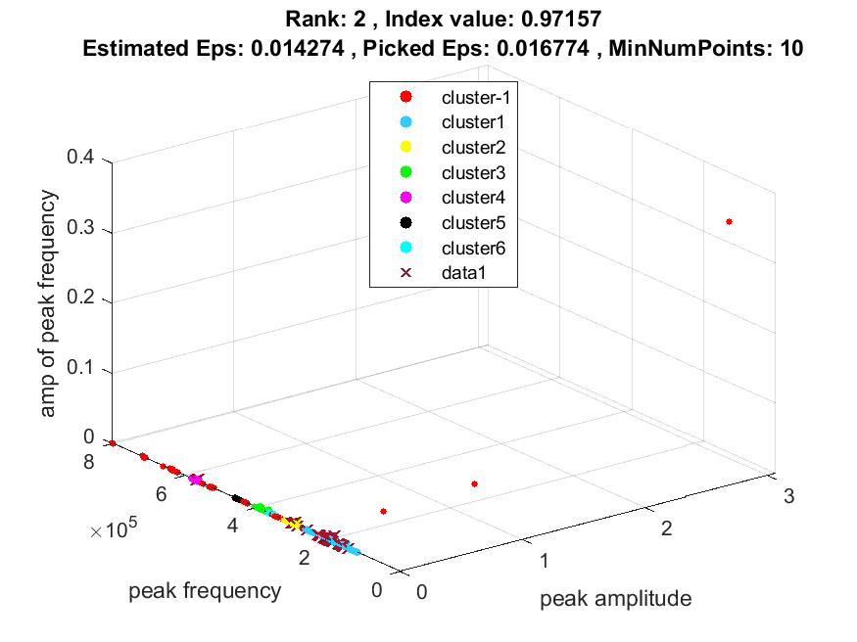
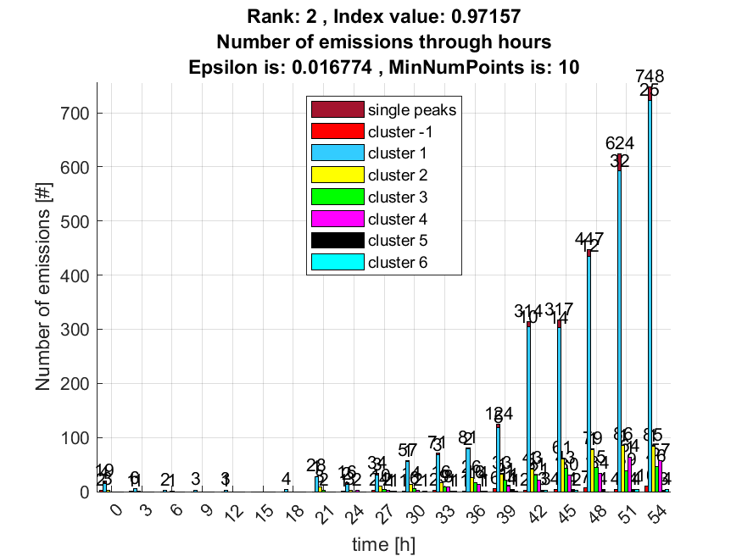

3. result: (signal_strength, peak_frequency, fall_time)
Estimated Epsilon: 0.016909, Picked Epsilon: 0.016909, MinNumPoints: 10
DBCV index value: 0.93074
cluster -1 had 0.80645% single peaks
cluster 1 had 93.5484% single peaks
cluster 2 had 4.0323% single peaks
cluster 3 had 0% single peaks
cluster 4 had 1.6129% single peaks
cluster 5 had 0% single peaks
cluster 6 had 0% single peaks
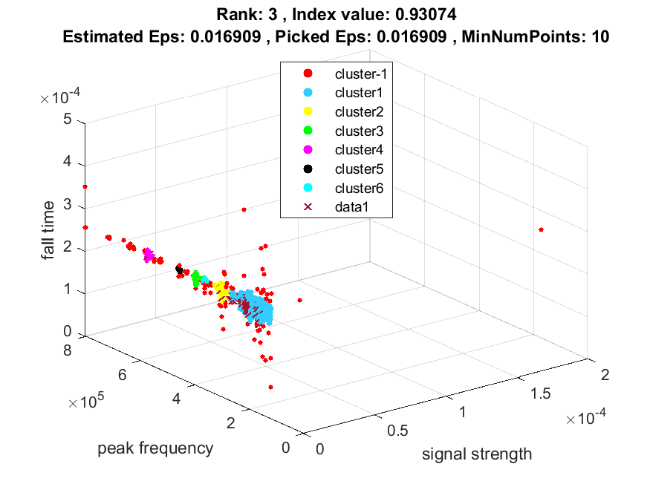
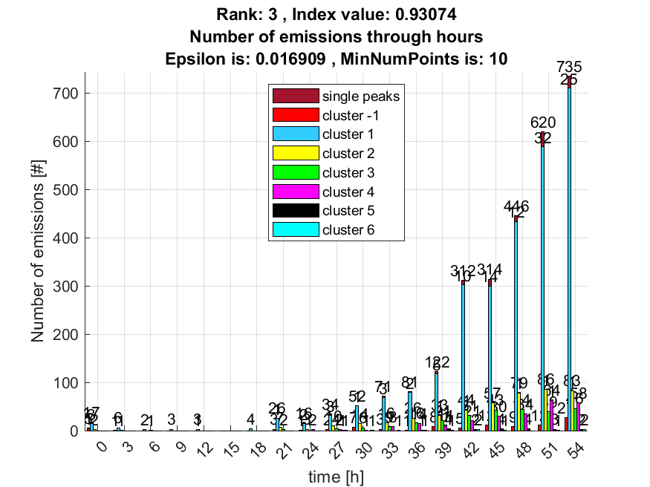

4. result: (peak_frequency, amp_of_peak_frequency, fall_time)
Estimated Epsilon: 0.01714, Picked Epsilon: 0.01714, MinNumPoints: 10
DBCV index value: 0.9307
cluster -1 had 0.80645% single peaks
cluster 1 had 93.5484% single peaks
cluster 2 had 4.0323% single peaks
cluster 3 had 0% single peaks
cluster 4 had 1.6129% single peaks
cluster 5 had 0% single peaks
cluster 6 had 0% single peaks
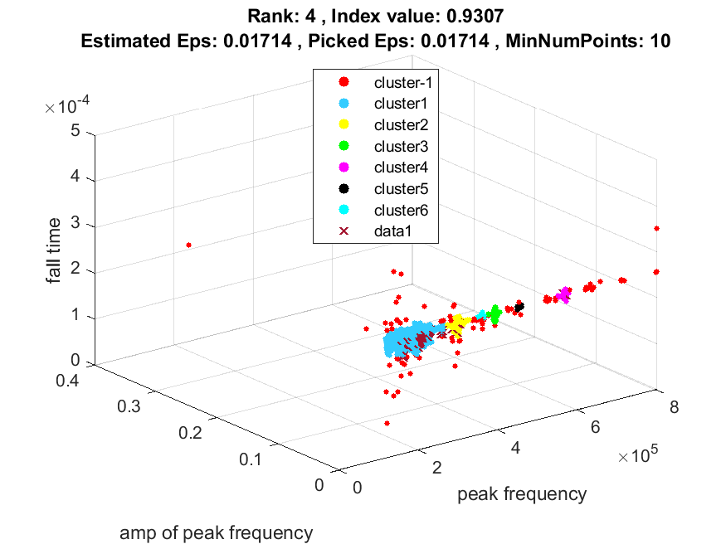
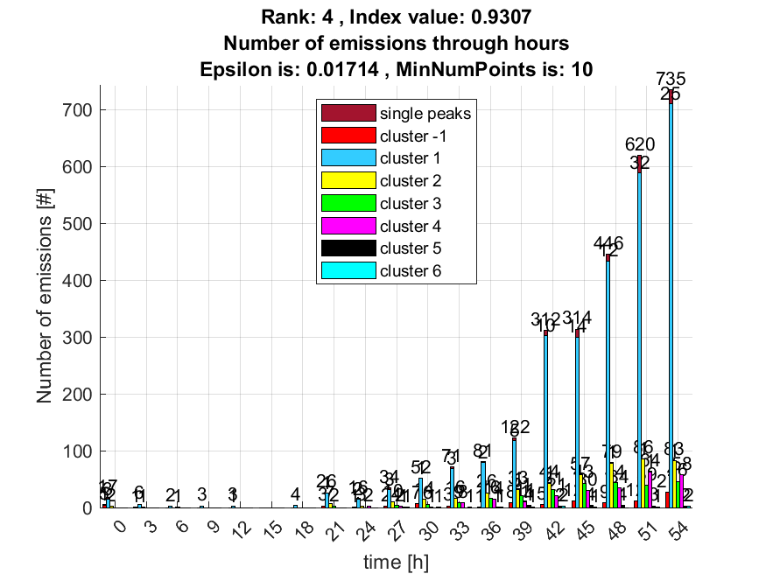

5. result: (peak_amplitude, peak_frequency, fall_time)
Estimated Epsilon: 0.016916, Picked Epsilon: 0.016916, MinNumPoints: 10
DBCV index value: 0.92817
cluster -1 had 0.80645% single peaks
cluster 1 had 93.5484% single peaks
cluster 2 had 4.0323% single peaks
cluster 3 had 0% single peaks
cluster 4 had 1.6129% single peaks
cluster 5 had 0% single peaks
cluster 6 had 0% single peaks
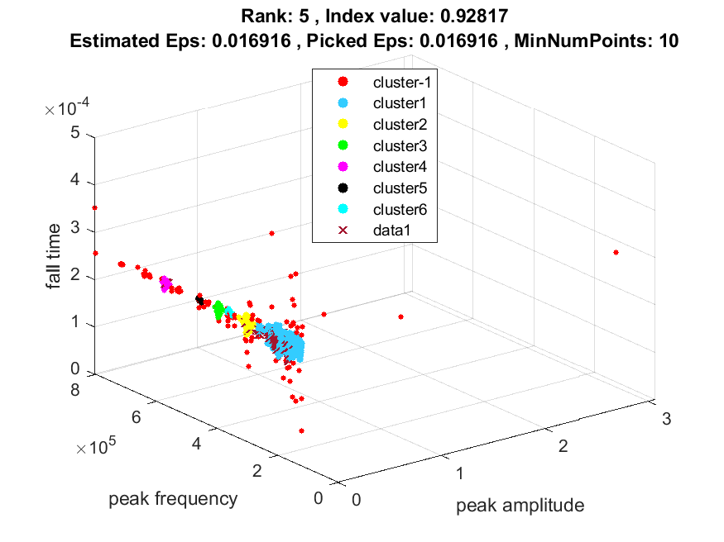
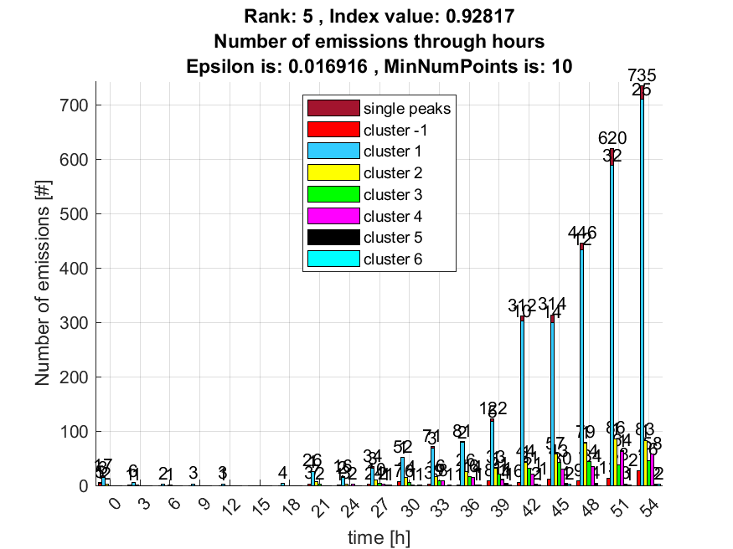

6. result: (rise_time, signal_strength, peak_frequency)
Estimated Epsilon: 0.022518, Picked Epsilon: 0.022518, MinNumPoints: 10
DBCV index value: 0.92649
cluster -1 had 0.80645% single peaks
cluster 1 had 93.5484% single peaks
cluster 2 had 4.0323% single peaks
cluster 3 had 0% single peaks
cluster 4 had 1.6129% single peaks
cluster 5 had 0% single peaks
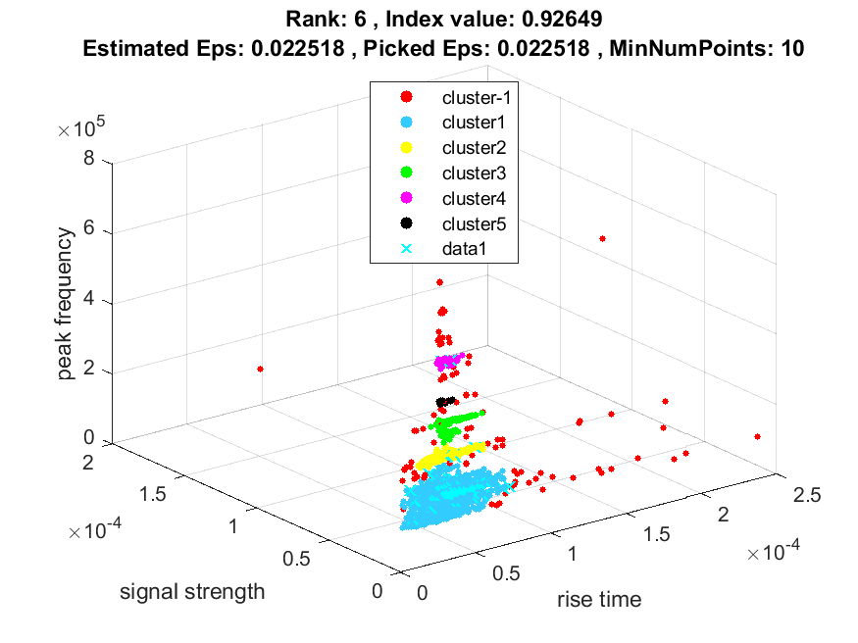
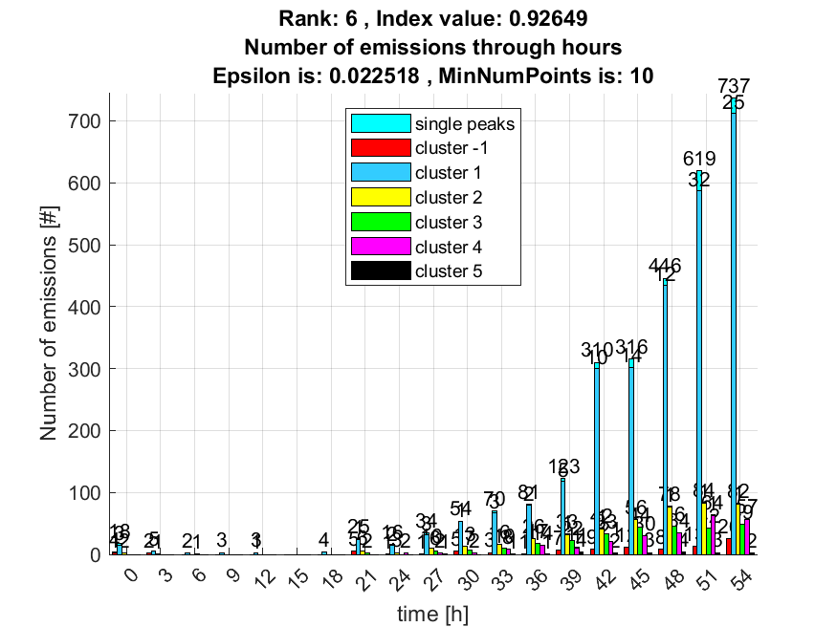

7. result: (rise_time, peak_frequency, amp_of_peak_frequency)
Estimated Epsilon: 0.022518, Picked Epsilon: 0.022518, MinNumPoints: 10
DBCV index value: 0.92639
cluster -1 had 0.80645% single peaks
cluster 1 had 93.5484% single peaks
cluster 2 had 4.0323% single peaks
cluster 3 had 0% single peaks
cluster 4 had 1.6129% single peaks
cluster 5 had 0% single peaks
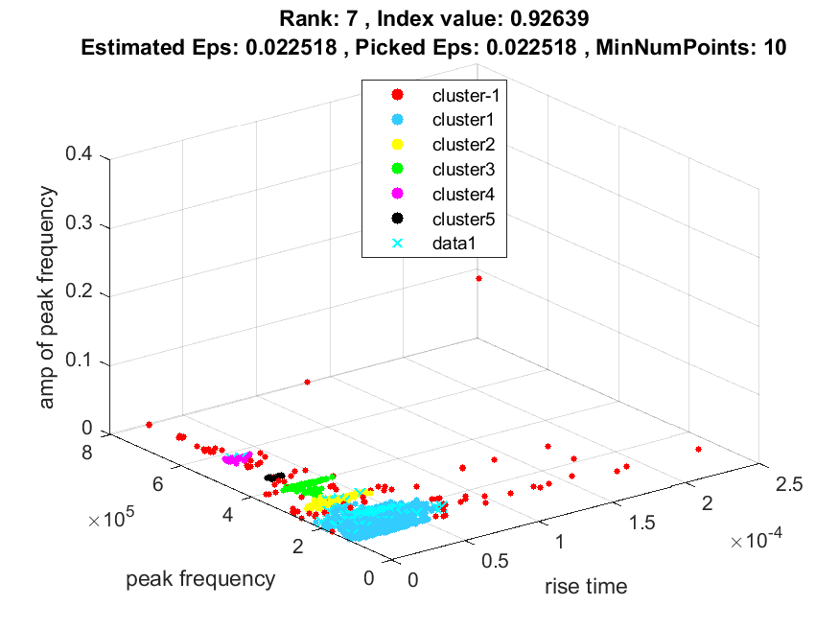
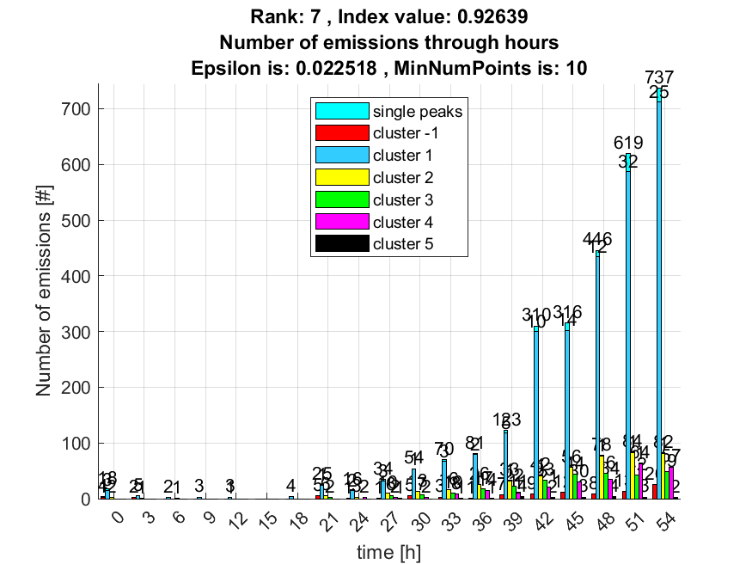

8. result: (rise_time, peak_amplitude, peak_frequency)
Estimated Epsilon: 0.022522, Picked Epsilon: 0.022522, MinNumPoints: 10
DBCV index value: 0.92398
cluster -1 had 0.80645% single peaks
cluster 1 had 93.5484% single peaks
cluster 2 had 4.0323% single peaks
cluster 3 had 0% single peaks
cluster 4 had 1.6129% single peaks
cluster 5 had 0% single peaks
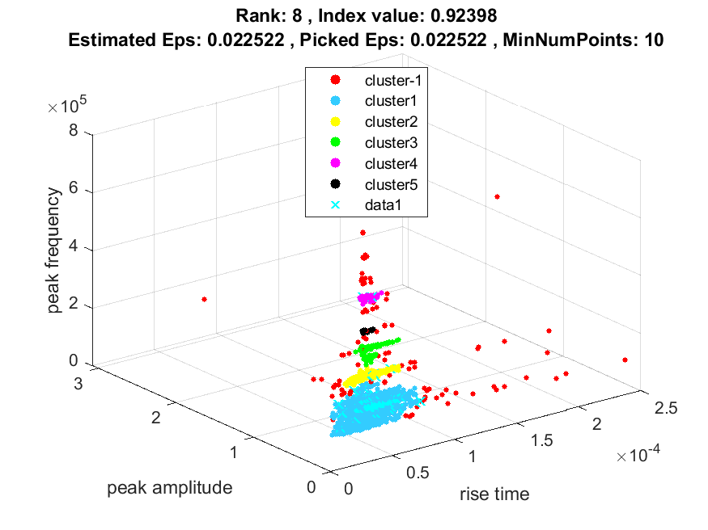
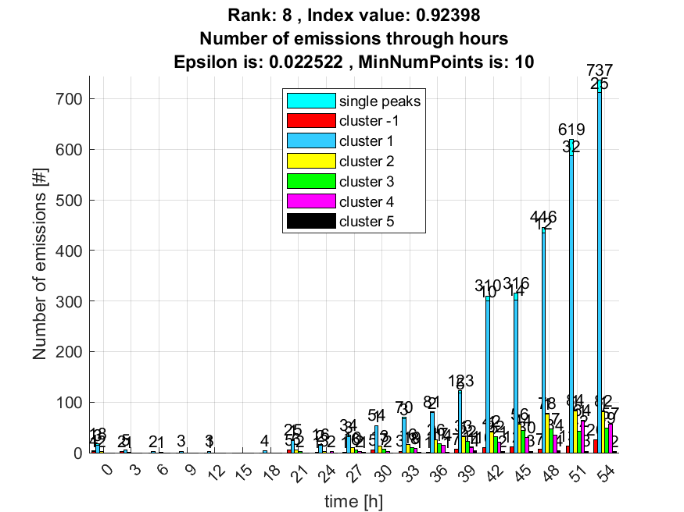

9. result: (counts_from, signal_strength, peak_frequency)
Estimated Epsilon: 0.027277, Picked Epsilon: 0.022277, MinNumPoints: 10
DBCV index value: 0.89609
cluster -1 had 0.80645% single peaks
cluster 1 had 93.5484% single peaks
cluster 2 had 4.0323% single peaks
cluster 3 had 0% single peaks
cluster 4 had 1.6129% single peaks
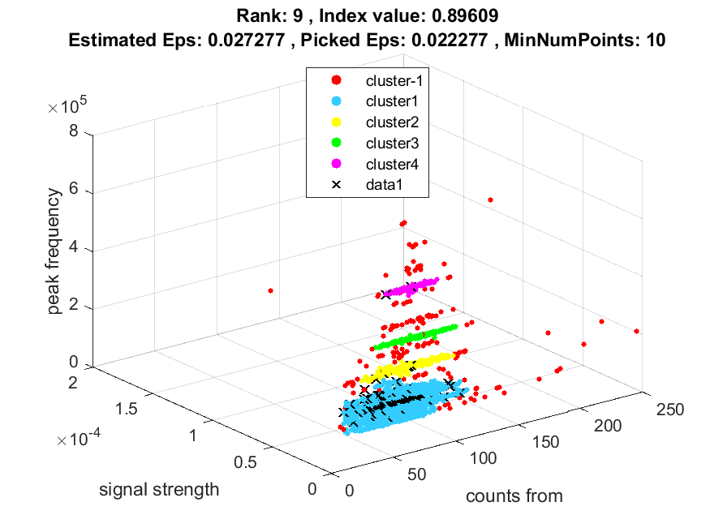
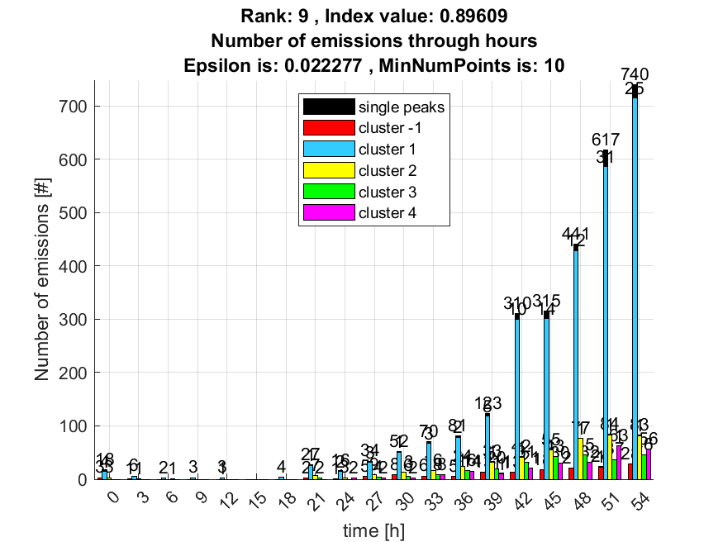

10. result: (counts_from, peak_frequency, amp_of_peak_frequency)
Estimated Epsilon: 0.027276, Picked Epsilon: 0.022276, MinNumPoints: 10
DBCV index value: 0.89553
cluster -1 had 0.80645% single peaks
cluster 1 had 93.5484% single peaks
cluster 2 had 4.0323% single peaks
cluster 3 had 0% single peaks
cluster 4 had 1.6129% single peaks
