Feature selection results for exp_7 and Nmin = 10

1. result: (counts_from, signal_strength, peak_frequency)
Estimated Epsilon: 0.027277, Picked Epsilon: 0.022277, MinNumPoints: 10
DBCV_single_clust index value: 0.89609
cluster -1 had 0.80645% single peaks
cluster 1 had 93.5484% single peaks
cluster 2 had 4.0323% single peaks
cluster 3 had 0% single peaks
cluster 4 had 1.6129% single peaks
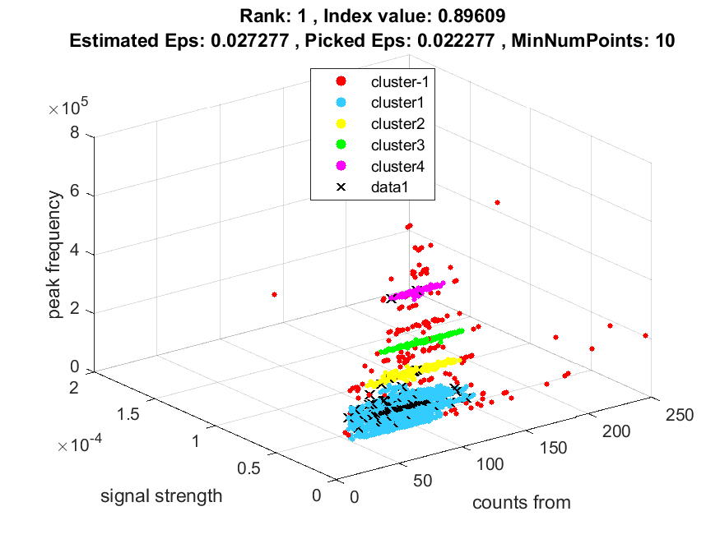
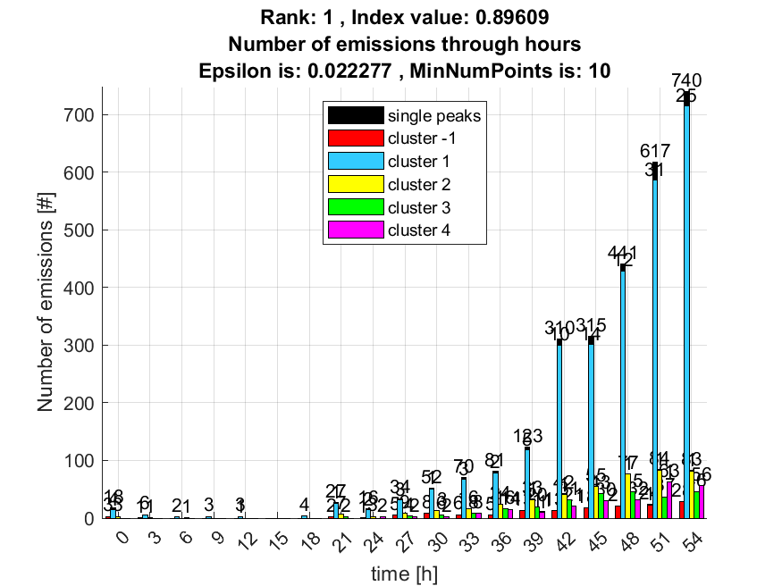

2. result: (counts_from, peak_frequency, amp_of_peak_frequency)
Estimated Epsilon: 0.027276, Picked Epsilon: 0.022276, MinNumPoints: 10
DBCV_single_clust index value: 0.89553
cluster -1 had 0.80645% single peaks
cluster 1 had 93.5484% single peaks
cluster 2 had 4.0323% single peaks
cluster 3 had 0% single peaks
cluster 4 had 1.6129% single peaks
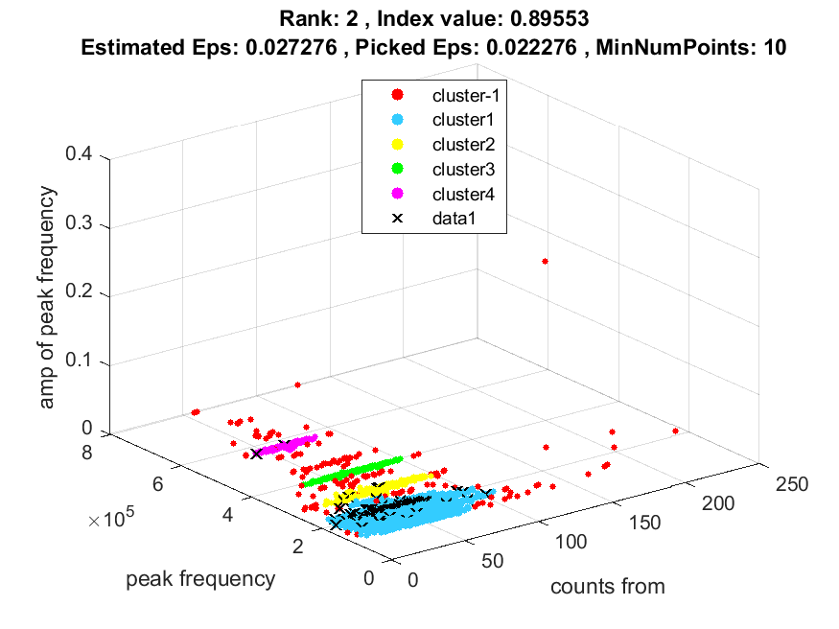
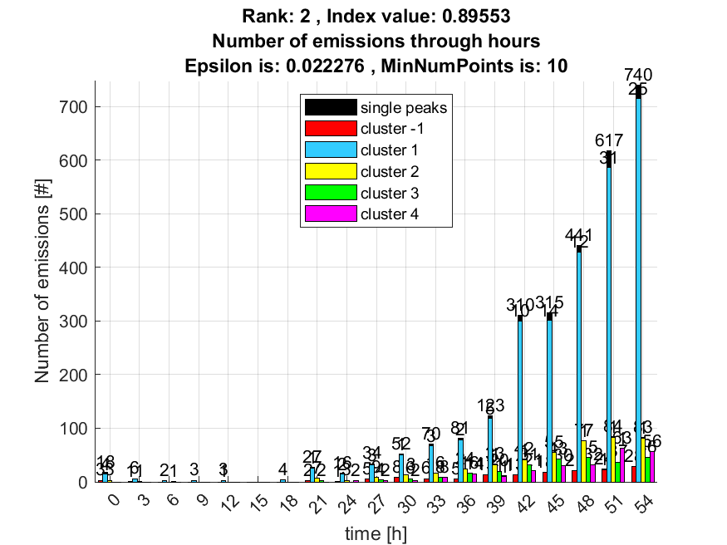

3. result: (counts_from, peak_amplitude, peak_frequency)
Estimated Epsilon: 0.027446, Picked Epsilon: 0.022446, MinNumPoints: 10
DBCV_single_clust index value: 0.89409
cluster -1 had 0.80645% single peaks
cluster 1 had 93.5484% single peaks
cluster 2 had 4.0323% single peaks
cluster 3 had 0% single peaks
cluster 4 had 1.6129% single peaks
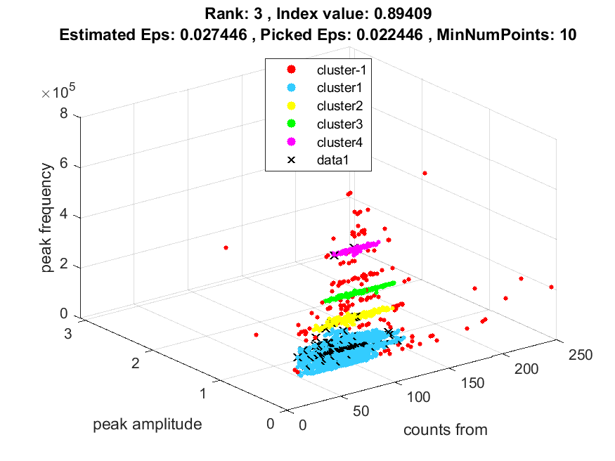
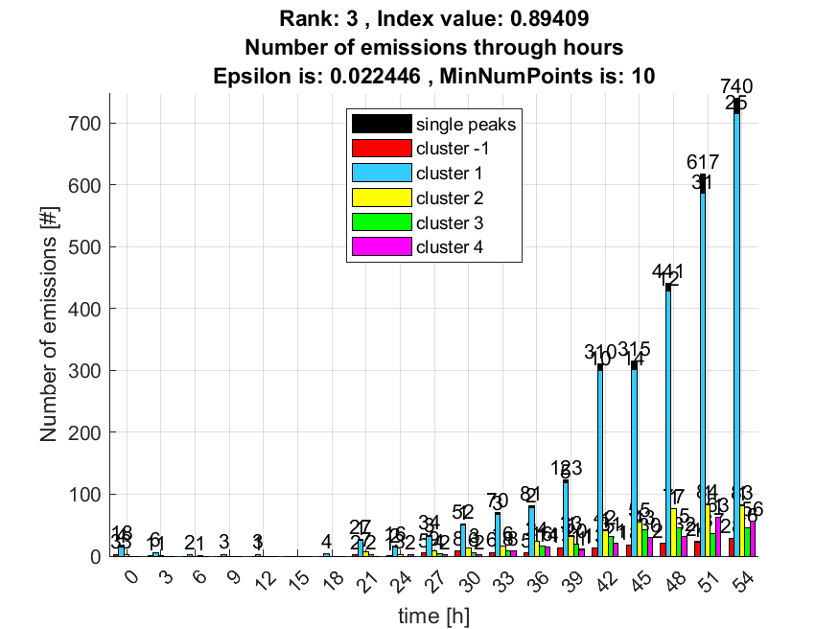

4. result: (signal_strength, pp3, peak_frequency)
Estimated Epsilon: 0.037575, Picked Epsilon: 0.030075, MinNumPoints: 10
DBCV_single_clust index value: 0.89266
cluster -1 had 2.4194% single peaks
cluster 1 had 92.7419% single peaks
cluster 2 had 3.2258% single peaks
cluster 3 had 0% single peaks
cluster 4 had 1.6129% single peaks
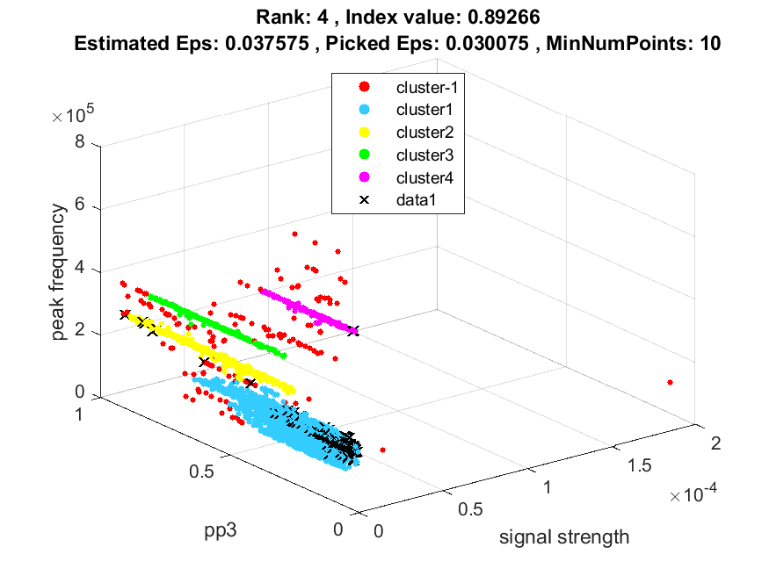
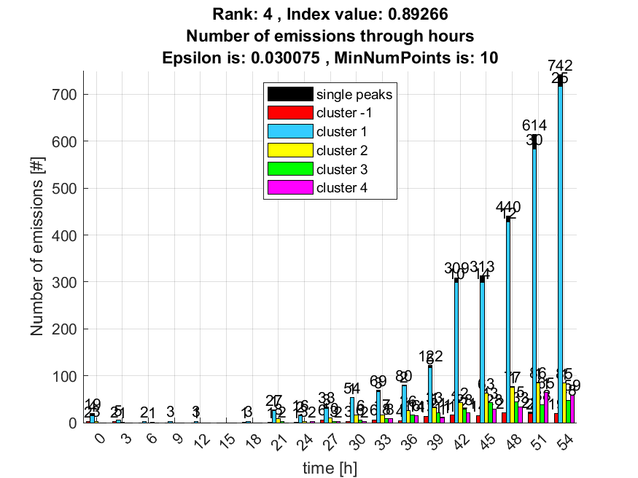

5. result: (pp3, peak_frequency, amp_of_peak_frequency)
Estimated Epsilon: 0.037575, Picked Epsilon: 0.030075, MinNumPoints: 10
DBCV_single_clust index value: 0.89251
cluster -1 had 2.4194% single peaks
cluster 1 had 92.7419% single peaks
cluster 2 had 3.2258% single peaks
cluster 3 had 0% single peaks
cluster 4 had 1.6129% single peaks
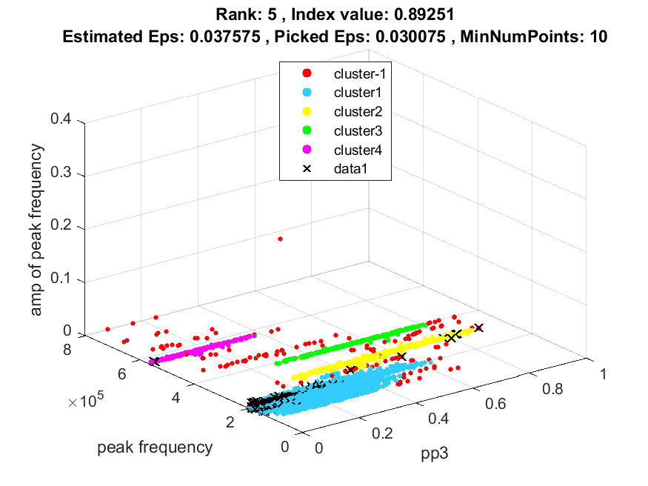
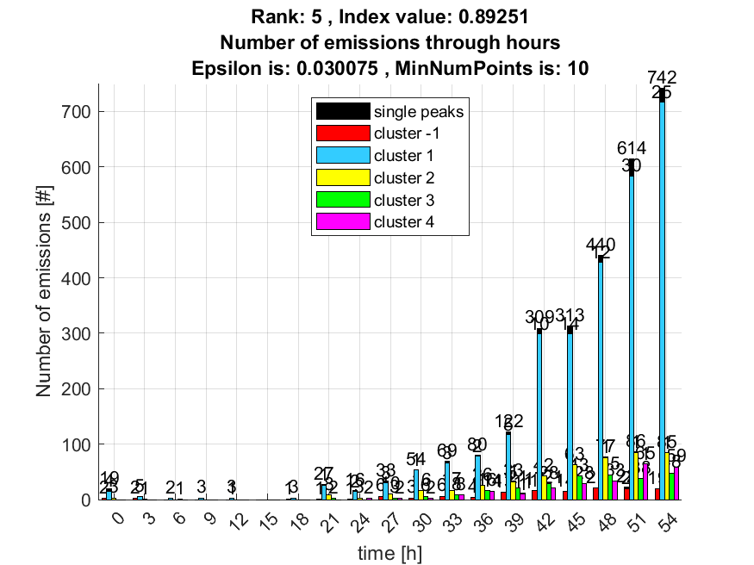

6. result: (peak_amplitude, pp3, peak_frequency)
Estimated Epsilon: 0.037612, Picked Epsilon: 0.030112, MinNumPoints: 10
DBCV_single_clust index value: 0.88987
cluster -1 had 2.4194% single peaks
cluster 1 had 92.7419% single peaks
cluster 2 had 3.2258% single peaks
cluster 3 had 0% single peaks
cluster 4 had 1.6129% single peaks
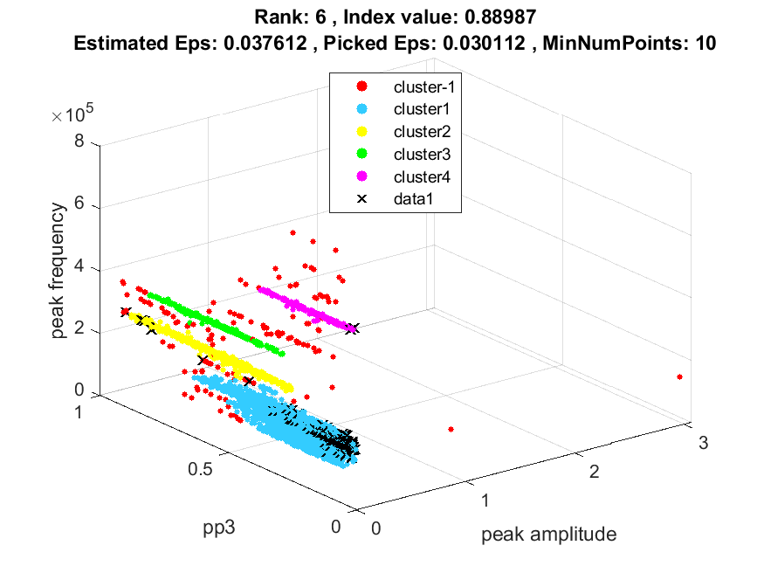
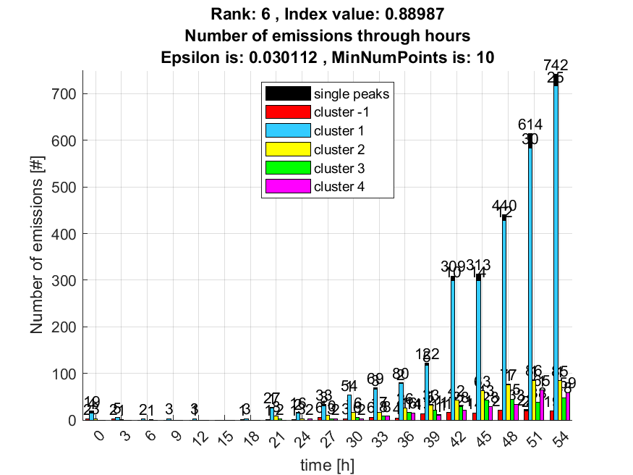

7. result: (centroid_frequency, peak_frequency, amp_of_peak_frequency)
Estimated Epsilon: 0.033139, Picked Epsilon: 0.025639, MinNumPoints: 10
DBCV_single_clust index value: 0.88533
cluster -1 had 1.6129% single peaks
cluster 1 had 92.7419% single peaks
cluster 2 had 4.0323% single peaks
cluster 3 had 0% single peaks
cluster 4 had 1.6129% single peaks
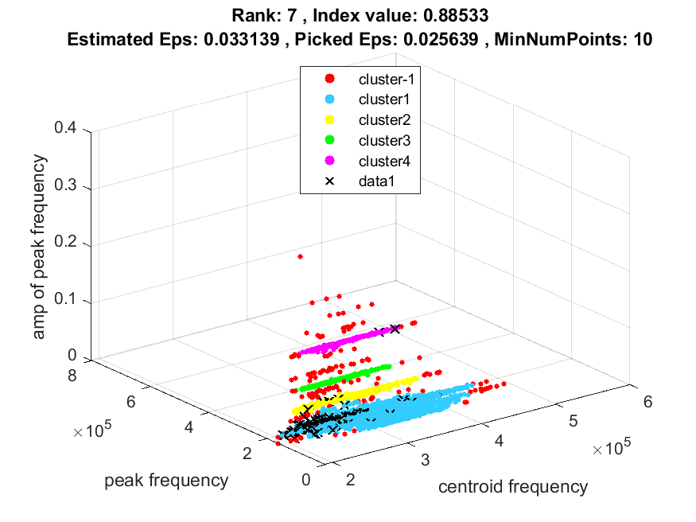
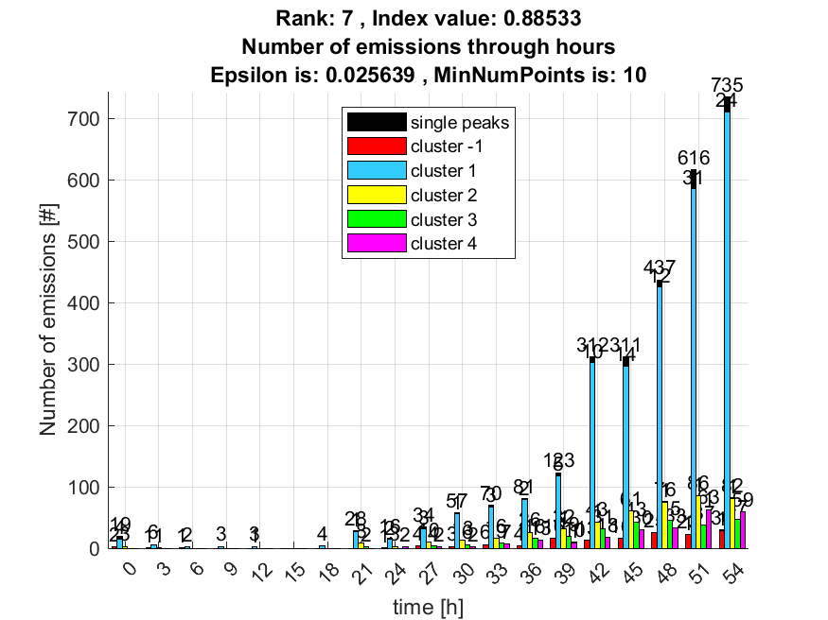

8. result: (signal_strength, centroid_frequency, peak_frequency)
Estimated Epsilon: 0.033139, Picked Epsilon: 0.025639, MinNumPoints: 10
DBCV_single_clust index value: 0.88528
cluster -1 had 1.6129% single peaks
cluster 1 had 92.7419% single peaks
cluster 2 had 4.0323% single peaks
cluster 3 had 0% single peaks
cluster 4 had 1.6129% single peaks
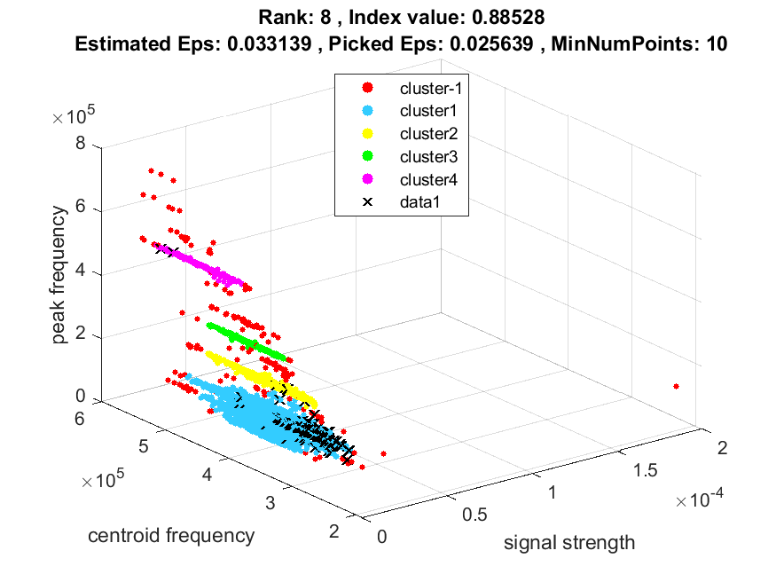
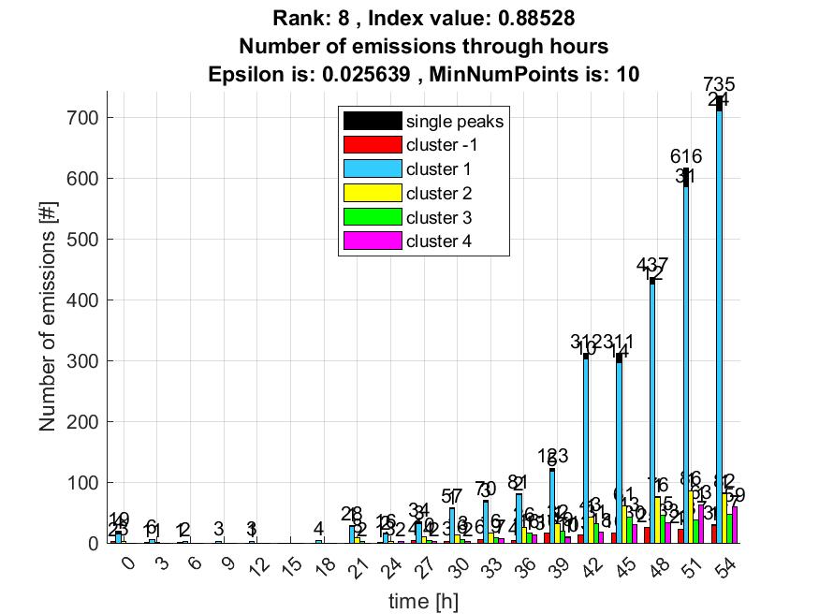

9. result: (peak_amplitude, centroid_frequency, peak_frequency)
Estimated Epsilon: 0.033143, Picked Epsilon: 0.025643, MinNumPoints: 10
DBCV_single_clust index value: 0.881
cluster -1 had 1.6129% single peaks
cluster 1 had 92.7419% single peaks
cluster 2 had 4.0323% single peaks
cluster 3 had 0% single peaks
cluster 4 had 1.6129% single peaks
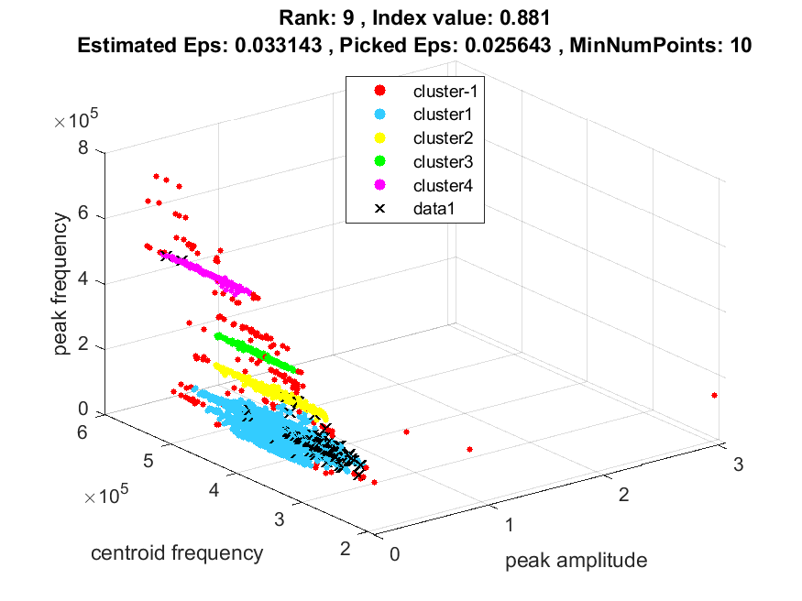
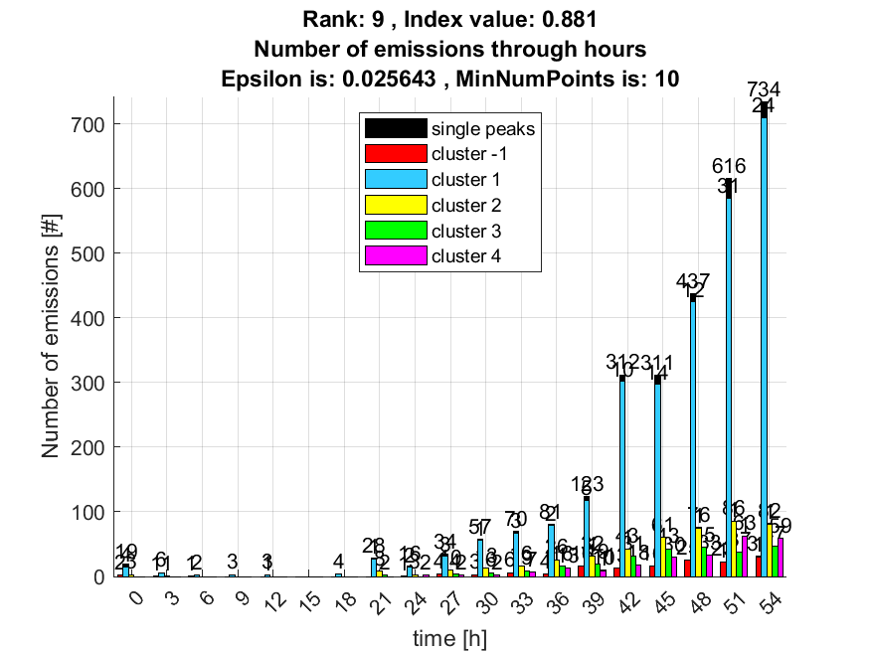

10. result: (signal_strength, pp2, peak_frequency)
Estimated Epsilon: 0.032128, Picked Epsilon: 0.024628, MinNumPoints: 10
DBCV_single_clust index value: 0.87823
cluster -1 had 3.2258% single peaks
cluster 1 had 91.9355% single peaks
cluster 2 had 4.0323% single peaks
cluster 3 had 0% single peaks
cluster 4 had 0.80645% single peaks
