Feature selection results for exp_8 and Nmin = 10

1. result: (signal_strength, peak_frequency, amp_of_peak_frequency)
Estimated Epsilon: 0.028462, Picked Epsilon: 0.040962, MinNumPoints: 10
DBCV index value: 0.88483
cluster -1 had 1.992% single peaks
cluster 1 had 96.0159% single peaks
cluster 2 had 1.5936% single peaks
cluster 3 had 0.39841% single peaks
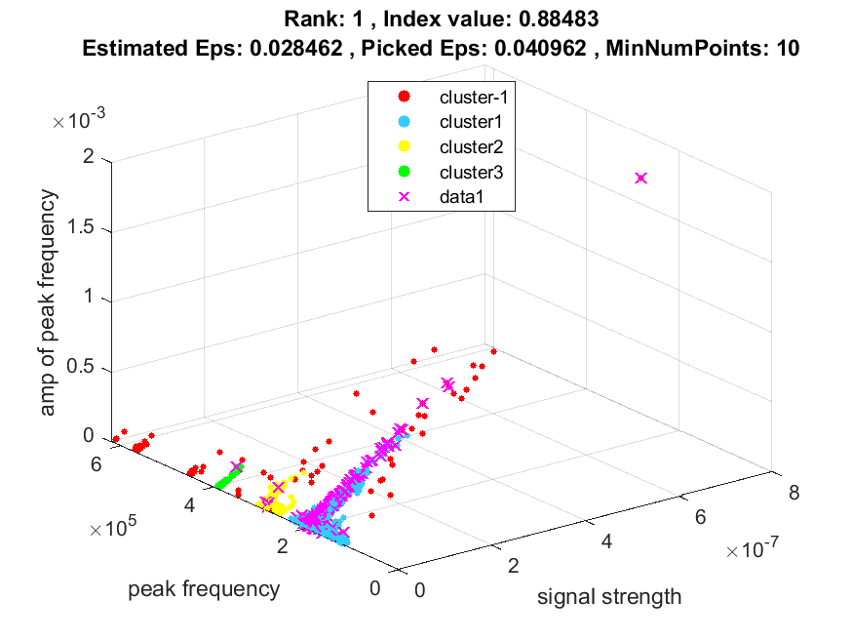
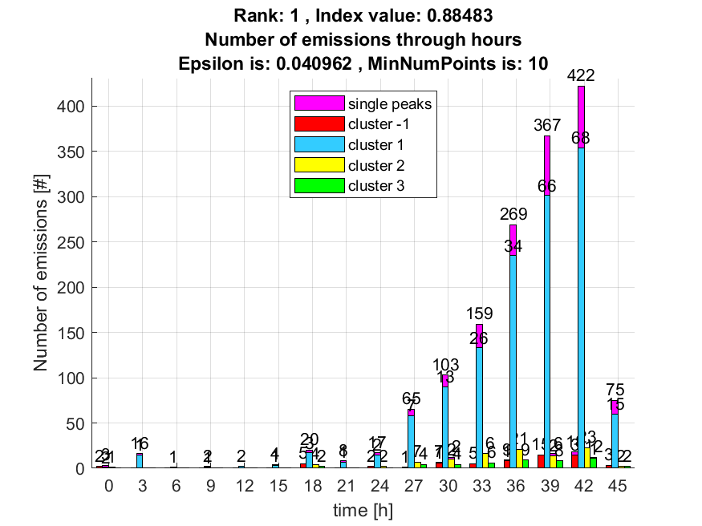

2. result: (pp1, peak_frequency, amp_of_peak_frequency)
Estimated Epsilon: 0.041526, Picked Epsilon: 0.056526, MinNumPoints: 10
DBCV index value: 0.84565
cluster -1 had 1.1952% single peaks
cluster 1 had 96.8127% single peaks
cluster 2 had 1.5936% single peaks
cluster 3 had 0.39841% single peaks
cluster 4 had 0% single peaks
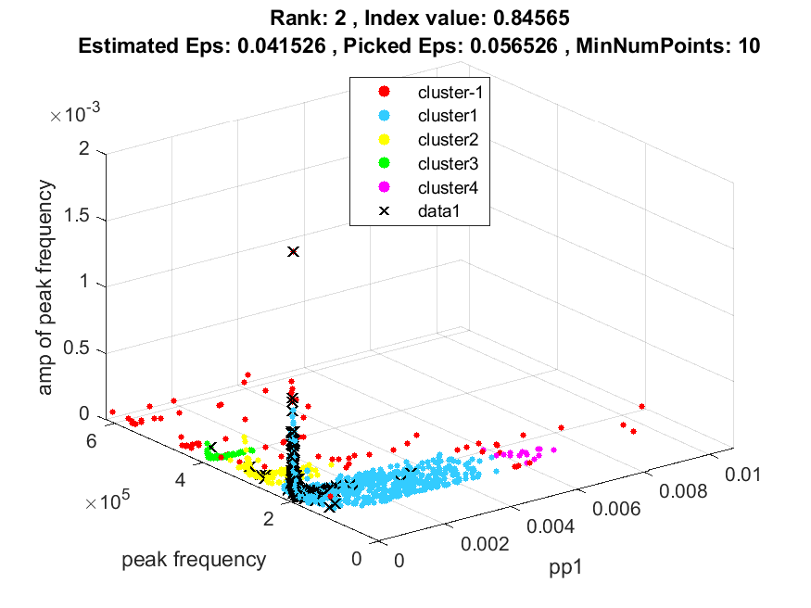
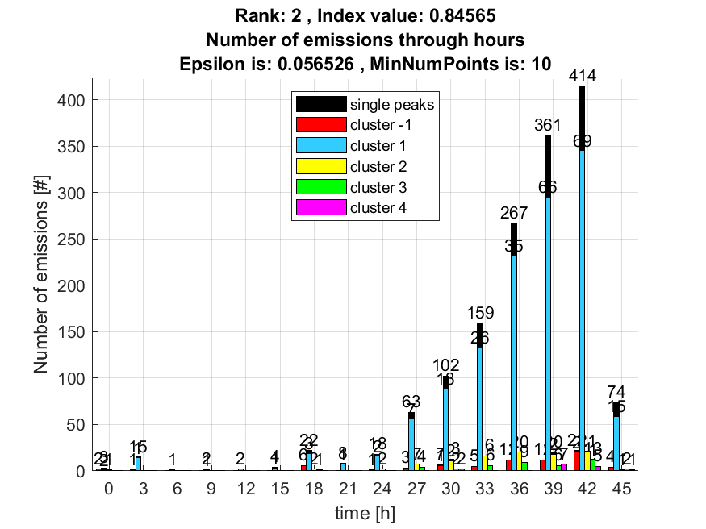

3. result: (signal_strength, pp1, peak_frequency)
Estimated Epsilon: 0.034264, Picked Epsilon: 0.054264, MinNumPoints: 10
DBCV index value: 0.82428
cluster -1 had 1.1952% single peaks
cluster 1 had 96.8127% single peaks
cluster 2 had 1.5936% single peaks
cluster 3 had 0.39841% single peaks
cluster 4 had 0% single peaks
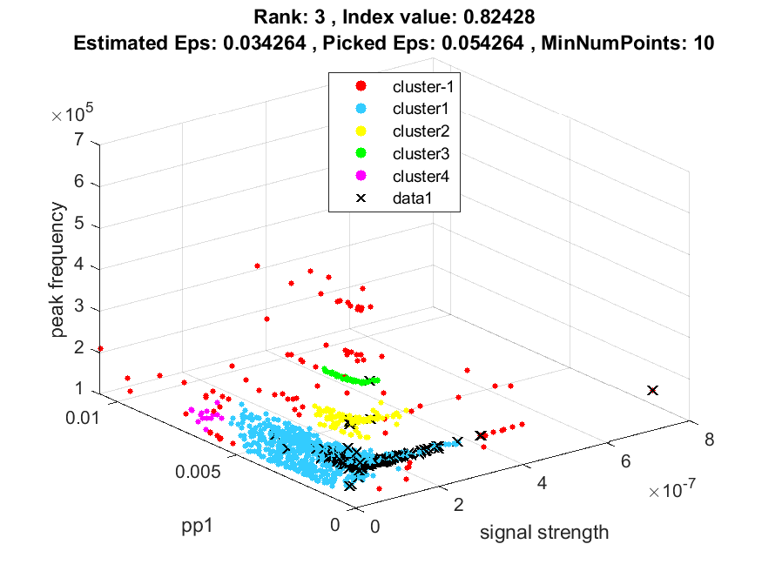
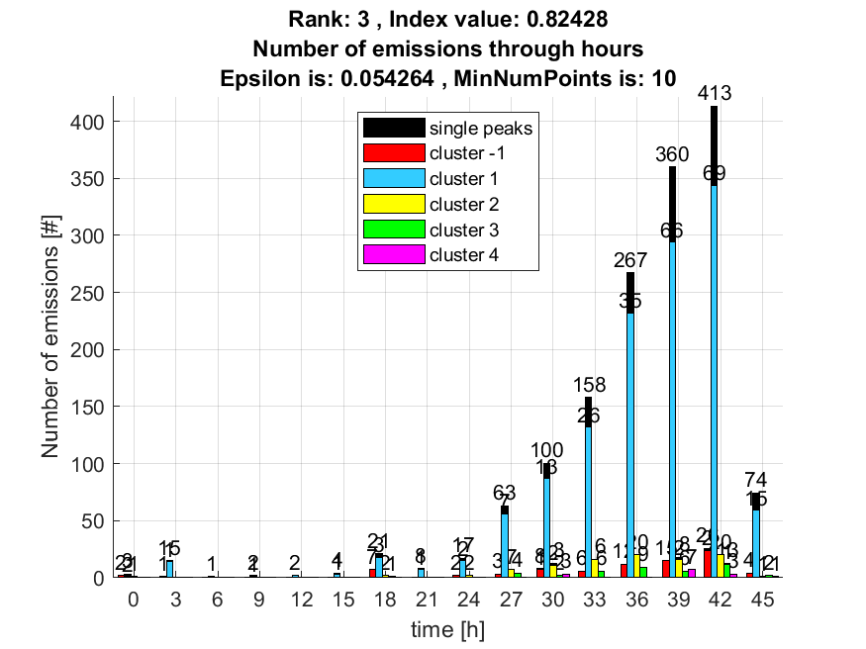

4. result: (centroid_frequency, peak_frequency, amp_of_peak_frequency)
Estimated Epsilon: 0.050703, Picked Epsilon: 0.063203, MinNumPoints: 10
DBCV index value: 0.8077
cluster -1 had 2.7888% single peaks
cluster 1 had 95.6175% single peaks
cluster 2 had 1.1952% single peaks
cluster 3 had 0.39841% single peaks
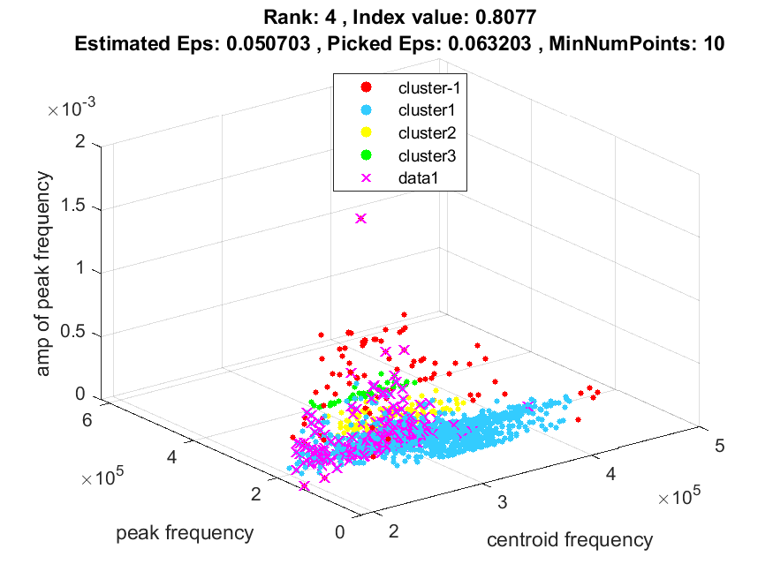
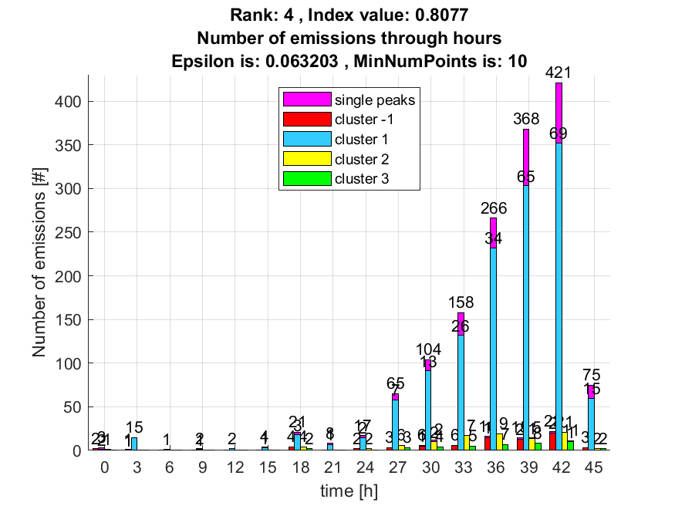

5. result: (peak_amplitude, pp1, peak_frequency)
Estimated Epsilon: 0.033046, Picked Epsilon: 0.053046, MinNumPoints: 10
DBCV index value: 0.8059
cluster -1 had 1.5936% single peaks
cluster 1 had 96.4143% single peaks
cluster 2 had 1.5936% single peaks
cluster 3 had 0.39841% single peaks
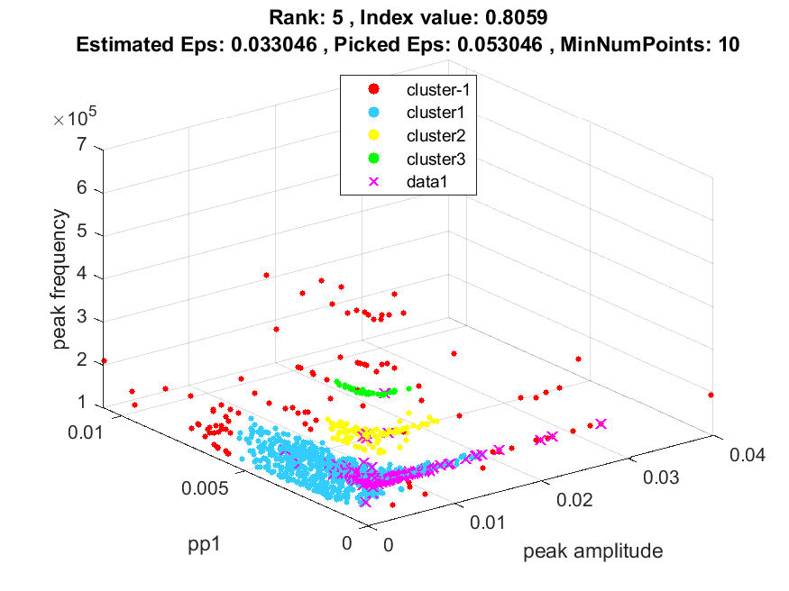
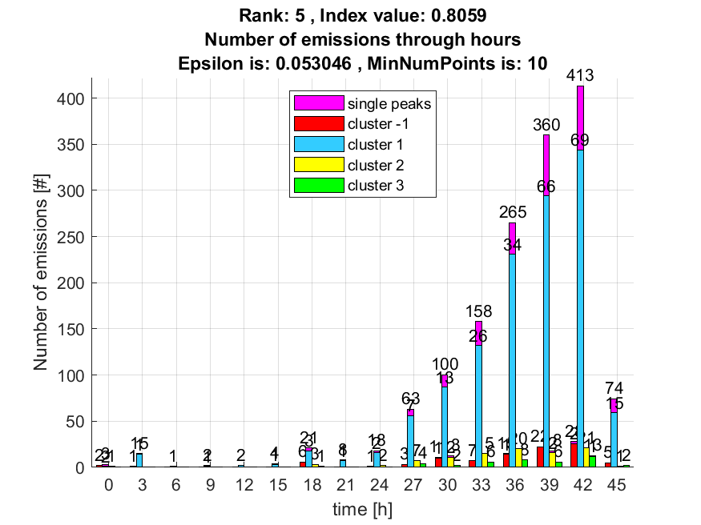

6. result: (centroid_frequency, peak_frequency, fall_time)
Estimated Epsilon: 0.060041, Picked Epsilon: 0.070041, MinNumPoints: 10
DBCV index value: 0.80374
cluster -1 had 1.1952% single peaks
cluster 1 had 97.2112% single peaks
cluster 2 had 1.1952% single peaks
cluster 3 had 0.39841% single peaks
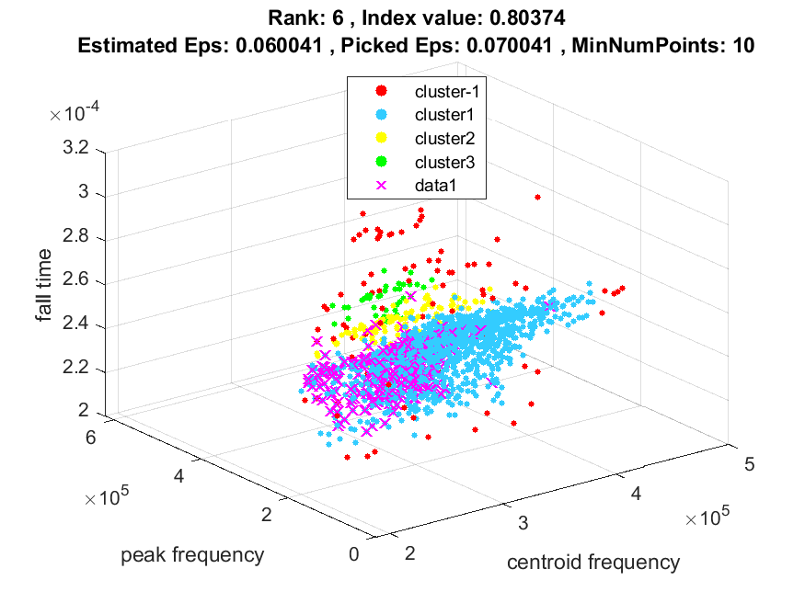
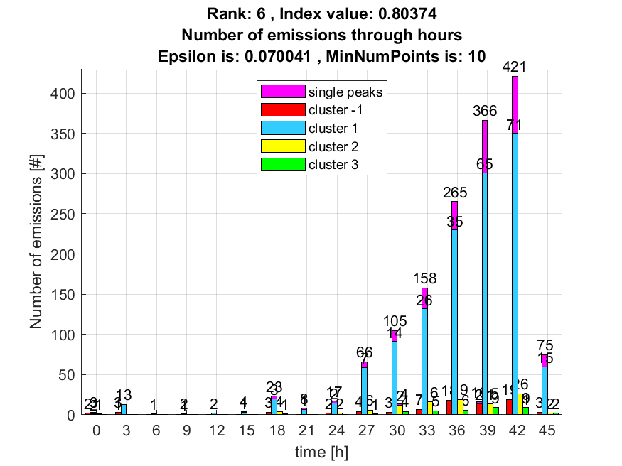

7. result: (pp2, peak_frequency, amp_of_peak_frequency)
Estimated Epsilon: 0.052317, Picked Epsilon: 0.057317, MinNumPoints: 10
DBCV index value: 0.7969
cluster -1 had 5.9761% single peaks
cluster 1 had 92.4303% single peaks
cluster 2 had 0.39841% single peaks
cluster 3 had 0% single peaks
cluster 4 had 1.1952% single peaks
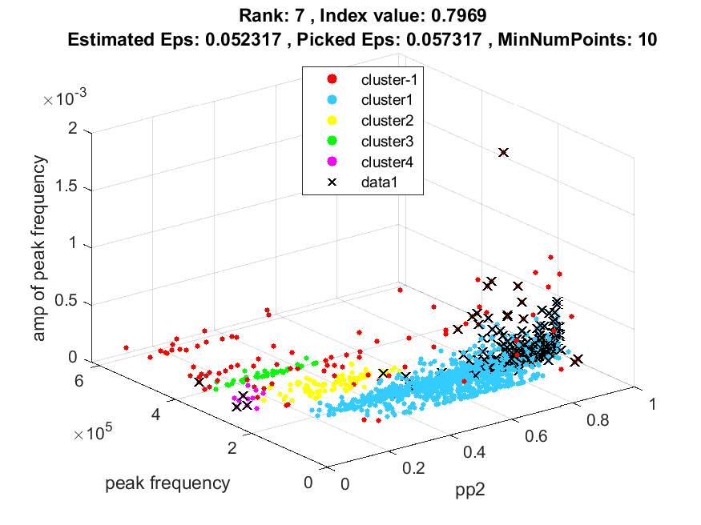
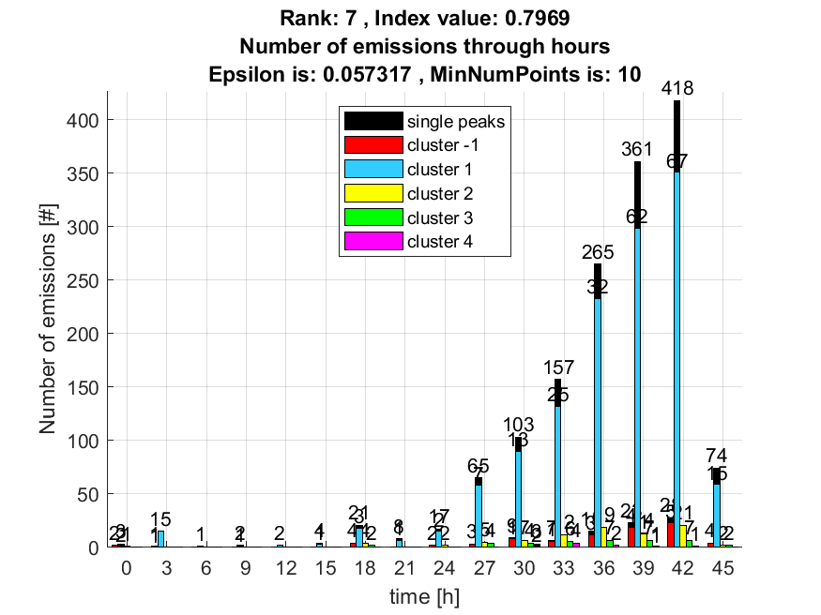

8. result: (peak_amplitude, centroid_frequency, peak_frequency)
Estimated Epsilon: 0.05413, Picked Epsilon: 0.06163, MinNumPoints: 10
DBCV index value: 0.79469
cluster -1 had 4.3825% single peaks
cluster 1 had 94.0239% single peaks
cluster 2 had 1.1952% single peaks
cluster 3 had 0.39841% single peaks
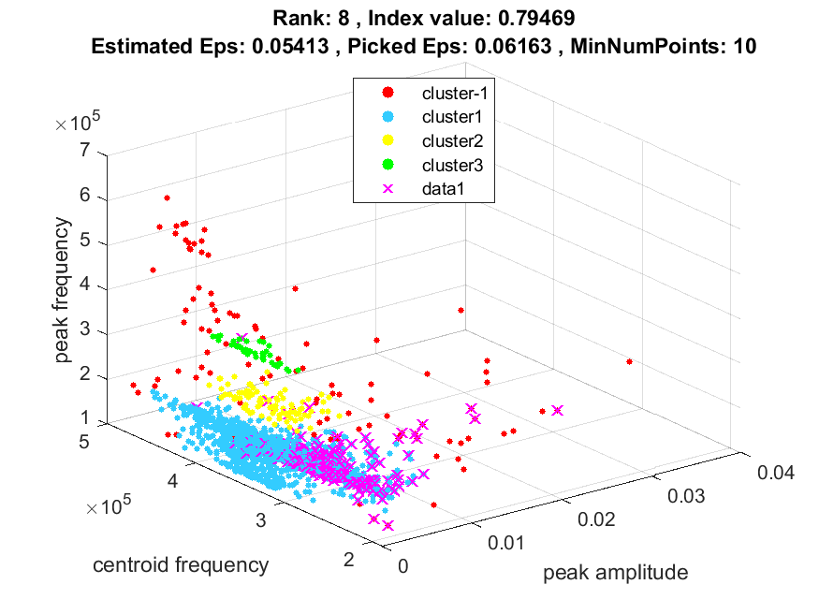
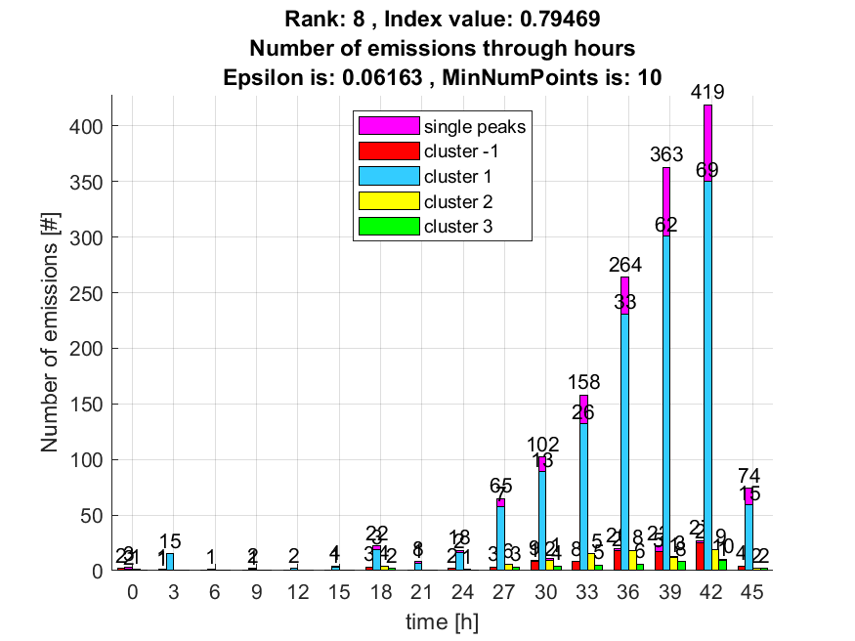

9. result: (peak_amplitude, peak_frequency, fall_time)
Estimated Epsilon: 0.034767, Picked Epsilon: 0.042267, MinNumPoints: 10
DBCV index value: 0.79336
cluster -1 had 4.3825% single peaks
cluster 1 had 93.6255% single peaks
cluster 2 had 1.5936% single peaks
cluster 3 had 0.39841% single peaks
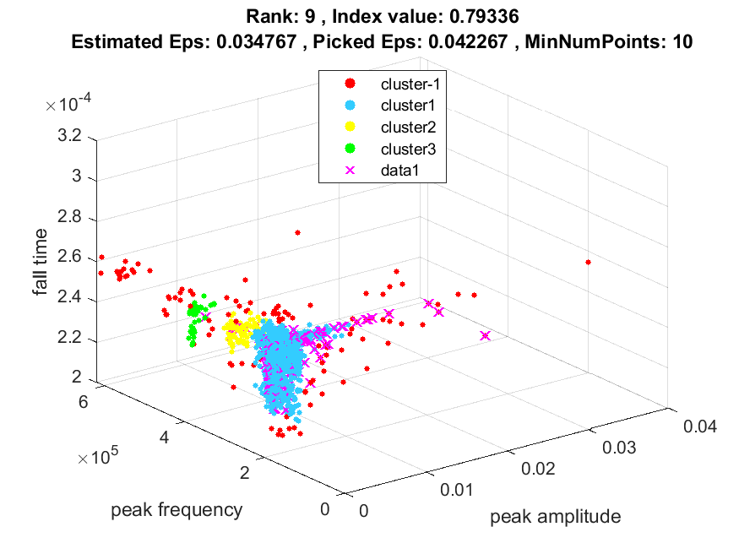
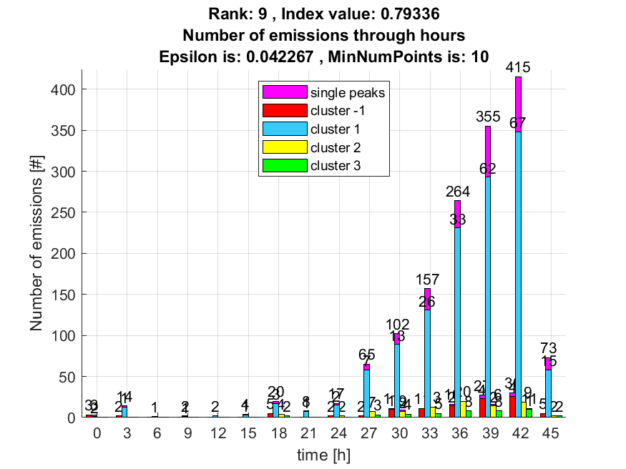

10. result: (signal_strength, centroid_frequency, peak_frequency)
Estimated Epsilon: 0.053175, Picked Epsilon: 0.063175, MinNumPoints: 10
DBCV index value: 0.79074
cluster -1 had 3.5857% single peaks
cluster 1 had 94.8207% single peaks
cluster 2 had 1.1952% single peaks
cluster 3 had 0.39841% single peaks
