Feature selection results for exp_8 and Nmin = 10

1. result: (peak_amplitude, peak_frequency, fall_time)
Estimated Epsilon: 0.034767, Picked Epsilon: 0.017267, MinNumPoints: 10
DBCV_single_clust index value: -0.0020601
cluster -1 had 18.7251% single peaks
cluster 1 had 81.2749% single peaks
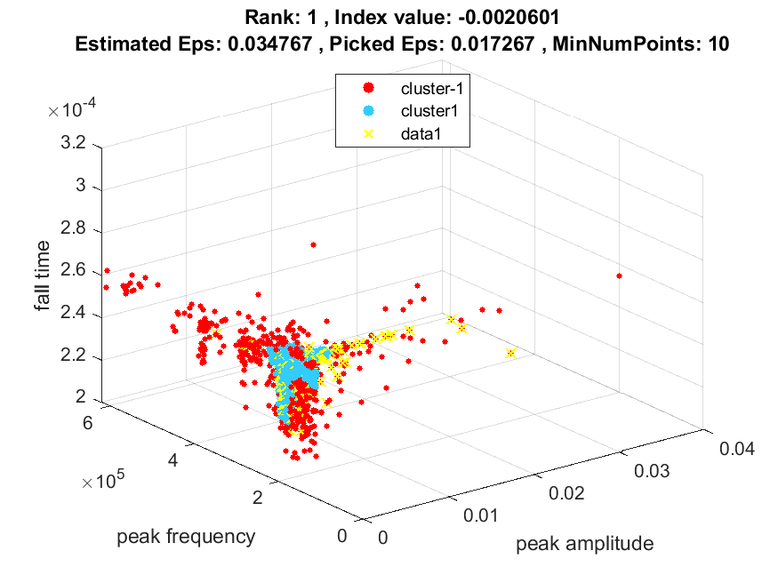
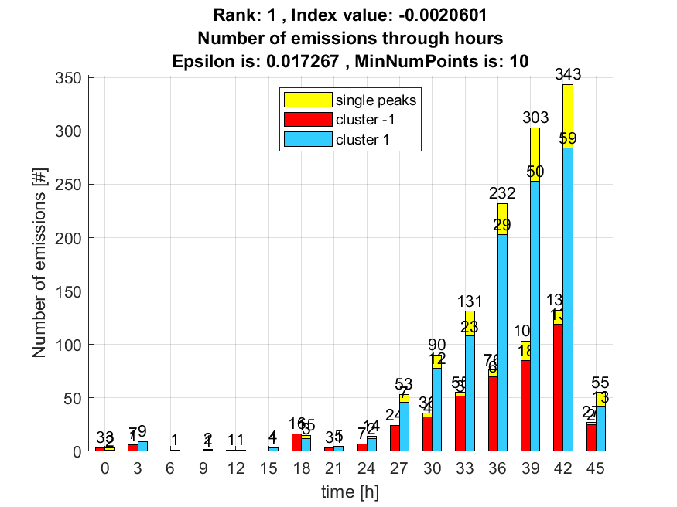

2. result: (counts_from, peak_amplitude, peak_frequency)
Estimated Epsilon: 0.041904, Picked Epsilon: 0.024404, MinNumPoints: 10
DBCV_single_clust index value: -0.0024793
cluster -1 had 15.5378% single peaks
cluster 1 had 84.4622% single peaks
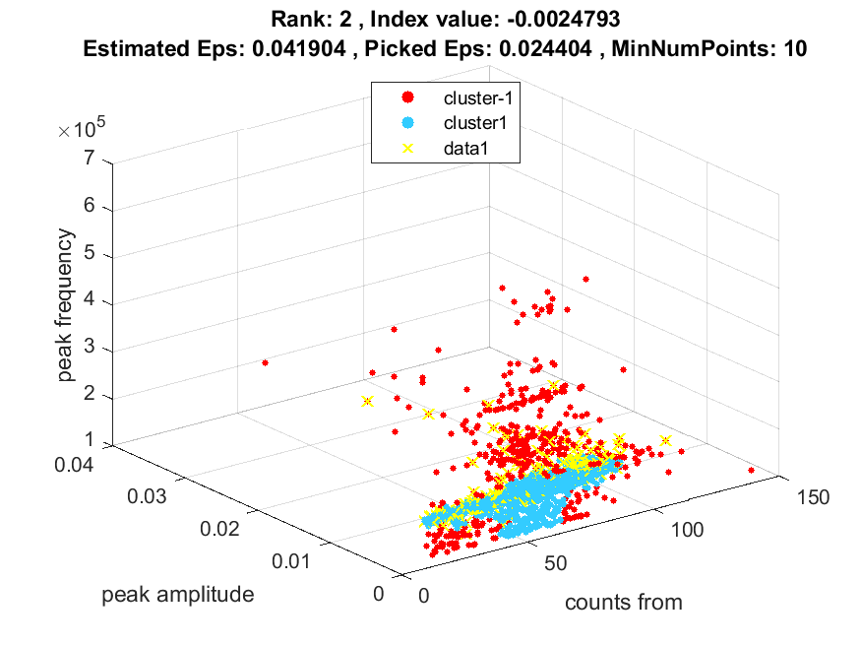
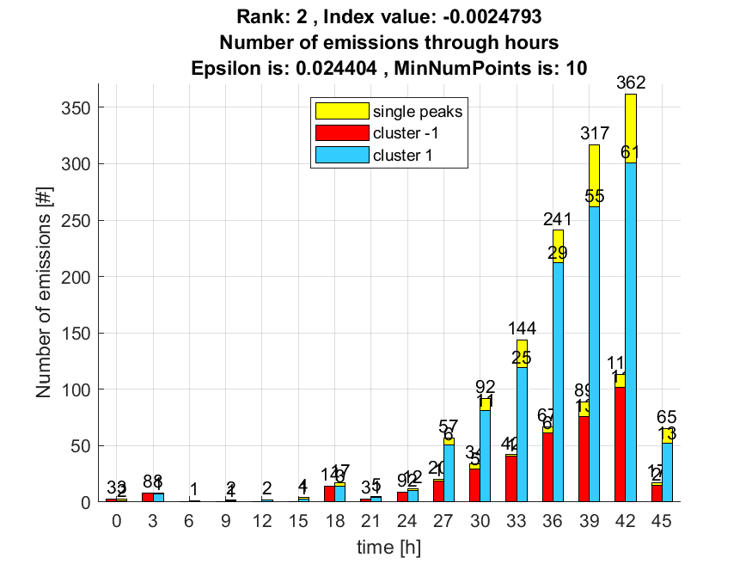

3. result: (peak_amplitude, pp4, peak_frequency)
Estimated Epsilon: 0.040175, Picked Epsilon: 0.022675, MinNumPoints: 10
DBCV_single_clust index value: -0.0025194
cluster -1 had 11.9522% single peaks
cluster 1 had 88.0478% single peaks
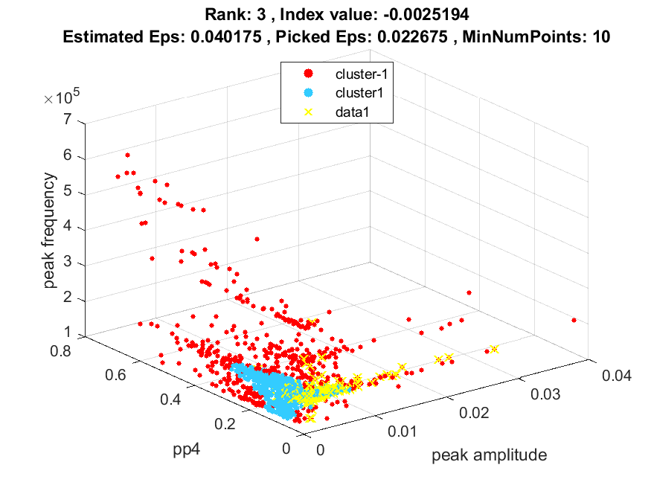
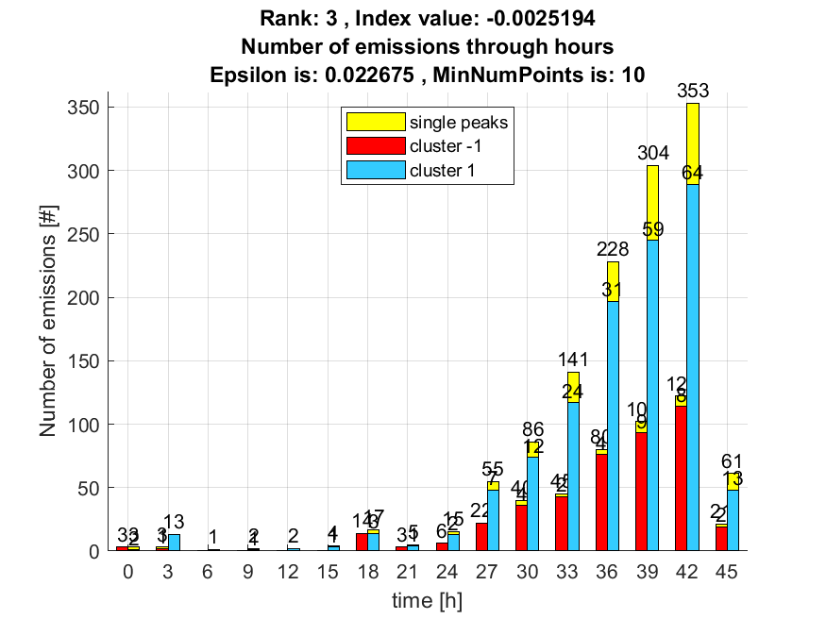

4. result: (pp3, peak_frequency, fall_time)
Estimated Epsilon: 0.054852, Picked Epsilon: 0.037352, MinNumPoints: 10
DBCV_single_clust index value: -0.0033053
cluster -1 had 3.9841% single peaks
cluster 1 had 96.0159% single peaks
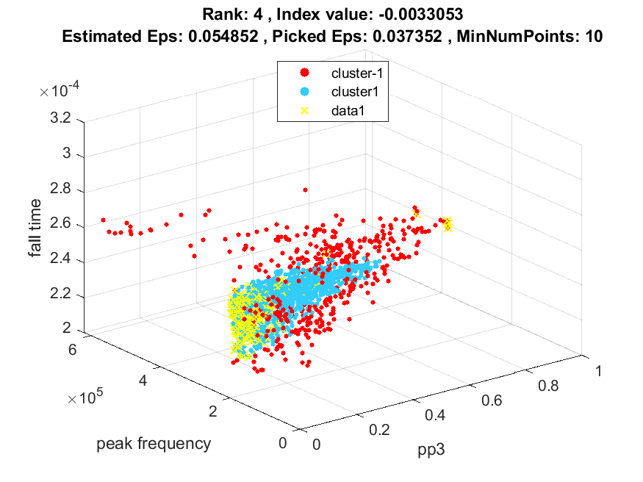
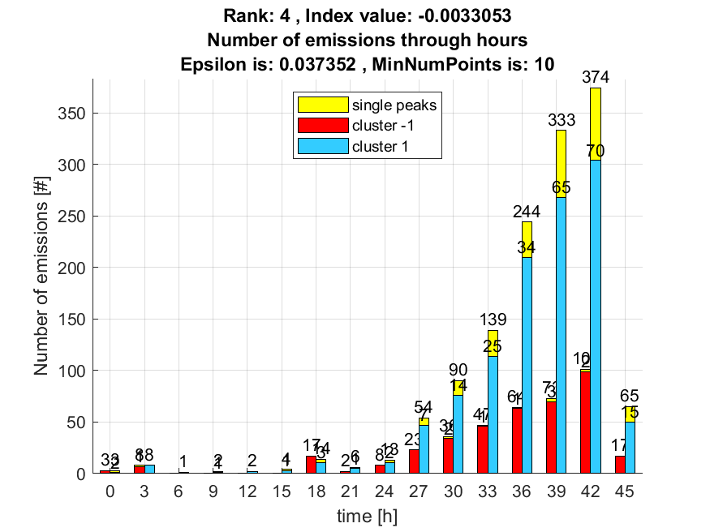

5. result: (pp3, pp4, peak_frequency)
Estimated Epsilon: 0.045704, Picked Epsilon: 0.048204, MinNumPoints: 10
DBCV_single_clust index value: -0.0033897
cluster -1 had 2.7888% single peaks
cluster 1 had 97.2112% single peaks
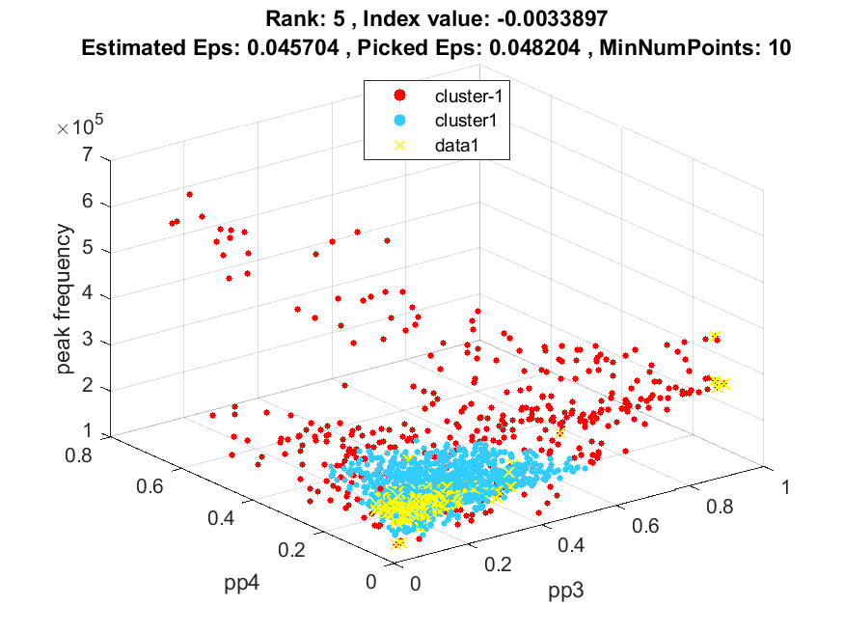
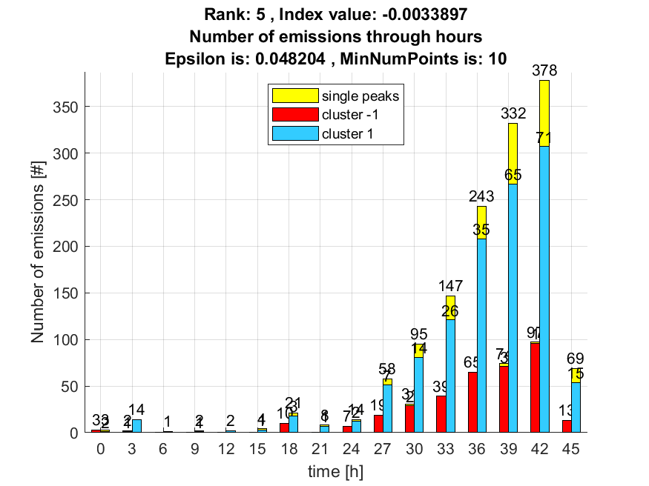

6. result: (rise_time, pp3, peak_frequency)
Estimated Epsilon: 0.056628, Picked Epsilon: 0.041628, MinNumPoints: 10
DBCV_single_clust index value: -0.0035686
cluster -1 had 5.9761% single peaks
cluster 1 had 94.0239% single peaks
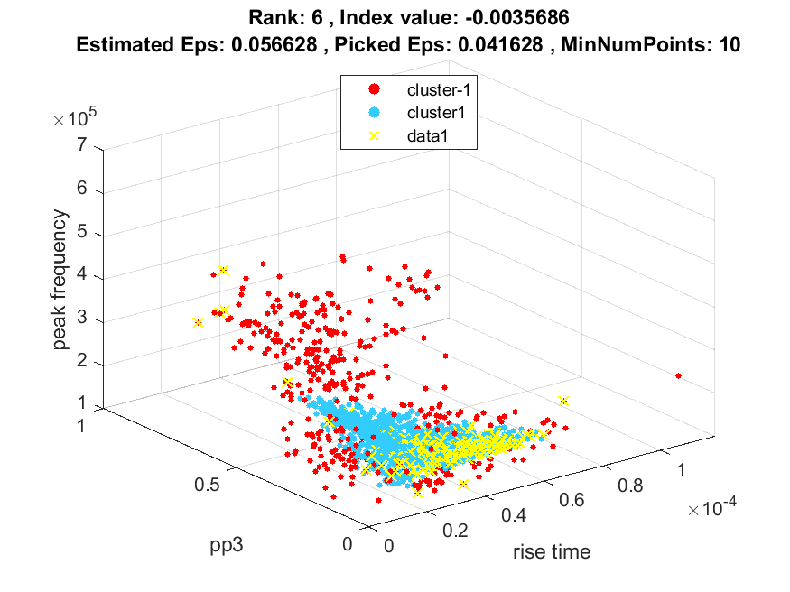
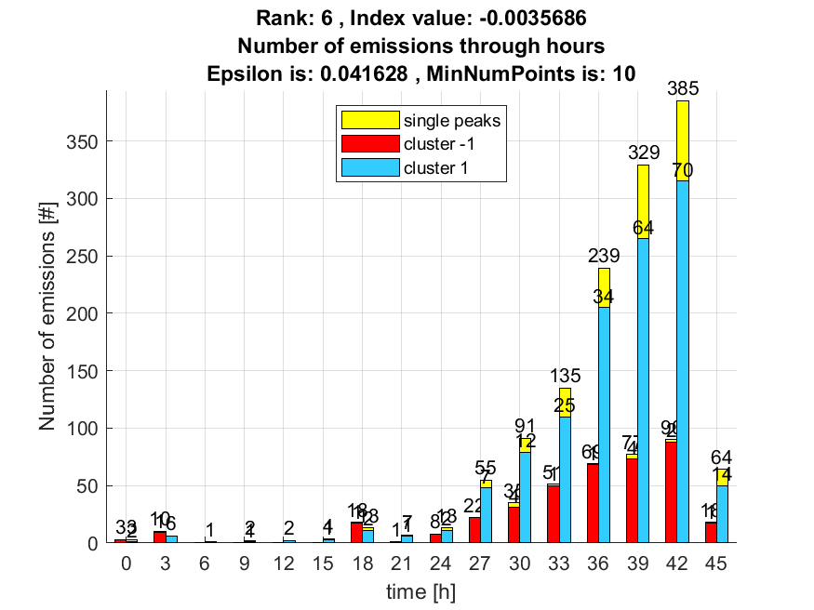

7. result: (pp2, pp4, peak_frequency)
Estimated Epsilon: 0.051265, Picked Epsilon: 0.046265, MinNumPoints: 10
DBCV_single_clust index value: -0.0038624
cluster -1 had 3.5857% single peaks
cluster 1 had 96.4143% single peaks
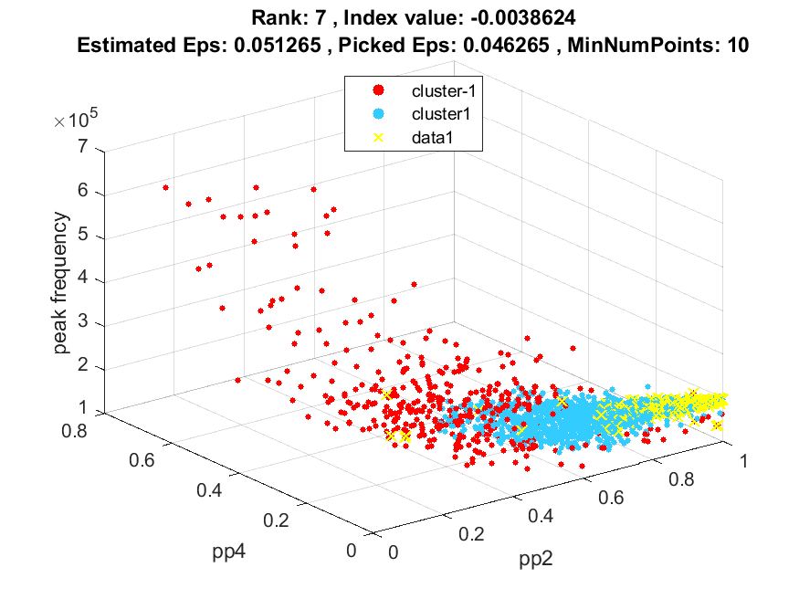
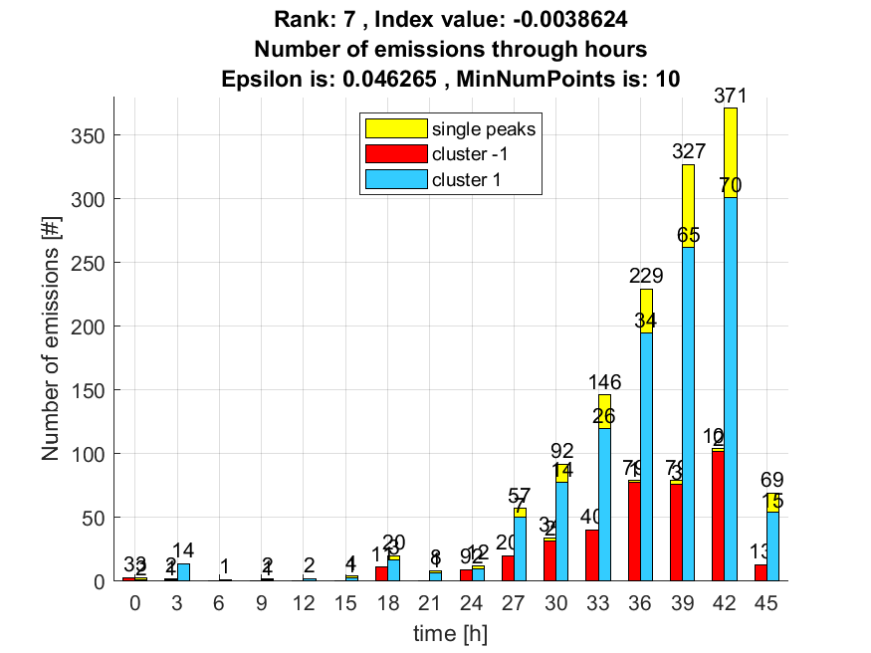

8. result: (pp3, peak_frequency, total_counts)
Estimated Epsilon: 0.057594, Picked Epsilon: 0.042594, MinNumPoints: 10
DBCV_single_clust index value: -0.0038931
cluster -1 had 7.5697% single peaks
cluster 1 had 92.4303% single peaks
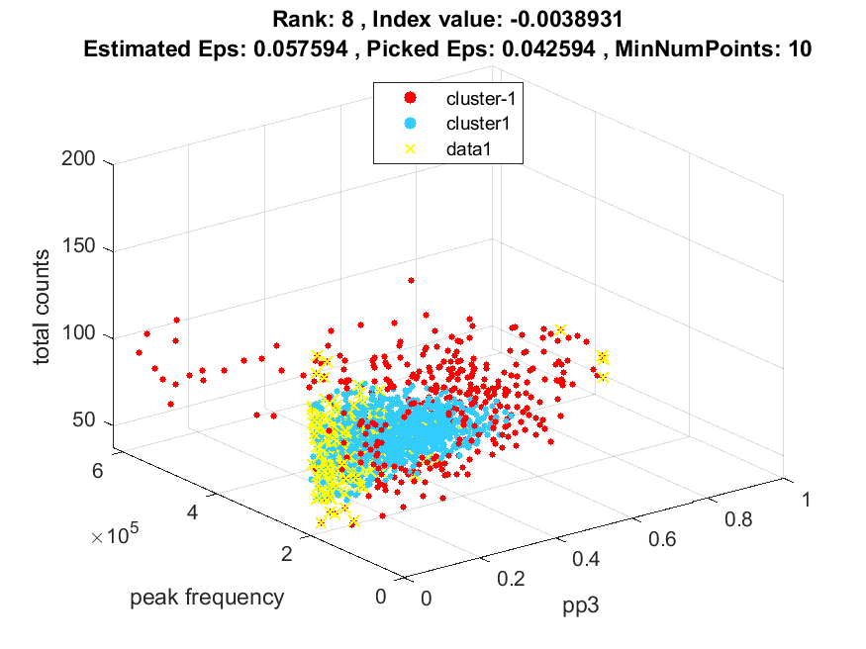
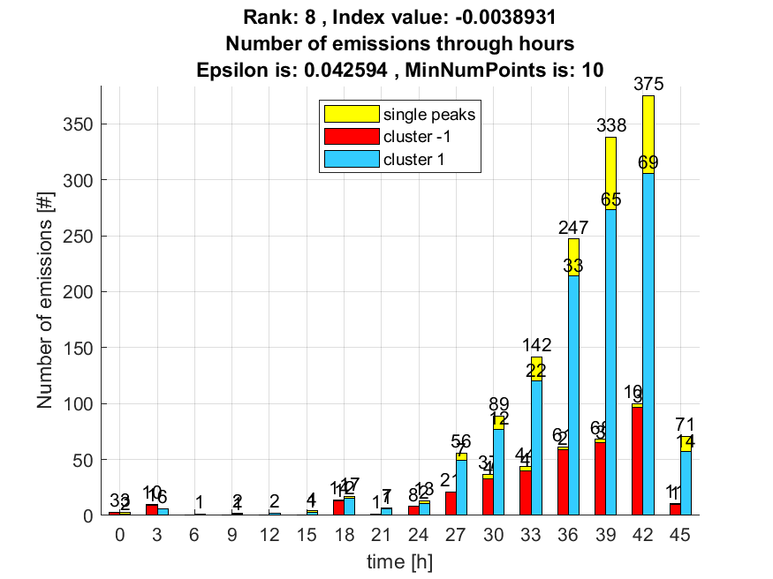

9. result: (pp2, pp3, peak_frequency)
Estimated Epsilon: 0.049537, Picked Epsilon: 0.042037, MinNumPoints: 10
DBCV_single_clust index value: -0.0038944
cluster -1 had 3.5857% single peaks
cluster 1 had 96.4143% single peaks
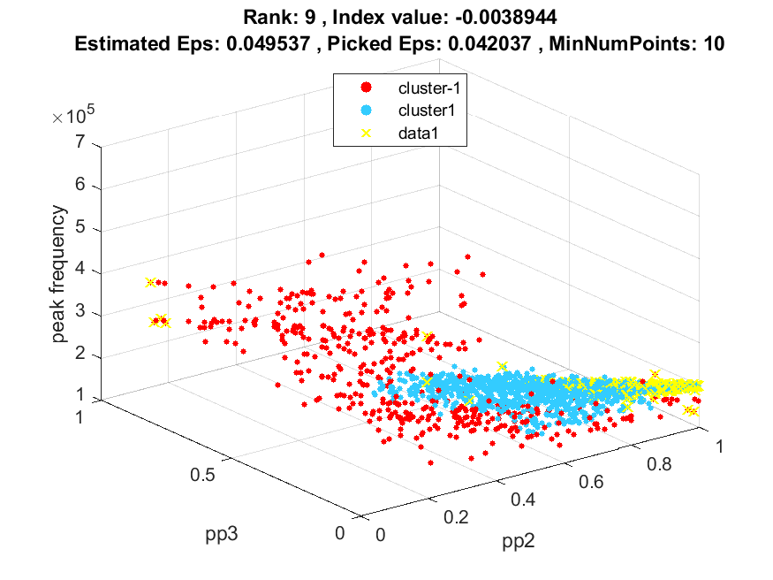
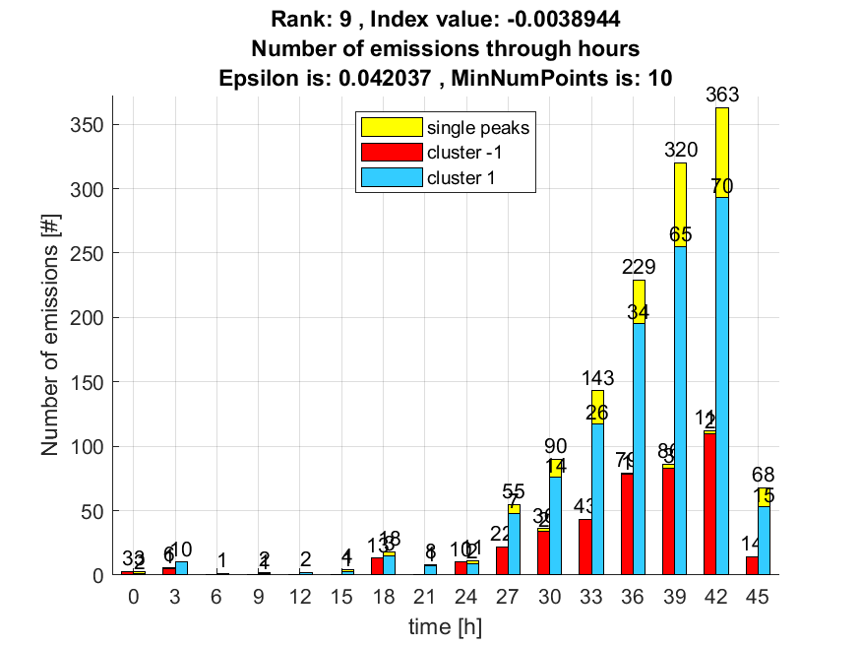

10. result: (pp3, centroid_frequency, peak_frequency)
Estimated Epsilon: 0.057703, Picked Epsilon: 0.050203, MinNumPoints: 10
DBCV_single_clust index value: -0.004235
cluster -1 had 3.1873% single peaks
cluster 1 had 96.8127% single peaks
