Feature selection results for exp_9 and Nmin = 10

1. result: (peak_amplitude, peak_frequency, amp_of_peak_frequency)
Estimated Epsilon: 0.032605, Picked Epsilon: 0.040105, MinNumPoints: 10
DBCV index value: 0.87109
cluster -1 had 7.1895% single peaks
cluster 1 had 92.1569% single peaks
cluster 2 had 0.65359% single peaks
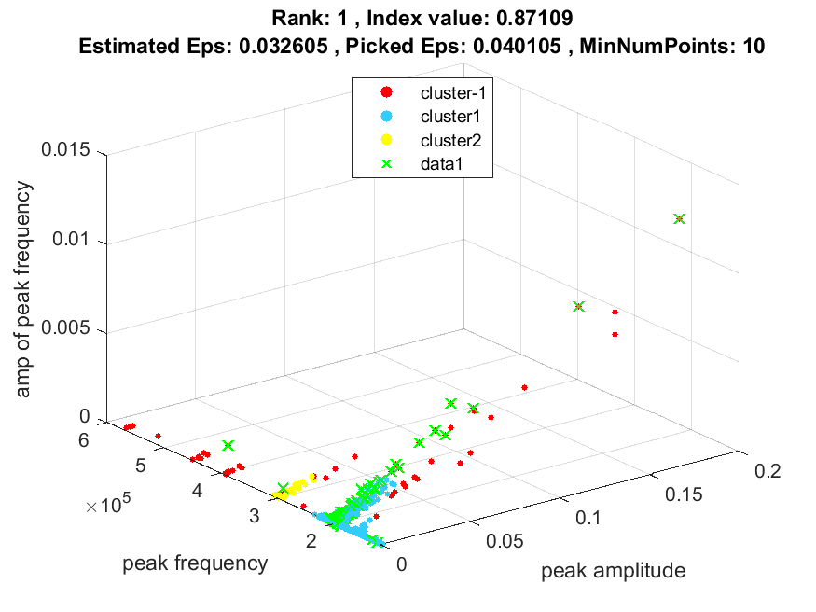
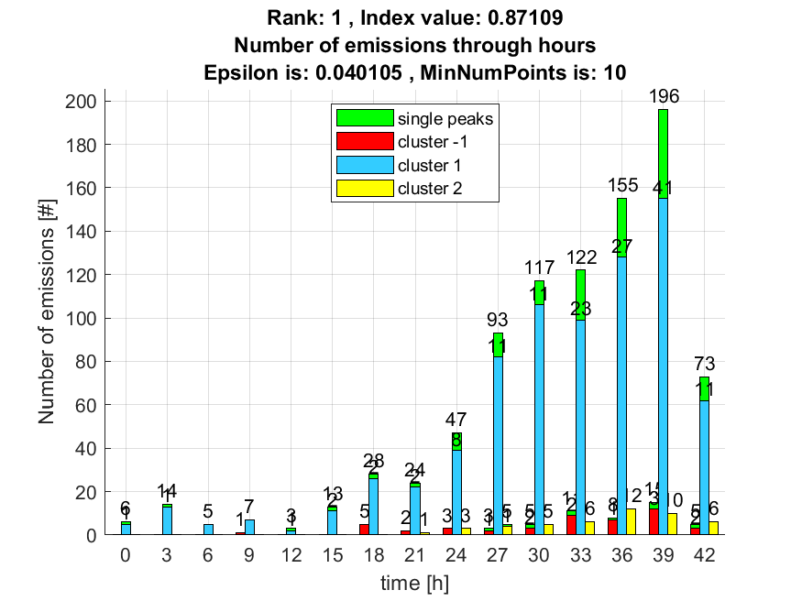

2. result: (peak_frequency, amp_of_peak_frequency, fall_time)
Estimated Epsilon: 0.038683, Picked Epsilon: 0.046183, MinNumPoints: 10
DBCV index value: 0.84803
cluster -1 had 7.8431% single peaks
cluster 1 had 91.5033% single peaks
cluster 2 had 0.65359% single peaks
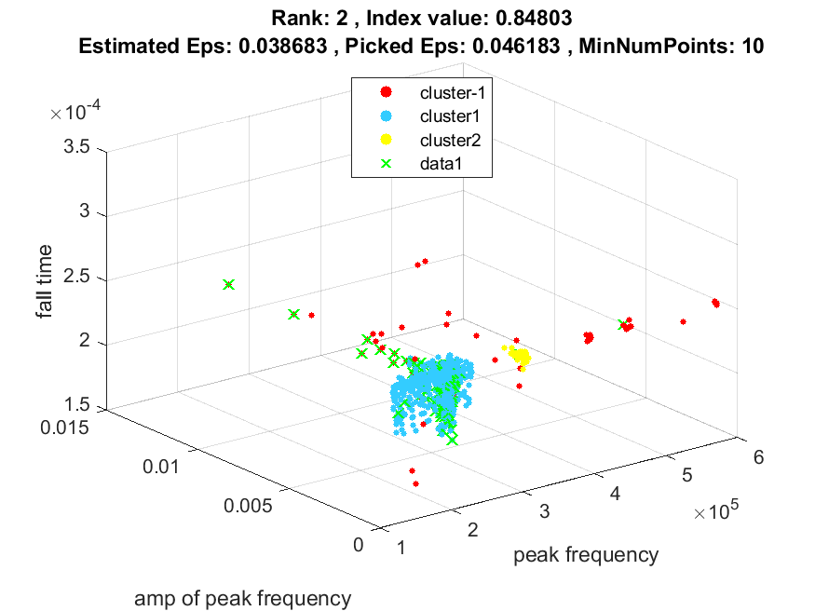
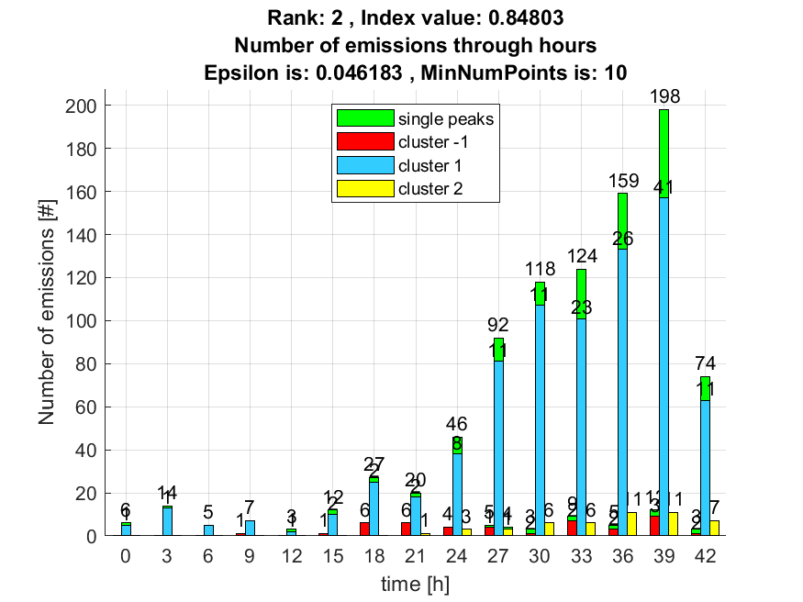

3. result: (rise_time, signal_strength, peak_frequency)
Estimated Epsilon: 0.03687, Picked Epsilon: 0.04687, MinNumPoints: 10
DBCV index value: 0.84296
cluster -1 had 6.5359% single peaks
cluster 1 had 93.4641% single peaks
cluster 2 had 0% single peaks
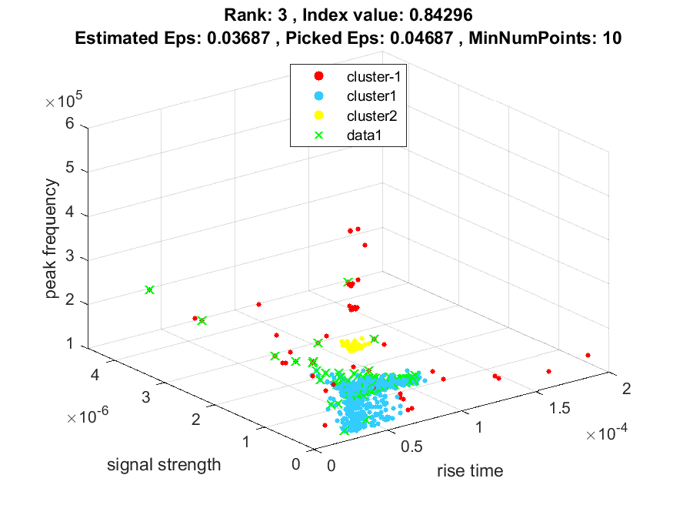
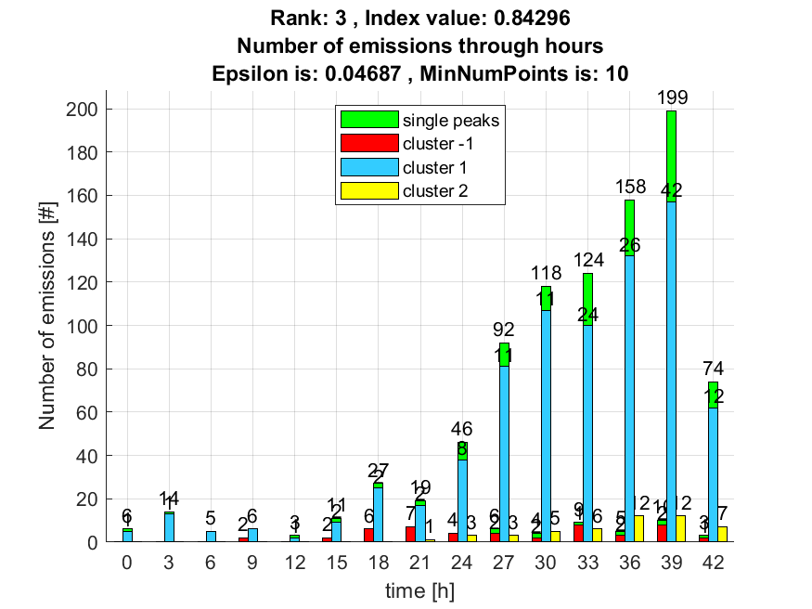

4. result: (signal_strength, peak_frequency, fall_time)
Estimated Epsilon: 0.033724, Picked Epsilon: 0.043724, MinNumPoints: 10
DBCV index value: 0.83918
cluster -1 had 7.1895% single peaks
cluster 1 had 92.1569% single peaks
cluster 2 had 0.65359% single peaks
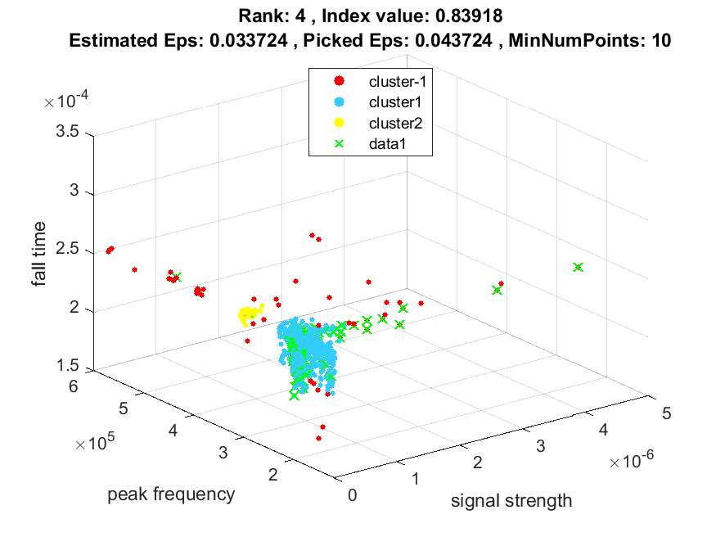
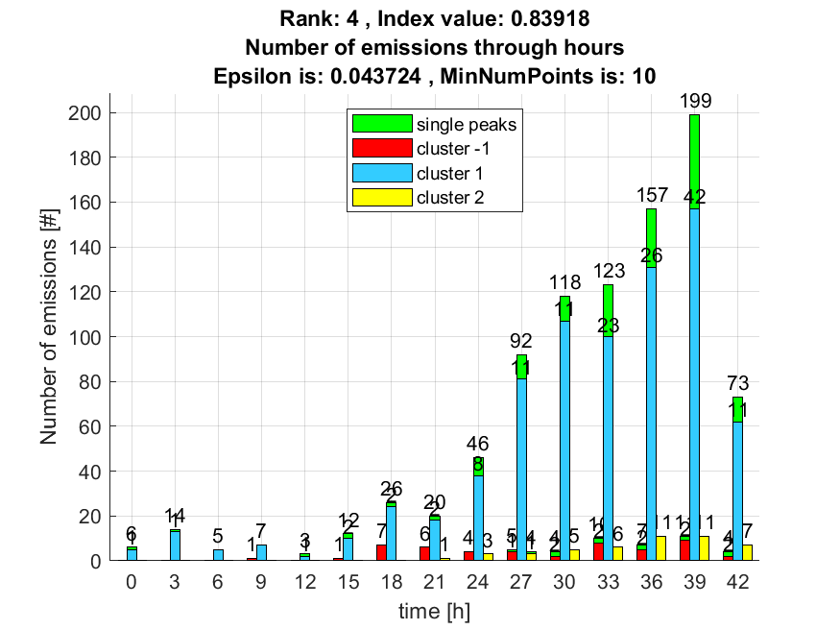

5. result: (rise_time, peak_frequency, amp_of_peak_frequency)
Estimated Epsilon: 0.033702, Picked Epsilon: 0.043702, MinNumPoints: 10
DBCV index value: 0.83475
cluster -1 had 9.1503% single peaks
cluster 1 had 90.8497% single peaks
cluster 2 had 0% single peaks
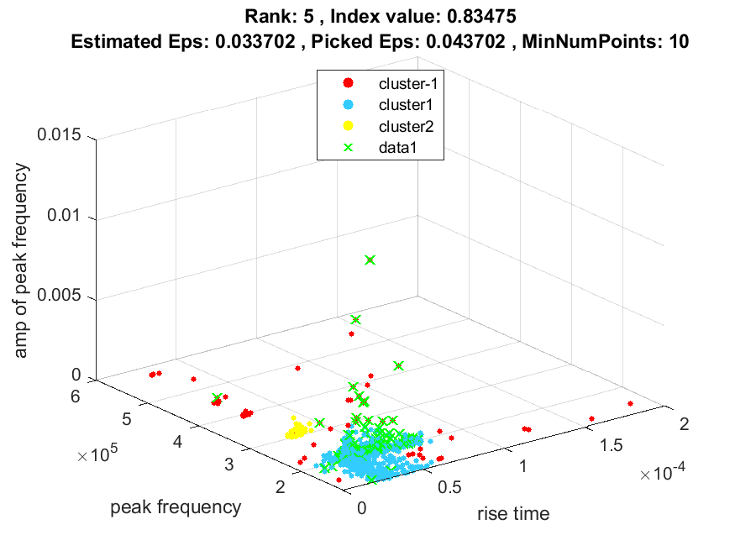
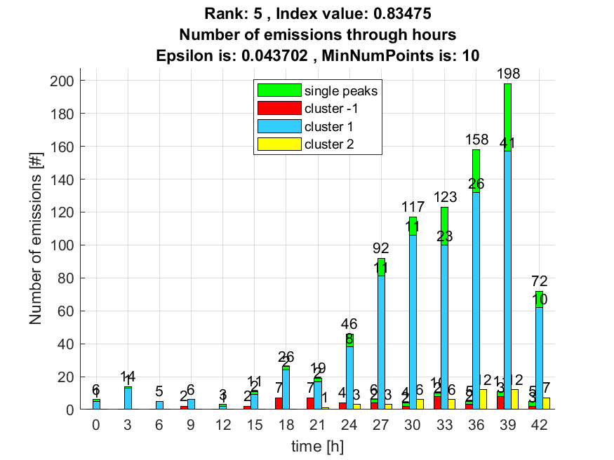

6. result: (pp1, peak_frequency, amp_of_peak_frequency)
Estimated Epsilon: 0.038873, Picked Epsilon: 0.048873, MinNumPoints: 10
DBCV index value: 0.82623
cluster -1 had 5.2288% single peaks
cluster 1 had 94.1176% single peaks
cluster 2 had 0.65359% single peaks
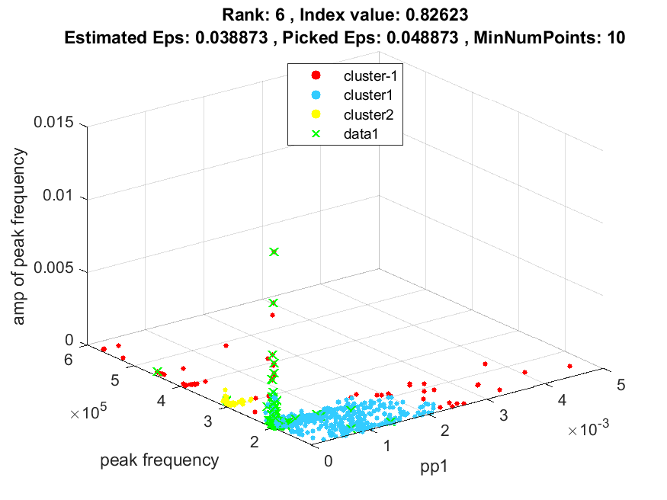
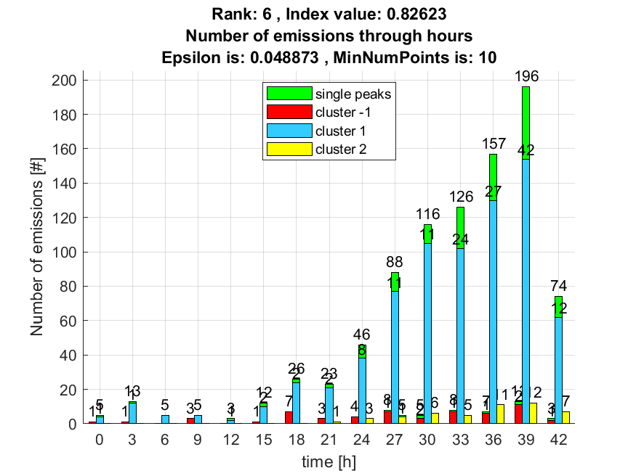

7. result: (signal_strength, pp1, peak_frequency)
Estimated Epsilon: 0.038378, Picked Epsilon: 0.048378, MinNumPoints: 10
DBCV index value: 0.82361
cluster -1 had 5.2288% single peaks
cluster 1 had 94.1176% single peaks
cluster 2 had 0.65359% single peaks
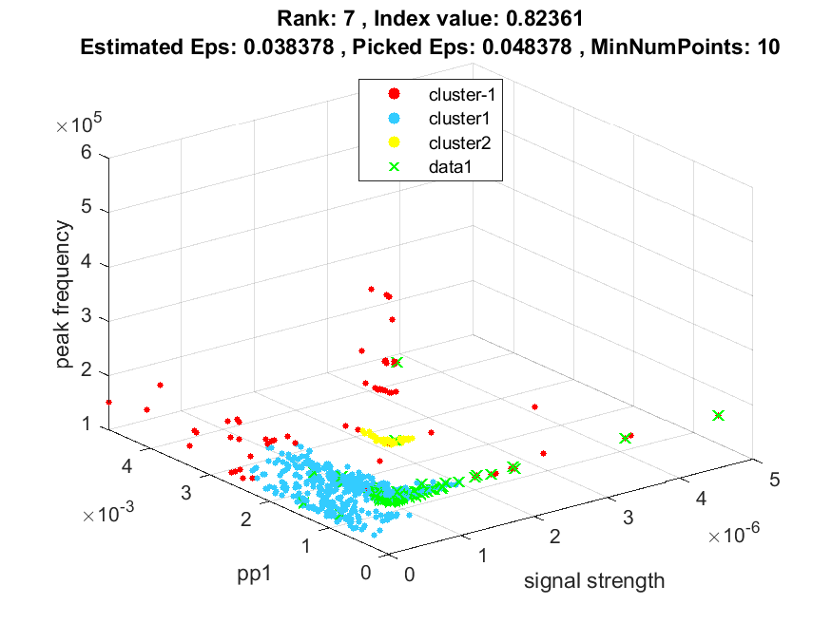
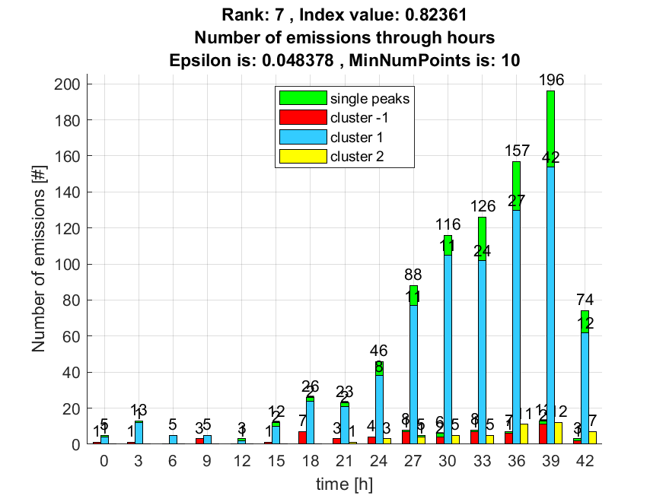

8. result: (rise_time, peak_frequency, total_counts)
Estimated Epsilon: 0.05203, Picked Epsilon: 0.05953, MinNumPoints: 10
DBCV index value: 0.82221
cluster -1 had 3.268% single peaks
cluster 1 had 96.732% single peaks
cluster 2 had 0% single peaks
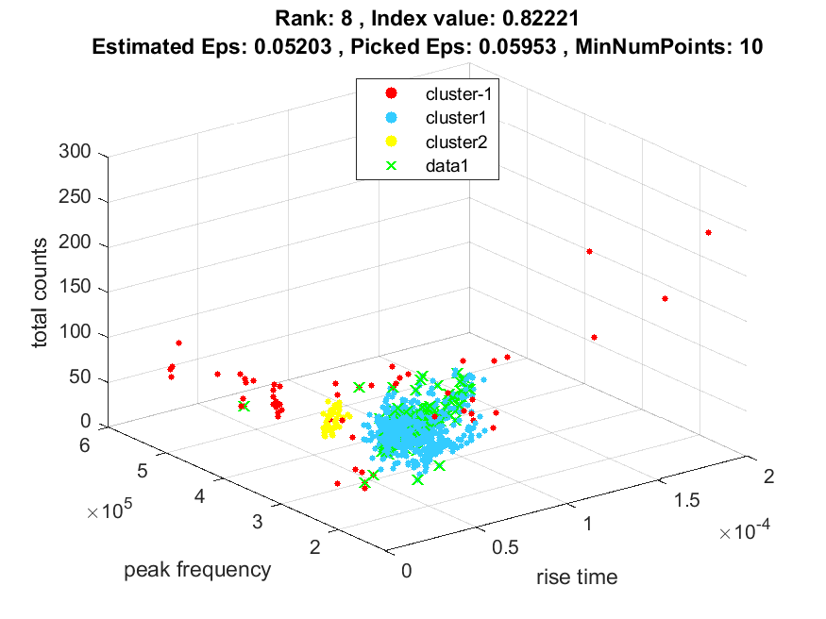
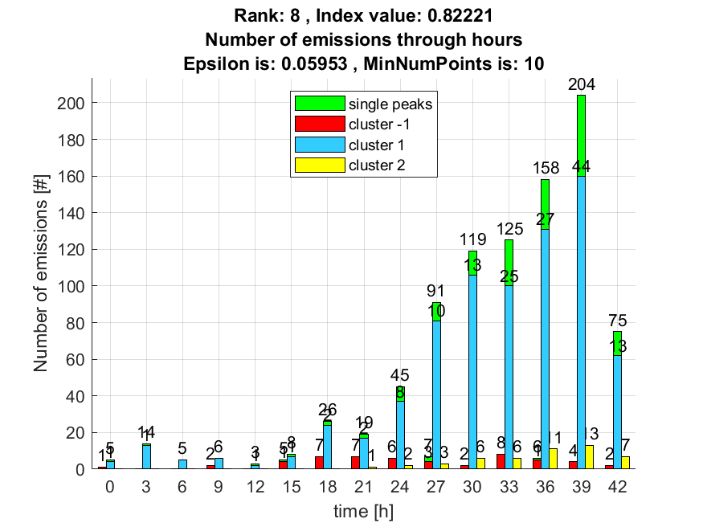

9. result: (peak_amplitude, pp1, peak_frequency)
Estimated Epsilon: 0.039304, Picked Epsilon: 0.049304, MinNumPoints: 10
DBCV index value: 0.81703
cluster -1 had 4.5752% single peaks
cluster 1 had 94.7712% single peaks
cluster 2 had 0.65359% single peaks
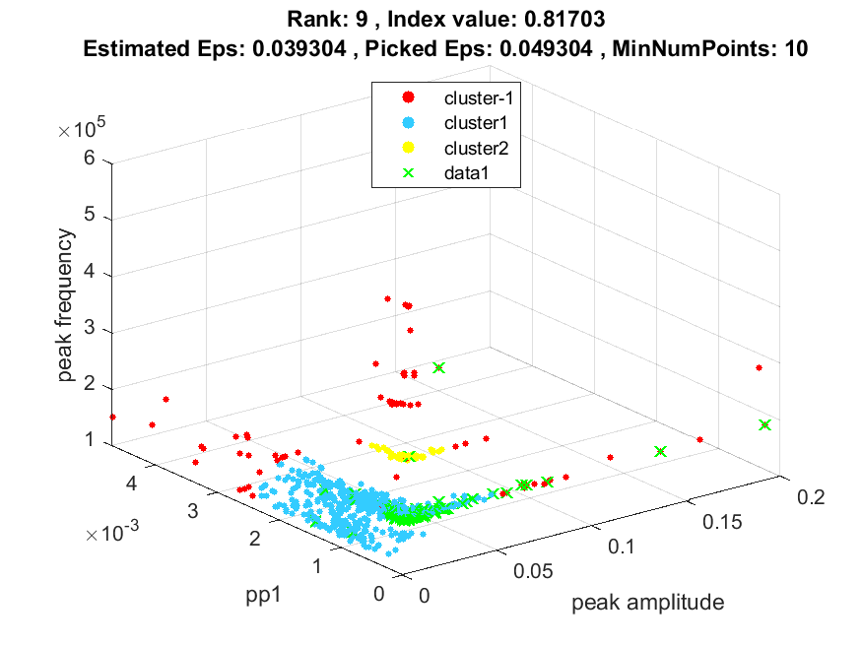
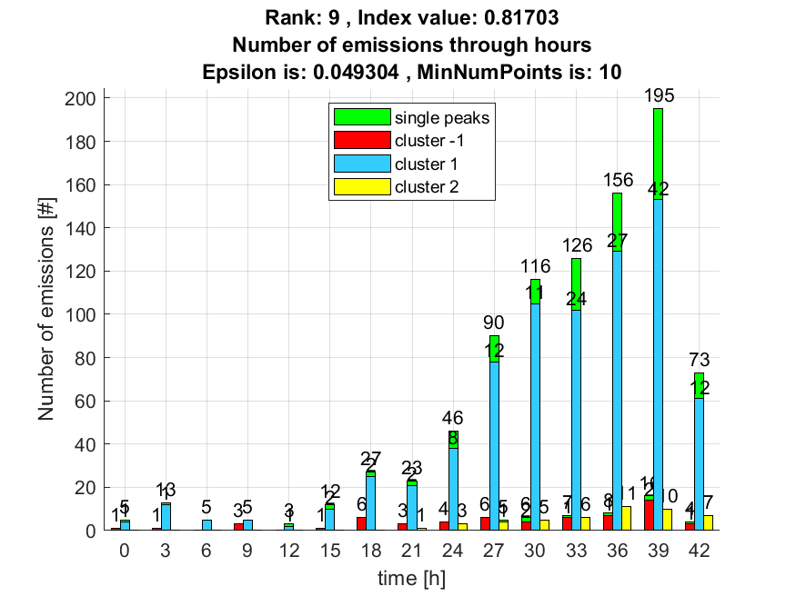

10. result: (counts_from, peak_frequency, amp_of_peak_frequency)
Estimated Epsilon: 0.049441, Picked Epsilon: 0.059441, MinNumPoints: 10
DBCV index value: 0.81656
cluster -1 had 8.4967% single peaks
cluster 1 had 90.8497% single peaks
cluster 2 had 0.65359% single peaks
