Feature selection results for exp_9 and Nmin = 10

1. result: (rise_time, peak_frequency, amp_of_peak_frequency)
Estimated Epsilon: 0.033702, Picked Epsilon: 0.041202, MinNumPoints: 10
DBCV_single_clust index value: 0.82953
cluster -1 had 9.1503% single peaks
cluster 1 had 90.8497% single peaks
cluster 2 had 0% single peaks
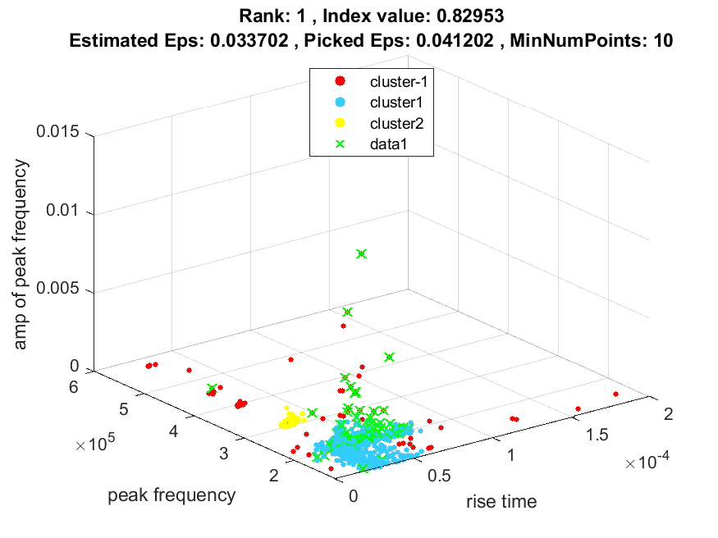
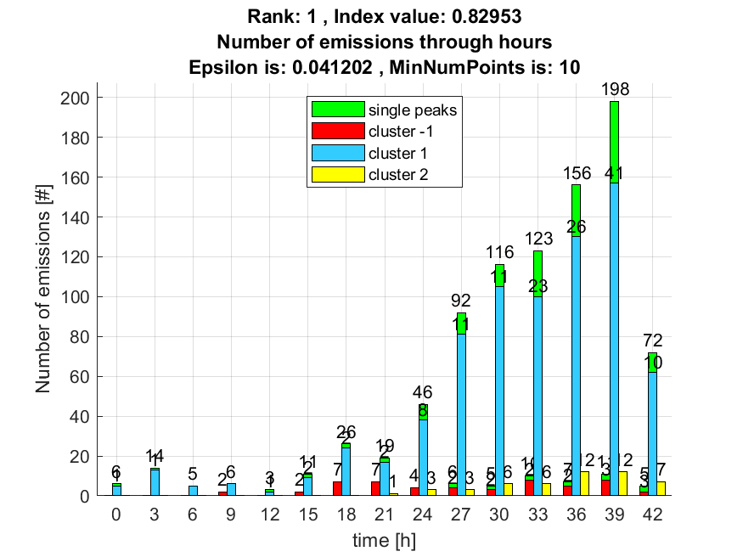

2. result: (rise_time, peak_frequency, total_counts)
Estimated Epsilon: 0.05203, Picked Epsilon: 0.05953, MinNumPoints: 10
DBCV_single_clust index value: 0.82221
cluster -1 had 3.268% single peaks
cluster 1 had 96.732% single peaks
cluster 2 had 0% single peaks
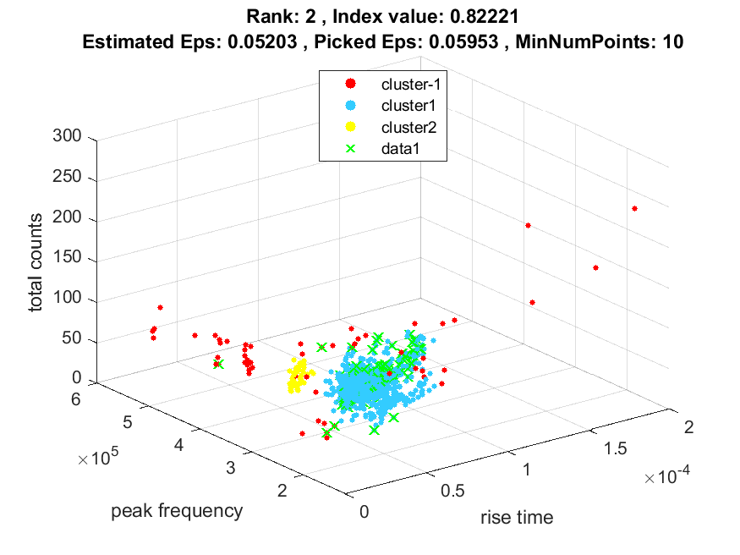
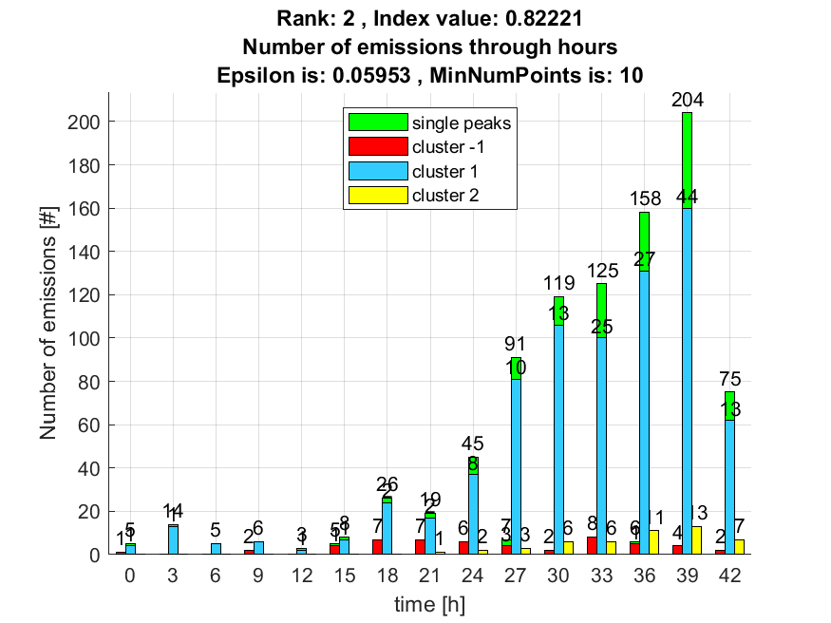

3. result: (rise_time, signal_strength, peak_frequency)
Estimated Epsilon: 0.03687, Picked Epsilon: 0.03937, MinNumPoints: 10
DBCV_single_clust index value: 0.81658
cluster -1 had 11.1111% single peaks
cluster 1 had 88.8889% single peaks
cluster 2 had 0% single peaks
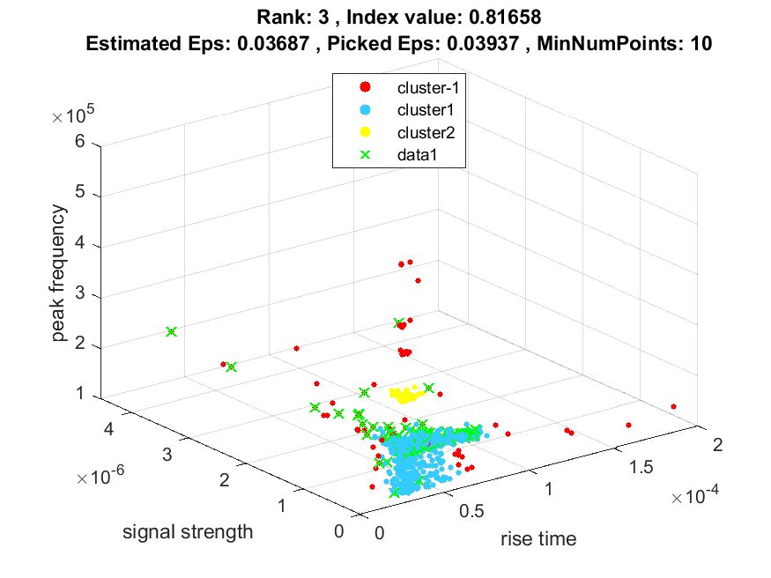
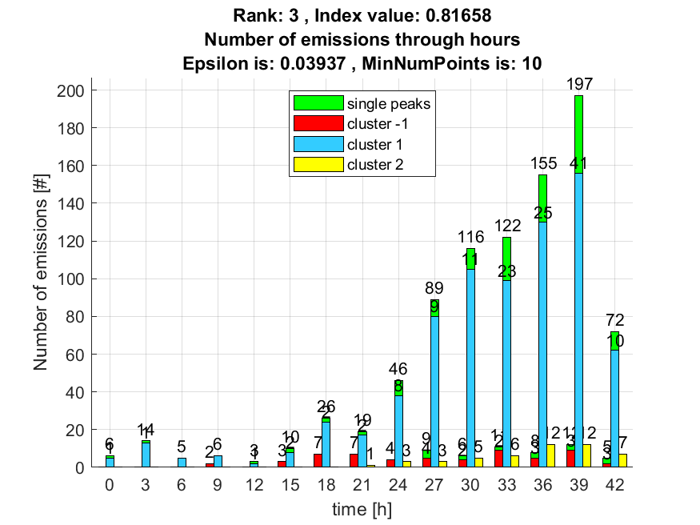

4. result: (rise_time, pp1, peak_frequency)
Estimated Epsilon: 0.057676, Picked Epsilon: 0.067676, MinNumPoints: 10
DBCV_single_clust index value: 0.80697
cluster -1 had 1.3072% single peaks
cluster 1 had 98.0392% single peaks
cluster 2 had 0.65359% single peaks
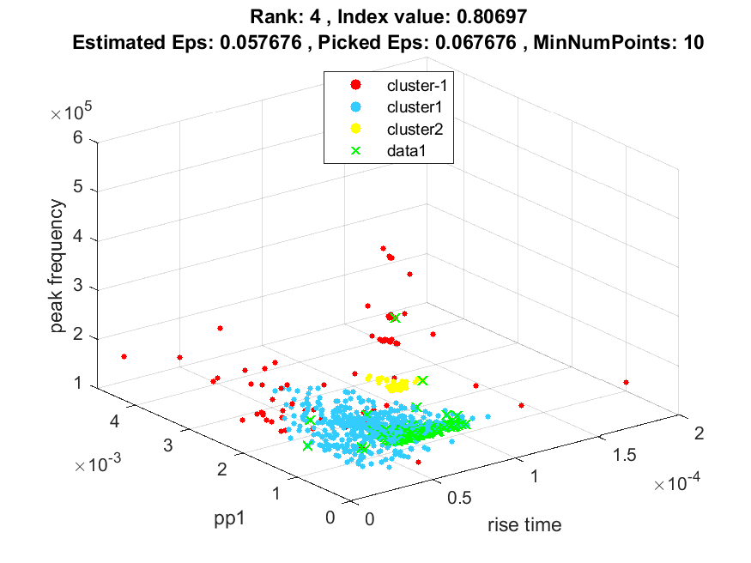
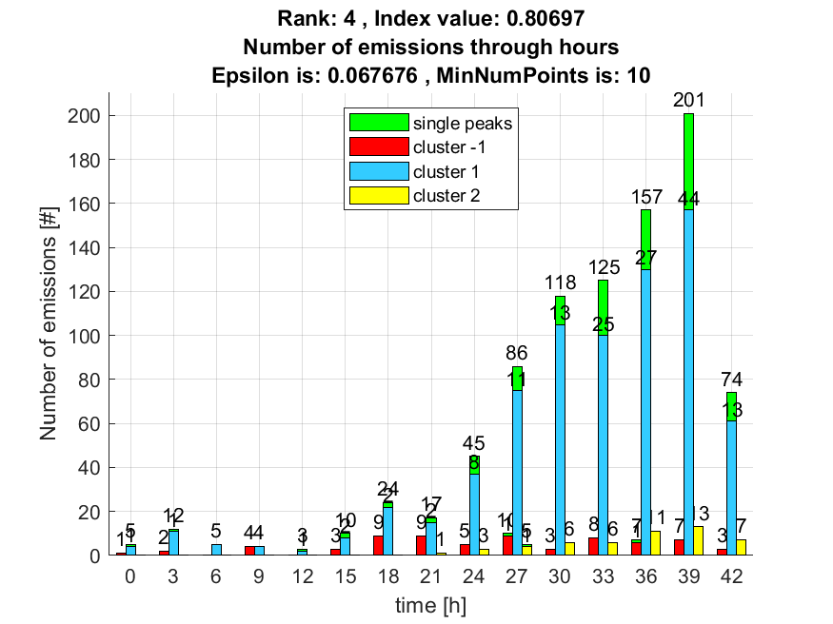

5. result: (pp3, peak_frequency, fall_time)
Estimated Epsilon: 0.056298, Picked Epsilon: 0.061298, MinNumPoints: 10
DBCV_single_clust index value: 0.80694
cluster -1 had 1.3072% single peaks
cluster 1 had 98.6928% single peaks
cluster 2 had 0% single peaks
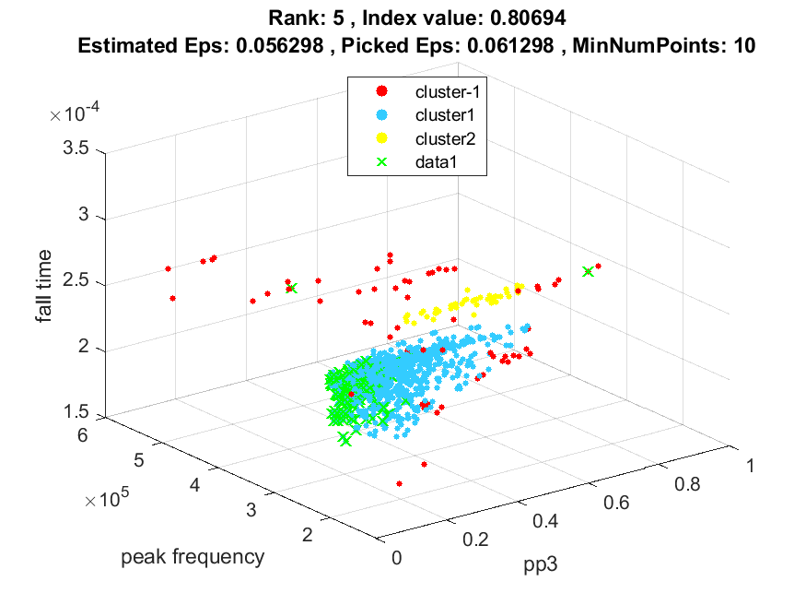
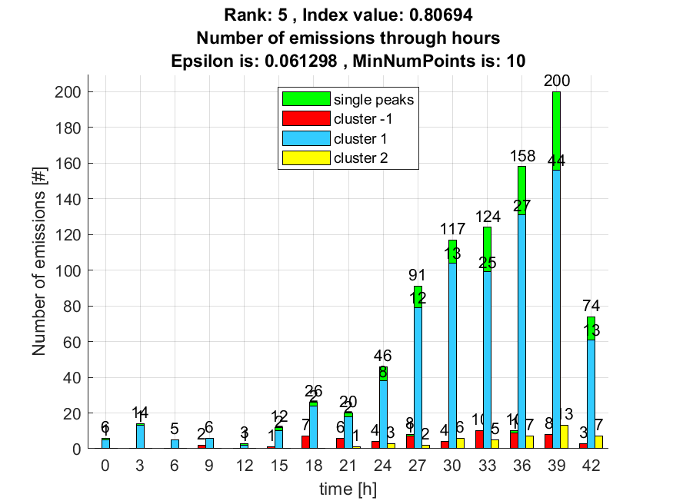

6. result: (counts_from, signal_strength, peak_frequency)
Estimated Epsilon: 0.047037, Picked Epsilon: 0.052037, MinNumPoints: 10
DBCV_single_clust index value: 0.80435
cluster -1 had 7.8431% single peaks
cluster 1 had 91.5033% single peaks
cluster 2 had 0.65359% single peaks
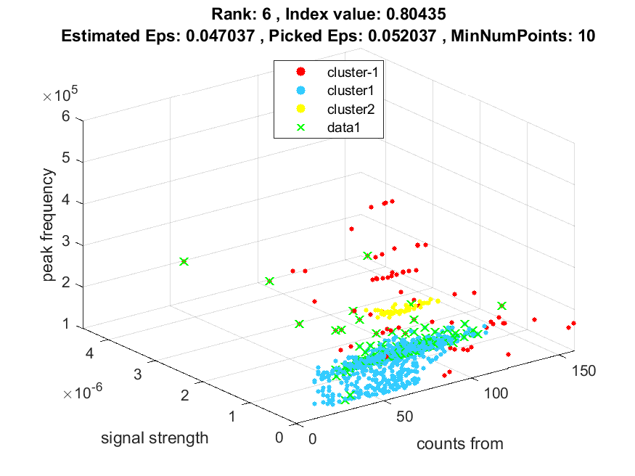
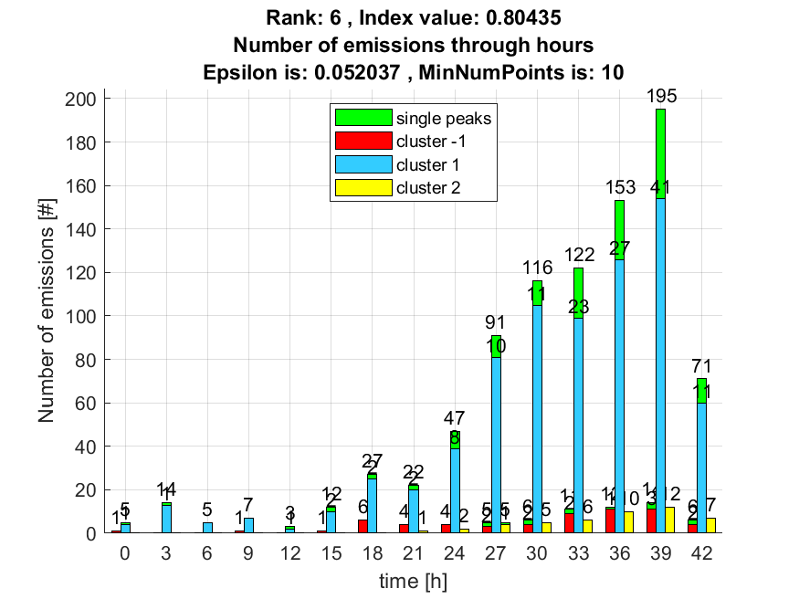

7. result: (centroid_frequency, peak_frequency, amp_of_peak_frequency)
Estimated Epsilon: 0.048376, Picked Epsilon: 0.053376, MinNumPoints: 10
DBCV_single_clust index value: 0.79642
cluster -1 had 9.1503% single peaks
cluster 1 had 90.1961% single peaks
cluster 2 had 0.65359% single peaks
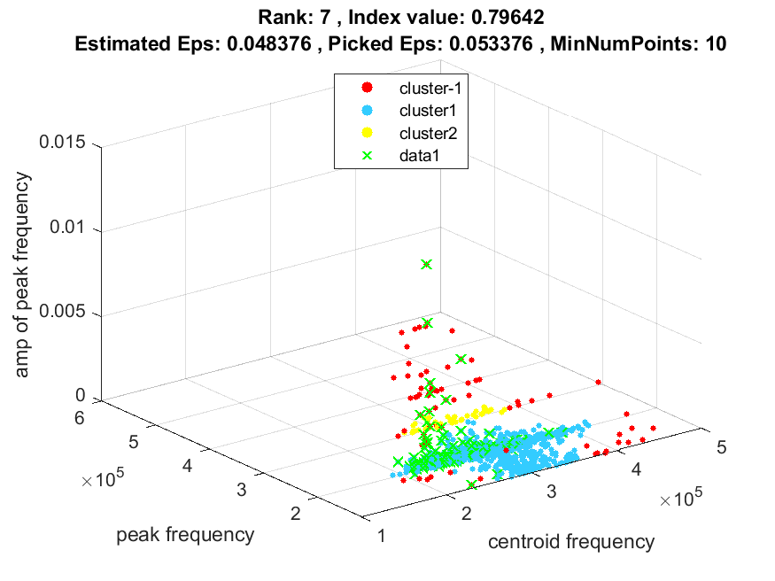
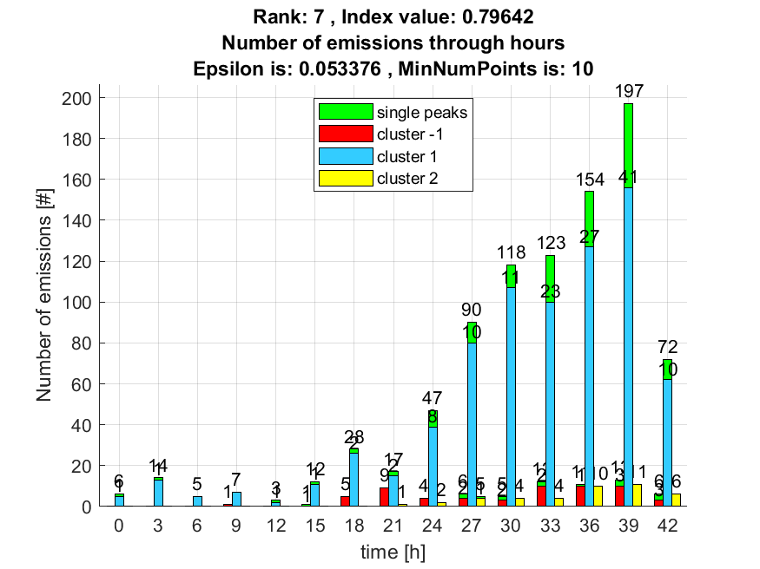

8. result: (rise_time, centroid_frequency, peak_frequency)
Estimated Epsilon: 0.058962, Picked Epsilon: 0.066462, MinNumPoints: 10
DBCV_single_clust index value: 0.79063
cluster -1 had 1.9608% single peaks
cluster 1 had 97.3856% single peaks
cluster 2 had 0.65359% single peaks
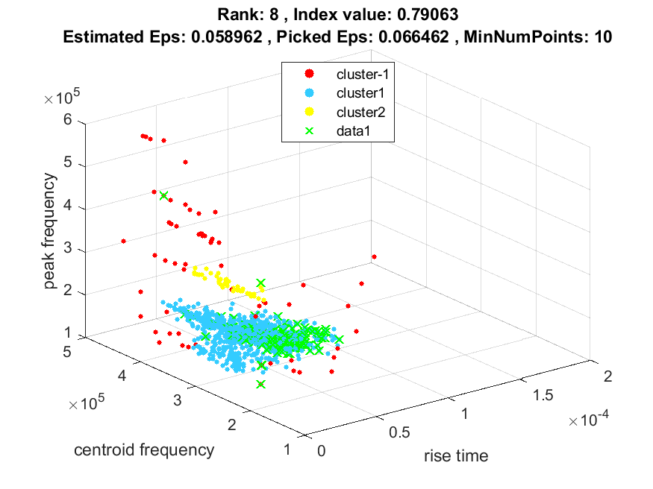
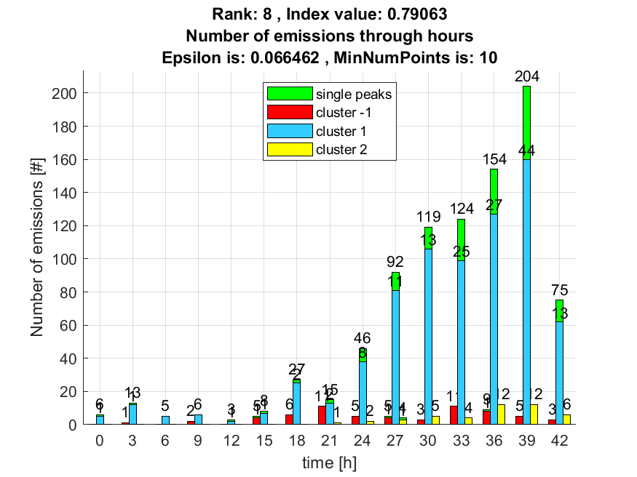

9. result: (rise_time, pp4, peak_frequency)
Estimated Epsilon: 0.058217, Picked Epsilon: 0.058217, MinNumPoints: 10
DBCV_single_clust index value: 0.78693
cluster -1 had 0.65359% single peaks
cluster 1 had 98.6928% single peaks
cluster 2 had 0.65359% single peaks
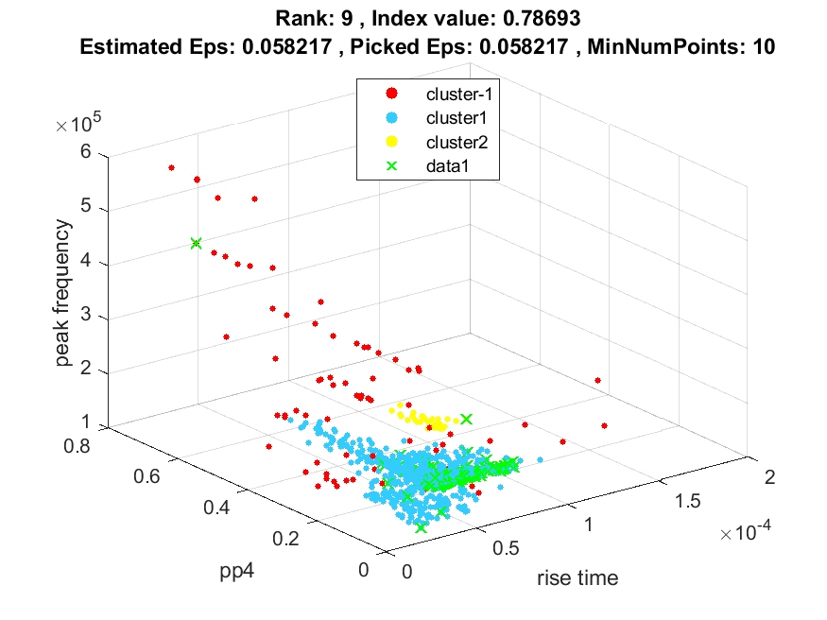
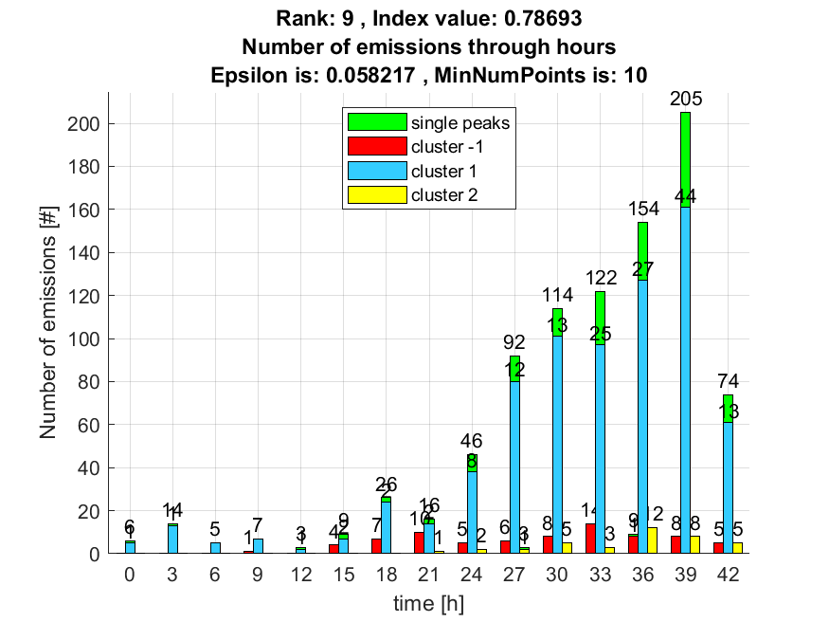

10. result: (counts_from, peak_frequency, total_counts)
Estimated Epsilon: 0.068279, Picked Epsilon: 0.065779, MinNumPoints: 10
DBCV_single_clust index value: 0.78095
cluster -1 had 6.5359% single peaks
cluster 1 had 93.4641% single peaks
cluster 2 had 0% single peaks
