Feature selection results for small_dataset and Nmin = 15

1. result: (pp2, peak_frequency, max_frequency)
Estimated Epsilon: 0.07611, Picked Epsilon: 0.08611, MinNumPoints: 15
DBCV index value: 0.91129
cluster -1 had 6.7797% single peaks
cluster 1 had 91.5254% single peaks
cluster 2 had 1.6949% single peaks
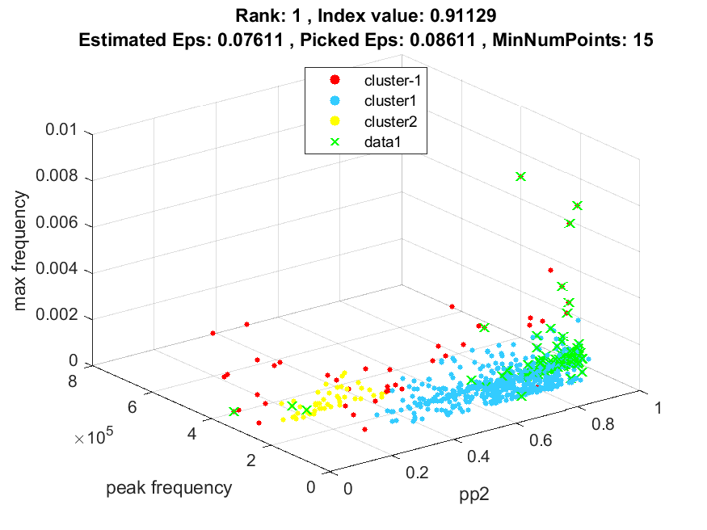
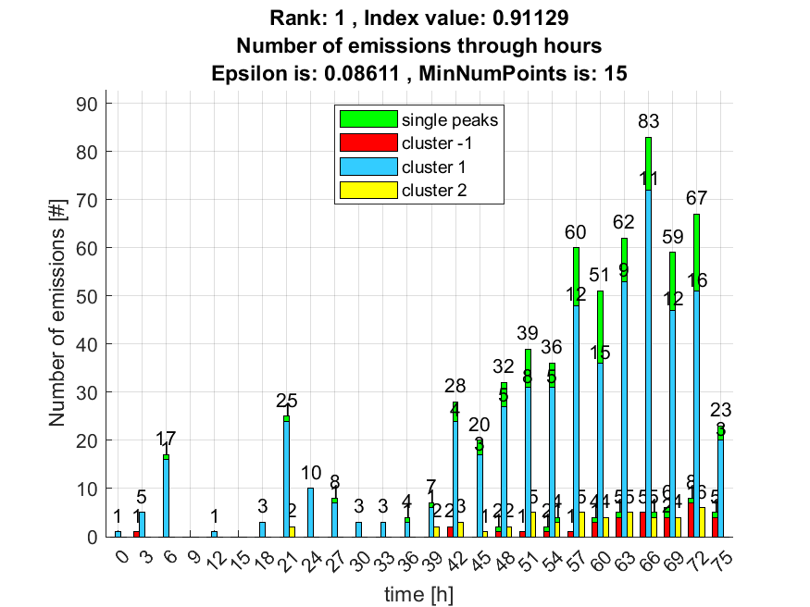

2. result: (pp2, peak_frequency, fall_time)
Estimated Epsilon: 0.065805, Picked Epsilon: 0.075805, MinNumPoints: 15
DBCV index value: 0.91115
cluster -1 had 0.84746% single peaks
cluster 1 had 97.4576% single peaks
cluster 2 had 1.6949% single peaks
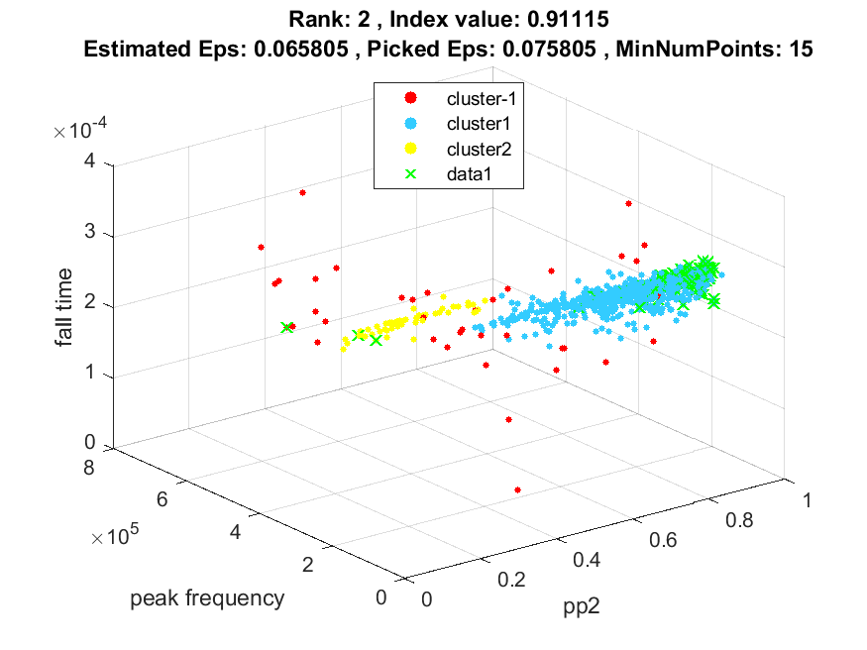
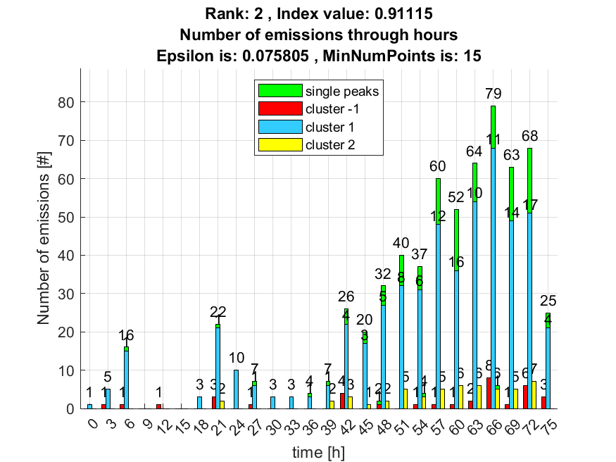

3. result: (pp3, peak_frequency, fall_time)
Estimated Epsilon: 0.061993, Picked Epsilon: 0.071993, MinNumPoints: 15
DBCV index value: 0.90686
cluster -1 had 0.84746% single peaks
cluster 1 had 97.4576% single peaks
cluster 2 had 1.6949% single peaks
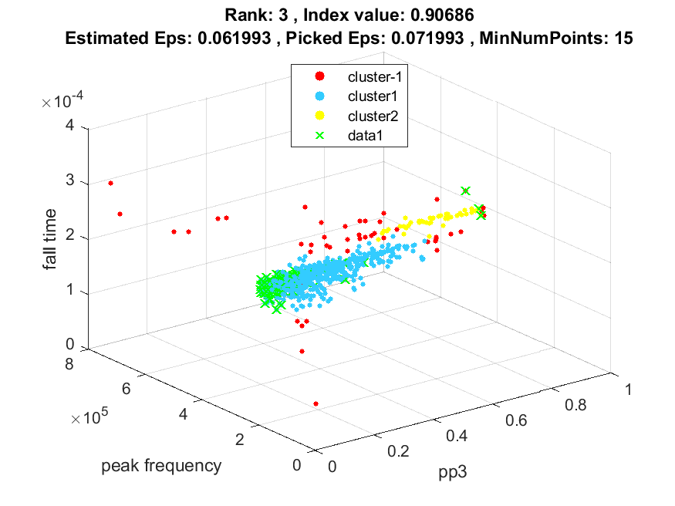
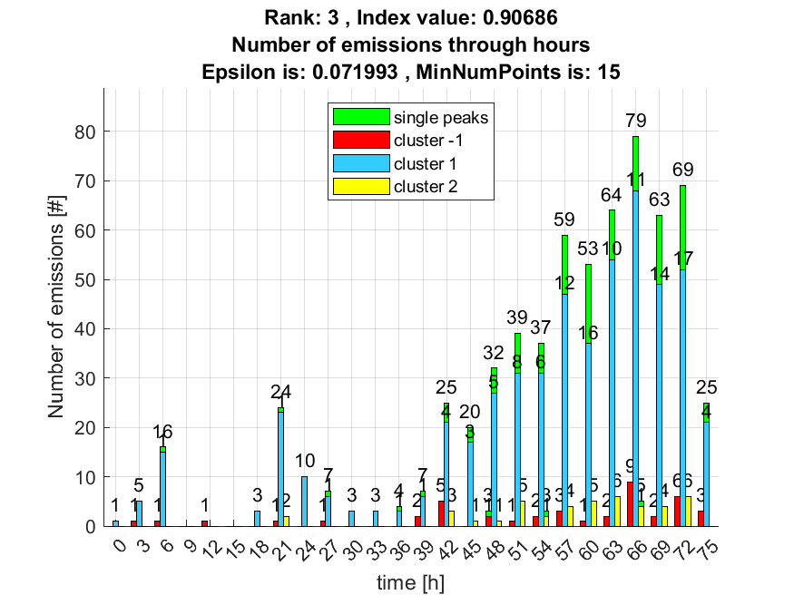

4. result: (signal_strength, peak_frequency, max_frequency)
Estimated Epsilon: 0.039093, Picked Epsilon: 0.039093, MinNumPoints: 15
DBCV index value: 0.90566
cluster -1 had 9.322% single peaks
cluster 1 had 89.8305% single peaks
cluster 2 had 0.84746% single peaks
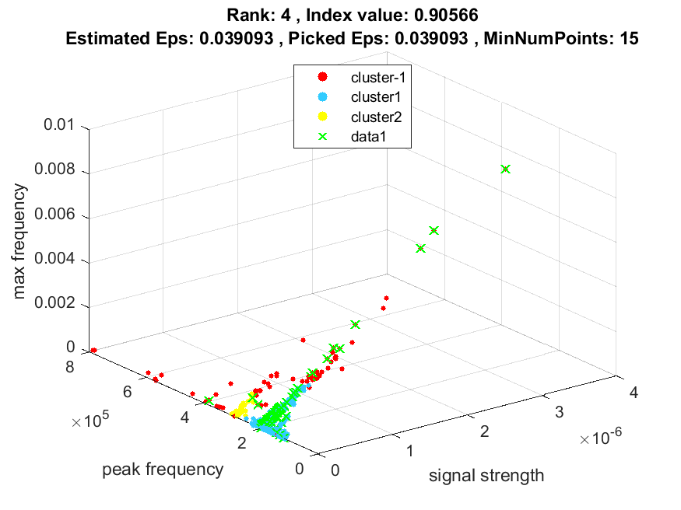
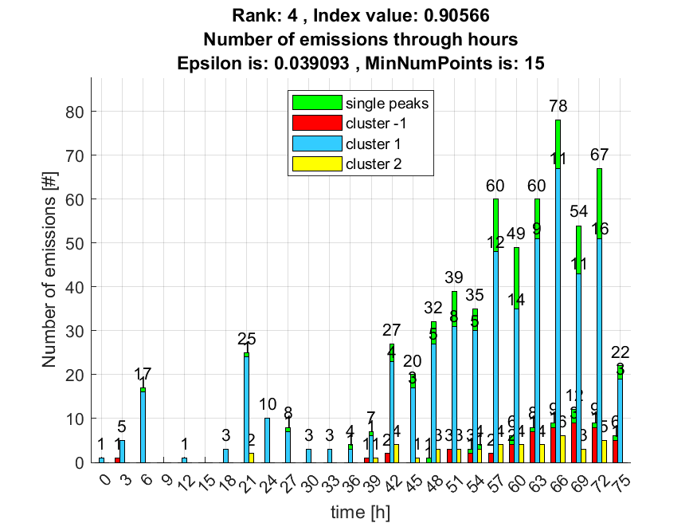

5. result: (peak_amplitude, peak_frequency, max_frequency)
Estimated Epsilon: 0.050078, Picked Epsilon: 0.040078, MinNumPoints: 15
DBCV index value: 0.90078
cluster -1 had 8.4746% single peaks
cluster 1 had 89.8305% single peaks
cluster 2 had 1.6949% single peaks
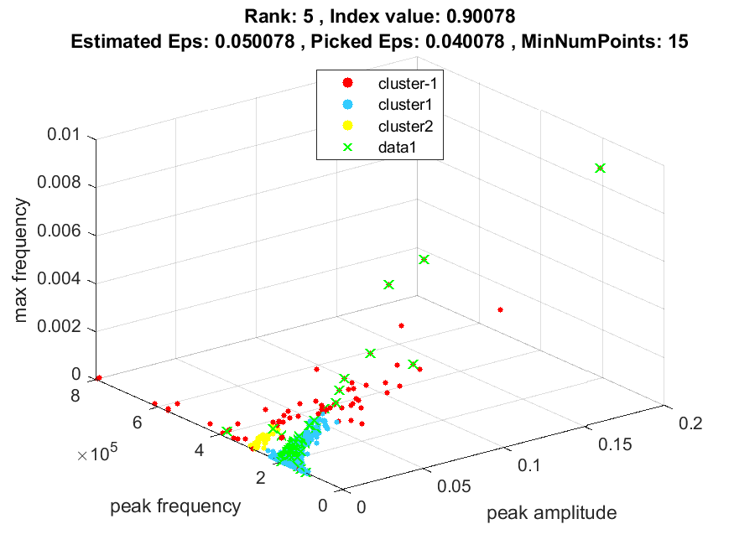
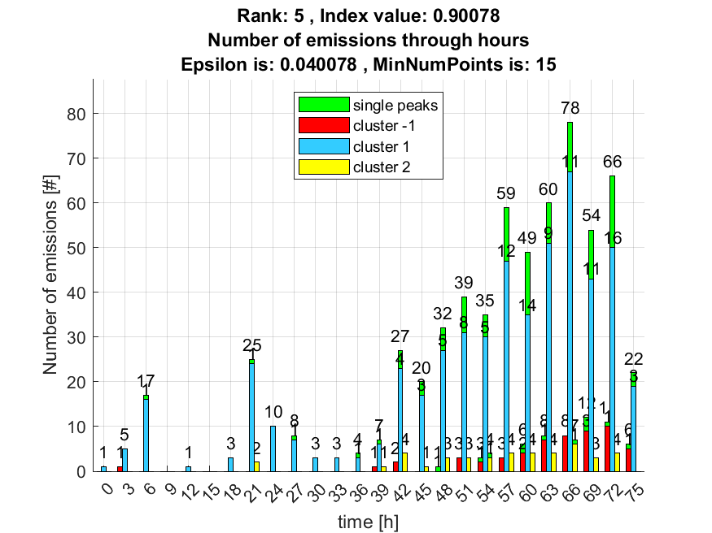

6. result: (rise_time, pp2, peak_frequency)
Estimated Epsilon: 0.078874, Picked Epsilon: 0.068874, MinNumPoints: 15
DBCV index value: 0.89701
cluster -1 had 0.84746% single peaks
cluster 1 had 97.4576% single peaks
cluster 2 had 1.6949% single peaks
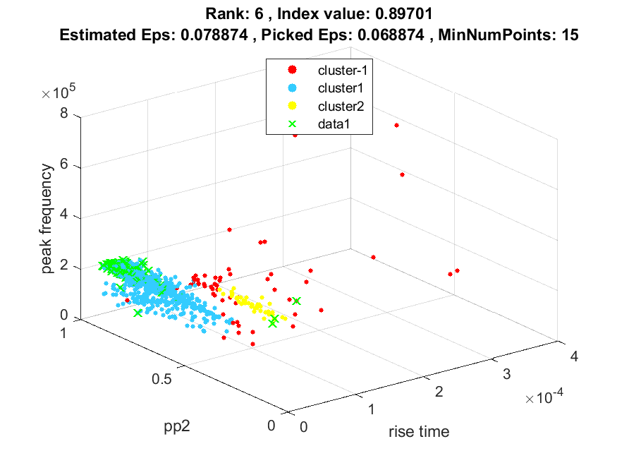
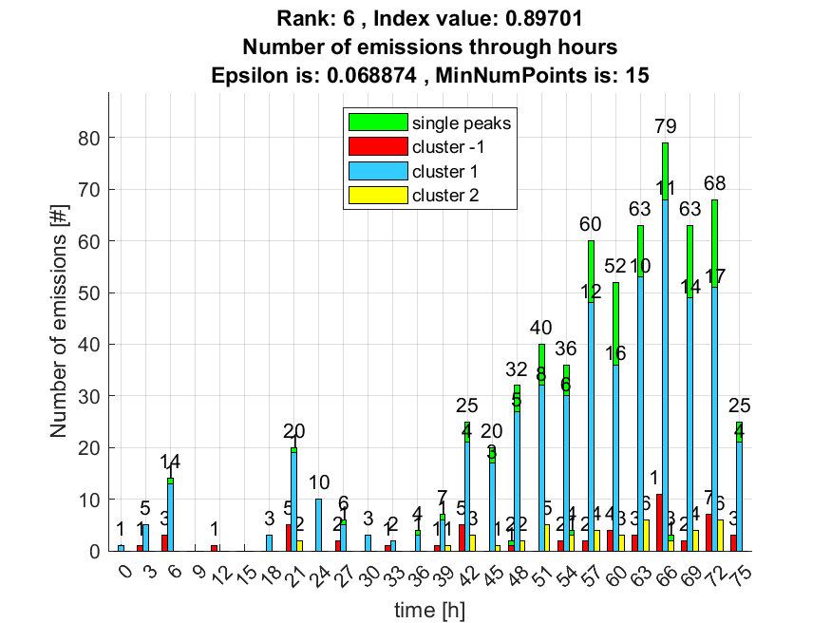

7. result: (pp2, peak_frequency, total_counts)
Estimated Epsilon: 0.085188, Picked Epsilon: 0.085188, MinNumPoints: 15
DBCV index value: 0.89651
cluster -1 had 0.84746% single peaks
cluster 1 had 97.4576% single peaks
cluster 2 had 1.6949% single peaks
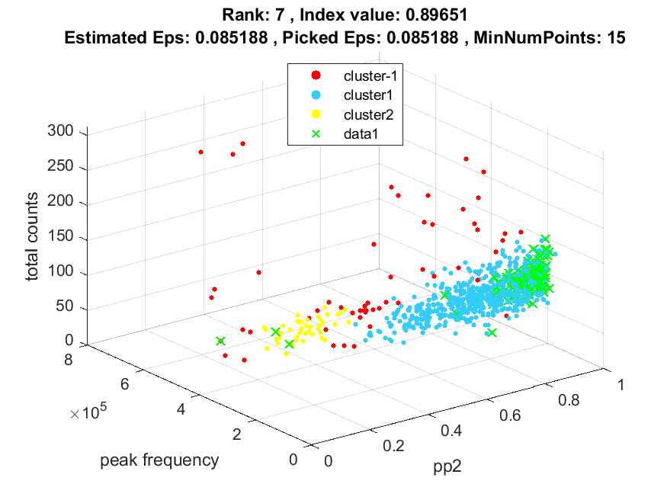
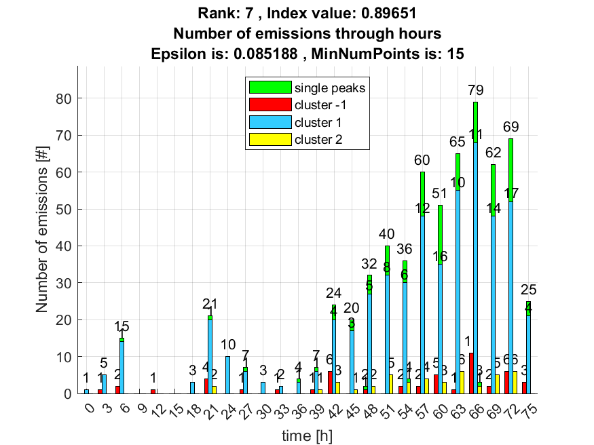

8. result: (peak_amplitude, peak_frequency, total_counts)
Estimated Epsilon: 0.059031, Picked Epsilon: 0.059031, MinNumPoints: 15
DBCV index value: 0.89562
cluster -1 had 5.0847% single peaks
cluster 1 had 93.2203% single peaks
cluster 2 had 1.6949% single peaks
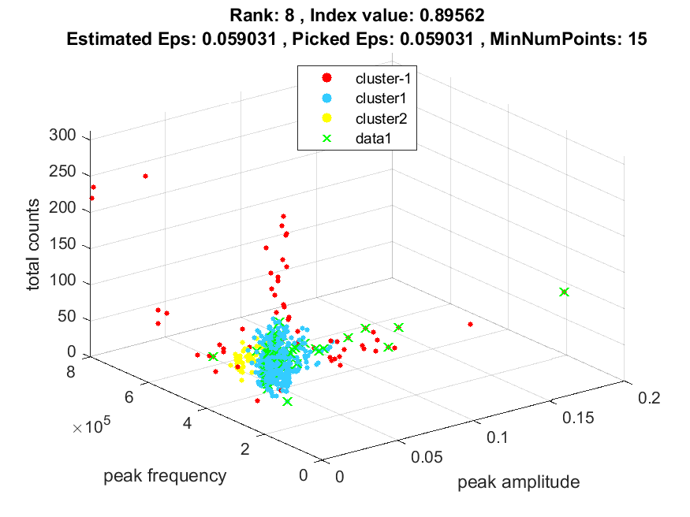
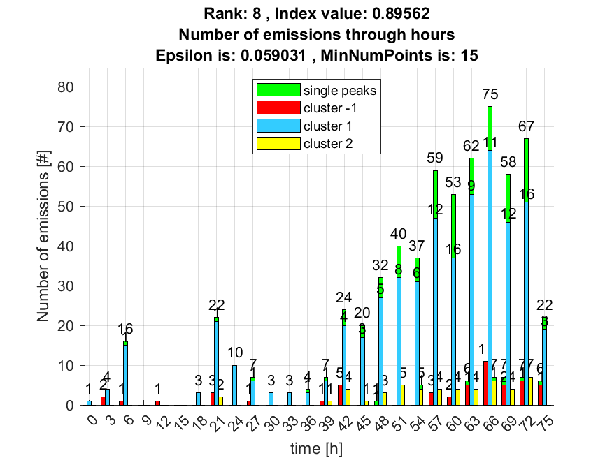

9. result: (peak_frequency, max_frequency, fall_time)
Estimated Epsilon: 0.048829, Picked Epsilon: 0.038829, MinNumPoints: 15
DBCV index value: 0.89528
cluster -1 had 8.4746% single peaks
cluster 1 had 89.8305% single peaks
cluster 2 had 1.6949% single peaks
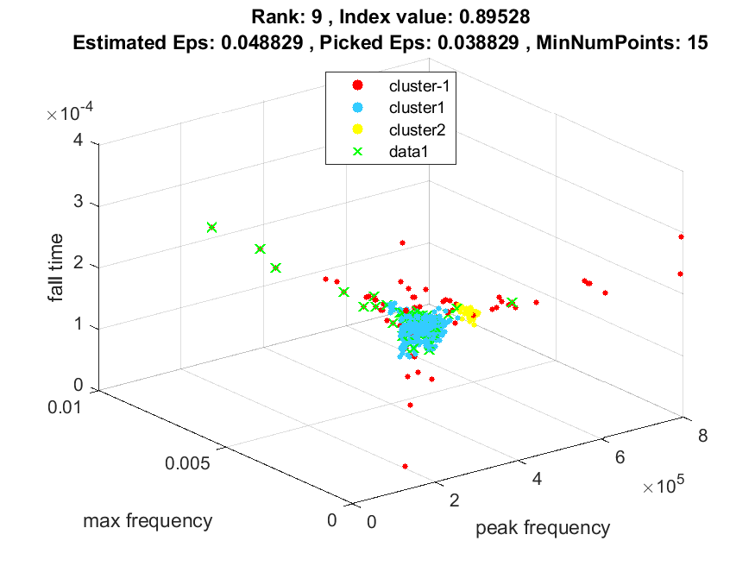
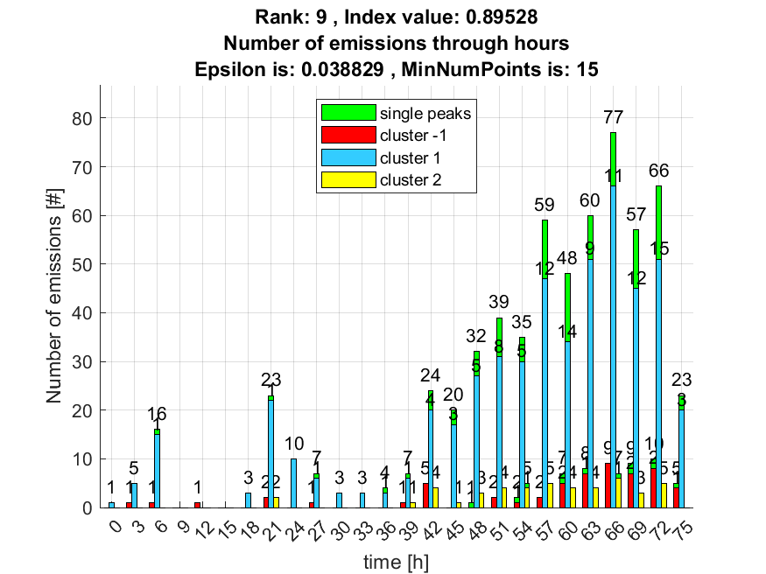

10. result: (rise_time, pp3, peak_frequency)
Estimated Epsilon: 0.07353, Picked Epsilon: 0.07353, MinNumPoints: 15
DBCV index value: 0.89521
cluster -1 had 1.6949% single peaks
cluster 1 had 97.4576% single peaks
cluster 2 had 0.84746% single peaks
