Feature selection results for small_dataset and Nmin = 10

1. result: (rise_time, pp3, peak_frequency)
Estimated Epsilon: 0.060683, Picked Epsilon: 0.068183, MinNumPoints: 10
DBCV_single_clust index value: 0.80815
cluster -1 had 0.84746% single peaks
cluster 1 had 97.4576% single peaks
cluster 2 had 1.6949% single peaks
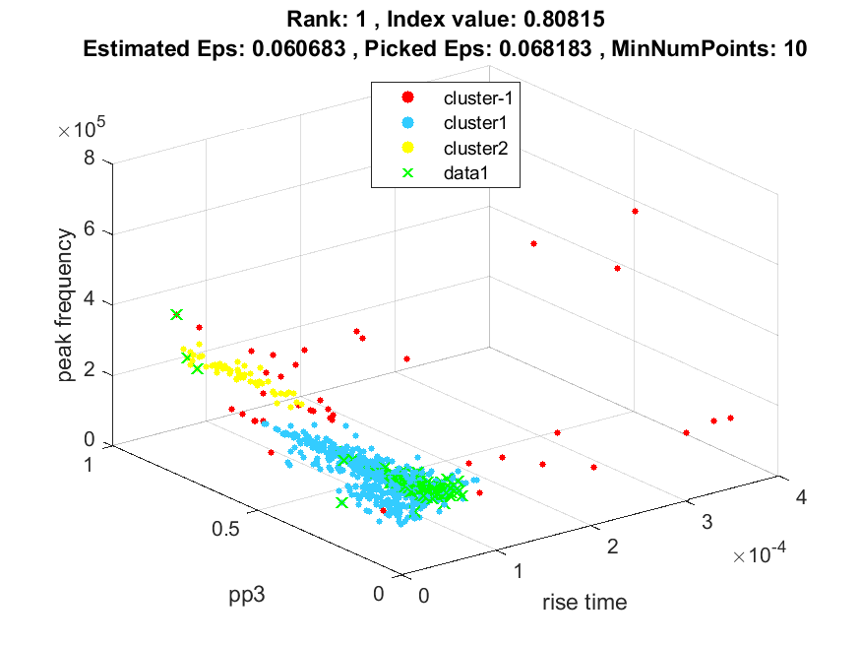
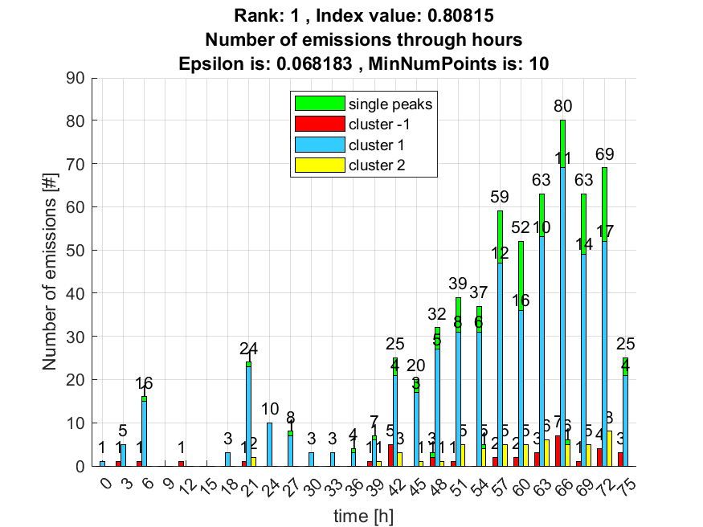

2. result: (rise_time, pp2, peak_frequency)
Estimated Epsilon: 0.062609, Picked Epsilon: 0.070109, MinNumPoints: 10
DBCV_single_clust index value: 0.79067
cluster -1 had 0.84746% single peaks
cluster 1 had 97.4576% single peaks
cluster 2 had 1.6949% single peaks
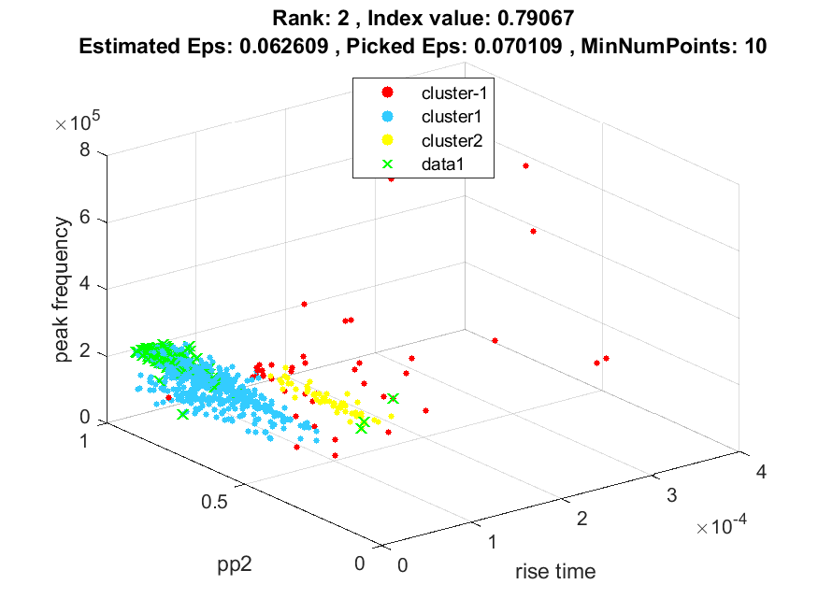
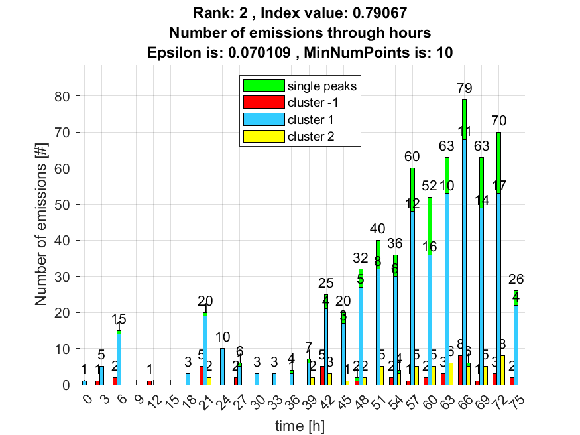

3. result: (peak_amplitude, peak_frequency, fall_time)
Estimated Epsilon: 0.036719, Picked Epsilon: 0.039219, MinNumPoints: 10
DBCV_single_clust index value: 0.78173
cluster -1 had 7.6271% single peaks
cluster 1 had 91.5254% single peaks
cluster 2 had 0.84746% single peaks
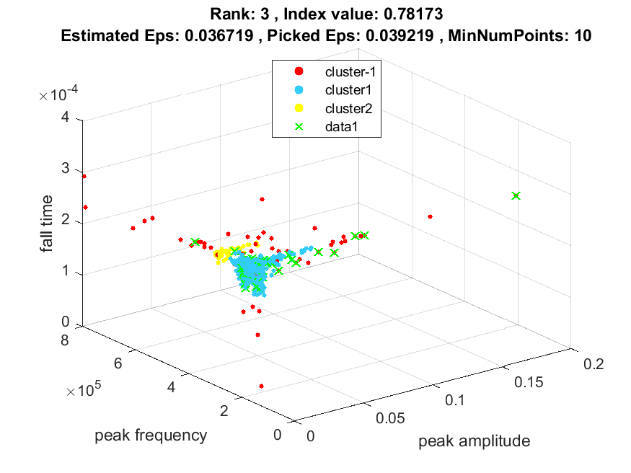
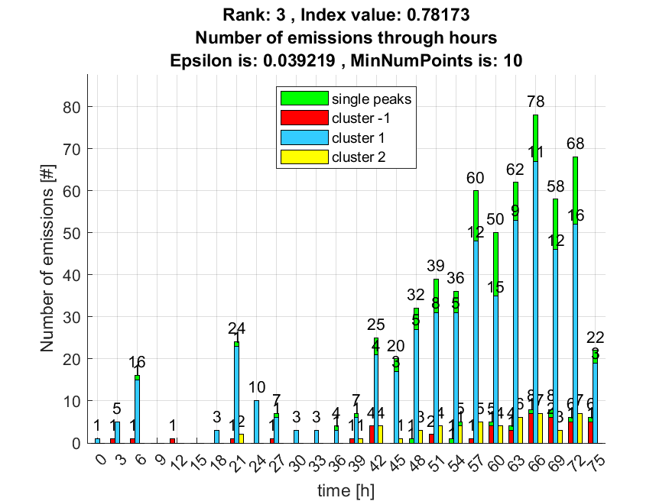

4. result: (rise_time, peak_frequency, fall_time)
Estimated Epsilon: 0.056663, Picked Epsilon: 0.039163, MinNumPoints: 10
DBCV_single_clust index value: 0.77864
cluster -1 had 1.6949% single peaks
cluster 1 had 96.6102% single peaks
cluster 2 had 1.6949% single peaks
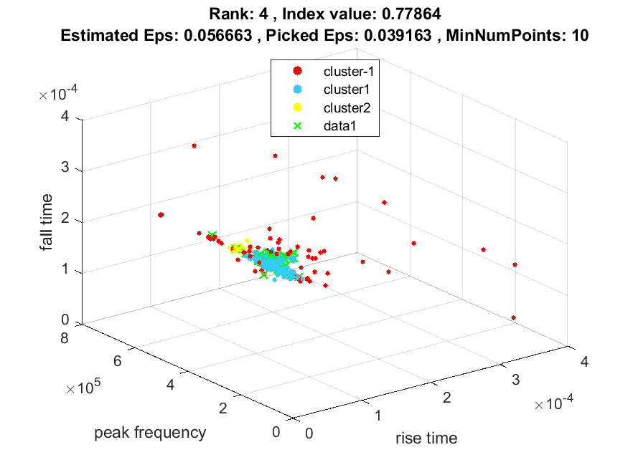
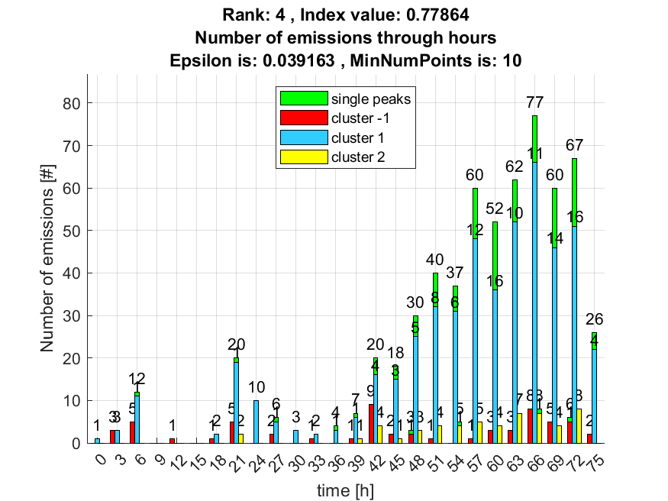

5. result: (signal_strength, peak_frequency, max_frequency)
Estimated Epsilon: 0.028967, Picked Epsilon: 0.026467, MinNumPoints: 10
DBCV_single_clust index value: 0.77617
cluster -1 had 11.0169% single peaks
cluster 1 had 88.9831% single peaks
cluster 2 had 0% single peaks
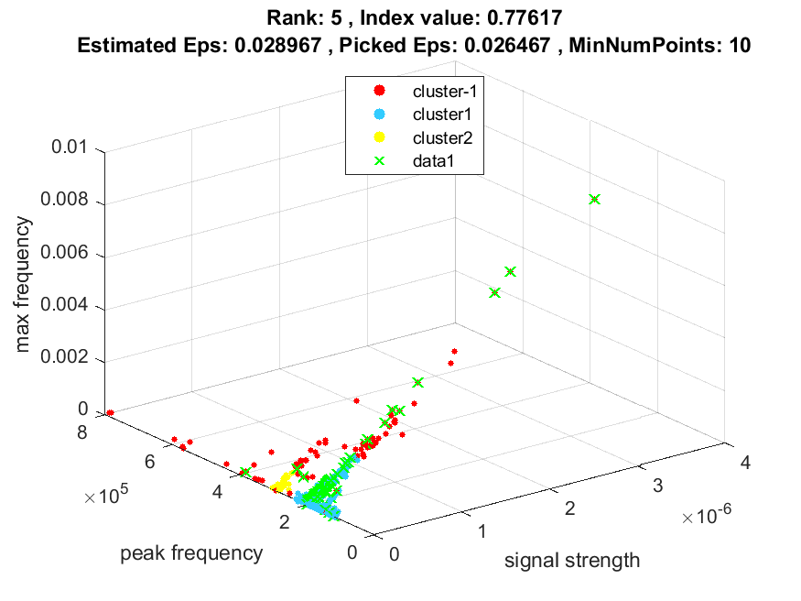
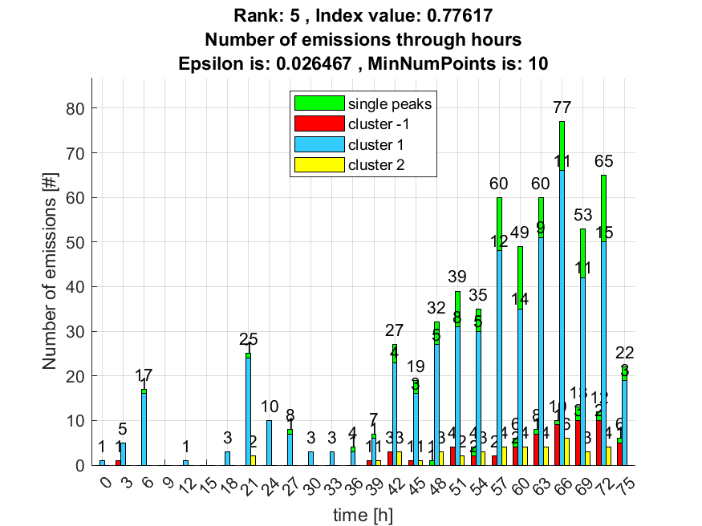

6. result: (peak_amplitude, peak_frequency, max_frequency)
Estimated Epsilon: 0.04127, Picked Epsilon: 0.03377, MinNumPoints: 10
DBCV_single_clust index value: 0.77461
cluster -1 had 10.1695% single peaks
cluster 1 had 89.8305% single peaks
cluster 2 had 0% single peaks
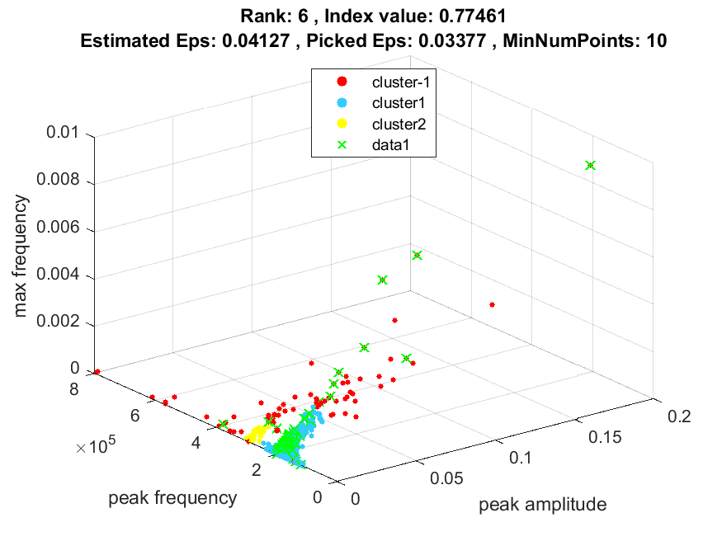
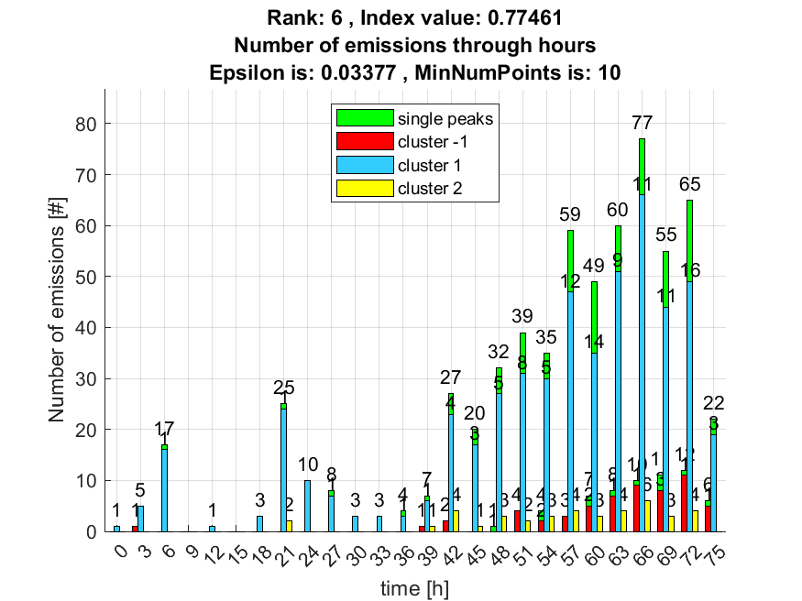

7. result: (pp2, peak_frequency, fall_time)
Estimated Epsilon: 0.057304, Picked Epsilon: 0.057304, MinNumPoints: 10
DBCV_single_clust index value: 0.76554
cluster -1 had 0.84746% single peaks
cluster 1 had 97.4576% single peaks
cluster 2 had 1.6949% single peaks
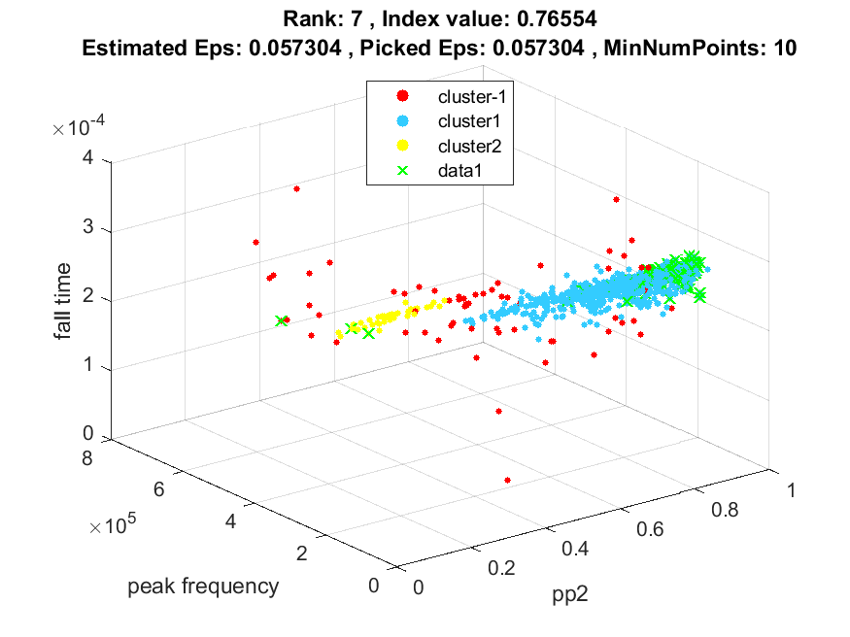
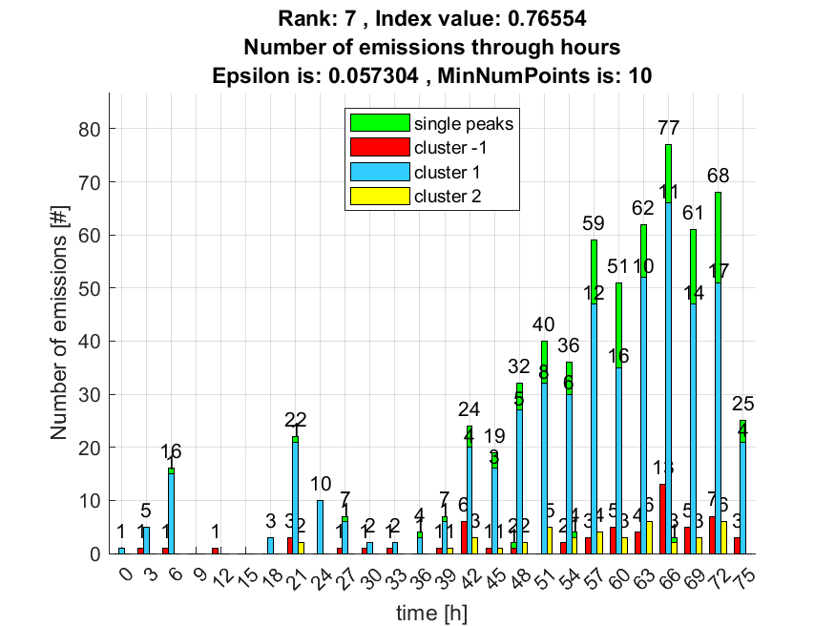

8. result: (rise_time, signal_strength, peak_frequency)
Estimated Epsilon: 0.051852, Picked Epsilon: 0.041852, MinNumPoints: 10
DBCV_single_clust index value: 0.7591
cluster -1 had 7.6271% single peaks
cluster 1 had 91.5254% single peaks
cluster 2 had 0.84746% single peaks
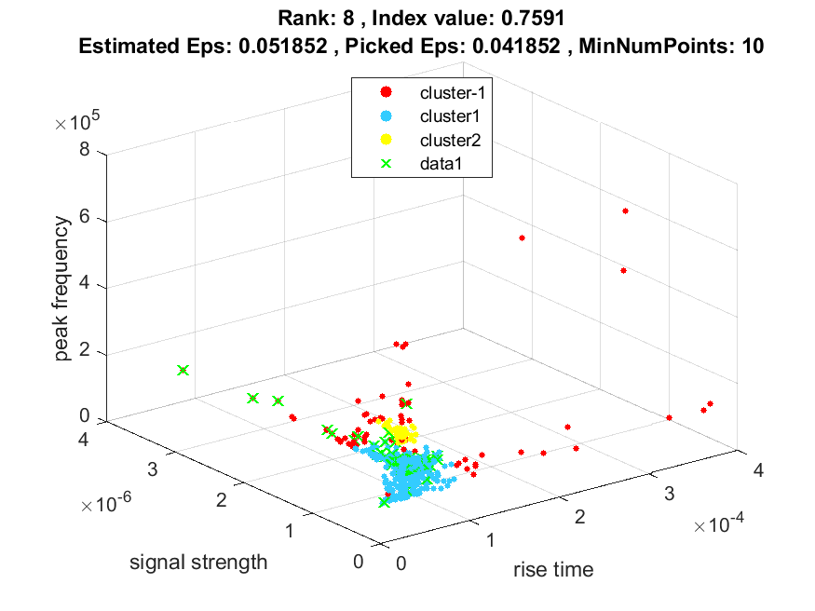
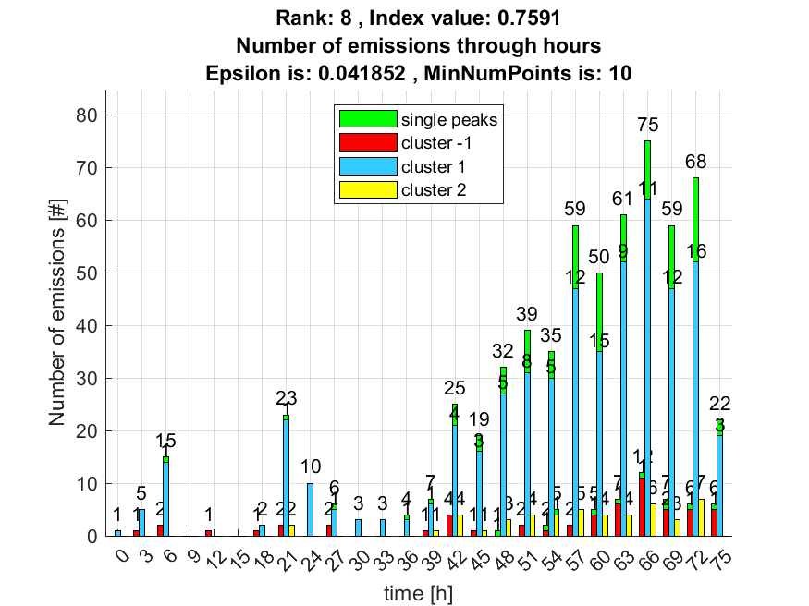

9. result: (peak_frequency, max_frequency, fall_time)
Estimated Epsilon: 0.044332, Picked Epsilon: 0.034332, MinNumPoints: 10
DBCV_single_clust index value: 0.75663
cluster -1 had 9.322% single peaks
cluster 1 had 89.8305% single peaks
cluster 2 had 0.84746% single peaks
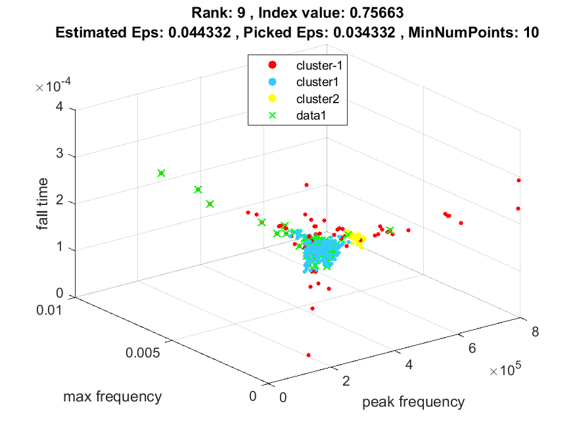
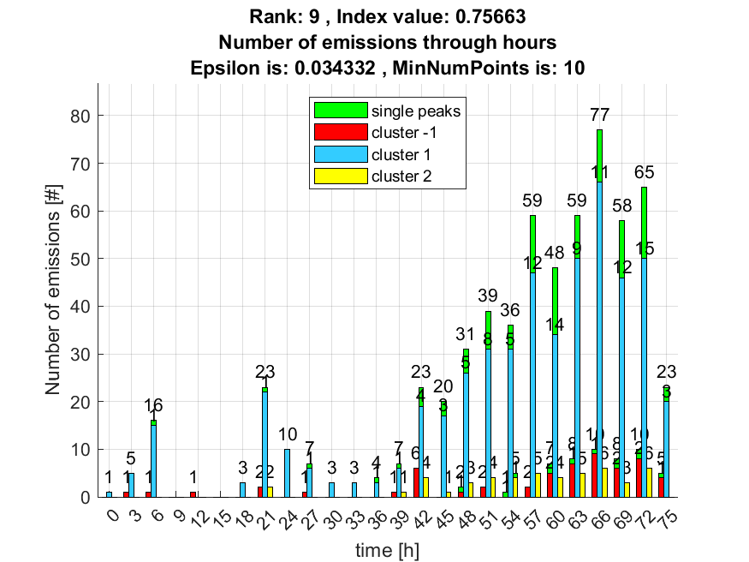

10. result: (signal_strength, pp1, peak_frequency)
Estimated Epsilon: 0.039502, Picked Epsilon: 0.042002, MinNumPoints: 10
DBCV_single_clust index value: 0.75377
cluster -1 had 5.9322% single peaks
cluster 1 had 92.3729% single peaks
cluster 2 had 1.6949% single peaks
