Feature selection results for small_dataset and Nmin = 15

1. result: (pp2, pp4, peak_frequency)
Estimated Epsilon: 0.078452, Picked Epsilon: 0.10845, MinNumPoints: 15
DBCV_single_clust index value: 0.025366
cluster -1 had 0.84746% single peaks
cluster 1 had 99.1525% single peaks
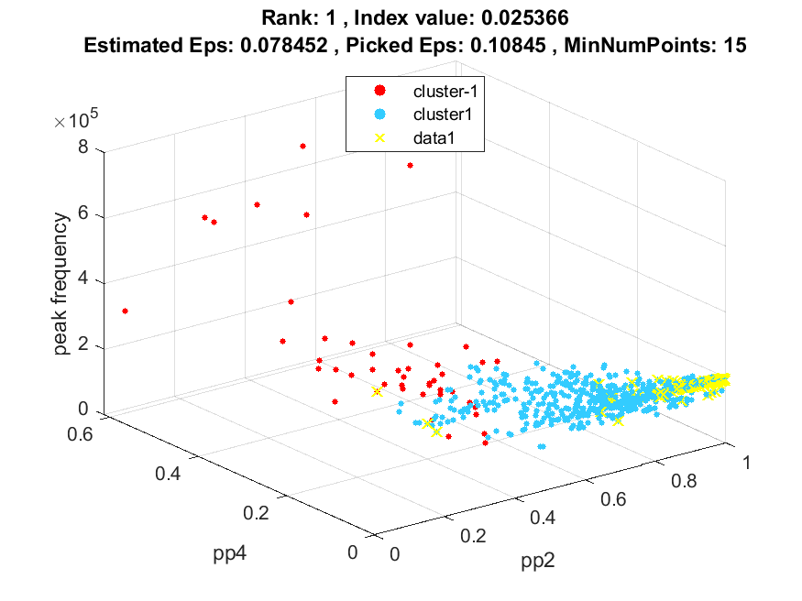
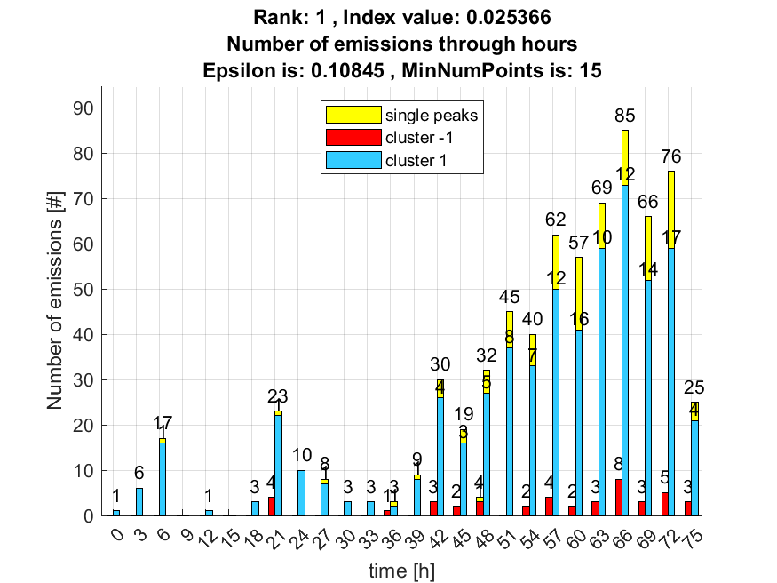

2. result: (pp1, pp4, peak_frequency)
Estimated Epsilon: 0.076603, Picked Epsilon: 0.086603, MinNumPoints: 15
DBCV_single_clust index value: 0.020359
cluster -1 had 1.6949% single peaks
cluster 1 had 98.3051% single peaks
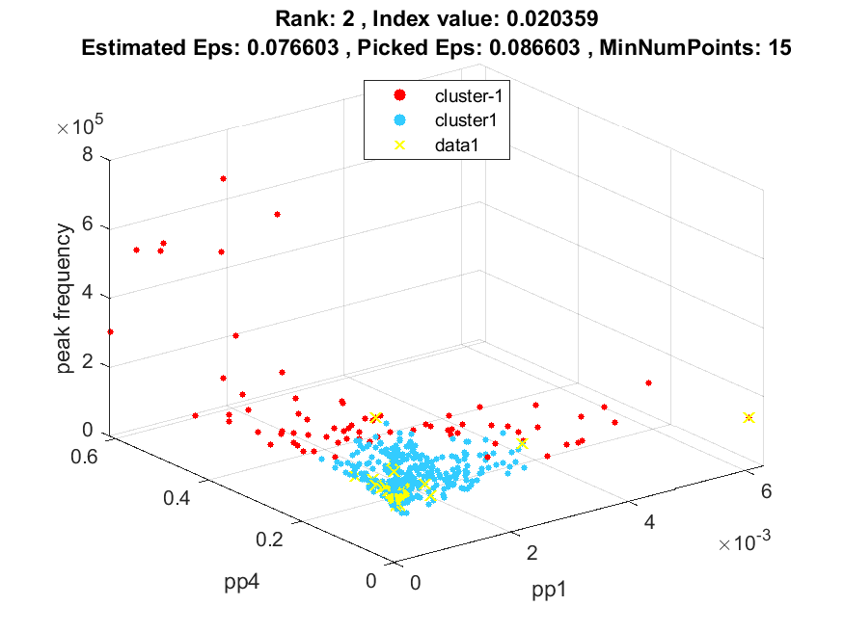
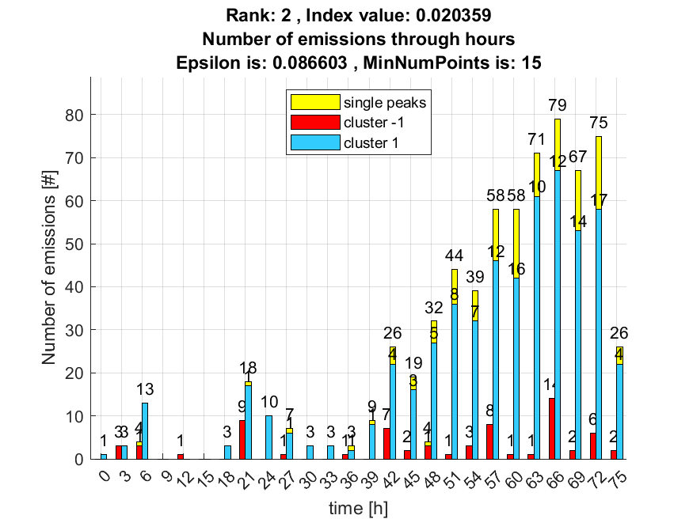

3. result: (pp2, pp3, peak_frequency)
Estimated Epsilon: 0.087338, Picked Epsilon: 0.11734, MinNumPoints: 15
DBCV_single_clust index value: 0.016348
cluster -1 had 0.84746% single peaks
cluster 1 had 99.1525% single peaks
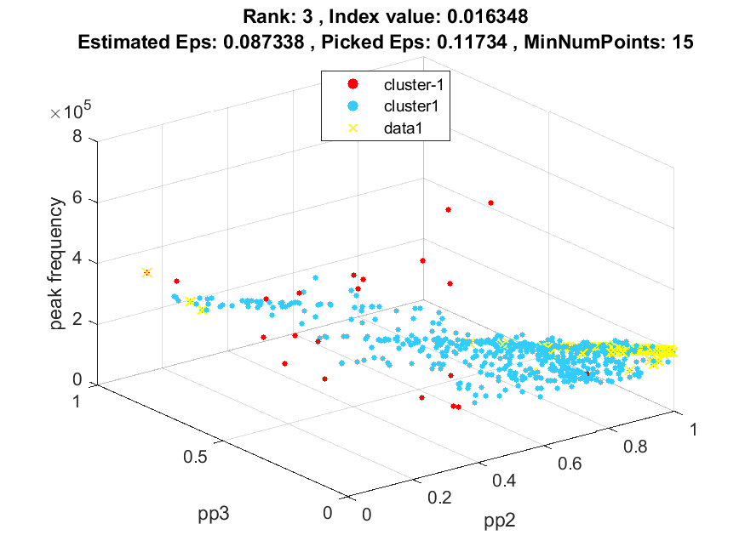
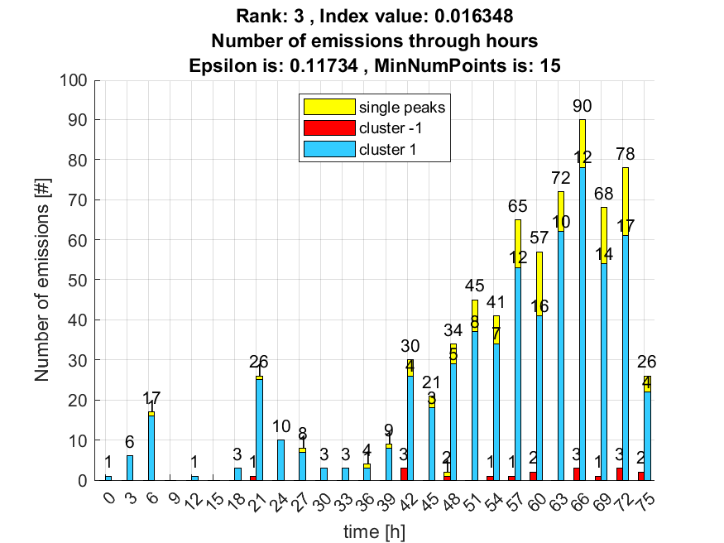

4. result: (pp2, peak_frequency, total_counts)
Estimated Epsilon: 0.085188, Picked Epsilon: 0.11519, MinNumPoints: 15
DBCV_single_clust index value: 0.016134
cluster -1 had 0.84746% single peaks
cluster 1 had 99.1525% single peaks
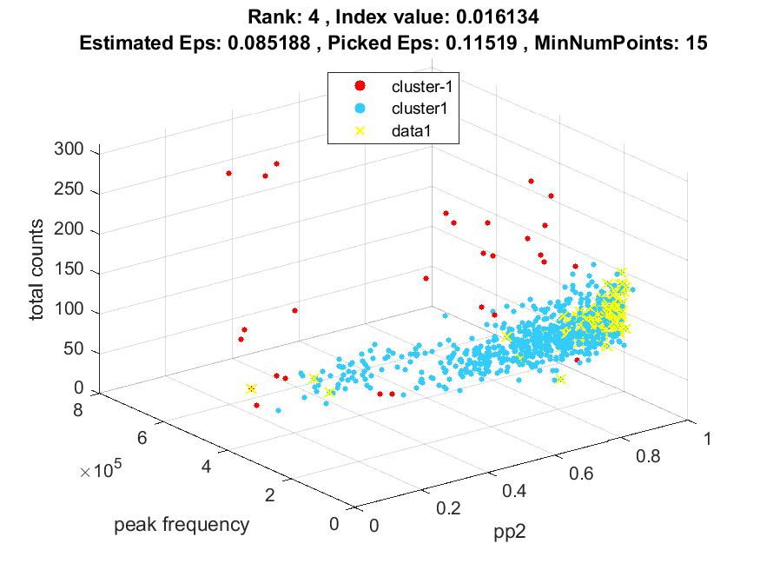
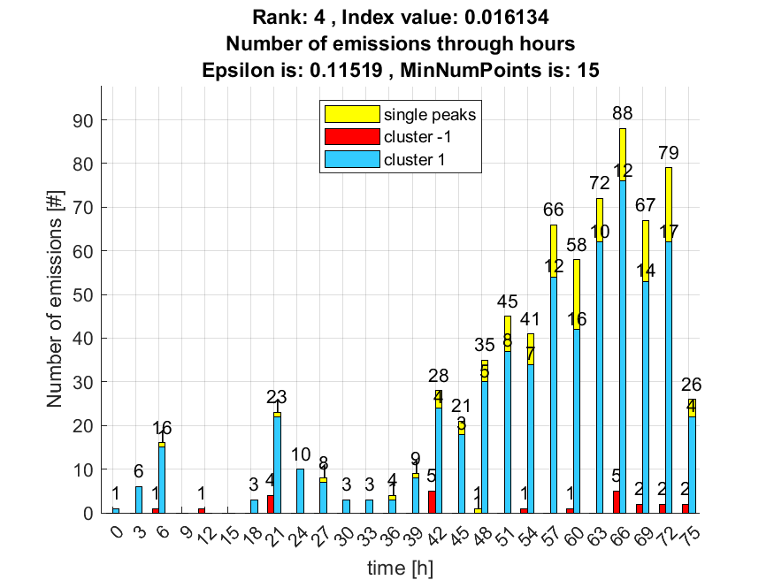

5. result: (pp2, centroid_frequency, peak_frequency)
Estimated Epsilon: 0.10552, Picked Epsilon: 0.13552, MinNumPoints: 15
DBCV_single_clust index value: 0.015505
cluster -1 had 0.84746% single peaks
cluster 1 had 99.1525% single peaks
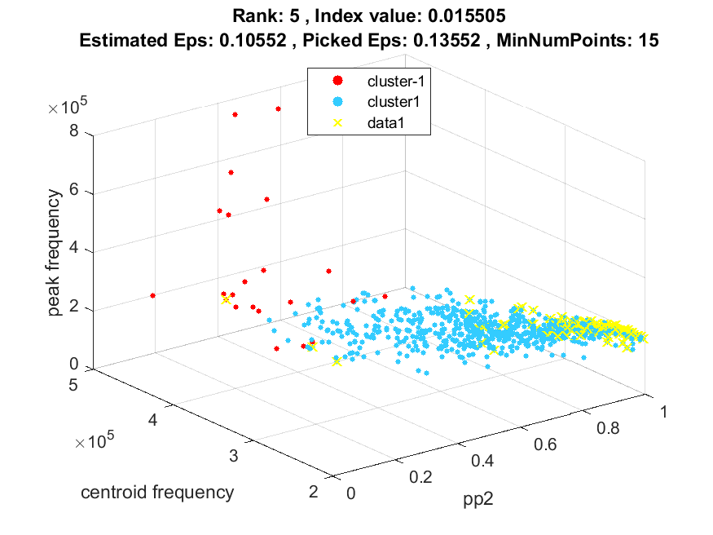
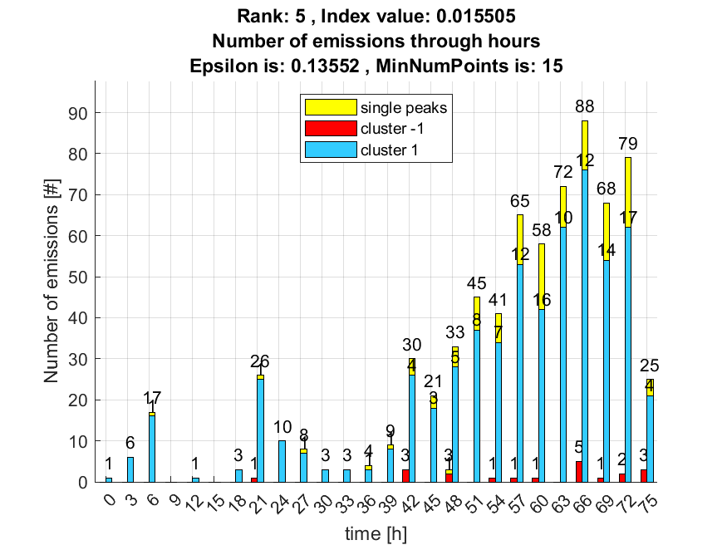

6. result: (pp4, peak_frequency, total_counts)
Estimated Epsilon: 0.085326, Picked Epsilon: 0.11533, MinNumPoints: 15
DBCV_single_clust index value: 0.015382
cluster -1 had 0% single peaks
cluster 1 had 100% single peaks
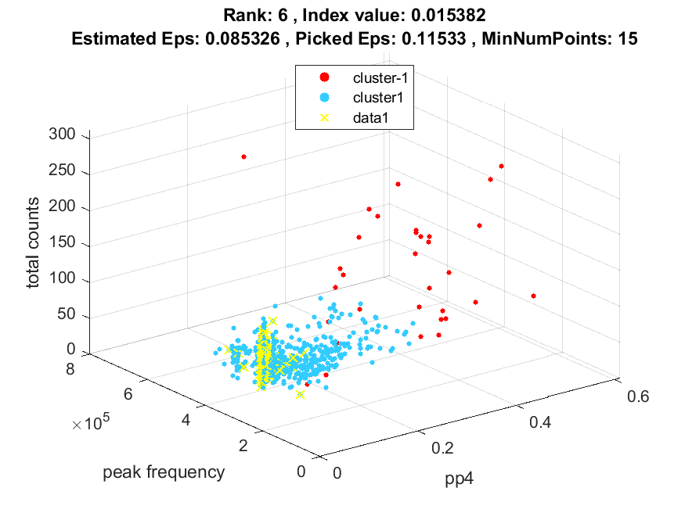
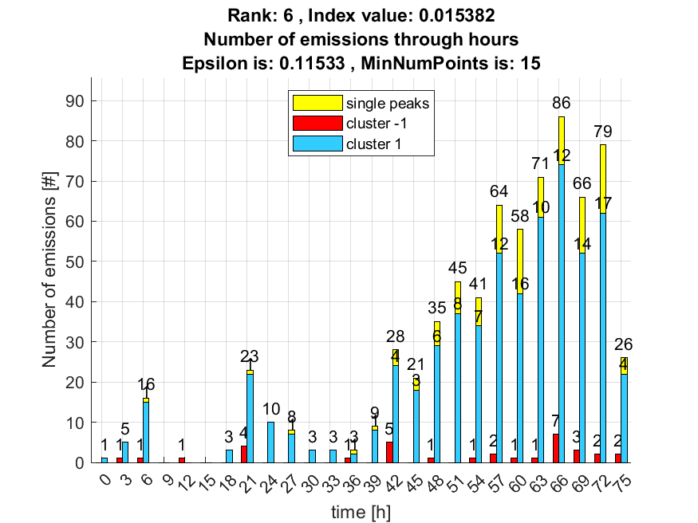

7. result: (pp1, peak_frequency, total_counts)
Estimated Epsilon: 0.077532, Picked Epsilon: 0.10753, MinNumPoints: 15
DBCV_single_clust index value: 0.015266
cluster -1 had 0.84746% single peaks
cluster 1 had 99.1525% single peaks
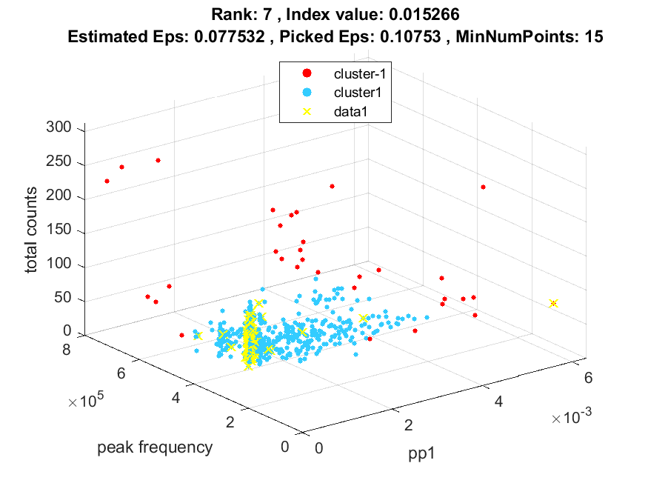
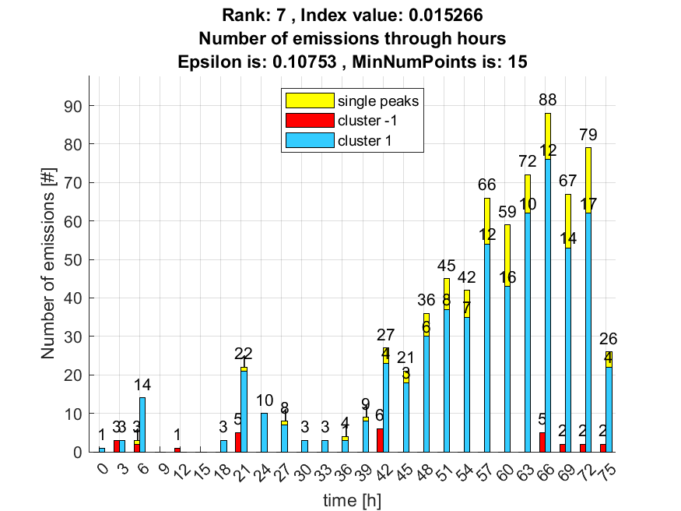

8. result: (pp3, centroid_frequency, peak_frequency)
Estimated Epsilon: 0.10985, Picked Epsilon: 0.13985, MinNumPoints: 15
DBCV_single_clust index value: 0.015253
cluster -1 had 0.84746% single peaks
cluster 1 had 99.1525% single peaks
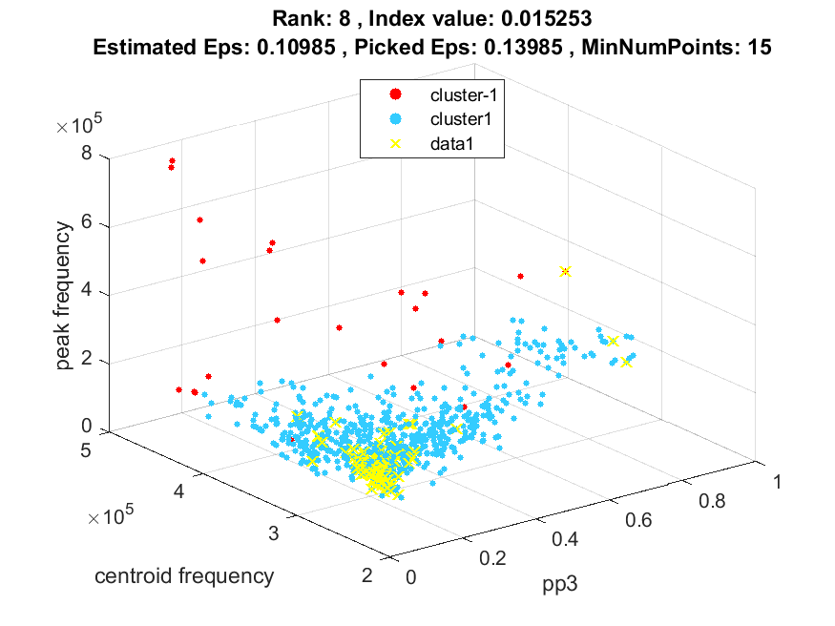
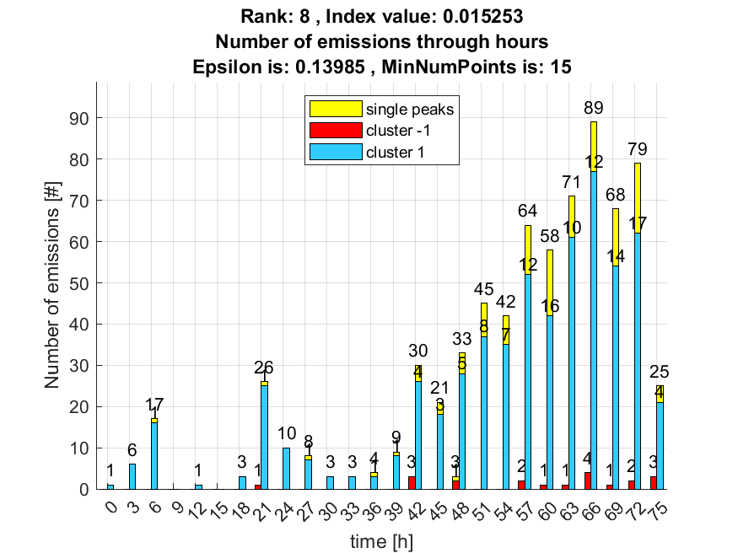

9. result: (counts_from, pp3, peak_frequency)
Estimated Epsilon: 0.092945, Picked Epsilon: 0.12295, MinNumPoints: 15
DBCV_single_clust index value: 0.01389
cluster -1 had 0.84746% single peaks
cluster 1 had 99.1525% single peaks
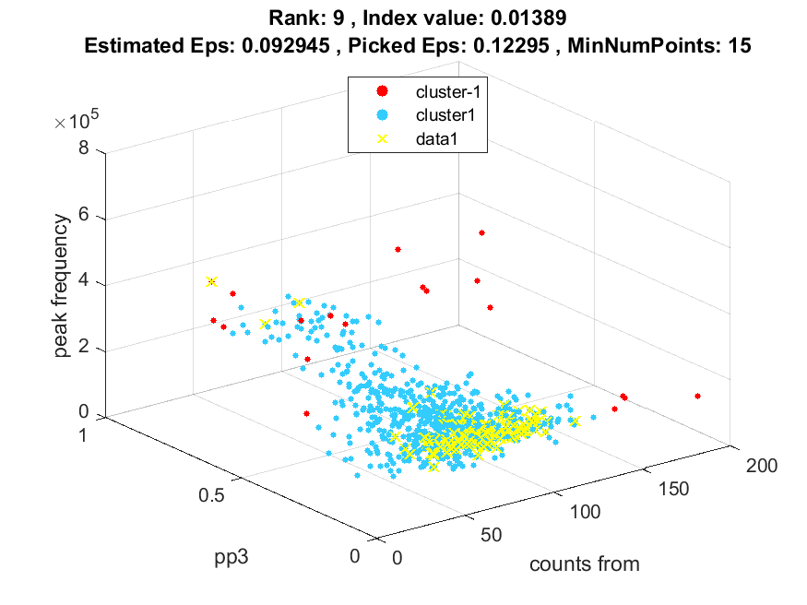
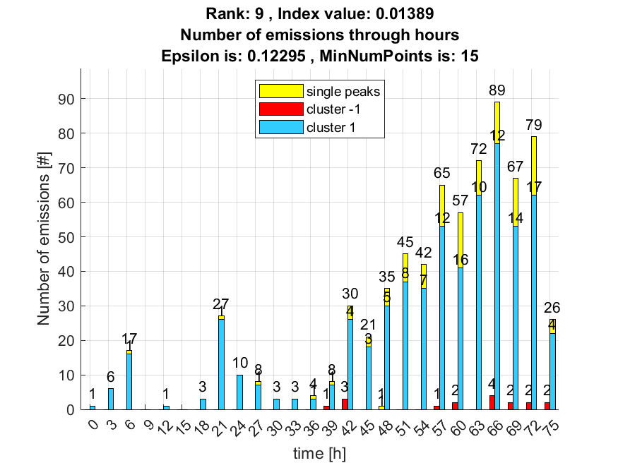

10. result: (counts_from, centroid_frequency, peak_frequency)
Estimated Epsilon: 0.099485, Picked Epsilon: 0.12949, MinNumPoints: 15
DBCV_single_clust index value: 0.013865
cluster -1 had 0.84746% single peaks
cluster 1 had 99.1525% single peaks
