Feature selection results for small_dataset and Nmin = 10

1. result: (rise_time, pp3, peak_frequency)
Estimated Epsilon: 0.060683, Picked Epsilon: 0.078183, MinNumPoints: 10
DBCV index value: 0.61073
cluster -1 had 0.84746% single peaks
cluster 1 had 97.4576% single peaks
cluster 2 had 1.6949% single peaks
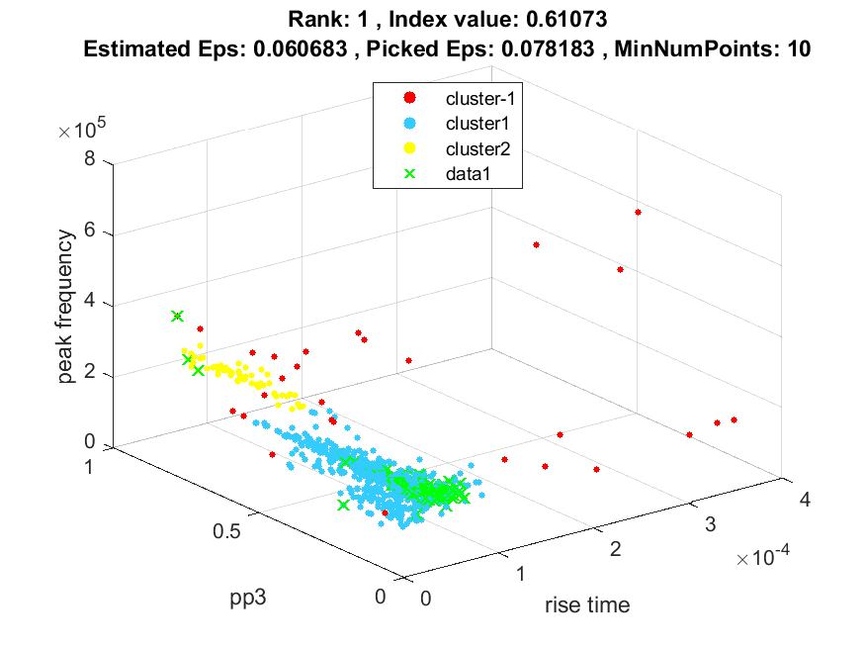
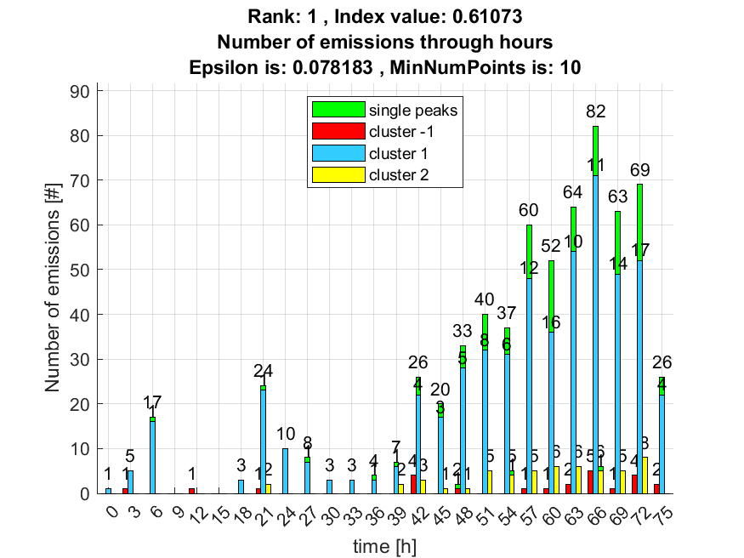

2. result: (signal_strength, peak_frequency, max_frequency)
Estimated Epsilon: 0.028967, Picked Epsilon: 0.038967, MinNumPoints: 10
DBCV index value: 0.58485
cluster -1 had 7.6271% single peaks
cluster 1 had 91.5254% single peaks
cluster 2 had 0.84746% single peaks
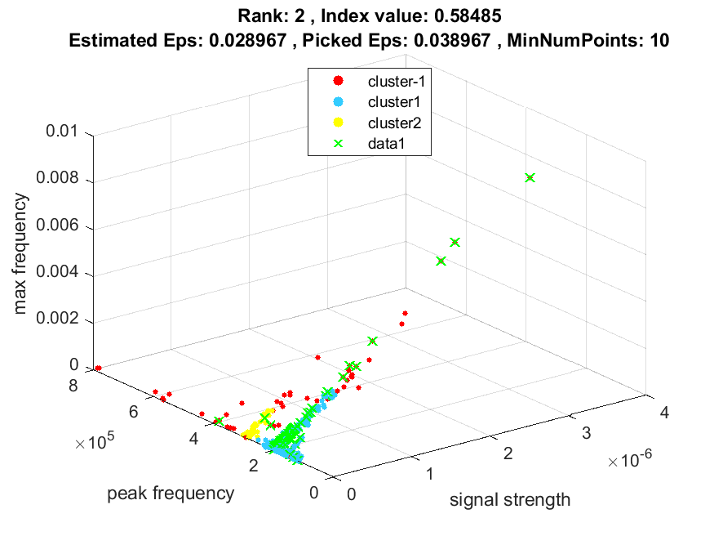
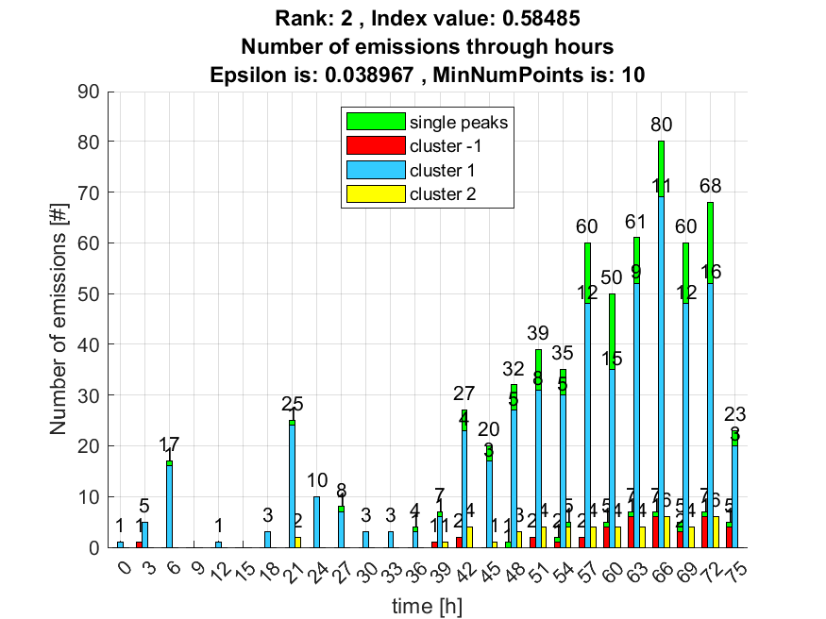

3. result: (pp3, peak_frequency, fall_time)
Estimated Epsilon: 0.053576, Picked Epsilon: 0.071076, MinNumPoints: 10
DBCV index value: 0.58405
cluster -1 had 0.84746% single peaks
cluster 1 had 97.4576% single peaks
cluster 2 had 1.6949% single peaks
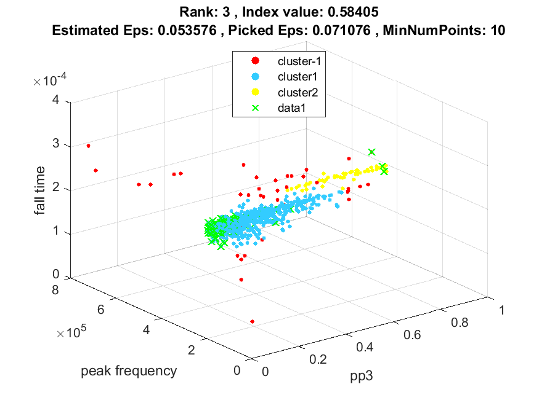
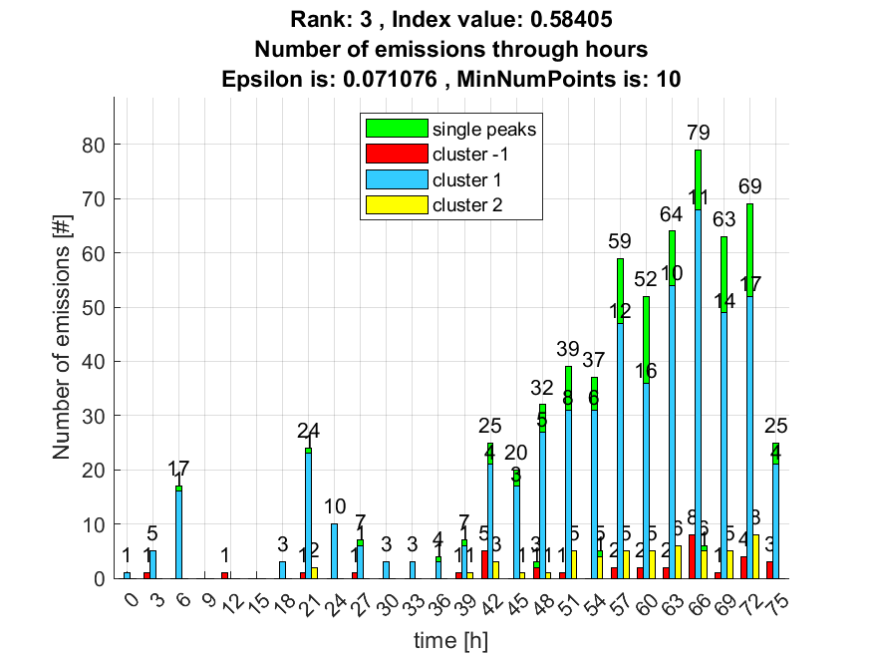

4. result: (rise_time, pp2, peak_frequency)
Estimated Epsilon: 0.062609, Picked Epsilon: 0.075109, MinNumPoints: 10
DBCV index value: 0.58248
cluster -1 had 0.84746% single peaks
cluster 1 had 97.4576% single peaks
cluster 2 had 1.6949% single peaks
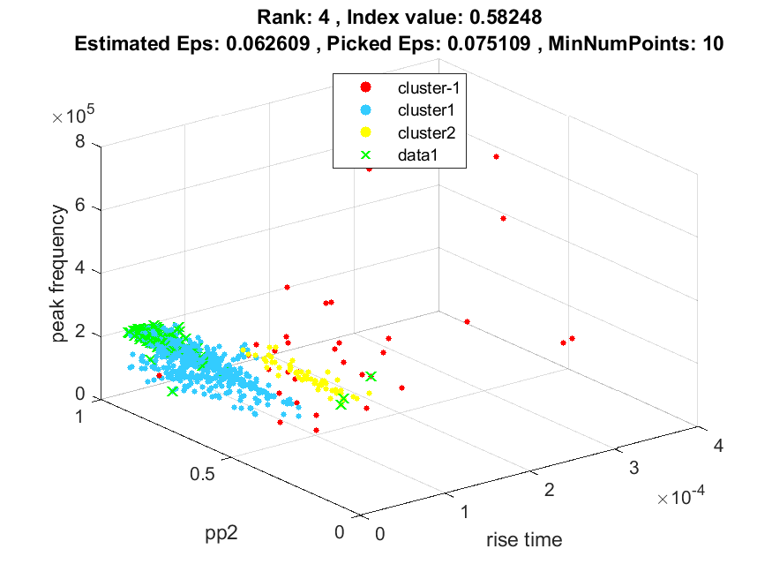
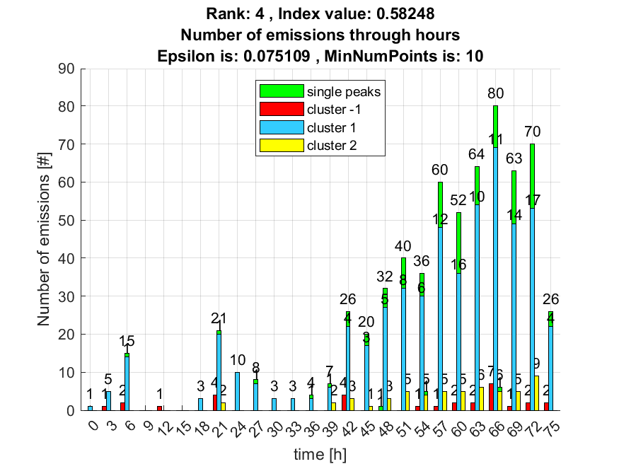

5. result: (pp2, peak_frequency, fall_time)
Estimated Epsilon: 0.057304, Picked Epsilon: 0.072304, MinNumPoints: 10
DBCV index value: 0.57698
cluster -1 had 0.84746% single peaks
cluster 1 had 97.4576% single peaks
cluster 2 had 1.6949% single peaks
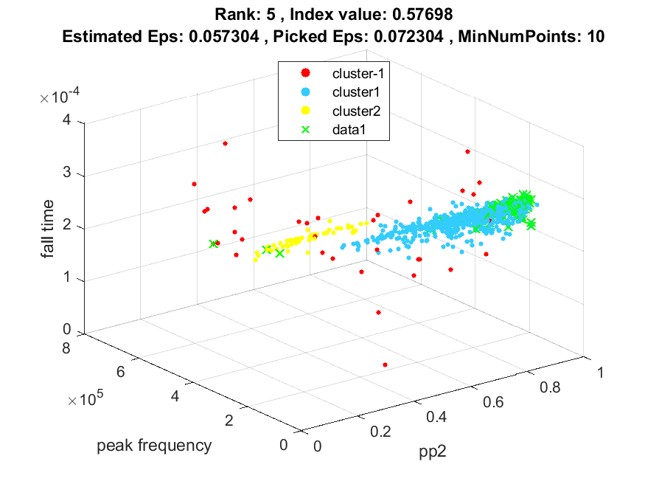
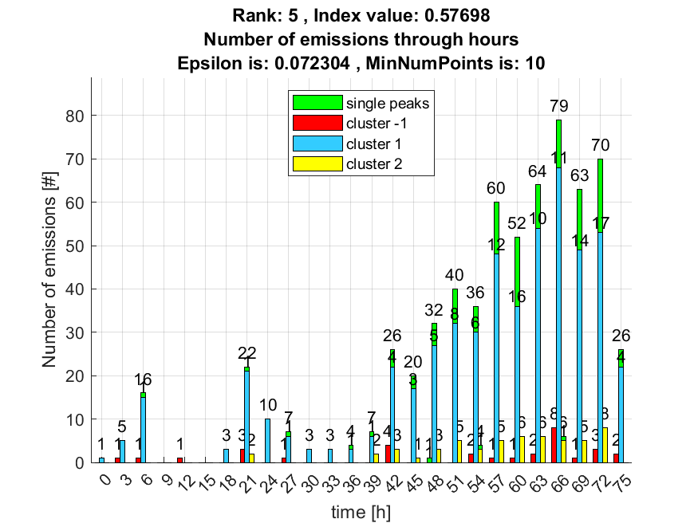

6. result: (signal_strength, pp2, peak_frequency)
Estimated Epsilon: 0.060104, Picked Epsilon: 0.077604, MinNumPoints: 10
DBCV index value: 0.57644
cluster -1 had 6.7797% single peaks
cluster 1 had 91.5254% single peaks
cluster 2 had 1.6949% single peaks
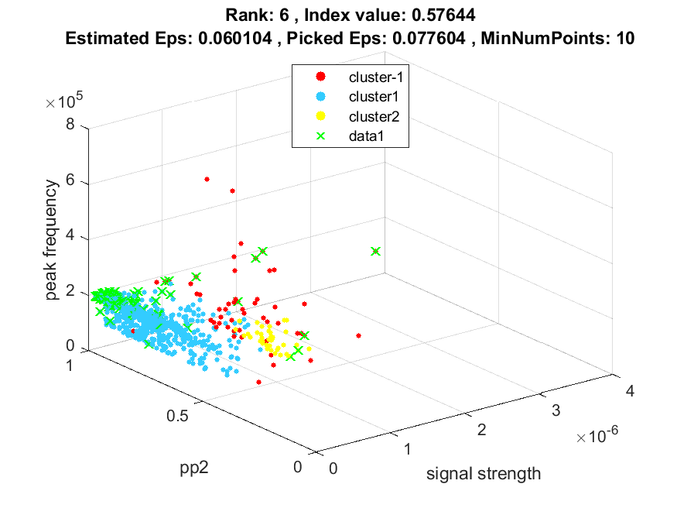
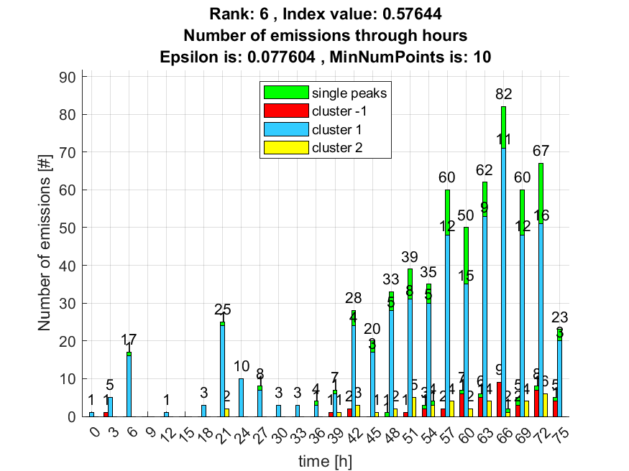

7. result: (peak_amplitude, pp3, peak_frequency)
Estimated Epsilon: 0.069149, Picked Epsilon: 0.074149, MinNumPoints: 10
DBCV index value: 0.56448
cluster -1 had 5.0847% single peaks
cluster 1 had 93.2203% single peaks
cluster 2 had 1.6949% single peaks
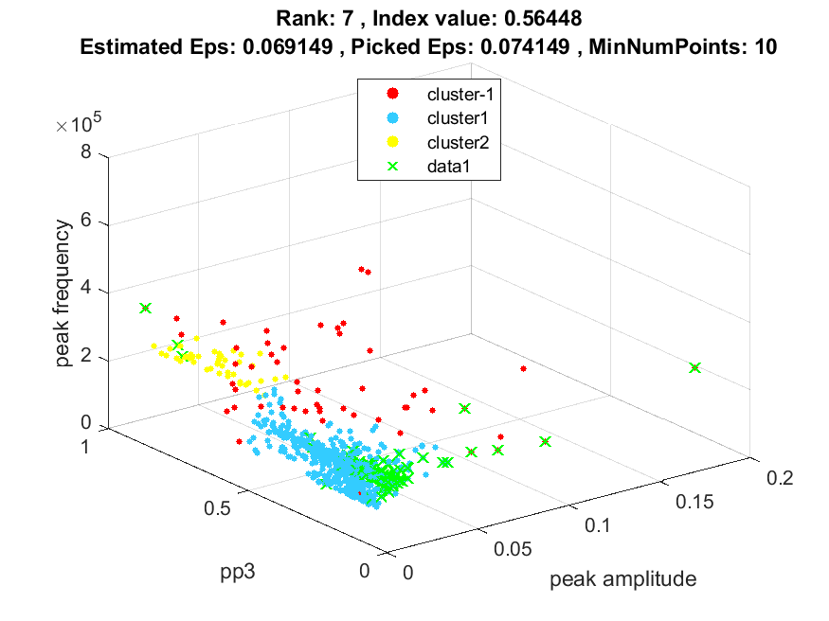
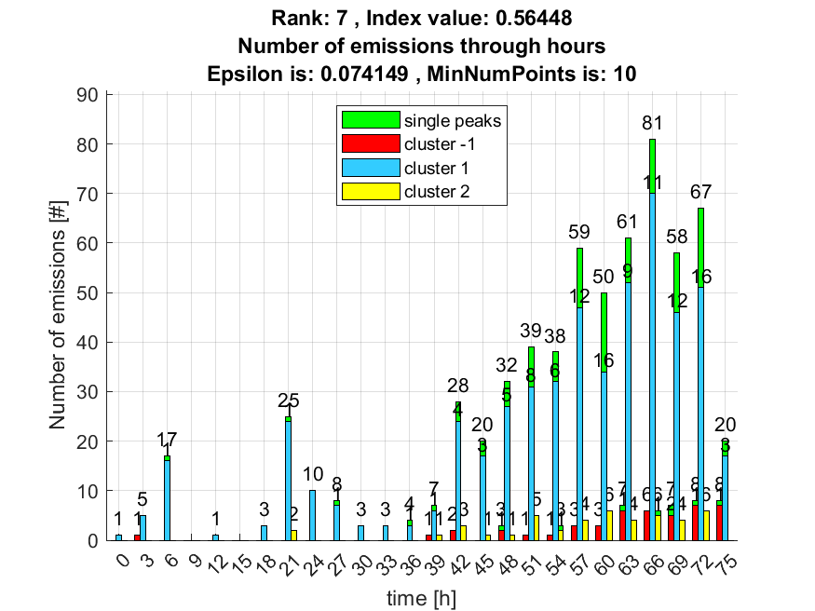

8. result: (signal_strength, pp3, peak_frequency)
Estimated Epsilon: 0.069955, Picked Epsilon: 0.077455, MinNumPoints: 10
DBCV index value: 0.56421
cluster -1 had 6.7797% single peaks
cluster 1 had 91.5254% single peaks
cluster 2 had 1.6949% single peaks
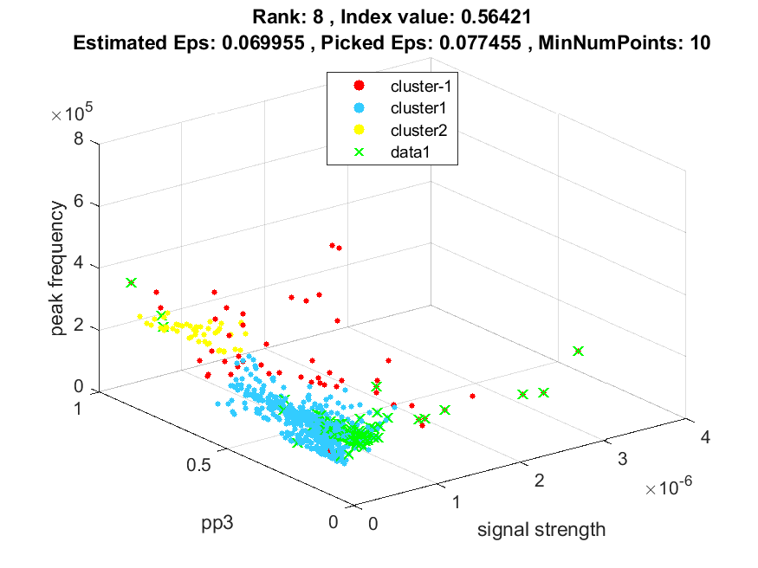
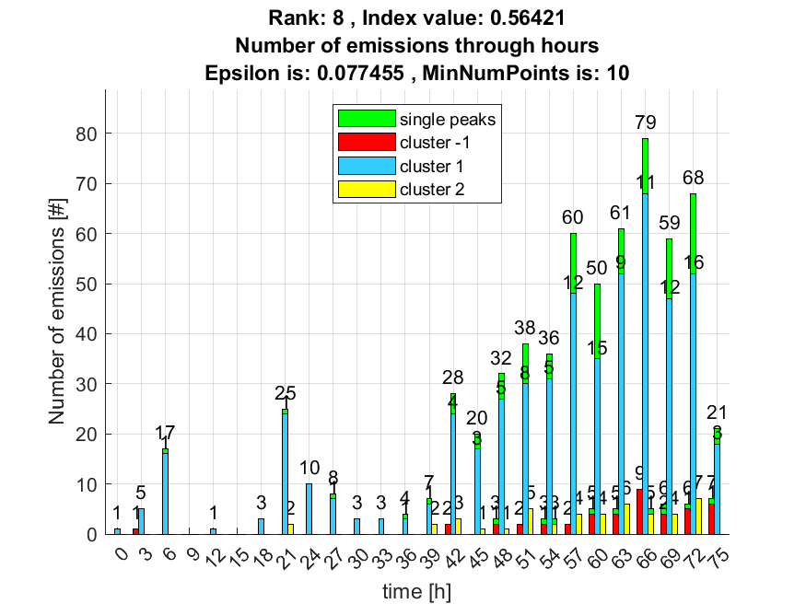

9. result: (peak_amplitude, pp2, peak_frequency)
Estimated Epsilon: 0.067802, Picked Epsilon: 0.075302, MinNumPoints: 10
DBCV index value: 0.55495
cluster -1 had 5.0847% single peaks
cluster 1 had 93.2203% single peaks
cluster 2 had 1.6949% single peaks
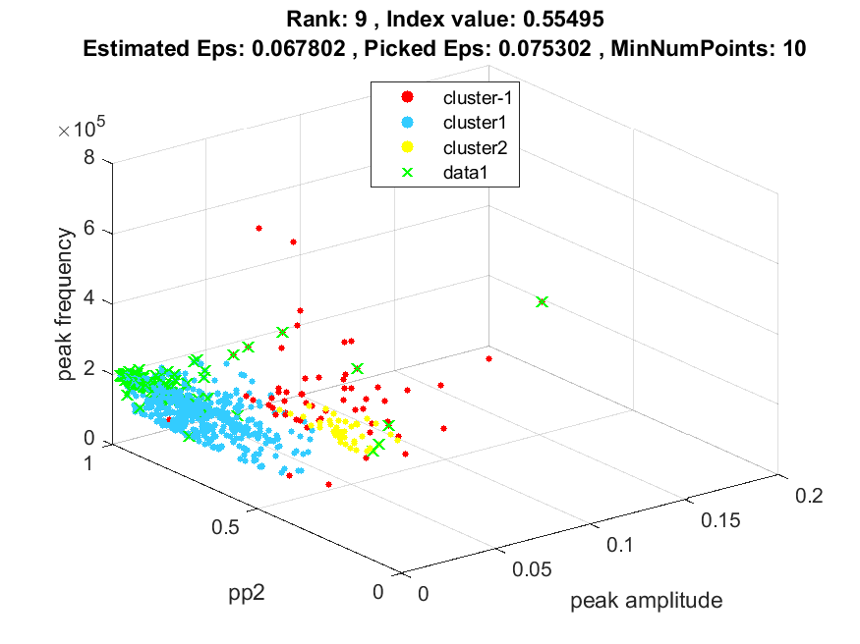
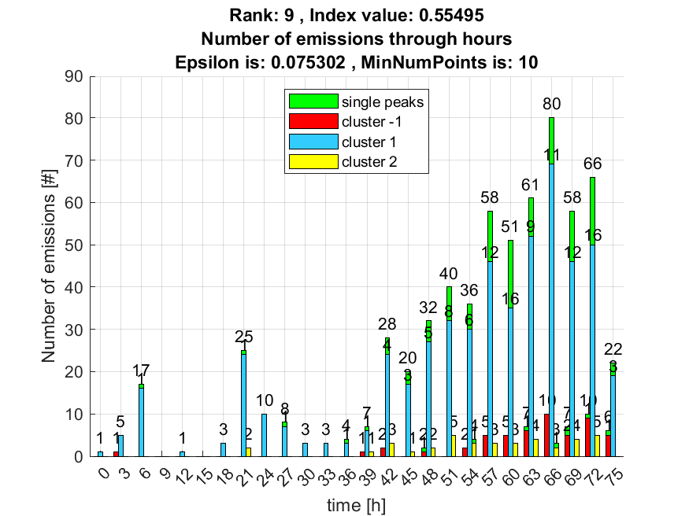

10. result: (pp3, peak_frequency, max_frequency)
Estimated Epsilon: 0.067099, Picked Epsilon: 0.072099, MinNumPoints: 10
DBCV index value: 0.55381
cluster -1 had 6.7797% single peaks
cluster 1 had 91.5254% single peaks
cluster 2 had 1.6949% single peaks
