Feature selection results for small_dataset and Nmin = 10

1. result: (counts_from, pp3, peak_frequency)
Estimated Epsilon: 0.07467, Picked Epsilon: 0.10467, MinNumPoints: 10
DBCV_single_clust index value: -0.00090339
cluster -1 had 0.84746% single peaks
cluster 1 had 99.1525% single peaks
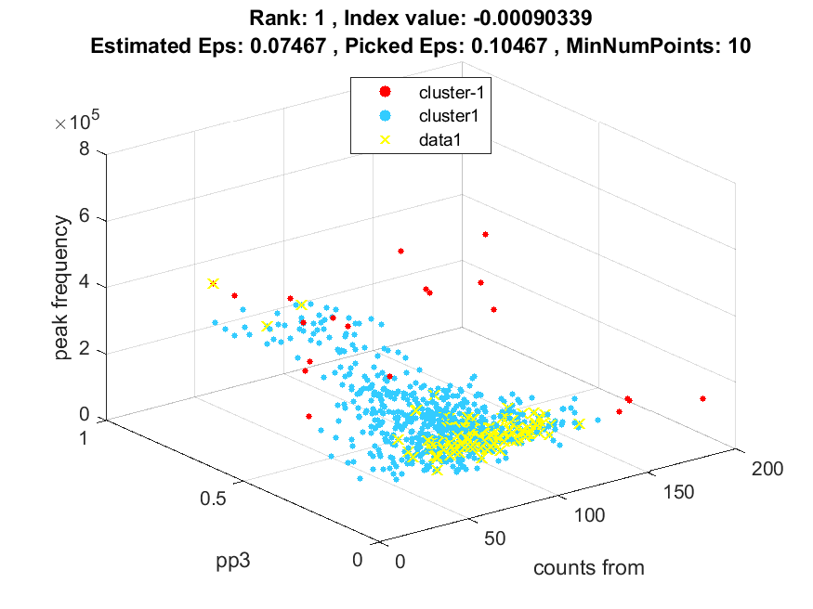
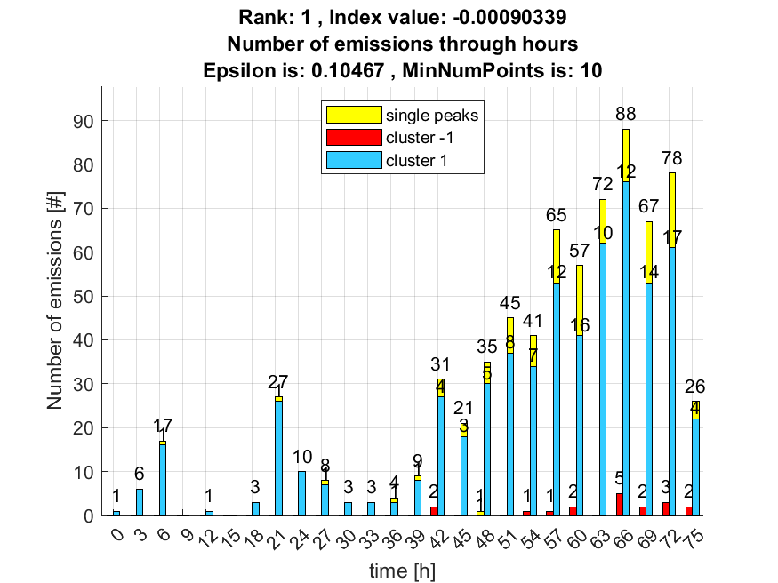

2. result: (pp1, pp4, peak_frequency)
Estimated Epsilon: 0.062677, Picked Epsilon: 0.092677, MinNumPoints: 10
DBCV_single_clust index value: -0.00090546
cluster -1 had 1.6949% single peaks
cluster 1 had 98.3051% single peaks
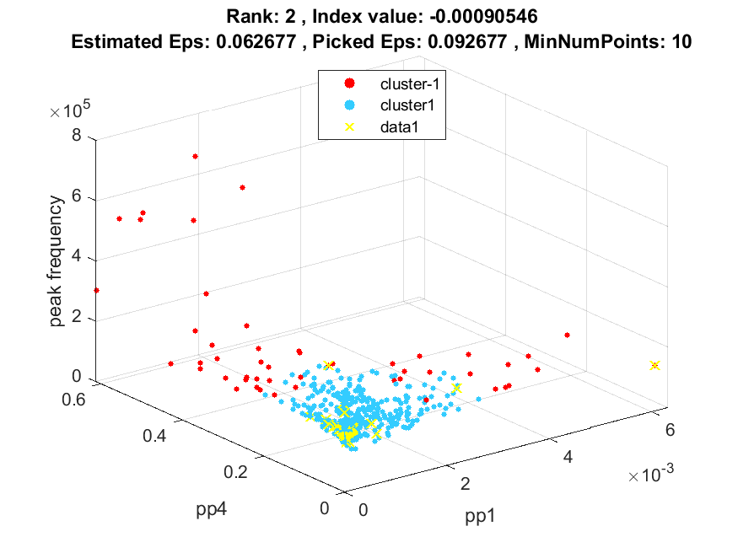
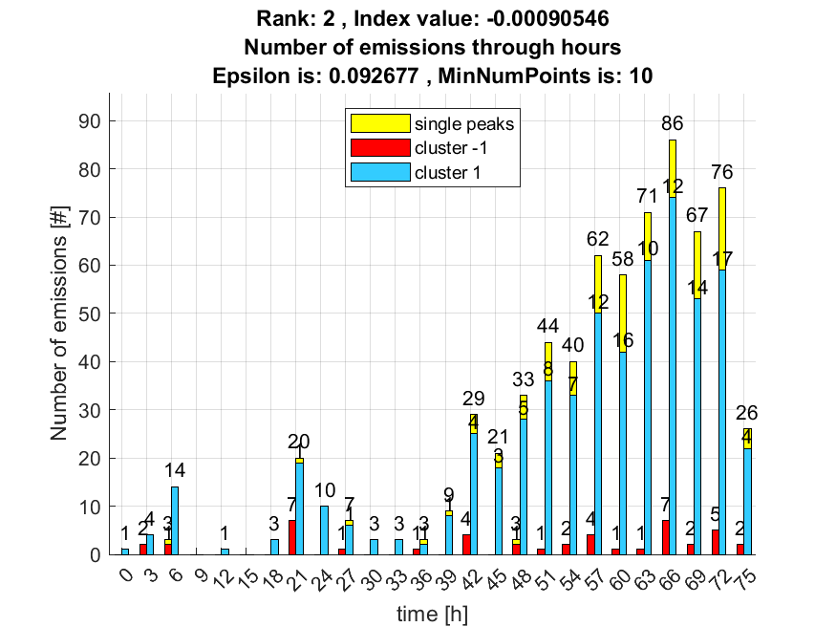

3. result: (counts_from, pp4, peak_frequency)
Estimated Epsilon: 0.075624, Picked Epsilon: 0.10562, MinNumPoints: 10
DBCV_single_clust index value: -0.00095855
cluster -1 had 0.84746% single peaks
cluster 1 had 99.1525% single peaks
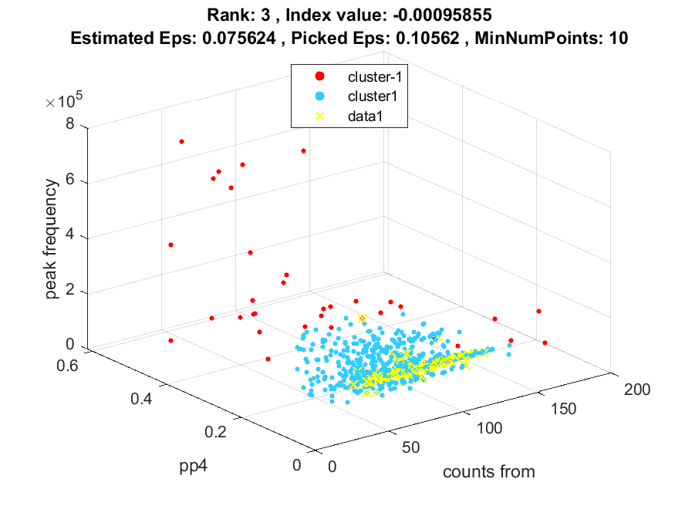
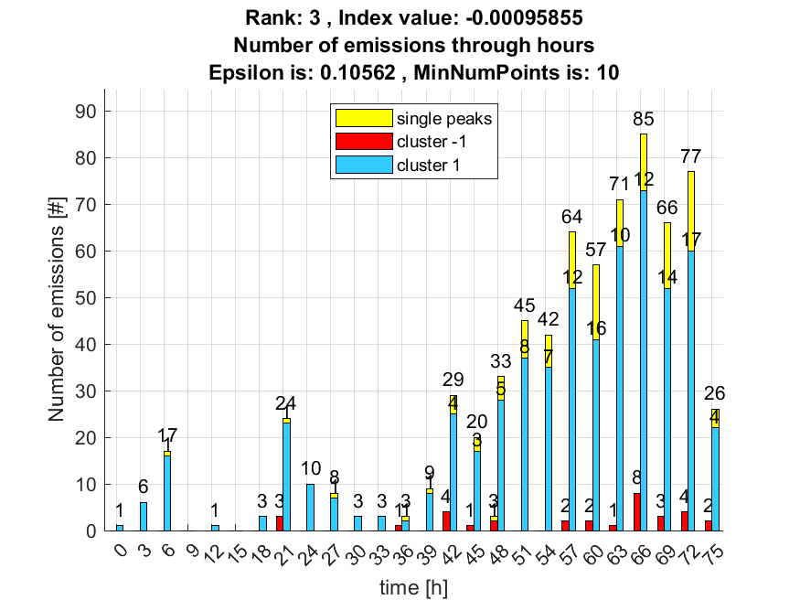

4. result: (centroid_frequency, peak_frequency, max_frequency)
Estimated Epsilon: 0.048603, Picked Epsilon: 0.078603, MinNumPoints: 10
DBCV_single_clust index value: -0.0010867
cluster -1 had 5.9322% single peaks
cluster 1 had 94.0678% single peaks
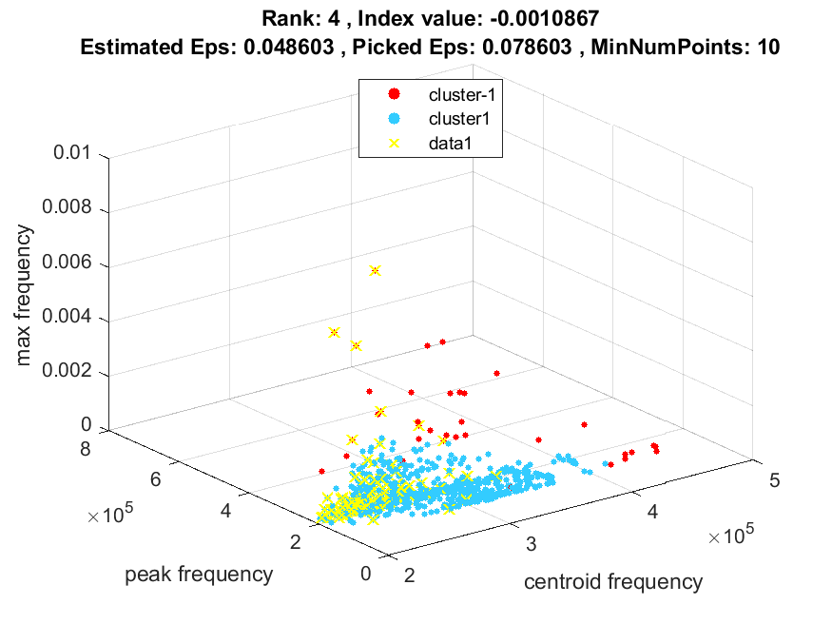
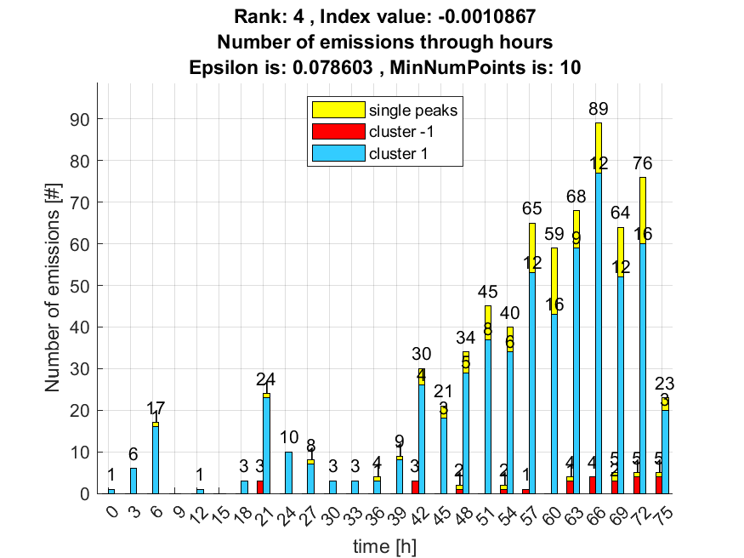

5. result: (centroid_frequency, peak_frequency, total_counts)
Estimated Epsilon: 0.072824, Picked Epsilon: 0.092824, MinNumPoints: 10
DBCV_single_clust index value: -0.0014948
cluster -1 had 0.84746% single peaks
cluster 1 had 99.1525% single peaks
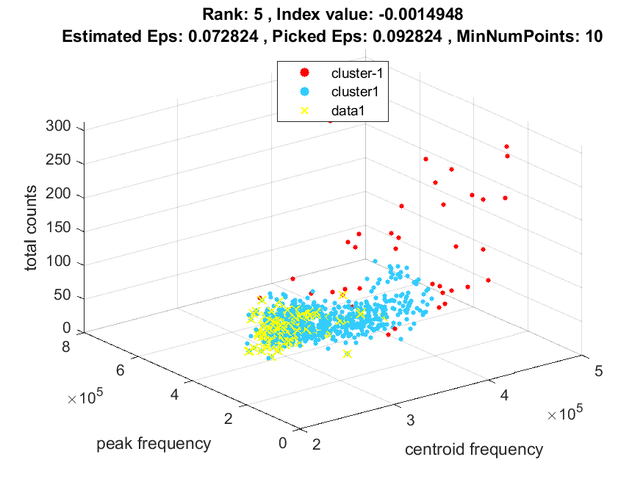
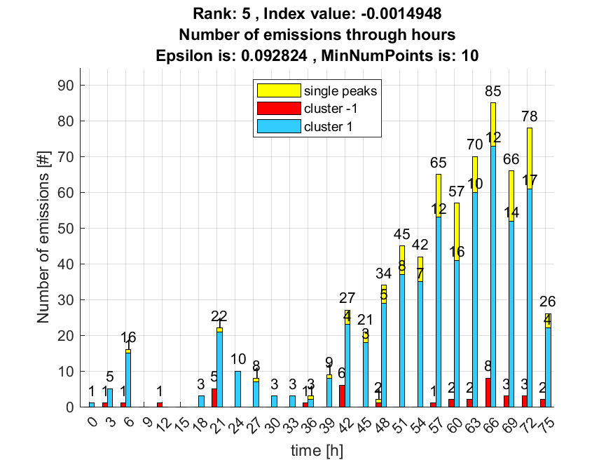

6. result: (pp2, pp4, peak_frequency)
Estimated Epsilon: 0.063191, Picked Epsilon: 0.093191, MinNumPoints: 10
DBCV_single_clust index value: -0.0015754
cluster -1 had 0.84746% single peaks
cluster 1 had 99.1525% single peaks
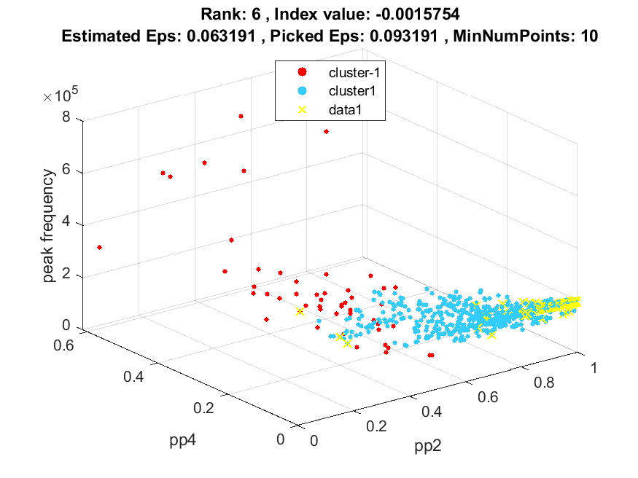
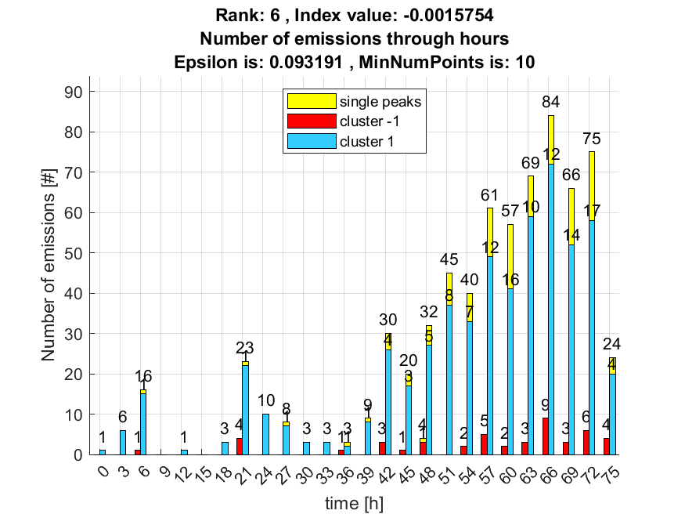

7. result: (rise_time, pp1, peak_frequency)
Estimated Epsilon: 0.060887, Picked Epsilon: 0.090887, MinNumPoints: 10
DBCV_single_clust index value: -0.0043291
cluster -1 had 0.84746% single peaks
cluster 1 had 99.1525% single peaks
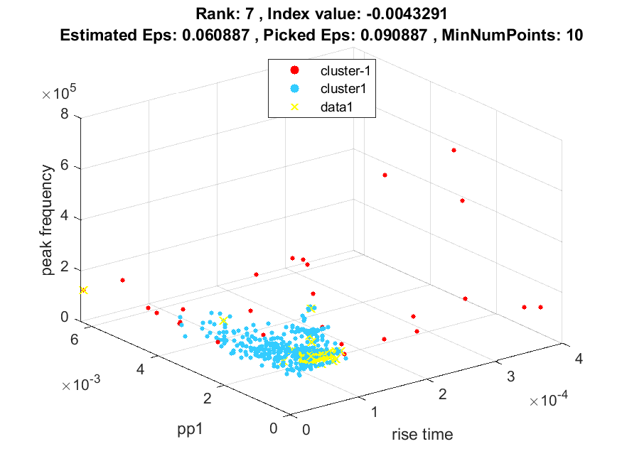
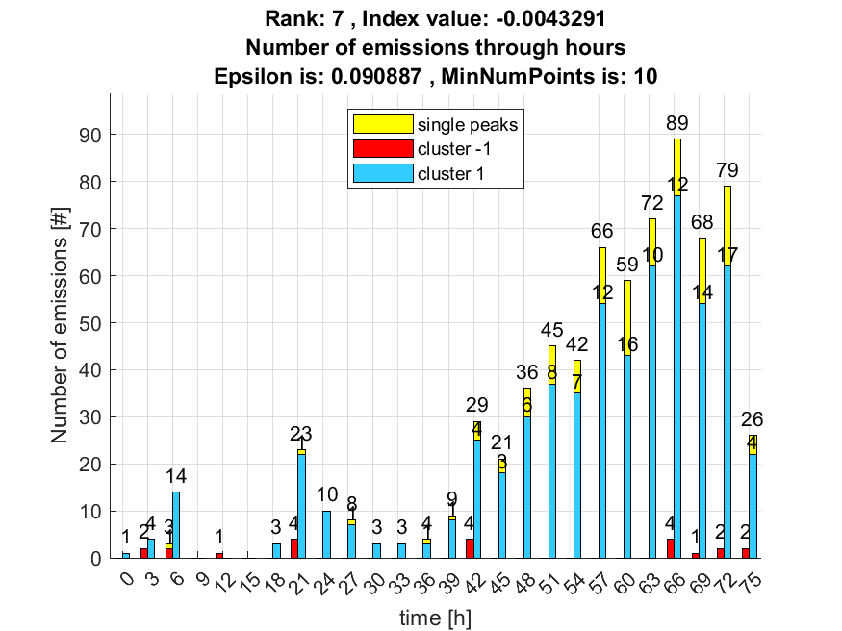

8. result: (rise_time, signal_strength, peak_frequency)
Estimated Epsilon: 0.051852, Picked Epsilon: 0.081852, MinNumPoints: 10
DBCV_single_clust index value: -0.0045198
cluster -1 had 2.5424% single peaks
cluster 1 had 97.4576% single peaks
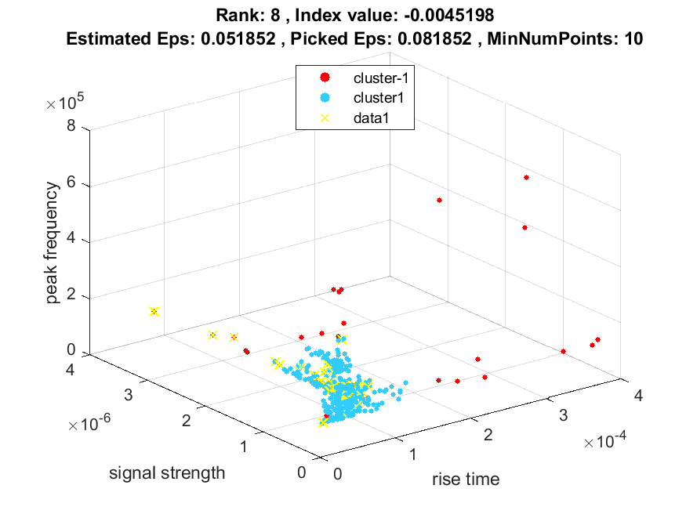
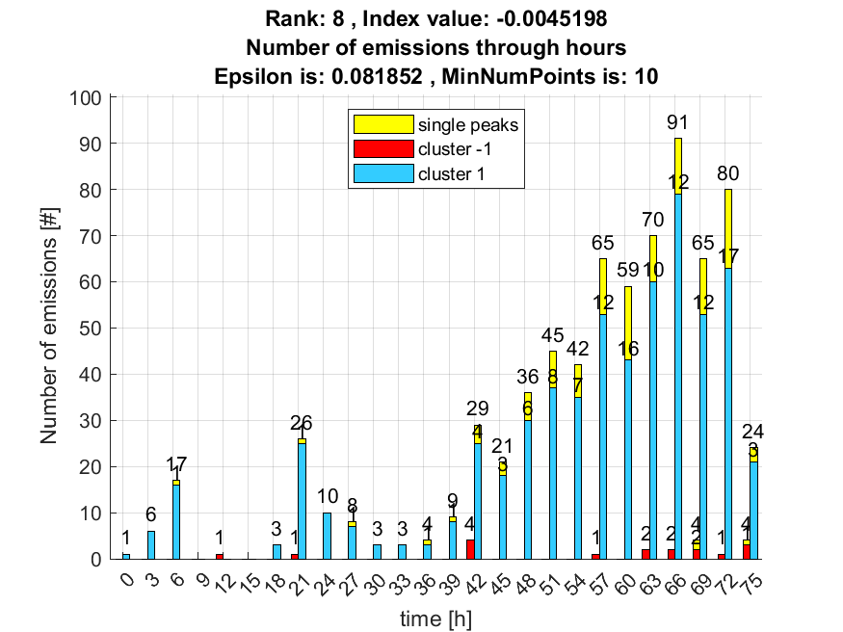

9. result: (rise_time, peak_frequency, max_frequency)
Estimated Epsilon: 0.044349, Picked Epsilon: 0.074349, MinNumPoints: 10
DBCV_single_clust index value: -0.0045963
cluster -1 had 3.3898% single peaks
cluster 1 had 96.6102% single peaks
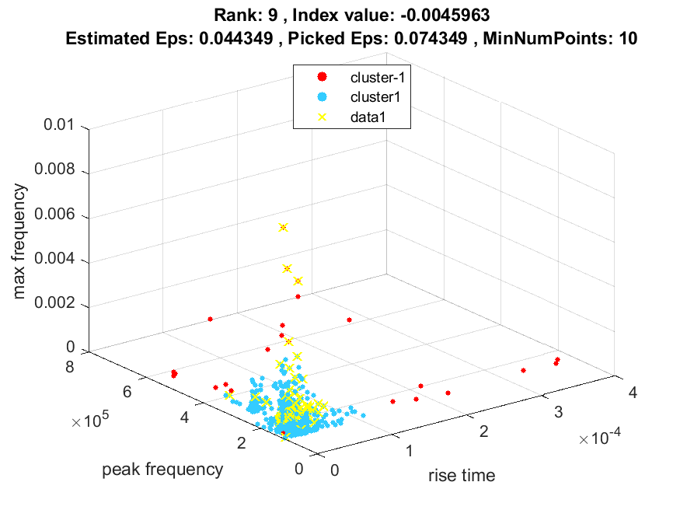
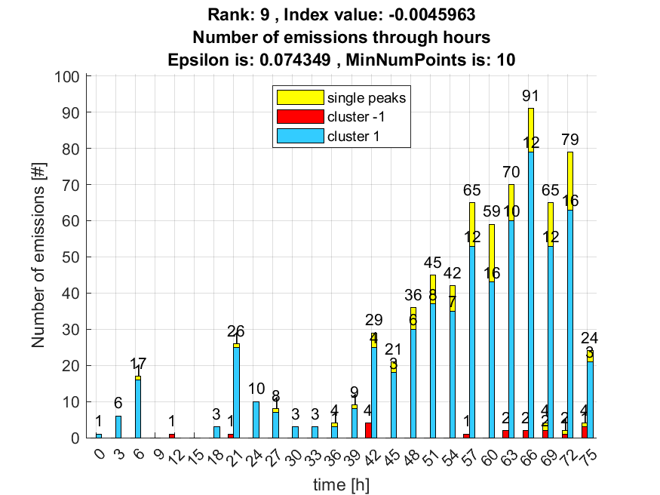

10. result: (peak_frequency, total_counts, fall_time)
Estimated Epsilon: 0.063469, Picked Epsilon: 0.093469, MinNumPoints: 10
DBCV_single_clust index value: -0.0046892
cluster -1 had 0% single peaks
cluster 1 had 100% single peaks
