# Feature selection results for big_dataset and Nmin = 10

1. result: **(signal_strength, peak_frequency, max_frequency)**

**Estimated Epsilon: 0.0062405, Picked Epsilon: 0.018741, MinNumPoints: 10**

**DBCV index value: 0.66925**

**cluster -1 had 1.4754% single peaks**

**cluster 1 had 97.0492% single peaks**

**cluster 2 had 1.1475% single peaks**

**cluster 3 had 0% single peaks**

**cluster 4 had 0% single peaks**

**cluster 5 had 0.32787% single peaks**

**cluster 6 had 0% single peaks**

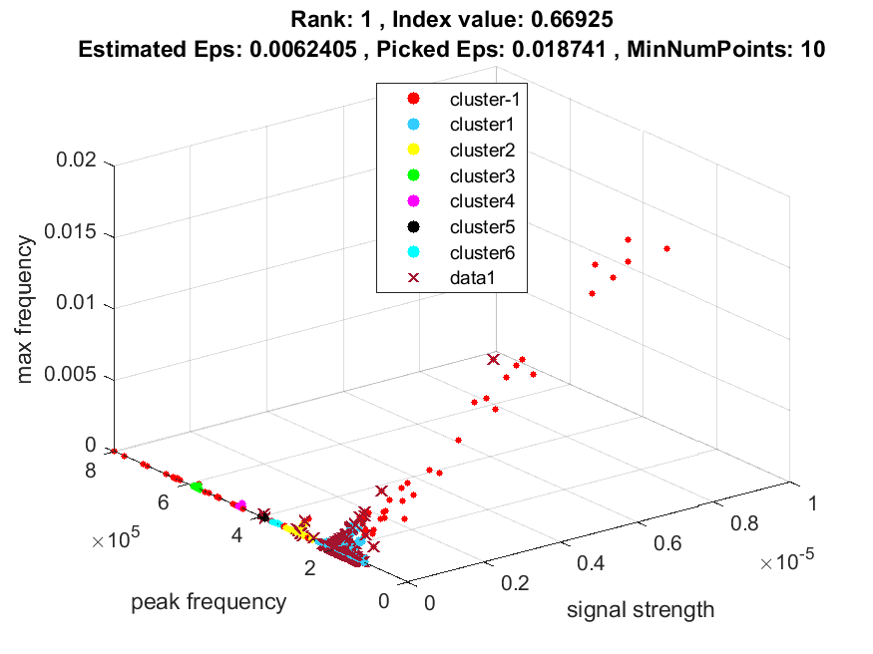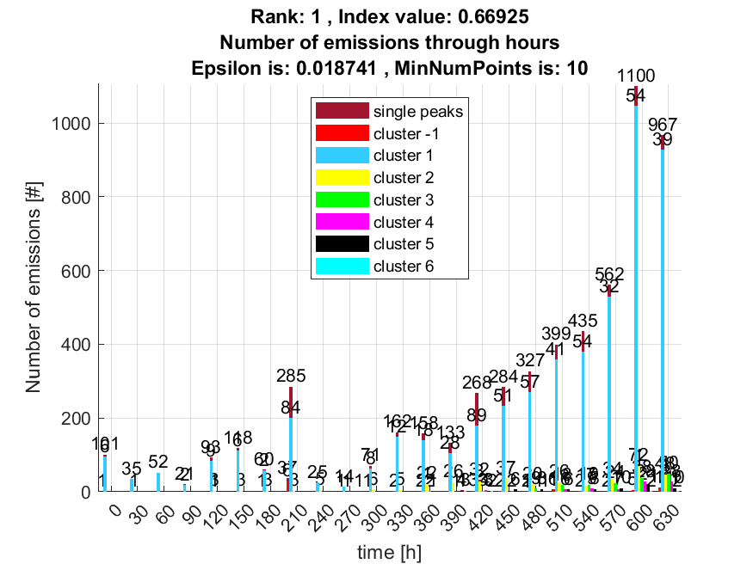

**2. result: (peak_amplitude, peak_frequency, max_frequency)**

**Estimated Epsilon: 0.0085671, Picked Epsilon: 0.021067, MinNumPoints: 10**

**DBCV index value: 0.66481**

**cluster -1 had 1.6393% single peaks**

**cluster 1 had 96.8852% single peaks**

**cluster 2 had 1.1475% single peaks**

**cluster 3 had 0% single peaks**

**cluster 4 had 0% single peaks**

**cluster 5 had 0.32787% single peaks**

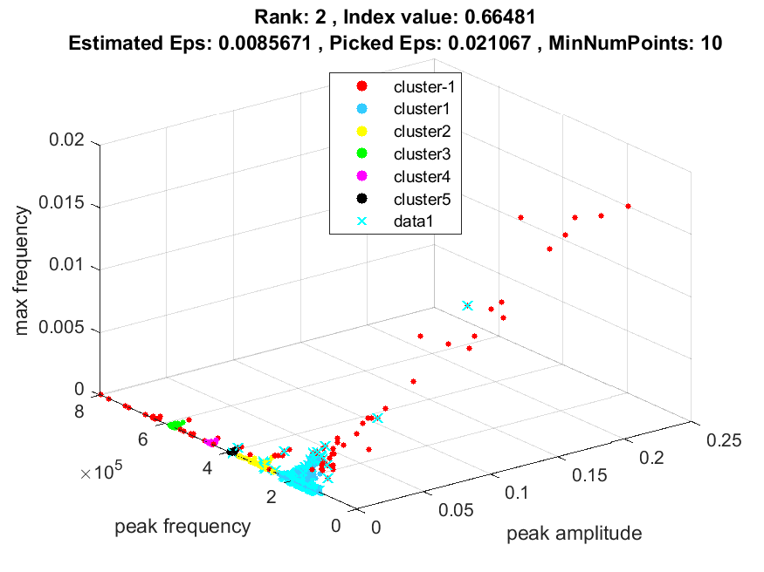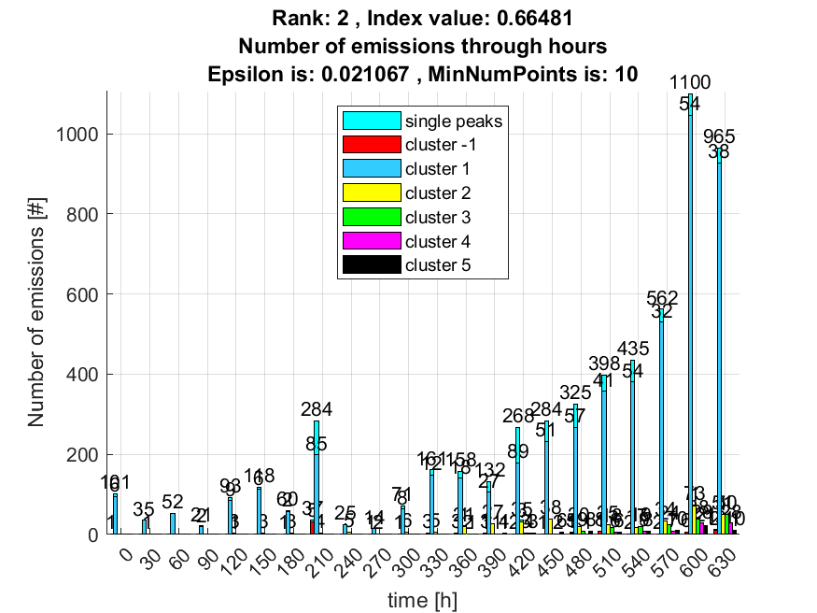

**3. result: (peak_amplitude, pp3, peak_frequency)**

**Estimated Epsilon: 0.018447, Picked Epsilon: 0.040947, MinNumPoints: 10**

**DBCV index value: 0.65286**

**cluster -1 had 1.3115% single peaks**

**cluster 1 had 98.0328% single peaks**

**cluster 2 had 0.32787% single peaks**

**cluster 3 had 0% single peaks**

**cluster 4 had 0% single peaks**

**cluster 5 had 0.16393% single peaks**

**cluster 6 had 0.16393% single peaks**

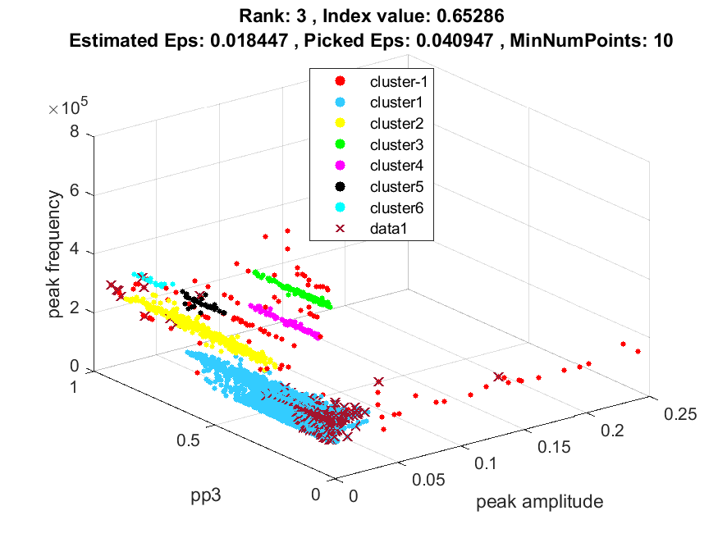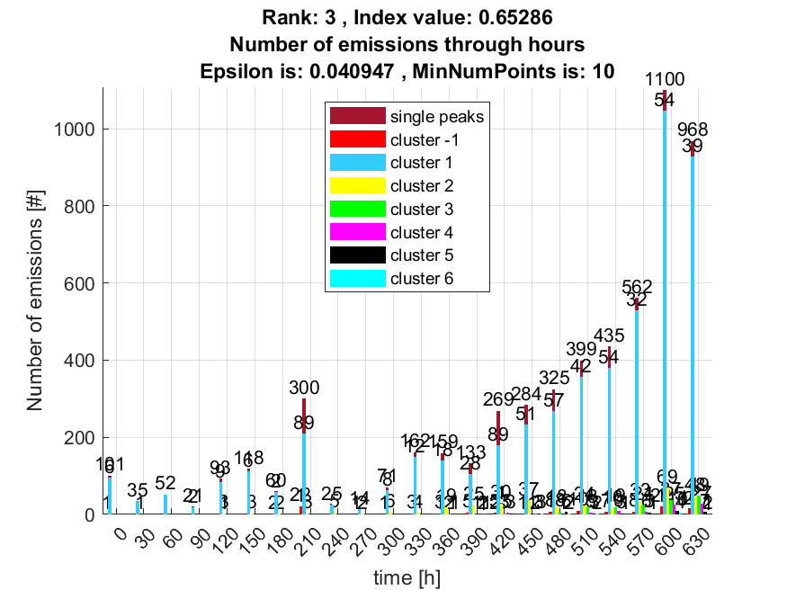

**4. result: (pp3, peak_frequency, max_frequency)**

**Estimated Epsilon: 0.014342, Picked Epsilon: 0.039342, MinNumPoints: 10**

**DBCV index value: 0.65251**

**cluster -1 had 1.3115% single peaks**

**cluster 1 had 98.0328% single peaks**

**cluster 2 had 0.32787% single peaks**

**cluster 3 had 0% single peaks**

**cluster 4 had 0% single peaks**

**cluster 5 had 0.16393% single peaks**

**cluster 6 had 0.16393% single peaks**

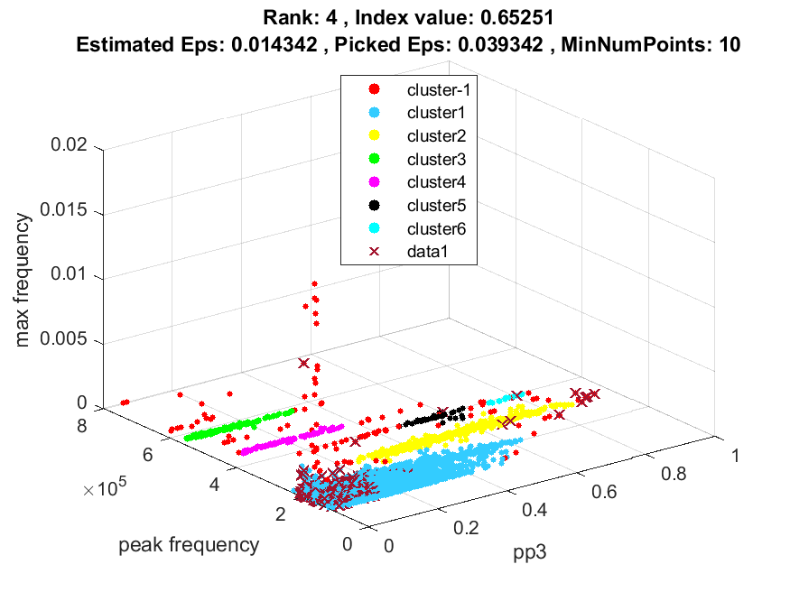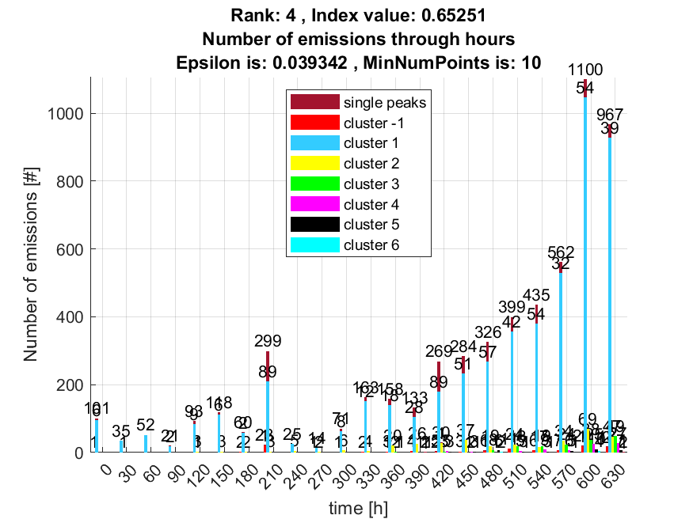

**5. result: (signal_strength, pp3, peak_frequency)**

**Estimated Epsilon: 0.017417, Picked Epsilon: 0.039917, MinNumPoints: 10**

**DBCV index value: 0.65191**

**cluster -1 had 1.3115% single peaks**

**cluster 1 had 98.0328% single peaks**

**cluster 2 had 0.32787% single peaks**

**cluster 3 had 0% single peaks**

**cluster 4 had 0% single peaks**

**cluster 5 had 0.16393% single peaks**

**cluster 6 had 0.16393% single peaks**

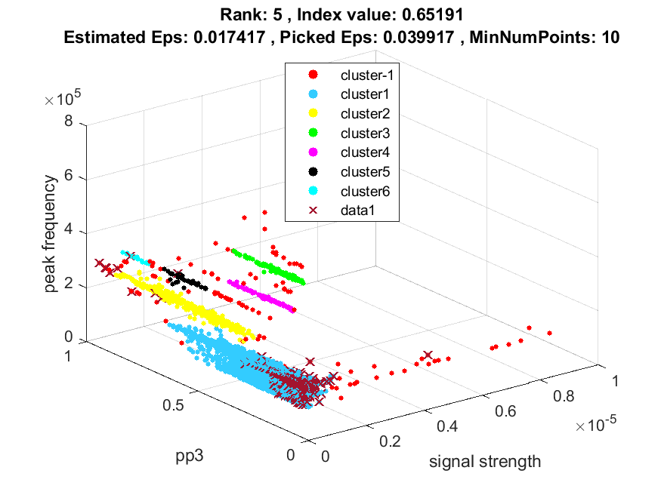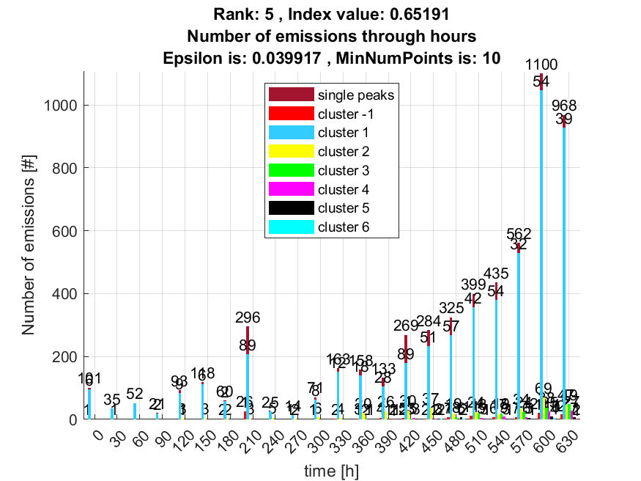

**6. result: (pp2, peak_frequency, max_frequency)**

**Estimated Epsilon: 0.01633, Picked Epsilon: 0.04383, MinNumPoints: 10**

**DBCV index value: 0.64942**

**cluster -1 had 0.65574% single peaks**

**cluster 1 had 98.0328% single peaks**

**cluster 2 had 1.1475% single peaks**

**cluster 3 had 0% single peaks**

**cluster 4 had 0% single peaks**

**cluster 5 had 0.16393% single peaks**

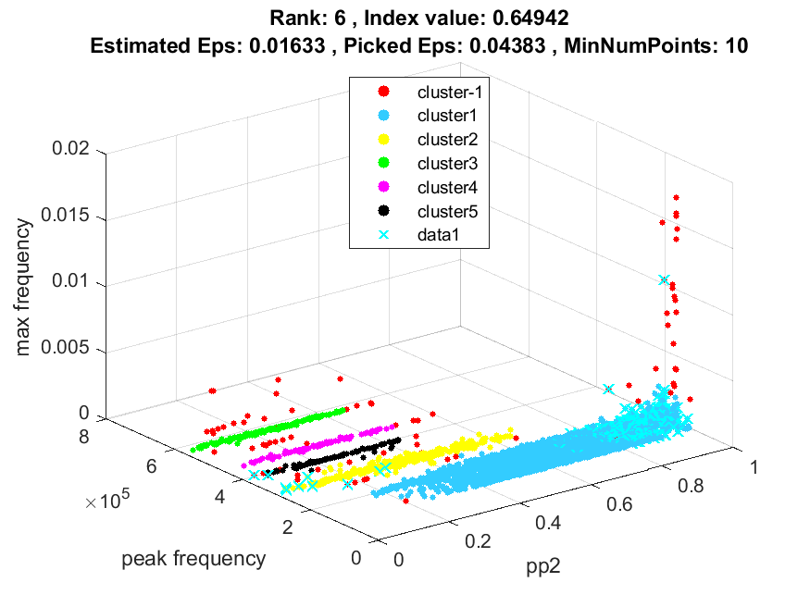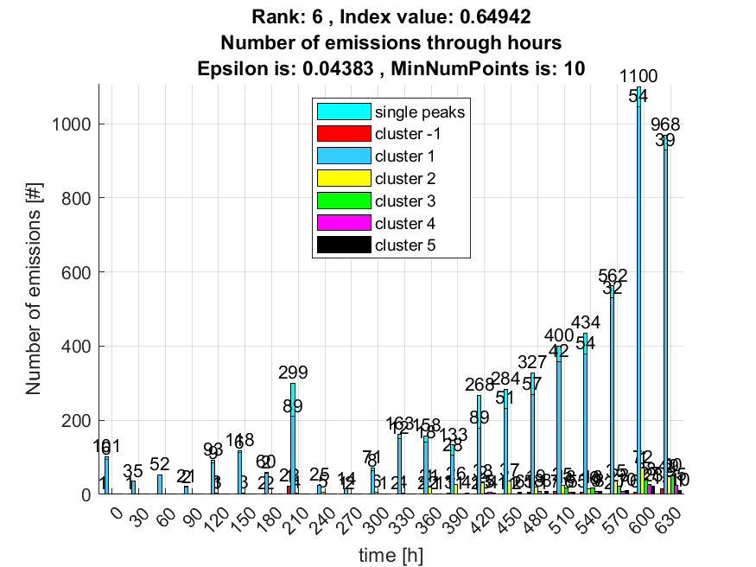

**7. result: (signal_strength, centroid_frequency, peak_frequency)**

**Estimated Epsilon: 0.01697, Picked Epsilon: 0.04197, MinNumPoints: 10**

**DBCV index value: 0.64873**

**cluster -1 had 0.4918% single peaks**

**cluster 1 had 98.0328% single peaks**

**cluster 2 had 1.1475% single peaks**

**cluster 3 had 0% single peaks**

**cluster 4 had 0% single peaks**

**cluster 5 had 0.32787% single peaks**

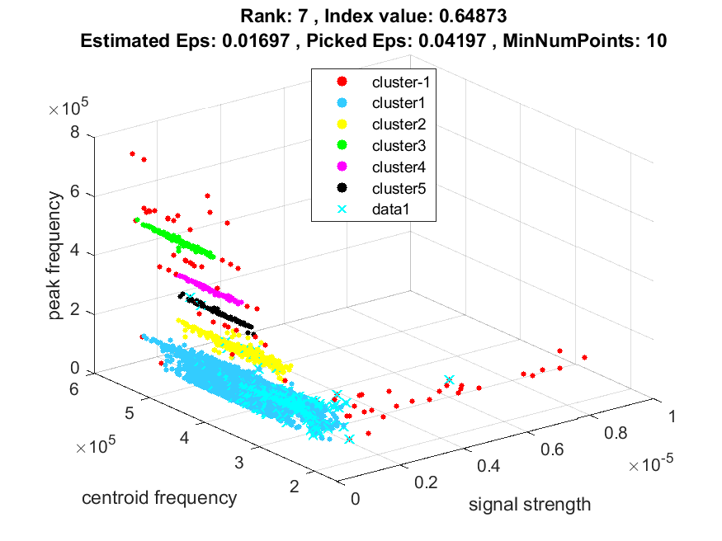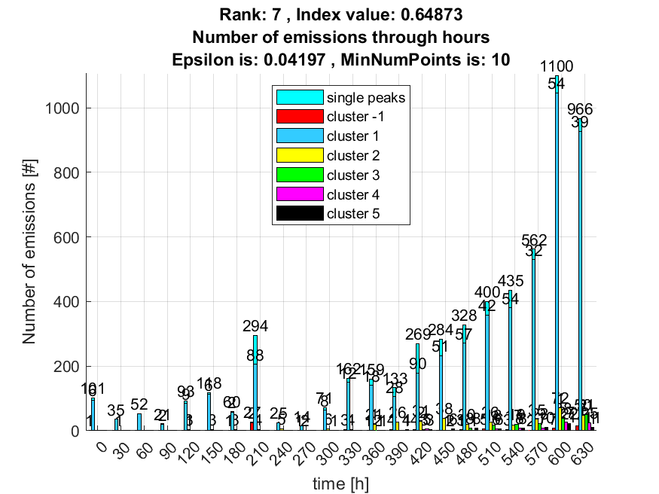

**8. result: (peak_amplitude, pp2, peak_frequency)**

**Estimated Epsilon: 0.018288, Picked Epsilon: 0.043288, MinNumPoints: 10**

**DBCV index value: 0.64832**

**cluster -1 had 0.98361% single peaks**

**cluster 1 had 98.0328% single peaks**

**cluster 2 had 0.98361% single peaks**

**cluster 3 had 0% single peaks**

**cluster 4 had 0% single peaks**

**cluster 5 had 0% single peaks**

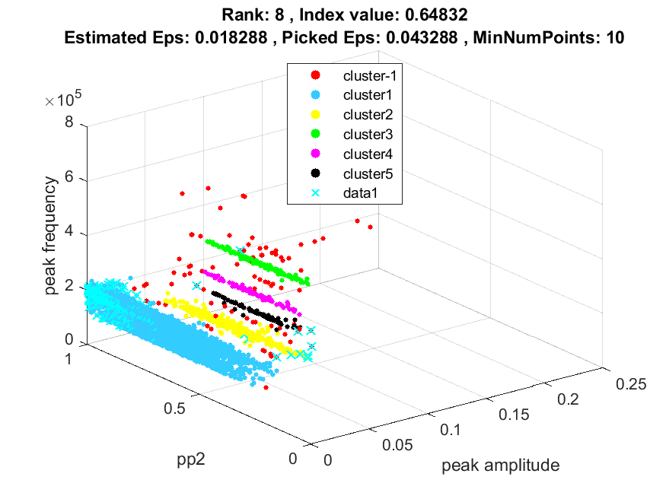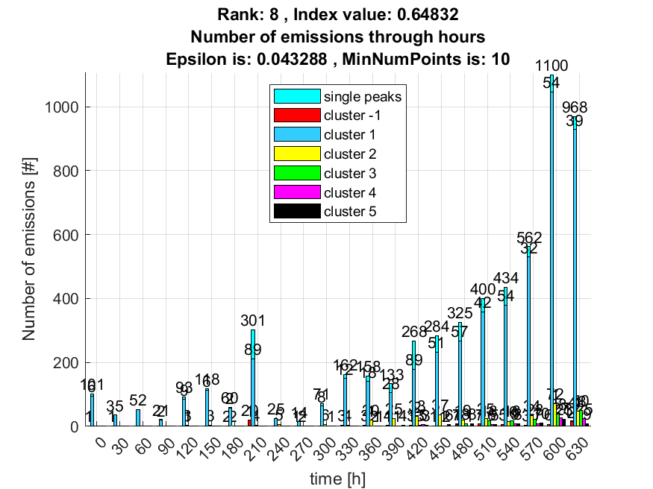

**9. result: (centroid_frequency, peak_frequency, max_frequency)**

**Estimated Epsilon: 0.016101, Picked Epsilon: 0.041101, MinNumPoints: 10**

**DBCV index value: 0.64811**

**cluster -1 had 0.4918% single peaks**

**cluster 1 had 98.0328% single peaks**

**cluster 2 had 1.1475% single peaks**

**cluster 3 had 0% single peaks**

**cluster 4 had 0% single peaks**

**cluster 5 had 0.32787% single peaks**

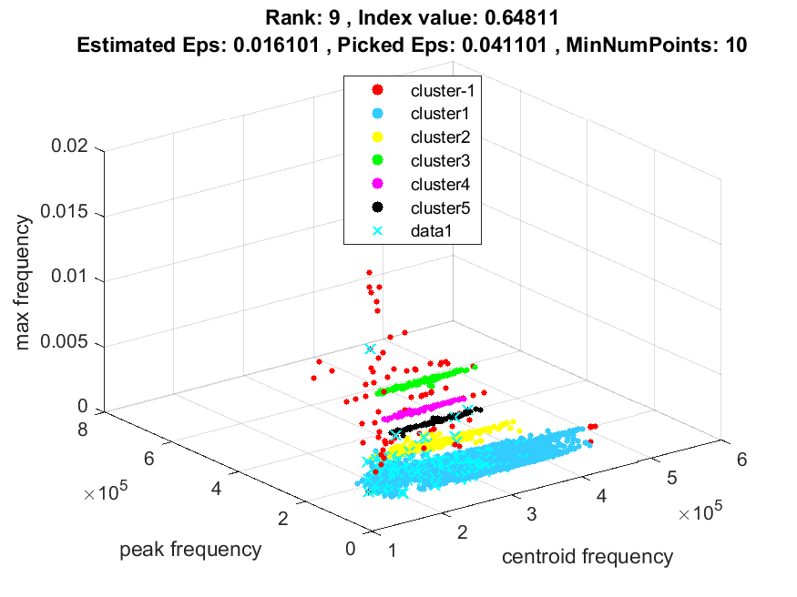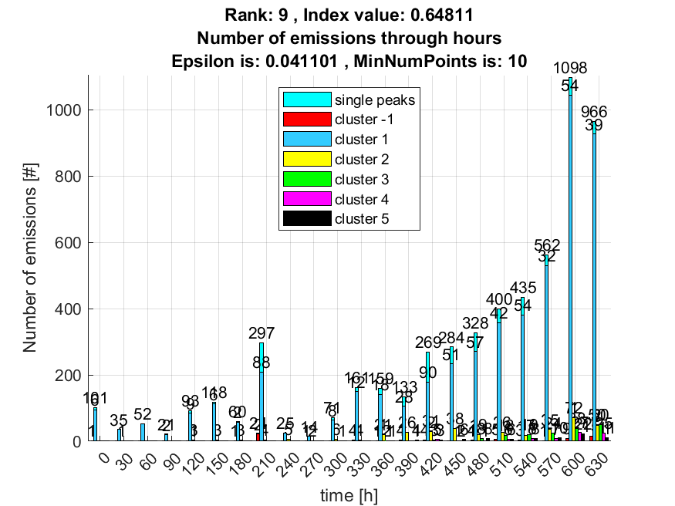

**10. result: (signal_strength, pp2, peak_frequency)**

**Estimated Epsilon: 0.016969, Picked Epsilon: 0.041969, MinNumPoints: 10**

**DBCV index value: 0.6467**

**cluster -1 had 0.98361% single peaks**

**cluster 1 had 97.8689% single peaks**

**cluster 2 had 1.1475% single peaks**

**cluster 3 had 0% single peaks**

**cluster 4 had 0% single peaks**

**cluster 5 had 0% single peaks**

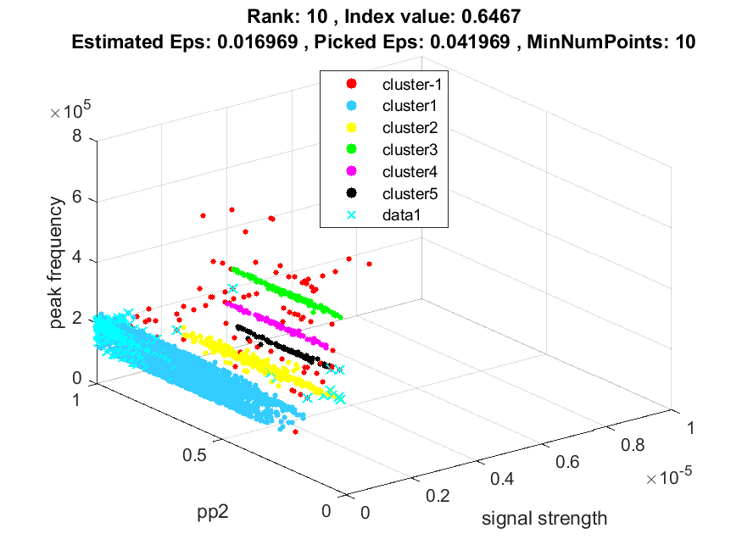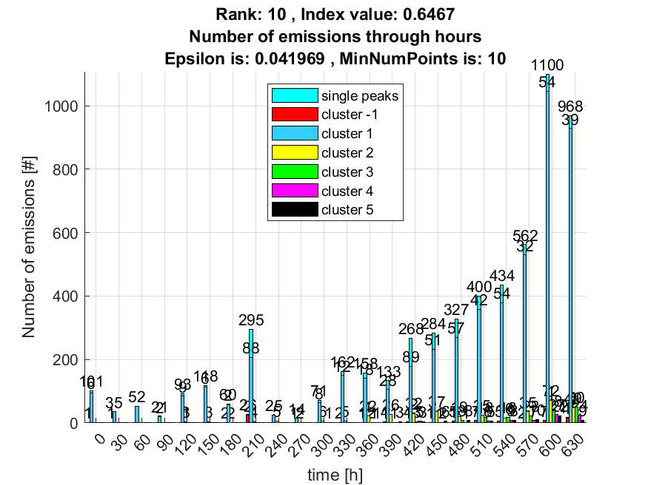

**Cluster results correlations:**

**Intersection between rank 1 and rank 2 :**

**1 0 0**

**0 1 0**

**0 0 1**

**Intersection between rank 1 and rank 3 :**

**0.9971 0.0002 0.0002 0.0026**

**0.0006 0.9767 0 0**

**0.0011 0 0.9195 0**

**Intersection between rank 1 and rank 4 :**

**0.9882 0 0.0002 0.0090 0.0026**

**0.0013 0.9535 0 0 0**

**0.0011 0 0.9195 0 0**

**Intersection between rank 1 and rank 5 :**

**0.9971 0.0002 0.0002 0.0026**

**0.0005 0.9826 0 0**

**0.0011 0 0.9195 0**

**Intersection between rank 1 and rank 6 :**

**0.9868 0 0.0002 0.0130**

**0.0015 0.9477 0 0**

**0.0007 0 0.9540 0**

**Intersection between rank 1 and rank 7 :**

**0.9870 0 0.0002 0.0129**

**0.0010 0.9651 0 0**

**0.0007 0 0.9540 0**

**Intersection between rank 1 and rank 8 :**

**0.9870 0 0.0002 0.0129**

**0.0013 0.9535 0 0**

**0.0007 0 0.9540 0**

**Intersection between rank 1 and rank 9 :**

**0.9868 0 0.0002 0.0130**

**0.0013 0.9535 0 0**

**0.0007 0 0.9540 0**

**Intersection between rank 1 and rank 10 :**

**0.9866 0 0.0002 0.0132**

**0.0013 0.9535 0 0**

**0.0007 0 0.9540 0**

**Intersection between rank 2 and rank 3 :**

**0.9971 0.0002 0.0002 0.0026**

**0.0006 0.9767 0 0**

**0.0011 0 0.9195 0**

**Intersection between rank 2 and rank 4 :**

**0.9882 0 0.0002 0.0090 0.0026**

**0.0013 0.9535 0 0 0**

**0.0011 0 0.9195 0 0**

**Intersection between rank 2 and rank 5 :**

**0.9971 0.0002 0.0002 0.0026**

**0.0005 0.9826 0 0**

**0.0011 0 0.9195 0**

**Intersection between rank 2 and rank 6 :**

**0.9868 0 0.0002 0.0130**

**0.0015 0.9477 0 0**

**0.0007 0 0.9540 0**

**Intersection between rank 2 and rank 7 :**

**0.9870 0 0.0002 0.0129**

**0.0010 0.9651 0 0**

**0.0007 0 0.9540 0**

**Intersection between rank 2 and rank 8 :**

**0.9870 0 0.0002 0.0129**

**0.0013 0.9535 0 0**

**0.0007 0 0.9540 0**

**Intersection between rank 2 and rank 9 :**

**0.9868 0 0.0002 0.0130**

**0.0013 0.9535 0 0**

**0.0007 0 0.9540 0**

**Intersection between rank 2 and rank 10 :**

**0.9866 0 0.0002 0.0132**

**0.0013 0.9535 0 0**

**0.0007 0 0.9540 0**

**Intersection between rank 3 and rank 4 :**

**0.9907 0.0002 0 0.0090 0.0002**

**0.0010 0.9645 0 0 0**

**0 0 1.0000 0 0**

**0.0002 0 0 0 0.9375**

**Intersection between rank 3 and rank 5 :**

**0.9997 0.0002 0 0.0002**

**0 0.9941 0 0**

**0 0 1.0000 0**

**0.0002 0 0 0.9375**

**Intersection between rank 3 and rank 6 :**

**0.9879 0.0003 0.0011 0.0106**

**0.0013 0.9527 0 0**

**0.0007 0 0.9167 0**

**0.0002 0 0 0.1852**

**Intersection between rank 3 and rank 7 :**

**0.9881 0.0005 0.0011 0.0103**

**0.0010 0.9645 0 0**

**0.0007 0 0.9167 0**

**0 0 0 0.2000**

**Intersection between rank 3 and rank 8 :**

**0.9879 0.0003 0.0011 0.0106**

**0.0011 0.9586 0 0**

**0.0007 0 0.9167 0**

**0.0003 0 0 0.1750**

**Intersection between rank 3 and rank 9 :**

**0.9881 0.0003 0.0011 0.0105**

**0.0011 0.9586 0 0**

**0.0007 0 0.9167 0**

**0 0 0 0.1975**

**Intersection between rank 3 and rank 10 :**

**0.9878 0.0003 0.0011 0.0108**

**0.0011 0.9586 0 0**

**0.0007 0 0.9167 0**

**0.0002 0 0 0.1829**

**Intersection between rank 4 and rank 5 :**

**0.9910 0.0010 0 0**

**0 0.9647 0 0**

**0 0 1.0000 0**

**0.0090 0 0 0**

**0 0 0 1.0000**

**Intersection between rank 4 and rank 6 :**

**0.9966 0.0003 0.0011 0.0019**

**0.0005 0.9817 0 0**

**0.0007 0 0.9167 0**

**0.0003 0 0 0.6667**

**0.0002 0 0 0.1852**

**Intersection between rank 4 and rank 7 :**

**0.9964 0.0006 0.0011 0.0018**

**0.0003 0.9759 0 0**

**0.0007 0 0.9167 0**

**0.0005 0 0 0.6625**

**0 0 0 0.2000**

**Intersection between rank 4 and rank 8 :**

**0.9963 0.0005 0.0011 0.0021**

**0.0005 0.9817 0 0**

**0.0007 0 0.9167 0**

**0.0005 0 0 0.6625**

**0.0003 0 0 0.1750**

**Intersection between rank 4 and rank 9 :**

**0.9964 0.0005 0.0011 0.0019**

**0.0005 0.9817 0 0**

**0.0007 0 0.9167 0**

**0.0005 0 0 0.6543**

**0 0 0 0.1975**

**Intersection between rank 4 and rank 10 :**

**0.9963 0.0005 0.0011 0.0021**

**0.0005 0.9817 0 0**

**0.0007 0 0.9167 0**

**0.0003 0 0 0.6585**

**0.0002 0 0 0.1829**

**Intersection between rank 5 and rank 6 :**

**0.9881 0.0002 0.0011 0.0106**

**0.0013 0.9529 0 0**

**0.0007 0 0.9167 0**

**0.0002 0 0 0.1852**

**Intersection between rank 5 and rank 7 :**

**0.9882 0.0003 0.0011 0.0103**

**0.0010 0.9647 0 0**

**0.0007 0 0.9167 0**

**0 0 0 0.2000**

**Intersection between rank 5 and rank 8 :**

**0.9881 0.0002 0.0011 0.0106**

**0.0011 0.9588 0 0**

**0.0007 0 0.9167 0**

**0.0003 0 0 0.1750**

**Intersection between rank 5 and rank 9 :**

**0.9882 0.0002 0.0011 0.0105**

**0.0011 0.9588 0 0**

**0.0007 0 0.9167 0**

**0 0 0 0.1975**

**Intersection between rank 5 and rank 10 :**

**0.9879 0.0002 0.0011 0.0108**

**0.0011 0.9588 0 0**

**0.0007 0 0.9167 0**

**0.0002 0 0 0.1829**

**Intersection between rank 6 and rank 7 :**

**0.9985 0.0007 0.0003 0.0005**

**0.0002 0.9759 0 0**

**0.0003 0 0.9762 0**

**0.0007 0 0 0.9506**

**Intersection between rank 6 and rank 8 :**

**0.9997 0.0002 0 0.0002**

**0 0.9939 0 0**

**0 0 1.0000 0**

**0.0003 0 0 0.9753**

**Intersection between rank 6 and rank 9 :**

**0.9987 0.0005 0.0003 0.0005**

**0.0003 0.9817 0 0**

**0.0003 0 0.9762 0**

**0.0005 0 0 0.9630**

**Intersection between rank 6 and rank 10 :**

**0.9997 0.0002 0 0.0002**

**0 0.9939 0 0**

**0 0 1.0000 0**

**0 0 0 0.9878**

**Intersection between rank 7 and rank 8 :**

**0.9985 0.0002 0.0003 0.0007**

**0.0005 0.9819 0 0**

**0.0003 0 0.9762 0**

**0.0007 0 0 0.9500**

**Intersection between rank 7 and rank 9 :**

**0.9997 0 0 0.0002**

**0.0003 0.9880 0 0**

**0 0 1.0000 0**

**0 0 0 0.9877**

**Intersection between rank 7 and rank 10 :**

**0.9987 0.0002 0.0003 0.0008**

**0.0005 0.9819 0 0**

**0.0003 0 0.9762 0**

**0.0005 0 0 0.9390**

**Intersection between rank 8 and rank 9 :**

**0.9987 0.0003 0.0003 0.0007**

**0.0003 0.9878 0 0**

**0.0003 0 0.9762 0**

**0.0005 0 0 0.9506**

**Intersection between rank 8 and rank 10 :**

**0.9997 0 0 0.0003**

**0 1.0000 0 0**

**0 0 1.0000 0**

**0 0 0 0.9756**

**Intersection between rank 9 and rank 10 :**

**0.9987 0.0003 0.0003 0.0007**

**0.0003 0.9878 0 0**

**0.0003 0 0.9762 0**

**0.0005 0 0 0.9512**