# Feature selection results for big_dataset and Nmin = 10

1. result: **(signal_strength, peak_frequency, max_frequency)**

**Estimated Epsilon: 0.0062405, Picked Epsilon: 0.018741, MinNumPoints: 10**

**DBCV index value: 0.66925**

**cluster -1 had 1.4754% single peaks**

**cluster 1 had 97.0492% single peaks**

**cluster 2 had 1.1475% single peaks**

**cluster 3 had 0% single peaks**

**cluster 4 had 0% single peaks**

**cluster 5 had 0.32787% single peaks**

**cluster 6 had 0% single peaks**

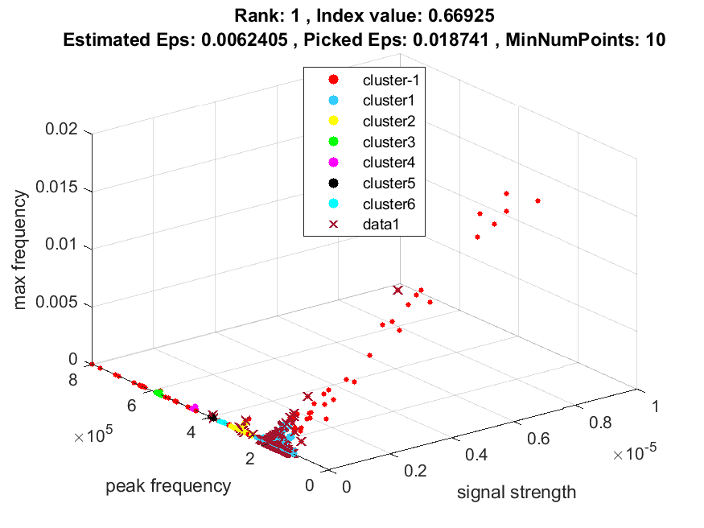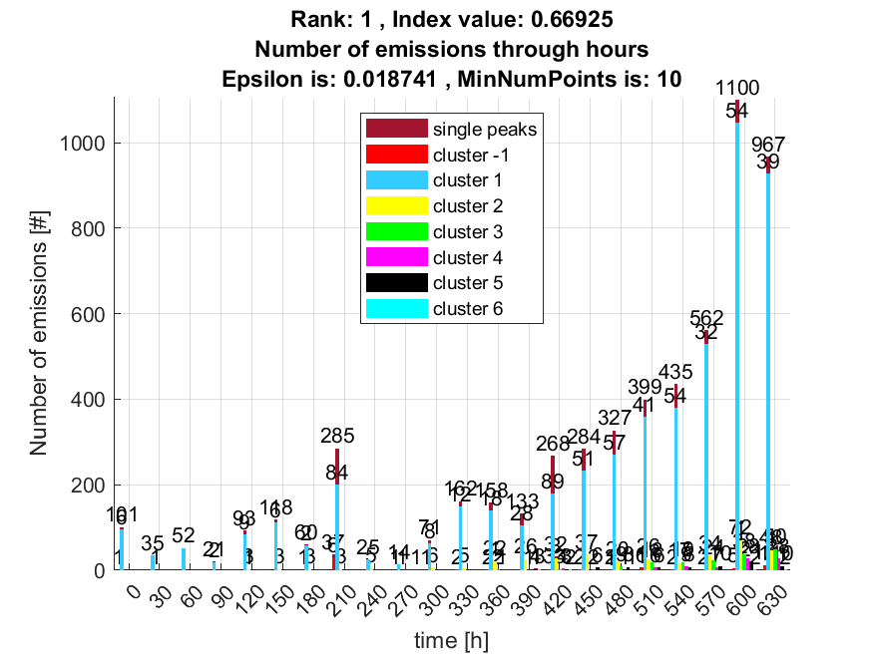

**2. result: (peak_amplitude, peak_frequency, max_frequency)**

**Estimated Epsilon: 0.0085671, Picked Epsilon: 0.021067, MinNumPoints: 10**

**DBCV index value: 0.66481**

**cluster -1 had 1.6393% single peaks**

**cluster 1 had 96.8852% single peaks**

**cluster 2 had 1.1475% single peaks**

**cluster 3 had 0% single peaks**

**cluster 4 had 0% single peaks**

**cluster 5 had 0.32787% single peaks**

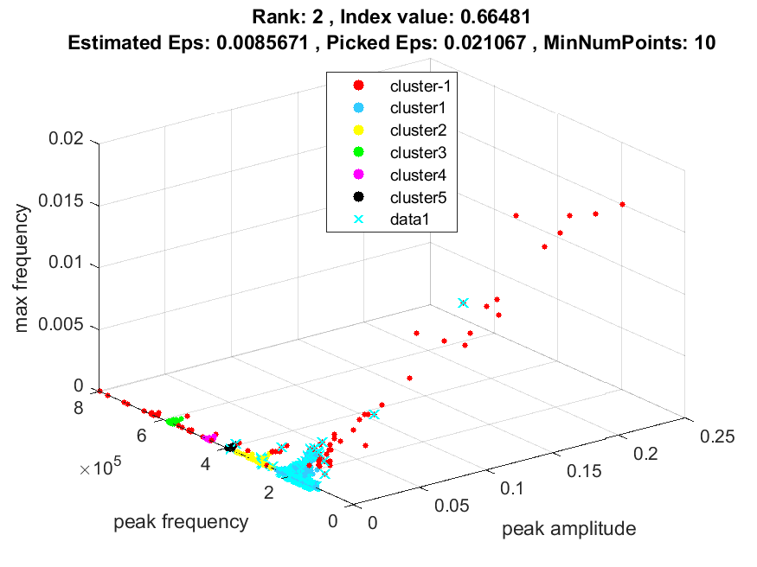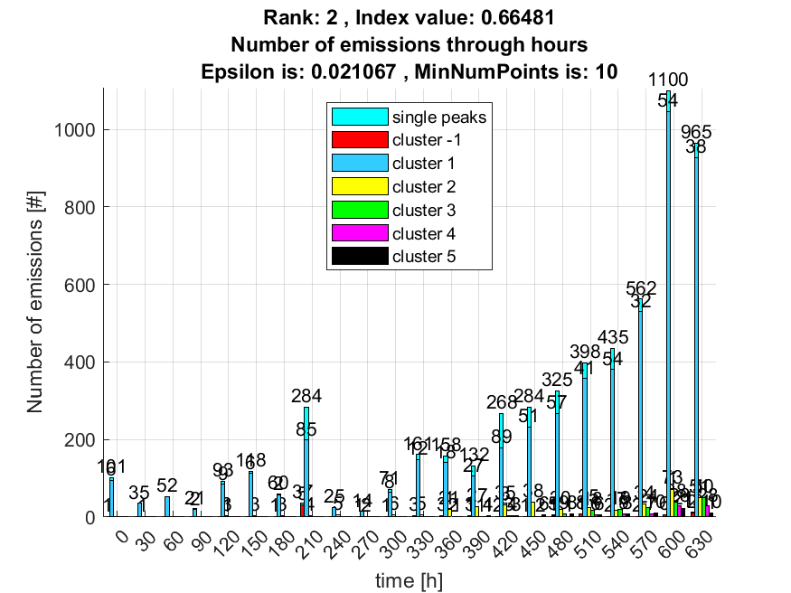

**3. result: (rise_time, counts_from, peak_frequency)**

**Estimated Epsilon: 0.019441, Picked Epsilon: 0.041941, MinNumPoints: 10**

**DBCV index value: 0.66373**

**cluster -1 had 2.2951% single peaks**

**cluster 1 had 97.377% single peaks**

**cluster 2 had 0% single peaks**

**cluster 3 had 0% single peaks**

**cluster 4 had 0.32787% single peaks**

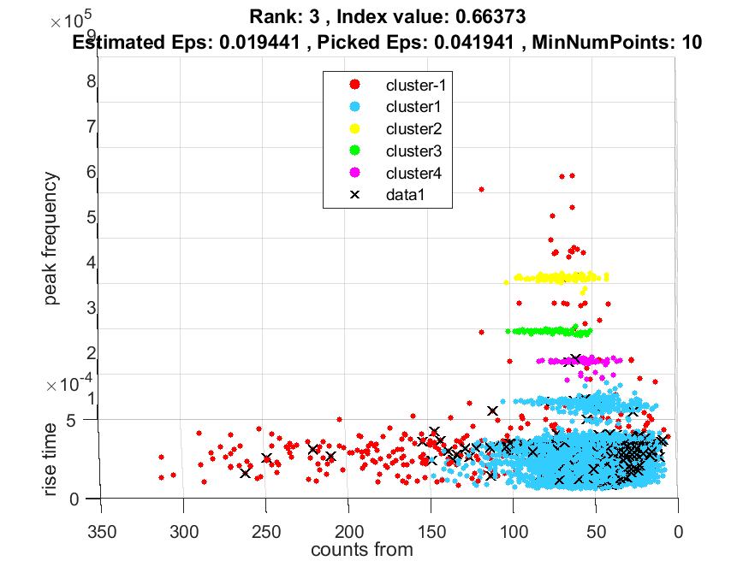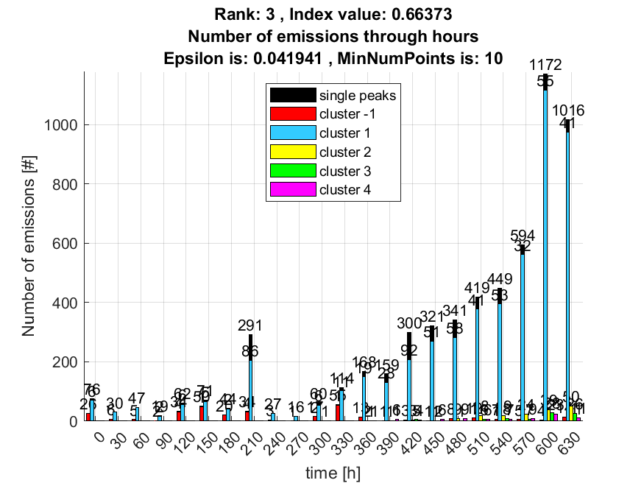

**4. result: (peak_amplitude, pp3, peak_frequency)**

**Estimated Epsilon: 0.018447, Picked Epsilon: 0.040947, MinNumPoints: 10**

**DBCV index value: 0.65286**

**cluster -1 had 1.3115% single peaks**

**cluster 1 had 98.0328% single peaks**

**cluster 2 had 0.32787% single peaks**

**cluster 3 had 0% single peaks**

**cluster 4 had 0% single peaks**

**cluster 5 had 0.16393% single peaks**

**cluster 6 had 0.16393% single peaks**

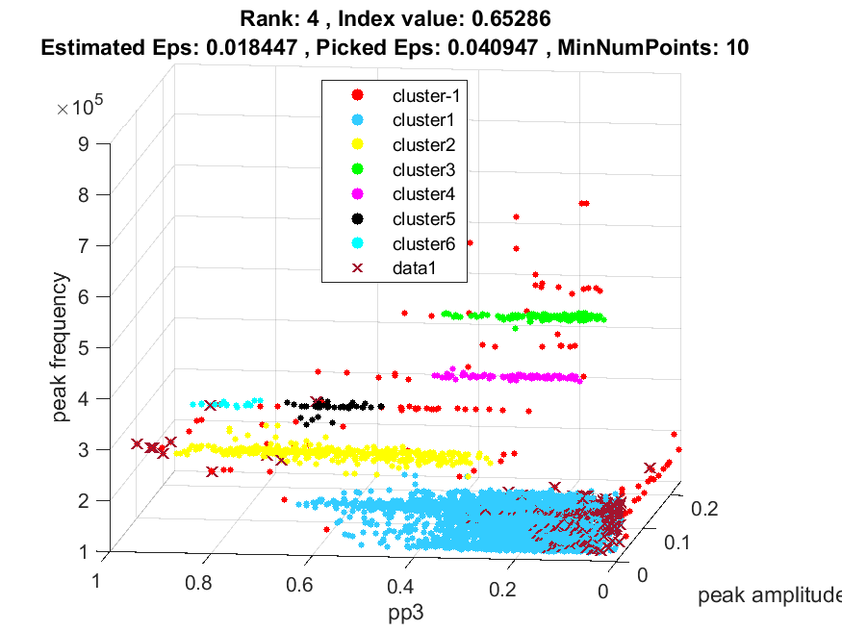

**5. result: (pp3, peak_frequency, max_frequency)**

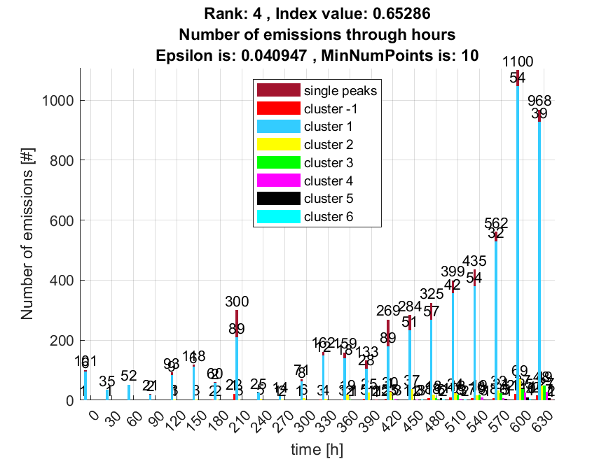

**Estimated Epsilon: 0.014342, Picked Epsilon: 0.039342, MinNumPoints: 10**

**DBCV index value: 0.65251**

**cluster -1 had 1.3115% single peaks**

**cluster 1 had 98.0328% single peaks**

**cluster 2 had 0.32787% single peaks**

**cluster 3 had 0% single peaks**

**cluster 4 had 0% single peaks**

**cluster 5 had 0.16393% single peaks**

**cluster 6 had 0.16393% single peaks**

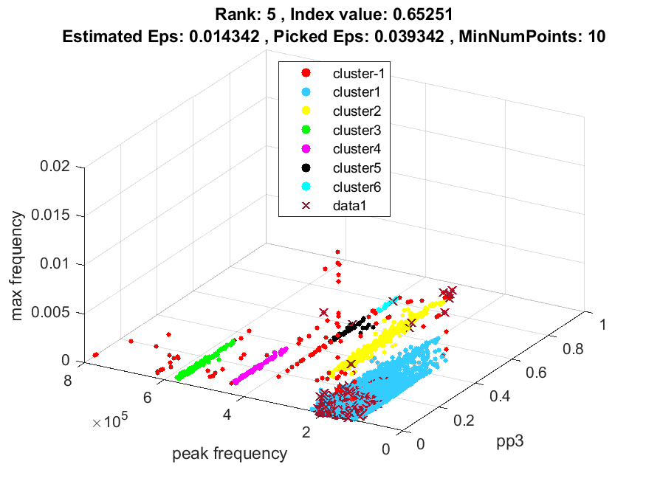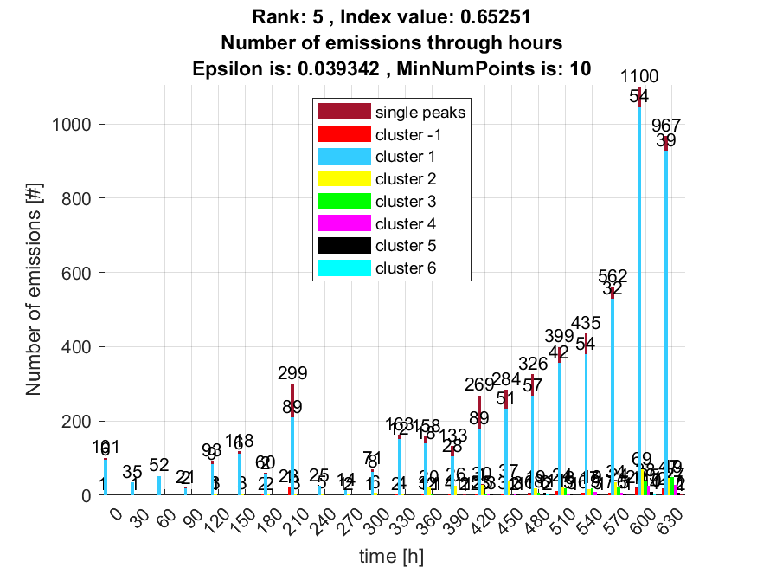

**6. result: (signal_strength, pp3, peak_frequency)**

**Estimated Epsilon: 0.017417, Picked Epsilon: 0.039917, MinNumPoints: 10**

**DBCV index value: 0.65191**

**cluster -1 had 1.3115% single peaks**

**cluster 1 had 98.0328% single peaks**

**cluster 2 had 0.32787% single peaks**

**cluster 3 had 0% single peaks**

**cluster 4 had 0% single peaks**

**cluster 5 had 0.16393% single peaks**

**cluster 6 had 0.16393% single peaks**

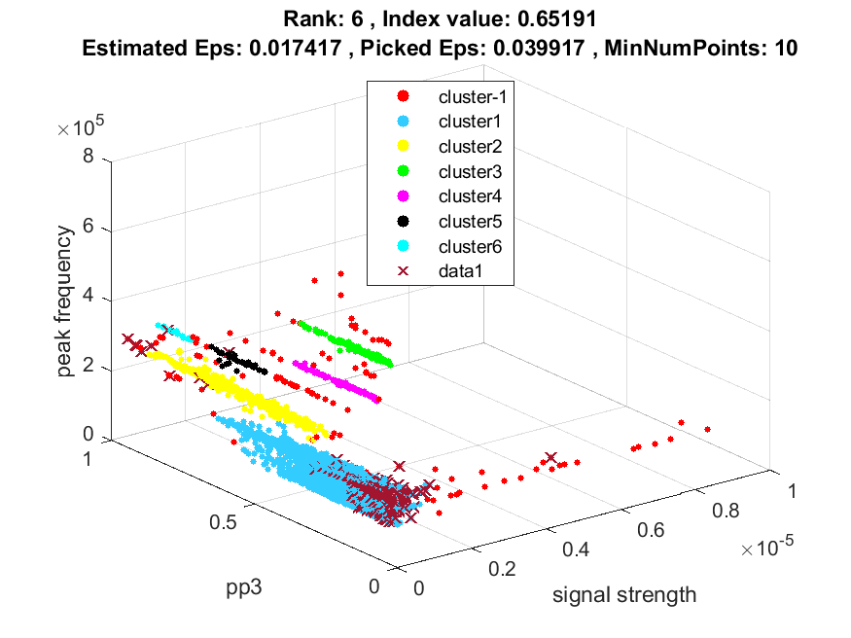

**7. result: (pp2, peak_frequency, max_frequency)**

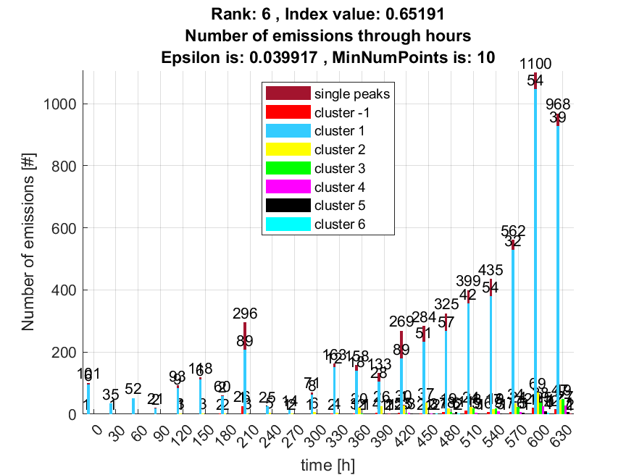

**Estimated Epsilon: 0.01633, Picked Epsilon: 0.04383, MinNumPoints: 10**

**DBCV index value: 0.64942**

**cluster -1 had 0.65574% single peaks**

**cluster 1 had 98.0328% single peaks**

**cluster 2 had 1.1475% single peaks**

**cluster 3 had 0% single peaks**

**cluster 4 had 0% single peaks**

**cluster 5 had 0.16393% single peaks**

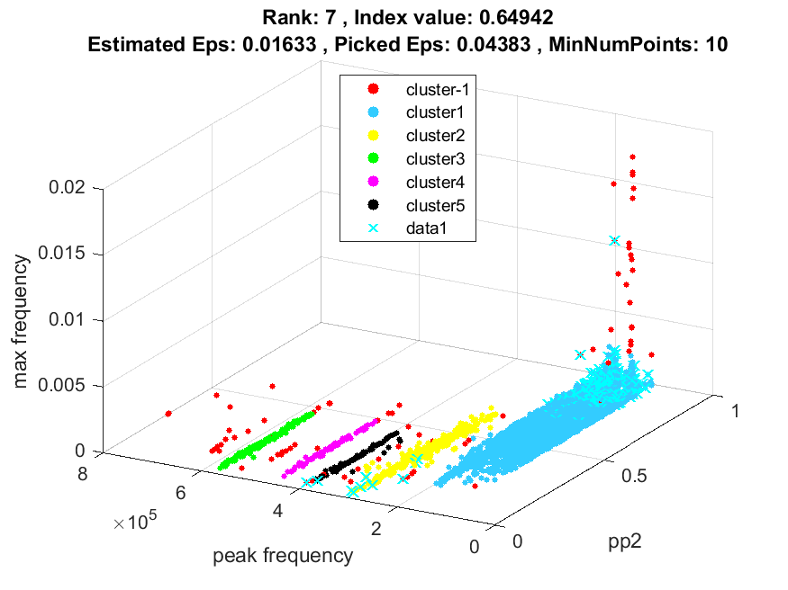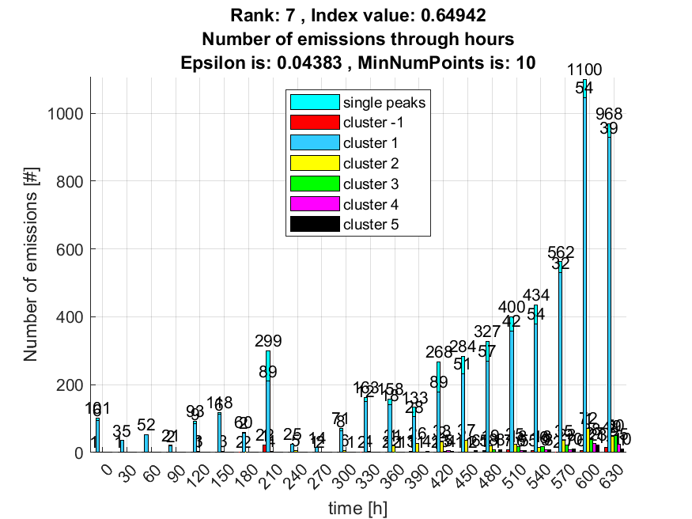

**8. result: (counts_from, peak_frequency, fall_time)**

**Estimated Epsilon: 0.018416, Picked Epsilon: 0.033416, MinNumPoints: 10**

**DBCV index value: 0.6489**

**cluster -1 had 2.2951% single peaks**

**cluster 1 had 97.377% single peaks**

**cluster 2 had 0% single peaks**

**cluster 3 had 0% single peaks**

**cluster 4 had 0.32787% single peaks**

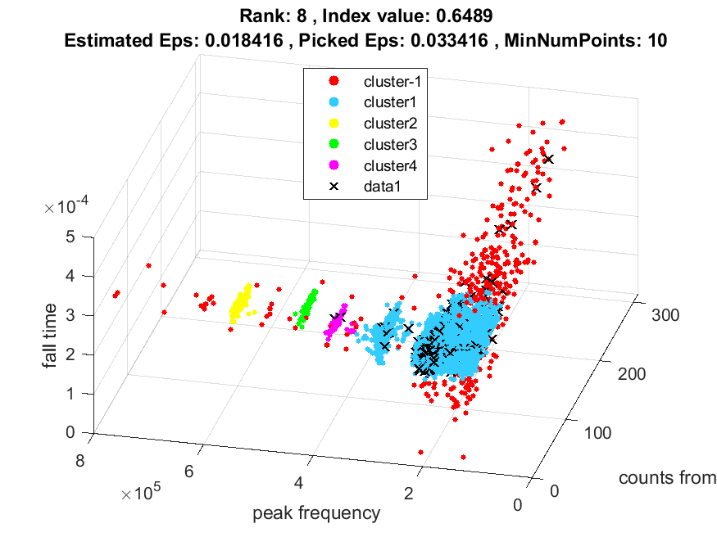

**Popravljeno:**

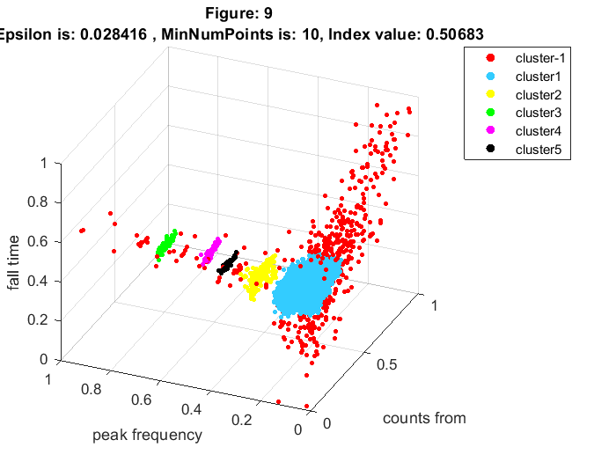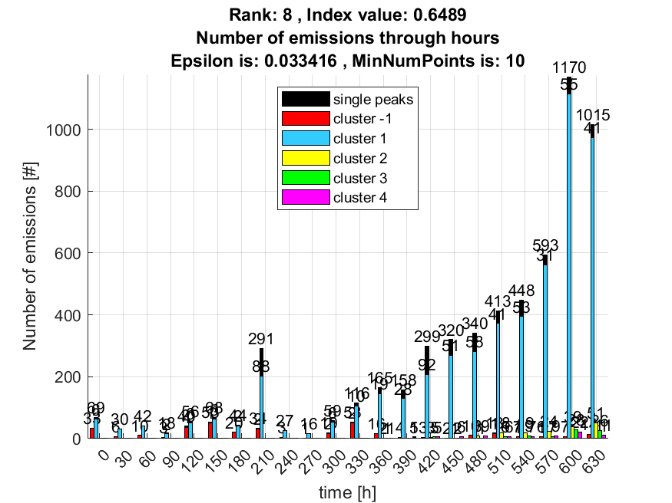

**9. result: (signal_strength, centroid_frequency, peak_frequency)**

**Estimated Epsilon: 0.01697, Picked Epsilon: 0.04197, MinNumPoints: 10**

**DBCV index value: 0.64873**

**cluster -1 had 0.4918% single peaks**

**cluster 1 had 98.0328% single peaks**

**cluster 2 had 1.1475% single peaks**

**cluster 3 had 0% single peaks**

**cluster 4 had 0% single peaks**

**cluster 5 had 0.32787% single peaks**

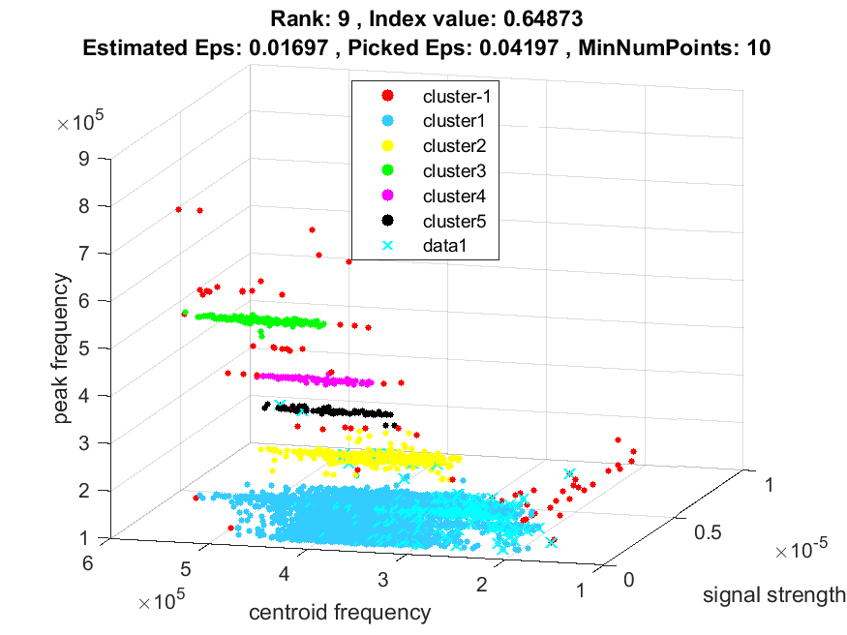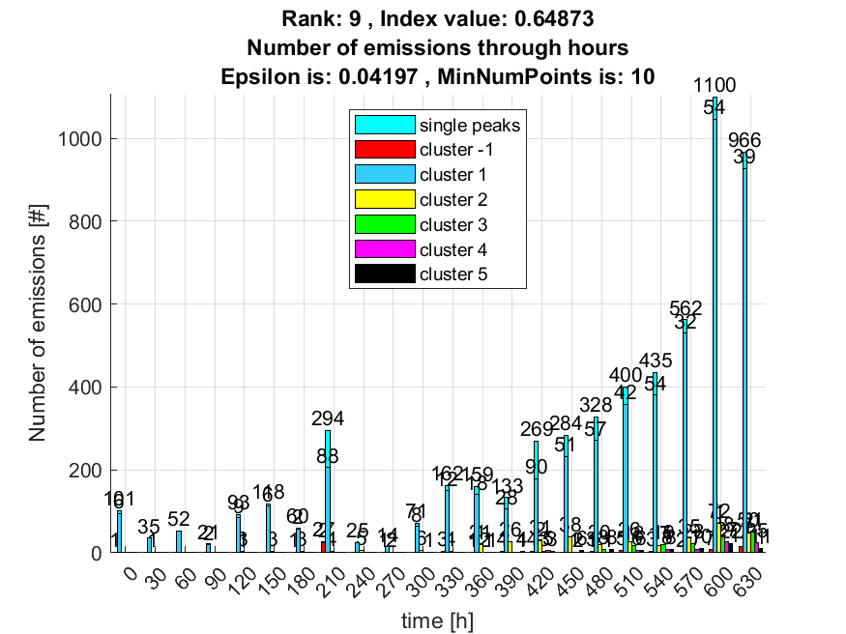

**10. result: (peak_amplitude, pp2, peak_frequency)**

**Estimated Epsilon: 0.018288, Picked Epsilon: 0.043288, MinNumPoints: 10**

**DBCV index value: 0.64832**

**cluster -1 had 0.98361% single peaks**

**cluster 1 had 98.0328% single peaks**

**cluster 2 had 0.98361% single peaks**

**cluster 3 had 0% single peaks**

**cluster 4 had 0% single peaks**

**cluster 5 had 0% single peaks**

