**ADANTE, RENCE R. BSIT2**

**FUNDAMENTALS OF DATABASES – WEEK 3 – ACTIVITY 1**

Supply/perform what is asking in the following statements. Attach or put a screenshot for each number to support your answers.

1. Search a website or install a free software (for those who have laptop) which can be used as example of different types of interfaces for database or data management in the software/system.
2. Capture or make a screenshot for each types of interface given below and briefly explain its importance or benefits to the users.
   1. Menu-Based Interface
   2. Forms-Based Interface
   3. Graphical User Interface
   4. Natural language Interface
   5. Speech Input and Output
   6. Interfaces for DBA

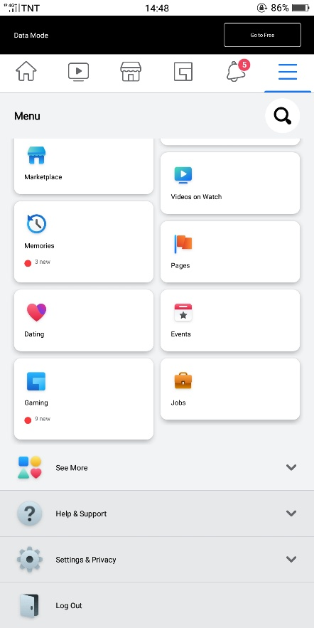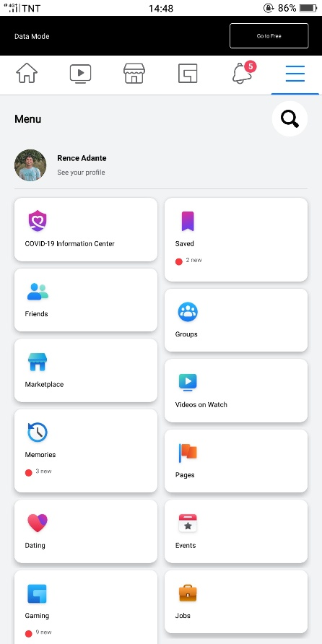

* + - 1. MENU – BASED INTERFACE

• you can easily see or find every options to snap and look

* + - 1. 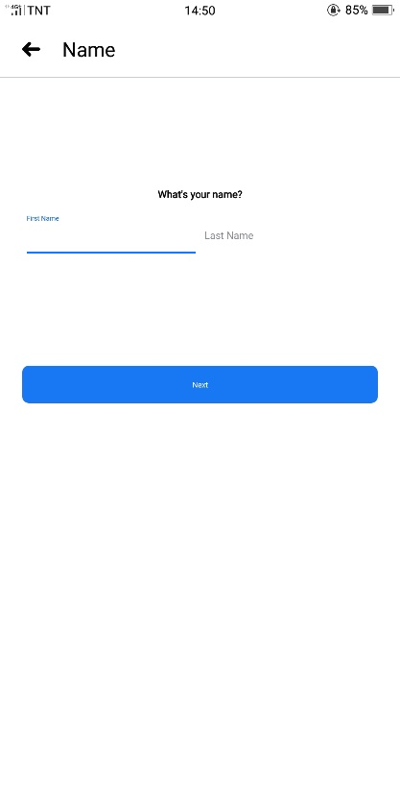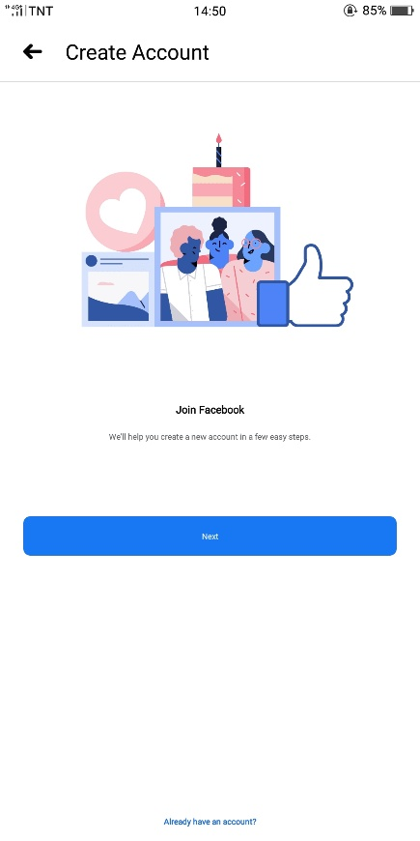FORM – BASED INTERFACE

• In this interface you can create your account

* + - 1. GRAPHICAL USER INTERFACE

• It will help you easily to find and just tap the apps

* + - 1. NATURAL LANGUAGE

• In this part will help you to easily translate word in to any language.

* + - 1. SPEECH INPUT AND OUTPUT

• In this part instead of typing you will just need to speak. It will help you easily to search and find what you want.

