**ADANTE, RENCE R. BSIT2**

**NETWORKING 1 – WEEK 3 – ACTIVITY 1**

Supply what is asking in the following statements. Attach or put a screenshot for each number to support your answers (if applicable).

As said, Bluetooth technology is one of the examples of technologies use in Personal Area Network.

1. For your activity, using two android phones with different specification (one low-end and the other one is high end if possible), determine and give how far can your Bluetooth connect or its longest range in meters or feet.

•Close: 1 minute and 9 seconds

•1 meter: 1 minute and 24 seconds

•5 meters: 2 minutes and 26 seconds

•8 meters: 2 minutes and 54 seconds

•10 meters: Failed

1. Make a documentation by taking two to five pictures of you and the other end device.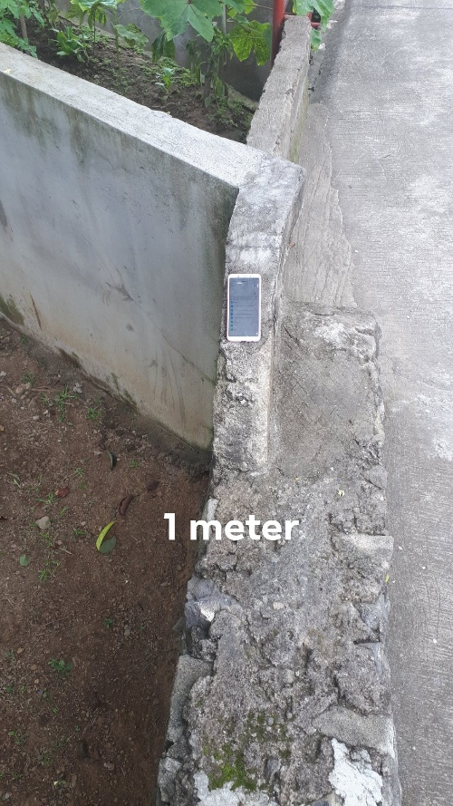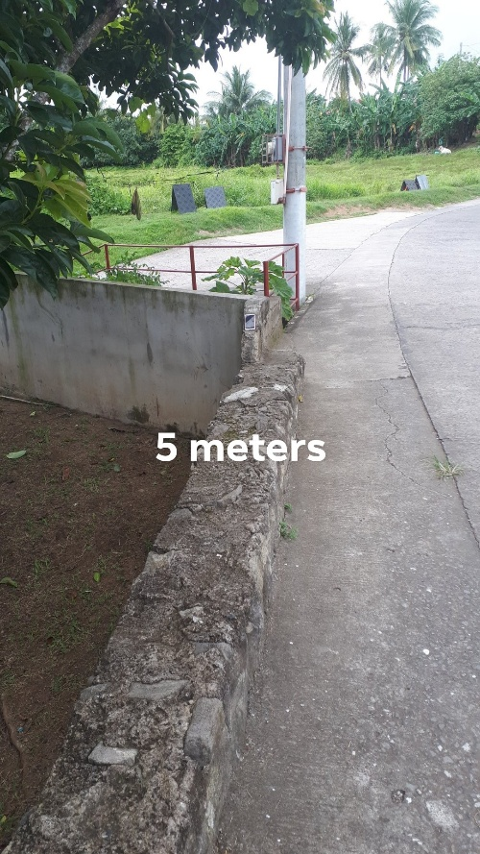

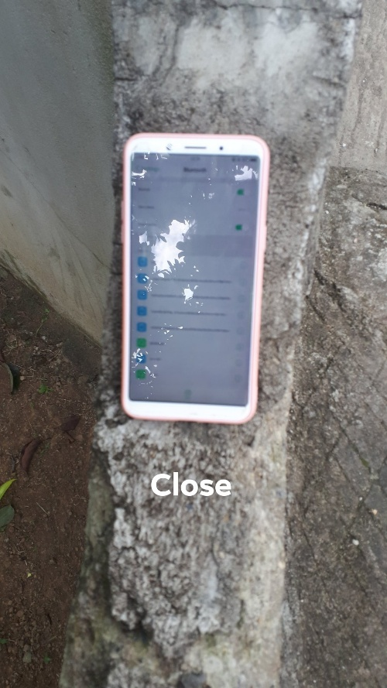

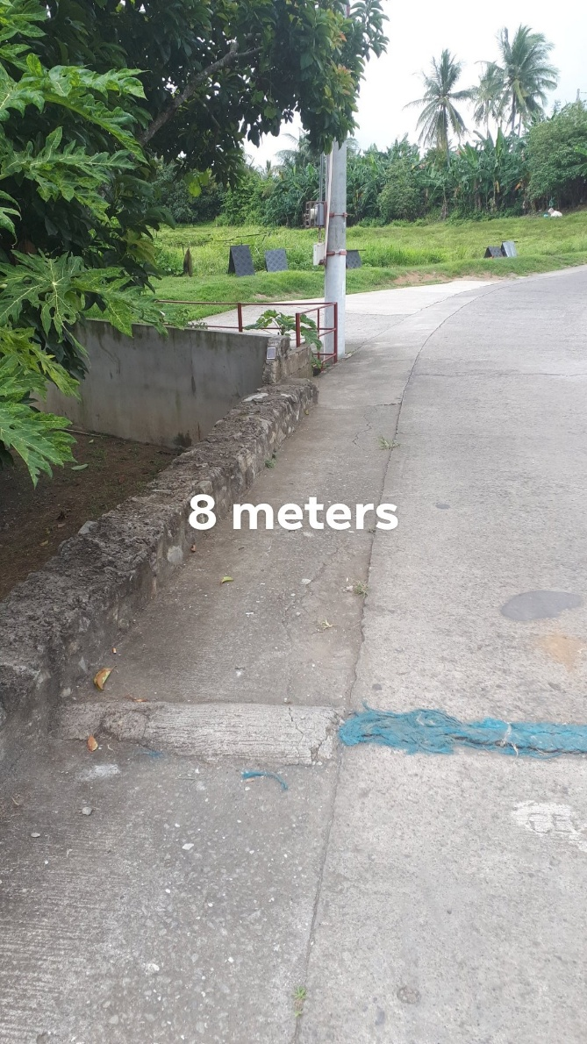

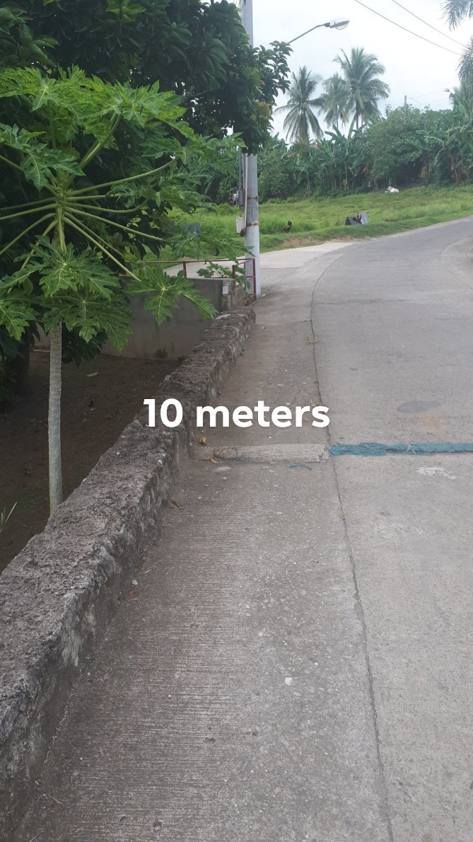

1. Using personal android phone, create a screenshot of your complete Bluetooth device properties/information.

