1. Ping Basics

- Explain the purpose of the ping utility and its basic syntax.

The ping utility is a network administration tool used to test the reachability of a host on an Internet Protocol (IP) network.

It also measures the round-trip time for messages sent from the originating host to a destination computer and back. The utility operates by sending Internet Control Message Protocol (ICMP) echo request packets to the target host and listening for echo response

- Provide examples of how to use ping to test connectivity to a website and a local host.

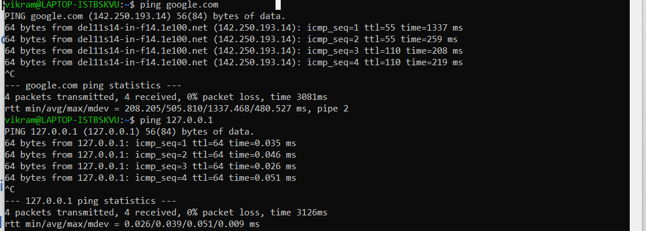

2. Ping Output Analysis

- Run the command ping (link unavailable) and capture the output.

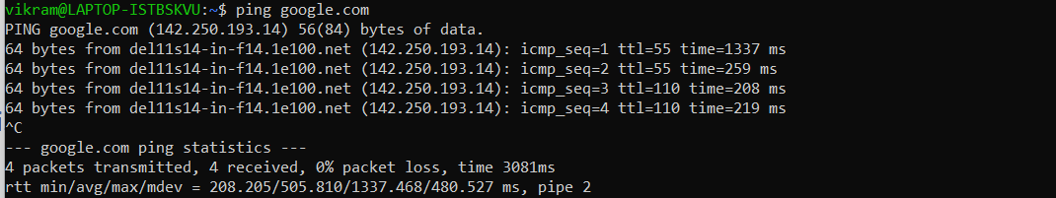

- Analyze the output, explaining each line and its significance (e.g., packet loss, round-trip time, etc.).

**PING google.com (**142.250.193.14**): 56 data bytes**

* This line indicates that the ping command is sending ICMP echo requests to google.com, which resolves to the IP address 142.250.193.14.
* The 56 data bytes part shows that each packet sent contains 56 bytes of data by default.

**64 bytes from 142.250.193.14: icmp_seq=1 ttl=15 time=24.3 ms**

* **64 bytes from** 142.250.193.14: This shows that a reply was received from the IP address 142.250.74.206, which is Google's server.
* **icmp_seq=1**: This is the sequence number of the ICMP packet. Each request increments this number by 1.
* **ttl=15**: The Time to Live (TTL) value indicates the number of hops the packet can take before it is discarded. It starts at a certain value (usually 64 or 128) and is decremented by 1 for each hop. The TTL of 115 means that the packet passed through 13 hops (128 - 115).
* **time=24.3 ms**: The time it took for the packet to travel to the destination and back, also known as the round-trip time (RTT), measured in milliseconds.

**round-trip min/avg/max/stddev = 23.7/24.0/24.3/0.2 ms**

* **min/avg/max/stddev**: The minimum, average, maximum, and standard deviation of the round-trip times recorded during the ping operation.
* **23.7 ms**: The fastest round-trip time recorded.
* **24.0 ms**: The average round-trip time.
* **24.3 ms**: The slowest round-trip time.
* **0.2 ms**: The standard deviation, indicating how much the times varied.

- Repeat the process for a local host (e.g., ping 127.0.0.1).

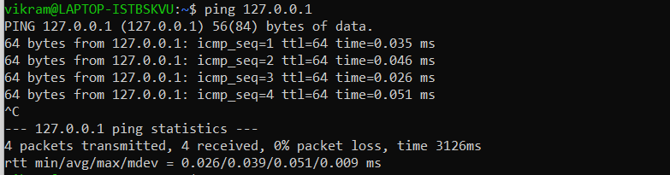

3. Ping Options

- Research and explain the following ping options:

- -c (count)

**1. -c (Count)**

**Purpose:**

* The -c option specifies the number of ICMP echo requests to send before stopping. By default, ping continues until it is manually stopped with Ctrl+C, but -c lets you limit the number of pings.

- -s (size)

**Purpose:**

The -s option allows you to specify the number of data bytes to be sent with each ICMP echo request packet. By default, ping sends 56 bytes of data, but you can adjust this to test how different packet sizes affect the network performance.

- -t (ttl)

**Purpose:**

* The -t option sets the Time to Live (TTL) for the packets. TTL limits the number of hops a packet can take before it is discarded. This is useful for determining how far a packet can travel in the network.

- -W (deadline)

**Purpose:**

* The -W option sets a deadline (in seconds) for how long ping will wait for a response before giving up. This is different from the -c option, as it does not limit the number of pings but rather the total time spent pinging.
* - Provide examples of how to use each option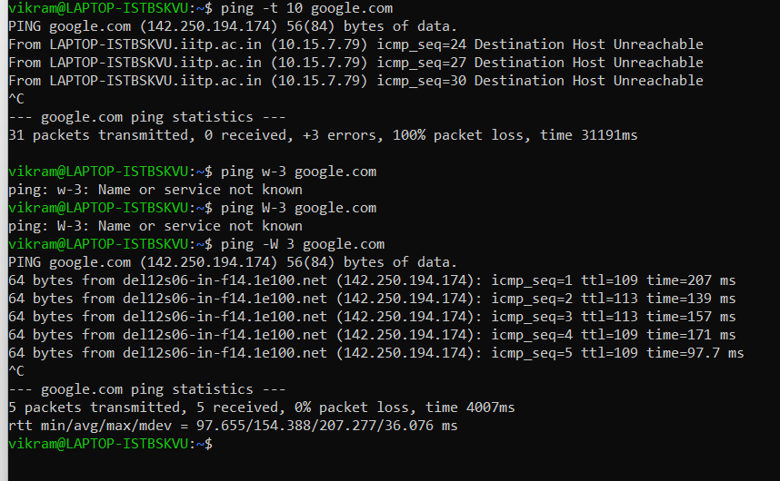



4. Troubleshooting with Ping

- Describe a scenario where ping would be used for network troubleshooting (e.g., connectivity issues, slow network speeds).

- Explain how to use ping to diagnose the issue, including which options to use and why.

Scenario: Slow Network Speeds and Intermittent Connectivity

**Situation:** Imagine college Lab environment where multiple Students are complaining about slow internet speeds and intermittent connectivity. Web pages are taking too long to load, and some Students are experiencing frequent timeouts when trying to access certain online services.

**How to Use Ping for Troubleshooting**

**1.Test Basic Conectivity(By simply ping <local_ip_addr>**

**Why?**: This test checks if the device can communicate with the gateway, which is crucial for accessing external networks.

**If successful:** The device has basic connectivity to the gateway.

**If there’s packet loss or timeouts:** There might be an issue with the device's connection to the router, or the router itself could be malfunctioning.

**2: Test Connectivity to External Websites**

**Why?:** This determines if the device can communicate with external networks (the internet). It helps identify if the issue is with the local network or with internet access.

**If successful with low RTT**: The internet connection is functioning, but the problem might be due to high usage or a congested network.

**If there’s high RTT or packet loss**: This indicates that the issue might be with the ISP or a problem in the wider internet.

3: **Check for Network Congestion(use** -c or -s opt)

**If the RTT increases significantly:** The network may be congested, which could explain the slow speeds.

**If packet loss occurs:** This could indicate network congestion, hardware issues, or ISP problems.

**4:Set a Deadline to Identify Intermittent Issues**

**Why?:** Running the ping command over a longer period can help catch intermittent issues, providing data on when and how often they occur.

**if packet loss or high RTT occurs sporadically:** The network might be experiencing intermittent congestion or interference.

**If the problem persists throughout:** This indicates a more consistent issue, possibly requiring hardware checks or ISP intervention.

**Summary**

* **Basic Connectivity:** Start by pinging the gateway and external sites to verify basic connectivity.
* **Network Congestion:** Use larger packet sizes and multiple pings to test for congestion.
* **Routing Issues:** Adjust the TTL to see how far packets are traveling before hitting problems.
* **Intermittent Issues:** Set a deadline to monitor the network over time and catch sporadic issues.

5. Develop a ping type utility using Scapy. It should have the following points.

- 1. Basic Functionality

- Ensure the provided code works correctly.

- Test with different destination IPs and counts.

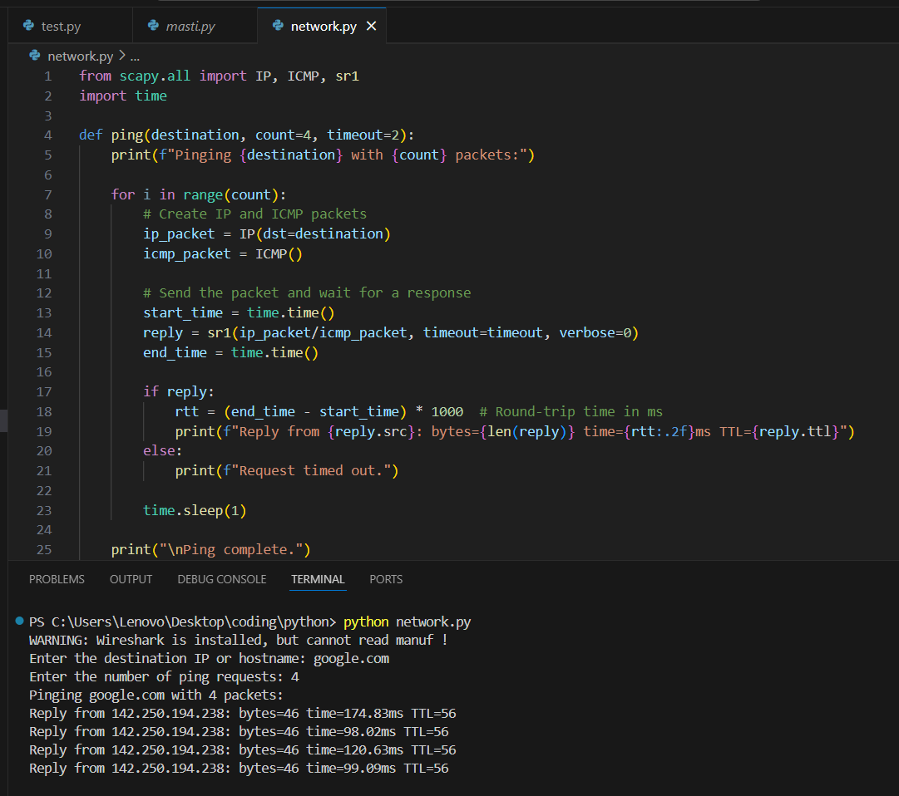

2. Additional Features

- Implement the following features:

- Option to specify TTL (Time-To-Live)

- Option to specify packet size

- Option to specify timeout

- Use Scapy's built-in functions to implement these features.

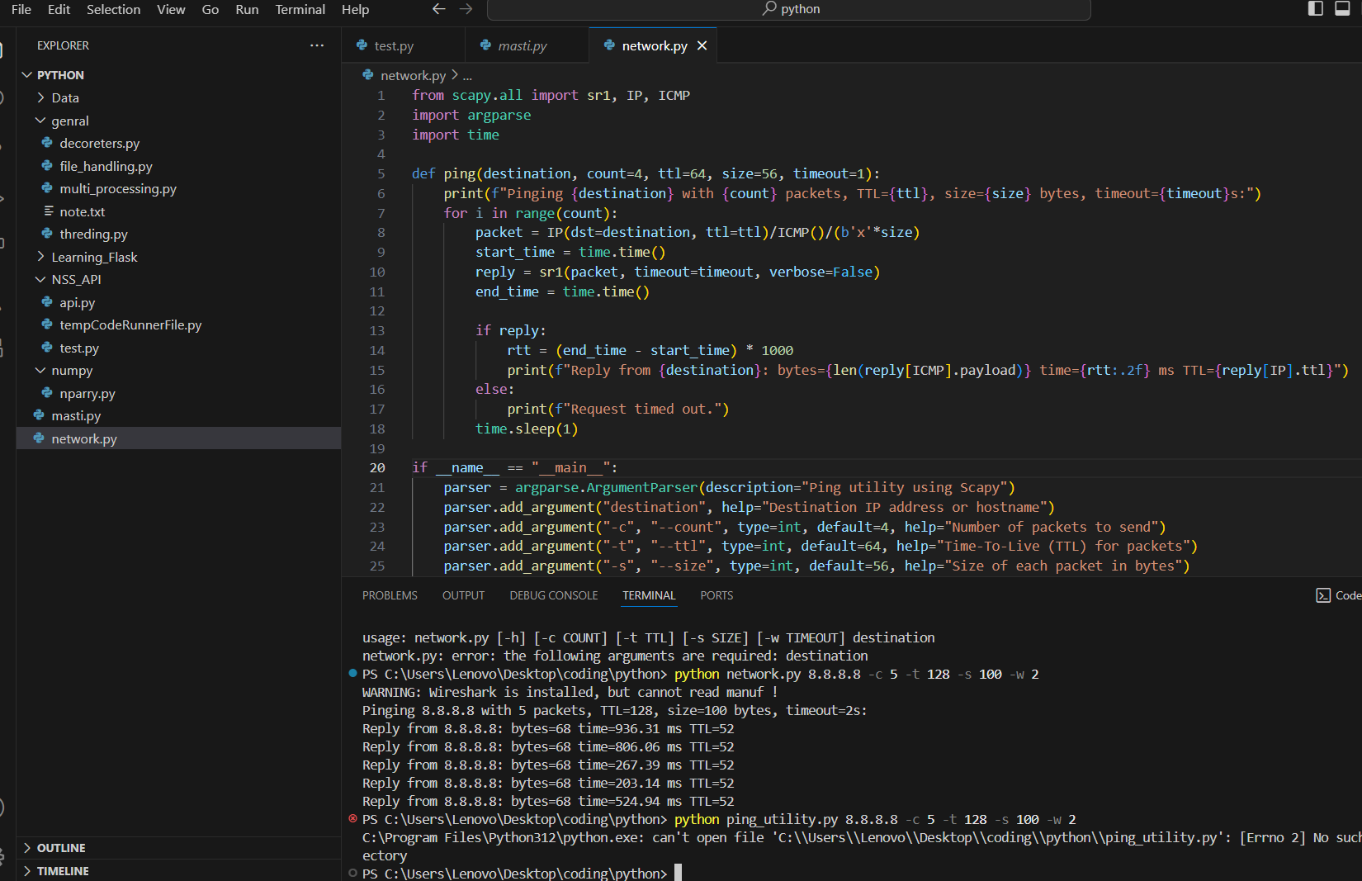

3. Error Handling

- Add error handling for cases like:

- Invalid destination IP

- Invalid count or TTL values

- Timeout errors

- Use try-except blocks to catch and handle exceptions.

