**МИНОБРНАУКИ РОССИИ**

**Санкт-Петербургский государственный**

**электротехнический университет**

**«ЛЭТИ» им. В.И. Ульянова (Ленина)**

**Кафедра МО ЭВМ**

отчет

**по лабораторной работе №1**

**по дисциплине «Параллельные алгоритмы»**

**Тема: Запуск параллельной программы на различном числе**

**одновременно работающих процессов, упорядочение вывода результатов.**

|  |  |  |
| --- | --- | --- |
| Студент гр. 3388 |  | Дубровин Д.Н. |
| Преподаватель |  | Татаринов Ю.С. |

Санкт-Петербург

2025

## Цель работы.

Написать параллельную программу с использованием MPI, исследовать зависимость скорости выполнения программы от числа процессов, построить графики и сети Петри.

## Задание.

*Задание 1:* 1. Все процессы, кроме процесса с рангом 0, передают значние своего ранга нулевому процессу. Процесс с рангом 0 сначала печатает

значение своего ранга, а далее принимает сообщения с рангами

процессов и также печатает их значения. При этом важно отметить, что порядок приема сообщений заранее не определен и зависит от условий

выполнения параллельной программы (более того, этот порядок может

изменяться от запуска к запуску).

2. Проанализировать порядок вывода сообщений на экран. Для этого запустит программу несколько раз при фиксированном числе

процессов, например -8ми. Вывести правило, определяющее порядок

вывода сообщений.

3. Выполнить требования к содержанию отчета для задания 1

*Задание 2:* Модифицировать программу таким образом, чтобы порядок

вывода сообщений на экран соответствовал номеру соответствующего

процесса.

1. Выполнить требования к содержанию отчета для задания 2

2. Сравнить результаты работы двух программ.

## Выполнение работы.

1. Процесс с номером 0 запускает таймер, выводит свой номер и начинает ожидать сообщения от всех остальных процессов. Каждый из других процессов отправляет нулевому свой ранг с помощью MPI_Send. Когда процесс 0 получает сообщение через MPI_Recv, он выводит информацию о том, от какого процесса и какой номер был получен. После получения всех сообщений процесс 0 останавливает таймер и выводит общее время выполнения программы, показывая количество задействованных процессов и затраченное время. Все процессы завершают работу после вызова MPI_Finalize.
2. Построим схему Петри для первого задания:

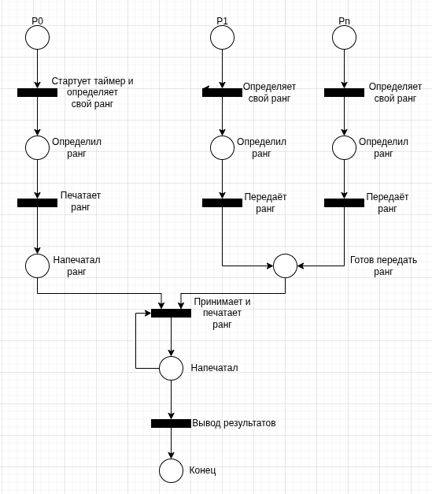

Риc.1 - сеть Петри для первой программы

Таблица 1- результаты выполнения программы.

|  |  |  |  |  |  |  |  |  |
| --- | --- | --- | --- | --- | --- | --- | --- | --- |
| N | 2 | 4 | 6 | 8 | 10 | 12 | 14 | 16 |
| t, сек | 0.000078 | 0.000072 | 0.000116 | 0.000070 | 0.000067 | 0.000081 | 0.000175 | 0.000106 |

Результаты выполнения программы:

*Запуск с 2 процессами...*

*Process 0: my rank is 0*

*Process 0: received rank 1 from process 1*

*============= Execution Results =============*

*Num of proc: 2 | Execution time: 0.000078 seconds*

*---*

*Запуск с 3 процессами...*

*Process 0: my rank is 0*

*Process 0: received rank 1 from process 1*

*Process 0: received rank 2 from process 2*

*============= Execution Results =============*

*Num of proc: 3 | Execution time: 0.000037 seconds*

*---*

*Запуск с 4 процессами...*

*Process 0: my rank is 0*

*Process 0: received rank 3 from process 3*

*Process 0: received rank 2 from process 2*

*Process 0: received rank 1 from process 1*

*============= Execution Results =============*

*Num of proc: 4 | Execution time: 0.000072 seconds*

*---*

*Запуск с 5 процессами...*

*Process 0: my rank is 0*

*Process 0: received rank 2 from process 2*

*Process 0: received rank 1 from process 1*

*Process 0: received rank 3 from process 3*

*Process 0: received rank 4 from process 4*

*============= Execution Results =============*

*Num of proc: 5 | Execution time: 0.000178 seconds*

*---*

*Запуск с 6 процессами...*

*Process 0: my rank is 0*

*Process 0: received rank 2 from process 2*

*Process 0: received rank 5 from process 5*

*Process 0: received rank 1 from process 1*

*Process 0: received rank 3 from process 3*

*Process 0: received rank 4 from process 4*

*============= Execution Results =============*

*Num of proc: 6 | Execution time: 0.000116 seconds*

*---*

*Запуск с 7 процессами...*

*Process 0: my rank is 0*

*Process 0: received rank 1 from process 1*

*Process 0: received rank 2 from process 2*

*Process 0: received rank 4 from process 4*

*Process 0: received rank 5 from process 5*

*Process 0: received rank 6 from process 6*

*Process 0: received rank 3 from process 3*

*============= Execution Results =============*

*Num of proc: 7 | Execution time: 0.000065 seconds*

*---*

*Запуск с 8 процессами...*

*Process 0: my rank is 0*

*Process 0: received rank 4 from process 4*

*Process 0: received rank 1 from process 1*

*Process 0: received rank 2 from process 2*

*Process 0: received rank 3 from process 3*

*Process 0: received rank 5 from process 5*

*Process 0: received rank 6 from process 6*

*Process 0: received rank 7 from process 7*

*============= Execution Results =============*

*Num of proc: 8 | Execution time: 0.000070 seconds*

*---*

*Запуск с 9 процессами...*

*Process 0: my rank is 0*

*Process 0: received rank 3 from process 3*

*Process 0: received rank 1 from process 1*

*Process 0: received rank 4 from process 4*

*Process 0: received rank 6 from process 6*

*Process 0: received rank 7 from process 7*

*Process 0: received rank 8 from process 8*

*Process 0: received rank 2 from process 2*

*Process 0: received rank 5 from process 5*

*============= Execution Results =============*

*Num of proc: 9 | Execution time: 0.000081 seconds*

*---*

*Запуск с 10 процессами...*

*Process 0: my rank is 0*

*Process 0: received rank 9 from process 9*

*Process 0: received rank 1 from process 1*

*Process 0: received rank 3 from process 3*

*Process 0: received rank 5 from process 5*

*Process 0: received rank 6 from process 6*

*Process 0: received rank 7 from process 7*

*Process 0: received rank 8 from process 8*

*Process 0: received rank 4 from process 4*

*Process 0: received rank 2 from process 2*

*============= Execution Results =============*

*Num of proc: 10 | Execution time: 0.000067 seconds*

*---*

*Запуск с 11 процессами...*

*Process 0: my rank is 0*

*Process 0: received rank 4 from process 4*

*Process 0: received rank 10 from process 10*

*Process 0: received rank 1 from process 1*

*Process 0: received rank 8 from process 8*

*Process 0: received rank 6 from process 6*

*Process 0: received rank 2 from process 2*

*Process 0: received rank 7 from process 7*

*Process 0: received rank 9 from process 9*

*Process 0: received rank 5 from process 5*

*Process 0: received rank 3 from process 3*

*============= Execution Results =============*

*Num of proc: 11 | Execution time: 0.000101 seconds*

*---*

*Запуск с 12 процессами...*

*Process 0: my rank is 0*

*Process 0: received rank 10 from process 10*

*Process 0: received rank 1 from process 1*

*Process 0: received rank 2 from process 2*

*Process 0: received rank 3 from process 3*

*Process 0: received rank 4 from process 4*

*Process 0: received rank 5 from process 5*

*Process 0: received rank 6 from process 6*

*Process 0: received rank 7 from process 7*

*Process 0: received rank 8 from process 8*

*Process 0: received rank 9 from process 9*

*Process 0: received rank 11 from process 11*

*============= Execution Results =============*

*Num of proc: 12 | Execution time: 0.000081 seconds*

*---*

*Запуск с 13 процессами...*

*Process 0: my rank is 0*

*Process 0: received rank 8 from process 8*

*Process 0: received rank 1 from process 1*

*Process 0: received rank 2 from process 2*

*Process 0: received rank 3 from process 3*

*Process 0: received rank 4 from process 4*

*Process 0: received rank 5 from process 5*

*Process 0: received rank 6 from process 6*

*Process 0: received rank 7 from process 7*

*Process 0: received rank 9 from process 9*

*Process 0: received rank 10 from process 10*

*Process 0: received rank 11 from process 11*

*Process 0: received rank 12 from process 12*

*============= Execution Results =============*

*Num of proc: 13 | Execution time: 0.000105 seconds*

*---*

*Запуск с 14 процессами...*

*Process 0: my rank is 0*

*Process 0: received rank 11 from process 11*

*Process 0: received rank 2 from process 2*

*Process 0: received rank 4 from process 4*

*Process 0: received rank 6 from process 6*

*Process 0: received rank 7 from process 7*

*Process 0: received rank 9 from process 9*

*Process 0: received rank 10 from process 10*

*Process 0: received rank 12 from process 12*

*Process 0: received rank 13 from process 13*

*Process 0: received rank 3 from process 3*

*Process 0: received rank 1 from process 1*

*Process 0: received rank 5 from process 5*

*Process 0: received rank 8 from process 8*

*============= Execution Results =============*

*Num of proc: 14 | Execution time: 0.000175 seconds*

*---*

*Запуск с 15 процессами...*

*Process 0: my rank is 0*

*Process 0: received rank 12 from process 12*

*Process 0: received rank 1 from process 1*

*Process 0: received rank 2 from process 2*

*Process 0: received rank 3 from process 3*

*Process 0: received rank 4 from process 4*

*Process 0: received rank 5 from process 5*

*Process 0: received rank 6 from process 6*

*Process 0: received rank 7 from process 7*

*Process 0: received rank 8 from process 8*

*Process 0: received rank 9 from process 9*

*Process 0: received rank 10 from process 10*

*Process 0: received rank 11 from process 11*

*Process 0: received rank 13 from process 13*

*Process 0: received rank 14 from process 14*

*============= Execution Results =============*

*Num of proc: 15 | Execution time: 0.000079 seconds*

*---*

*Запуск с 16 процессами...*

*Process 0: my rank is 0*

*Process 0: received rank 11 from process 11*

*Process 0: received rank 1 from process 1*

*Process 0: received rank 3 from process 3*

*Process 0: received rank 5 from process 5*

*Process 0: received rank 10 from process 10*

*Process 0: received rank 13 from process 13*

*Process 0: received rank 15 from process 15*

*Process 0: received rank 9 from process 9*

*Process 0: received rank 2 from process 2*

*Process 0: received rank 4 from process 4*

*Process 0: received rank 6 from process 6*

*Process 0: received rank 7 from process 7*

*Process 0: received rank 8 from process 8*

*Process 0: received rank 12 from process 12*

*Process 0: received rank 14 from process 14*

*============= Execution Results =============*

*Num of proc: 16 | Execution time: 0.000106 seconds*

3. Построим графики времени выполнения и ускорения для 2-16 процессов.

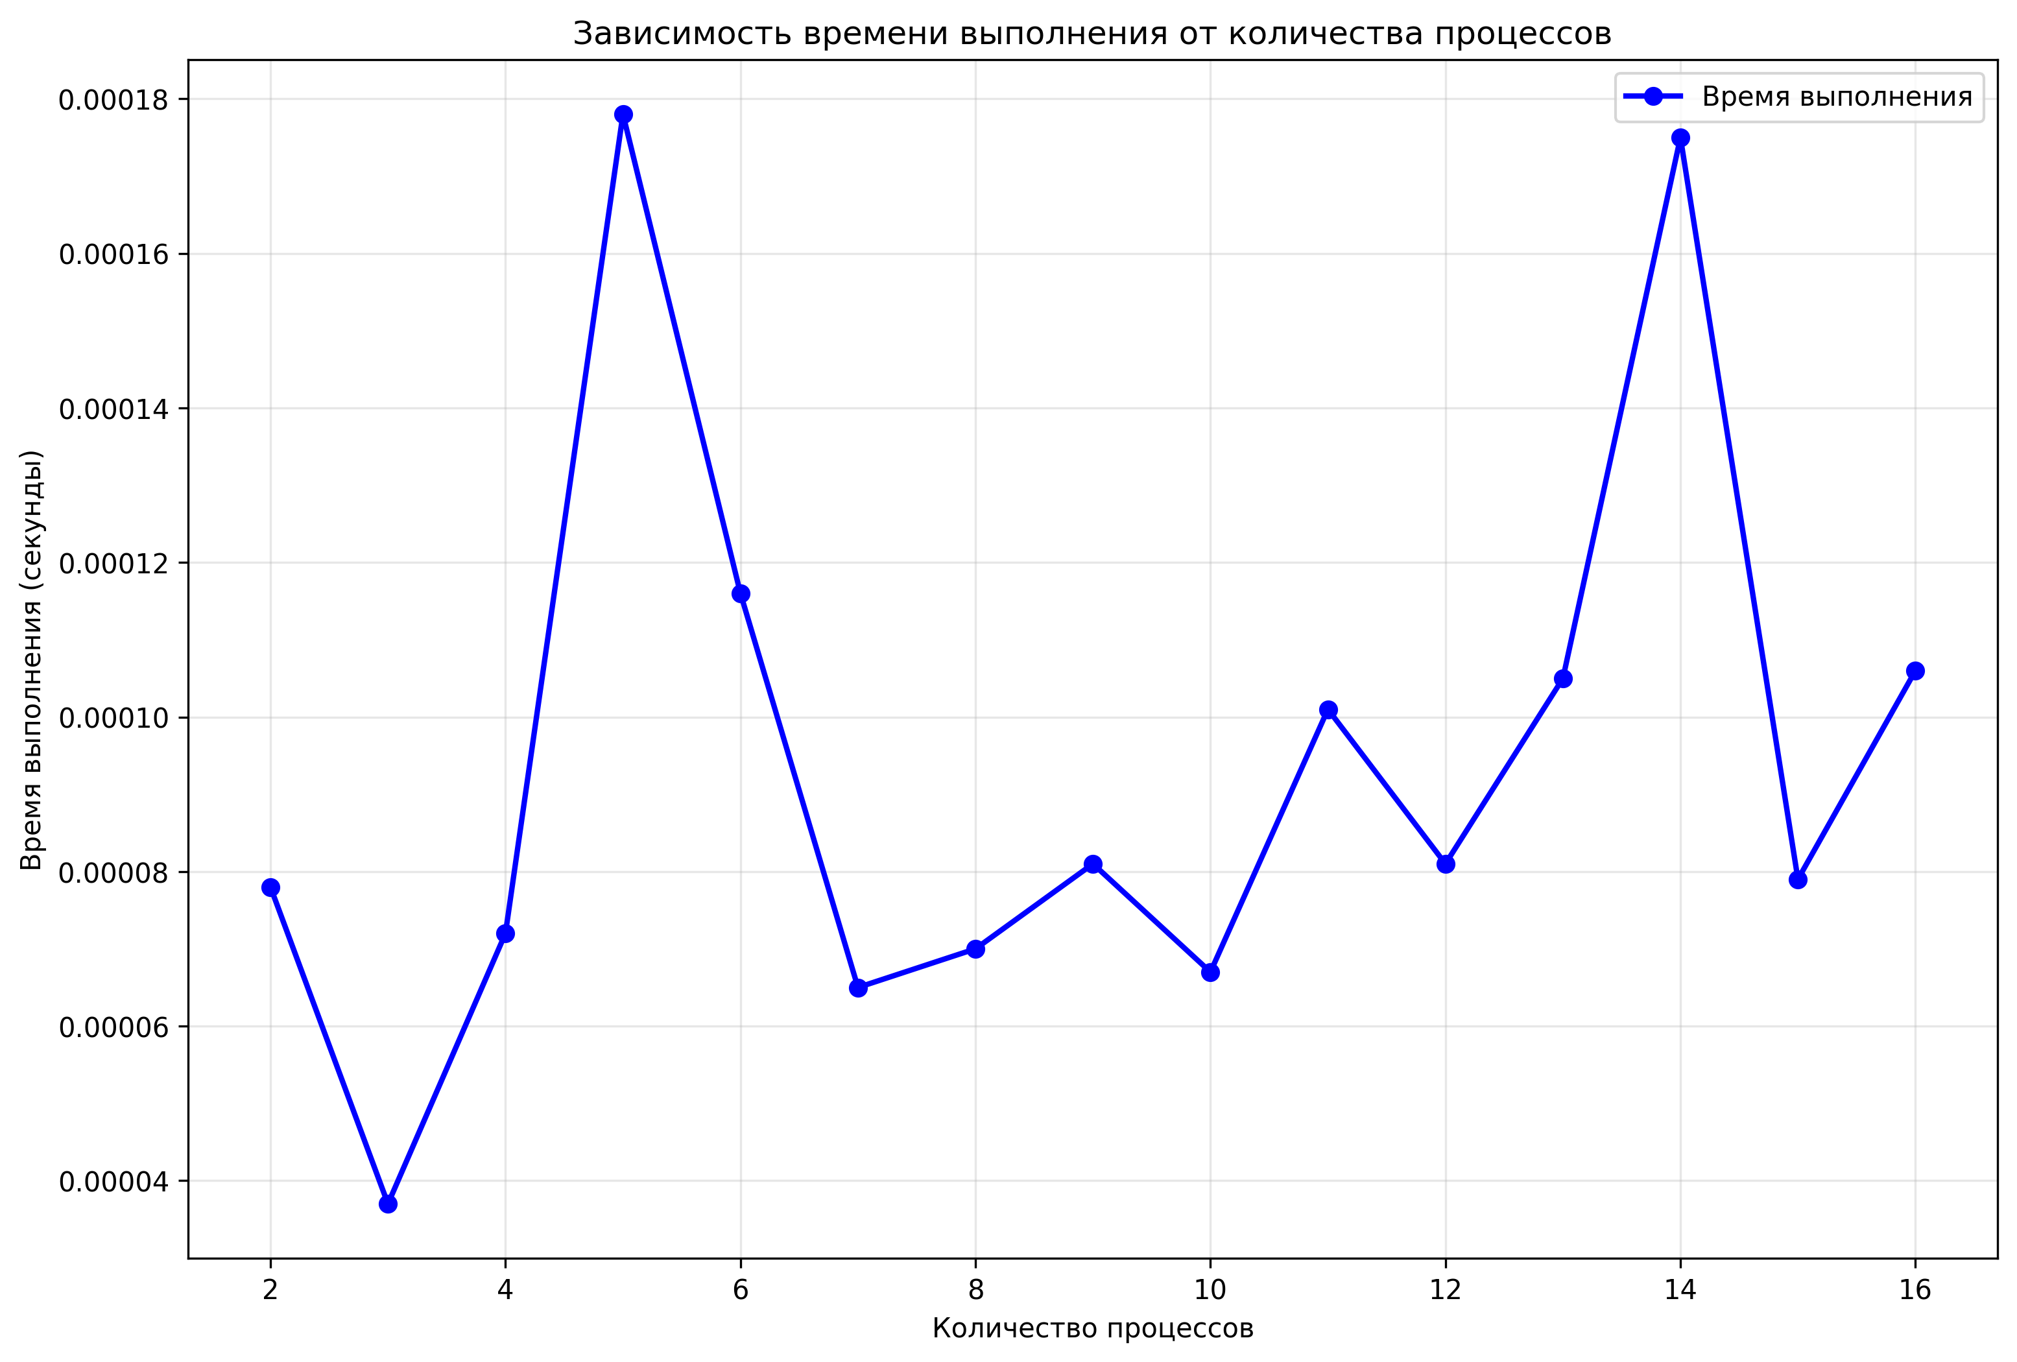

Рис.2 – график зависимости времени выполнения от числа процессов

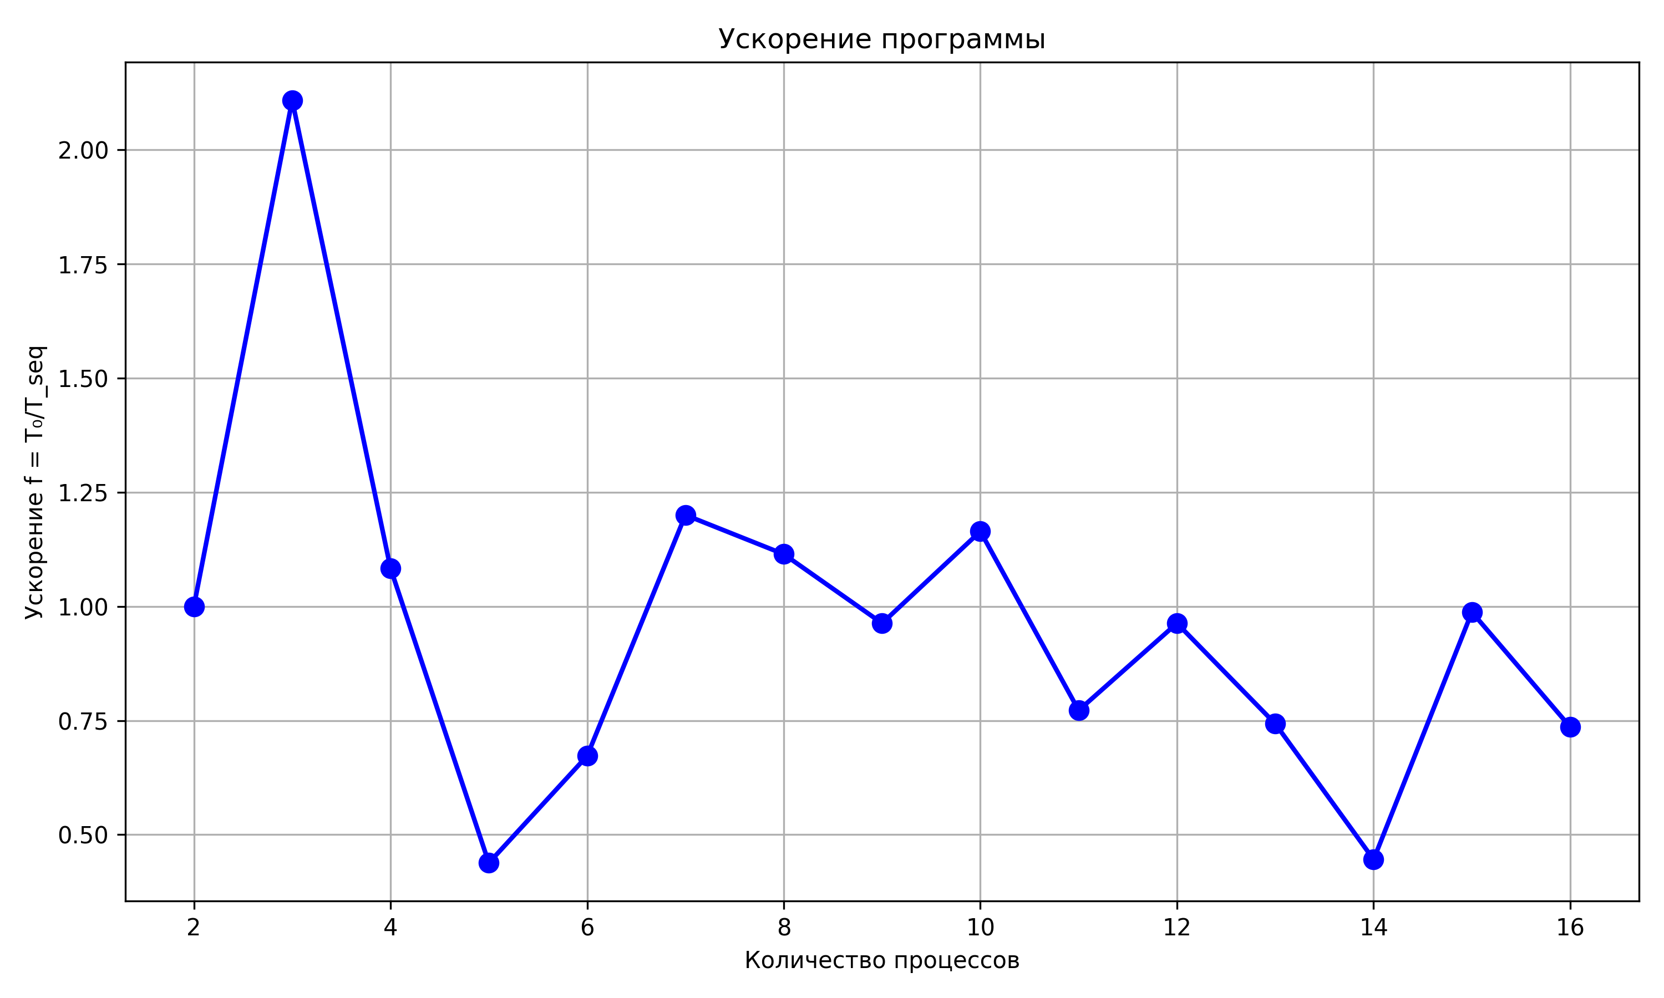Рис.3 - график ускорения

4. Преобразуем программу, чтобы порядок вывода сообщений на экран соответствовал номеру соответствующего процесса. Для этого изменим аргументы source и tag в функции MPI_Recv на i (переменную цикла) и 0, чтобы ожидать данные от соответствующего процесса.

5. Построим схему Петри для второй программы.

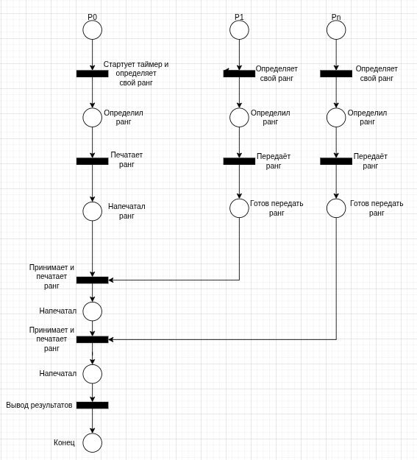

Рис.4 - сеть Петри для второй программы

6. Запустим программу и получим следующие результаты:

Таблица 2 – результаты экспериментов

|  |  |  |  |  |  |  |  |  |
| --- | --- | --- | --- | --- | --- | --- | --- | --- |
| N | 2 | 4 | 6 | 8 | 10 | 12 | 14 | 16 |
| t, сек | 0.000074 | 0.000084 | 0.000040 | 0.000109 | 0.000093 | 0.000148 | 0.000097 | 0.000136 |

Результаты эксперимента:

Запуск с 2 процессами...

Process 0: my rank is 0

Process 0: received rank 1 from process 1

============= Execution Results =============

Num of proc: 2 | Execution time: 0.000074 seconds

---

Запуск с 3 процессами...

Process 0: my rank is 0

Process 0: received rank 1 from process 1

Process 0: received rank 2 from process 2

============= Execution Results =============

Num of proc: 3 | Execution time: 0.000104 seconds

---

Запуск с 4 процессами...

Process 0: my rank is 0

Process 0: received rank 1 from process 1

Process 0: received rank 2 from process 2

Process 0: received rank 3 from process 3

============= Execution Results =============

Num of proc: 4 | Execution time: 0.000084 seconds

---

Запуск с 5 процессами...

Process 0: my rank is 0

Process 0: received rank 1 from process 1

Process 0: received rank 2 from process 2

Process 0: received rank 3 from process 3

Process 0: received rank 4 from process 4

============= Execution Results =============

Num of proc: 5 | Execution time: 0.000060 seconds

---

Запуск с 6 процессами...

Process 0: my rank is 0

Process 0: received rank 1 from process 1

Process 0: received rank 2 from process 2

Process 0: received rank 3 from process 3

Process 0: received rank 4 from process 4

Process 0: received rank 5 from process 5

============= Execution Results =============

Num of proc: 6 | Execution time: 0.000040 seconds

---

Запуск с 7 процессами...

Process 0: my rank is 0

Process 0: received rank 1 from process 1

Process 0: received rank 2 from process 2

Process 0: received rank 3 from process 3

Process 0: received rank 4 from process 4

Process 0: received rank 5 from process 5

Process 0: received rank 6 from process 6

============= Execution Results =============

Num of proc: 7 | Execution time: 0.000107 seconds

---

Запуск с 8 процессами...

Process 0: my rank is 0

Process 0: received rank 1 from process 1

Process 0: received rank 2 from process 2

Process 0: received rank 3 from process 3

Process 0: received rank 4 from process 4

Process 0: received rank 5 from process 5

Process 0: received rank 6 from process 6

Process 0: received rank 7 from process 7

============= Execution Results =============

Num of proc: 8 | Execution time: 0.000109 seconds

---

Запуск с 9 процессами...

Process 0: my rank is 0

Process 0: received rank 1 from process 1

Process 0: received rank 2 from process 2

Process 0: received rank 3 from process 3

Process 0: received rank 4 from process 4

Process 0: received rank 5 from process 5

Process 0: received rank 6 from process 6

Process 0: received rank 7 from process 7

Process 0: received rank 8 from process 8

============= Execution Results =============

Num of proc: 9 | Execution time: 0.000110 seconds

---

Запуск с 10 процессами...

Process 0: my rank is 0

Process 0: received rank 1 from process 1

Process 0: received rank 2 from process 2

Process 0: received rank 3 from process 3

Process 0: received rank 4 from process 4

Process 0: received rank 5 from process 5

Process 0: received rank 6 from process 6

Process 0: received rank 7 from process 7

Process 0: received rank 8 from process 8

Process 0: received rank 9 from process 9

============= Execution Results =============

Num of proc: 10 | Execution time: 0.000093 seconds

---

Запуск с 11 процессами...

Process 0: my rank is 0

Process 0: received rank 1 from process 1

Process 0: received rank 2 from process 2

Process 0: received rank 3 from process 3

Process 0: received rank 4 from process 4

Process 0: received rank 5 from process 5

Process 0: received rank 6 from process 6

Process 0: received rank 7 from process 7

Process 0: received rank 8 from process 8

Process 0: received rank 9 from process 9

Process 0: received rank 10 from process 10

============= Execution Results =============

Num of proc: 11 | Execution time: 0.000091 seconds

---

Запуск с 12 процессами...

Process 0: my rank is 0

Process 0: received rank 1 from process 1

Process 0: received rank 2 from process 2

Process 0: received rank 3 from process 3

Process 0: received rank 4 from process 4

Process 0: received rank 5 from process 5

Process 0: received rank 6 from process 6

Process 0: received rank 7 from process 7

Process 0: received rank 8 from process 8

Process 0: received rank 9 from process 9

Process 0: received rank 10 from process 10

Process 0: received rank 11 from process 11

============= Execution Results =============

Num of proc: 12 | Execution time: 0.000148 seconds

---

Запуск с 13 процессами...

Process 0: my rank is 0

Process 0: received rank 1 from process 1

Process 0: received rank 2 from process 2

Process 0: received rank 3 from process 3

Process 0: received rank 4 from process 4

Process 0: received rank 5 from process 5

Process 0: received rank 6 from process 6

Process 0: received rank 7 from process 7

Process 0: received rank 8 from process 8

Process 0: received rank 9 from process 9

Process 0: received rank 10 from process 10

Process 0: received rank 11 from process 11

Process 0: received rank 12 from process 12

============= Execution Results =============

Num of proc: 13 | Execution time: 0.000111 seconds

---

Запуск с 14 процессами...

Process 0: my rank is 0

Process 0: received rank 1 from process 1

Process 0: received rank 2 from process 2

Process 0: received rank 3 from process 3

Process 0: received rank 4 from process 4

Process 0: received rank 5 from process 5

Process 0: received rank 6 from process 6

Process 0: received rank 7 from process 7

Process 0: received rank 8 from process 8

Process 0: received rank 9 from process 9

Process 0: received rank 10 from process 10

Process 0: received rank 11 from process 11

Process 0: received rank 12 from process 12

Process 0: received rank 13 from process 13

============= Execution Results =============

Num of proc: 14 | Execution time: 0.000097 seconds

---

Запуск с 15 процессами...

Process 0: my rank is 0

Process 0: received rank 1 from process 1

Process 0: received rank 2 from process 2

Process 0: received rank 3 from process 3

Process 0: received rank 4 from process 4

Process 0: received rank 5 from process 5

Process 0: received rank 6 from process 6

Process 0: received rank 7 from process 7

Process 0: received rank 8 from process 8

Process 0: received rank 9 from process 9

Process 0: received rank 10 from process 10

Process 0: received rank 11 from process 11

Process 0: received rank 12 from process 12

Process 0: received rank 13 from process 13

Process 0: received rank 14 from process 14

============= Execution Results =============

Num of proc: 15 | Execution time: 0.000135 seconds

---

Запуск с 16 процессами...

Process 0: my rank is 0

Process 0: received rank 1 from process 1

Process 0: received rank 2 from process 2

Process 0: received rank 3 from process 3

Process 0: received rank 4 from process 4

Process 0: received rank 5 from process 5

Process 0: received rank 6 from process 6

Process 0: received rank 7 from process 7

Process 0: received rank 8 from process 8

Process 0: received rank 9 from process 9

Process 0: received rank 10 from process 10

Process 0: received rank 11 from process 11

Process 0: received rank 12 from process 12

Process 0: received rank 13 from process 13

Process 0: received rank 14 from process 14

Process 0: received rank 15 from process 15

============= Execution Results =============

Num of proc: 16 | Execution time: 0.000136 seconds

8. Построим графики аналогично первой задаче.

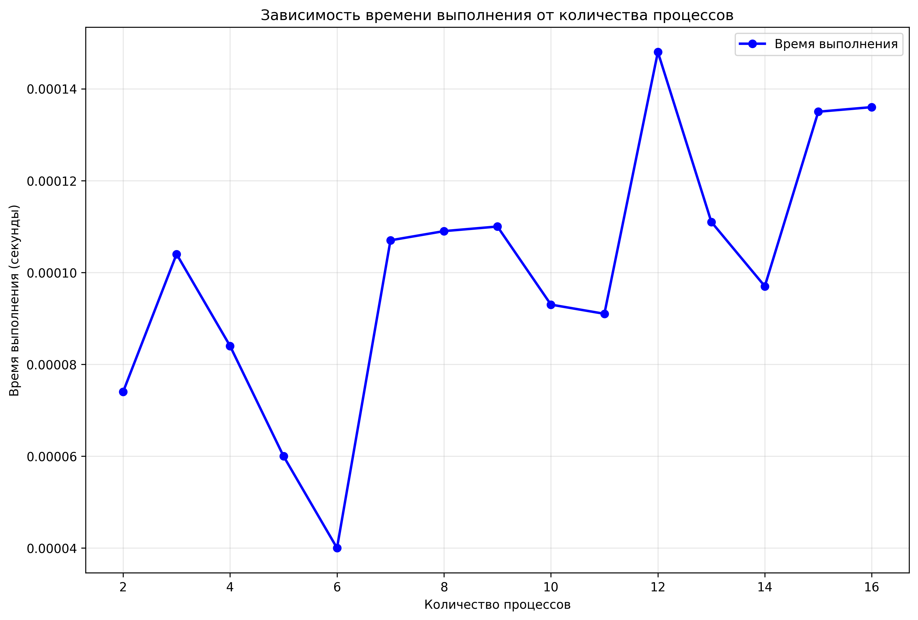Рис.5 – график зависимости времени выполнения от числа процессов

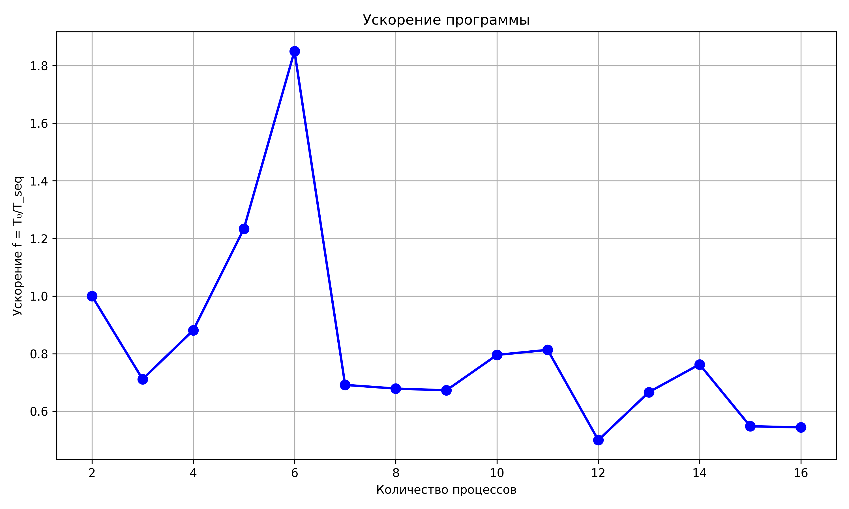

Рис.6 - график ускорения

**Разработанный программный код см. в приложении А.**

## Выводы.

В рамках лабораторной работы создана параллельная MPI-программа. Изучены основы обмена сообщениями, включая недетерминизм при получении данных. Замеры производительности показали, что алгоритм с последовательным приемом сообщений от процессов в среднем приводит к увеличению времени работы программы на 0.0001 секунды по сравнению с непоследовательным приёмом. Параллельное выполнение не привело к ускорению программы ни в одном из случаев.

**Приложение А  
Исходный код программы**

Название файла: task1.с

#include <stdio.h>

#include <mpi.h>

int main(int argc, char **argv)

{

int rank, size;

MPI_Status status;

MPI_Init(&argc, &argv);

MPI_Comm_rank(MPI_COMM_WORLD, &rank);

MPI_Comm_size(MPI_COMM_WORLD, &size);

if (rank == 0) {

double start_time, end_time;

start_time = MPI_Wtime();

printf("Process 0: my rank is %d\n", rank);

for (int i = 1; i < size; ++i) {

int received_rank;

MPI_Recv(&received_rank,

1,

MPI_INT,

MPI_ANY_SOURCE,

MPI_ANY_TAG,

MPI_COMM_WORLD,

&status);

printf("Process 0: received rank %d from process %d\n",

received_rank, status.MPI_SOURCE);

}

end_time = MPI_Wtime();

double exec_time = end_time - start_time;

puts("============= Execution Results =============");

printf("Num of proc: %d | Execution time: %.6f seconds",

size, exec_time);

}

else {

MPI_Send(&rank, 1, MPI_INT, 0, 0, MPI_COMM_WORLD);

}

MPI_Finalize();

return 0;

}

Название файла: task2.с

#include <stdio.h>

#include <mpi.h>

int main(int argc, char **argv)

{

int rank, size;

MPI_Status status;

MPI_Init(&argc, &argv);

MPI_Comm_rank(MPI_COMM_WORLD, &rank);

MPI_Comm_size(MPI_COMM_WORLD, &size);

if (rank == 0) {

double start_time, end_time;

start_time = MPI_Wtime();

printf("Process 0: my rank is %d\n", rank);

for (int i = 1; i < size; i++) {

int received_rank;

MPI_Recv(&received_rank,

1,

MPI_INT,

i,

0,

MPI_COMM_WORLD,

&status);

printf("Process 0: received rank %d from process %d\n",

received_rank, status.MPI_SOURCE);

}

end_time = MPI_Wtime();

double exec_time = end_time - start_time;

puts("============= Execution Results =============");

printf("Num of proc: %d | Execution time: %.6f seconds",

size, exec_time);

}

else {

MPI_Send(&rank, 1, MPI_INT, 0, 0, MPI_COMM_WORLD);

}

MPI_Finalize();

return 0;

}