

|  |
| --- |
| Business Template |
| **Logo / Image** |

Contents

1 Business Description 3

1.1 Business background 3

1.2 Problems. Current Situation 3

1.3 The benefits of implementing a database. Project Vision 3

2 Model description 3

2.1 Definitions & Acronyms 3

2.2 Logical Scheme 3

2.3 Objects 3

# Business Description

## Business background

## Problems. Current Situation

## the Benefits of implementing a database. Project Vision

# Model description

A rough sketch of how a logical scheme would look.

## 2.1 Definitions & Acronyms

The following terms and acronyms are used throughout this document:  
- PK: Primary Key  
- FK: Foreign Key  
- bigint: A data type used for storing large integer values  
- text: A data type used for storing long text strings  
- boolean: A data type used for storing binary values (True/False)

## 2.2 Logical Scheme

The logical scheme representing the database structure is shown below:

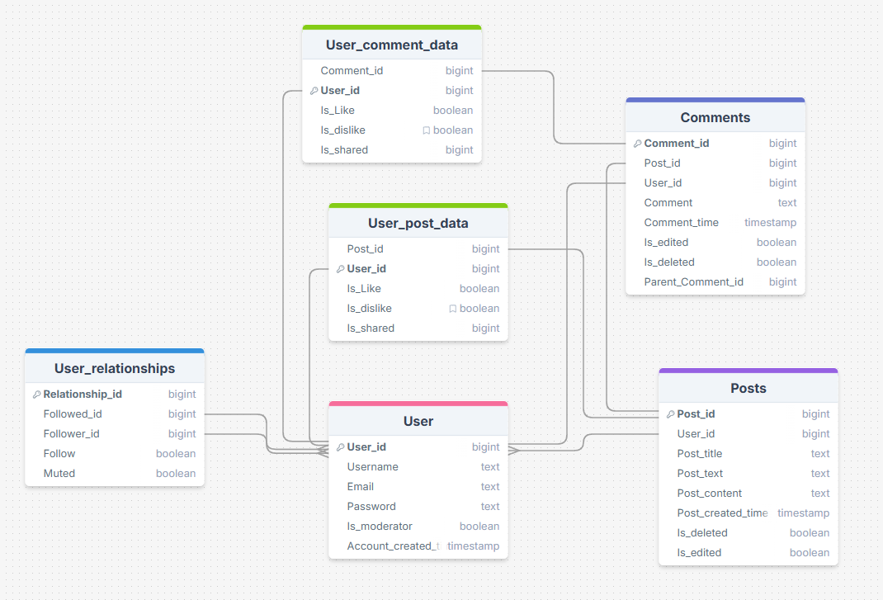

## 2.3 Objects

The following are the tables and fields included in the database:

### Table: User_comment_data

|  |  |  |
| --- | --- | --- |
| Field Name | Data Type | Description |
| Comment_id | bigint | Primary Key |
| User_id | bigint | Foreign Key to User |
| Is_Like | boolean | Indicates if the comment is liked |
| Is_dislike | boolean | Indicates if the comment is disliked |
| Is_shared | boolean | Indicates if the comment is shared |

### Table: Comments

|  |  |  |
| --- | --- | --- |
| Field Name | Data Type | Description |
| Comment_id | bigint | Primary Key |
| Post_id | bigint | Foreign Key to Posts |
| User_id | bigint | Foreign Key to User |
| Comment | text | Text of the comment |
| Comment_time | timestamp | Time when the comment was made |
| Is_edited | boolean | Indicates if the comment is edited |
| Is_deleted | boolean | Indicates if the comment is deleted |
| Parent_Comment_id | bigint | Foreign Key to parent comment |

### Table: Posts

|  |  |  |
| --- | --- | --- |
| Field Name | Data Type | Description |
| Post_id | bigint | Primary Key |
| User_id | bigint | Foreign Key to User |
| Post_title | text | Title of the post |
| Post_text | text | Main text content of the post |
| Post_content | text | Content or body of the post |
| Post_created_time | timestamp | Creation time of the post |
| Is_deleted | boolean | Indicates if the post is deleted |
| Is_edited | boolean | Indicates if the post is edited |

### Table: User

|  |  |  |
| --- | --- | --- |
| Field Name | Data Type | Description |
| User_id | bigint | Primary Key |
| Username | text | User's username |
| Email | text | User's email address |
| Password | text | User's password |
| Is_moderator | boolean | Indicates if the user is a moderator |
| Account_created_time | timestamp | Time when the account was created |

### Table: User_relationships

|  |  |  |
| --- | --- | --- |
| Field Name | Data Type | Description |
| Relationship_id | bigint | Primary Key |
| Followed_id | bigint | User being followed |
| Follower_id | bigint | User following another user |
| Follow | boolean | Indicates if the relationship is a follow |
| Muted | boolean | Indicates if the relationship is muted |

### Table: User_post_data

|  |  |  |
| --- | --- | --- |
| Field Name | Data Type | Description |
| Post_id | bigint | Foreign Key to Posts |
| User_id | bigint | Foreign Key to User |
| Is_Like | boolean | Indicates if the post is liked |
| Is_dislike | boolean | Indicates if the post is disliked |
| Is_shared | boolean | Indicates if the post is shared |