**JOURNAL OF INFORMATION**

**SYSTEM AND TECHNOLOGY**

**MANAGEMENT (JISTM)**

[www.jistm.co](http://www.jistm.com/)

[m](http://www.jistm.com/)



**AN EFFECTIVE LOST AND FOUND SYSTEM IN UNIVERSITY CAMPUS**

Siok Yee Tan1*, Cia Rui Chong2

1. Fakulti Teknologi dan Sains Maklumat, Universiti Kebangsaan Malaysia, Malaysia Email: esther@ukm.edu.my
2. Fakulti Teknologi dan Sains Maklumat, Universiti Kebangsaan Malaysia, Malaysia Email: a165563@siswa.ukm.edu.my

* Corresponding Author

|  |  |
| --- | --- |
| **Article Info:** | **Abstract:** |
| **Article history:**  Received date: 25.07.2023  Revised date: 15.08.2023  Accepted date: 07.09.2023 Published date: 24.09.2023 **To cite this document:**  Tan, S. Y., & Chong, C. R. (2023). An  Effective Lost And Found System In University Campus. *Journal of Information System and Technology Management, 8* (32), 99-112.    **DOI:** 10.35631/JISTM.832007  **This work is licensed under** [**CC BY 4.0**](https://creativecommons.org/licenses/by/4.0/?ref=chooser-v1) | Different organizations and researchers have carried out much work to highlight the problem of lost and misplaced items. In this work, a web and mobile-based lost and found service for The National University of Malaysia (UKM) is designed and developed. The primary goal of this research is to help the students, staff, and visitors on the UKM campus find their lost items more efficiently. The main features of this web and mobile application included a login system and a lost and found listing page where the user can add things they have discovered or items reported as lost. Users can add extra information about the items, such as where the items are found or lost, and even attach pictures. Besides, users must update their contact information and matric number to ensure authenticity. Due to security issues, users must add security questions for every post to protect users from any frauds and tricks. Once the users have held an item for over a month, the disposal system will automatically delete the item. The application is an online lost and found system created using programming languages such as PHP, HTML, CSS, and Java Script connected to the MySQL database. The software used in this project is Sublime Text, XAMPP, and Filezilla, whereas the software used to develop the mobile application is Android Studio, and the programming language is Java. In conclusion, the system has successfully helped the students and staff of UKM to find their lost belongings and items faster and easier. This research also played an essential role in creating an efficient digital campus environment and enhancing the university's sustainability.  **Keywords:**  Lost And Found System, Mobile-Based, Usability, Web-Based |

# Introduction

A fast-paced lifestyle is unavoidable in a world surrounded by the advancement of science and technology. Time is more important than ever as everyone does multiple daily tasks (Appelbaum, 2008; Sanbonmatsu, 2013; Srna, 2018). As everyone gets busier, the issue of lost and misplaced items is also increasing significantly. The problem of lost and misplaced items has caused losses in both money and time (Ahmad, 2015). An increasing number of university students are experiencing higher rates of lost belongings. Surprising statistics reveal that during a single academic year, more than half of the students, approximately 50%, have reported losing possessions on campus. Each student misplaces around two items annually, ranging from chargers to identification cards. Considering the substantial enrollment of 2.19 million students in universities, the collective data suggests a staggering count of 4.5 million lost items among students nationwide each year. This value represents significant lost personal property (NotLost Press, 2020). Universities are large places that may stretch out for miles. So, it is hard for the students to search for their lost belongings in every building (Oke, 2017; Zborovsky, 2018).

Numerous academic institutions provide designated lost and found collection points, allowing students and faculty to reclaim misplaced belongings. Examples include Cornell University and York University. (Cornell, 2023; York, 2023), but they are inefficient as most students do not know the exact places to check for the items (RepoApp, 2019). There are various lost and found systems outside the university (Kientz, 2006; Suchana, 2021; Xue, 2022), but most of the system does not provide the services for The National University of Malaysia (UKM). The current lost and found system available in the market, such as Troov, is not convenient to the students as the system is designed for the whole world and does not focus on a specific area (Troov, 2022). So, recovering lost belongings becomes harder as not every student will use this application to find them. Besides, InstaFile Reporting only allows students to upload information about lost items after paying $29.90, which is not affordable for most students (InstaFileReporting, 2019). Besides that, Malaysia Airports also provides lost and found services for all the passengers who lost or found items around KLIA and KLIA2 (Malaysia Airports Holdings Berhad, 2015).

According to the survey conducted among 50 students and staff of UKM, the loss of personal belongings around the campus is one of the problems they always face. As no specific lost and found system is built for the students and staff of UKM, the lost and misplaced issue has disrupted their campus lives. If they lost their belongings, they will upload the information on social media applications such as WhatsApp and Facebook. However, the opportunity to recover their belongings is small as the messages that can be spread to students throughout the university are limited. Another problem faced by the students is that they could not determine the actual owner of the items, which increases the chance of the wrong owner picking up the lost item. The time for the students on campus is not flexible as they have different classes to attend at other hours, so they might miss out on the chance to recover their lost belongings. Hence, this study aims to investigate the pretesting and function requirement for the lost and found application on university campuses. The lost and found management system should fulfil the students' demand, which allows them to upload information about their lost and found belongings and search the items by category or keywords. This research is carried out at UKM. Hence, the pretesting survey and usability testing are completed by UKM students and staff only.

This paper is organized into seven (7) sections. Section 2 briefly reviews the lost and found web and mobile-based systems that had been developed previously. The methodology research that discusses the pretesting output, system model, and data flow diagram is presented in Section 3. Section 4 discusses the output of the web and mobile applications for this study. The evaluation procedure and results of the evaluation are presented in Section 5. Section 6 delves into the discourse, while Section 7 explores the concluding remarks and prospects for future research in this study.

# Background Works

There are many existing lost and found management systems and mobile applications in the market, such as Troov, InstaFile Reporting, and Malaysia Airports. The advantages and functions found in the existing systems and mobile applications have been studied as a guideline during the development process of the lost and found management system (FoundeLost).

## Troov

Troov is a lost and found management system developed by Aurelie Toubol, Gregoire ReyBrot, and Ibrahim Fofana in 2018 (Troov, 2022). This website aims to help users to report a lost or found item through an online matching algorithm. Users need to fill in the details such as location, type of item, description of the item, and date lost in order to help the algorithm identify similar items. Once there is any matching item that has similar features as the reported item, the users will receive a notification. In order to recover the lost belongings, users need to prove their ownership of the item by answering the security question correctly. As soon as the users are proven to be authenticated, they will receive the information to pick the item up or have it delivered.

## InstaFile Reporting

InstaFile Reporting provides a platform for reporting lost property between each airport and company flights nationwide (InstaFileReporting, 2019). Users need to fill in the information about flight numbers and airport names before reporting the lost items. Once the information on the lost item has been successfully uploaded to the website, a service agent will act on your behalf to liaise with necessary authorities, such as airports and airlines, to follow and update the operating procedures. Users are required to make a payment of $29.90 before uploading the details of lost items. However, this payment does not ensure that the lost items will surely be recovered. In addition, this website will not refund if the lost items cannot be recovered.

## Malaysia Airports

Malaysia Airports is a website developed to facilitate the operation of KLIA and KLIA2 in Malaysia (Malaysia Airports Holdings Berhad, 2015). This website is built specifically for KLIA and KLIA2 passengers to check the information about each flight between KLIA and KLIA2 as well as report any lost or found items between KLIA and KLIA2. The designated place to return or recover the lost or found items is at the Main Terminal Building (Level 2, next to the entrance of the Food Park). However, these found items that are sent to the counter and information regarding the lost items will be disposed of within 30 days.

Based on the study, the three existing websites and applications mentioned above have two important features, which are uploading details of the lost and found items and authentication, which requires users to answer security questions. Users can choose their status if they have lost or found the items before uploading the details of the items if they are using Troov, InstaFile Reporting, and Malaysia Airports. Users are not required to register, but they need to fill in their personal information when they upload the details of items for further contact. In order to protect the privacy of the user's personal information, security questions play an important role in validating the authenticity of the users. However, UKM does not have a specific lost and found management system or application designed for the students and staff currently. Hence, the students or staff who found or lost their belongings around the campus find it difficult to recover their lost items. Table 1 shows the comparison of the three existing system namely Troov, instaFile Reporting and Malaysia Airports with the FoundeLost.

|  |  |  |  |  |  |  |
| --- | --- | --- | --- | --- | --- | --- |
|  | | **Table 1: Comparison with existing system** | | |  | |
| **Criteria**    **Display** | | **Troov**    Webpage | **instaFile**  **Reporting** Webpage | **Malaysia**  **Airports** Webpage and mobile application | **FoundeLost**  Webpage and mobile application | |
| **Log In** | | Log in before uploading information. | Do not need to log in before uploading information. | Do not need to log in before uploading the information | Log in before uploading the information | |
| **Registration** | | The user needs to register. | Users do not need to register. | Users do not need to register. | The user needs to register using the UKM email. | |
| **Upload items information function** | | Upload lost and found items. | Upload lost items only. | Upload lost and found items. | Upload lost and found items. | |
| **Searching function** | | Cannot search items. | Can search items. | Cannot search items. | Can search items. | |
| **Choose category function** | | Can choose the  item's category. | Cannot choose  item's category. | Can choose the item's category. | Can choose the item's category.  . | |
| **Upload pictures function** | | Can upload pictures. | Can upload pictures. | Cannot upload pictures. | Can upload pictures. | |
| **Set security question function** | The security question is  optional | Does not provide security questions. | Does not provide  security questions. | The security question is required. |
| **Update profile function** | Cannot update profile | Cannot update profile | Cannot update profile | Can update profile |

# Methodology

The methodology section discusses the analysis of the pretesting, functional requirement, and system model to develop a web-based and mobile-based lost and found application for UKM.

## Pretesting

The pretesting survey is conducted among the students and staff of UKM. There are 50 respondents who participated in this survey, and the survey consists of a total of 7 questions. The survey questions are as follows:

1. Have you ever lost your belongings (s) around the campus in UKM? (Yes/No)
2. If Yes, did you manage to recover your lost belongings (s)? (Yes/No)
3. Have you ever found someone's belongings (s) around the campus in UKM? (Yes/No)
4. If Yes, did you manage to return it back to its owner? (Yes/No)
5. If you had found someone's lost belonging(s) or lost your own belonging(s), what would you do? (1. Post it on social media (WhatsApp, Facebook and so on) 2. Inform any of the offices nearby. 3. I have no idea what to do.)
6. If an online platform is provided to have direct inquiries about your lost and found item(s), do you think it can help owners recover their belongings (s) more efficiently? (Yes/No)
7. Would you use this online platform to make inquiries regarding lost and found item(s)? (Yes/No)

Figure 1 shows the analysis of pretesting survey for all seven questions. Based on the analysis, most of the participants (66%) agree that they have lost their belongings around the university campus, and they (76.5%) could not recover their lost belongings. Most of the participants (62%) agreed that they had found someone's belongings around the university campus, but they (68.8%) could not return the items to their owners. Furthermore, the majority of participants will inform the office nearby (28%) or post the news on social media (56%) if they have found someone's lost belongings or they have lost their own belongings. There are a total of 49 students out of 50 participants who agree that if an online platform is provided with direct inquiries about lost and found items, it can help the owners recover their belongings more efficiently. All the participants (50 out of 50) agree that they would use the online platform provided to make inquiries regarding the lost and found items around UKM. Based on the pretesting survey, a lost and found management system is in high demand for the university's students and staff. A web and mobile-based lost and found management system should be built to solve the students' lost and found problems that happened around UKM.

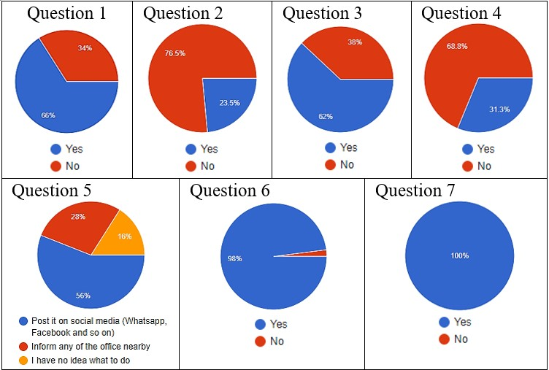

# Figure 1: Pretesting Survey Analysis

## System Model

During the process of system development, context diagrams, use case diagrams and flow charts should be used.

## Context Diagram

The context diagram shows the system environment and the interaction between entities. Figure 2 shows the context diagram of the lost and found management system (FoundeLost).

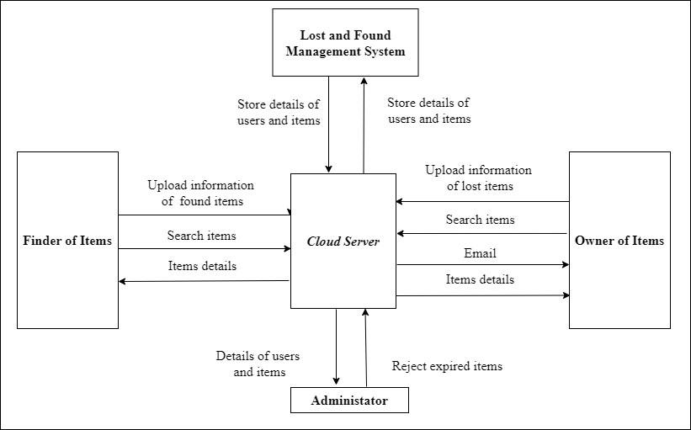

# Figure 2: FoundeLost Application Context Diagram

## Use Case Diagram

The use case diagram shows an overview of graphics from several actors, use cases, and interactions among them. Figure 3 shows the use case diagram of the FoundeLost application.

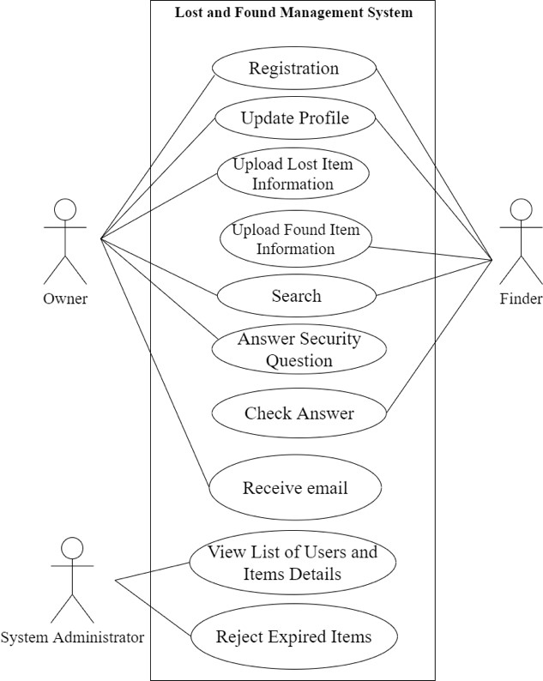

# Figure 3: FoundeLost Application Use Case Diagram

## Flow Chart

The system flow chart shows the overall structure of the system that will be developed, as well as the process of each function present in the system. Figure 4 shows the flow chart of the FoundeLost application.

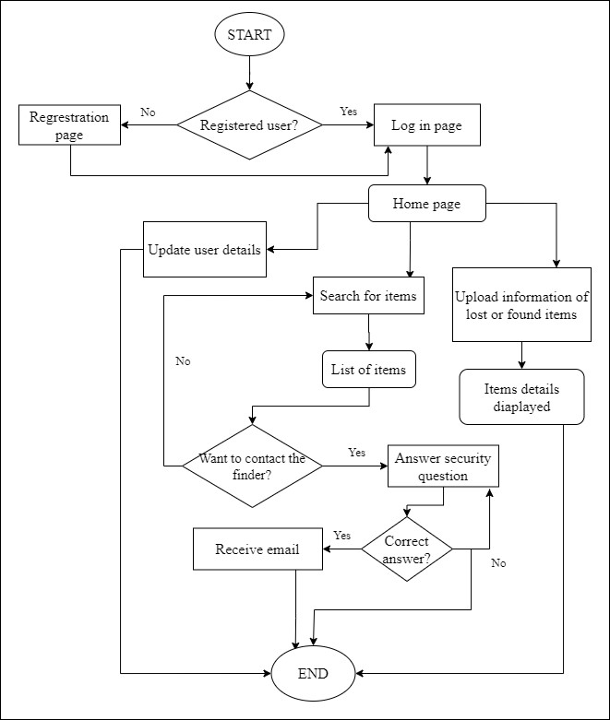

# Figure 4: FoundeLost Application Flow Chart

## Data Flow Diagram

The data flow diagram shows the overview and description of the data flow process of a system. Figure 5 shows the data flow diagram of the FoundeLost application.

System users can be divided into two categories, which are the finder and owner of items. They can upload their personal information and update their profile. The data is stored in the Profile database. Next, the owner of the items can get information about the items from the Items database, which is uploaded by the finder.

Finders can get the answers to security questions answered by the owner of the items from the database Answers. System administrators can get information about the list of users as well as items uploaded by users from the Profile and Item database. The information on items that are not expired is stored again in the Items database.

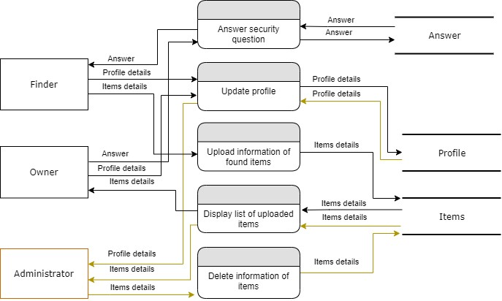

**Figure 5: Data Flow of FoundeLost Application**

# Output

Figure 6 shows the user interface of a web-based lost and found system. Once the users successfully log in using the UKM email and password, they can view and update their profile information. Before uploading the information of items, users can choose their status as lost or found. The users can view the existing items that are uploaded by other users by searching the keywords. Once the users have found their lost or found items in the list of existing items, they need to answer the security question, which is set by the finder of the items. If the users answer the security question correctly, they will receive an email sent by the finder who uploads the information of items.

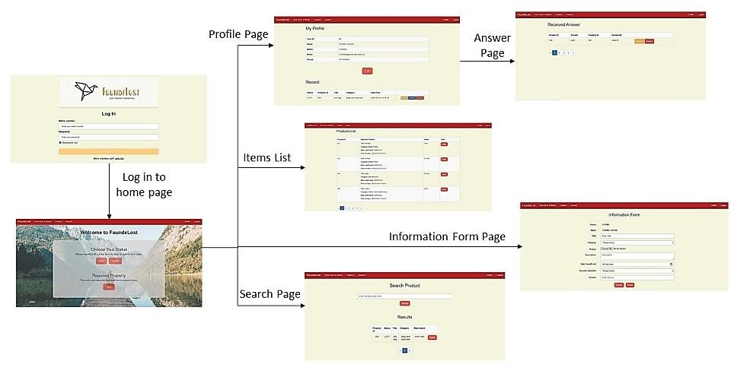

# Figure 6: FoundeLost Web-based System User Interface

Figure 7 shows the user interface of a mobile-based lost and found application. Once the users successfully log in using the UKM email and password, they can upload the information of items by choosing their status as either lost or found. The users can view the existing items that are uploaded by other users through the list that stores the information of all existing items. Once the users have found their lost or found, they need to answer the security question, which is set by the finder of the items. If the users answer the security question correctly, they will receive an email sent by the finder who uploads the information of items.

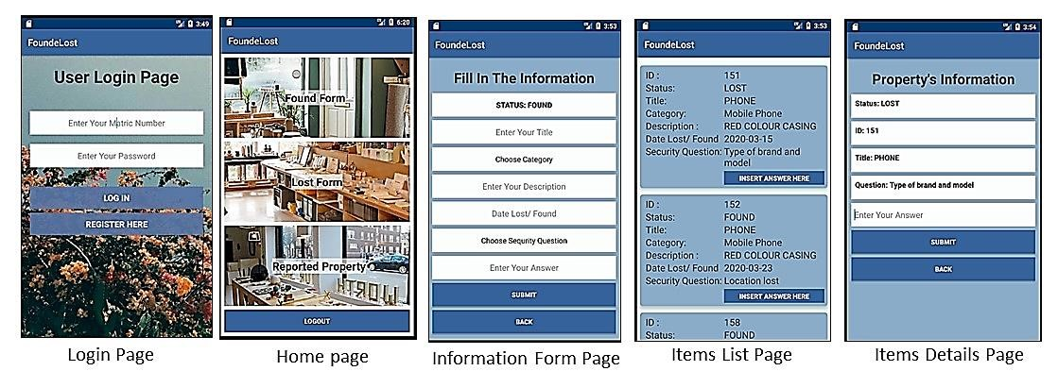

**Figure 7: FoundeLost Mobile Application User Interface**

# Evaluation Result

The evaluation procedure is a process of evaluation and testing on the developed system in order to measure that it is built according to the specific requirements. The system testing that has been carried out includes unit testing, integration testing, and user acceptance testing. Unit testing is a method used to test every function and component that is present in the system in order to ensure that it can work without any problems.

A questionnaire containing 24 questions on aspects of usability, ease of use, ease of learning, and subjective satisfaction is distributed to 20 testers from UKM. The questionnaire design referring to previous work (Mei et at., 2019; Lam et al., 2020; Tan et al., 2020). The feedback from users in terms of positive and negative aspects, as well as suggestions related to system functions and interfaces, are also recorded. Testers are required to respond to the questions with a scale of 1 (Strongly Disagree) up to a scale of 5 (Strongly Agree) after they have tested every function of the system. The questions are as follows:

1. This application helps me perform tasks effectively.
2. This application is time-saving.
3. This application meets the requirements of my task.
4. This application performs the task I need.
5. This application helps me perform tasks productively.
6. This application is user-friendly.
7. This application is flexible to perform tasks.
8. This application is easy to use without a written guide.
9. I can use this application smoothly.
10. I can get the results I need quickly and easily.
11. This application is easy to learn.
12. I learned to use this application quickly.
13. I can remember how to use this application easily.
14. I can understand the function of this application quickly.
15. I am good at using this application quickly.
16. I am satisfied with using this application.
17. I will share this application with my friends.
18. I need this application.
19. It is easy to use this application.
20. This application works with the capabilities I want.
21. In your opinion, what are the positive aspects of this application? Please explain.
22. In your opinion, what are the negative aspects of this application? Please explain.
23. Is there any suggestion for the functionality of this application? 24) Is there any suggestion for the interface of the application?

Figure 8 shows the analysis of the usability testing (Question 1 to Question 20) from the 20 testers. Overall results show that users are satisfied with the FoundeLost application. Most of them agree that the FoundeLost application can work effectively and is easy to learn.

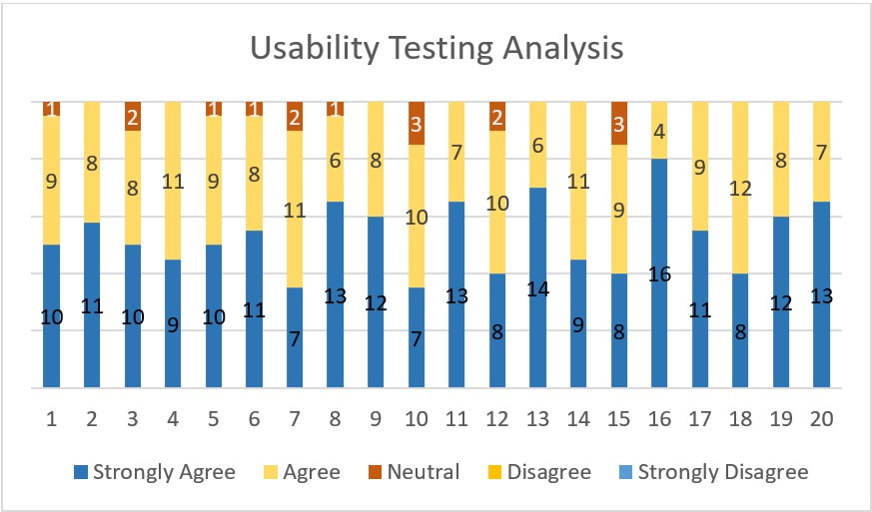

# Figure 8: FoundeLost Mobile Application User Interface

Based on the analysis, the majority of users agree that the FoundeLost application is userfriendly and time-saving in the process of finding lost items. Users also agree that the FoundeLost application is useful in the process of recovering lost items or returning found items and are satisfied with the function provided in the system. However, there are also some users who feel that the FoundeLost application does not provide a pop-up notification function that shows the latest messages, as well as customer services. The suggestion given by the user based on the function of the system is that users who do not register on the FoundeLost application can also search and view the list of items that have been uploaded by other users. In addition, suggestions for the interface are also given by users. Among the suggestions given are inserting the guide message on every button for first-time users and the additional languages used in this application, such as Bahasa Malaysia and Chinese. This application can be further improved by taking into the user's feedback.

FoundeLost system that has been developed is a web and mobile application specially designed for students and staff of UKM. Every user needs to use the UKM email as well as the matric number for registration. While uploading item information, users need to select the category of items as well as upload the pictures. FoundeLost also provides a search function for every user. Users are required to set security questions before uploading any in this system.

# Discussion and Limitations

The development of the web and mobile-based lost and found service for UKM has several notable implications and benefits. Firstly, the system provides a user-friendly and efficient platform for reporting lost items and recovering them. The inclusion of a login system ensures that only authorized users can interact with the system, reducing the risk of misuse. The ability to add detailed information about lost and found items, including images, enhances the chances of successful reunions between owners and their belongings. This is particularly important for a university campus with a diverse community, where items are frequently misplaced.

The requirement for users to update their contact information and matric number adds an additional layer of authenticity to the system. This helps in preventing fraudulent activities and ensures that legitimate users can be reached promptly when their lost items are found. The automatic disposal system is a valuable feature, as it keeps the system up-to-date and prevents it from becoming cluttered with outdated listings. This contributes to the overall efficiency and usability of the platform. From a technological perspective, the use of commonly employed programming languages such as PHP, HTML, CSS, JavaScript, and Java for web and mobile development ensures that the system is accessible and maintainable.

In terms of the broader impact, this research project not only solves a practical problem but also contributes to a more sustainable digital campus environment. It aligns with the university's goals of improving the overall experience of its students and staff and showcases the institution's commitment to innovation and efficiency. In conclusion, the development of this web and mobile-based lost and found service for UKM represents a successful integration of technology and practicality, addressing a common issue faced by the campus community. Its features enhance user experience, improve security, and contribute to the overall efficiency and sustainability of the university environment. Further enhancements and user feedback may be considered for future iterations to continually improve the system's effectiveness.

There are several limitations in this lost and found system. One challenge is the potential for limited user engagement. Encouraging active participation from students, staff, and visitors in terms of reporting lost items may prove challenging. Strategies for promoting the platform and incentivizing its use should be explored. Additionally, despite the presence of security measures, the system is not immune to security concerns. Continuous vigilance and improvements in security features, particularly in terms of authentication and data protection, are essential to safeguard against potential misuse. Moreover, the mobile application's exclusivity to Android devices may limit its accessibility, necessitating future work to expand compatibility with other operating systems.

# Conclusion and Future Work

The development of a web and mobile-based lost and found service for The National University of Malaysia (UKM) has been a significant step towards addressing the problem of lost and misplaced items on campus. Overall, this research project has successfully addressed the issue of lost and misplaced items on the UKM campus by creating an efficient and user-friendly digital lost and found system. It has played a vital role in enhancing the university's sustainability by reducing the frustration and inconvenience caused by lost belongings and contributing to a more organized and digitally-driven campus environment.

However, there several avenues for future work can be pursued to address the limitations discussed in the previous section. First and foremost, efforts should focus on user education and promotion. Creating awareness within the UKM community and providing user education sessions can foster greater user engagement. Expanding the mobile application's compatibility to iOS and other platforms is also crucial to reach a broader user base. Furthermore, implementing data analytics tools can yield insights into item recovery rates, user behavior, and trends, enabling data-driven decision-making and system improvements. Collaborating with campus security to integrate the system with their operations could streamline the reporting and recovery processes. Establishing a user feedback mechanism, such as surveys or feedback forms, can facilitate ongoing enhancements based on user suggestions and needs. Additionally, the system could benefit from extended item tracking features and the integration of machine learning algorithms for improved accuracy in item matching and automation of certain tasks, enhancing the overall user experience and the system's efficiency. These future endeavors will contribute to a more robust and user-centric lost and found service at UKM.

# Acknowledgments

This research was funded by the Ministry of Higher Education Malaysia [FRGS/1/2022/ICT10/UKM/02/2] and Universiti Kebangsaan Malaysia [GUP-2020-060].

# References

Ahmad, S., Ziaullah, M., Rauniyar, L., Su, M., & Zhang, Y. (2015). How does matter lost and misplace items issue and its technological solutions in 2015-a review study. IOSR J. Bus. Manag. Ver. I, 17(4), 2319-7668. Appelbaum, S., Marchionni, A., & Fernández, A. (2008). The multi‐tasking paradox: perceptions, problems and strategies. Management Decision, 46, 1313-1325.

Cornell Police (2023). Lost and Found. Retrieved June 30, 2023, from

<https://www.cupolice.cornell.edu/about-the-department/lost-and-found/>

InstaFileReporting. (2019). Airport Lost & Found Service. Retrieved June 30, 2023, from [https://www.instafilereporting.com/?gclid=CjwKCAjwq4fsBRBnEiwANTahcFPRGZ Nv8mQUMkyRKG76_WRJEAQ-aLp0sczqc73tR3uR1XYzcXl1hoCpeoQAvD_BwE](https://www.instafilereporting.com/?gclid=CjwKCAjwq4fsBRBnEiwANTahcFPRGZNv8mQUMkyRKG76_WRJEAQ-aLp0sc-zqc73tR3uR1XYzcXl1hoCpeoQAvD_BwE)

Kientz, J., Patel, S., Tyebkhan, A., Gane, B., Wiley, J., & Abowd, G. (2006). Where's my stuff?: design and evaluation of a mobile system for locating lost items for the visually impaired. , 103-110.

Lam, M. C., Tee, H. K., Nizam, S. S. M., Hashim, N. C., Suwadi, N. A., Tan, S. Y., ... & Liew, S. Y. (2020). Interactive Augmented Reality with Natural Action for Chemistry Experiment Learning. Tem Journal, 9(1).

Malaysia Airports Holdings Berhad. (2015). Lost & Found at Kuala Lumpur International

Airport (KUL) KLIA Terminal. Retrieved June 30, 2023, from

<http://www.klia.com.my/airport-amenities/services/lost-found>

Mei, Y. C., & Siok, Y. T. (2019). A Food Delivery Mobile Application in University Campus Based on Market Demand. International Journal of Advanced Science and Technology, 28(10), 239-246.

NotLost Press. (2020). 4.5 million items lost: The hidden cost of lost property at university. Retrieved June 30, 2023, from [https://notlost.com/the-hidden-cost-of-lost-property-atuniversity/](https://notlost.com/the-hidden-cost-of-lost-property-at-university/)

Oke, A., Aigbavboa, C., & Raphiri, M. (2017). Students’ satisfaction with hostel accommodations in higher education institutions. Journal of Engineering, Design and Technology, 15, 652-666.

RepoApp. (2019). Lost and Found Software for Universities. Retrieved June 30, 2023, from <https://www.repoapp.com/lost-found-software-universities/>

Sanbonmatsu, D., Strayer, D., Medeiros-Ward, N., & Watson, J. (2013). Who Multi-Tasks and Why? Multi-Tasking Ability, Perceived Multi-Tasking Ability, Impulsivity, and Sensation Seeking. PLoS ONE, 8.

Srna, S., Schrift, R., & Zauberman, G. (2018). The Illusion of Multitasking and Its Positive Effect on Performance. Psychological Science, 29, 1942 - 1955.

Suchana, K., Alam, S., Meem, A., Turjo, M., & Khan, M. (2021). Development of UserFriendly Web-Based Lost and Found System. Journal of Software Engineering and Applications.

Tan, S. Y., Lee, K. J., & Lam, M. C. (2020). A Shopping Mall Indoor Navigation Application using Wi-Fi Positioning System. Int. J, 9, 4483-4489.

TROOV. (2022). Report a lost item, Report a found item. Retrieved June 30, 2023, from <https://www.troov.com/en/lost>

Xue, Q., Ma, H., & Sun, C. (2022). Exploratory Research on Blockchain-based Lost and Found Platform. 2022 7th International Conference on Intelligent Informatics and Biomedical Science (ICIIBMS), 7, 45-50.

York Police (2023). Lost and Found. Retrieved Jul 8, 2023, from

<https://www.yorku.ca/safety/lostandfound/>

Zborovsky, G., & Ambarova, P. (2018). Higher Education as a Factor of the Cities’ Preservation in the Ural Macro-Region. Economy of Region.