Insert your name, centre number and candidate number into the header above.
70/75
Save this evidence document as evidence_ followed by your centre number_ candidate number. For example: evidence_ zz999_9999.doc
Screenshots or program listings must be copied into appropriate cells in the following tables.
Examiners must be able to read the contents including any screenshots without the use of a magnifying glass. Answers that are not readable or missing will not be awarded any marks.
Save this evidence document at regular intervals, for example, every 10 minutes.
Question 1
Part 1(a)(i) +4
class EventItem:
def __init__(self, EN, TY, DI):
self.__EventName = EN # STRING
self.__Type = TY # STRING
self.__Difficulty = DI # INTEGER

Part 1(a)(ii) +3
def GetName(self):
return self.__EventName

def GetEventType(self):
return self.__Type

def GetDifficulty(self):
return self.__Difficulty

Part 1(b)(i) +1/1 missing size of array
Group = [] # ARRAY OF 5 EventItem

Part 1(b)(ii) +3
Group.append(EventItem("Bridge", "jump", 3))
Group.append(EventItem("Water wade", "swim", 4))
Group.append(EventItem("100 mile run", "run", 5))
Group.append(EventItem("Gridlock", "drive", 2))
Group.append(EventItem("Wall on wall", "jump", 4))

Part 1(c) +4
class Character:
def __init__(self, CN, JP, SM, RN, DR):
self.__CharacterName = CN # INTEGER
self.__Jump = JP # INTEGER
self.__Swim = SM # INTEGER
self.__Run = RN # INTEGER
self.__Drive = DR # INTEGER

def GetName(self):
return self.__CharacterName

Part 1(d) +4
def CalculateScore(self, TheTY, TheDI):
mylevel = -1
if TheTY == "jump":
mylevel = self.__Jump
if TheTY == "swim":
mylevel = self.__Swim
if TheTY == "run":
mylevel = self.__Run
if TheTY == "drive":
mylevel = self.__Drive

if mylevel >= TheDI:
return 100
else:
return 100 - (TheDI - mylevel) * 20

Part 1(e)(i) +2
ChT = Character("Tarz", 5, 3, 5, 1)
ChG = Character("Geni", 2, 2, 3, 4)

Part 1(e)(ii) +7
PointT = 0
PointG = 0

for env in Group:
ScoreT = ChT.CalculateScore(env.GetEventType(), env.GetDifficulty())
ScoreG = ChG.CalculateScore(env.GetEventType(), env.GetDifficulty())
if ScoreT == ScoreG:
print("The event is a draw.")
if ScoreT > ScoreG:
PointT = PointT + 1
print(ChT.GetName(), "have won the event.")
if ScoreT < ScoreG:
PointG = PointG + 1
print(ChG.GetName(), "have won the event.")

if PointT == PointG:
print("The Group is a draw.")
if PointT > PointG:
print(ChT.GetName(), "have won with", PointT, "points.")
if PointT < PointG:
print(ChG.GetName(), "have won with", PointG, "points.")

Part 1(e)(iii) +1
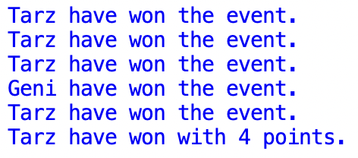

Question 2
Part 2(a) +2/3 worng function header
class Queue:
def __init__(self, QA, HP, TP):
self.QueueArray = QA [] # 1D ARRAY TO 100 OF INTEGER
self.Headpointer = HP 0 # INTEGER
self.Tailpointer = TP 0 # INTEGER

Part 2(b) +3
Tmp = []
for _ in range(100)://no anonymous
Tmp.append(-1)
TheQueue = Queue(Tmp, -1, 0)

Part 2(c) +4/5 wrong IF condition
def Enqueue(AQueue, TheData):
if AQueue.Headpointer == -1:
AQueue.QueueArray[AQueue.Tailpointer] = TheData
AQueue.Headpointer = 0
AQueue.Tailpointer = AQueue.Tailpointer + 1
return 1
else:
if AQueue.Tailpointer > 10099:
return -1
else:
AQueue.QueueArray[AQueue.Tailpointer] = TheData
AQueue.Tailpointer = AQueue.Tailpointer + 1
return 1

Part 2(d) +2/3 wrong function header
def ReturnAllData(TheQueue):
global TheQueue
result = ""
current = TheQueue.Headpointer
while current < TheQueue.Tailpointer:
result = result + str(TheQueue.QueueArray[current]) + " "
current = current + 1
return result

Part 2(e)(i) +5
for _ in range(10):
TheInput = -1
while int(TheInput) < 0:
TheInput = input("Please input a integer: ")
if Enqueue(TheQueue, TheInput):
print("The item has been added")

print(ReturnAllData())

Part 2(e)(ii) +2
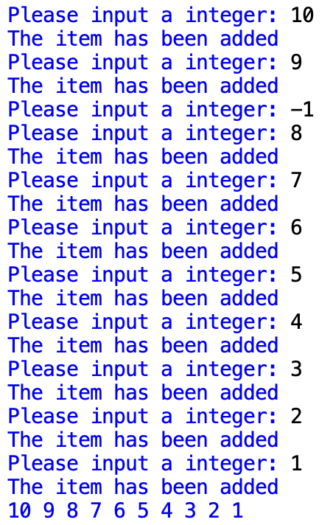

Part 2(f) +3/4 wrong function header
def Dequeue(TheQueue):
global TheQueue
if TheQueue.Headpointer == TheQueue.Tailpointer or TheQueue.Headpointer == -1:
return -1
else:
nextItem = TheQueue.QueueArray[TheQueue.Headpointer]
TheQueue.Headpointer = TheQueue.Headpointer + 1
return nextItem

\

Part 2(g)(i) +3
DQ = Dequeue()
if DQ == -1:
print("Queue empty")
else:
print(DQ)
DQ = Dequeue()
if DQ == -1:
print("Queue empty")
else:
print(DQ)

print(ReturnAllData())

Part 2(g)(ii) +1
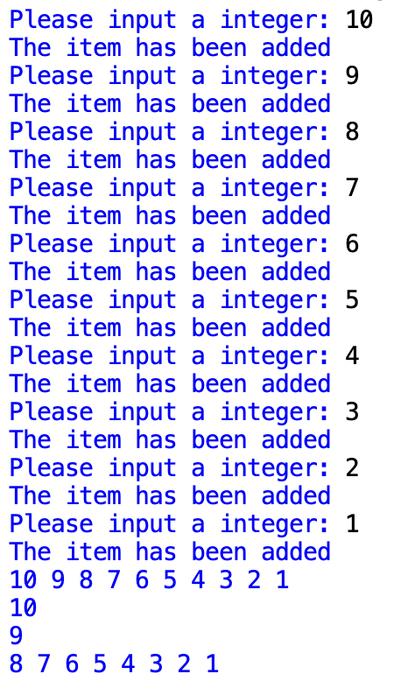

Question 3
Part 3(a) +2
HighScores = [] # 2D ARRAY OF STRING
for i in range(7):
HighScores.append(["", "", ""])

Part 3(b) +4/5 file not close
def ReadData():
NewHighScores = []
for i in range(7):
NewHighScores.append(["", "", ""])
try:
Thefile = open("HighScoreTable.txt")
for index in range(7):
NewHighScores[index][0] = Thefile.readline().strip()
NewHighScores[index][1] = Thefile.readline().strip()
NewHighScores[index][2] = Thefile.readline().strip()
Thefile.close()
return NewHighScores
except:
print("[ERROR] Can't open the file")

Part 3(c) +2
def OutputHighScores(TheArray):
for player in TheArray:
print(player[0], "reached level", player[1], "with a score of", player[2])

Part 3(d) +4
def SortScores(TheArray):
SortedHighScores = TheArray
move = True
while move:
move = False
for i in range(6, 0, -1):
cur = SortedHighScores[i]
pre = SortedHighScores[i - 1]
if cur[1] > pre[1]:
SortedHighScores[i - 1] = cur
SortedHighScores[i] = pre
move = True
else:
if cur[1] == pre[1] and cur[2]> pre[2]:
SortedHighScores[i - 1] = cur
SortedHighScores[i] = pre
move = True
return SortedHighScores

Part 3(e)(i) +2
HighScores = ReadData()
print("Before")
OutputHighScores(HighScores)
HighScores = SortScores(HighScores)
print("After")
OutputHighScores(HighScores)

Part 3(e)(ii) +2
