Overview
Battery electric vehicles use rechargeable batteries. At home, a wallbox provides a dedicated charging connection and can recharge a vehicle in a reasonable amount of time. Depending on the model, a wallbox can supply up to 11 kW or 22 kW. Premium models offer access control for multiple users and can bill each user for electricity.
Lower-cost wallboxes such as the Heidelberg Home Eco can charge a vehicle but have no built-in access control or billing functions.
ViLa (Visual Charging) adds the following functions to the wallbox:
- Support for multiple users
- Wallbox unlocking for authorized users
- Energy metering
- Separate billing for each user
- Display of instantaneous power and current
- A web interface accessible on the local wireless network

Wiring diagrams
Variant A uses a contactor to switch power to the wallbox on and off.
Variant B uses an enable switch to allow charging.

S0 interface
The S0 (S-zero) interface transmits meter readings, for example for electricity, temperature or gas. The original design refers to EN 62053-31 and DIN 43 864. Each pulse represents a quantity determined by the installed meter, so the pulse scaling must be configurable in ViLa. A meter can specify either:
- the pulse value $w=x\frac{energy units}{pulses}$ (e.g. 0.01 m³/pulse) or
- the pulse output rate f$=x\frac{pulses}{energy units}$ (e.g. 100 pulses/m³)
Each pulse lasts between 30 and 120 ms and is followed by a LOW signal lasting at least 30 ms. ViLa polls the pulse output at intervals of 30 ms or less to detect changes in state.
Meters fall into two classes.
- Class A: 25 V at 8 mA for long transmission distances
- Class B: 14 V at 2 mA for short transmission distances
The connection voltage ranges from 5 to 27 V for class A and from 5 to 15 V for class B. The current must not exceed 27 mA for class A or 15 mA for class B. The Raspberry Pi provides 3.3 V and a pull-up resistor on GPIO 3. GPIO 2 is an alternative. The original design reports that the components in the shopping list operated at this voltage, below the S0 specification.

GPIO pin assignments
- GPIO 3 reads the S0 pulse output.
- GPIO 13 controls the relay that switches the contactor.

Software
ViLa is open source. The source code is available at https://github.com/ReneSchwarzer/ViLa.

Raspberry Pi setup
ViLa is a WebExpress plugin. For WebExpress setup instructions, see the user manual at https://github.com/ReneSchwarzer/WebExpress/blob/master/doc/Anwenderhandbuch.docx.
Copy the ViLa binaries into the WebExpress execution directory, usually /opt/wx. Reboot the Raspberry Pi to complete the installation.

Shopping list
Item | Link | Price
2.5 mm standoffs   | https://www.amazon.de/gp/product/B01MY07FSU/ref=oh_aui_detailpage_o01_s00?ie=UTF8&psc=1 | €15
Raspberry Pi  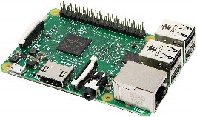 | https://www.amazon.de/gp/product/B01CD5VC92/ref=ppx_yo_dt_b_asin_title_o00_s00?ie=UTF8&psc=1 | €40
Relay board  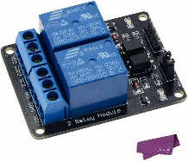 | https://www.amazon.de/gp/product/B019Z8LWFE/ref=oh_aui_detailpage_o06_s00?ie=UTF8&psc=1 | €10
V2A stainless steel base plate, 125 × 80 × 3 mm |  | Not specified

Assembly

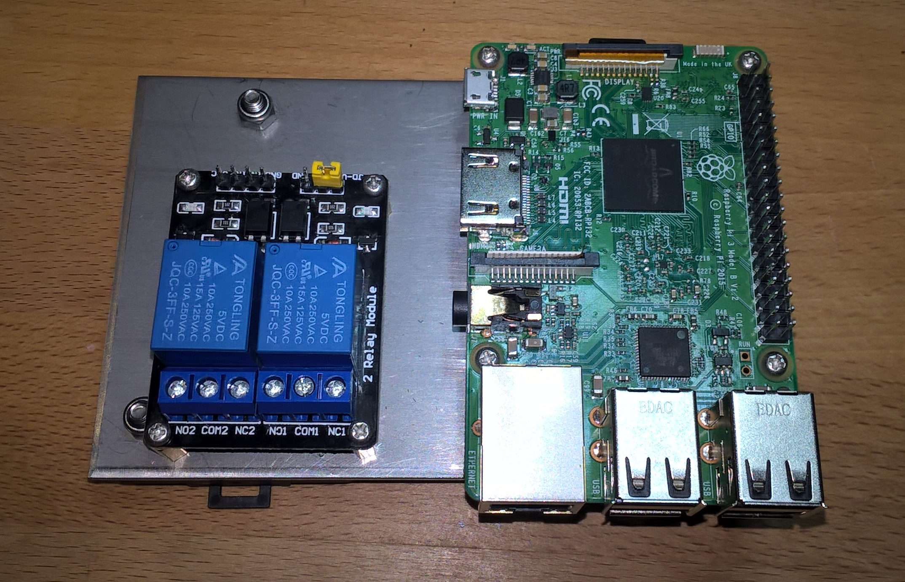

Application


