Yerevan Housing Code and Chart Guide
  - Understanding the six chart research story
DS116 Data Visualization
American University of Armenia
Research snapshot 5 November 2026
Read a question, look at its chart, then use the short code explanation to understand how the result was made. This guide follows the exact R Markdown code in order and keeps the same charts beside the relevant steps.
Related source: Yerevan_Housing_Research.Rmd
The study compares one agency's advertised monthly rents with modeled commuting and winter utility costs. Its conclusions apply to the stated sample and assumptions, not every household in Yerevan.

How to use this guide
The Rmd is the editable analysis. It reads the four CSV inputs in data, calculates the results, and saves six charts in figures. The HTML report starts with the visual story; this companion explains the code behind it.
Line numbers restart at 1 for each chunk. They are added only in Word and are not part of executable R. A wrapped display line is still the same numbered code line. Read each logical block together; the glossary explains recurring verbs once.
R expression | Meaning
read.csv | Read a CSV file into an R table.
<- and %>% | Store a result; then pass it into another operation.
group_by and summarise | Group records and calculate a summary such as a median.
mutate and filter | Create a column; keep rows matching a condition.
ggplot and aes | Start a chart and connect variables to positions or colors.
geom_col and facet_wrap | Draw bars; make separate panels for the modes.
ggsave | Save the same chart to the figures folder.
stopifnot | Stop if a required data or arithmetic check is false.
Observed asking rents and sample counts come from the cleaned agency dataset. Road inputs are network-model outputs. Consumption, transit speed/waiting, car costs and the value of time are assumptions. A modeled budget is not an observed household bill.
Jump to a code step: 1 · 2 · 3 · 4 · 5 · 6 · 7 · 8 · 9

1 Prepare the four inputs
R Markdown chunk: prepare
Load the local tables and choose a consistent visual style before drawing the charts.

Exact code
1 if (.Platform$OS.type == "windows") Sys.setlocale("LC_CTYPE", "English_United States.utf8")
2 library(ggplot2)
3 library(dplyr)
4 library(tidyr)
5 options(tinytex.install_packages = FALSE, scipen = 999)
6 rentals <- read.csv("data/rentals.csv", stringsAsFactors = FALSE)
7 tariffs <- read.csv("data/tariffs.csv")
8 wages <- read.csv("data/wages.csv")
9 sources <- read.csv("data/sources.csv", stringsAsFactors = FALSE)
10 rate <- setNames(tariffs$value, tariffs$parameter)
11 knitr::opts_chunk$set(echo = knitr::is_html_output(), message = FALSE,
12 warning = TRUE, dev = "png", dpi = 160, fig.show = "hold", fig.width = 9, fig.height = 5.5,
13 fig.path = file.path(normalizePath(tempdir(), winslash = "/"), "yerevan-chart-"),
14 out.width = "100%")
15 dir.create("figures", showWarnings = FALSE)
16 theme_set(theme_minimal(base_size = 12, base_family = "sans") + theme(plot.margin = margin(8, 24, 8, 8)))
17 blue <- "#286C8E"
18 orange <- "#AF572E"
19 amd <- scales::label_number(scale = 0.001, suffix = "k", accuracy = 1)

Read the code in blocks
Line 1. On Windows, set this R process's character-handling locale to a UTF-8-compatible Windows locale. This keeps symbols and text readable when the report is knitted. It does not change Windows settings or other applications.
Lines 2–4. library loads ggplot2 for charts, dplyr for table operations and tidyr for reshaping. No package is installed here.
Line 5. Disable automatic installation of LaTeX packages during rendering, so missing dependencies cause a clear failure instead of an unexpected download. scipen favors ordinary decimal notation in narrative numbers rather than compact scientific notation.
Lines 6–9. read.csv imports the four files from data. rentals holds the already-cleaned advertisement and road inputs; tariffs and wages hold source facts; sources supplies the references. stringsAsFactors = FALSE keeps text labels as text.
Line 10. setNames turns tariff values into a named lookup. rate["fare_single"] retrieves the verified single-boarding price without repeating that number in every formula.
Lines 11–14. The knitr settings show code only in HTML, where it is folded by default. PNG dimensions and resolution are set once. Temporary knitting images use a forward-slash path so PDF rendering also works on Windows.
Lines 15–19. Create figures if needed, select a shared plot theme and leave breathing room around the chart, then store the blue/orange colors. amd formats monetary axes in thousands: 350k means 350000 AMD. These settings change appearance, not research values.
Expected output: Four R tables, a tariff lookup and shared plotting settings; this preparation chunk does not display a chart.
Actual result: Loaded four CSVs: 276 cleaned advertisements, 11 tariff facts, 11 wage years and 15 source entries.
What it means: The analysis uses the documented cleaned sample rather than rebuilding the entire acquisition pipeline while the student reads. Original records and exclusion evidence remain archived. Chart style settings change appearance, not the data.
Research connection: Preparation makes the six comparisons reproducible; it does not itself support or contradict the housing-cost claim.
Sources: references.

2 Where is rent cheaper
R Markdown chunk: rent
Compare the full asking-rent distributions in each named district, keeping the median and small-sample cautions visible.
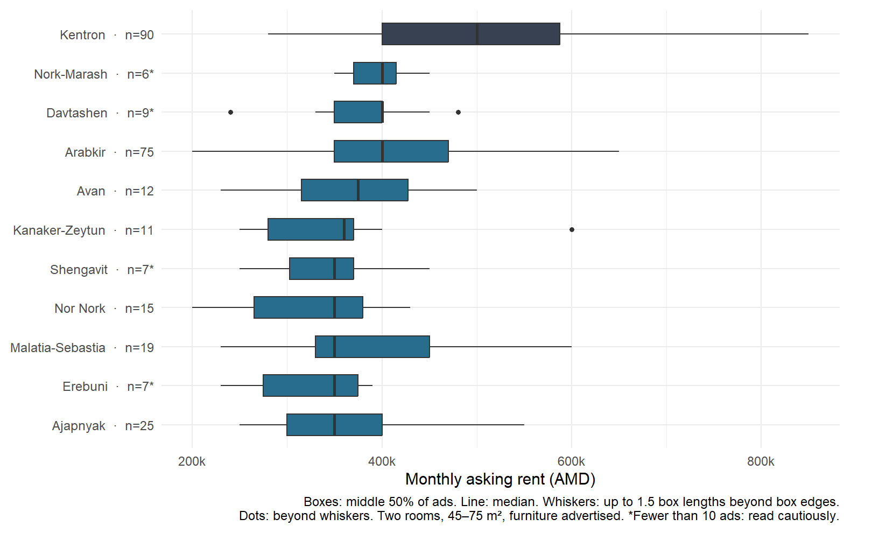

Exact code
1 districts <- rentals %>% group_by(district) %>% summarise(
2 n = n(), rent = median(rent_amd), q1 = quantile(rent_amd, 0.25),
3 q3 = quantile(rent_amd, 0.75), area = median(area_m2),
4 km = median(round_trip_km), minutes = median(freeflow_minutes), .groups = "drop")
5 order <- districts$district[order(districts$rent)]
6 district_labels <- setNames(paste0(districts$district, " · n=", districts$n,
7 ifelse(districts$n < 10, "*", "")), districts$district)
8 rent_plot <- ggplot(rentals, aes(rent_amd, factor(district, levels = order))) +
9 geom_boxplot(aes(fill = district == "Kentron"), width = 0.55, outlier.size = 1.3) +
10 scale_fill_manual(values = c("FALSE" = blue, "TRUE" = "#374151"), guide = "none") +
11 scale_y_discrete(labels = district_labels) + scale_x_continuous(labels = amd) +
12 labs(x = "Monthly asking rent (AMD)", y = NULL,
13 caption = "Boxes: middle 50% of ads. Line: median. Whiskers: up to 1.5 box lengths beyond box edges.\nDots: beyond whiskers. Two rooms, 45–75 m², furniture advertised. *Fewer than 10 ads: read cautiously.")
14 rent_plot
15 ggsave("figures/01-rent.png", rent_plot, width = 9, height = 5.5, dpi = 180)

Read the code in blocks
Lines 1–4. group_by separates records by district. summarise creates one row per district: n counts advertisements; median gives the middle rent, area and round-trip road inputs; quantile finds the 25th and 75th percentiles. .groups = "drop" returns an ordinary ungrouped table.
Lines 5–7. order arranges districts by median rent. paste0 adds each sample count to its label, and ifelse adds an asterisk below ten advertisements. That is a presentation caution, not a formal statistical threshold.
Lines 8–11. Plot the individual rental records with geom_boxplot. Each box covers the middle half of asking rents, with a median line. Whiskers reach the most extreme observations within 1.5 box lengths of the box edges; separate points show values beyond them. The fill condition highlights Kentron in dark gray, and the named labels preserve counts and district order.
Lines 12–15. labs explains the monthly AMD axis, boxplot marks and comparable-property filter. Evaluating rent_plot displays it in the report. ggsave writes the same chart into figures/01-rent.png.
Expected output: Sorted horizontal boxplots of asking rents, with medians, distribution spread, outlier points and district sample counts.
Actual result: The sample has 11 districts. Kentron's median is 500000 AMD; the other district medians range from 350000 to 400000 AMD.
What it means: Kentron is the dark central-area comparator. Boxes and whiskers describe this agency sample; they are not population confidence intervals. An outlier point is a boxplot category, not evidence of a data error. Condition, building mix and agency selection can still explain some rent differences.
Research connection: Rent savings are the first part of the research question. This chart cannot decide whether transport, time and heating erase them.
Sources: references.

3 How much longer is the commute
R Markdown chunk: commute
Compare two modeled travel modes directly on each district row, using the same road inputs and destination.
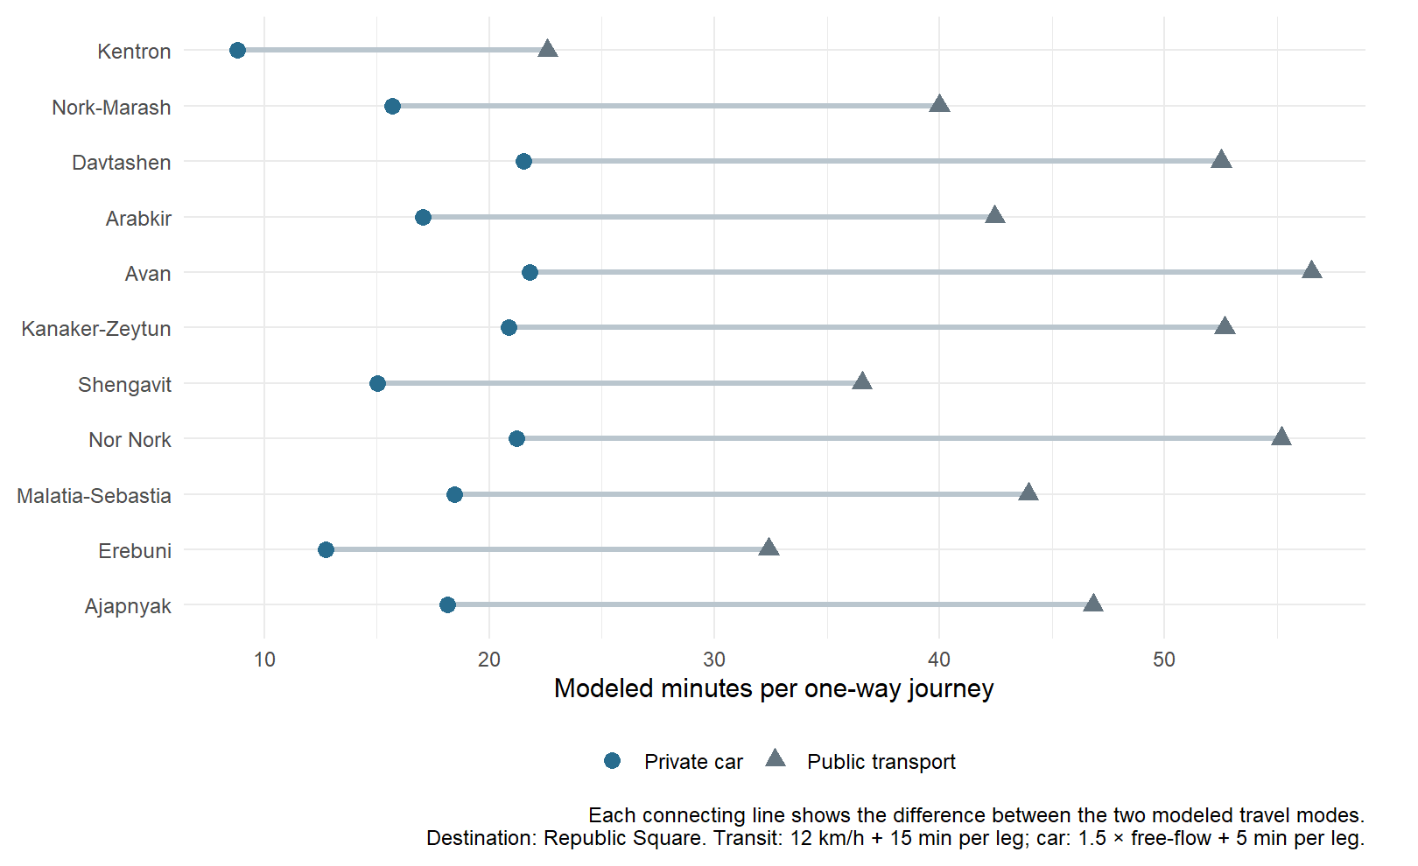

Exact code
1 travel <- bind_rows(
2 districts %>% mutate(mode = "Public transport", trip_minutes = km / 12 * 60 + 30),
3 districts %>% mutate(mode = "Private car", trip_minutes = minutes * 1.5 + 10))
4 commute_pairs <- travel %>% select(district, mode, trip_minutes) %>%
5 pivot_wider(names_from = mode, values_from = trip_minutes)
6 commute_plot <- ggplot(travel, aes(trip_minutes / 2,
7 factor(district, levels = order), color = mode, shape = mode)) +
8 geom_segment(data = commute_pairs,
9 aes(x = `Private car` / 2, xend = `Public transport` / 2,
10 y = factor(district, levels = order), yend = factor(district, levels = order)), inherit.aes = FALSE,
11 color = "#BAC6CE", linewidth = 1.2) +
12 geom_point(size = 3.2) +
13 scale_color_manual(values = c("Private car" = blue, "Public transport" = "#657580"), name = NULL) +
14 scale_shape_manual(values = c("Private car" = 16, "Public transport" = 17), name = NULL) +
15 labs(x = "Modeled minutes per one-way journey", y = NULL,
16 caption = "Each connecting line shows the difference between the two modeled travel modes.\nDestination: Republic Square. Transit: 12 km/h + 15 min per leg; car: 1.5 × free-flow + 5 min per leg.") +
17 theme(legend.position = "bottom")
18 commute_plot
19 ggsave("figures/02-commute.png", commute_plot, width = 9, height = 5.5, dpi = 180)

Read the code in blocks
Lines 1–3. bind_rows stacks two modeled versions of each district. Public transport converts round-trip road kilometres to minutes at 12 km/h, then adds 30 minutes for access and waiting across the two legs. Car time multiplies round-trip free-flow minutes by 1.5 and adds ten minutes across the two legs.
Lines 4–5. select keeps district, mode and time. pivot_wider places the two mode values in separate columns on each district row, so a line can connect their endpoints.
Lines 6–11. Divide round-trip minutes by two to display the average one-way journey. geom_segment draws a horizontal connection from the car value to the public-transport value. Backticks refer to mode column names containing spaces. inherit.aes = FALSE prevents the connection layer from inheriting the point-only color and shape mappings.
Lines 12–14. geom_point marks both endpoints: blue circles for private car and gray triangles for public transport. The manual color and shape scales share a mode legend, so readers can distinguish endpoints without relying on color alone.
Lines 15–19. The axis and caption label these as modeled minutes and identify Republic Square as the destination. The line length makes the difference between modes visible. Display the chart and save exactly that figure.
Expected output: A dumbbell chart: one row per district, with connected car and public-transport endpoints measured in modeled one-way minutes.
Actual result: The modeled one-way times range from 8.8 to 56.5 minutes across the district–mode examples. These are scenario estimates, not observed commutes.
What it means: These values are not timed commutes, live congested travel or actual bus itineraries. They combine cached car-road network inputs with explicit speed, waiting and congestion assumptions. Kentron retains its own journey rather than receiving a zero-time advantage.
Research connection: The comparison makes the potential time cost visible, while leaving its financial importance for the following budget calculations.
Sources: references.

4 What does the monthly budget include
R Markdown chunk: budgets
Build the selected cash budget and prepare the central comparison without double-counting time or heating.
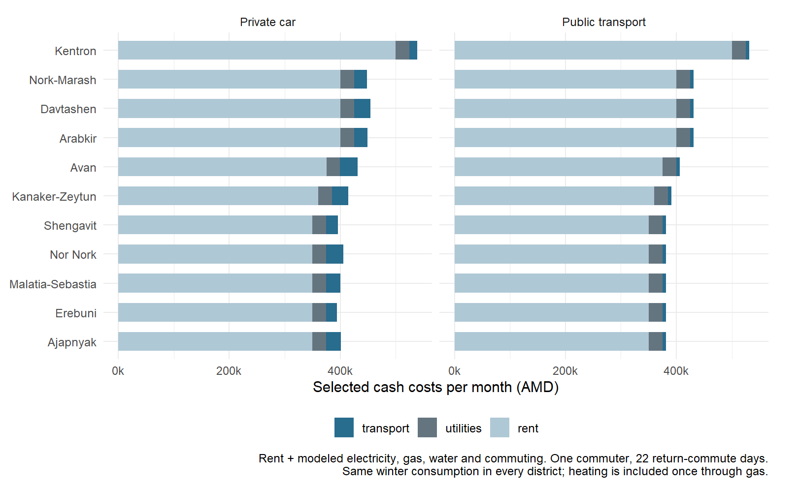

Exact code
1 days <- 22
2 commuters <- 1
3 wage <- wages$Value[wages$Year == 2025]
4 hourly <- wage / (22 * 8)
5 time_value <- hourly / 2
6 utilities <- 150 * rate["electric_day_low"] + 50 * rate["electric_night_low"] +
7 100 * rate["gas_per_1000m3"] / 1000 + 8 * rate["water_per_m3"]
8 budgets <- travel %>% mutate(
9 transport = ifelse(mode == "Public transport",
10 commuters * pmin(2 * days * rate["fare_single"], rate["fare_30day"]),
11 commuters * (km * days * 60 + 10000)),
12 hours = trip_minutes * days * commuters / 60,
13 direct = rent + utilities + transport,
14 with_time = direct + hours * time_value)
15 central <- budgets %>% filter(district == "Kentron") %>%
16 select(mode, central_direct = direct, central_hours = hours, central_total = with_time)
17 comparisons <- budgets %>% left_join(central, by = "mode") %>% mutate(
18 saving = central_total - with_time, direct_difference = direct - central_direct,
19 extra_hours = hours - central_hours)
20 components <- budgets %>% mutate(utilities = utilities) %>%
21 select(district, mode, rent, utilities, transport) %>%
22 pivot_longer(c(rent, utilities, transport), names_to = "component", values_to = "amd")
23 components$component <- factor(components$component, levels = c("transport", "utilities", "rent"))
24 budget_plot <- ggplot(components, aes(amd, factor(district, levels = order), fill = component)) +
25 geom_col(width = 0.65) + facet_wrap(~mode, nrow = 1) +
26 scale_fill_manual(values = c(rent = "#AFC8D5", utilities = "#657580", transport = blue), name = NULL) +
27 scale_x_continuous(labels = amd) +
28 labs(x = "Selected cash costs per month (AMD)", y = NULL,
29 caption = "Rent + modeled electricity, gas, water and commuting. One commuter, 22 return-commute days.\nSame winter consumption in every district; heating is included once through gas.") +
30 theme(legend.position = "bottom")
31 budget_plot
32 ggsave("figures/03-budget.png", budget_plot, width = 9, height = 5.5, dpi = 180)

Read the code in blocks
Lines 1–5. Set one commuter and 22 return-commute days. Select the 2025 national gross monthly wage, divide it by an assumed 22 × 8 paid hours, and use half that hourly value for the baseline time scenario. It is a benchmark, not the renter's observed net wage.
Lines 6–7. Multiply assumed consumption by verified tariffs: 150 daytime and 50 nighttime kWh, 100 m³ gas and 8 m³ water. Divide the gas tariff by 1000 because its source unit is AMD per 1000 m³. Heating is represented by gas and is not added again.
Lines 8–14. ifelse chooses the spending formula for each mode. pmin picks the lower of individual boardings and a 30-day pass per commuter. Car spending uses already-round-trip kilometres × commuting days × an assumed 60 AMD/km, plus 10000 AMD parking per commuter. Convert round-trip minutes into household monthly hours once. direct adds cash components; with_time adds hours × the assumed time value.
Lines 15–19. Select Kentron's result separately for each mode. left_join attaches the appropriate central result to every district. Positive saving means that the district example costs less after time is valued. direct_difference and extra_hours use the opposite subtraction for the break-even equation.
Lines 20–23. pivot_longer puts rent, utilities and transport into a single component column and an amount column so they can be stacked. This is a reshaping of calculated budgets, not additional apartment observations. The factor levels control stack and legend ordering.
Lines 24–32. geom_col stacks the three cash components and facet_wrap separates the two modes. Color, units and captions identify what is included. The final lines display and save the same budget chart.
Expected output: A stacked chart of rent, modeled utilities and commuting spending for each district and mode.
Actual result: Winter utilities total 24769.36 AMD. The half-wage time value is 861.19 AMD/hour. The stacked chart contains 22 modeled district–mode cash budgets.
What it means: Each district example combines median inputs that may come from different apartments. It is neither an observed household bill nor the median of listing-level total costs. Equal winter consumption produces the same utility component everywhere. Car spending is a marginal operating assumption, excluding full ownership.
Research connection: This shows whether lower asking rent survives the selected cash costs. Valued commuting time is a separate noncash component shown in the next chart.
Sources: references.

5 How much saving remains after valuing time
R Markdown chunk: savings
Show how rent saved is reduced by extra transport and valued time for a transparently selected district example.
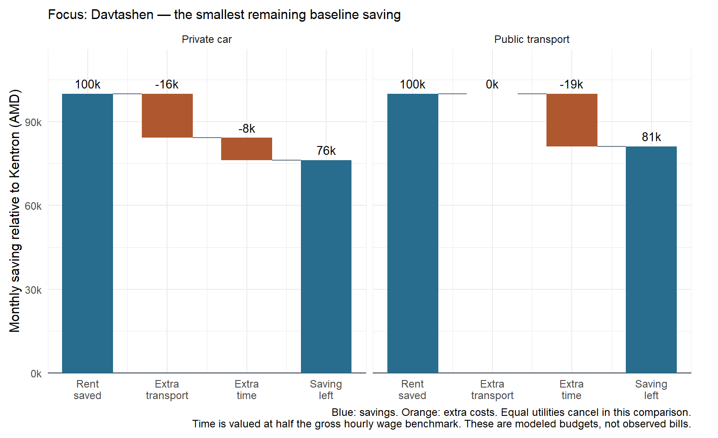

Exact code
1 noncentral <- comparisons %>% filter(district != "Kentron")
2 focus_district <- noncentral$district[which.min(noncentral$saving)]
3 central_transport <- budgets %>% filter(district == "Kentron") %>%
4 select(mode, transport_kentron = transport)
5 focus <- noncentral %>% filter(district == focus_district) %>%
6 left_join(central_transport, by = "mode") %>% mutate(
7 rent_saved = districts$rent[districts$district == "Kentron"] - rent,
8 transport_added = transport - transport_kentron, time_added = extra_hours * time_value)
9 waterfall <- focus %>% select(mode, rent_saved, transport_added, time_added, saving) %>%
10 mutate(transport_added = -transport_added, time_added = -time_added) %>%
11 pivot_longer(-mode, names_to = "step_name", values_to = "amount") %>%
12 group_by(mode) %>% mutate(step = row_number(),
13 end = ifelse(step == 4, amount, cumsum(amount)),
14 start = ifelse(step %in% c(1, 4), 0, end - amount),
15 kind = ifelse(step %in% c(1, 4), "Saving", "Added cost")) %>% ungroup()
16 saving_plot <- ggplot(waterfall) +
17 geom_hline(yintercept = 0, color = "#374151") +
18 geom_rect(aes(xmin = step - 0.32, xmax = step + 0.32,
19 ymin = pmin(start, end), ymax = pmax(start, end), fill = kind)) +
20 geom_segment(data = filter(waterfall, step < 4),
21 aes(x = step + 0.32, xend = step + 0.68, y = end, yend = end), color = "#657580") +
22 geom_text(aes(step, pmax(start, end), label = amd(amount)), vjust = -0.6, size = 3.8) +
23 facet_wrap(~mode, nrow = 1) +
24 scale_fill_manual(values = c("Saving" = blue, "Added cost" = orange), guide = "none") +
25 scale_x_continuous(breaks = 1:4, labels = c("Rent\nsaved", "Extra\ntransport", "Extra\ntime", "Saving\nleft")) +
26 scale_y_continuous(labels = amd, expand = expansion(mult = c(0, 0.16))) +
27 labs(x = NULL, y = "Monthly saving relative to Kentron (AMD)",
28 subtitle = paste("Focus:", focus_district, "— the smallest remaining baseline saving"),
29 caption = "Blue: savings. Orange: extra costs. Equal utilities cancel in this comparison.\nTime is valued at half the gross hourly wage benchmark. These are modeled budgets, not observed bills.")
30 saving_plot
31 ggsave("figures/04-saving.png", saving_plot, width = 9, height = 5.5, dpi = 180)
32 cheaper <- sum(noncentral$saving > 0)

Read the code in blocks
Lines 1–2. Remove Kentron because its saving relative to itself is zero. which.min finds the district-mode row with the smallest remaining baseline saving, and focus_district stores its district. This selects the most marginal baseline example rather than a convenient large saving.
Lines 3–8. Select Kentron transport spending separately for each mode. Keep both modes for the chosen district and join their matched central spending. rent_saved is the rent gap; transport_added is extra cash travel spending; time_added is extra monthly commuting hours multiplied by the chosen time value. Equal utility assumptions cancel.
Lines 9–15. Keep the four waterfall quantities in display order. Turn extra costs negative, then pivot_longer makes one row per step. Within each mode, row_number numbers the steps and cumsum tracks the saving as costs are deducted. The last step is the already-calculated final saving, drawn from zero rather than added to the running total. start and end define each rectangle; kind identifies savings and added costs.
Lines 16–22. geom_hline marks zero. geom_rect draws each waterfall step between start and end; pmin and pmax keep rectangle boundaries in the correct order when a cost is negative. geom_segment connects consecutive levels. geom_text labels each signed amount in AMD thousands.
Lines 23–29. facet_wrap puts the two travel modes side by side. Blue marks the initial and final savings; orange marks added costs. The step labels explain the subtraction, while the subtitle names the selected district and its selection rule. Extra headroom keeps value labels readable.
Lines 30–32. Display and save the waterfall. cheaper still counts positive savings across every noncentral district-mode example, rather than only the selected district. Its executed narrative therefore summarizes the wider comparison while the chart explains one example.
Expected output: Two mode-specific waterfall panels showing rent saved, extra transport, extra valued time and the saving left for the selected district.
Actual result: All 20 noncentral district–mode examples remain cheaper than Kentron; monthly savings range from 76172 to 143786 AMD. The waterfall follows Davtashen: 76172 AMD left for the car example and 81094 AMD for public transport.
What it means: The focus is selected from the smallest remaining baseline district-mode saving, and both modes are shown for that district. This chart explains the calculation; it is not a complete plot of every district. Remaining saving combines cash costs and valued time, which is not a fare paid or a verified reduction in earnings. Equal baseline utilities cancel, while different heating assumptions are tested next.
Research connection: A positive saving contradicts the blanket claim that lower noncentral rents always disappear after extra costs; it does not establish that every noncentral apartment is cheaper.
Sources: references.

6 When can the answer change
R Markdown chunk: stress
See whether heavier commuting, a different value of time and extra heating can change the cost comparison.
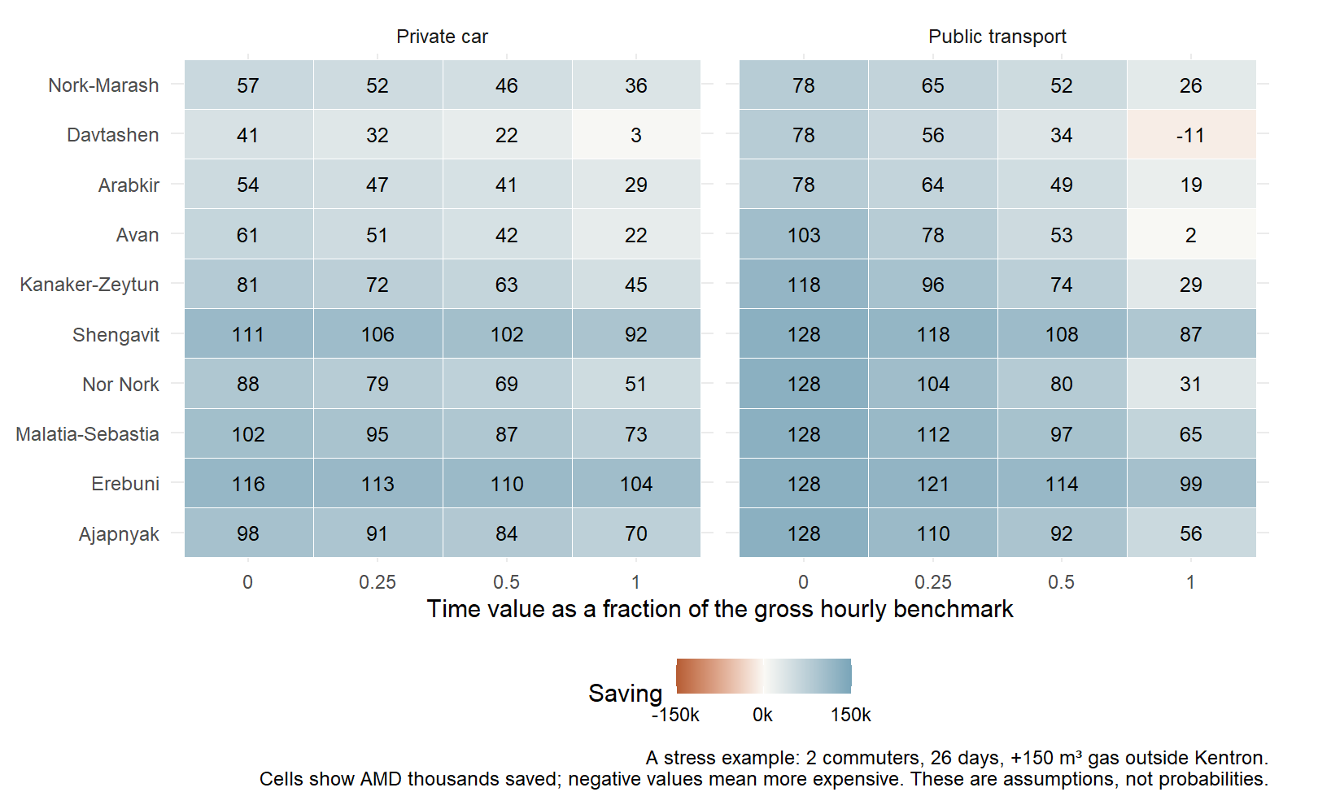

Exact code
1 grid <- expand.grid(workers = c(1, 2), workdays = c(16, 22, 26),
2 fraction = c(0, 0.25, 0.5, 1), extra_gas = c(0, 75, 150))
3 scenarios <- merge(travel, grid, by = NULL) %>% mutate(
4 fare = workers * pmin(2 * workdays * rate["fare_single"], rate["fare_30day"]),
5 car = workers * (km * workdays * 60 + 10000),
6 gas_extra = ifelse(district == "Kentron", 0, extra_gas * rate["gas_per_1000m3"] / 1000),
7 total = rent + utilities + gas_extra + ifelse(mode == "Public transport", fare, car) +
8 trip_minutes * workdays * workers / 60 * fraction * hourly)
9 scenario_central <- scenarios %>% filter(district == "Kentron") %>%
10 select(mode, workers, workdays, fraction, extra_gas, reference = total)
11 scenarios <- scenarios %>% left_join(scenario_central,
12 by = c("mode", "workers", "workdays", "fraction", "extra_gas")) %>%
13 mutate(saving = reference - total)
14 stress_rows <- scenarios %>% filter(workers == 2, workdays == 26,
15 extra_gas == 150, district != "Kentron")
16 stress_plot <- ggplot(stress_rows, aes(factor(fraction),
17 factor(district, levels = order), fill = saving)) +
18 geom_tile(color = "white") + geom_text(aes(label = round(saving / 1000)), size = 3.5) +
19 facet_wrap(~mode, nrow = 1) +
20 scale_fill_gradient2(low = "#B65D34", mid = "#FAF9F5", high = "#78A4B8",
21 midpoint = 0, limits = c(-150000, 150000), breaks = c(-150000, 0, 150000), labels = amd) +
22 labs(x = "Time value as a fraction of the gross hourly benchmark", y = NULL, fill = "Saving",
23 caption = "A stress example: 2 commuters, 26 days, +150 m³ gas outside Kentron.\nCells show AMD thousands saved; negative values mean more expensive. These are assumptions, not probabilities.") +
24 theme(legend.position = "bottom")
25 stress_plot
26 ggsave("figures/05-sensitivity.png", stress_plot, width = 9, height = 5.5, dpi = 180)
27 reversals <- sum(scenarios$saving < 0 & scenarios$district != "Kentron")

Read the code in blocks
Lines 1–2. expand.grid lists the chosen combinations of commuter count, commuting days, time-value fraction and additional gas. A grid combination is an assumption set, not a new sampled household.
Lines 3–8. merge pairs every district–mode example with each assumption set. Recalculate fares, car spending, added noncentral gas and valued commuting hours. Car scenarios with two commuters assume separate journeys and vehicles. Added gas is a stress assumption applied outside Kentron, not a measured geographic effect.
Lines 9–13. Attach the Kentron total with exactly the same mode, workers, days, time fraction and extra-gas setting. Subtract each district total from its matched central reference so positive saving keeps the same meaning as the previous chart.
Lines 14–15. Select one displayed slice: two commuters, 26 days and 150 m³ added gas outside Kentron. The complete grid still exists for checks; the chart does not try to display every row.
Lines 16–24. geom_tile draws one cell per district and time-value fraction. geom_text prints savings in AMD thousands. The diverging color scale is centered at zero: negative savings are more expensive. Both panels use the same scale and explicit assumptions.
Lines 25–27. Display and save the heatmap. Count the noncentral grid rows with negative savings for the result narrative. This count describes only the chosen grid, not the probability that a real household becomes worse off.
Expected output: A readable heatmap for the stated heavy-commuting winter example, plus a retained scenario grid in R memory.
Actual result: The complete grid contains 1584 scenario rows. Exactly 2 noncentral rows become more expensive; this is a grid count, not a probability. The displayed heavy-winter slice has one negative-saving cell.
What it means: The heatmap reveals conditional reversals without estimating how common those households are. Actual household composition, car sharing, energy efficiency and observed travel could produce different costs. The chart does not turn scenarios into statistical observations.
Research connection: A reversal shows how the hidden-cost claim can hold under some assumptions, even when the baseline still favors noncentral district examples.
Sources: references.

7 When would the saving disappear
R Markdown chunk: threshold
Calculate the value of extra commuting time that makes a district example equal in cost to Kentron.
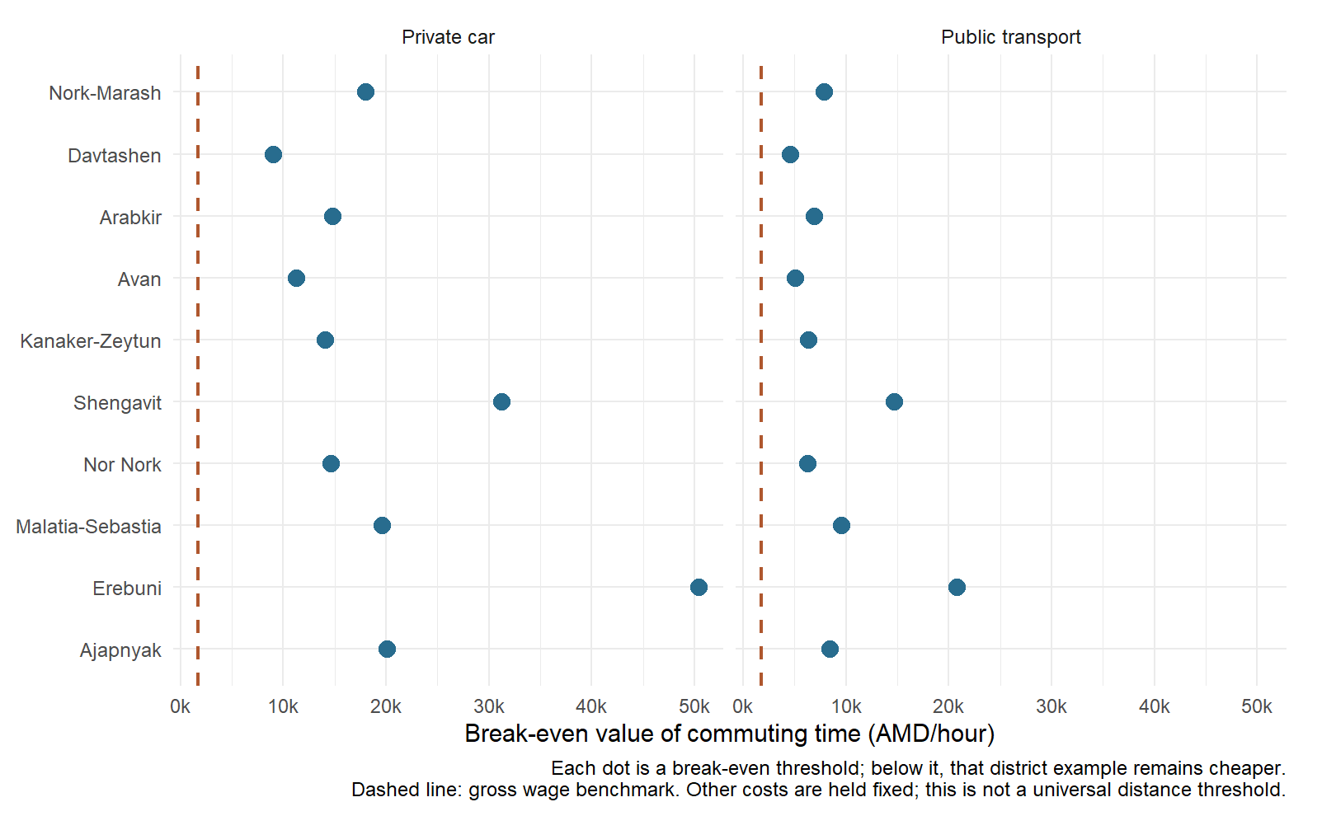

Exact code
1 thresholds <- noncentral %>% mutate(
2 break_even = ifelse(direct_difference < 0 & extra_hours > 0,
3 -direct_difference / extra_hours, NA_real_))
4 threshold_plot <- ggplot(thresholds, aes(break_even,
5 factor(district, levels = order))) +
6 geom_point(color = blue, size = 3.5) +
7 geom_vline(xintercept = hourly, linetype = "dashed", color = orange, linewidth = 0.8) +
8 facet_wrap(~mode, nrow = 1) + scale_x_continuous(labels = amd) +
9 labs(x = "Break-even value of commuting time (AMD/hour)", y = NULL,
10 caption = "Each dot is a break-even threshold; below it, that district example remains cheaper.\nDashed line: gross wage benchmark. Other costs are held fixed; this is not a universal distance threshold.")
11 threshold_plot
12 ggsave("figures/06-break-even.png", threshold_plot, width = 9, height = 5.5, dpi = 180)
13 lowest_threshold <- min(thresholds$break_even, na.rm = TRUE)

Read the code in blocks
Lines 1–3. A positive crossing exists here when the district example is cheaper directly but uses more time. Dividing cash saving by extra monthly hours gives AMD per hour. ifelse returns NA for other cases instead of presenting a misleading negative or infinite threshold.
Lines 4–10. geom_point places each positive break-even threshold on an AMD-per-hour axis. The dashed orange line marks the gross hourly wage benchmark for context; it is not a fitted relationship. Separate mode panels and the shared district order make the position of each dot easy to compare.
Lines 11–13. Display and save the dot plot. min finds the lowest available positive threshold; na.rm = TRUE ignores cases without such a crossing.
Expected output: Mode-specific break-even dot plots with a wage-benchmark reference line.
Actual result: All 20 examples have positive time-value thresholds. The lowest is 4555 AMD/hour, compared with the gross benchmark of 1722 AMD/hour.
What it means: Below its threshold, the district example remains cheaper under the fixed other assumptions. A higher value of extra time can reverse that result. This is not a universal kilometre threshold or a guarantee for every home, particularly where the district sample is small.
Research connection: The threshold gives the rent-versus-time tradeoff a conditional decision rule without claiming statistical proof.
Sources: references.

8 Check the sample and arithmetic
R Markdown chunk: checks
Stop the report if a core sample or budget identity no longer holds.

Exact code
1 stopifnot(nrow(rentals) == 276, !anyDuplicated(rentals$listing_id))
2 stopifnot(all(rentals$rooms == 2), all(between(rentals$area_m2, 45, 75)))
3 stopifnot(isTRUE(all.equal(as.numeric(utilities), 24769.36)))
4 stopifnot(all(budgets$direct == budgets$rent + utilities + budgets$transport))
5 stopifnot(all(abs(noncentral$direct_difference +
6 noncentral$extra_hours * thresholds$break_even) < 0.000001))

Read the code in blocks
Lines 1–2. Require 276 unique advertisement IDs and the declared two-room, 45–75 m² sample. anyDuplicated detects repeated IDs; between checks the size limits for every retained record.
Lines 3–4. Check the utility total against the independently hand-derived sum, and verify that direct cash cost equals rent plus utilities plus transport. all.equal permits normal floating-point comparison, wrapped in isTRUE for the assertion.
Lines 5–6. Substitute each positive break-even time value back into the cost-difference equation. The result should be zero within a tiny numerical tolerance. abs takes the size of the residual so either sign of an error is detected.
Expected output: No visible chart; a failed condition stops knitting instead of producing an invalid report.
Actual result: The 276-row sample, unique IDs, room/area limits, utility sum, direct-cost identity and break-even substitution all passed. Separate verification also matched every baseline and sensitivity result against the archived version.
What it means: Passing arithmetic checks cannot repair selection bias, missing renovation information or inaccurate source coordinates. Independent comparison with the archived version checks that presentation simplification did not change the verified calculations.
Research connection: The checks protect the link between inputs and conclusions; they do not prove the research hypothesis or justify a population p-value.
Sources: references.

9 Print the source list
R Markdown chunk: references
Keep data and methodology citations tied to the local source table.

Exact code
1 for (i in seq_len(nrow(sources))) {
2 cat(sprintf("- %s. [%s](%s). %s. Accessed %s.\n\n",
3 sources$publisher[i], sources$title[i], sources$url[i],
4 sources$date[i], sources$accessed[i]))
5 }

Read the code in blocks
Lines 1–5. seq_len creates one index for each source row. The for loop formats each publisher, title, URL, date and access date as a Markdown reference. cat writes the text into the report; results = asis in the chunk header makes it render as references rather than printed console output.
Expected output: A clickable reference list read from data/sources.csv.
Actual result: Printed 15 source entries read from data/sources.csv. Dataset and model sources are retained with dates and links.
What it means: The list records where evidence and methods came from. It does not establish an open redistribution license for the agency catalogue, and it does not turn source availability into independent validation of every advertisement.
Research connection: Traceable sources allow the evidence and assumptions behind the conditional conclusion to be checked.
Sources: references.

Statistics and responsible interpretation
The median is the middle observed rent. Quartiles show the middle half of the selected advertisements; they are not confidence intervals for all Yerevan rentals. Differences shown by the charts are not proof that otherwise identical homes would cost the same amount after a move.
A p-value requires a justified sampling and statistical model. It is not the probability that a hypothesis is true. This single-agency convenience dataset and its repeated cost scenarios do not support the intended population inference, so the analysis does not manufacture p-values or confidence intervals.
Sensitivity charts change declared assumptions. Their cells are scenarios, not probabilities. A break-even value holds the other model inputs fixed; it does not identify a universal distance where savings vanish. Advertised furnishing, missing condition and approximate district geography remain important limits.
AI assistance was used for planning, code and explanations. The student should understand and independently explain the work and confirm the instructor's project and AI-assistance rules before submission.

References
WSE.AM. Snapshot 2026-11-05. WSE.AM rental catalogue and public property API. Accessed 2026-11-05.
WSE.AM. Accessed 2026-11-05. Public property API access rules. Accessed 2026-11-05.
Yerevan Municipality. 2025 onward. Unified public transport ticket comparison. Accessed 2026-11-05.
Electric Networks of Armenia. 2022 rates with 2025 amendments. Household electricity tariffs. Accessed 2026-11-05.
Public Services Regulatory Commission. 2022-03-01. Natural gas tariff decision. Accessed 2026-11-05.
Public Services Regulatory Commission. 2026. Resident gas tariffs unchanged from August 2026. Accessed 2026-11-05.
Veolia Djur. 2025-11-26. 2026 drinking water tariff. Accessed 2026-11-05.
Veolia Djur. 2025 tariff description. Water tariff units and metering FAQ. Accessed 2026-11-05.
Armstat. Data updated 2026-06-10; observation 2025. SDG8.5.1.a average monthly nominal wages and metadata. Accessed 2026-11-05.
Project OSRM. v26.5.0 documentation. OSRM HTTP API table service. Accessed 2026-11-05.
OpenStreetMap contributors. Accessed 2026-11-05. OpenStreetMap data attribution and license. Accessed 2026-11-05.
Habet Madoyan, American University of Armenia. Repository commit 1a74f34584c85b08b0f9a87d055b663d209df9de. DS116 lecture materials. Accessed 2026-11-05.
ggplot2 authors. Documentation accessed 2026-11-05. ggplot2 reference. Accessed 2026-11-05.
dplyr authors. Documentation accessed 2026-11-05. dplyr reference. Accessed 2026-11-05.
Yihui Xie and contributors. Documentation accessed 2026-11-05. knitr documentation. Accessed 2026-11-05.

