Smartfit.am Website Specification
Polished project description for client and developer understanding

1. Project Overview
Smartfit.am is a gym website and management system. It should work both as a public website for gym visitors and as an internal tool for managing customers, packages, coaches, check-ins, sessions, notes, logs, and analytics.
The project is not only a simple informational website. It must include separate working areas for different user types, each with its own permissions and responsibilities.
Main areas of the platform
- Admin Panel - full management access for the gym owner or administrator.
- Registration Panel - operational access for reception staff to manage daily customer entry, exit, and session usage.
- User Panel / Mobile App Experience - public, no-login experience for gym clients, focused on mobile users and live occupancy information.
- Regular Website Pages - public pages such as Home, About Us, Coaches, Packages, Contact, Gallery, and Our App.

2. Access Areas and Responsibilities
Area | Main user | Purpose
Admin Panel | Gym owner / admin | Manage the website, customers, packages, coaches, settings, analytics, logs, and data exports.
Registration Panel | Receptionist / registration staff | Track customer check-in and check-out, adjust sessions, manage notes, and control the current gym occupancy count.
User Panel / Mobile App | Gym clients and public visitors | View the live gym occupancy count, basic gym information, contact links, motivational message, and installation instructions for adding the app to the phone home screen.
Regular Website | Public visitors | Present the gym, offers, coaches, packages, location, images, and contact information.

3. Admin Panel Requirements
The Admin Panel is the main control center of the system. The admin should have full access to all website and gym-management features. All important actions should be recorded in the system logs.

3.1 Website Content Management
- The admin can update homepage offers, promotions, discounts, and news.
- The homepage hero section should be dedicated to current offers and announcements.
- The admin should be able to create, update, renew/reactivate, and delete public content where appropriate.
- Offer and promotion history should be stored so the admin can review or export it later.

3.2 Customer Management
- The admin can create, view, update, renew/reactivate, and delete customer profiles.
- Each customer profile should include personal information, customer ID, active/inactive status, assigned coach if applicable, and package history.
- The admin should be able to see whether the customer is currently inside the gym or outside the gym.
- The admin should be able to search and filter customers by name, ID, status, package, coach, expiration date, and remaining sessions.

3.3 Package Management
- The admin can create, view, update, renew/reactivate, and delete gym packages.
- Each package should include package name, price, number of sessions, package type, assigned coach if required, activation date, expiration date, and active/inactive status.
- The system must support customers who have one package, no active package, or multiple active packages at the same time.
- Examples of package types may include general gym access, coach sessions, pool access, group training, or other services that the gym may add later.
The admin should be able to create packages with optional usage restrictions. Some packages may be available only during specific hours. For example, a package may allow customers to check in only before 3:00 PM. When creating or editing a package, the admin should be able to define whether the package is available all day or only during a specific time range.
Each package should include:
- Package name
- Price
- Number of sessions
- Assigned coach, if applicable
- Activation date
- Expiration date
- Active or inactive status
- Optional time restriction
Example: “Can be used only before 3:00 PM”

3.4 Coach Management
- The admin can create, view, update, renew/reactivate, and delete coach profiles.
- Coach profiles should include name, surname, photo, specialty, contact information if needed, and active/inactive status.
- Coaches can be connected to packages and customers when a package includes personal training or coach-specific sessions.

3.5 Customer Package Overview Table
The admin should have a table that gives a clear operational overview of every customer and their current package situation. The table should include:
- Customer name and customer ID.
- Current gym status: In gym or Not in gym.
- Active package or packages.
- Assigned coach, if any.
- Package activation date.
- Package expiration date.
- Remaining sessions for each package.
- Active, inactive, expired, or frozen status.

3.6 Customer Status and Alerts
The admin should have a separate section for customers who require attention. This section should prioritize:
- Customers with expired packages.
- Customers with zero remaining sessions.
- Customers whose package will expire soon.
- Customers with missing or incomplete data.
- Customers who are still marked as In gym after an unusually long period, if this rule is added later.

3.7 Gym Logs
The system should keep logs of important gym actions. Logs are visible only to the admin and should not be editable by reception staff.
- Example log: Rene checked in - date and time.
- Example log: Rene used 1 general session.
- Example log: Rene used 1 Coach Davit session.
- Example log: Rene checked out - date and time.
- Example log: Reception manually changed Rene general sessions from 6 to 7.
- Example log: Admin updated the monthly package price.

3.8 Data Export Section
The admin should have a Data section where important information can be exported as Excel files. Export options may include:
- Customers.
- Packages.
- Coaches.
- Customer package history.
- Check-in and check-out logs.
- Promotion and offer history.
- Notes, if the admin wants to keep a record outside the system.

3.9 Admin Settings
The admin should have a Settings section for changing general system and gym information. The exact settings can be expanded later, but the first version should include:
- Gym name, logo, contact number, WhatsApp link, Instagram link, and address.
- Google Maps or Yandex Maps location link.
- Gym working days and working hours.
- Occupancy color thresholds for the public live count, such as green for low crowd, yellow for medium crowd, and red for crowded.
- Public app display settings, including whether to show Instagram, phone number, WhatsApp, motivational text, and other links.
- Option for registration staff to hide inactive customers from their daily view.

3.10 Analytics
The Admin Panel should include analytics that help the gym understand usage and activity. Useful analytics include:
- Peak gym hours.
- Average time customers spend in the gym.
- Number of daily, weekly, and monthly check-ins.
- Most active customers.
- Most used package types.
- Coach-related session usage.
- Current and historical occupancy trends.

4. Registration Panel Requirements
The Registration Panel is designed for reception staff. It should be simple, fast, and focused on daily operations. Reception staff should not need full admin access, but they must be able to manage customer entry, exit, session usage, corrections, notes, and the live number of people currently inside the gym.

4.1 Customer Search
- The receptionist can search for a customer by name or customer ID.
- Search results should make it easy to identify the correct customer quickly.
- After selecting a customer, the receptionist can view and modify the allowed operational fields, then click Save.

4.2 Customer Card
Each customer card should clearly show the information needed at reception:
- Customer name.
- Customer ID.
- Current gym status badge: In gym or Not in gym.
- Active and inactive packages, depending on the selected filter.
- Remaining sessions for each package.
- Expiry date for each package.
- Active, inactive, expired, or frozen status for each package.

4.3 Customer Status Badge
The status badge should appear next to the customer name.
- Not in gym - the customer is currently outside the gym.
- In gym - the customer has checked in and is currently inside the gym.

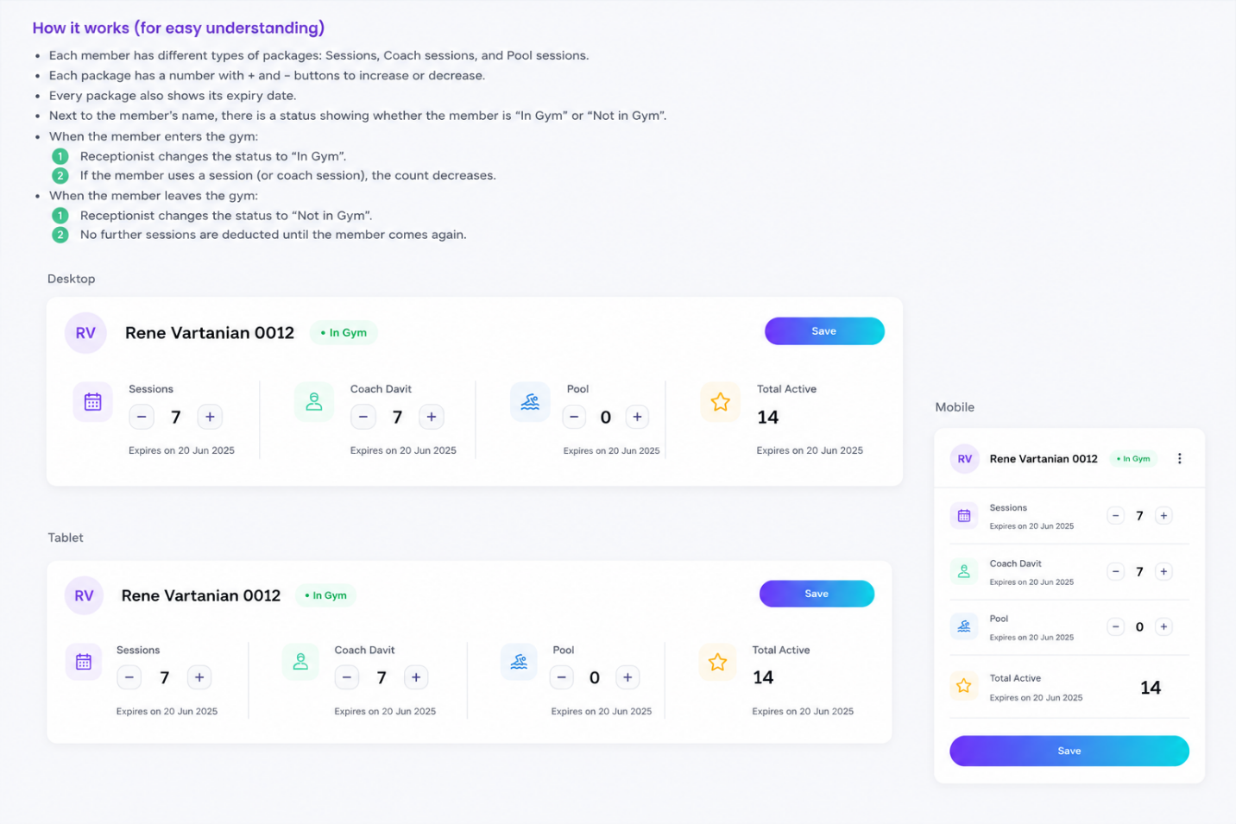

4.4 Check-In Workflow
When a customer enters the gym, the receptionist clicks Check in. Before confirming check-in, the receptionist should be able to select which package or packages are being used for that visit.
1. The customer status changes from Not in gym to In gym.
2. The customer overall gym session count decreases by 1, if the customer is using a general gym package.
3. If the customer is using a coach package that day, the selected coach package also decreases by 1.
4. Other packages do not change unless they are selected for that visit.
5. The live number of people currently inside the gym increases automatically by 1.
6. A log entry is saved for the check-in and all session deductions.
Before confirming check-in, the system must check whether the selected package is allowed to be used at the current time. If the package has no time restriction, the customer can check in normally. If the package has a time restriction, the system must compare the current time with the allowed package time.
Example:
Rene has a package that can only be used before 3:00 PM.
If Rene checks in at 2:30 PM:
- Check-in is allowed.
- Customer status changes to “In gym”.
- The correct package session count decreases by 1.
If Rene checks in at 4:00 PM:
- The system warns the receptionist that this package cannot be used after 3:00 PM.
- The receptionist should not be able to use that package unless admin override is allowed.
- No session should be decreased unless the check-in is approved.

Example check-in scenario
- Rene enters the gym and trains with Coach Davit.
- Overall Sessions: 7 becomes 6.
- Coach Davit Sessions: 7 becomes 6.
- Pool Sessions do not change unless Rene also uses the pool package during that visit.

4.5 Check-Out Workflow
When the customer leaves the gym, the receptionist clicks Check out.
1. The customer status changes from In gym to Not in gym.
2. No sessions are deducted during check-out.
3. Check-out only updates the customer gym status and exit time.
4. The live number of people currently inside the gym decreases automatically by 1.
5. A log entry is saved for the check-out.

4.6 Manual Session Corrections
- Each package should have plus and minus buttons so the receptionist can manually correct the number of remaining sessions when needed.
- Manual changes should require clicking Save before they are stored.
- Every saved manual correction should create a log entry visible to the admin.
- The system should prevent remaining sessions from going below zero unless the admin specifically allows it later.
- Some Customers based on their package cannot enter after specific time, this is also monitored

4.7 Package Display Rules
- The design must work if a customer has no active package.
- The design must work if a customer has only one package.
- The design must work if a customer has 4-5 active packages at the same time.
- Inactive packages can be hidden from the receptionist view if the setting is enabled.
- Each package card should show package name, remaining sessions, expiry date, and package status.
- Regular Gym Package Remaining sessions: 6 Expiry date: 20 July 2026 Status: Active Time rule: Available all day
- Morning Package Remaining sessions: 8 Expiry date: 15 July 2026 Status: Active Time rule: Can be used only before 3:00 PM

4.8 Freezing and Reactivating Packages
- Reception staff should be able to freeze a customer package if the gym allows this operationally.
- A frozen package should not be treated as active for session usage.
- Reactivation or renewal behavior should be clearly logged.
- The admin may later define rules for whether freezing extends the expiration date.

4.9 Notes Section
- The Registration Panel should include a Notes section.
- Reception staff can create, read, update, and delete notes if they have permission.
- Notes should be sorted by date, with the newest notes easiest to find.
- Notes may be used for operational reminders, customer-specific details, or internal communication.

4.10 Manual Occupancy Count
- The number of people currently inside the gym should mainly be automated through check-in and check-out actions.
- Reception staff should also be able to manually increase or decrease the number if a correction is needed.
- Manual changes should require Save and should create a log entry visible to the admin.
- The public User Panel should use this current occupancy count.

5. User Panel / Mobile App Experience
The User Panel does not require sign-up or login. It is a public mobile-first experience for gym customers. Its main purpose is to help customers quickly see how crowded the gym is and access useful gym information.

5.1 Add Our App Section
- The website should include a section called Add Our App or Our App.
- This section should explain how users can add the website to their phone home screen, similar to the iPhone flow: Share -> More -> Add to Home Screen.
- The installed app icon should use the Smartfit.am logo.
- This should behave like a simple progressive web app experience, even if there is no separate App Store or Play Store application.

5.2 Public Live Occupancy Count
- The user-facing mobile page should show the current number of people inside the gym.
- The number should be easy to read on mobile screens.
- The color should change depending on how crowded the gym is: green for low crowd, yellow for medium crowd, and red for crowded.
- The exact number ranges for green, yellow, and red should be editable by the admin in Settings.
- The public page should not show private customer names, IDs, or package information.

5.3 Public App Content
- The public app page can show the Smartfit.am logo.
- It can show a short motivational message.
- It can show contact information such as phone number, WhatsApp, Instagram, and location link.
- The admin should decide from Settings which of these items are visible to users.

6. Regular Public Website
The regular website should present the gym professionally and simply. It should not be overcomplicated, but it must clearly explain the gym, its offers, packages, coaches, location, and the mobile app feature.

6.1 Suggested Public Pages
- Home - a summary of the gym, current offers, packages, coaches, gallery, location, and call-to-action sections.
- About Us - information about the gym, atmosphere, values, and services.
- Coaches - coach image, name, surname, specialty, and short description.
- Packages - available gym packages, prices, session counts, expiration rules, and included services.
- Gallery - photos of the gym, equipment, training areas, and atmosphere.
- Contact Us - phone number, WhatsApp, Instagram, address, working hours, and map link.
- Our App - instructions and benefits of adding the Smartfit.am app to the home screen.

6.2 Homepage Requirements
- The homepage should show current news, discounts, and offers in the hero section.
- The homepage should include enough information from the other pages so a visitor understands the gym quickly.
- The homepage content should be editable from the Admin Panel.
- The homepage should include a clear link or section for the mobile app/live occupancy feature.

7. Key Business Rules
- Admin users have full access; registration users have limited daily-operation access.
- A customer can have multiple packages at the same time.
- Check-in can deduct sessions; check-out must not deduct sessions.
- A customer should not be checked in twice at the same time unless the admin specifically allows an override.
- Every check-in, check-out, session deduction, manual correction, freeze, renewal, and important edit should create a log entry.
- Logs should be visible to the admin and protected from normal editing.
- The public user panel must show only general gym information and the live occupancy count, not private customer data.
- Expired packages and zero-session packages should be clearly marked and easy for the admin to find.

8. Recommended MVP Scope
For the first working version, the project can be divided into practical development priorities:
- Public website pages: Home, About Us, Coaches, Packages, Contact, Our App.
- Admin login and Admin Panel basics.
- Customer, package, and coach CRUD.
- Registration Panel with customer search, check-in, check-out, package cards, and manual session corrections.
- Automatic live occupancy count connected to check-in and check-out.
- Public mobile page showing live occupancy count and app-install instructions.
- Basic logs and Excel export.
- Basic analytics: daily check-ins, current occupancy, and peak hours.

9. Open Decisions to Confirm With
These details should be confirmed before or during development to avoid misunderstandings:
- Should reception staff be allowed to delete notes, or only create and edit them?
- Should package freezing automatically extend the expiration date?
- Should customers receive a unique numeric ID, QR code, membership card, or all of these?
- Should the system allow check-in if the customer has expired packages or zero remaining sessions?
- Should manual occupancy changes require an admin password or only receptionist permission?
- Should the public occupancy number update instantly, every few seconds, or only when the page is refreshed?

