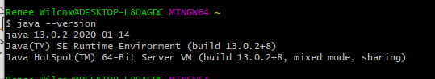

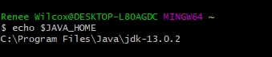

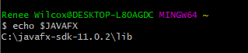

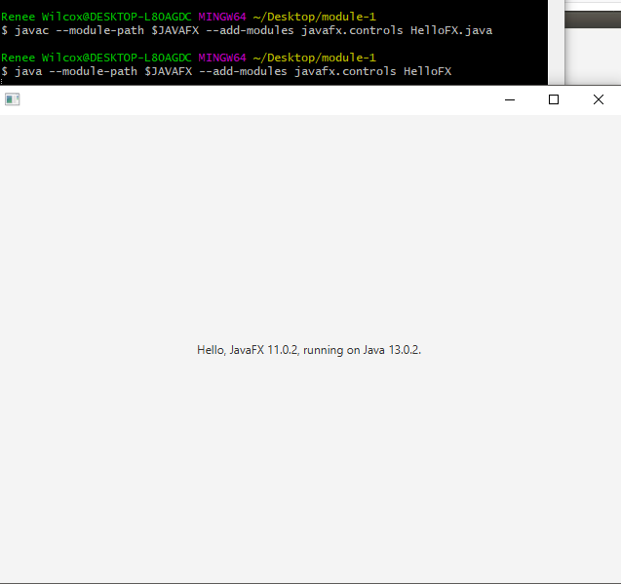

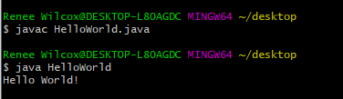\*NO ERRORS! YAY! ☺