1. Set an array of 10 numbers (int) elements

Find the average of it by adding them together and divide the result over 10

1. Input is defined as a string variable and should define an array containing the letters of the alphabet.

Compare every letter at the input string with the elements of the array to find the index at that array which has the same letter.

Return the letter which has the index of the [ old letter index + itself ] and that will be the new letter in the cipher.

1. Same algorithm as before, only we divide the old letter index by itself (for example, if we have 6…we get 3 so say we have X, three letters to the LEFT of X will give U)
2. Set a vector to store unlimited amount of numbers

When a certain number is entered (“-999 to stop” etc.) any number but the stop number will be added to a total accumulator variable.

Divide the accumulator by the number of entered averages (another variable: numofAveragesEntered….etc.)

Average will be calculated.

1. Output is 46
2. Output is 10

**8.**

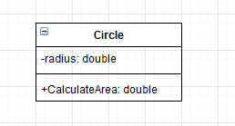

**9.**

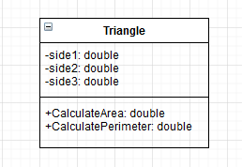

**10.**

