Analyzing Client Satisfaction and Service Utilization at the Dempsey Center: A Four-Year Longitudinal Study (2022-2025)

Min-Hsin Chang Ziyue Shen

Introduction
The Dempsey Center is a nonprofit organization that provides free support services to individuals and families affected by cancer in Maine. Since its founding, the center has offered a comprehensive range of services including individual counseling, support groups, complementary therapies such as massage and acupuncture, movement and fitness programs, and educational workshops. These services aim to address the physical, emotional, and social challenges that come with a cancer diagnosis.

Each year, the Dempsey Center conducts an annual client survey to assess satisfaction with services, identify areas for improvement, and understand the evolving needs of their client population. This study analyzes four years of survey data from 2022 through 2025, totaling over 1,180 client responses. Our analysis focuses on three primary research questions:

- Has client satisfaction improved over the four-year period?
- Which factors most strongly predict high satisfaction with Dempsey Center services?
- Are there distinct client segments with different service needs and usage patterns?

By examining satisfaction trends, service utilization patterns, and client demographics, this study aims to provide data-driven insights that can inform the Dempsey Center's strategic planning and resource allocation decisions. Understanding what drives client satisfaction and how different populations engage with services will enable the organization to better serve the cancer-affected community in Maine.

Background
Cancer diagnosis and treatment create significant physical, emotional, and social challenges for patients and their families. Research shows that people with cancer who have social and resource support are less distressed and have a better overall quality of life. Despite this, access to psychosocial support services remains inconsistent, and many patients who could benefit are unaware that such services exist.

The Dempsey Center's model recognizes that cancer affects more than just physical health. Their holistic approach addresses emotional wellbeing through counseling and support groups, physical health through complementary therapies and movement programs, and social connection through community-building activities. Prioritizing psychosocial care can lead to better adherence to treatment plans and a more holistic approach to cancer care, ultimately fostering a supportive environment that recognizes the psychological burdens of cancer.

Feeling heard, understood, and supported contributes to patients' overall satisfaction with their cancer care. Moreover, addressing emotional distress has been shown to improve patient outcomes, including treatment adherence, symptom management, and quality of life. Understanding which services are most valued and what factors drive satisfaction is therefore critical for organizations like the Dempsey Center — particularly given limited resources and growing demand.

Research on psychosocial cancer support services indicates that well-being shows significant improvements when concerns are successfully addressed, and that evaluating client satisfaction is essential for understanding service quality and identifying areas for improvement. This analysis builds on the Dempsey Center's commitment to continuous improvement by examining four years of client feedback to provide actionable, data-driven insights.

Methods

3.1 Data Overview and Cleaning
This study draws on four years of annual client survey data from the Dempsey Center, covering 2022 through 2025. The raw datasets contained 270, 298, 293, and 319 responses respectively, with column counts ranging from 72 to 105 as the survey instrument expanded over time. Because column positions for equivalent questions shifted across years, each variable's location was manually verified before extraction.

Six variables were extracted from each year: overall satisfaction, perceived life improvement, service utilization frequency, cancer status, treatment stage, age group, and gender. The 2025 dataset required an additional four-column offset due to prepended metadata fields. After merging, the combined dataset totaled 1,179 rows. Cleaning involved removing duplicate header rows, standardizing gender labels across years, and dropping rows missing core satisfaction or life improvement values. The final dataset retained 1,047 rows (257 from 2022, 262 from 2023, 252 from 2024, 276 from 2025).

3.2 Analytical Methods
Exploratory Data Analysis. Descriptive visualizations were used to characterize client demographics, satisfaction trends, and service usage patterns across years.

Chi-Square Tests. Three tests of independence were conducted to assess associations with high satisfaction ("Very Satisfied" vs. all others): service frequency vs. satisfaction, age vs. satisfaction, and cancer status vs. satisfaction.

Machine Learning Classification. Four classifiers were trained to predict high satisfaction: Gaussian Naive Bayes, K-Nearest Neighbors (k=3), Decision Tree (max depth=5), and Random Forest (100 estimators, max depth=5). Features were age, gender, service frequency, and cancer status, all label-encoded. Models were evaluated on an 80/20 train-test split and additionally assessed using 5-fold cross-validation.

K-Means Clustering. Clustering was applied on age, service frequency, and cancer status to identify distinct client segments. The elbow method was used to select the optimal k.

PCA and Correlation Analysis. Principal Component Analysis was run on the standardized feature matrix to examine variance structure. A Pearson correlation heatmap was generated to quantify relationships between features and the satisfaction outcome.

Results

4.1 Exploratory Data Analysis
Demographics
The client population was predominantly older and female. The 65–74 age group made up the largest share of respondents, followed by the 75 or older group, indicating that the Dempsey Center primarily serves an older adult population. Younger age groups (25–44) were notably underrepresented throughout the four-year period.
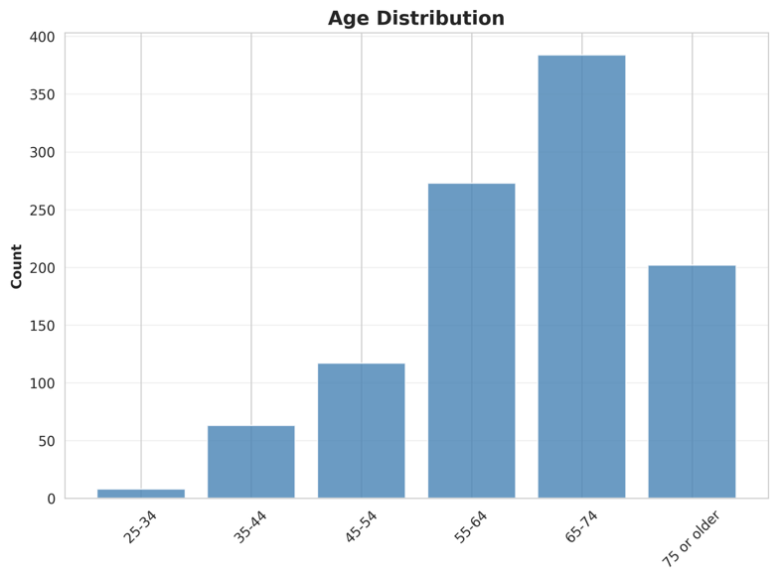
Figure 1. Age distribution of Dempsey Center survey respondents (2022–2025).
Across all four years, approximately 81% of respondents identified as women. This gender composition remained stable over time, suggesting a consistent demographic profile in the client base.
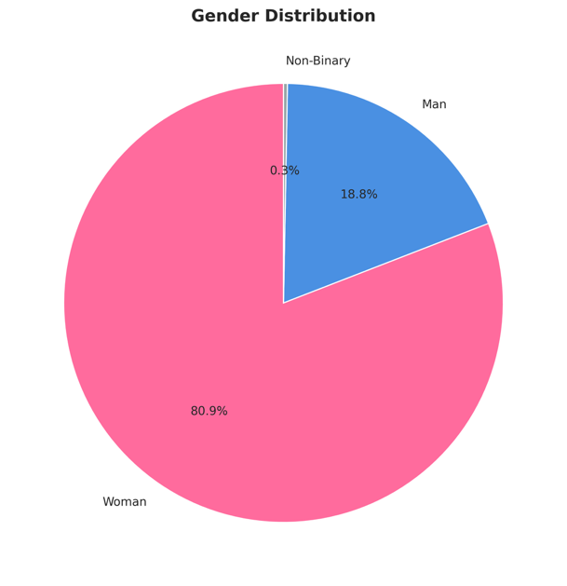
Figure 2. Gender distribution of Dempsey Center survey respondents (2022–2025).
The majority of respondents were cancer survivors or current patients. "I have had cancer" was the most common status (n=406), followed by "I currently have cancer" (n=327). A notable portion of clients were care partners or family members (n=107 and n=72 respectively), reflecting the center's broader mission to support those affected by cancer beyond the patients themselves.
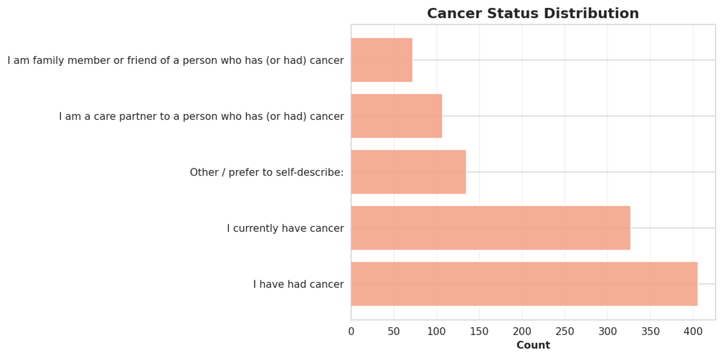
Figure 3. Cancer status distribution across all respondents (2022–2025).

Trends Over Time
The number of survey responses increased modestly from 257 in 2022 to 276 in 2025, with a slight dip in 2024 (n=252). Overall response volume remained relatively stable across the four years.
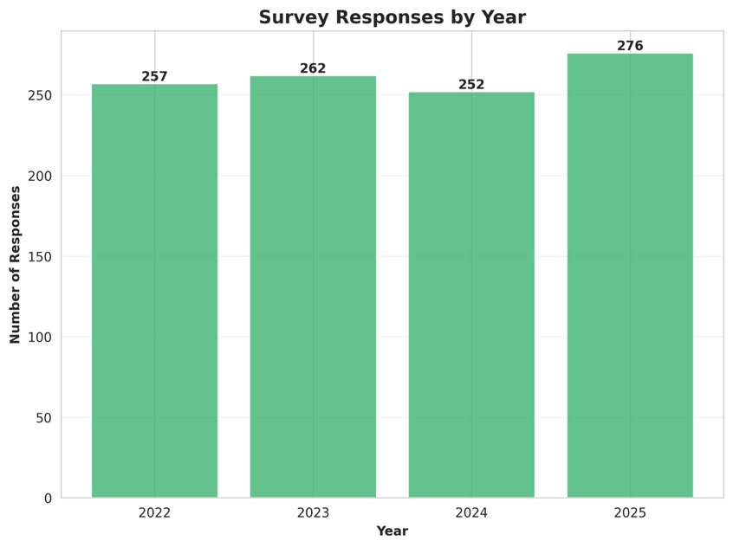
Figure 4. Number of survey responses by year (2022–2025).
Overall satisfaction remained consistently high throughout the study period. The proportion of "Very Satisfied" responses hovered around 76% each year, with no clear upward or downward trend. While the distribution of other response categories (Satisfied, Neither, Unsatisfied, Very Unsatisfied) showed minor fluctuations year to year, the overall picture suggests stable service quality.
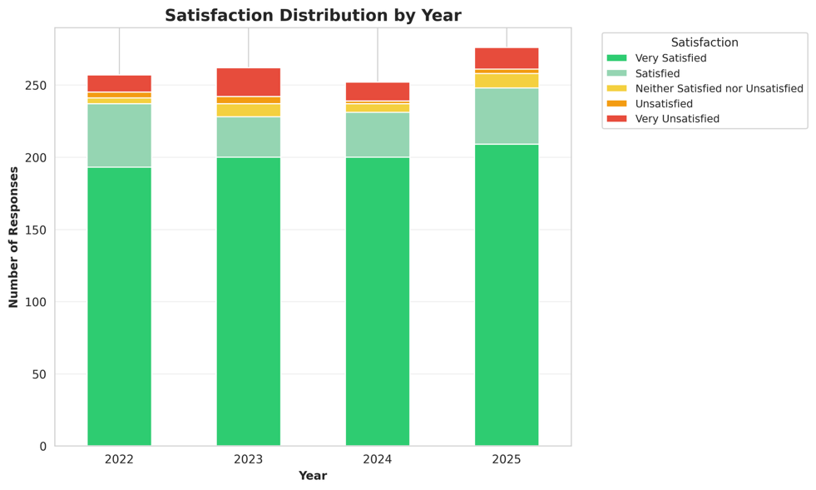
Figure 5. Satisfaction ratings by year (2022–2025).
Between 95% and 97% of respondents each year reported that Dempsey Center services made their life better. This metric was the most consistently positive finding across the entire dataset, with virtually no meaningful variation across years.
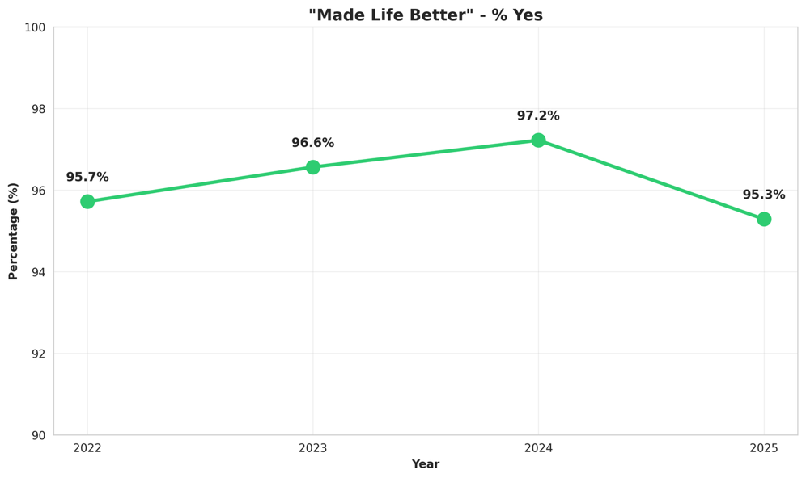
Figure 6. Proportion of respondents who reported services made their life better (2022–2025).

Service Utilization
Service usage was heavily skewed toward high-frequency clients. Nearly half of all respondents (44%) reported using services more than 10 times, while only 7% had visited just once. This distribution suggests that the center retains a loyal core user base rather than primarily serving one-time visitors.
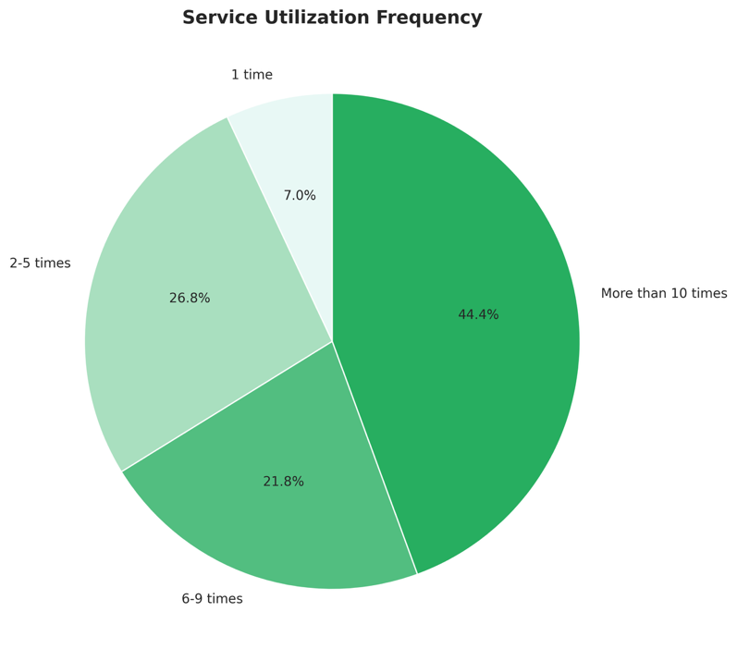
Figure 7. Overall service frequency distribution across all respondents (2022–2025).
The frequency distribution remained broadly consistent year over year, with high-frequency usage (more than 10 times) dominating each year. This pattern suggests that engagement levels have not shifted significantly despite the modest growth in total respondents.
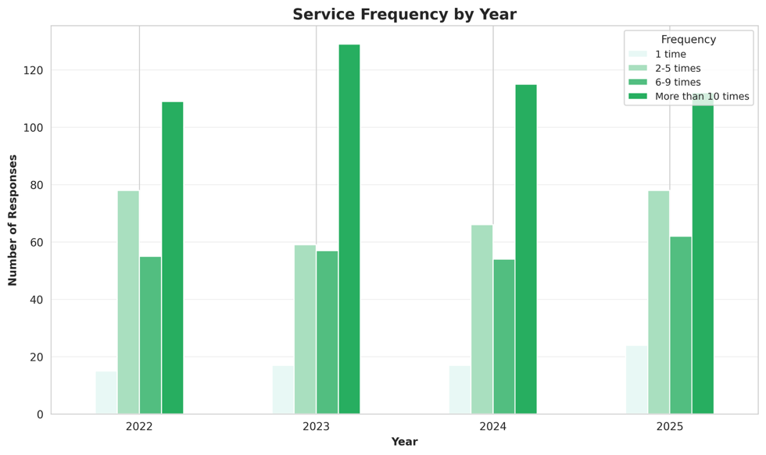
Figure 8. Service frequency distribution broken down by year (2022–2025).

4.2 Statistical Tests
Three chi-square tests of independence were conducted to assess whether key demographic and behavioral variables were associated with high satisfaction (defined as reporting "Very Satisfied").

Service frequency showed the strongest association with satisfaction (χ²=66.05, p<0.0001). Clients who used services more frequently were substantially more likely to report high satisfaction — 86% of those who visited more than 10 times reported being very satisfied, compared to only 49% of those who visited just once. This dose-response pattern suggests that repeated engagement with the center's services is closely tied to client satisfaction.
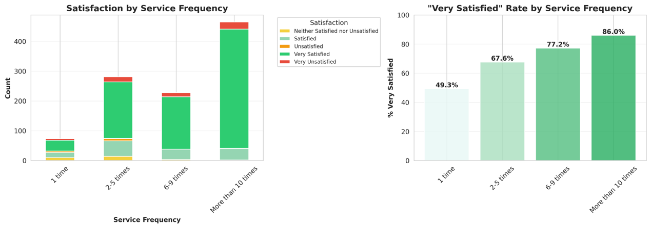
Figure 9. High satisfaction rate by service frequency.
Age was also significantly associated with satisfaction (χ²=13.18, p=0.022). Clients aged 75 or older had the highest satisfaction rate at 84.7%, while the 25–34 group had the lowest at 62.5%. The general trend suggests that older clients tend to report higher satisfaction, though the sample sizes for younger age groups were small.
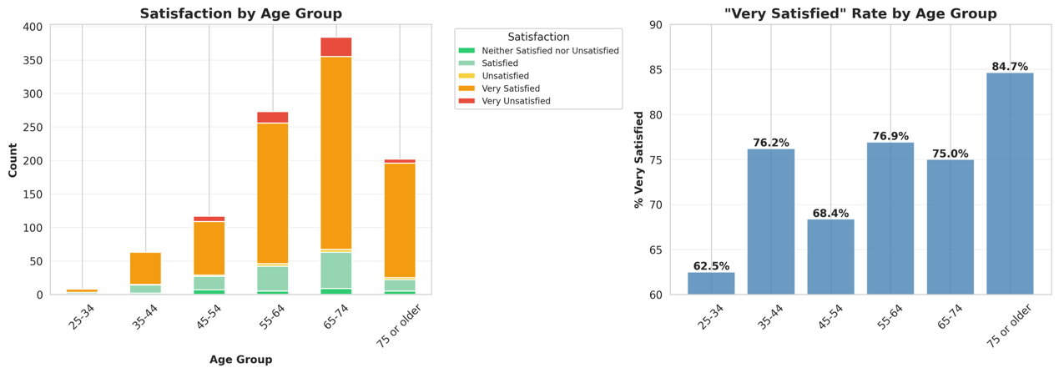
Figure 10. High satisfaction rate by age group.
Cancer status was not significantly associated with satisfaction (χ²=7.73, p=0.172). Satisfaction rates across all status groups — current patients, survivors, care partners, and family members — fell within a narrow 72–80% range, indicating that the center serves all groups at a comparably high level regardless of their relationship to cancer.
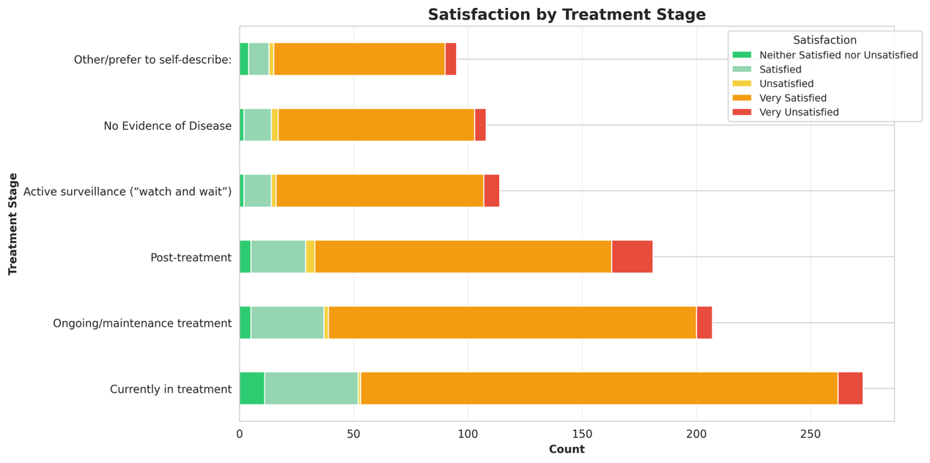
Figure 11. Satisfaction rate by treatment stage.

4.3 Machine Learning Classification
Four classifiers were trained to predict whether a client would report "Very Satisfied," using age, gender, service frequency, and cancer status as features.

In the single 80/20 train-test evaluation, Gaussian Naive Bayes achieved the highest accuracy at 74.6%. Decision Tree and Random Forest both reached 72.1%, while KNN performed lowest at 67.9%. Under 5-fold cross-validation, Gaussian Naive Bayes remained the strongest model (76.1% ± 1.4%), suggesting it generalizes well to unseen data. The relatively narrow gap between models indicates that the feature set has moderate but consistent predictive power.
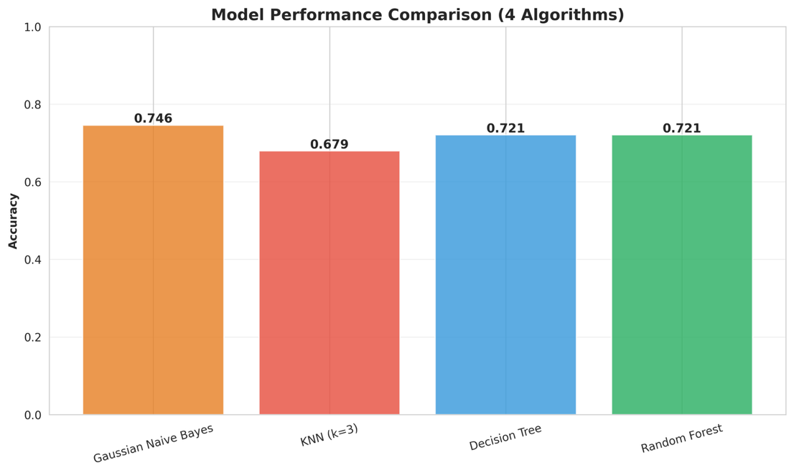
Figure 12. Model accuracy comparison across four classifiers (single train-test split).
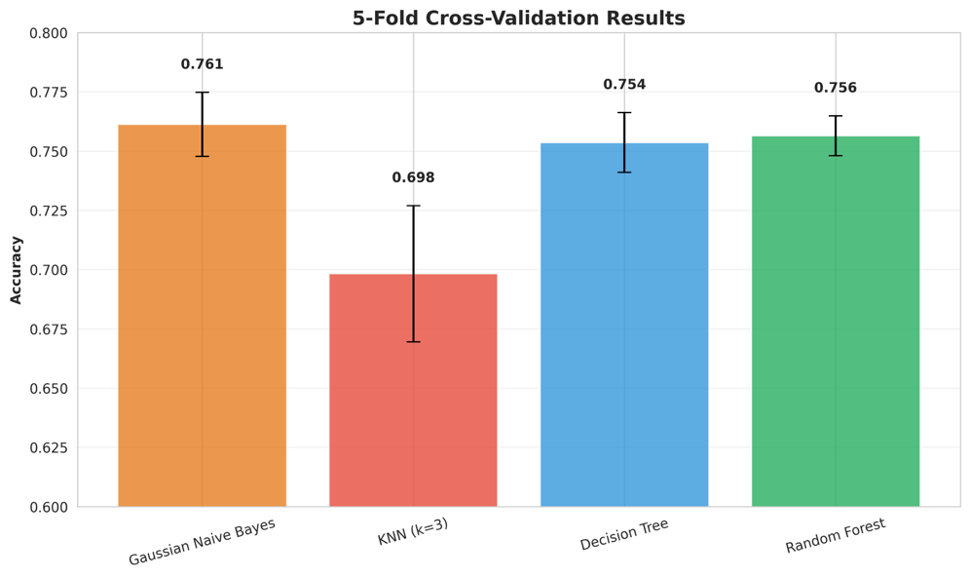
Figure 13. 5-fold cross-validation accuracy for each classifier.

Table 1. Summary of classifier performance.
Model | Test Accuracy | CV Mean | CV Std
Gaussian Naive Bayes | 74.6% | 76.1% | ±1.4%
Random Forest | 72.1% | 75.6% | ±1.5%
Decision Tree | 72.1% | 74.3% | ±1.6%
KNN (k=3) | 67.9% | 69.8% | ±3.2%
Feature importance analysis from both tree-based models consistently identified service frequency as the dominant predictor of satisfaction, with importance scores of 0.446 (Decision Tree) and 0.413 (Random Forest). Age and cancer status were secondary contributors, while gender had the lowest importance across both models. This ranking aligns with the chi-square results and reinforces the central role of service engagement in predicting client satisfaction.
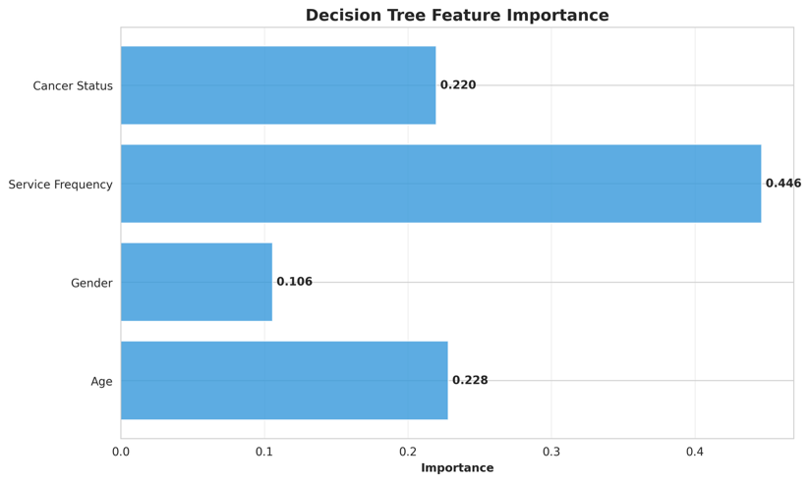
Figure 14. Decision Tree feature importance.
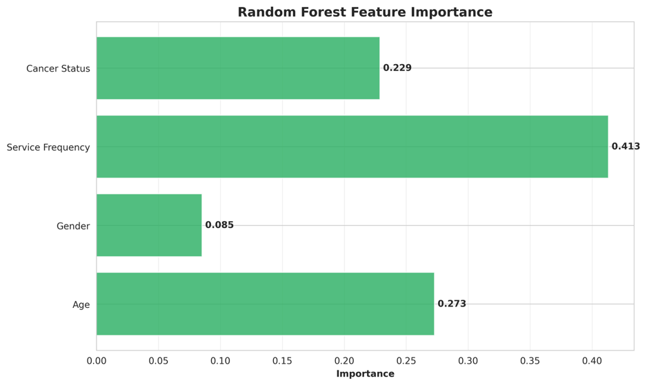
Figure 15. Random Forest feature importance.
Confusion matrices for both tree-based models show strong performance on the majority "Very Satisfied" class but limited recall on minority classes such as "Unsatisfied" and "Very Unsatisfied." This is expected given the class imbalance in the dataset, where over 76% of responses fall in the "Very Satisfied" category.
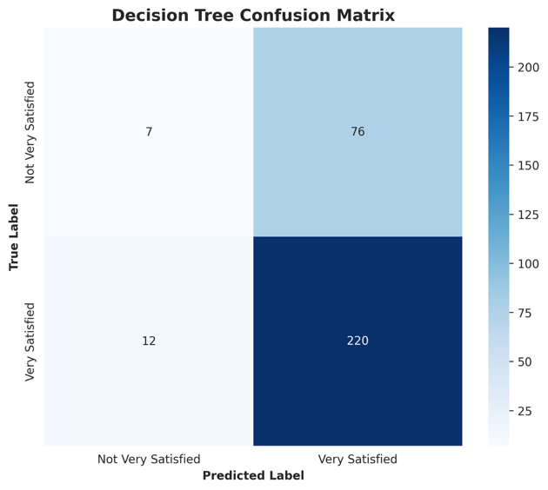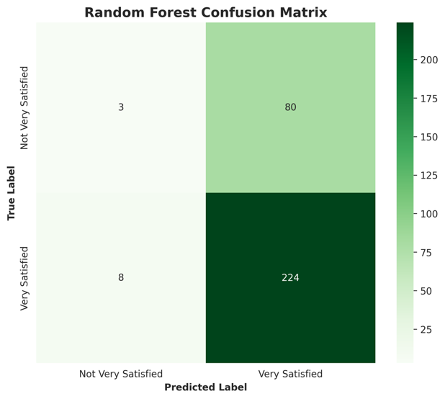
Figure 16. Decision Tree confusion matrix.
Figure 17. Random Forest confusion matrix.

4.4 Clustering Analysis
K-means clustering was applied to identify distinct client segments based on age, service frequency, and cancer status. The elbow plot indicated that k=4 was the optimal number of clusters, where the rate of inertia reduction began to flatten.
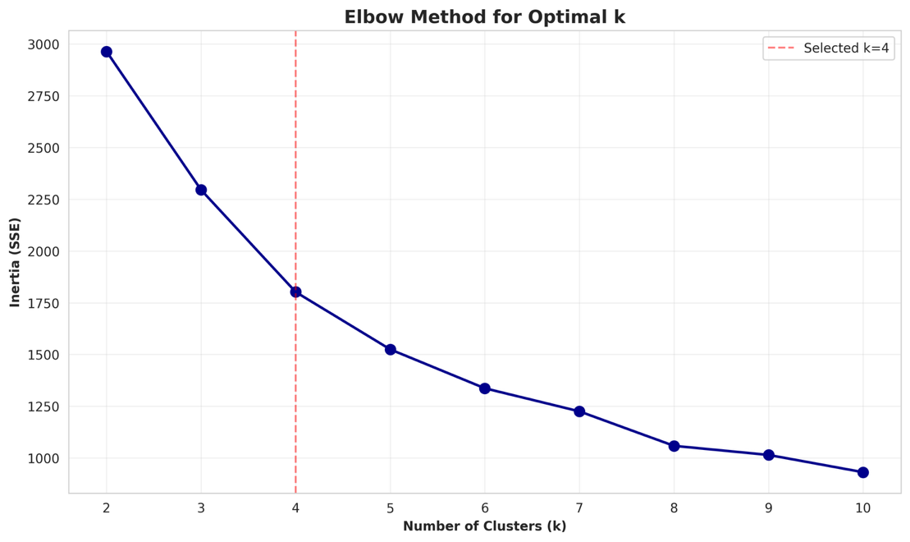
Figure 18. Elbow plot for K-means cluster selection.
Four client segments emerged from the analysis. Cluster 3 (n=433) represented the core user group — primarily clients aged 65–74 with high service frequency and an 85% satisfaction rate, the highest of any cluster. Cluster 1 (n=281) consisted of younger clients (55–64) with lower usage frequency (2–5 times) and a noticeably lower satisfaction rate of 65%, suggesting that less-engaged clients in this age bracket may have unmet needs. Cluster 2 (n=187) was characterized by middle-aged clients (45–54) who visited frequently but reported a 74% satisfaction rate. Cluster 0 (n=146) shared a similar age and frequency profile to Cluster 3 but had a lower satisfaction rate of 76%, possibly reflecting differences in the types of services used.
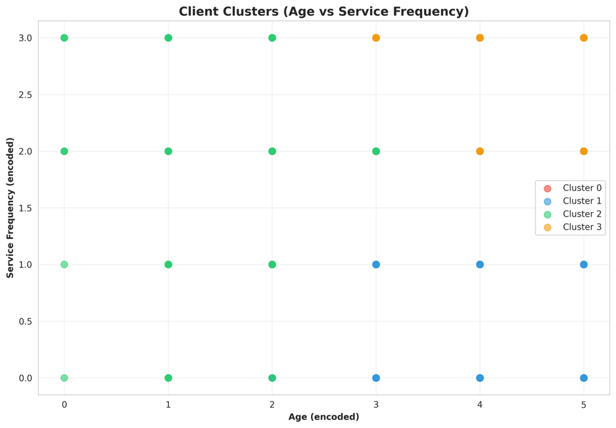
Figure 19. K-means cluster visualization (2D PCA projection).

4.5 PCA
Principal Component Analysis was conducted on the standardized feature matrix to examine the underlying variance structure. Three principal components were needed to capture 81.5% of cumulative variance: PC1 explained 31.0%, PC2 explained 26.2%, and PC3 explained 24.3%.
Based on the PC loadings, PC1 was primarily driven by the contrast between age and gender (loadings of −0.667 and 0.668 respectively), suggesting that these two variables tend to vary together in opposing directions across the dataset. PC2 was dominated by cancer status (loading of 0.912), capturing variation related to clients' relationship to cancer. PC3 reflected service frequency (loading of 0.938), isolating usage intensity as a distinct dimension of variation independent of demographics.
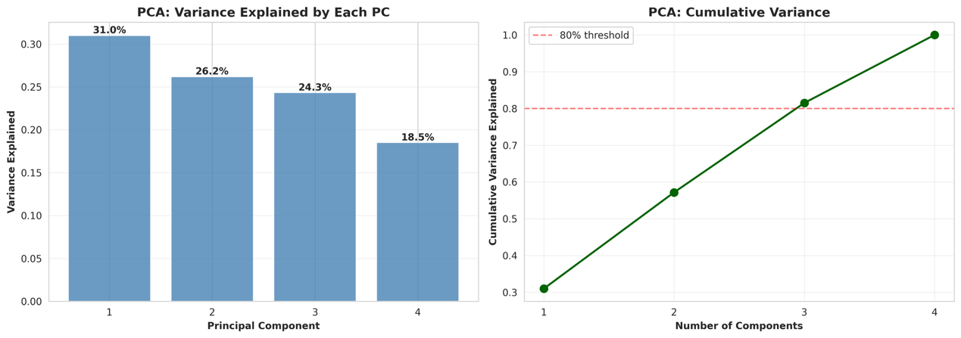
Figure 20. PCA scree plot and component loadings.

4.6 Correlation Analysis
The Pearson correlation heatmap confirmed that service frequency had the strongest linear relationship with high satisfaction (r=0.247). Age showed a weak positive correlation (r=0.079). Gender and cancer status were near zero (r=−0.017 and r=−0.033 respectively), consistent with the chi-square findings that these variables are not meaningfully associated with satisfaction outcomes.
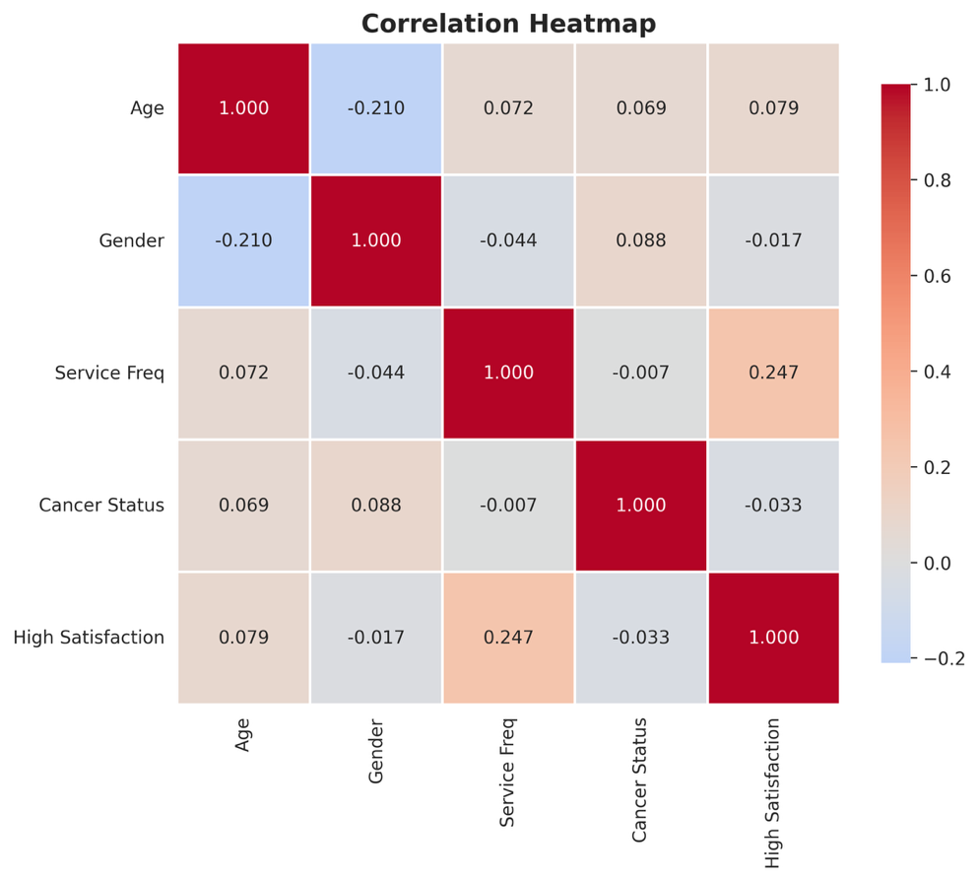
Figure 21. Pearson correlation heatmap of encoded features and satisfaction.

Discussion
Service frequency emerged as the most consistent predictor of client satisfaction across every method used in this study — chi-square tests, feature importance rankings, correlation analysis, and clustering all pointed to the same conclusion. Clients who visited more than 10 times reported very satisfied at nearly double the rate of one-time visitors (86% vs. 49%). This pattern likely reflects a combination of two dynamics: clients who find the services valuable tend to return more often, and repeated engagement itself deepens familiarity with staff and services, building trust over time. Either way, the implication for the Dempsey Center is the same — retaining clients beyond their first visit is critical.

Age was the second most influential factor. Older clients, particularly those 75 or older, reported the highest satisfaction rates, while the 25–34 group had the lowest. This gap may reflect differences in expectations, prior experience with support services, or simply how well the current service offerings match the needs of different age groups. The underrepresentation of younger clients in the dataset also makes it difficult to draw strong conclusions for that demographic, but the lower satisfaction rate warrants attention.

Cancer status, on the other hand, showed no significant association with satisfaction. Clients across all categories — current patients, survivors, care partners, and family members — reported broadly similar satisfaction levels. This is an encouraging finding, suggesting that the center's services are accessible and effective regardless of where someone is in their cancer experience.

The clustering analysis added texture to these findings by identifying four distinct client segments. The largest cluster (Cluster 3, n=433) consisted of older, high-frequency users with an 85% satisfaction rate — this group represents the center's most engaged and satisfied core. The most concerning segment was Cluster 1 (n=281): younger, lower-frequency clients with only a 65% satisfaction rate. This group may benefit from targeted outreach or programming designed to lower barriers to repeated engagement.

The machine learning models performed at moderate accuracy levels (around 74–76% under cross-validation), which is reasonable given that only four demographic and behavioral features were used. Gaussian Naive Bayes outperforming the tree-based models slightly suggests the features have relatively independent contributions to satisfaction, consistent with the low inter-feature correlations seen in the heatmap. The class imbalance — over 76% of responses being "Very Satisfied" — also places a ceiling on how much the models can distinguish minority classes without additional features or resampling techniques.

The PCA results reinforced that the four variables capture largely independent dimensions of variation. Service frequency, cancer status, and the age-gender axis each loaded onto separate principal components, confirming that these variables contribute distinct information rather than redundant signals.

Limitation
Several limitations should be considered when interpreting these findings. First, the survey captures only clients who actively completed the annual questionnaire, introducing selection bias — clients with more negative experiences or lower engagement may be less likely to respond, which could inflate overall satisfaction rates.

Second, the survey instrument changed across the four years studied, with column counts growing from 72 to 105. While core variables were manually verified and extracted consistently, some variables (such as income) were only available for certain years and could not be included in the longitudinal analysis.

Third, the features available for modeling were limited to four demographic and behavioral variables. Other factors that likely influence satisfaction — such as specific services used, staff interactions, physical accessibility, or emotional support needs — were not captured in a format suitable for this analysis.

Finally, the class imbalance in the outcome variable (76% "Very Satisfied") constrained the classifiers' ability to predict minority satisfaction levels. Future work could apply resampling techniques such as SMOTE to address this issue.

Conclusion
This study analyzed four years of client survey data from the Dempsey Center to assess satisfaction trends, identify predictors of high satisfaction, and segment the client population. Overall satisfaction remained stable at around 76% "Very Satisfied" across 2022–2025, and 95–97% of clients consistently reported that services made their life better — both findings reflect well on the center's service quality over time.

Service frequency was the strongest predictor of satisfaction across all analytical methods. Age showed a secondary but significant effect, with older clients reporting higher satisfaction. Cancer status did not meaningfully differentiate satisfaction levels, indicating equitable service delivery across client types. Clustering revealed four distinct segments, with the most actionable finding being a group of younger, low-frequency clients whose satisfaction lagged considerably behind the rest.

Based on these findings, the Dempsey Center may benefit from strategies that encourage clients to return beyond a first visit — such as follow-up outreach, introductory program series, or reduced-barrier entry points for new clients. Particular attention to the needs of younger and lower-engagement clients could help close the satisfaction gap identified in Cluster 1.

References

Dempsey Center. (2025). About the Dempsey Center. https://www.dempseycenter.org/about/

American Cancer Society. (2025). Therapy, counseling, and support resources for people with cancer. https://www.cancer.org/cancer/survivorship/coping/understanding-psychosocial-support-services.html

Gao, Y., et al. (2024). Global unmet psychosocial needs in cancer care: Health policy. eClinicalMedicine. https://doi.org/10.1016/j.eclinm.2024.102855

Sautier, L., et al. (2021). Evaluations of psychosocial cancer support services: A scoping review. PLOS ONE. https://doi.org/10.1371/journal.pone.0251126

Dempsey Center. (2025). About the Dempsey Center. https://www.dempseycenter.org/about/

