Model Training Report
AI-Based Waste Detection and Classification System

1. YOLOv8L

Model Explanation
YOLOv8L is a CNN-based, anchor-free single-stage detector: a CSPDarknet-style backbone extracts multi-scale features, a PAN/FPN neck fuses them, and a decoupled head predicts class and box offsets per grid cell directly, with no separate region-proposal stage. This run overrides Ultralytics' default optimizer with a 2-group differential learning-rate schedule: the first 5 backbone layers (generic edge/texture filters) are frozen outright, the remaining backbone/neck layers train at a low learning rate (3.5x10-4), and the detection head - which must learn this project's 6 classes from scratch - trains at a high learning rate (7.0x10-3), both annealed on a cosine schedule.

Dataset
Dataset is taken from the project's main conveyor/pour capture set - 7,389 training images and 1,847 validation images, hand-annotated in YOLO format across all 6 material classes.

Training Parameters
Base model | YOLOv8L
Classes | 6 - aluminium, plastic, metal, stone, ceramic, glass
Training images | 7,389
Validation images | 1,847
Batch size | 8
Training Image Input size | 640px
Epochs trained | 100
Training time | 2h 19m (100 epochs)
Precision | 0.945
Recall | 0.932
mAP50 | 0.975
mAP50-95 | 0.935

Average model Inference time is : 5.82 ms (171.8 FPS)
Average end to end latency : 87.61 ms
(Measured on an RTX 5080, 3622x1779 test frame, 5 warmup + 30 timed passes. End-to-end includes reading the frame and drawing the annotated output, not just the model's forward pass.)

Model curve
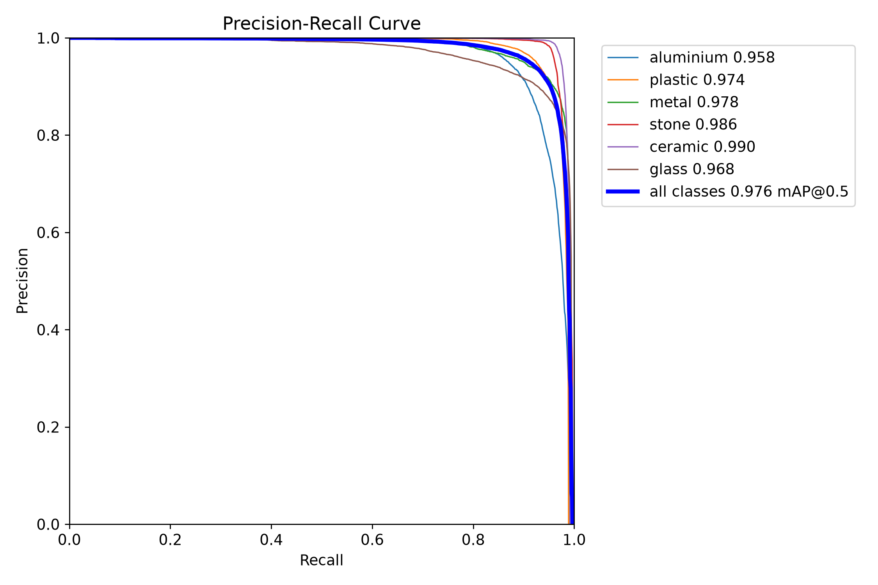

Prediction
Plain inference (no tiling):
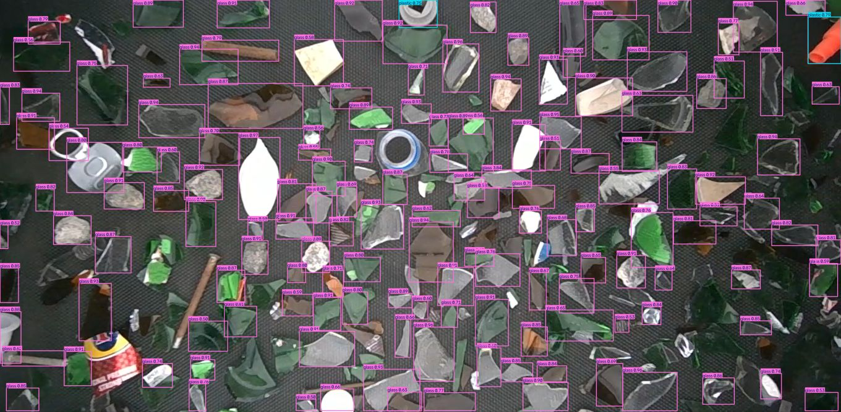
SAHI inference (6-tile):
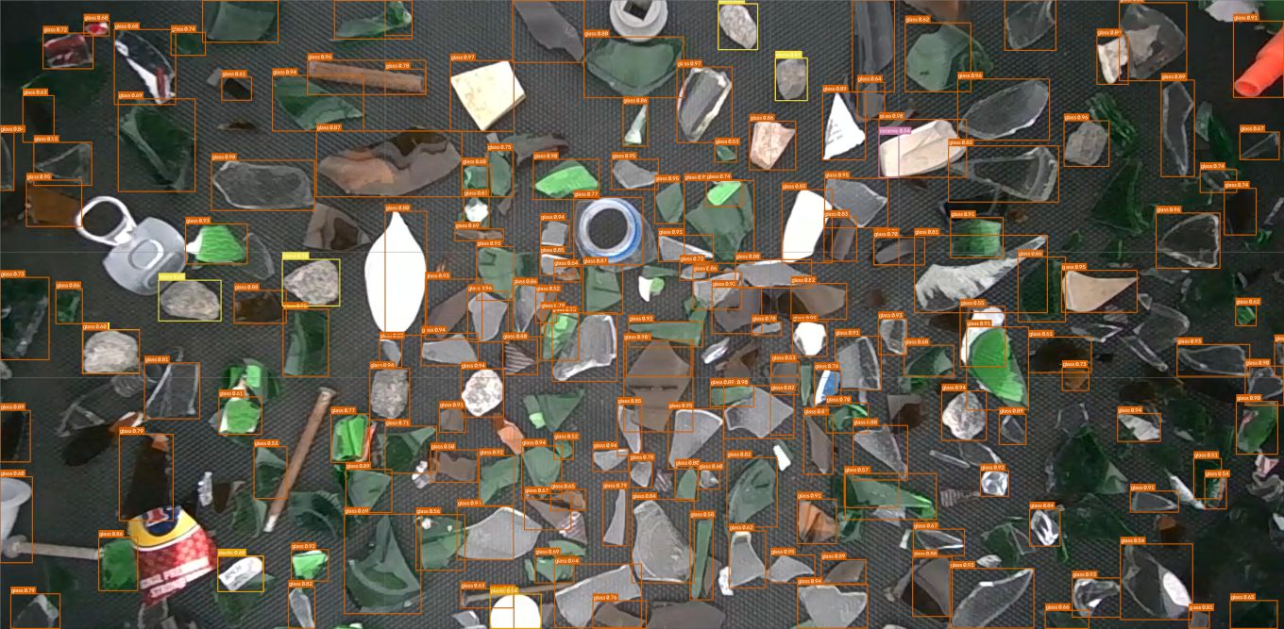

2. YOLO26s

Model Explanation
Same YOLO26 architecture family as exp006, but trained as a narrow specialist: a single output class (glass cullet) on a dataset roughly a third the size of the main six-class set. Glass-cullet fragments have no consistent silhouette the way a whole bottle or can does, which - combined with the smaller dataset - explains its lower headline numbers versus the six-class models.

Dataset
Dataset is a separate, narrower capture set of glass-cullet fragments only - 2,350 training images and 587 validation images, single class.

Training Parameters
Base model | YOLO26s
Classes | 1 - glass (cullet fragments only)
Training images | 2,350
Validation images | 587
Batch size | 8
Training Image Input size | 640px
Epochs trained | 120
Training time | 1h 23m (120 epochs)
Precision | 0.694
Recall | 0.553
mAP50 | 0.602
mAP50-95 | 0.370

Average model Inference time is : 6.03 ms (165.7 FPS)
Average end to end latency : 79.87 ms
(Measured on an RTX 5080, 3622x1779 test frame, 5 warmup + 30 timed passes. End-to-end includes reading the frame and drawing the annotated output, not just the model's forward pass.)

Model curve
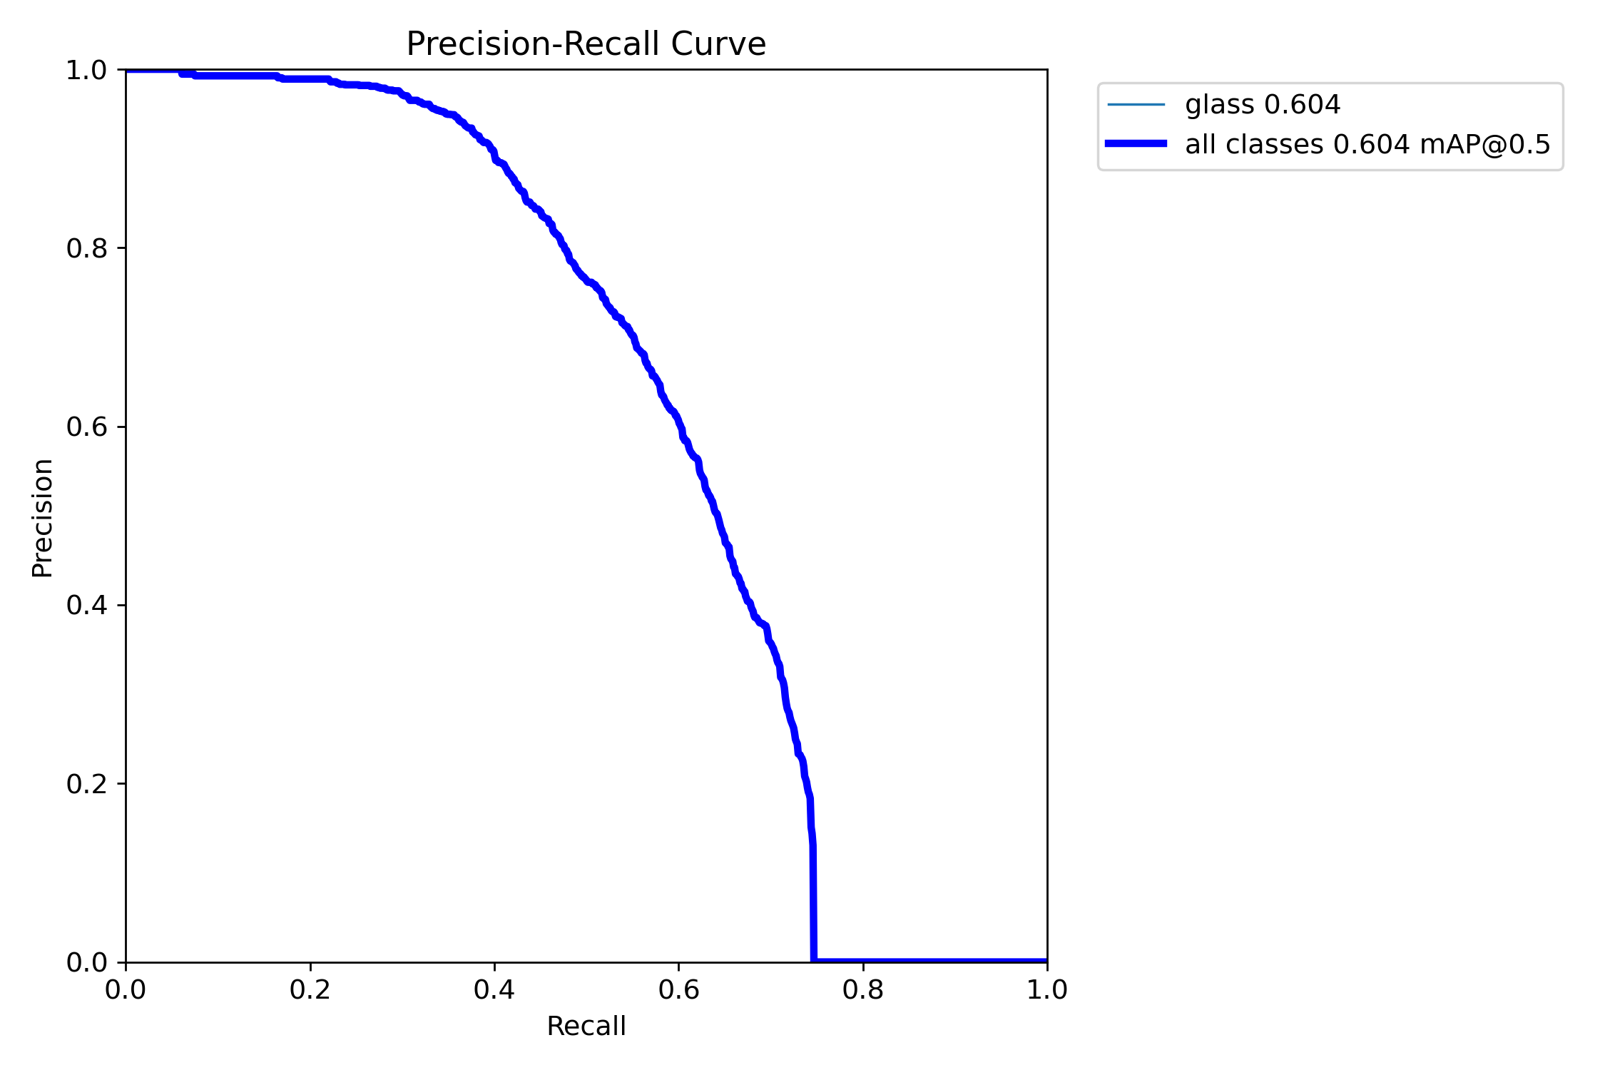

Prediction
Plain inference (no tiling):
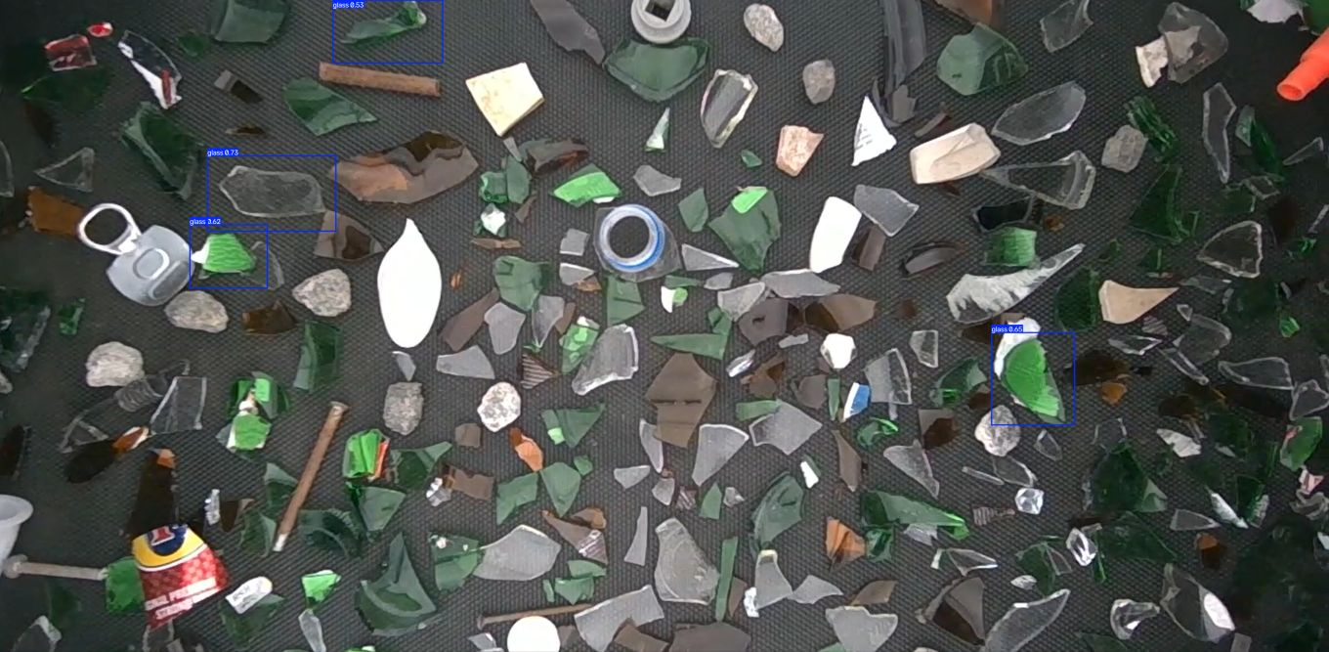
SAHI inference (6-tile):
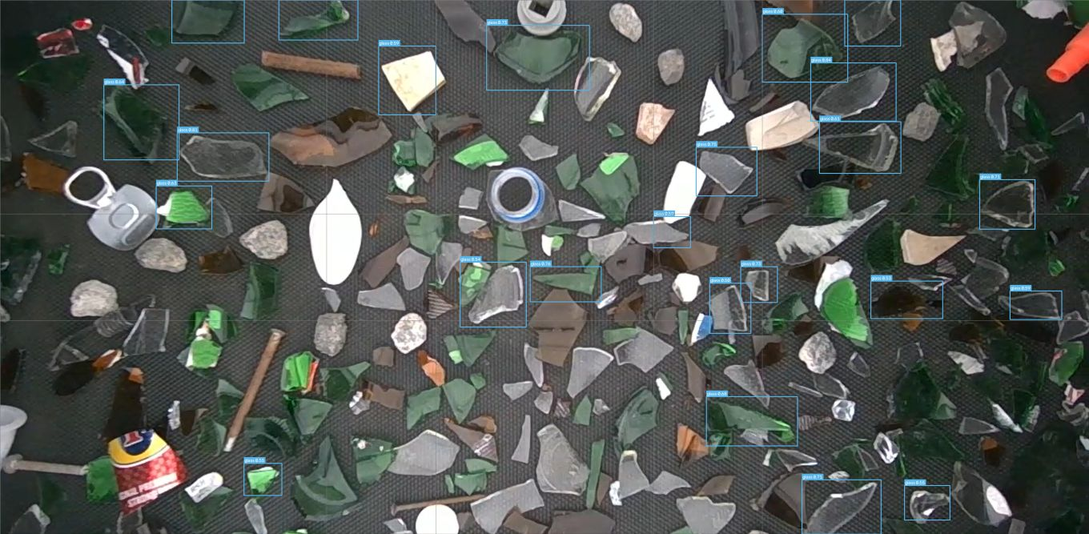

3. YOLO26L + P2

Model Explanation
The only architectural change from a stock YOLO26L is an added P2 (160x160) detection head alongside the stock P3/P4/P5 heads, giving the network a detection path with less downsampling - better suited to small or distant objects on the conveyor. Every other hyperparameter is left at Ultralytics defaults, isolating the P2 head's own effect on accuracy. This is the best-performing model in the project on every headline metric.

Dataset
Same main dataset as YOLOv8L above - 7,389 training images and 1,847 validation images, identical split for a fair comparison.

Training Parameters
Base model | YOLO26L + P2
Classes | 6 - aluminium, plastic, metal, stone, ceramic, glass
Training images | 7,389
Validation images | 1,847
Batch size | 16
Training Image Input size | 640px
Epochs trained | 100
Training time | 41h 17m (100 epochs)
Precision | 0.947
Recall | 0.930
mAP50 | 0.977
mAP50-95 | 0.951

Average model Inference time is : 11.6 ms (86.2 FPS)
Average end to end latency : 91.74 ms
(Measured on an RTX 5080, 3622x1779 test frame, 5 warmup + 30 timed passes. End-to-end includes reading the frame and drawing the annotated output, not just the model's forward pass.)

Model curve
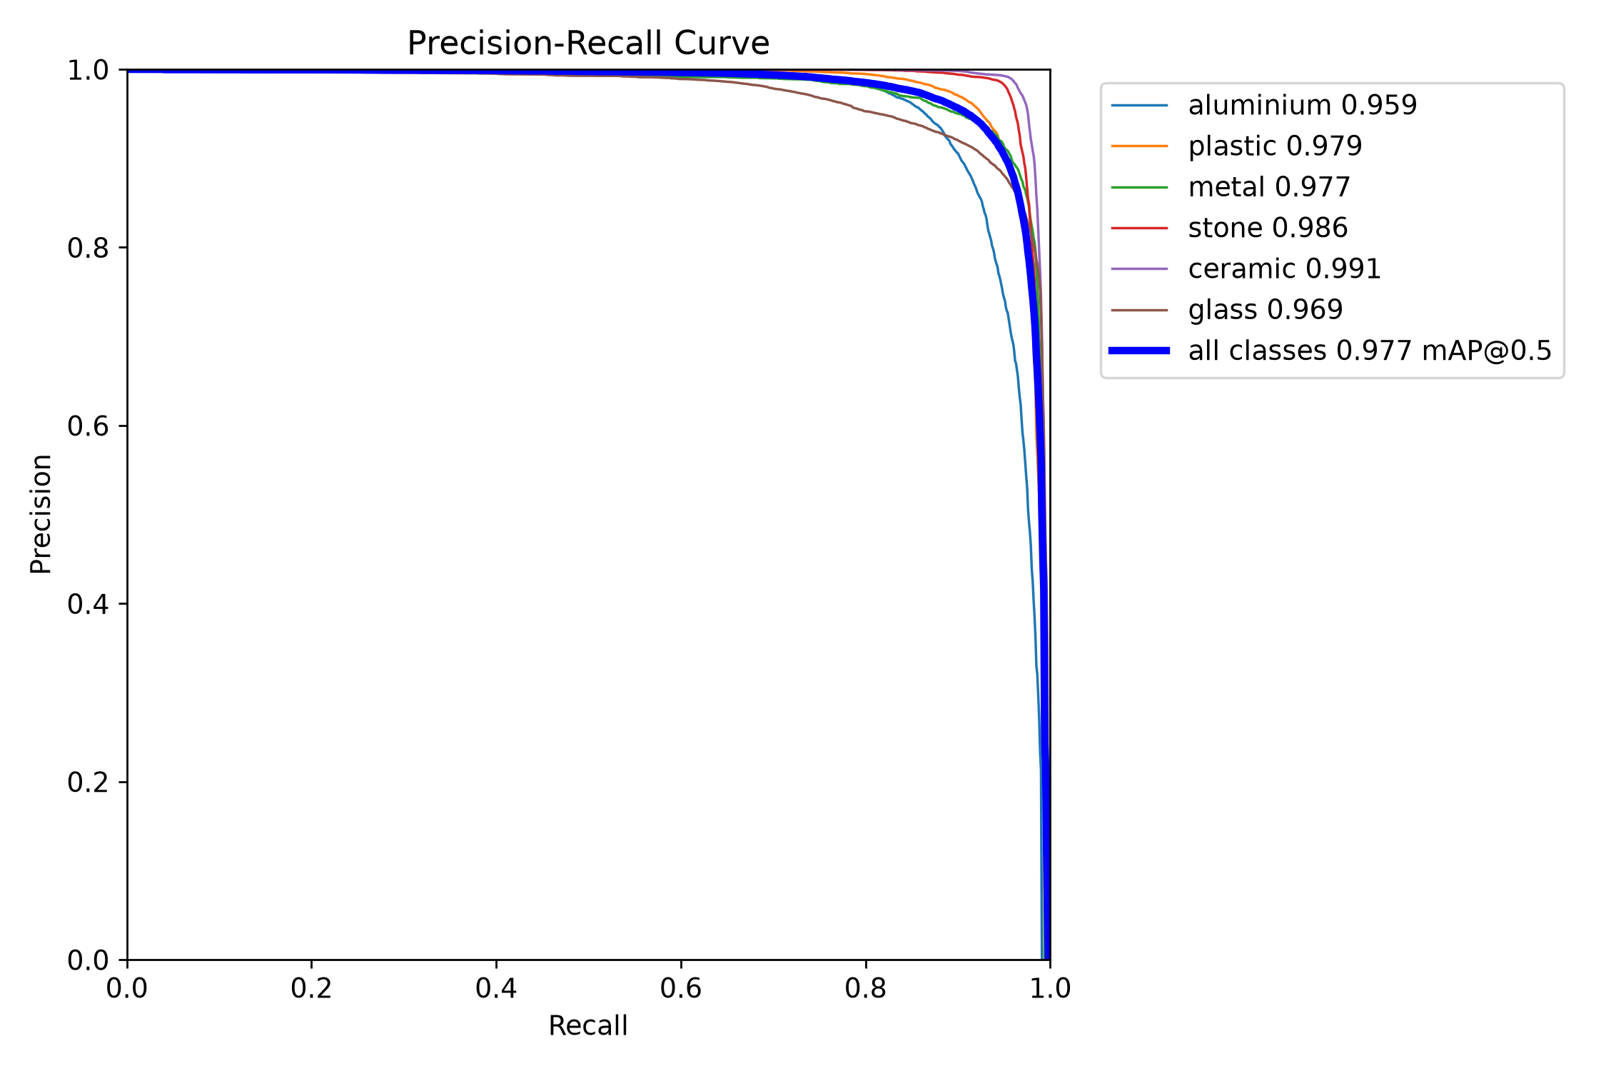

Prediction
Plain inference (no tiling):
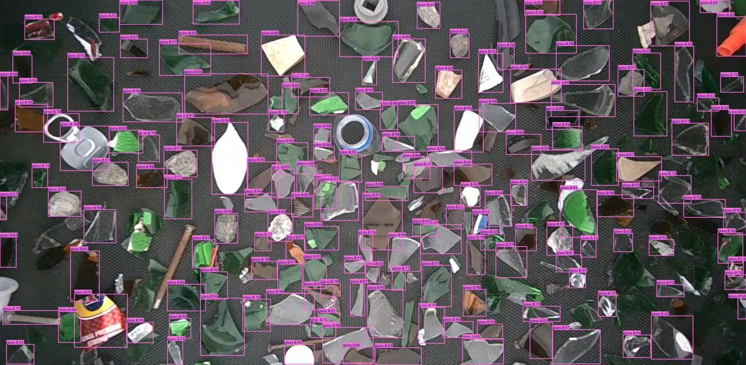
SAHI inference (6-tile):
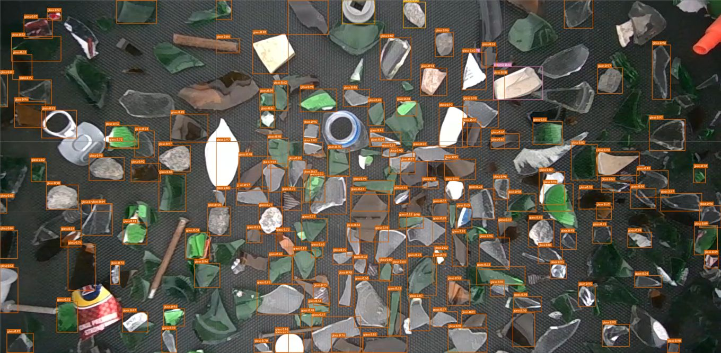

4. ResNet-50

Model Explanation
A standard ResNet-50 backbone, ImageNet-pretrained, with its final layer replaced by a 6-way linear classifier. Not a detector: it is the second stage of a two-model pipeline where YOLO detects and localizes an object first, then this classifier looks only at that tightly cropped region to assign the final material label, using heavy color/lighting augmentation for robustness to glare. It cannot localize objects in a raw multi-object frame on its own.

Dataset
Dataset is not separately captured - it is built by cropping every labeled YOLO box out of the main dataset's own images (10% padding added, boxes under 10px skipped), giving 294,959 training crops and 73,448 validation crops with zero new manual labeling.

Training Parameters
Base model | ResNet-50
Classes | 6 - aluminium, plastic, metal, stone, ceramic, glass
Training crops | 294,959 crops
Validation crops | 73,448 crops
Batch size | 64
Training Image Input size | 224px
Epochs trained | 29
Training time | not logged for this run (29 epochs to best checkpoint)
Accuracy | 99.37%

Average model Inference time is : 3.33 ms (300.2 FPS)
Average end to end latency : 77.63 ms
(Measured on an RTX 5080, 3622x1779 test frame, 5 warmup + 30 timed passes. End-to-end includes reading the frame and drawing the annotated output, not just the model's forward pass.)

Model curve
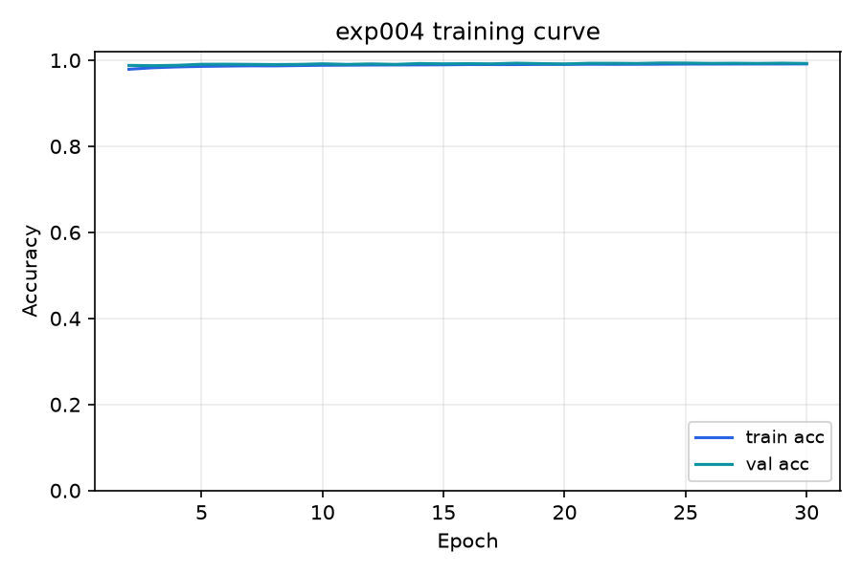

Prediction
Plain inference (no tiling):
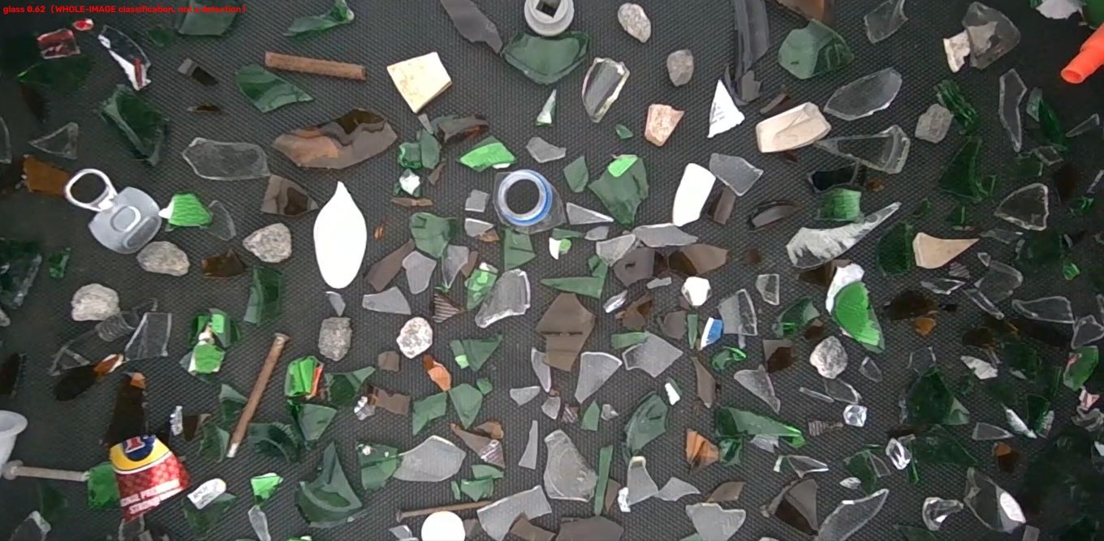
SAHI inference (6-tile):
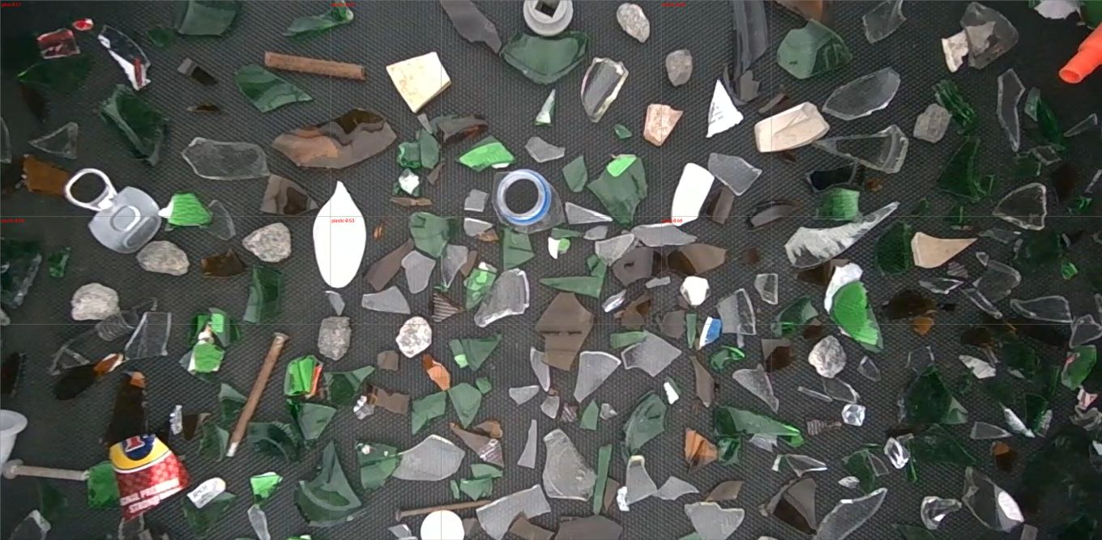

5. RT-DETR-L

Model Explanation
RT-DETR (Baidu, 2023) is a transformer-based detector with no anchor boxes and no NMS post-processing - a CNN backbone feeds a transformer encoder-decoder that predicts a fixed set of object queries directly. Trained via Ultralytics' own RTDETR class, the same .train() API as every YOLO model here, making it a fair architecture-only comparison. Training completed all 100 epochs, but the process was interrupted during Ultralytics' final validation pass, so no confusion matrix or PR-curve image exists for this run - the chart below is a live per-epoch training curve instead.

Dataset
Same main dataset and identical validation split as YOLOv8L and YOLO26L+P2 above - 7,389 training images and 1,847 validation images.

Training Parameters
Base model | RT-DETR-L
Classes | 6 - aluminium, plastic, metal, stone, ceramic, glass
Training images | 7,389
Validation images | 1,847
Batch size | 16
Training Image Input size | 640px
Epochs trained | 100
Training time | 4h 48m (100 epochs)
Precision | 0.946
Recall | 0.924
mAP50 | 0.975
mAP50-95 | 0.922

Average model Inference time is : 13.93 ms (71.8 FPS)
Average end to end latency : 96.87 ms
(Measured on an RTX 5080, 3622x1779 test frame, 5 warmup + 30 timed passes. End-to-end includes reading the frame and drawing the annotated output, not just the model's forward pass.)

Model curve
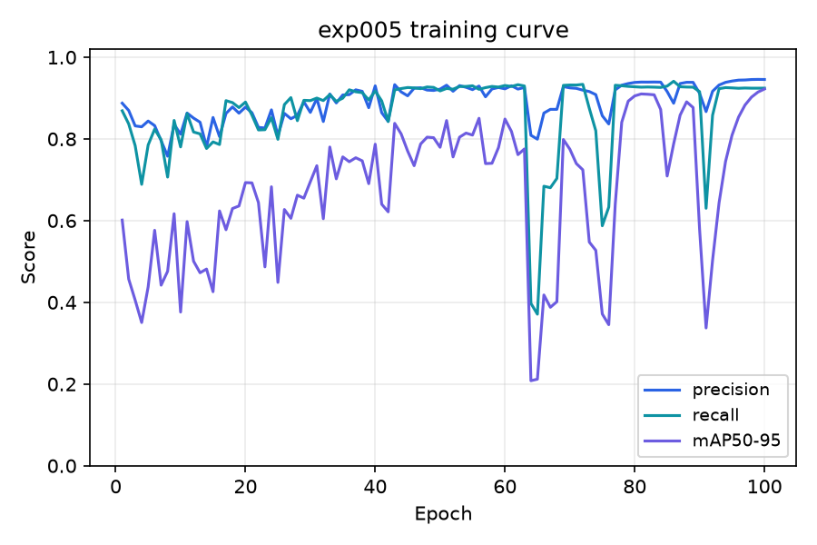

Prediction
Plain inference (no tiling):
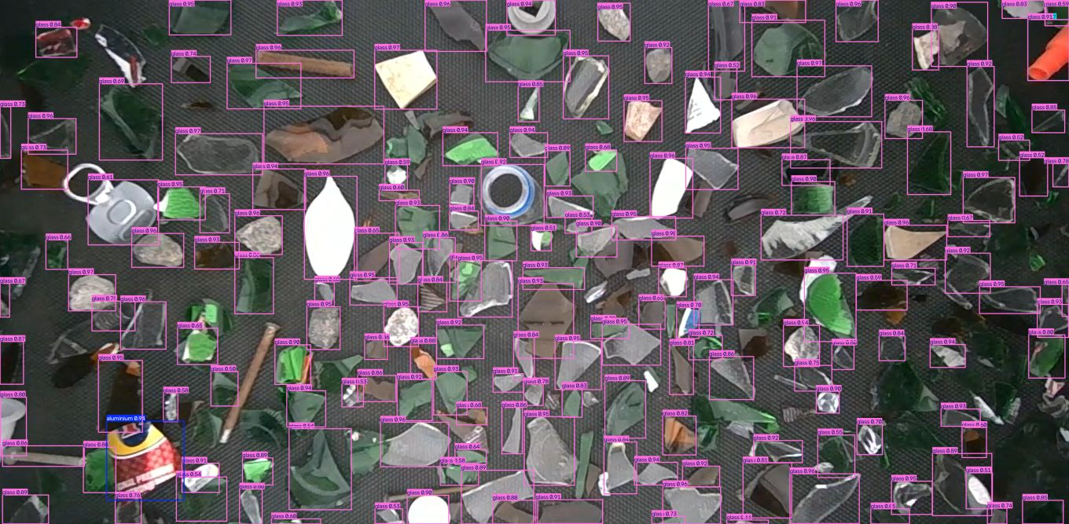
SAHI inference (6-tile):
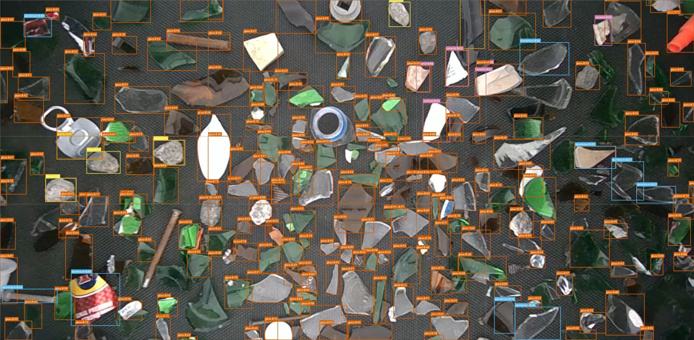

6. YOLO26s (fine-tuned)

Model Explanation
Same YOLO26s architecture as exp002, trained in two stages instead of one: stage 1 base-trains on a separate smaller dataset, then stage 2 fine-tunes the resulting weights on this project's main six-class dataset. It lands between YOLOv8L and YOLO26L+P2 on the final held-out set despite being a much smaller, faster network - evidence that the base-training stage transfers useful structure before the model ever sees this project's own data.

Dataset
Trained in two stages: base-trained on its own 1,631/408 dataset, then fine-tuned on the main 7,389/1,847 dataset - the numbers below are the final fine-tuned model.

Training Parameters
Base model | YOLO26s (fine-tuned)
Classes | 6 - aluminium, plastic, metal, stone, ceramic, glass
Training images | 1,631 + 7,389
Validation images | 408 / 1,847
Batch size | 8
Training Image Input size | 640px
Epochs trained | 100
Training time | 29m (fine-tune stage, 100 epochs) + a separate base-training stage
Precision | 0.944
Recall | 0.927
mAP50 | 0.975
mAP50-95 | 0.943

Average model Inference time is : 6.7 ms (149.2 FPS)
Average end to end latency : 85.24 ms
(Measured on an RTX 5080, 3622x1779 test frame, 5 warmup + 30 timed passes. End-to-end includes reading the frame and drawing the annotated output, not just the model's forward pass.)

Model curve
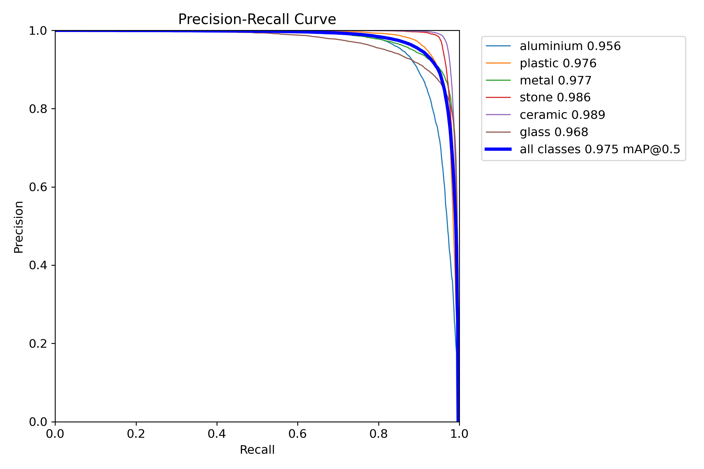

Prediction
Plain inference (no tiling):
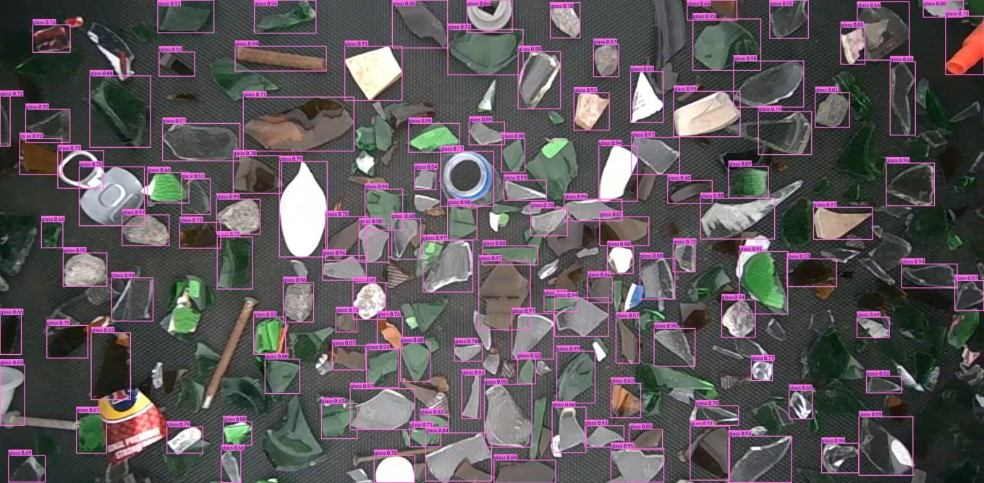
SAHI inference (6-tile):
