BITS Pilani
M.Tech AIML (WILP)
Machine Learning Operations (MLOps) AIMLCZG523 | Assignment 01
End-to-End MLOps Pipeline for Heart Disease Risk Prediction
Model development, experiment tracking, CI/CD, containerisation, Kubernetes deployment and monitoring
Item | Details
Student name | Rengaprakash S
BITS ID | 2025AE05107
Code repository | https://github.com/Rengaprakash4440/AIMLCZG523_Assignment_01
Deployed API | http://a2fd3c035818e4cee912d8bb8f47f7d8-1536463618.ap-south-1.elb.amazonaws.com (temporary: the cluster is deleted after the evidence is captured to avoid cost)
Pipeline video | [Paste the video link]
Submission date | 20/10/2026

1. Introduction and objectives
The goal of this assignment is to build a heart disease classifier on the UCI Heart Disease dataset and to ship it the way a production ML system is shipped: reproducible training, tracked experiments, automated tests and security checks, a container image, a Kubernetes deployment and live monitoring. The model matters less than the engineering around it, so the project is organised around the nine tasks in the brief.
The result is a scikit-learn pipeline served by a FastAPI application. It is built and tested by a five-stage GitHub Actions pipeline, stored in Amazon ECR, deployed to Amazon EKS behind a load balancer after a manual approval, and observed with Prometheus and Grafana.
Brief task | Where it lives in the repository
1 Data and EDA | src/download_data.py, src/data.py, report/notebooks/01_eda.ipynb, data/
2 Features and models | src/features.py, src/train.py
3 Experiment tracking | MLflow calls in src/train.py (mlflow.db created at run time)
4 Packaging | models/model.joblib, models/metadata.json, requirements*.txt
5 CI/CD and tests | .github/workflows/*.yml, tests/ (22 tests), .flake8
6 Containerisation | dockerfiles/Dockerfile, src/app.py
7 Deployment | kubernetes/ (namespace, deployment, service, network policy)
8 Monitoring | src/app.py metrics, monitoring/ (dashboard JSON, Helm values)
9 Documentation | This report, README.md, screenshots/

2. Setup and installation
Prerequisites: Python 3.14 (the same minor version as the container image, so the pickled model loads identically), Docker, Git, and for the cloud steps the AWS CLI, kubectl and an AWS account.
git clone https://github.com/Rengaprakash4440/AIMLCZG523_Assignment_01.git
cd AIMLCZG523_Assignment_01
python3 -m venv .venv && source .venv/bin/activate
pip install -r requirements.txt

python -m src.download_data # UCI dataset id 45 -> data/heart_raw.csv
python -c "from src.data import load_clean; load_clean().to_csv('data/heart_clean.csv', index=False)"
pytest -v # 22 tests, with coverage
flake8 src tests # style check
python -m src.train # trains both models, logs to MLflow, writes models/
mlflow ui --backend-store-uri sqlite:///mlflow.db

uvicorn src.app:app --port 8000 # run the API locally
docker build -f dockerfiles/Dockerfile -t heart-api:1.0 .
docker run -d -p 8000:8000 heart-api:1.0 # containerised API

3. Data acquisition and exploratory analysis
Source and cleaning. The data comes from the UCI Machine Learning Repository (Heart Disease, id 45) and is downloaded by a script rather than committed by hand, so the step is repeatable. The original target num takes values 0 to 4; it is binarised to 0 (no disease) and 1 (disease present, values 1 to 4). Duplicates are dropped. The cleaned file has 303 patients, 13 predictors (5 numeric, 8 categorical) and a binary target. Only ca (4 rows) and thal (2 rows) have missing values; they are deliberately left in the CSV and imputed inside the model pipeline so that no statistic is learned from validation data.
Findings.
- Balanced classes. About 54% of patients have no disease and 46% have it (164 against 139), so no resampling is needed and accuracy is a meaningful metric, although recall is still tracked because a missed case is the costly error in screening.
- Strongest signals. thal (r = 0.53), ca (0.46), exang (0.43), oldpeak (0.42), thalach (-0.42) and cp (0.41) correlate most with the target. Patients with disease have a lower mean maximum heart rate (139 vs 158) and a higher ST depression (oldpeak 1.6 vs 0.6).
- Chest pain type. Asymptomatic chest pain (cp = 4) has a disease rate of 73%, against 18% to 30% for the other three types, which is counter-intuitive but well documented for this dataset. The disease rate is also higher for males (55%) than for females (26%).
- Weak features. fbs (0.03) and chol (0.09) carry little linear signal. Cholesterol has four values above 400 mg/dl (maximum 564); they were kept, since standard scaling and a regularised model tolerate them and removing 1% of a small dataset would cost more than it gains.
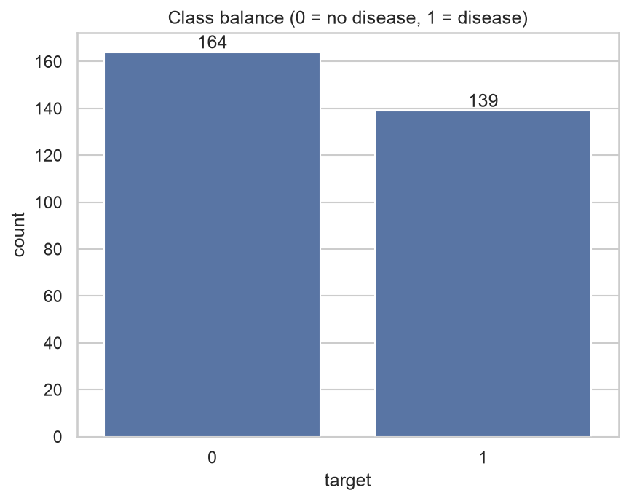  Figure 1: class balance (164 without disease, 139 with disease) | 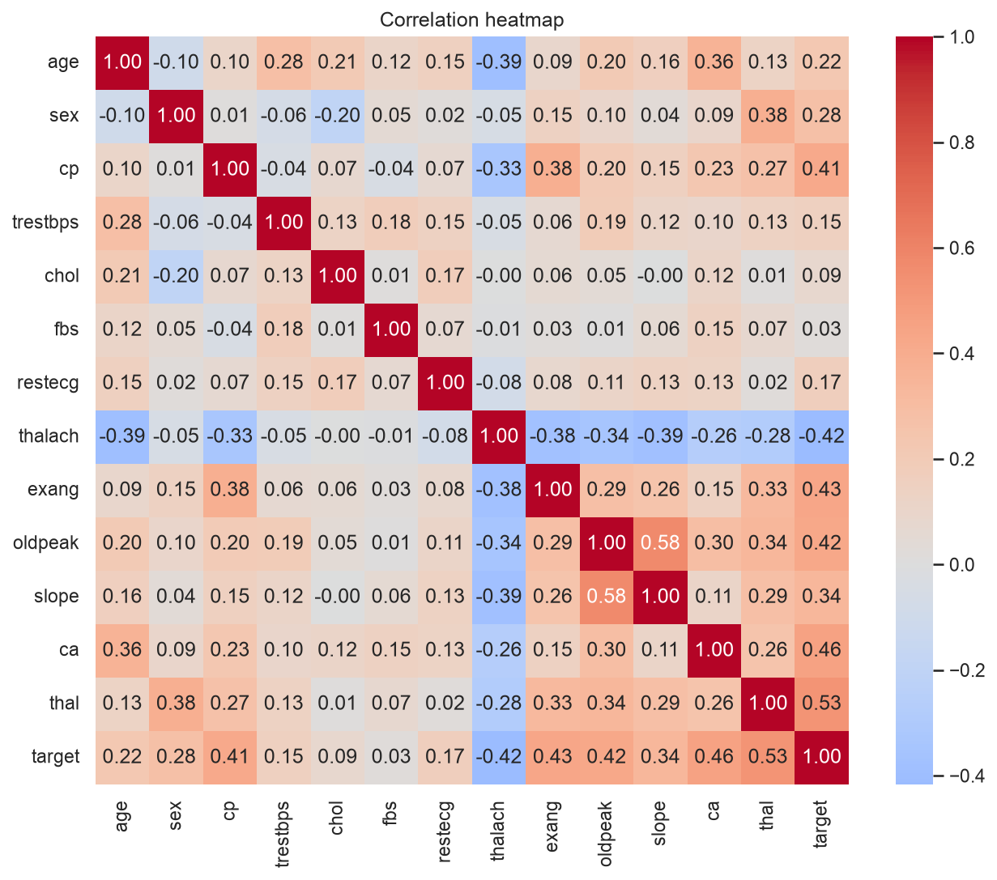  Figure 2: correlation heatmap

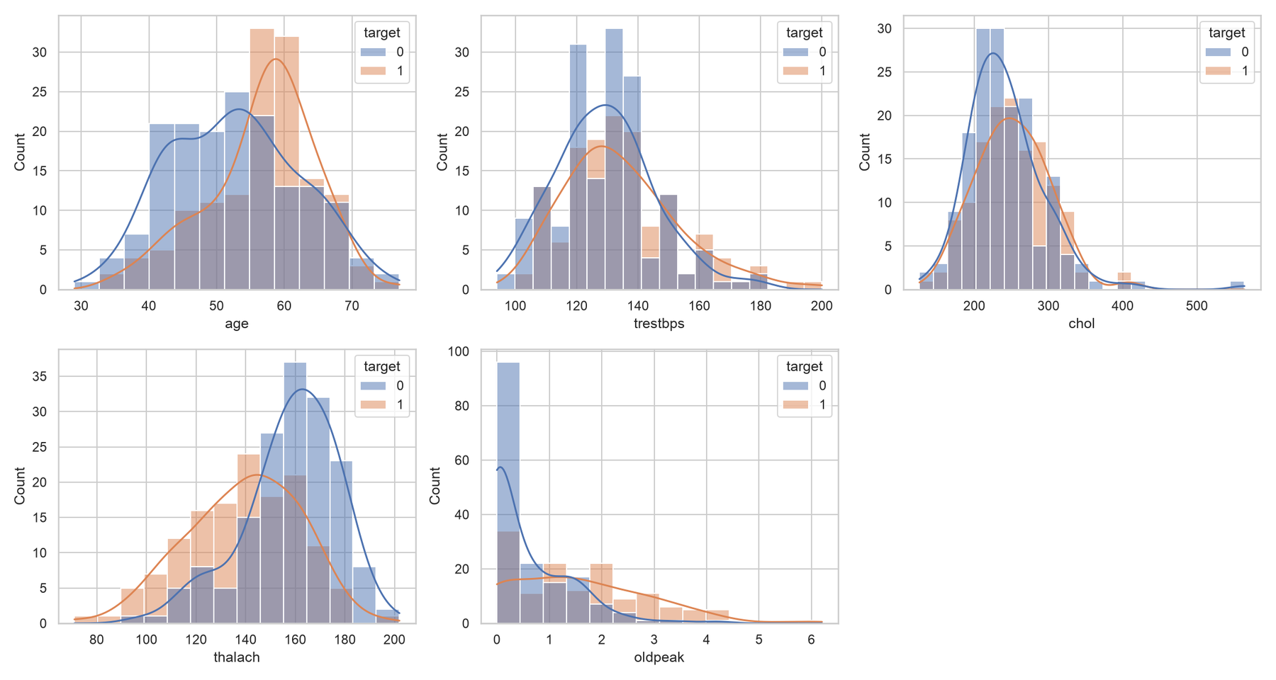
Figure 3: distributions of the numeric features, split by target
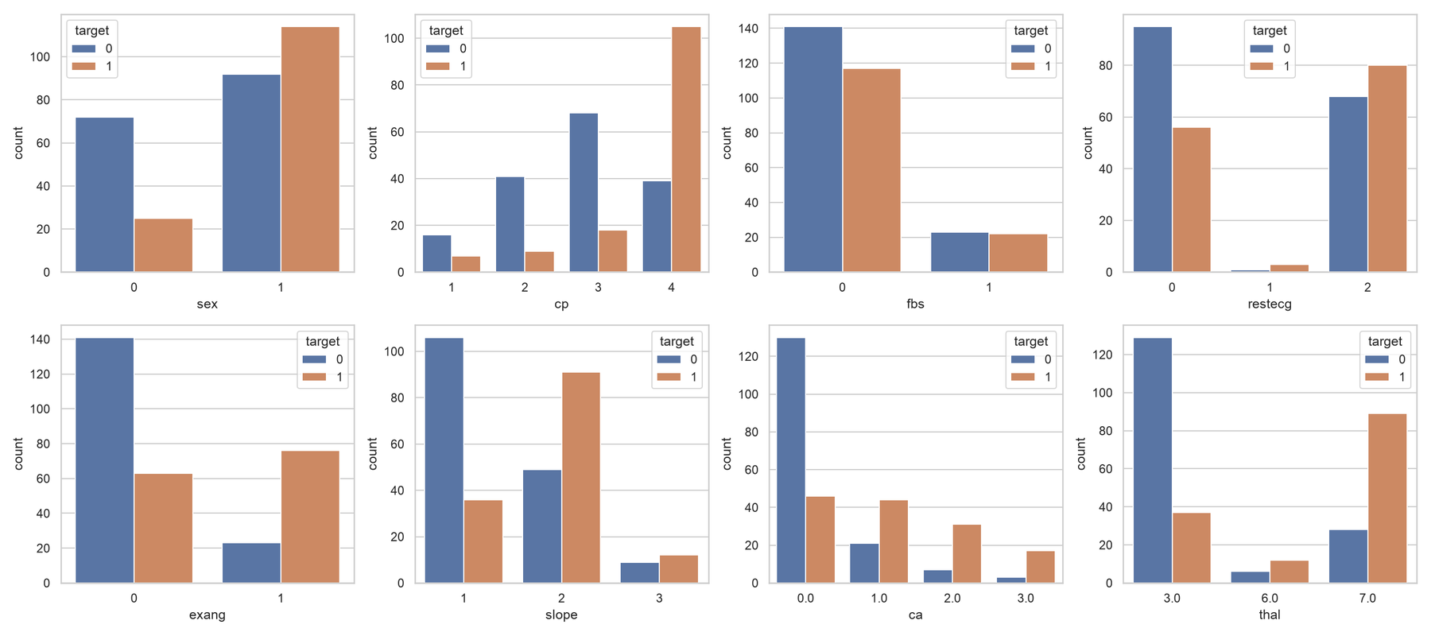
Figure 4: categorical features against the target

4. Feature engineering and model development
Preprocessing pipeline. A ColumnTransformer handles the two column types: numeric columns get median imputation followed by standard scaling; categorical columns get most-frequent imputation followed by one-hot encoding with handle_unknown="ignore", so an unseen category at inference cannot crash the API. The transformer and the estimator are fitted as one scikit-learn Pipeline, which means training, cross-validation and serving all apply exactly the same transformations.
Training protocol. The data is split 80/20 with stratification (242 training and 61 test patients, seed 42). Each model is tuned with GridSearchCV using 5-fold stratified cross-validation on the training split, refitting on the best ROC-AUC. The test split is touched only once, for the final report.
Model | Search space | Best parameters
Logistic Regression | C in {0.01, 0.1, 1, 10} (4 candidates) | C = 1
Random Forest | n_estimators {100, 300} x max_depth {None, 5, 10} x min_samples_leaf {1, 3} (12 candidates) | n_estimators = 100, max_depth = 5, min_samples_leaf = 3

Metric | Logistic Regression | Random Forest
CV accuracy | 0.847 | 0.806
CV precision | 0.877 | 0.811
CV recall | 0.783 | 0.764
CV ROC-AUC | 0.902 | 0.902
Test accuracy | 0.885 | 0.869
Test precision | 0.839 | 0.833
Test recall | 0.929 | 0.893
Test F1 | 0.881 | 0.862
Test ROC-AUC | 0.966 | 0.948
All values are those logged in MLflow (experiment heart-disease) and saved in models/.
Model selection. Logistic Regression was selected. Both models are statistically tied on cross-validated ROC-AUC (0.902 for both), but Logistic Regression is ahead on test ROC-AUC (0.966 vs 0.948) and on recall (0.929 vs 0.893), which is the metric that matters most when a false negative means a missed patient. It also gives well-behaved probabilities, which the API reports as its confidence, trains in milliseconds and is easy to explain. One caution: the test set has only 61 patients, so one prediction moves accuracy by about 1.6 points and the gap between the two models is within that noise. The choice is therefore justified by simplicity and recall rather than by a decisive accuracy margin.
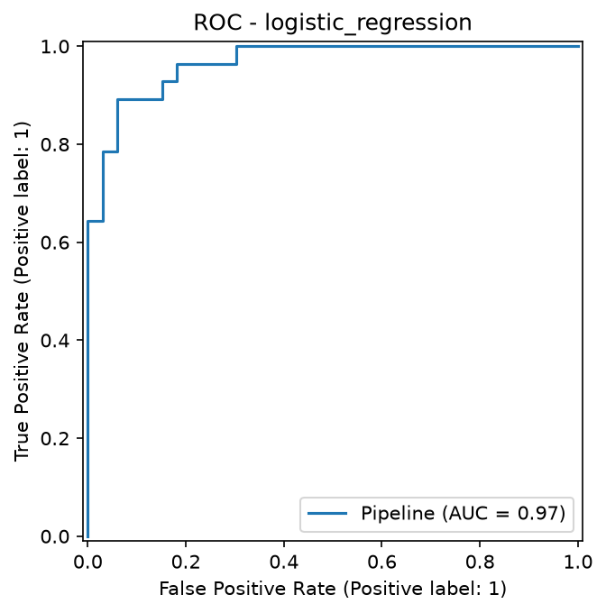  Figure 5: ROC curve, Logistic Regression | 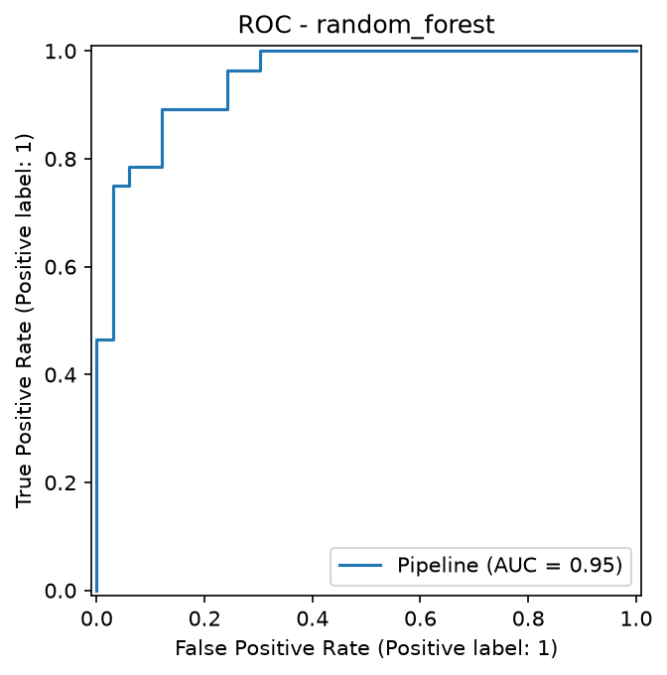  Figure 6: ROC curve, Random Forest

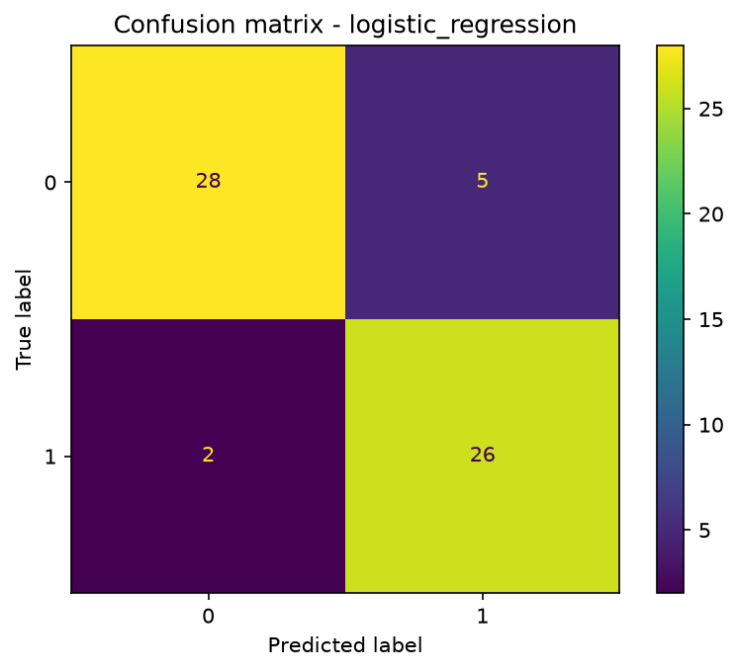  Figure 7: confusion matrix, Logistic Regression | 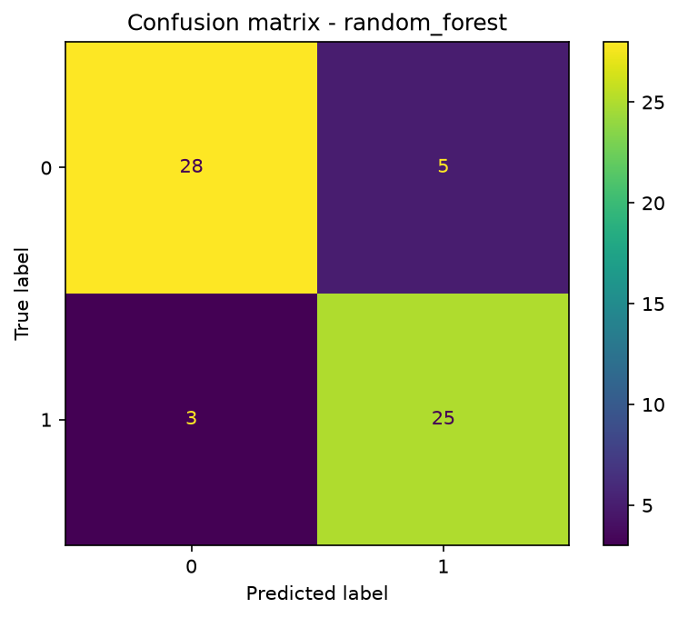  Figure 8: confusion matrix, Random Forest

5. Experiment tracking
Every training run is logged to MLflow (sqlite:///mlflow.db, experiment heart-disease), one run per model. A run records everything needed to compare or reproduce it:
Category | What is logged
Parameters | model name, CV folds, seed, test size, best hyperparameters
Metrics | cv_accuracy, cv_precision, cv_recall, cv_roc_auc and test_accuracy, test_precision, test_recall, test_f1, test_roc_auc
Artifacts | ROC curve and confusion matrix PNGs, the full grid-search results CSV, the cleaned dataset snapshot
Model | the complete fitted pipeline as an MLflow logged model, serialised with cloudpickle

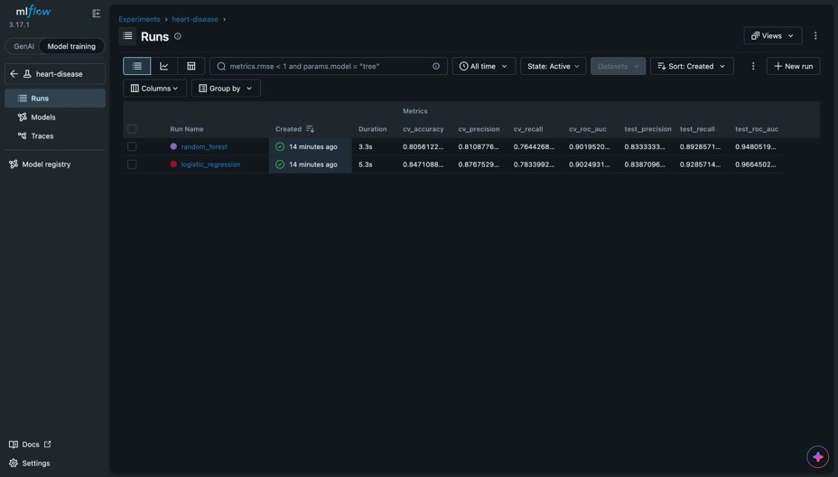
Figure 9: MLflow experiment page with both runs and their cross-validation and test metrics
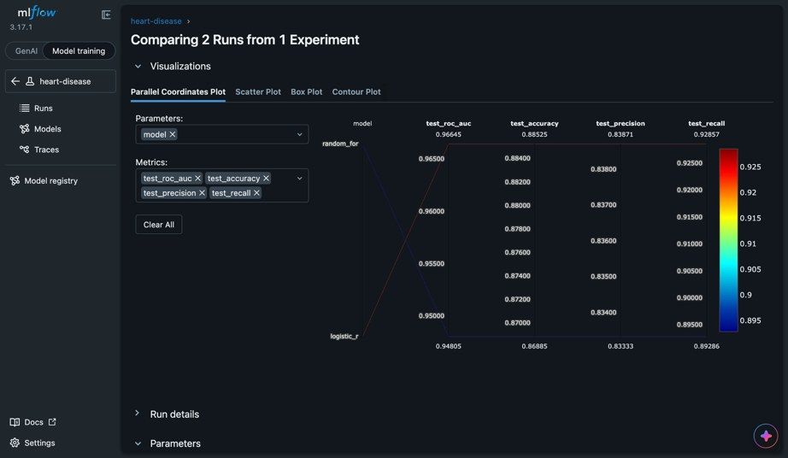
Figure 10: MLflow comparison of the two runs on the four test metrics (parallel coordinates)
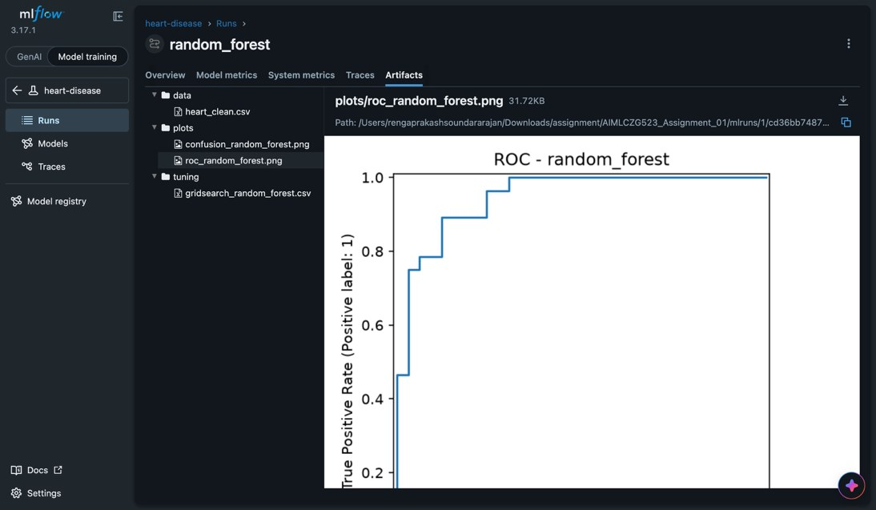
Figure 11: artifacts stored with the random_forest run: data snapshot, plots and tuning results
The CI pipeline also queries MLflow after training and writes a ranked model_comparison.csv, so the comparison is regenerated and archived on every run.

6. Model packaging and reproducibility
- One artifact. models/model.joblib holds the whole fitted pipeline (imputers, scaler, encoder and classifier), so serving needs no separate preprocessing code. models/metadata.json records the feature list, best parameters and test metrics next to it.
- Dependencies. requirements.txt covers development and CI; requirements-api.txt is a pinned, minimal runtime list for the container, which keeps the image small and the build deterministic.
- Seeded and checked. All randomness uses seed 42. The CI pipeline trains twice and fails if the two metadata.json files differ, and it re-creates the cleaned dataset from the UCI download and fails if it differs from the committed CSV.
- Environment record. CI saves pip freeze output as environment-lock.txt in the run artifacts.
- Across environments. Results are identical when training is repeated in one environment. A comparison file produced in a different environment matched exactly for Logistic Regression but moved Random Forest in the third decimal place (test ROC-AUC 0.947 against 0.948), so library versions matter for bit-for-bit results and the runtime image pins them.

7. CI/CD pipeline and automated testing
Unit tests. Twenty-two pytest tests run on synthetic data, so they need neither MLflow nor the real model: 4 for data loading (target binarisation, duplicate removal, schema), 3 for the preprocessor (no missing values, scaling, unseen categories), 4 for the model (valid probabilities, missing inputs at inference, save and load round trip, beats chance), 6 for the API (health, prediction and confidence, optional fields, range validation, missing fields, metrics endpoint) and 5 more for the download script and the training entry point. pytest-cov reports 98% line coverage of src/ (193 statements, 4 missed), and the coverage report is passed to SonarQube. Code style is checked with flake8.
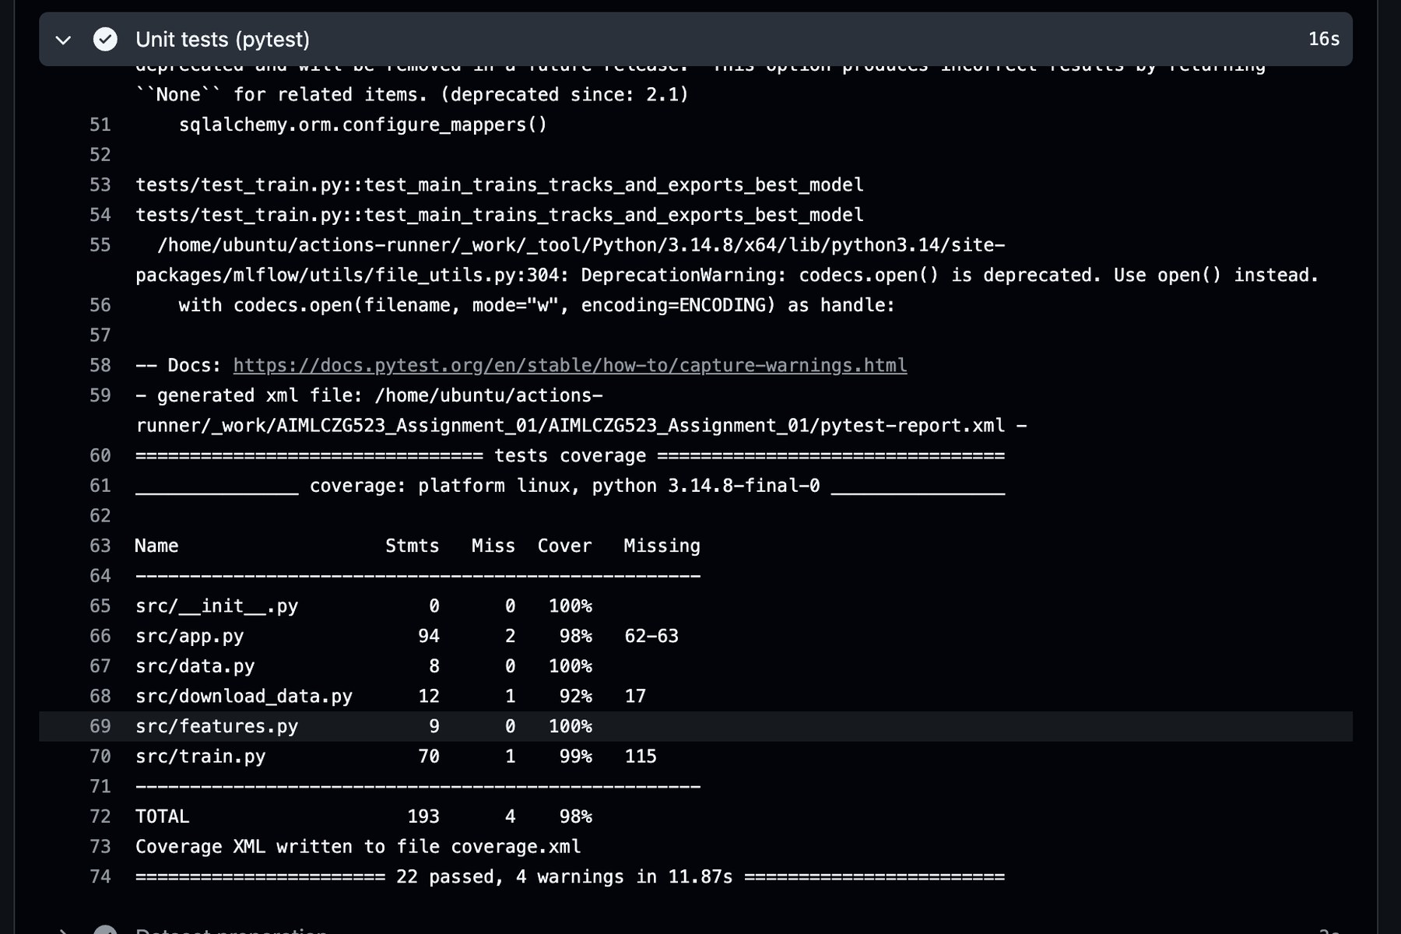
Figure 12: pytest summary and coverage table from the CI run (22 passed)
Pipeline. One orchestrator workflow (pipeline.yml) calls five reusable workflows in order. Pull requests run only stage 1; stages 2 to 5 run on pushes to main or on manual dispatch.
Stage | Runner | What it does | Fails when
1 ML pipeline | GitHub-hosted | flake8, pytest with coverage, dataset re-creation, EDA notebook run, training with MLflow, model comparison, reproducibility check | a lint or test error, a notebook error, data or results that differ between runs
2 Quality and security | self-hosted VM | SonarQube scan and quality gate; Checkov on the Dockerfile and Kubernetes manifests | the quality gate or a Checkov policy fails
3 Build | self-hosted VM | Docker build, Trivy scan for HIGH and CRITICAL vulnerabilities, push to ECR tagged with the commit SHA | the image has fixable high-severity vulnerabilities
4 Deploy | self-hosted VM | manual approval, kubectl apply, rollout wait, health smoke test, automatic rollback | approval is rejected, the rollout times out or the smoke test fails
5 ZAP | self-hosted VM | OWASP ZAP API scan from the OpenAPI definition plus a passive baseline scan | a high-risk alert is found

Every stage uploads its evidence as a run artifact (test reports, models, figures, MLflow database, Trivy and ZAP reports). Each later stage depends on the one before it, so a failure anywhere stops the pipeline and the log shows where. Deployment is behind a GitHub environment with a required reviewer, so nothing reaches the cluster without an explicit approval.
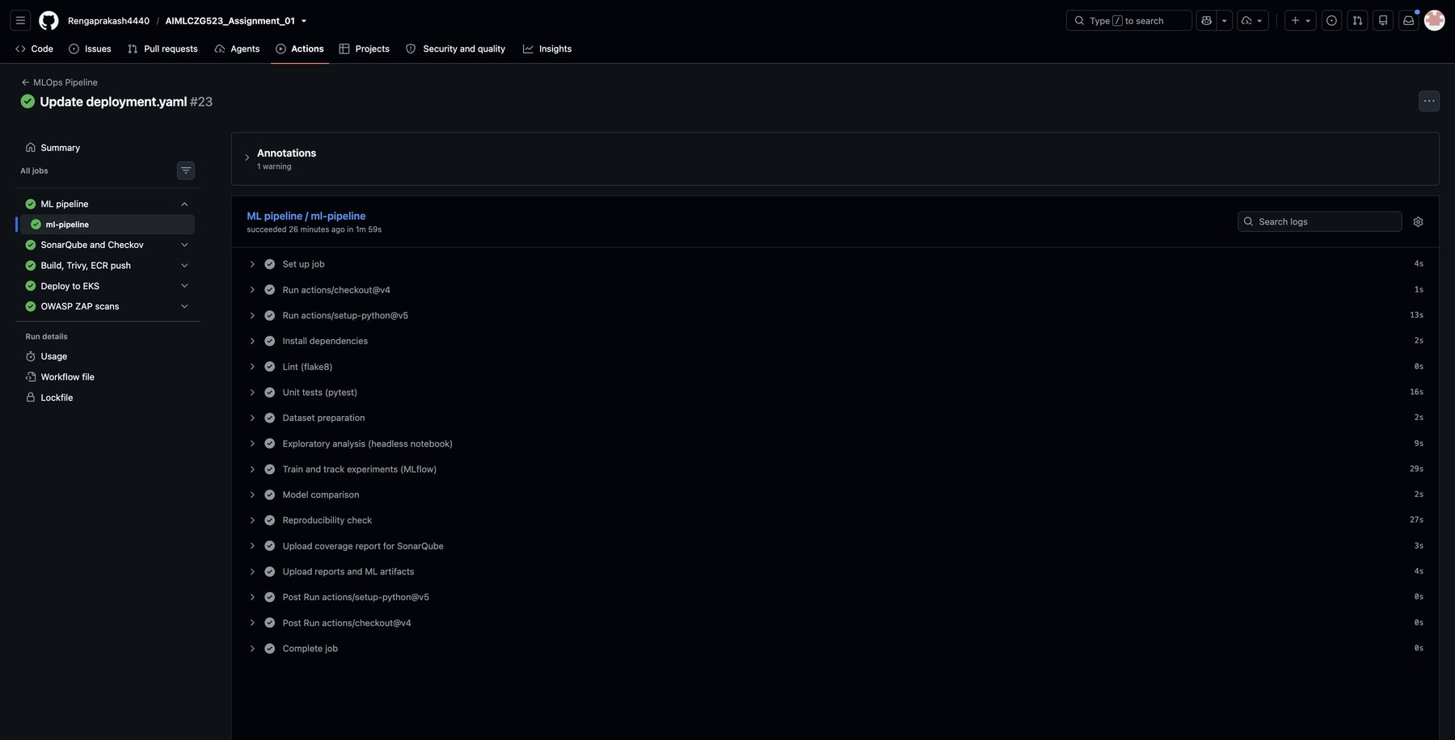
Figure 13: a pipeline run: the five stages as jobs, with the steps of the ML pipeline job
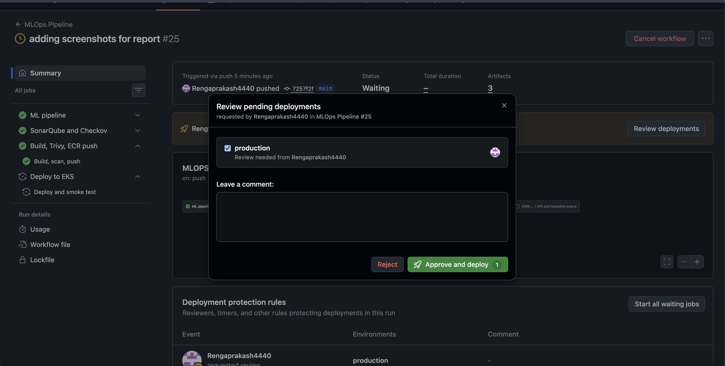
Figure 14: manual approval gate: reviewers approve the production environment before deployment
Security scan results. The scan evidence is in Appendix A. SonarQube reports the quality gate as Passed, with 0 new issues, 0 security hotspots and 0.0% duplication on the new code. Checkov evaluated the Dockerfile and the Kubernetes manifests, and Trivy scanned the built image before the push. The OWASP ZAP report for the deployed endpoint lists 0 high, 0 medium, 2 low and 2 informational alerts.

8. Model containerisation and API
The API is a FastAPI application (src/app.py) that loads the pipeline once at start-up. The image (dockerfiles/Dockerfile) uses a slim Python base, installs only the pinned runtime requirements, copies the code and the model, runs as a non-root user and declares a health check against /health. The build is part of the pipeline (Appendix A).
Endpoint | Purpose
POST /predict | accepts the 13 patient fields as JSON, validates ranges with Pydantic (out-of-range input returns 422) and returns prediction, label, confidence and probability_disease
GET /health | liveness and readiness check used by Docker and Kubernetes
GET /metrics | Prometheus metrics
GET /docs | interactive Swagger UI generated from the schema

Example request and response against the deployed service:
curl -X POST http://a2fd3c035818e4cee912d8bb8f47f7d8-1536463618.ap-south-1.elb.amazonaws.com/predict \
-H "Content-Type: application/json" \
-d '{"age":67,"sex":1,"cp":4,"trestbps":160,"chol":286,"fbs":0,"restecg":2,
"thalach":108,"exang":1,"oldpeak":1.5,"slope":2,"ca":3,"thal":3}'

{"prediction":1,"label":"heart disease","confidence":0.9856,"probability_disease":0.9856}
confidence is the probability of the predicted class, and ca and thal may be omitted because the pipeline imputes them.

9. Production deployment on Amazon EKS
The image is pushed to a private Amazon ECR repository (heart-api, region ap-south-1) and deployed to an EKS cluster (heart-mlops) with a managed node group. The manifests in kubernetes/ define:
- Namespace heartbeat-api, which isolates the application.
- Deployment with several replicas (five were running when the evidence was captured), readiness and liveness probes on /health, CPU and memory requests and limits, and a hardened security context: non-root user, read-only root filesystem, no privilege escalation, all Linux capabilities dropped and no service account token mounted. Prometheus scrape annotations are included.
- Service of type LoadBalancer, which exposes the API through an AWS load balancer.
- NetworkPolicy restricting pod traffic.
The pipeline replaces the image reference with the freshly built, commit-tagged image at deploy time, waits for the rollout to complete, calls /health through the load balancer and rolls back automatically if anything fails. A first attempt to create the node group failed because the account only allowed certain instance types; switching to c7i-flex.large solved it. The cluster bills by the hour, so it is deleted once the screenshots and the video are captured, which is why the API URL on the title page is temporary.
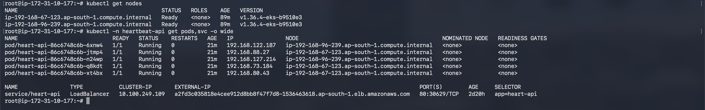
Figure 15: worker nodes Ready, five heart-api pods Running and the LoadBalancer service
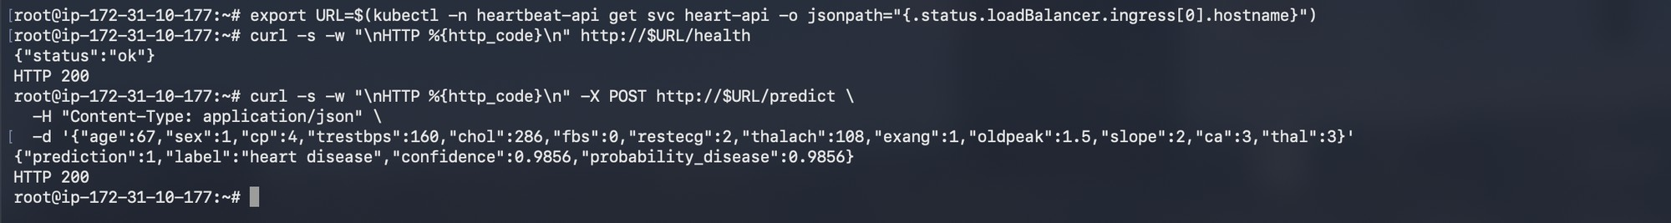
Figure 16: public endpoint test through the load balancer: /health and /predict both return HTTP 200
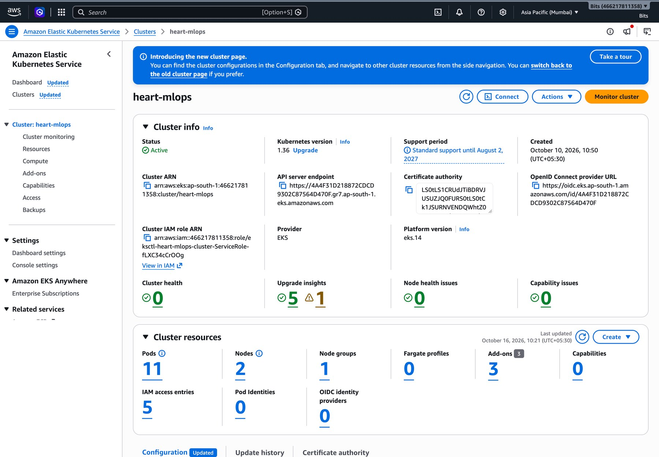
Figure 17: the heart-mlops EKS cluster Active in the AWS console (Mumbai region)

10. Monitoring and logging
Logging. A middleware logs every request (method, path, status and latency in milliseconds) and every prediction (class and confidence). The logs are read with kubectl logs or docker logs.
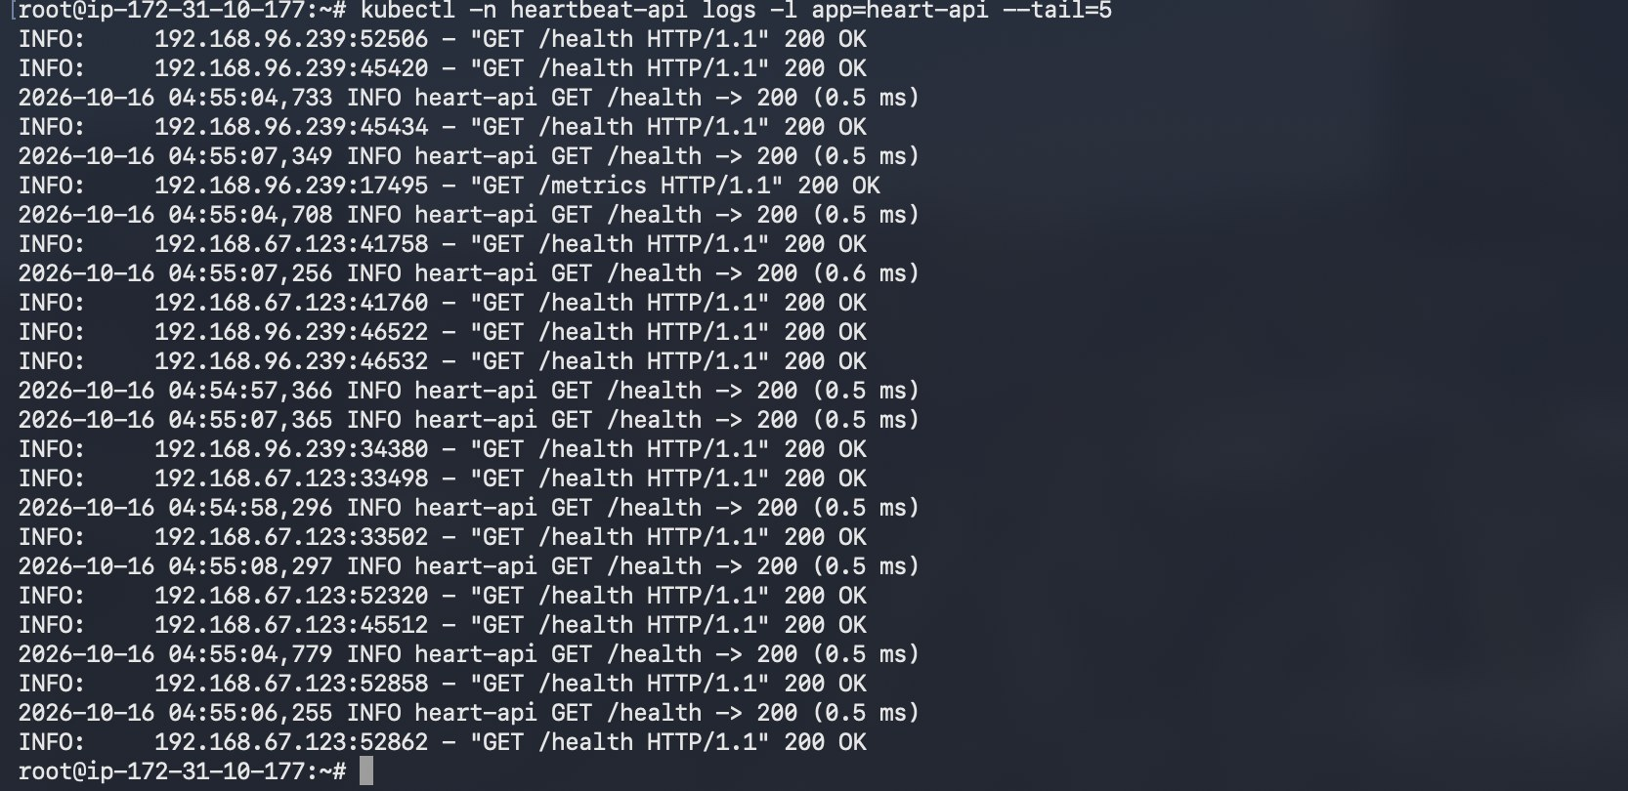
Figure 18: API request logs from the running pods (kubectl logs)
Metrics. The API exposes Prometheus metrics for traffic (api_requests_total by method, endpoint and status, api_request_latency_seconds as a histogram, and predictions_total by class) and for model behaviour: the hold-out test metrics, the distribution of predicted probabilities, mean confidence, inference latency, the share of positive predictions and the running mean of key input features as a simple drift check. Prometheus and Grafana run on a separate VM, so monitoring survives a cluster rebuild and does not compete with the API for node resources; Prometheus scrapes the load balancer URL every 15 seconds. Helm values for an in-cluster installation are also kept in monitoring/.
Grafana panel | Query
Request rate by endpoint | sum(rate(api_requests_total[1m])) by (endpoint)
p95 latency | histogram_quantile(0.95, sum(rate(api_request_latency_seconds_bucket[5m])) by (le))
Error rate (4xx and 5xx) | sum(rate(api_requests_total{status=~"4..|5.."}[1m]))
Predictions by class | sum(predictions_total) by (label)

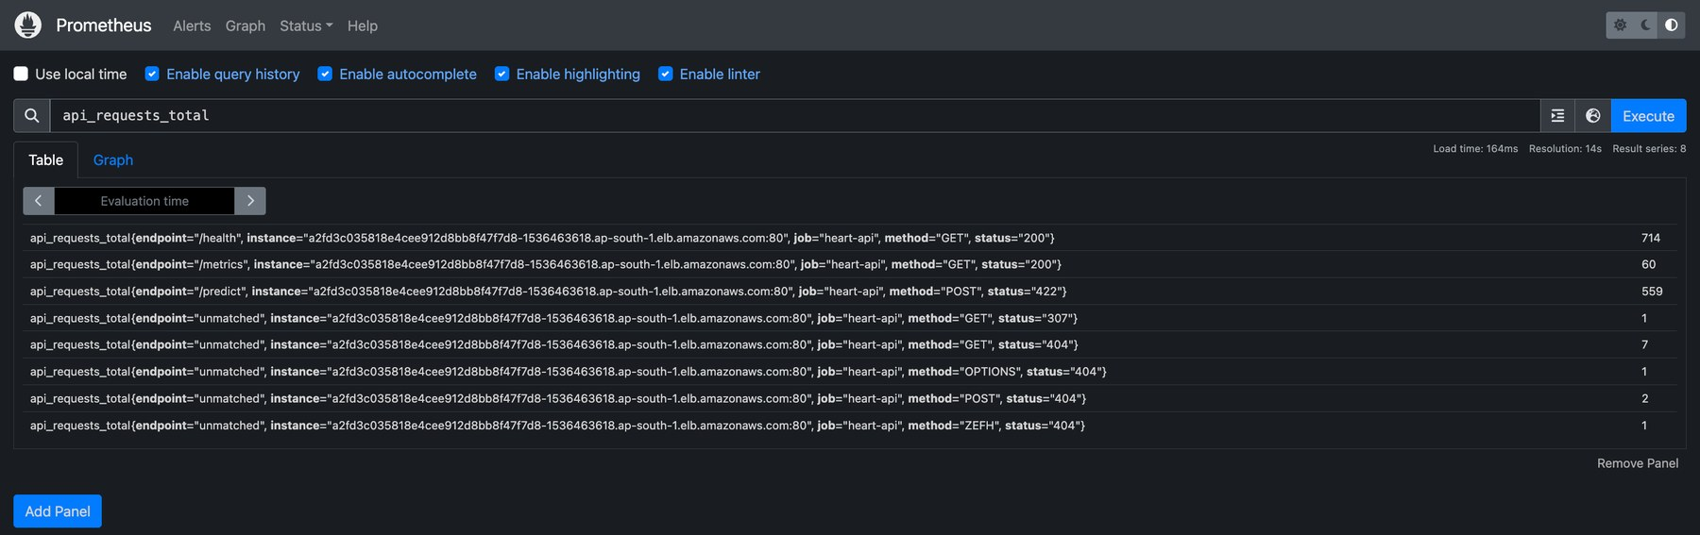
Figure 19: Prometheus query api_requests_total returning the API counters
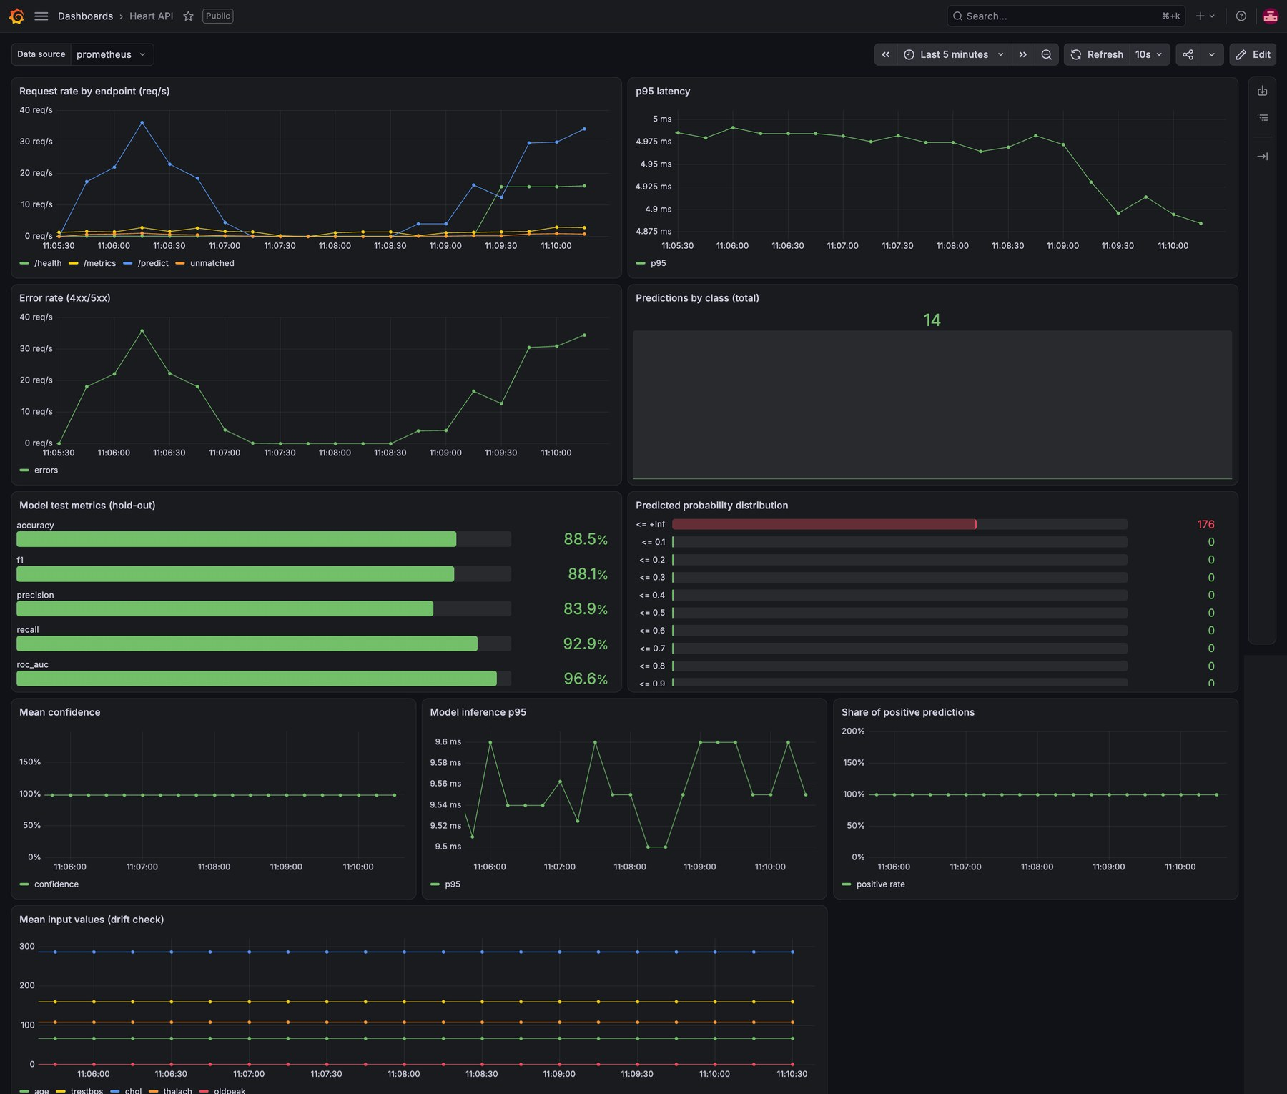
Figure 20: Grafana "Heart API" dashboard: traffic, latency, errors, predictions, model quality and input drift
Limitation. Prometheus reaches the pods through the load balancer, so with more than one replica each scrape lands on a random pod and the per-pod counters interleave. In-cluster scraping would remove this.

11. Architecture
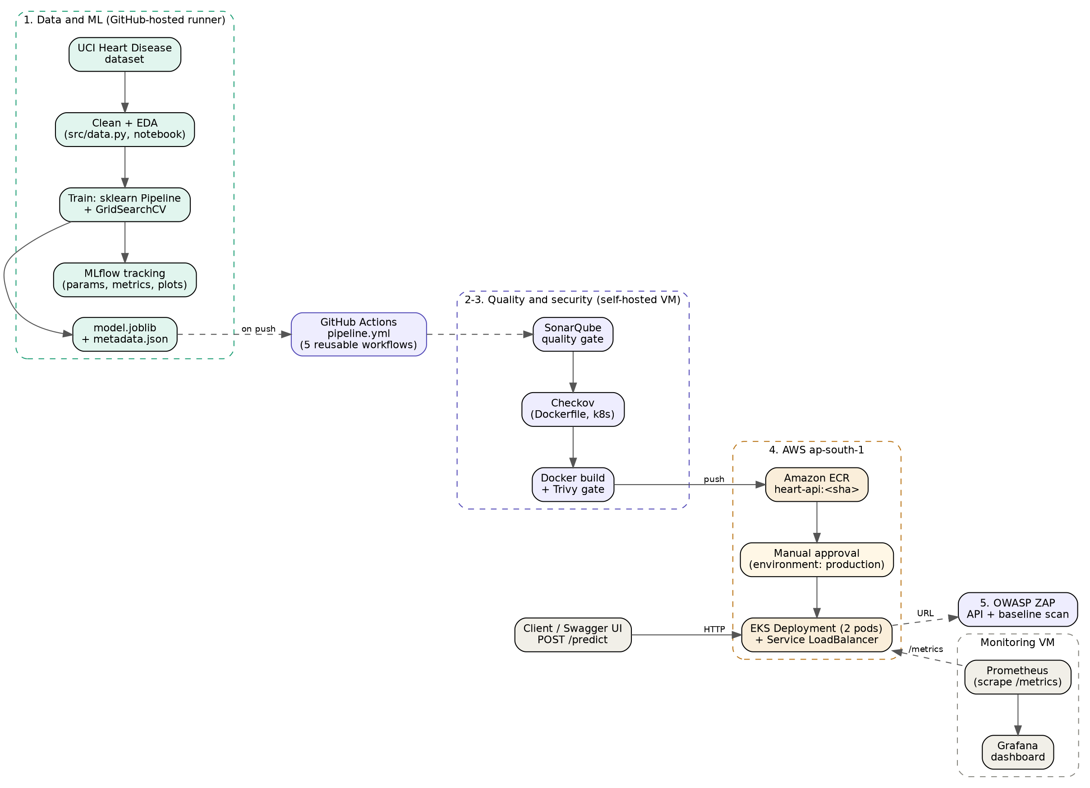
Figure 21: end-to-end architecture, from dataset to monitored API
Code pushed to GitHub triggers the orchestrator. The ML stage produces the model; the quality stage checks the code and infrastructure files; the build stage produces a scanned image and pushes it to ECR; after approval the deploy stage rolls it out to EKS; ZAP scans the live endpoint; and Prometheus and Grafana observe the running service.

12. Challenges and lessons learned
- MLflow model format. Logging the pipeline with the default format failed because the safer skops serialiser rejected a NumPy dtype inside the pipeline. Using the cloudpickle format fixed it.
- Instance types. The EKS node group failed with a generic error until the real cause (the account only allowed some instance types) was found in the Auto Scaling activity and node group health.
- Reusable workflows. GitHub requires called workflows to sit directly in .github/workflows/; placing them in a subfolder is rejected, and every uses: path must match exactly.
- Load balancer DNS. A new ELB hostname took a few minutes to resolve, which looked like a failed deployment until the load balancer state was checked.

13. Limitations, future work and conclusion
Limitations. The dataset is small (303 patients), so test metrics carry wide uncertainty and the model is not a clinical tool. The API has no authentication or rate limiting and is served over plain HTTP; adding an ACM certificate to the load balancer and an API key are the obvious next steps. Drift monitoring is basic: the dashboard tracks the mean of key inputs, but there is no statistical drift test or alerting. The model is baked into the image rather than pulled from a registry, and the cluster is small.
Conclusion. The project delivers every item in the brief: a reproducible and tracked training workflow, a tested and scanned pipeline that fails on errors, a container that serves the model in isolation, a Kubernetes deployment exposed through a load balancer, and a monitoring setup that shows the live service. The same structure would carry a larger model unchanged; only the training step and the data would be replaced.
Links. Repository, deployed API and video are listed on the title page.

Appendix A. Pipeline and security evidence
Supporting screenshots from the CI/CD pipeline, referenced from sections 7 and 8.
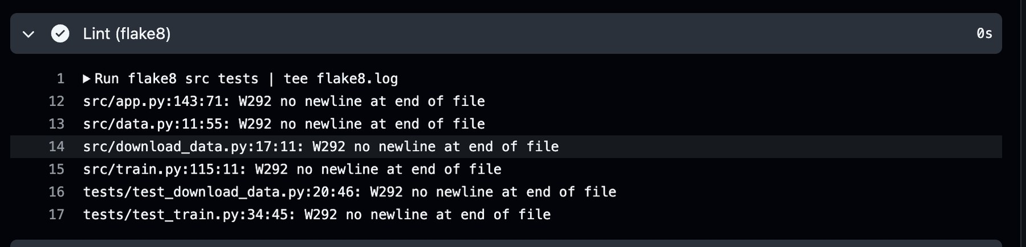
Figure 22: flake8 step of the ML pipeline job
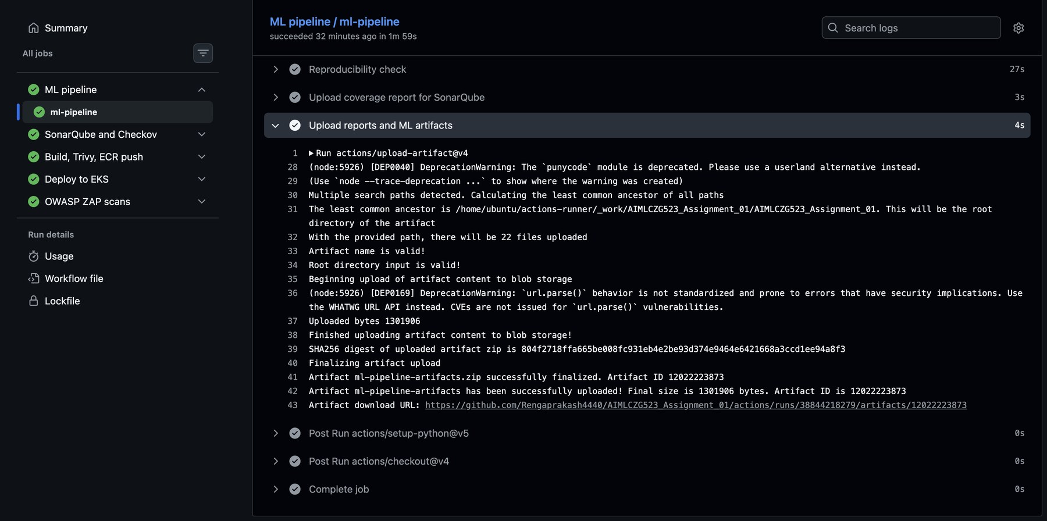
Figure 23: artifact upload step: the ML pipeline stores its outputs with each run
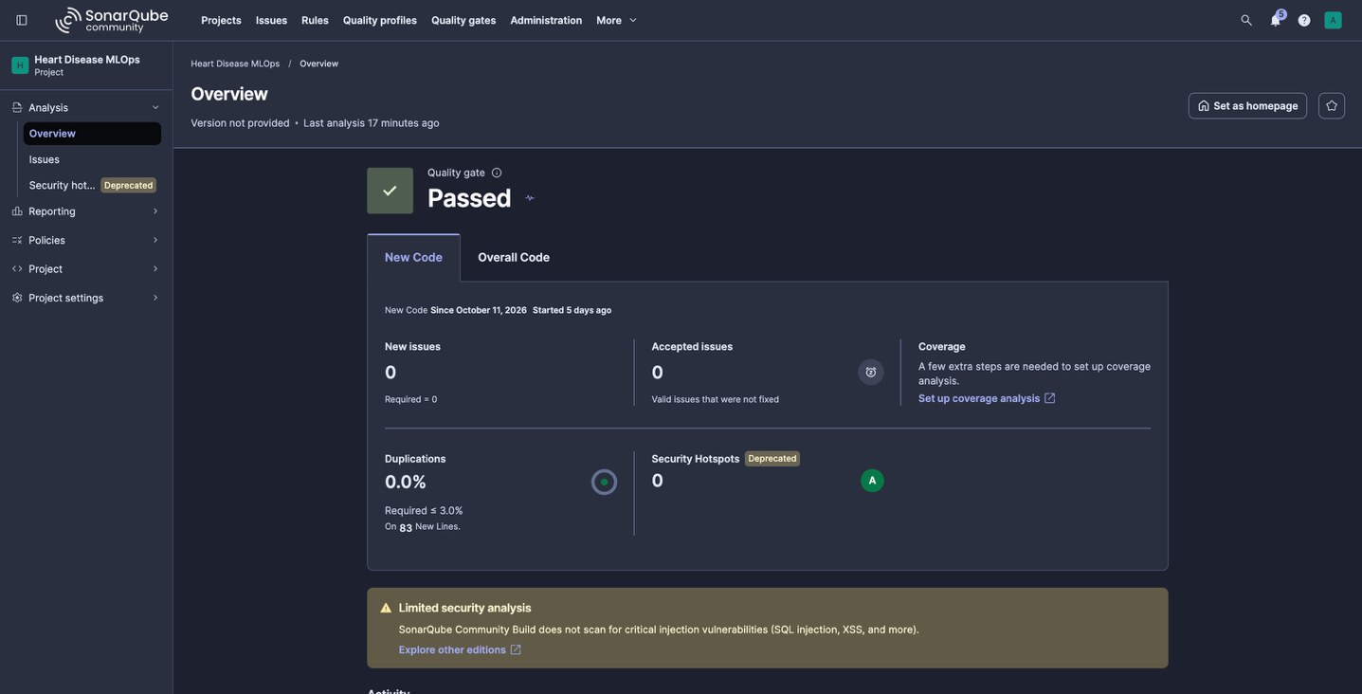
Figure 24: SonarQube project overview: quality gate Passed
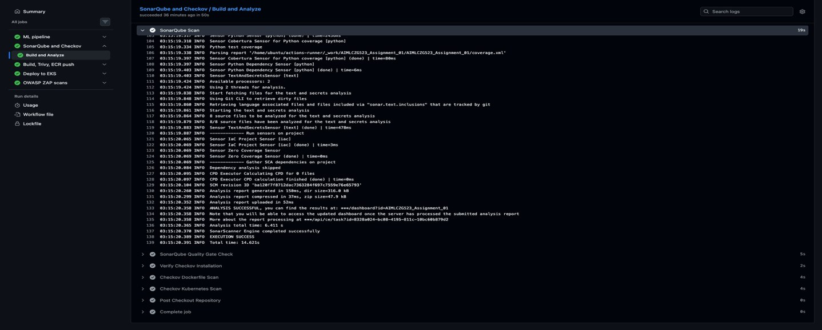
Figure 25: SonarQube analysis step in the pipeline log
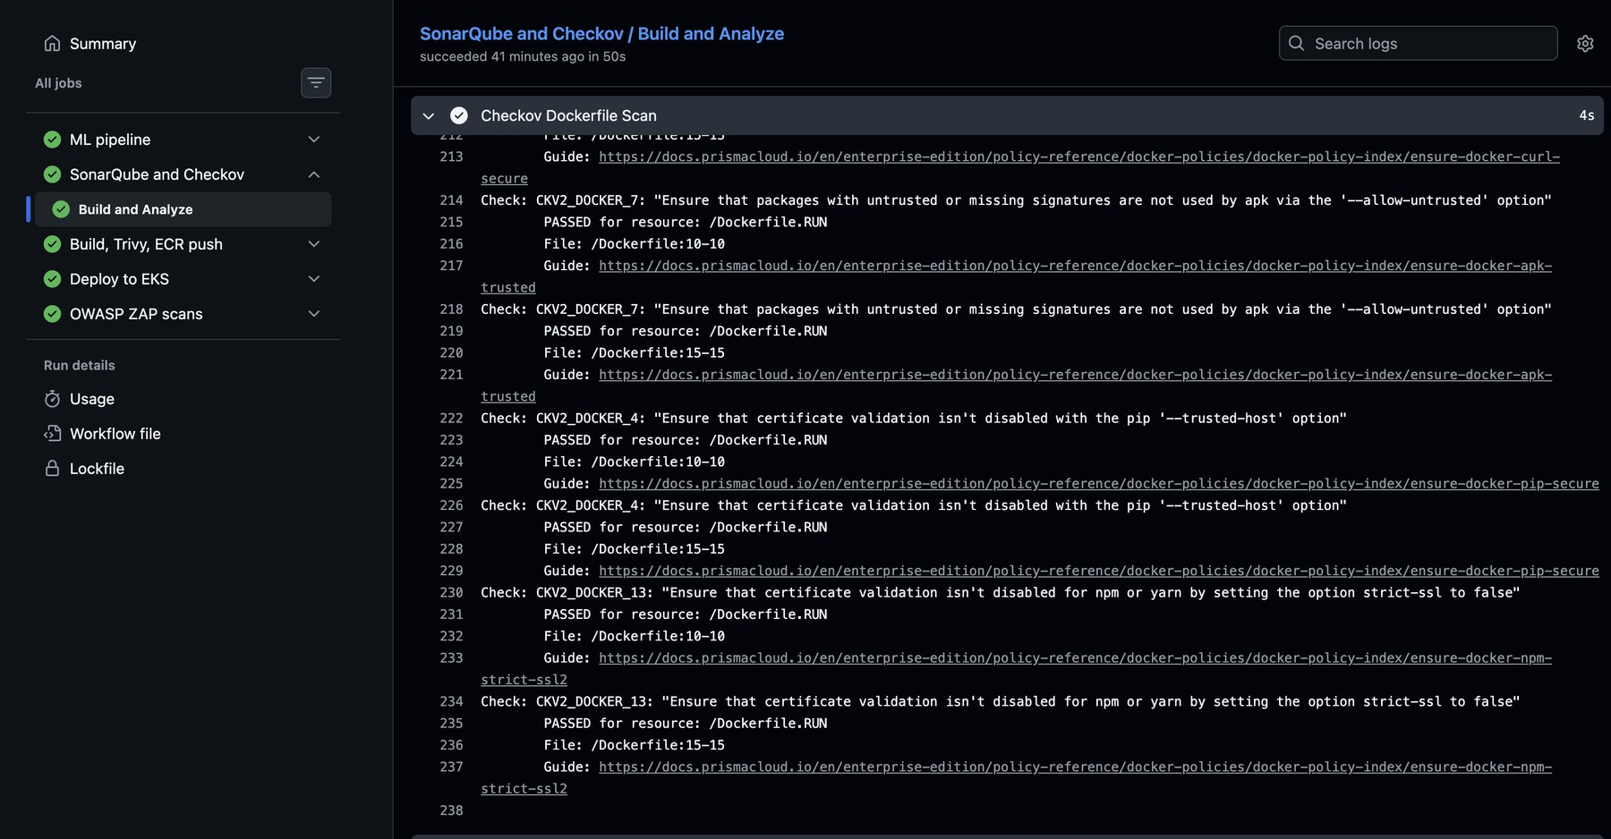
Figure 26: Checkov scan of the Dockerfile
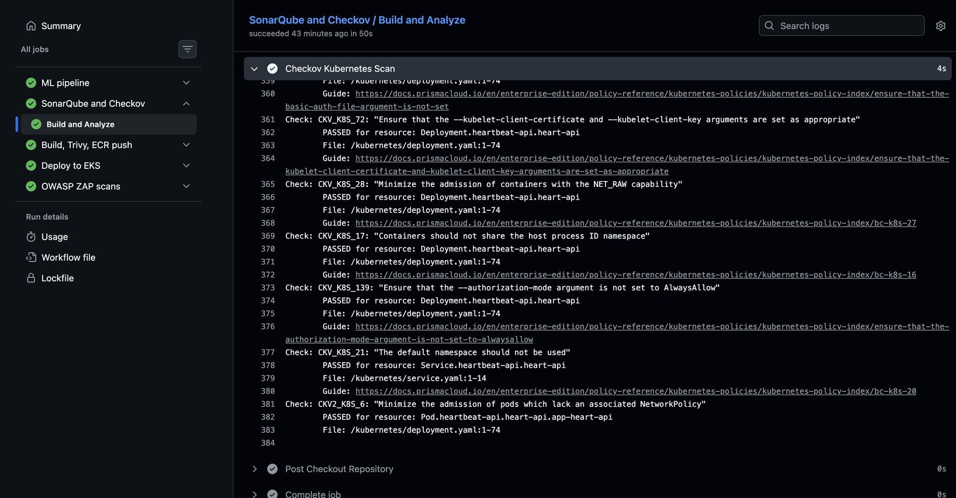
Figure 27: Checkov scan of the Kubernetes manifests
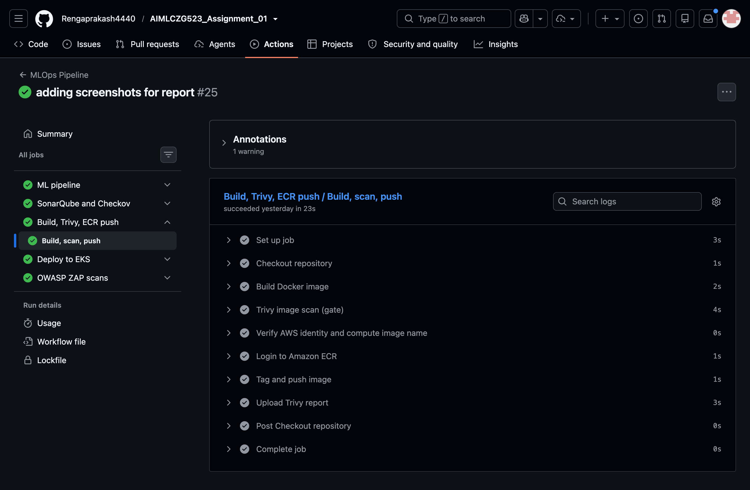
Figure 28: Build, Trivy, ECR push
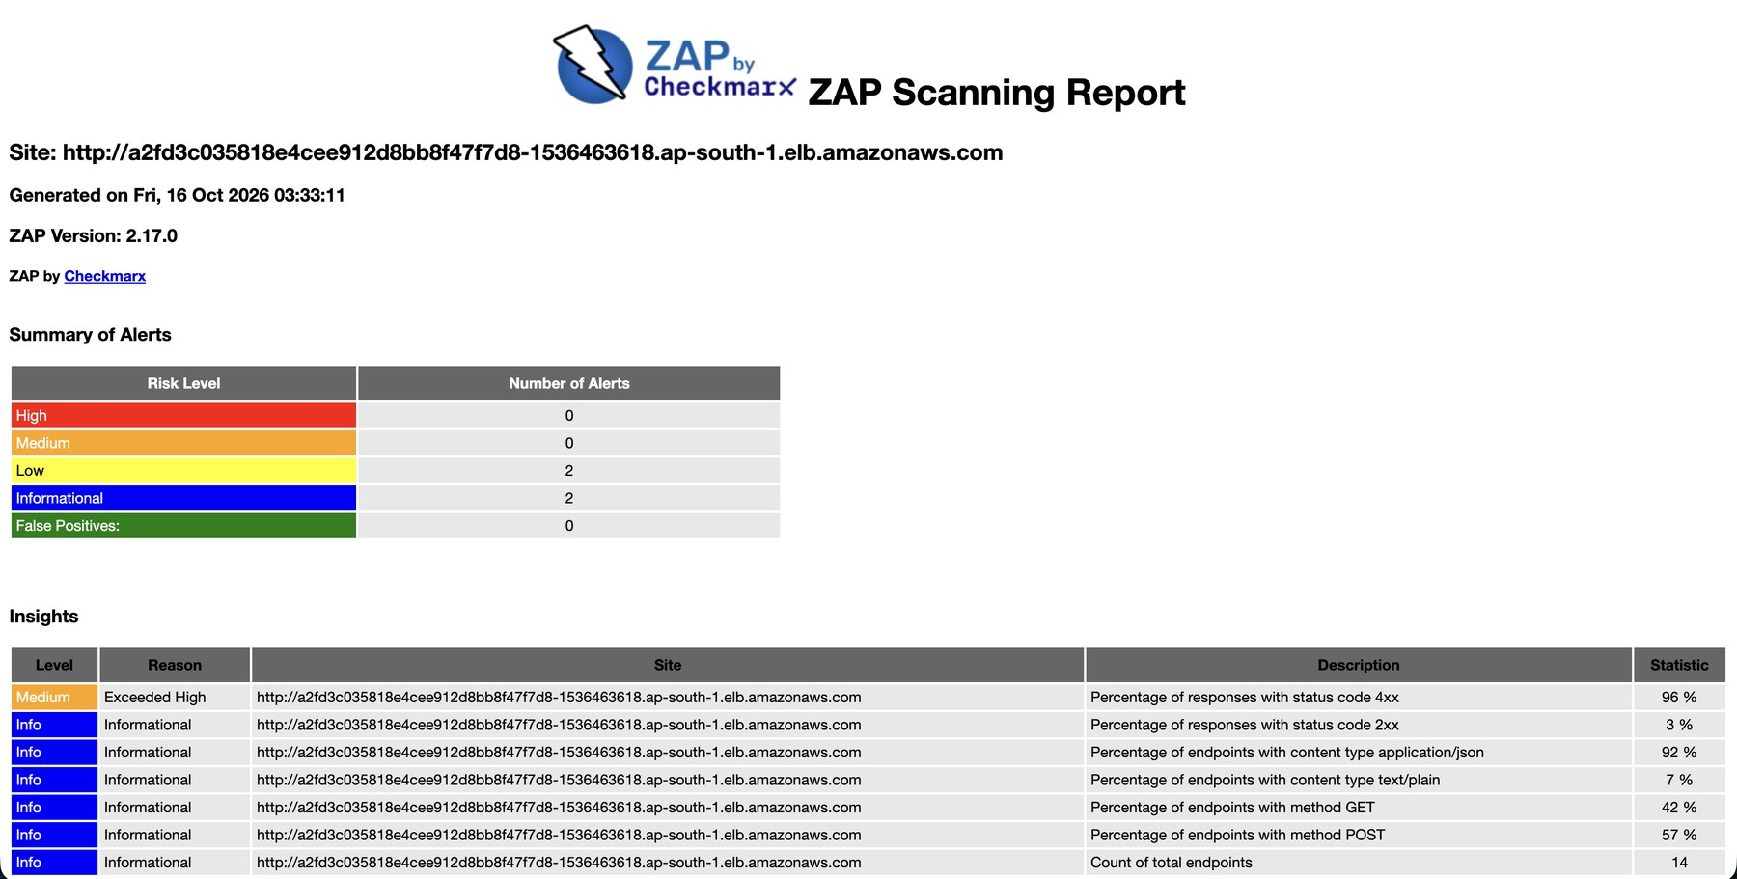
Figure 29: OWASP ZAP scanning report for the deployed endpoint (0 high, 0 medium, 2 low, 2 informational)
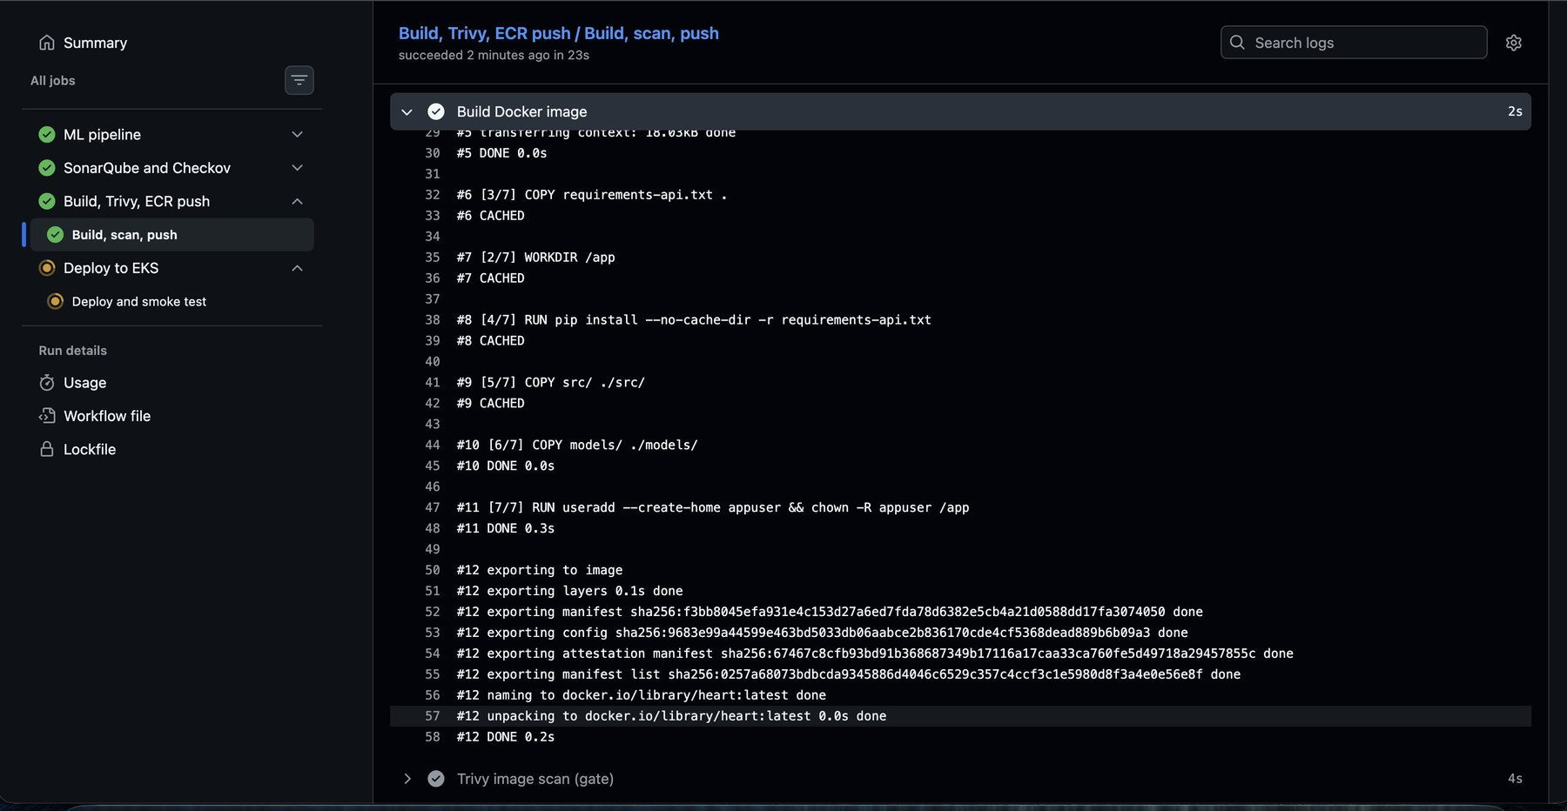
Figure 30: Docker image build step in the pipeline (build, scan, push job)
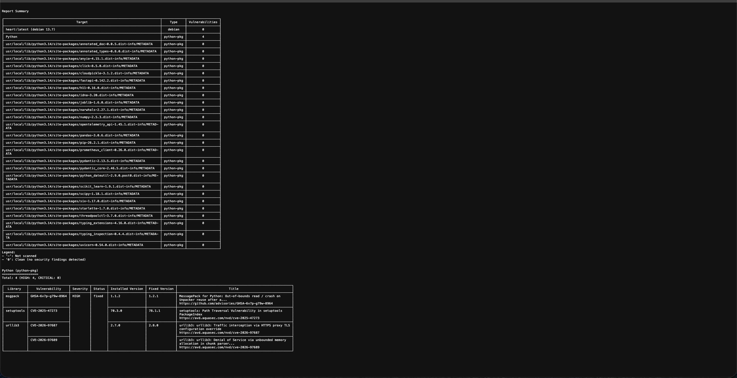
Figure 31: Trivy report

