Moldova State University

Faculty of Mathematics and Informatics

Department of Informatics

**Operations on graphs**

Laboratory Report II

Author Ciobanu Stanislav

Group I2302

Date 23.10.23

Table of contents

**Project code**

**Task 0**

1. **Picture**
2. **Results**

**Task 2**

1. **results**

**Task 3**

1. **results**

**Task 4**

1. **results**

**Task 5**

1. **results**

**Task 6**

1. **results**

**Task 7**

1. **results**

**Task 8**

1. **results**

**Task 9**

1. **results**

**Task 10**

1. **results**

**Project Code**

#include <iostream>

#include <fstream>

#include <string>

using namespace std;

class Vertex;

class Edge

{

private:

Vertex* _vertex1;

Vertex* _vertex2;

int _weight;

public:

Edge(Vertex* v1, Vertex* v2, int weight)

{

_weight = weight;

_vertex1 = v1;

_vertex2 = v2;

}

int GetWeight()

{

return _weight;

}

Vertex* GetVertex1()

{

return _vertex1;

}

Vertex* GetVertex2()

{

return _vertex2;

}

};

class Vertex

{

private:

Edge** _edges;

unsigned int _size;

int _ID;

public:

Vertex(unsigned int size, unsigned int ID)

{

_edges = new Edge * ();

_size = size;

_edges = (Edge**)calloc(_size, sizeof(Edge*));

for (int i = 0; i < _size; i++)

{

_edges[i] = (Edge*)malloc(sizeof(Edge));

_edges[i] = NULL;

}

_ID = ID;

}

void EnlargeEdgeList()

{

_size++;

Edge* edge = (Edge*)malloc(sizeof(Edge));

_edges = (Edge**)realloc(_edges, sizeof(Edge*) * _size);

_edges[_size - 1] = edge;

}

void ShortenEdgeList(int ID)

{

_size--;

for (int i = ID; i < _size; i++)

{

_edges[i] = _edges[i + 1];

}

Edge** tempEdges = (Edge**)calloc(_size, sizeof(Edge*));

for (int i = 0; i < _size; i++)

{

tempEdges[i] = _edges[i];

}

_edges = tempEdges;

}

unsigned int GetID() {

return _ID;

}

void ChangeID(int delta)

{

_ID += delta;

}

Edge* GetEdge(int ID)

{

return _edges[ID];

}

void SetEdge(Edge* edge, unsigned int ID)

{

_edges[ID] = edge;

}

Edge** GetEdgeArray()

{

return _edges;

}

};

class Graph

{

private:

Vertex** _verts;

unsigned int _size;

Edge** _allEdges;

unsigned int _edgesArraySize;

public:

Graph(int size)

{

_verts = new Vertex * ();

_size = size;

_verts = (Vertex**)calloc(_size, sizeof(Vertex*));

for (int i = 0; i < _size; i++)

{

_verts[i] = new Vertex(_size, i);

}

_allEdges = (Edge**)malloc(sizeof(Edge*));

_edgesArraySize = 0;

}

int GetSize() {

return _size;

}

Vertex** GetVertexArray()

{

return _verts;

}

Edge** GetEdgeArray()

{

return _allEdges;

}

int GetEdgeArraySize()

{

return _edgesArraySize;

}

void CreateEdge(unsigned ID1, unsigned ID2, unsigned int weight)

{

Edge* edge = new Edge(_verts[ID1], _verts[ID2], weight);

_verts[ID1]->SetEdge(edge, ID2);

_verts[ID2]->SetEdge(edge, ID1);

AddToEdgeList(edge);

}

void AddToEdgeList(Edge* edge)

{

if (_allEdges[0] == NULL)

{

_allEdges[0] = edge;

}

else

{

_edgesArraySize++;

Edge** tempEdges = (Edge**)calloc(_edgesArraySize, sizeof(Edge*));

for (int i = 0; i < _edgesArraySize; i++)

{

tempEdges[i] = _allEdges[i];

}

tempEdges[_edgesArraySize - 1] = edge;

_allEdges = tempEdges;

}

}

void RemoveFromEdgeList(unsigned int ID1, unsigned int ID2)

{

for (int i = 0; i < _edgesArraySize; i++)

{

if (((_allEdges[i]->GetVertex1()->GetID() == ID1) or (_allEdges[i]->GetVertex1()->GetID() == ID2))

and ((_allEdges[i]->GetVertex2()->GetID() == ID1) or (_allEdges[i]->GetVertex2()->GetID() == ID2)))

{

for (int j = i; j < _edgesArraySize - 1; j++)

{

_allEdges[j] = _allEdges[j + 1];

}

_edgesArraySize--;

Edge** tempEdges = (Edge**)calloc(_edgesArraySize, sizeof(Edge*));

for (int j = 0; j < _edgesArraySize; j++)

{

tempEdges[j] = _allEdges[j];

}

_allEdges = tempEdges;

break;

}

}

}

void AddVertex()

{

for (int i = 0; i < _size; i++)

{

_verts[i]->EnlargeEdgeList();

}

_size++;

Vertex* vert = new Vertex(_size, _size - 1);

Vertex** tempVerts = (Vertex**)calloc(_size, sizeof(Vertex*));

for (int i = 0; i < _size; i++)

{

tempVerts[i] = _verts[i];

}

tempVerts[_size - 1] = vert;

_verts = tempVerts;

}

void DeleteEdge(int ID1, int ID2)

{

for (int i = 0; i < _edgesArraySize; i++)

{

if ((_allEdges[i]->GetVertex1()->GetID() == ID1) and (_allEdges[i]->GetVertex2()->GetID() == ID2))

{

_allEdges[i]->GetVertex1()->SetEdge(NULL, ID2);

_allEdges[i]->GetVertex2()->SetEdge(NULL, ID1);

RemoveFromEdgeList(ID1, ID2);

}

else if (((_allEdges[i]->GetVertex2()->GetID() == ID1) and (_allEdges[i]->GetVertex1()->GetID() == ID2)))

{

_allEdges[i]->GetVertex1()->SetEdge(NULL, ID1);

_allEdges[i]->GetVertex2()->SetEdge(NULL, ID2);

RemoveFromEdgeList(ID1, ID2);

}

}

}

void DeleteVertex(int ID)

{

for (int i = 0; i < _edgesArraySize; i++)

{

int a = _allEdges[i]->GetVertex1()->GetID();

int b = _allEdges[i]->GetVertex2()->GetID();

if (a == ID)

{

RemoveFromEdgeList(a, b);

i--;

}

else if (b == ID)

{

RemoveFromEdgeList(b, a);

i--;

}

}

for (int i = 0; i < ID; i++)

{

_verts[i]->ShortenEdgeList(ID);

}

_size--;

for (int i = ID; i < _size; i++)

{

_verts[i] = _verts[i + 1];

_verts[i]->ShortenEdgeList(ID);

_verts[i]->ChangeID(-1);

}

Vertex** tempVerts = (Vertex**)calloc(_size, sizeof(Vertex*));

for (int i = 0; i < _size; i++)

{

tempVerts[i] = _verts[i];

}

_verts = tempVerts;

}

void PrintAdjacenceMatrix()

{

std::cout << "\n\n\t[ ADJACENCE MATRIX ]\n";

printf("\n");

for (int i = 0; i < _size; i++)

{

Vertex vert = *_verts[i];

for (int j = 0; j < _size; j++)

{

if (vert.GetEdge(j) != NULL) {

std::cout << "\t" << 1 << "\t ";

}

else {

std::cout << "\t" << 0 << "\t ";

}

}

printf("\n\n");

}

}

void PrintWeightMatrix()

{

std::cout << "\n\t[ WEIGHT MATRIX ]\n";

printf("\n");

for (int i = 0; i < _size; i++)

{

Vertex vert = *_verts[i];

for (int j = 0; j < _size; j++)

{

if (vert.GetEdge(j) != NULL) {

std::cout << "\t" << vert.GetEdge(j)->GetWeight() << "\t ";

}

else {

std::cout << "\t" << 0 << "\t ";

}

}

printf("\n\n");

}

}

void PrintEdgesList()

{

std::cout << "\n\t[ ALL EDGES ]\n";

for (int i = 0; i < _edgesArraySize; i++)

{

if (_allEdges[i] != NULL)

{

std::cout << "\n\t[ \t" << _allEdges[i]->GetVertex1()->GetID()

<< "\t,\t" << _allEdges[i]->GetVertex2()->GetID() << "\t]\n";

}

}

std::cout << "\n";

}

void PrintNeighboursList()

{

std::cout << "\n\t[ ALL NEIGHBOURS ]\n";

for (int i = 0; i < _size; i++)

{

std::cout << "\n\t[" << _verts[i]->GetID() << "]\t";

Edge** edges = _verts[i]->GetEdgeArray();

for (int j = 0; j < _size; j++)

{

if (edges[j] != NULL)

{

if (edges[j]->GetVertex1()->GetID() == i)

{

std::cout << edges[j]->GetVertex2()->GetID() << " \t";

}

else

{

std::cout << edges[j]->GetVertex1()->GetID() << " \t";

}

}

}

std::cout << "\n";

}

}

void PerformDFS(int start)

{

int vertsArrSize = _msize(_verts) / sizeof(Vertex*);

std::cout << "\t[DFS]\n";

bool** visited = (bool**)calloc(vertsArrSize, sizeof(bool*));

for (int i = 0; i < vertsArrSize; i++)

{

visited[i] = (bool*)malloc(sizeof(bool));

*visited[i] = 0;

}

DFS(start, visited);

}

bool** DFS(int current, bool** visited)

{

int vertsArrSize = _msize(_verts) / sizeof(Vertex*);

*visited[current] = 1;

std::cout << "\n\tVisited - " << current;

for (int i = 0; i < vertsArrSize; i++)

{

if ((_verts[current]->GetEdgeArray()[i] != NULL) and (*visited[i] == 0))

{

visited = DFS(i, visited);

}

}

return visited;

}

void PerformBFS(int start)

{

int vertsArrSize = _msize(_verts) / sizeof(Vertex*);

std::cout << "\n\t[BFS]\n";

bool** visited = (bool**)calloc(vertsArrSize, sizeof(bool*));

for (int i = 0; i < vertsArrSize; i++)

{

visited[i] = (bool*)malloc(sizeof(bool));

*visited[i] = 0;

}

bool** checked = (bool**)calloc(vertsArrSize, sizeof(bool*));

for (int i = 0; i < vertsArrSize; i++)

{

checked[i] = (bool*)malloc(sizeof(bool));

*checked[i] = 0;

}

visited = VisitVertex(start, visited);

BFS(start, visited, checked);

}

void BFS(int current, bool** visited, bool** checked)

{

int vertsArrSize = _msize(_verts) / sizeof(Vertex*);

*checked[current] = 1;

for (int i = 0; i < vertsArrSize; i++)

{

bool b = (*checked[i] == 0);

bool d = (_verts[current]->GetEdgeArray()[i] != NULL);

bool g = (*visited[i] == 0);

if ((_verts[current]->GetEdgeArray()[i] != NULL) and (*visited[i] == 0) and (*checked[i] == 0))

{

visited = VisitVertex(i, visited);

}

}

for (int i = 0; i < vertsArrSize; i++)

{

if ((_verts[current]->GetEdgeArray()[i] != NULL) and (*checked[i] == 0))

{

BFS(i, visited, checked);

}

}

}

bool** VisitVertex(int vertex, bool** visited)

{

*visited[vertex] = 1;

std::cout << "\n\tVisited - " << vertex;

return visited;

}

};

};

Graph CreateComplementaryGraph(Graph graph) // Not really a good code but it works

{

int size = graph.GetSize();

Graph complementaryGraph = *new Graph(size);

for (int i = 0; i < size; i++)

{

for (int j = 0; j < size; j++)

{

if (graph.GetVertexArray()[i]->GetEdgeArray()[j] == NULL)

{

complementaryGraph.CreateEdge(i, j, 1);

}

}

}

return complementaryGraph;

}

Graph CreateAssociatedGraph(Graph graph) // Not really a good code too but it works

{

int size = graph.GetEdgeArraySize();

Graph asGraph = *new Graph(size);

for (int i = 0; i < size - 1; i++)

{

graph.GetEdgeArray()[i];

for (int j = i + 1; j < size; j++)

{

if ((graph.GetEdgeArray()[i]->GetVertex1()->GetID() == graph.GetEdgeArray()[j]->GetVertex1()->GetID()) or

(graph.GetEdgeArray()[i]->GetVertex2()->GetID() == graph.GetEdgeArray()[j]->GetVertex1()->GetID()) or

(graph.GetEdgeArray()[i]->GetVertex1()->GetID() == graph.GetEdgeArray()[j]->GetVertex2()->GetID()) or

(graph.GetEdgeArray()[i]->GetVertex2()->GetID() == graph.GetEdgeArray()[j]->GetVertex2()->GetID()))

{

asGraph.CreateEdge(i, j, 1);

}

}

}

return asGraph;

}

int main()

{

cout << "\n Created Graph\n";

Graph graph = *new Graph(11); //Task 1

graph.CreateEdge(0, 1, 1);

graph.CreateEdge(0, 4, 4);

graph.CreateEdge(0, 8, 9);

graph.CreateEdge(1, 3, 13);

graph.CreateEdge(1, 10, 110);

graph.CreateEdge(10, 8, 108);

graph.CreateEdge(10, 7, 107);

graph.CreateEdge(7, 3, 73);

graph.CreateEdge(7, 6, 76);

graph.CreateEdge(6, 4, 64);

graph.PrintAdjacenceMatrix();

cout << "\n Printed edges \n";

graph.PrintEdgesList(); //Task 2

graph.PrintNeighboursList();

cout << "\n Created vertex \n";

graph.AddVertex(); //Task 3

graph.PrintAdjacenceMatrix();

cout << "\n Deleted vertex \n";

graph.DeleteVertex(5); //Task 4

graph.PrintAdjacenceMatrix();

cout << "\n Created edge \n";

graph.CreateEdge(0, 3, 3); //Task 5

graph.PrintAdjacenceMatrix();

cout << "\n Deleted edge \n";

graph.DeleteEdge(0, 3); //Task 6

graph.PrintAdjacenceMatrix();

cout << "\n Created complementary graph \n";

Graph compGraph = CreateComplementaryGraph(graph); // Task 7

compGraph.PrintAdjacenceMatrix();

cout << "\n Created assiciated graph \n";

Graph asGraph = CreateAssociatedGraph(graph); // Task 8

asGraph.PrintAdjacenceMatrix();

cout << "\n Performed DFS \n";

graph.PerformDFS(0); //Task 9

cout << "\n Performed BFS \n";

graph.PerformBFS(0); //Task 10

return 0;

}

Task 0

1. **Picture of graph**

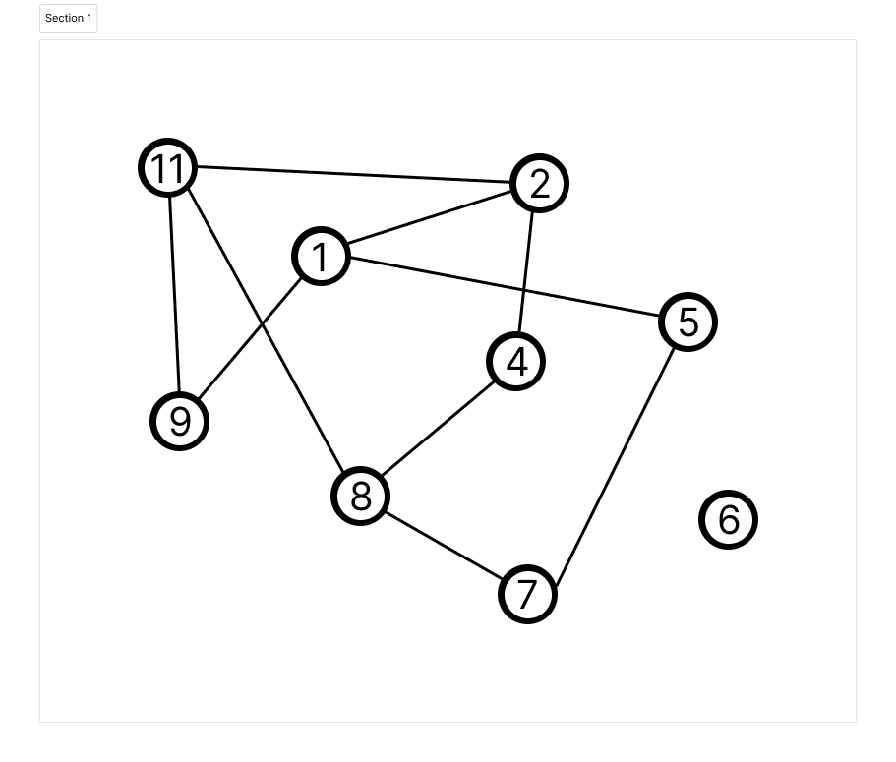

1. **Results**

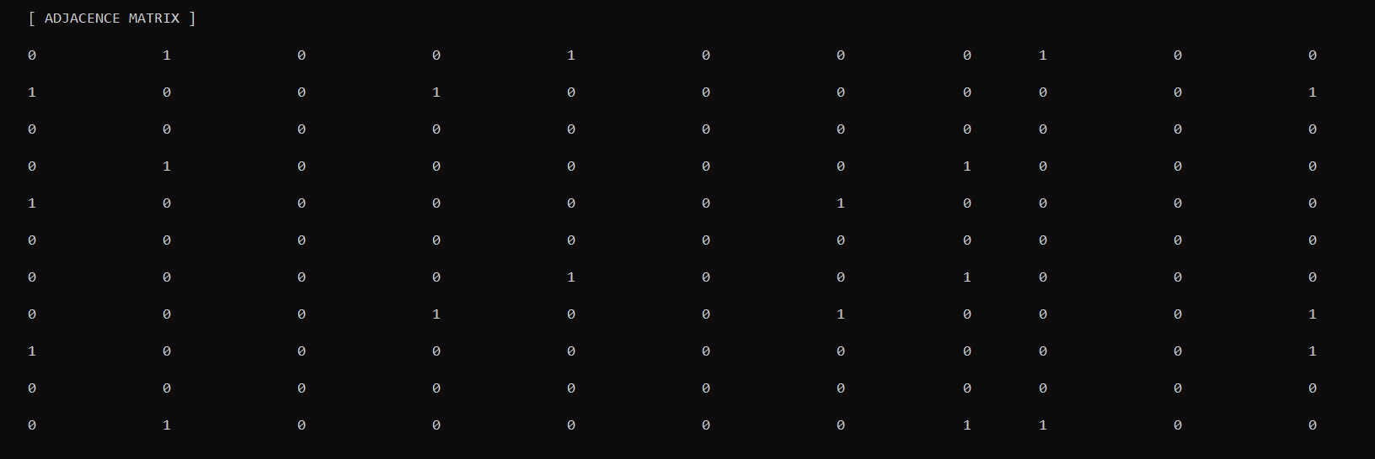

Task 2

**Results**

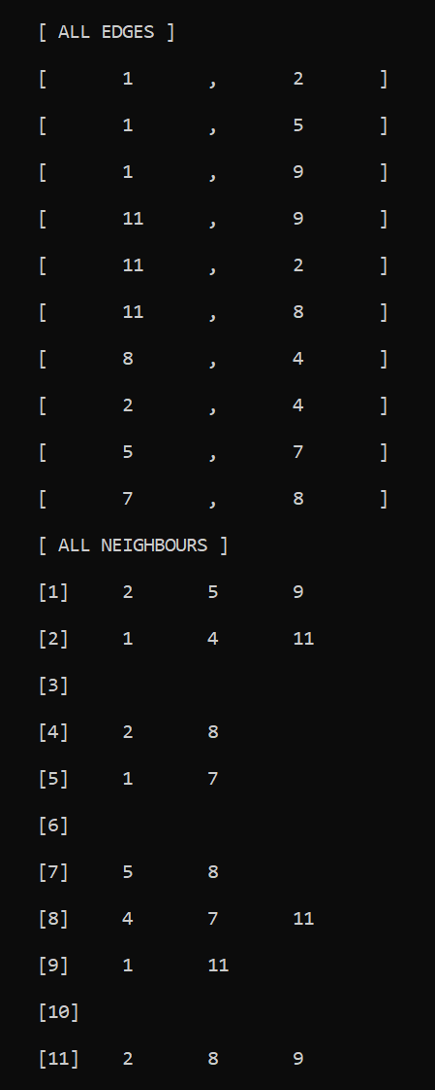

Task 3

**Results**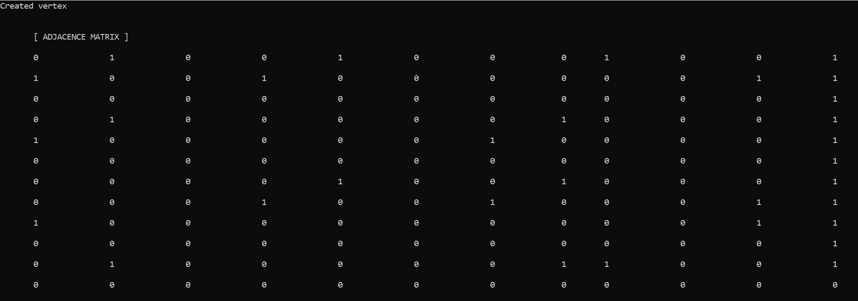

Task 4

**Results** 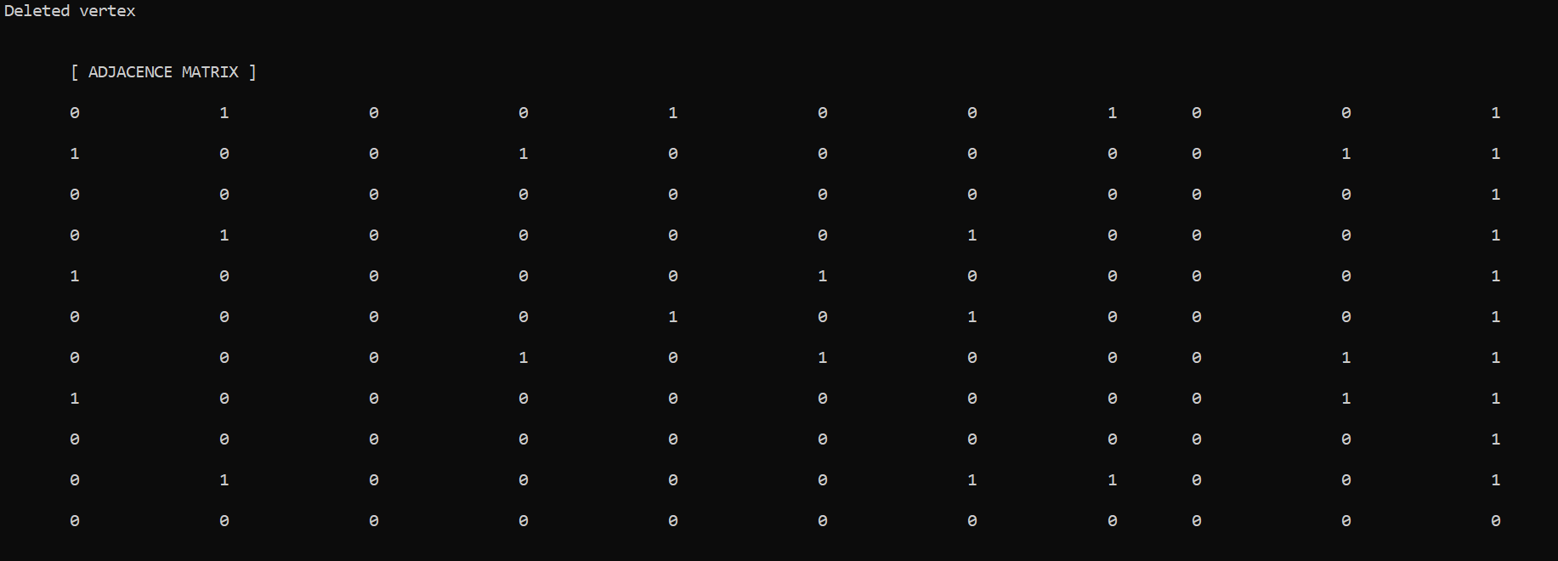

Task 5

**Results** 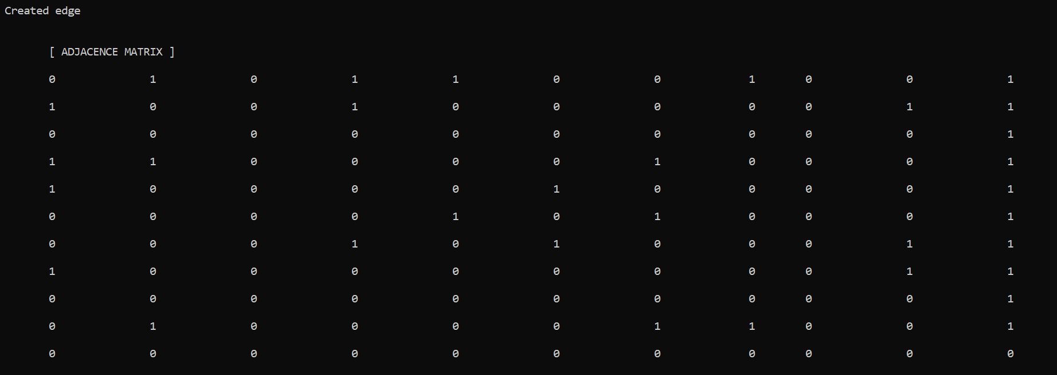

Task 6

**Results** 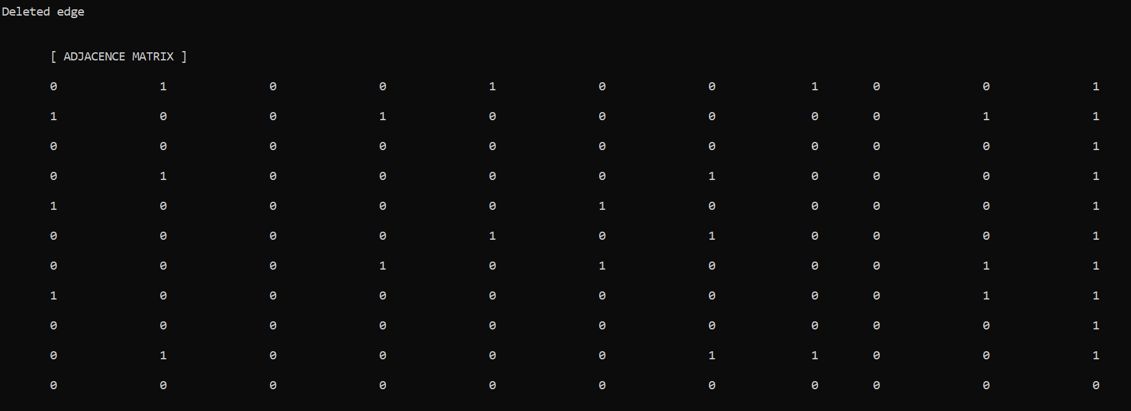

Task 7

**Results** 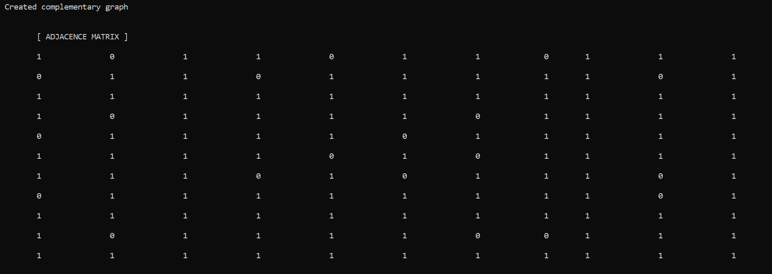

Task 8

**Results** 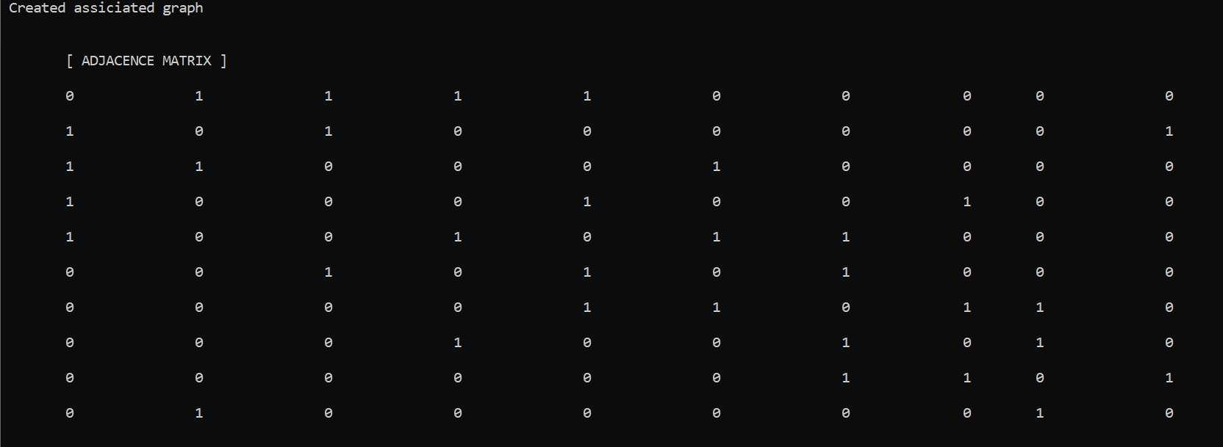

Task 9

**Results**

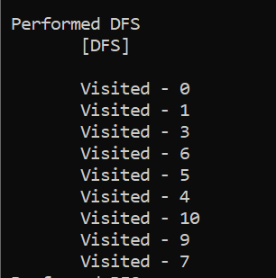

Task 10

**Results**

