CONTROLS

Street fighter 2: The World Warrior first appeared back in 1991, serving as one of the cornerstones of the “fighting game” revolution than took arcades by storm in the late 80s, early 90s era. As a clear consequence of that, the device players used to play the game was an arcade stick, which was inserted itself on a arcade cabinet. Later on 1992, an adaptation was released for Super Nintendo, changing a bit how the player interacted with he game. Further away from that period in time, the game has been re-mastered multiple times, hitting the latest instalment in 2006, with a Xbox / PS2 adaptation. In this explanation, we'll delve specifically into the arcade stick variant of the controls, since it's both the original and the intended way to experience the game.

First, we'll start with the basics of how a arcade stick is structured. Then, we'll discuss how that layout affects directly the playability of the game.

General Layout

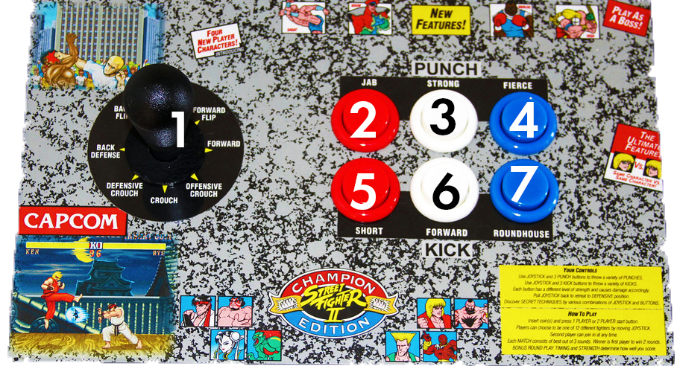
SF2 arcade stick, original from newavetoys

We will use a street fighter 2 arcade stick for the sake of consistency, but the same holds true for any other 6-buttons arcade stick.

1. Directional Stick
2. Light punch, lp or Jab
3. Medium punch, mp or strong
4. Hard punch, hp or fierce
5. Light kick, lk or short
6. Medium kick, mk or forward
7. Hard kick, hk or roundhouse
That's the general layout of a 6-buttons arcade stick, which are the ones present in all of the Street fighter cabinets from the first one to the latest one.

With the directional stick, players control their characters movement, while the 6 buttons on the right are used to input an array of different attacks. As we're going to see in the next chapter, special moves might require a combination of both directional moves and button inputs to be executed.

User interaction

In a classic arcade stick, we see a classic motif shared between multiple gaming devices: one hand controls general directional movement while the other handles different actions.

So, how can the different aspects of the arcade stick impact gameplay? We'll go in order one by one:

Starting with the directional stick, there are 2 main properties that affect gameplay: the gate and the grip. The gate is the piece of plastic of metal that is located beneath the stick itself, serving a double purpose: lock it into motion, preventing it from moving freely without the player's action and limiting the are in which the stick can be moved.
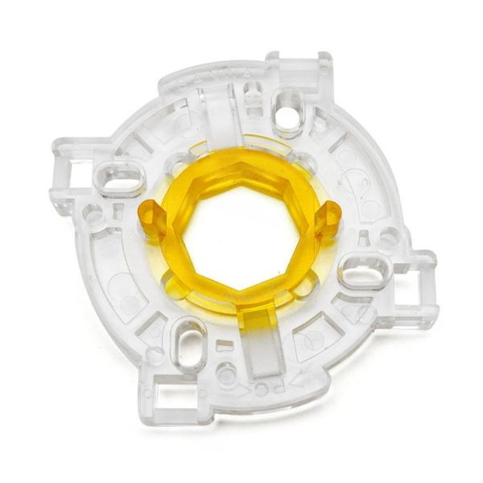
Sangwa gate, extracted from their selling page

Back in 1991, there were 2 types of gate: square gates (the originals, made in Japan) and the octagonal gates (found later in the USA/EU adaptation of the arcade game, following the typical occidental manufacture of arcades).
Image originally found in Slagcoin.com

Octagonal gate: an octagonal gate provides the user with a more sensitive response to diagonal direction. By limiting the area of the diagonal direction, the player seldom miss inputs a diagonal jump while trying to move forward or backwards (something extremely relevant if trying to input a special move, as we'll discuss later). As an added bonus, the hand position to input a crouching defence is quite different to a standing defence, since both positions don't share a vertex.

However, octagonal gates come with two problems: first of all, the central part of the stick (known as “neutral”) is quite big. This is a liability to the user, since the stick needs to traverse the region to register any kind of input. Therefore, a bigger neutral area means that the player will need to move the stick for quite a while until the stick registers the motion. This might prove especially harmful while trying to input certain special moves, as Chun Li's Spinning bird kick or Guile's Flash kick (explained in the “Super Inputs” section). The other added inconvenience is that the distance from the neutral position to the furthest point of the main 4 cardinal points is quite large. As a consequence, a player trying to input a dash (tapping forward 2 times in a sequence) needs to move the stick all the way up to the right corner of the gate, back to neutral, and all the way right one more time. As speed is crucial in street fighter, this added distance creates quite the inconvenience to the player.

Square gate: the original Japanese type of gate presents the user with a perfectly balanced distribution all across. This has quite some great attributes attached: the neutral region is significantly smaller than the octagonal one, which means that less distance has to be travelled before the stick registers the input. The second benefit is that the distance from neutral to the furthest cardinal points is remarkably smaller than the octagonal gate. This allows the player to perform faster movements, thus giving more time to the player to react (since the input that needs to be done is faster, the player has a wider time window to react).

The square gate presents only one main disadvantage: it's equal distribution of area makes it quite easy to “slip” into an undesired region if the input is not accurate. Although an experienced player would not find that a problem, the average player does not have an extremely precise control of his hand motions, thus easily making input mistakes. This is terrible from a user experience point of view: the player thought to do something, did input something “close enough” (in their eyes, good enough) and the character did not perform the desired action. If we add that already frustrating experience to the fact that fighting games are designed so players can punish their opponents mistakes, we see how terrible of a problem this becomes. Not only the player is angry since he thinks “the stick did not respond correctly to my inputs”, but he has to see how his opponent further punishes him by having a “free” round of attack.

Side note: Most professional players use a square gate, since the main disadvantage of that one is negated once the player has sharpened his skills enough. In fact, there is quite a famous anecdote regarding gates and 2 professional players: Daigo Umehara and Alex Valle. The first time Daigo leaved Japan to compete in America, he was quite afraid to face Valle, since he heard from fellow players all around the world speak highly of him. However, once the match started, he noticed Valle was going to use a octagonal American gate. From that moment, he says he was certain he could defeat him, since he regarded those type of gates (never seen in Japanese arcades) to be quite impractical and a sign of lack of finesse.

Side note: On modern times, some Korean arcade sticks manufacturers have started designing round gates, also known as “gateless”, since for a lack of a better name, no gate is used in the structure of the stick, allowing complete free movement.

The second attribute of the directional stick is the grip. Here, we see again 2 distinct model, one present in Japan and another one for EU/USA. The Japanese grip is quite a bit shorter than it's counterpart, topped with a sphere. The American stick is a bit bigger, topped with a rubber bat that descends all the way down to the middle of the stick itself.
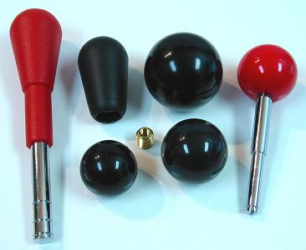
Image originally found in Slagcoin.com

Bluntly put, the Japanese grip is commonly regarded as flat out better. It's smaller, thus needing less movement to input the same commands than it's American counterpart. In addition, the grip of the hand itself around the stick is noticeably smoother in the Japanese version. This is direct consequence of it's spherical form, that allows the player to grab it in quite a different plethora of ways. Here, I'll present the most common ways of grabbing the stick, and whether or not such grip is possible using each type of stick.

All images extracted from fighter101.net

Grip | Name | Japanese | American
 | Wineglass | Yes | No
 | Side Wineglass | Yes | No
 | Monkey Grip | Yes | Yes
 | Eagle Grip | Yes | No
 | Doom | Yes | Yes

However, if already used at one grip doable on an American stick, the difference is small enough so a player might prefer to stick to a familiar American stick rather than start getting used all the way up from zero with a Japanese stick. However, other than for “legacy purposes” or particular feel-driven opinion, there is no reason why anyone should use a American grip over a Japanese one.

Moving from the direction stick to the buttons, we find one major factor that defines them.

Addressing first the elephant in the room, the main characteristic that defines a button is it's resistance. As a repeating trend, we find again two versions: the Japanese one, which presents buttons with almost zero resistance and the American one, which pack quite a punch.

Soft resistance buttons offer one major and obvious benefit: it's faster to press them. As an added bonus, they return faster to a neutral position, making them faster to press multiple times (something extremely beneficial in performing certain special moves, as Chun Li's Lightning legs). However, this advantage comes at a cost: their weak resistance makes it so they can be easily unintentionally pushed. As a consequence, when playing with this kind of buttons, the fingers can't be resting directly on the buttons, begin thus forced to be held ever so slightly above them. Keeping this “hovering finger” stance for a long period of time puts quite a strain on the hand, thus handicapping the player's action. In larger sessions of gaming (or in a tournament setting, where it is normal to face multiples best of threes in a row, topping at best of 5s or best of 7s finals) this can prove to be fatal.

On the other end of the spectrum, hard resistance buttons have one major downside and quite a few perks. Obviously, the more resistance they have, the harder they are to press, making the whole motion slower. So, what do they offer in return? Two main things: first, the whole hand can easily rest on the layout without miss-pressing any buttons. In that state, no restrain is put on the hand and the position is easily maintained for hours. As a secondary benefit, the buttons offer a characteristic distinct feel when they are pressed and when they are released. This distinction is crucial if the player tries to pull off some advanced moves using Negative Edge (further explained in gameplay, this technique allows players to input commands both at button press and button release).

Note: The fact that the American buttons make sound once pressed is known to have caused some curious situations in tournament play. There, some players are known to react to the sound of the enemy buttons before the in game animation starts, thus giving them a slight edge (although almost negligible, it is known that humans react faster to sound than to images). As a countermeasure, some players were known to purposely press buttons at random times just to throw off their opponents. Such practice can be seen in the legendary Evo moment 37. While Daigo Umehara is trying to concentrate on the game, his adversary, Justin Wong, furiously presses the buttons on his arcade stick so the sound throws off Daigo's timing. The video can be found at https://www.youtube.com/watch?v=JzS96auqau0 and, focusing on Justin Wong at 0:30, one can see such practice begin used.

Super motions / Special moves

While special moves will be addressed from a gameplay perspective it's important to understand why their use and attributes are directly in relation with how they are executed. To show such relations, we will address a few moves previously mentioned in this section plus a few more and explain the relation between the type of stick at use and the hand motion needed to execute them. Beware, the examples shown below are just a representation, as similar instances happen multiple times in each character.

Chun Li's Spinning Bird Kick

Input motion: Down, Up, Kick

Problem associated: If the motion from down to up is slow enough, the game will not register the input as a special move, thus making Chun Li crouch, followed by a jump and a jumping kick. This problem is aggravated on a octagonal gate, since the distance in neutral going from down to up is greater than in a square gate. As direct consequence, a faster motion is required so the game correctly interprets the motion as Spinning Bird Kick.

Similar moves: Guile's Flash Kick

Chun Li's Lightning Legs

Input motion: Press a Kick button multiple times rapidly

Problem associated: Pressing the buttons slow enough will make Chun Li do 1-2 regular kicks before performing Lightning Legs. If pressed quickly enough, 3 inputs can be read before the charging animation of the first kick is done, causing a cancel. When that happens, Chun Li performs Lightning Legs without the need to throw a single kick before. Using hard resistance buttons make this move significantly harder, demanding from the player more speed and strength to be put in each press.

Similar moves: Honda's Hundred times Slap, Blanka's Electricity

Guile's Sonic Boom

Input motion: Back, Forward, Punch

Problem associated: First, it's the whole Spinning Bird Kick situation all over again. In addition, there's a problem which cannot be solved, but it's a direct consequence of the infrastructure of the arcade stick. Since the motion starts with a Back input, Sonic Boom can't be performed while advancing to your opponent. Thus, it's a strictly defensive fireball, making it objectively worse than the hadouken which can be used both in offence and defence. If playing Street Fighter with a regular keyboard, one can click simultaneously back and forward (which is physically impossible on an arcade stick for obvious reasons), allowing oneself to move forward while pressing back and then releasing back and pressing punch, performing the Sonic Boom. For this reason alone, it's universally forbidden to enter any kind of Street Fighter tournament using a keyboard.

Similar moves: Honda's Sumo Headbutt, Blanka's Rolling Attack

Dhalsim's Yoga Flame

Input motion: Back, Back-Down, Down, Down-Forward, Forward, Punch

Problem associated: Doing what it's essentially a half-circle motion can be quite difficult on a square gate in comparison to an octagonal one (trivial on a modern no-gate stick). The reason behind this is that the stick gives no distinct feeling when moving from a diagonal position to a cardinal one. For that reason alone, it can prove difficult to notice if we started the motion at Back or at Up/Down-Back AND it can be equally difficult to know when to stop (since Forward / Down-Forward / Up-Forward can be easily mistaken).

Similar moves: Zangief's Spinning Piledriver

So, as shown with this few examples, the nuances of each type of arcade stick can prove to be important to the user experience of each player, regardless of skill level or character choice.

Bibliography

https://es.wikipedia.org/wiki/Street_Fighter_II:_The_World_Warrior, Wikipedia.com, at 2/03/2019
https://en.wikipedia.org/wiki/Super_Nintendo_Entertainment_System, Wikipedia.com, at 2/03/2019
https://www.slagcoin.com/joystick/restrictors.html, Slagcoin.com, at 3/03/2019
https://newwavetoys.com/products/street-fighter-2-x-replicade, at 3/03/2019
http://www.sanwa-d.co.jp/en/ at 8/03/2019
https://www.youtube.com/watch?v=fxCAsKdvj0U, Youtube, 10/03/2019
http://fighter101.net/main/2016/08/08/everything-you-ever-wanted-to-know-about-arcade-sticks/ Fighter 101.net, 10/03/2019
https://www.youtube.com/watch?v=JzS96auqau0 Youtube, 10/03/2019

