**Wireframe**

|  |  |  |  |
| --- | --- | --- | --- |
| **Student Details** | | | |
| **Sr.**  **No.** | **Enrollment No.** | **Name** | **Division – Roll No.** |
| **1.** | 22030401061 | Renil Garala Sandipbhai | BCA-224 |
| **Project Title** | | | |
| **Learning Management System** | | | |

**User Screens**

**

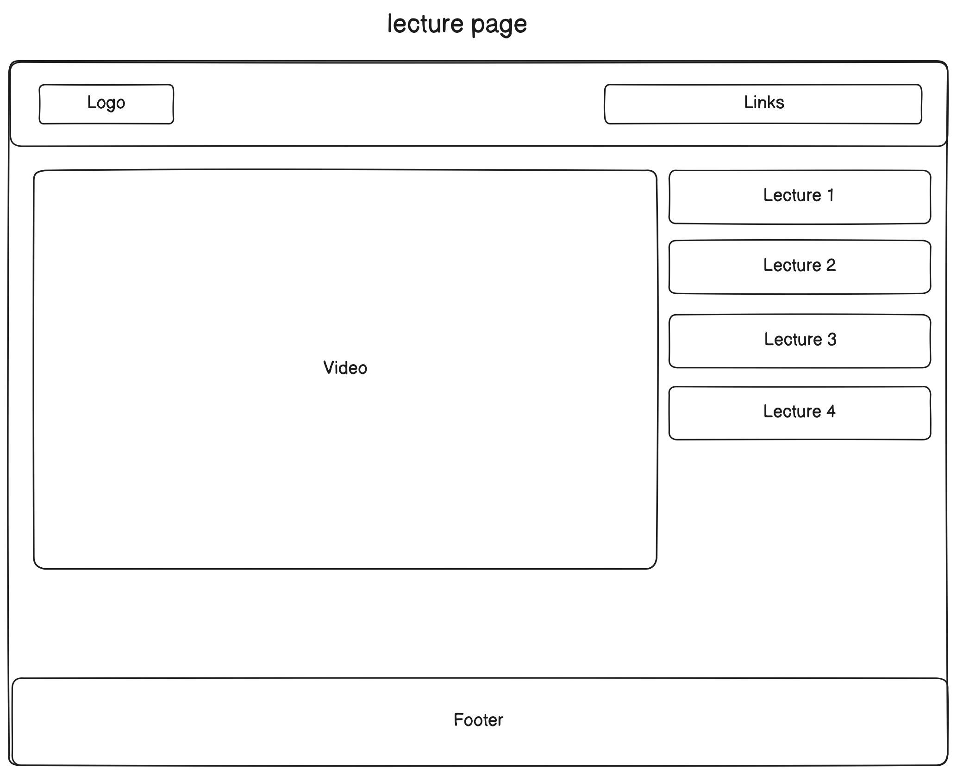

**Admin Screen**

