Ryan White, Keegan Chhay, Renin Kingsly Jose

Network Design Project: Phase 5

Implement Go-Back-N protocol over an unreliable UDP channel

Design Documentation

12/09/2022

**Introduction:**

In this phase, the RDT service that was developed on phase 4 will further be improved to handle pipeline data transfer over the unreliable UDP connection.

**Code Description:**

Most of the functionalities remains the same, that is, the 32bit checksum, packet structure, socket configuration, raw data corrupter, packet dropper, and file handling. This section will only cover the changes made to the sender.py and the receiver.py in order to provide a coherent report.

Sender.py

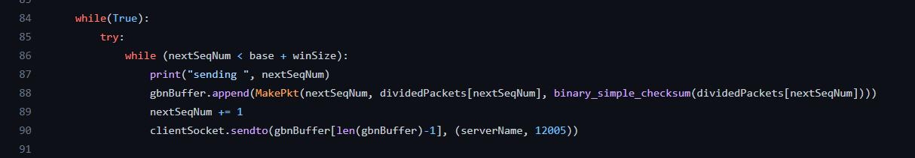

The sender is further changed to send multiple packets rather than one. This is achieved by appending the array “gbnBuffer” of packets “base + winsize (window size)” number of times and sending them through the UDP socket all together. The variable “winsize” is set by the user through the command line argument.

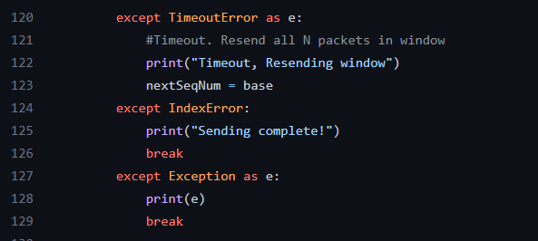

The timeout handling has also been modified to support resending of all packets in the window.

Receiver.py

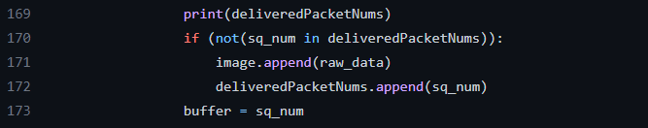

The receiver.py required only one small modification to its code. It now avoids appending the repeated raw data into the output.png.

**Performance Plots:**

Performance comparison with each options implemented.

Option 1: No loss/bit-error

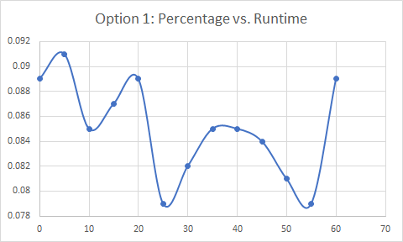

Option 2: ACK packet bit-error

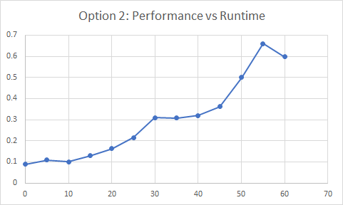

Option 3: Data packet bit-error

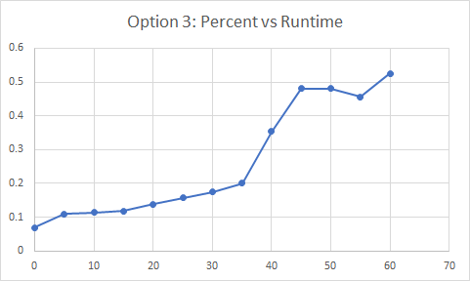

Option 4: ACK packet loss

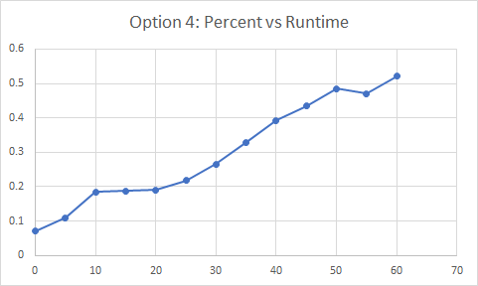

Option 5: Data packet loss

