**INDUSTRIAL ORIENTATION REPORT**

**ON**

**“…………………………………………….”**

**Bachelor of Technology**

**in**

**[Information & Communication Technology Engineering]**

by

**Meet Sheladiya** (Roll No: 19BIT076)

**Renish Jagani** (Roll No: 19BIT108)

**Vivek Devre** (Roll No: 19BIT131)

**Ananya Khandelwal** (Roll No: 19BIT144)

Under the guidance of

**Faculty Mentor’s Name:**

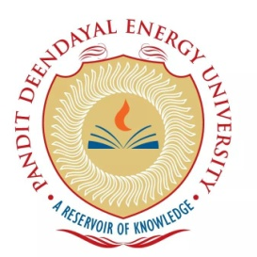

**School of Technology**

**Pandit Deendayal Energy University**

**Gandhinagar – 382426, Gujarat, India**

**June-July – 2021**

**Declaration**

I declare that this written submission represents my ideas in my own words and where others’ idea or words have been included, I have adequately cited and referenced the original sources. I also declare that I have adhered to all principles of academic honestly and integrity and have not misrepresented of fabricated or falsified any idea / data / fact / source in my submission. I understand that any violation of the above will be cause for disciplinary action by the PANDIT DEENDAYAL ENERGY UNIVERSITY.

__________________

(Signature of the Student)

(Name of the Student)

**Specimen ‘B’: Approval Sheet**

This report entitled (title) by (Author name) is recommended for the credits of Industrial Orientation.

Sign. of Examiners

______________________

______________________

Sign. of Supervisors

______________________

Date:_______________

Place: ______________

Table of Contents

**1 INTRODUCTION** 1

**2.1 HISTORY AND EMERGING OF THE INDUSTRY** 2

**2.2 MAN POWER AND ORGANIZATIONAL HIERARCHY** 4

**2.2.1 Man Power** 4

**2.2.2 Organizational Hierarchy** 5

**2.3 FLOW CHART AND DESCRIPTION OF THE PROCESS INCLUDING RAW MATERIAL/ INTERMEDIATE STAGES AND PRODUCT** 6

**2.3.1 Flow Chart** 6

**2.3.2 Manufacturing Process of Tesla Model S** 6

**2.4 DESCRIPTION OF IMPORTANT PRODUCTS** 9

**2.4.1 Model S** 9

**2.4.2 Model X** 10

**2.4.3 Model 3** 11

**2.5 TECHNOLOGICAL AND BUSINESS CHALLENGES AS ON DAY AND PROBABLE WAY OUT** 12

**2.5.1 Challenges Faced by Tesla** 12

**2.5.2 Probable Way Out** 13

**2.6 THE SPECIFIC USE OF TECHNOLOGIES, SKILLS, COMPETENCIES** 16

**2.6.1 Technologies** 16

**2.6.2 Skills** 17

**2.6.3 Competencies** 17

**2.7 PRESENT STATUS IN TERMS OF MARKET DEMAND AND WAY FORWARD (FUTURE SCOPE)** 19

**2.8 ENVIRONMENTAL IMPACT** 21

**2.9 COMPETITORS AND OTHER THREATS FOR EXISTENCE** 22

**2.9.1 Threats to Tesla** 22

**2.9.2 Competitor of Tesla** 23

**2.10 LONG TERM POLICIES OF THE INDUSTRY FOR ITS EXISTENCE** 24

**2.11 SAFETY AND HEALTH NORMS FOLLOWED** 25

**3 LEARNING FROM INDUSTRIAL ORIENTATION** 26

**4 REFERENCES** 27

# **1 INTRODUCTION**

# **2.1 HISTORY AND EMERGING OF THE INDUSTRY**

Tesla,Inc., which was Tesla motors(2003-17) is an American electric-automobile manufacturer founded in 2003 by two American entrepreneurs Martin Eberhard and Marc Tarpenning. It was named after Serbian-American inventor Nikola Tesla. The main purpose of Tesla was to manufacture electric sports car.

In the earlier days Eberhard was Tesla’s chief executive officer and Tarpenning was its chief financial officer. Tesla obtained its funding from many sources, most notably PayPal’s co-founder Elon Musk Who made the contributions worth $30 million and more and became the chairman of the company in early 2004.

In 2008 Tesla Motors released its first car which was completely electric, “Roadster”. It was able to achieve 394km on a single charge which was comparable to the performance of gasoline-powered sports cars. It could accelerate from 0 to 96 km/hr in less than 4 seconds with the top speed of 200km/hr. The car body was light, made of carbon fiber and gained power from lithium-ion cells. The Roadster produced no tailpipe emissions as it didn’t used internal combustion engine. It had mileage equivalent to 57 km/lt. The Roadster costed $109,000 which made it a luxury item.

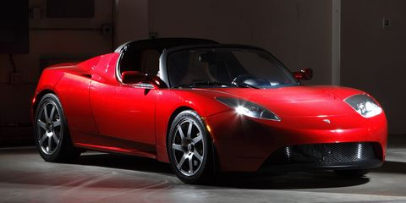

In 2007, Eberhard resigned as CEO and president of technology and joined the advisory board and the in 2008 it was announced that he left the company, though he still was a share-holder. Tarpenning also left Tesla in 2008. Elon Musk then took over as CEO. Tesla’s initial public offering in 2008 raised about $226 million.

2012 was the year when Tesla stopped the production of the Roadster so that it could focus on its new Model S sedan. It was acclaimed for its design and performance as it came with three different battery options which made it ranging from 379 tons 483 kilometers. Its highest acceleration was 96 km/hr in around 4 seconds with the top speed of 209 km/hr. the Tesla auto-pilot was made available in Model in 2014.

In 2015 Tesla finally introduced its crossover vehicle Model X with a maximum battery range of 475 kilometers and was a seven seater. With the increasing demand of more inexpensive electric car, Tesla landed Model 3 in 2017 which was a $35,000 4 seater sedan having range of 354 kilometers.

Tesla also branched out into solar products in 2015 and bought solar panel company SolarCity in 2016. In 2017 Tesla Motors changed itself to Tesla,Inc. to show that it no longer sold just cars.

In September 2018 Tesla and Musk got involved in some controversy with the U.S. Securities and Exchange Commission(SEC) and had to bear a fine of $20 million with a ban on Musk as a chairman of Tesla for 3 whole years.

# **2.2 MAN POWER AND ORGANIZATIONAL HIERARCHY**

## **2.2.1 Man Power**

“By the end of 2020, 70,757 people were employed(full-time) by Tesla.” This phenomenal increase in man-power in Tesla came after a decline of around 1.6 % between 2018 and 2019.

Starting in 2007, the work on Model S was completed by March 2009. At this time, they continued manufacturing the Roadster and had only a few hundred employees. In spite of this Tesla managed to hire experienced automotive engineers and manufacturing specialists from leading automotive companies to design and manufacture the Model S. Also, engineers from electrical, electronics and I.T. background were hired from various Silicon Valley firms. This team included people like Franz von Holzhausen (from GM, AudiandMazda), chief designer of Model S and Gilbert Passin (from Toyota) as VP manufacturing. By 2010, 2011 and 2012 Tesla had 899, 1417 and 2964 employees respectively. By the end of 2011 when the company was at its peak, Tesla had out of 1417, 315 (22%) in R&D and 216 (15%) in Design and Engineering which is a much higher percentage than any other traditional automotive company.

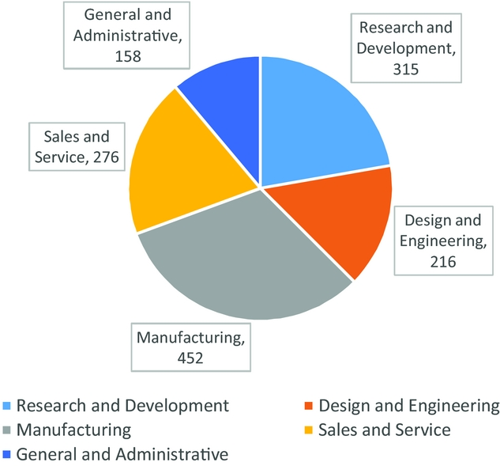

## **2.2.2 Organizational Hierarchy**

What is an organizational structure? It is the systems and designs that define the working of a company. Tesla with its traditional approach mainly considers company’s managerial focus and control along with limited expansion of the business in the global market.

Tesla has **U-form** (functional, unitary form) organizational structure which has organizational function as its main defining factor. Tesla has a structural group of employees for engineering and sales and services. The most significant feature of Tesla is grouping based on business function. These characteristics are significant in Tesla’s organizational structure:

* **Function based hierarchy (most significant)**

In Tesla’s global organization this is the most significant feature which involves functional offices or teams to look upon domestic and international operations. This feature is typically observed in traditional corporate companies. Here, for Tesla the following functional offices direct and represent the global hierarchy:

1. Chairman and CEO
2. Finance
3. Technology
4. Engineering
5. Global sales and services
6. Legal

* **Centralization**

Tesla uses this in its corporate structure. The main aim of centralization is managerial control on the whole organization through decisions that a central group generates. Here, the heads of the offices of the global hierarchy form the company’s central headquarters which directly control all the other organizations.

* **Divisions**

This attribute of the corporate structure mainly focuses on the geographical and other types of divisions in Tesla’s automotive business. These kind of divisions are used to implement different strategies and marketing campaigns and to organize financial reports. Tesla’s main divisions contain 1. Automotive and 2. Energy generation and storage. Though these divisions are less important than the function based hierarchy of the company. For financial reporting Tesla’s organizational structure has following geographical divisions which are mainly used for financial reporting:

1. United States
2. Norway
3. China
4. Other

# **2.3 FLOW CHART AND DESCRIPTION OF THE PROCESS INCLUDING RAW MATERIAL/ INTERMEDIATE STAGES AND PRODUCT**

## **2.3.1 Flow Chart**

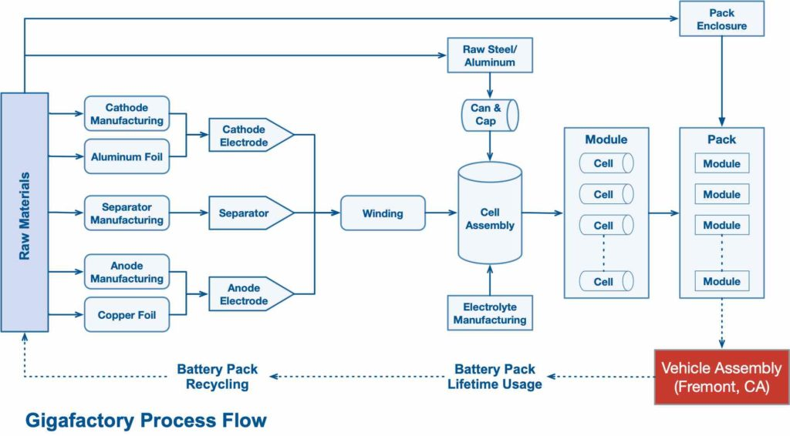

## **2.3.2 Manufacturing Process of Tesla Model S**

Named after the characters of x-men, 160 specialist robots (including 10 of the largest ones in the world) are used in the manufacturing process of Model S. Some of the main components of Model S like battery pack, battery module and drive units are manufactured in-house. The process includes hydraulic press lines which are used to stamp 5,000 body panels/day with a force of 10,000 tons (largest in North America/6th largest in the world). As of March 2015, Japan became its 2nd biggest supplier of components, though, 60% of components are sourced from North America.

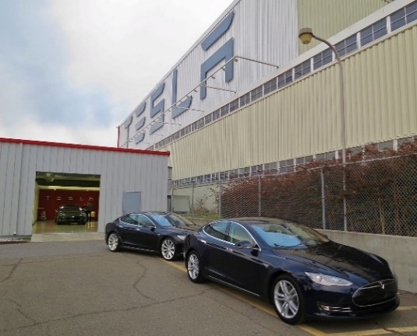

It takes 2-3 month of wait for the delivery of each ordered vehicle, although the individual machine is built in a span of 3-5 days at the end of assembly process (Note: The assembly line moves at a speed of 5cm/s). Tesla prefers delivery by train rather than by truck as its cheap and causes less damage.

**Construction of Drive-Unit:**

Construction of Motor:

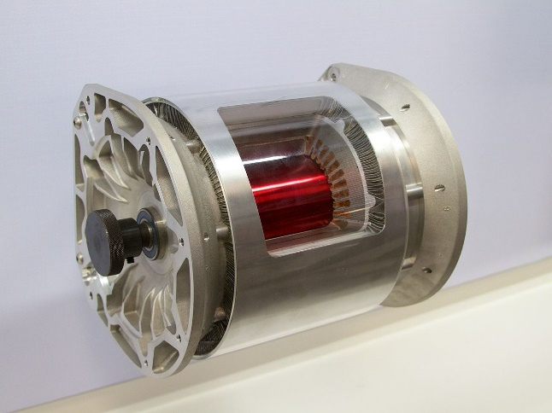

The A.C. current induction motor is built in house. Its main components are rotor and stator.

* The construction of motor begins when the robot winds over 0.8 km of copper wire per motor and pulls the copper wire over the stack.
* The motor has three phases and requires three coils of copper.
* Then a worker straightens and lengthens each bundle of wire and inserts a hydraulic lift to transfer the motor to the next station. Then the coils are insulated and are binded together to keep them in place. This binding increases motor’s efficiency.
* Insertion of stator and rotor completes the construction of the motor.

**Additional components of Drive-Unit:**

* A worker installs other sections of the gearbox and an air leak test is conducted.
* Then a 3 phase tri-pole inverter is installed onto the top of the motor to convert D.C. current from battery into alternating current for the motor. The motor is then tested and moved to the general assembly area for installation in the car.

**Battery pack construction:**

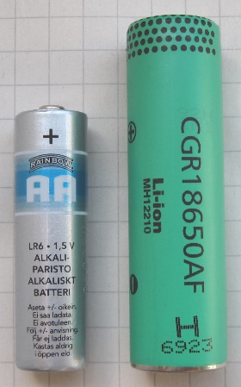

The 85 kWh battery pack of the Model S uses 7104 (‘18650’) lithium-ion battery cells in 16 modules wired in series (two stacked in the front section and fourteen in the flat section). From June 2012 Tesla started using Panasonic NCR18650A (3100 mAh) cells. Tesla cools the battery pack using intumescent gel for even heat distribution and to aid fireproofing.

**Construction of the body:**

About 98% of the body of Model S is made from aluminium which is produced between fifty and sixty separate coils of aluminium (each for different components). The weight of aluminium used in the manufacturing of the Model S is about 190 kg.

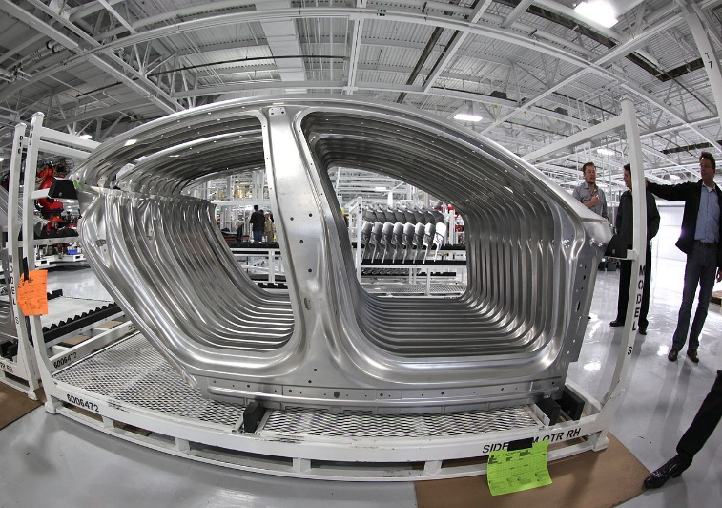

The Schuler SMG hydraulic stamping press line (largest in North America/6th largest in world) is used to form the body panels. The machine press 1/6th part every second and creates 5000 parts/day.

**Installation of the Drive-Unit:**

The car is raised for the installation of the drive unit in the rear axle assembly. Without the drive shaft, power is directly provided.

**Installation of Battery-Pack:**

The battery pack weighs about 540 kg and is raised into the car using lift, in the installation area. Placing it under the cabin floor adds rigidity and strength to the car and also lowers its center of gravity to 46 cm. to protect the pack from collision a titanium plate is installed over it.

# **2.4 DESCRIPTION OF IMPORTANT PRODUCTS**

## **2.4.1 Model S**

The all-electric Tesla Model S brags the exhibition specs a supercar with the legroom and common luxuries of a five-traveller extravagance car. Some contend that the EV is as yet in its original since it got gradual updates as opposed to a full upgrade, however it's anything but a minor outside and inside invigorate in 2016. Tesla likewise doesn't assign model a very long time to its vehicles. It's trim level naming show used to relate to battery measuring, yet today there is Long Range, Plaid and Plaid+.

The base Long Range trim uses an all-wheel-drive double engine powertrain to create 670 pull, arrive at a maximum velocity of 155 mph and hit 60 mpg in 3.1 seconds. Its refreshed battery engineering empowers up to 412 miles of reach. Another Plaid release utilizes a tri-engine powertrain to convey 1,020 torque, knocking the maximum velocity to 200 mph and dropping the zero-to-60 opportunity to 1.99 seconds. The drawback is a more limited 390-mile range. The Plaid+ ups accessible reach to 520 miles and pull to 1,100. Utilizing the Tesla's hearty Supercharger Network, the full-size electric car can amount to 200 miles of reach quickly.

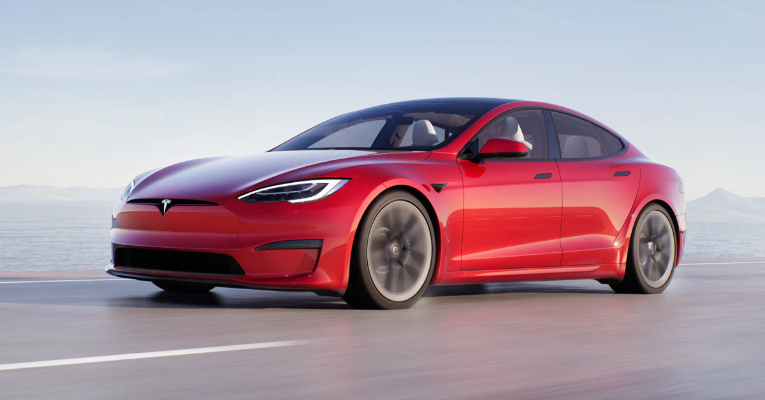

The Model S got a revived outside and inside upgrade, including new driver cockpit highlighting a stalkless guiding burden before a 12.3-inch advanced driver show. Focused in the moderate dashboard is another 17-inch scene touchscreen show equipped for 10 teraflops of handling ability to run the Tesla Arcade with remote gaming regulator similarity, web based video stations, satellite-see maps, web perusing and Karaoke (network membership required). An overhauled second line includes an eight-inch show screen.

## **2.4.2 Model X**

The 2021 Tesla Model X is the SUV of things to come that is accessible to purchase today. It has no controlling wheel, no blinkers, and no stuff shifter—it surmises in which course the vehicle should go, and if it's off-base, the driver can address it utilizing the new 17-inch touchscreen mounted on the middle stack.

Controlled by a 100-kWh battery and double engines that produce up to 670 pull, the base all-wheel-drive Model X Long Range is fit for a 360-mile driving reach and arriving at 60 miles each hour in 3.8 seconds. The best in class Plaid trim uses a tri-engine powertrain that builds yield to 1,020 strengths, yet lessens the traveling reach to 340 miles. It additionally drops the zero-to-60 mph time from 3.8 second to 2.5. When associated with one of Tesla's 25,000 chargers all throughout the planet, it can recover 17 miles shortly.

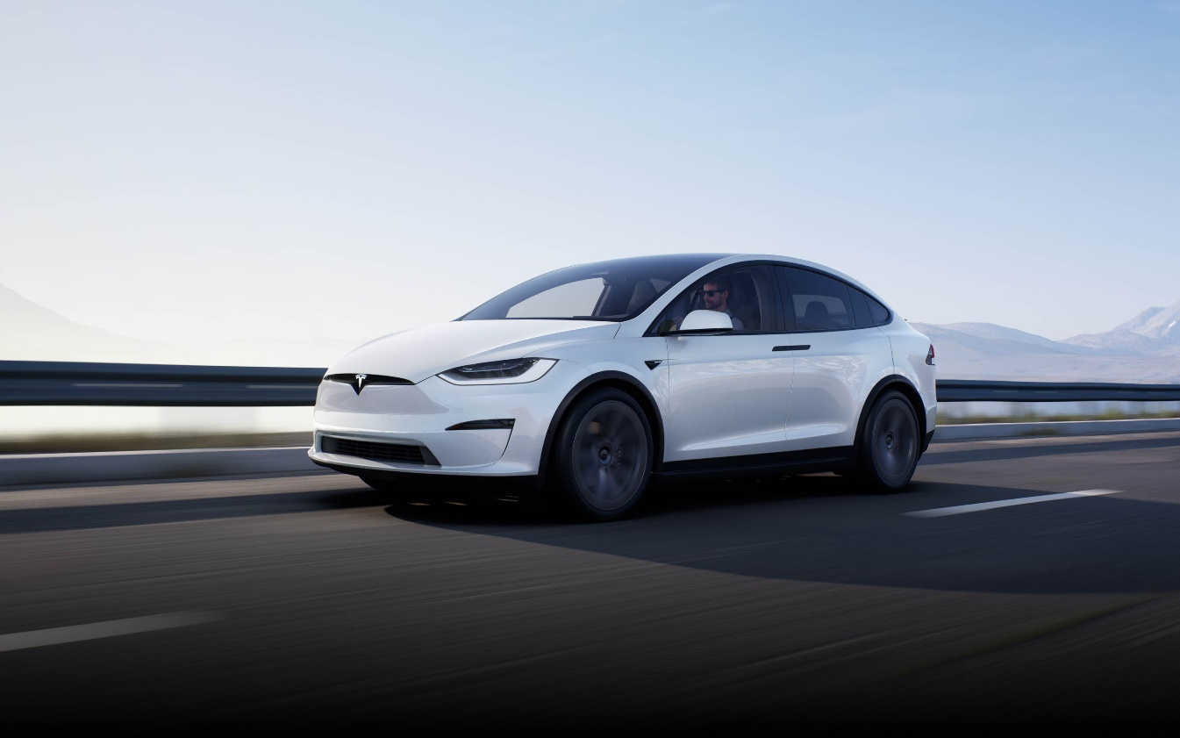

The Model X highlights accompanies gullwing entryways, a camera-and sensor-based security framework and an all-encompassing windshield. It's anything but's a few column design with guest plans for five, six or seven travellers. With all lines collapsed level, the updated lodge and frunk (front trunk) fit up to 91 cubic-feet of payload. Utilizing a standard trailer hitch, it can tow as much as 5,000 pounds. The touchscreens toward the front and second columns upholds remote gaming, real time video and karaoke (membership required).

Standard progressed driving-help security innovation incorporates versatile voyage control, programmed crisis slowing down and path keeping help. Tesla likewise offers semi-independent driving highlights, including distant leaving, dynamic driving help, and the capacity for the vehicle to follow route on autopilot under particular conditions.

## **2.4.3 Model 3**

The first generation Model 3 is an all-electric minimized car with the entire bundle: whiplash-instigating speed increase, accessible forefront semi-self-ruling driving innovation and tailpipe discharges free driving with a beginning cost of under $40,000.

The base Standard Range Plus model is prepared back tire drive and accomplishes a 263-mile driving reach with its 75 kWh lithium-particle battery pack, while the Long Range alternative uses all-wheel travel and offers 353 miles of reach. The first in class AWD Performance release utilizes a similar battery, however its higher-force delivering abilities and hardware updates improve the driving experience and empower the EV to arrive at 60 mph from a halt in 3.1 seconds (contrasted and 4.2 seconds in the Long Range and 5.3 seconds in the standard reach). The tradeoff is a lower traveling scope of 315 miles.

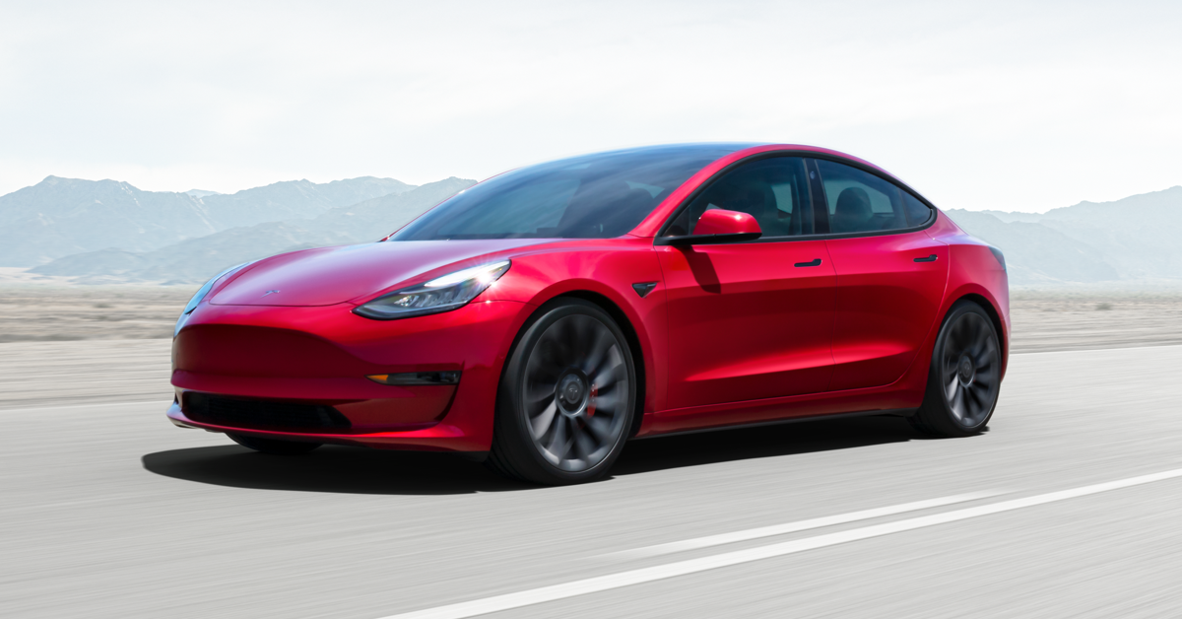

Contingent upon trim, the Model 3 uses a 7.6 kW or 11.5 kW on-board charger. The lodge offers seating for five, "veggie lover" cowhide inside upholstery, an extensive glass rooftop and a 15-inch touchscreen focused dashboard that controls the vehicle capacities and supports its numerous diversion abilities. These incorporate web based video channels, web perusing and karaoke (availability membership required). Versatile voyage control, programmed crisis slowing down, forward impact notice, vulnerable side admonition and encompass see camera are a portion of the standard progressed driver security tech, while the semi-self-sufficient powerful driving help frameworks, like Navigate-On-Autopilot, path change help and distant stopping, are alternatively accessible with the Full Self-Driving Capability bundle.

# **2.5 TECHNOLOGICAL AND BUSINESS CHALLENGES AS ON DAY AND PROBABLE WAY OUT**

## **2.5.1 Challenges Faced by Tesla**

* **Make framework accessible for EV vehicles:**

Electric vehicles hit another worldwide deals record in 2017 — 1 million vehicles sold, with the greater part of that in China — however there might be a hitch to mass selection: the quantity of satisfactory charging stations accessible. Before shoppers venture out on another electric vehicle, they need to realize that they can charge it. The quantity of electric charging stations in the US is little however developing. As of September 2018, there are an expected 83 22,000 public charging stations in the US and Canada that are delegated level 2 and DC quick charging. (Ordinarily, quick charging stations supply 60 to 80 miles of reach for like clockwork of charging.) By examination, there are multiple times more service stations: around 168,000, as indicated by FuelEconomy.gov.

* **Build more vehicles:**

Fluctuating crude material costs, and bugs in current models must be checked, and in view of that new and more proficient vehicles need to be created and mass delivered.

* **Manage financial backers and claims:**

Various petitions have been against Tesla, also, it needs to go through every single one of them, and select costly attorneys in request to get the ideal choice. This additionally antagonistically influences the financing, as the offer costs may go down with every claim.

* **Set up trust on Wall Street:**

Tesla has developed quick in light of the financial backers furthermore; the cash they provide for develop the organization. In any case, after introductory energy, market has shown profound financial backer questions, and this must be dealt with to keep dealing with advancement.

* **Deals and administration fabricate the brand:**

Tesla "feels" enormous in light of the fact that it has a $50 Billion value esteem and huge media presence. Be that as it may, Tesla has sold less than 500,000 vehicles. It has little involvement with fix, utilized deals, reusing, scrap 84 also, squander. It isn't close proportional or benefit on any of these different pieces of the business.

Conversely, Ford additionally has a complete value esteem around $50 billion, however sell and administration about 6.5 million vehicles each year; around the world. As Tesla inclines up its Fremont processing plant to get away from what Elon Musk called "production hell" with the Model3, a few clients are persevering through their own condition of experiencing attempting to get Tesla's adjusted.

## **2.5.2 Probable Way Out**

The challenges that Tesla is now dealing with are listed above. So, here are some suggestions that can be used to tackle the difficulties listed above. Only by concentrating on the main aspects can the concept be validated;

* Branding
* Customer Experience
* Production Strategy
* Talent- Invest in Expertise
* Business Model- Create and Grow the Ecosystem

The company may overcome the issues by focusing on the above-mentioned areas, as they are the main points that should be investigated and concentrated on.

* **Branding – Build a recognisable EV-dedicated brand**

Perhaps the best strength a current Original Equipment Manufacturer (OEM) has is their set up client base and the capacity to get to business sectors across the world. Also, numerous OEMs enjoy the benefit of having fabricated trust among clients over various years. Such benefits represent a significant test to new contestants. Brands in the auto market depend intensely on their own security certifications and this isn't required to change as Electric Vehicles (EVs) become more famous. In reality, there is a generous hole between OEMs that can flaunt amazing wellbeing records and new contestants that have no set of experiences of vehicle producing.

In any case, depending on a current brand name and notoriety has its dangers. Ecological maintainability is a key selling point for EVs, and OEMs without believable green certifications – particularly those that have had negative press over the most recent couple of years over emanations testing – may need their EV items to be seen independently from their center brands. OEMs focusing on achievement in the EV market should survey cautiously the worth of their current image with regards to the EV market. On the off chance that their green accreditations are not considered good, persisting with a current brand system may wind up being an exercise in futility, cash and exertion.

* **Customer Experience – Capitalise on aftersales credentials**

Client experience has been, and will keep on being, a vital differentiator in the auto market, regardless of whether during the business interaction, the in-vehicle driving experience or the aftersales market. The opposition between EV producers to convey the most recent in vehicle innovation will probably follow similar examples as found in Internal Combustion Engines (ICE) vehicles.

While Battery Electric Vehicles (BEVs) are innovatively more straightforward and need less successive support than ICE vehicles, the upkeep and fix foundation required is in reality more unpredictable, wellbeing basic and costly than for ICEs. The intricacy of adjusting an EV makes a prompt hindrance for new contestants, who have no insight or existing interest in overhauling clients. One system for new contestants, who might not have the experience, capacity or hunger to arrangement vendor arrangements, could incorporate banding together with existing outsider mechanics or carports. In any case, even outsider mechanics may battle with the expense and intricacies of overhauling future EVs, leaving OEMs with huge seller networks at a reasonable benefit.

* **Production strategy**

Construct incredible battery organizations in all creation districts While the production of EVs requires less mechanical parts it requires countless new electric and electronic segments, and a battery – the costliest piece of the vehicle. On the off chance that an OEM doesn't deliver its own battery cells, fruitful EV creation will require solid and profitable associations – especially with battery cell makers. Without these associations, OEMs will be compelled to acknowledge 'off-the-rack' determinations for their vehicle batteries. This could affect basic components of their EV plan and execution and, at last, their market offering. Battery packs are trying to move, requiring their creation near vehicle gathering. Notwithstanding, today the heft of cell creation is situated in Asia. Accordingly, OEMs will progressively depend on Asian battery producers and the foundation of worthwhile and all around arranged provider plans.

Anybody hoping to enter the EV market needs to think about the ordered expenses of arranging, reusing or reusing batteries toward the finish of their life. While a few associations will actually want to ingest the expenses, most of makers should consider making further organizations to give battery packs a 'second life'. A second life for an EV battery could incorporate mechanical on/off framework energy stockpiling or network administrations, home grown energy stockpiling or remanufacturing. For both OEMs and new participants, the current battery cell creation and end-of-life scene imply that it is basic to shape profound and solid associations with battery cell providers also as associations that can help with second life use. Albeit this will be expensive, it will eventually offer better combination with their vehicles and expand their control over the whole worth chain.

* **Talent – Invest in expertise**

The shift to EV assembling will require a generous interest in ability from both OEMs and new contestants. In the race for ability, OEMs are attempting to keep up with their current benefits related with the business information on their labour force as new participants, and new companies specifically, endeavour to 'take' top leaders from OEMs due to their experience.

Regardless of expanded efficiencies coming about because of mechanization, the assembling of vehicles stays a work serious cycle. In Europe, the car area at present utilizes 3.4 million individuals in high-talented positions – 11.3 percent of the EU's assembling employment10.86

Regardless of the quantity of exceptionally gifted labourers as of now utilized in the business, the plan and assembling of EVs will require a significant interest in new ability. Working with battery packs rather than ICEs requires OEMs to increment both the broadness and profundity of information inside their pool of designers. The shift to EVs implies that multi-talented specialists, who are as alright with science as they are with electrical and mechanical designing, are required. This is a test as multi-gifted architects are scant and accordingly, they for the most part request higher wages. Building the labour force of things to come turns out to be considerably more trying for OEMs when the best and the most splendid science, innovation, designing and math (STEM) graduates are progressively attracted to new companies.

* **Business model – Build and expand the ecosystem**

Advancing client needs and needs are requiring a shift away from conventional plans of action. Clients are progressively looking for versatility arrangements that offer more noteworthy adaptability, accommodation and cost viability than previously, for instance 'usership' over possession. New contestants to the car market hold a benefit around here over their generally less deft OEM rivals.

Albeit new contestants may enjoy an underlying benefit around here, imaginative client centered plans of action will be vital to accomplishment in the EV market. There is a chance for both OEMs (in the event that they can be spryer) and new companies (on the off chance that they can acquire market validity) to make a benefit by recognizing explicit client 'problem areas' and hindrances to EV take-up and offering creative arrangements. For instance, another plan of action that is framed by an organization or coalition between an EV auto player and a service organization could see custom power taxes packaged into the acquisition of an EV.

Taking into account how the car business is changing, the shift to EVs bears the cost of everybody in the business the chance to test and refine new possession models that will be used later on. Numerous clients that are right now purchasing EVs can be viewed as early adopters of innovation. Utilizing early adopters as a test market for future possession models will give significant understanding that can be utilized to illuminate the plan and execution regarding future plans of action.

# **2.6 THE SPECIFIC USE OF TECHNOLOGIES, SKILLS, COMPETENCIES**

## **2.6.1 Technologies**

* **A computer you can drive**

The Tesla Motors roadster, Model S sedan, and Model X SUV may appear to be vehicles, but they are actually computers that you can drive. Software controls almost every element of the driving experience, including torque management.

* **Touchscreen control**

The 17-inch capacitive touchscreen show in the Model S is essentially the vehicle's order and-control focus, in addition to an internet browser, on account of the implicit 3G association. The Model S has not many catches; most capacities are overseen through the touchscreen, including inward environment control, route, sans hands telephone sync, and music streaming. The screen is exceptionally configurable, considering all way of survey alternatives.

* **Constant connectivity**

Notwithstanding 3G remote, Tesla S vehicles are Wifi-empowered, permitting you to get to Wifi areas of interest any place you may wander. This likewise accelerates the product redesign measure and further develops the internet browser usefulness on the 17-inch touchscreen at the most secure time: when you're not driving. In the interim, the going with cell phone application permits you to control the vehicle from a far distance, setting the interior temperature or defogging the windshield before you're even in the vehicle.

* **Autosteer**

The autosteer work allows the Tesla to remain focused in a path, switch to another lane, and self-park. To keep the Tesla focused, the cameras around the vehicle track the situating of street markings and the sensors screen different vehicles making a course for maintain a protected separation. For the Tesla to move to another lane, the driver physically demonstrates the blinker, then, at that point the sensors keep the Tesla from converging into different vehicles. To self-leave in equal and opposite positions the vehicle utilizes both the sensors and cameras to try not to hit any environmental factors.

* **Cruise Control**

The radar and front oriented cameras track the situation of vehicles ahead and change the Tesla's speed in like manner. This element keeps a protected separation among you and the vehicle in front. The distance between the vehicles relies upon the speed the two vehicles are voyaging. On the off chance that a vehicle converges into your path, the Tesla will screen its position and decrease speed if vital. The Tesla won't frenzy and pummel on the brakes if a vehicle converges in your path and speeds up.

## **2.6.2 Skills**

* **Computer vision**

One significant computer vision task is object location. A few articles, like ponies, just show up out and about once in a while. At whatever point a Tesla experiences what the neural organization thinks may be a pony (or maybe an unnoticed article blocking a fix of street), the cameras will take a depiction, which will be transferred later over wifi. It assists with having vehicles traveling billions of miles each year since you can source numerous instances of uncommon items.

* **Prediction**

Expectation is the capacity to expect the developments and activities of vehicles, walkers, and cyclists a couple of moments early. Tesla's armada of roughly 500,000 vehicles is an awesome asset here. Any time a Tesla makes a mistaken expectation about a vehicle or passer-by, the Tesla can save an information preview to later transfer and add to Tesla's preparation set. Tesla might have the option to transfer a theoretical portrayal of the scene (wherein objects are pictured as shading coded cuboid shapes and pixel-level data is discarded) delivered by its PC vision neural organizations, as opposed to transfer video. This would drastically diminish the transmission capacity and capacity necessities of transferring this information.

* **Path planning/driving policy**

Path planning and driving policy allude to the moves that a vehicle makes: remaining focused in its path at as far as possible, switching to another lane, passing a lethargic vehicle, making a left turn on a green light, prodding around a left vehicle, halting for a jaywalker, etc. It appears to be naughtily hard to determine a bunch of decides that envelop each activity a vehicle may at any point need to take for any reason. One way around this evil trouble is to get a neural organization to duplicate what people do. This is known as impersonation learning.

Tesla is applying impersonation figuring out how to driving tasks, like how to deal with the lofty bends of a roadway cloverleaf, or how to make a left turn at a crossing point. It seems like Tesla intends to stretch out impersonation figuring out how to more undertakings after some time, similar to how and when to switch to another lane on the expressway.

## **2.6.3 Competencies**

The company produces vehicles at sensible costs, yet their vehicles can overcome bigger distances contrasted with Tesla's rivals. This is one of the major upper hands of the company. The emphasis on advancement is another peculiarity and core competence that can permit Tesla to stay a top maker of electric vehicles. It is important to add that the company licensed many advancements that make it the forerunner in the business. The company offers parts to numerous companies creating compelling partnerships.

The utilization of complex and compelling programming is another capability making an upper hand for the company. Tesla items can be portrayed by the most recent advances in innovation as their vehicles are outfitted with programming that empowers the driver to get a wide scope of information, which makes the driving experience simple and charming.

In this way, Tesla's significant assets and skills are connectedness, advancement, information. The company produces electric vehicles that are worked with the assistance of refined programming, which makes driving agreeable and very multi-layered. The vehicle producer's charging network is broad, which additionally makes an upper hand. The utilization of powerful procedures has prompted the collection of huge assets that, in their turn, added to the making of upper hand.

# **2.7 PRESENT STATUS IN TERMS OF MARKET DEMAND AND WAY FORWARD (FUTURE SCOPE)**

The market for all electric automobiles is expanding. There are numerous causes for this, including new restrictions on car safety and emissions, technological advancements, and evolving customer expectations. However, Tesla Motors and its unique business strategy are responsible for most of the public acceptance and excitement for electric vehicles. Tesla’s automobiles are popular because of their modern design, innovative technology, and great performance and hence possess a better market value.

The first Tesla vehicles were quite expensive. Aside from increasing demand, another factor for Tesla automobiles' high prices is the high cost of the electric battery packs that power the vehicles. Tesla still sells its flagship 2020 Model S car for $74,990, while the Model X starts at $79,990. However, the 2021 Model 3 starts at less than $40,000. Since then, Tesla has made numerous attempts to cut the price of its vehicles.

The constant rise in the sales of Tesla model 3 over the past four years from the given statistics below shows the market demand.

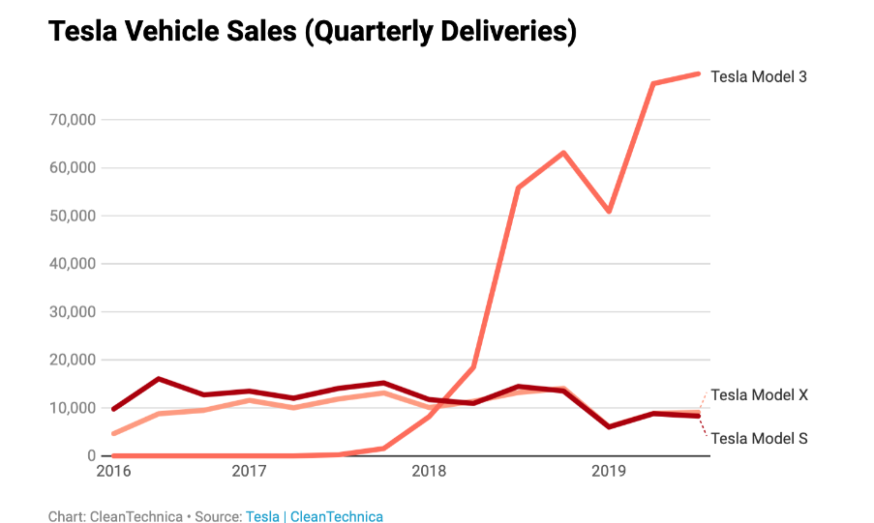

If we look at Tesla's strategy, projects like Cybertruck aren't really about making money; they're about getting attention and proving that Tesla is one of the world's most innovative companies, with the goal of building Tesla's ability to win support from stakeholders — what we call innovation capital. Tesla never misses an opportunity to try new things and excel it to new level which in turn will always help to grow its market capitalisation. With the manufacturing of its most affordable electric automobile to date, Tesla continues to make products accessible and affordable to an increasing number of people, thereby accelerating the usage of clean transportation and clean energy in automobile. Electric vehicles, batteries, and renewable energy generation and storage all exist on their own, but when combined, they become even more powerful and promise a better future in terms of environment and capitalization.

Tesla vehicles are certainly in high demand. Every month, it appears that the corporation is setting new sales records. Despite the high demand, there is a production bottleneck, resulting in a growing waitlist for backordered vehicles. The green energy movement is helping to boost growth. Because Tesla vehicles are all-electric, they do not require greenhouse gas-emitting fuel and do not emit carbon dioxide directly. However, CO2 is still produced as a by-product of the electrical generating required to charge the car's batteries. In addition, Tesla cars are high performance. The Model S can travel over 400 kilometres on a single charge, and charging is simple. The Model S can accelerate from 0 to 60 miles per hour in 2.3 seconds. All of this is combined with the fact that electric cars are nearly silent when driving, which is a highly desirable characteristic for many.

# **2.8 ENVIRONMENTAL IMPACT**

* Tesla's priority has always been on developing products that are not just sustainable, but also superior to fossil-fuel equivalents, as many consumers assume that choosing sustainable products means giving up price or performance.
* Tesla’s all-electric vehicles combine performance, safety, and efficiency to make them the best cars in the world, while Tesla's energy generation and storage technologies provide reliable, affordable energy to both metropolitan and distant populations.
* Over 600K Tesla vehicles have been sold, and they have driven over 11B miles to date, resulting in a combined savings of over 6M metric tons of CO2. This is the equivalent of preventing nearly 500K ICE vehicles with a fuel economy of 22 miles per gallon(MPG) from emitting pollution into the environment.
* Transportation and energy generation are two of the main sources of GHG emissions in the United States, accounting for more than half of total emissions. Tesla's ecosystem (solar, batteries, and automobiles) attempts to reduce the environmental consequences of transportation, electricity generation, and energy consumption by people, homes, businesses, and the grid. Prior to the release of the Tesla Roadster in 2006, there was no feasible all-electric vehicle choice on the market. Now, 12 years later, there are over 3 million electric vehicles on the road worldwide, with more being developed on a daily basis.
* The car industry is moving toward electrification, and governments throughout the world have recognized the negative impact of internal combustion engine (ICE) vehicle emissions and have begun to take meaningful actions toward a more ecologically friendly and sustainable future.
* However, many lightweight materials used in electric car components, such as aluminium and carbon-fibre-reinforced plastics, require a lot of energy to manufacture and process. Electric motors and batteries contribute to the energy used in the production of electric vehicles. Rare-earth metals are used in the magnets found in permanent magnet motors used in electric vehicles to boost the power output of these motors. Mining and processing of metals such as lithium, copper, and nickel require a lot of energy and can result in the emission of hazardous chemicals.
* Tesla had installed over 3.5 Gigawatts of solar capacity and generated over 13 Terawatt hours (TWhs) of zero-emissions electricity as of February 2019. To put 13 TWhs into perspective, this amount of energy could provide the entire state of Connecticut's yearly household power demand. These solar systems are estimated to create 86.5 TWh of energy throughout their whole expected usage life of 35+ years, which is enough electricity to power all of Washington, D.C. for about a decade.

# **2.9 COMPETITORS AND OTHER THREATS FOR EXISTENCE**

## **2.9.1 Threats to Tesla**

* **Product Liability Claims**

Despite Tesla’s premium quality assurance and high standards of manufacturing, the automobile industry, in particular, is bound to face product liability claims to some extent which the company is concerned about to be one of the biggest financial loss factors.

Tesla has the main objective of autopilot vehicles, but not all of them have been successful in case of an accident. The company has faced several accusations and lawsuits and claims related to the failure of technology in their cars. If these types of claims continued, then Tesla may face greater financial setbacks.

* **Extensive Competition**

Tesla, faces massive competition from both alternative fuel vehicles (Hybrid, Plug-in hybrid, fully electric car) and self-driving/autopilot technology. Many automotive brands in the luxury segment like Mercedes, BMW, Audi, Lexus and in the budget segment like Toyota, Ford, Volvo, General Motors are getting ready for an aggressive competition.

Many brands are not only launching or planning to launch their environment-friendly/ self-driving technology but also, they are offering them at a comparably lower price. It is a definite threat for a company like Tesla, which blossoms on its unique value for innovative cars which are extremely expensive and unaffordable for many.

* **High-Risk Factor Due to Usage of Lithium-ion**

Tesla uses lithium-ion cells in their battery packs which basically replaces fuel engines. Lithium is a highly reactive and explosive element, which increases the risk factor of the products. Tesla has faced a few cases where the cars have caught fire and released smoke, which has affected the company’s name on a major level.

* **Lack of regulations for self-driving.**

As there are no proper rules and regulations for self-driving in many countries, including the US, Tesla’s struggles to make greater sales due to the self-driving restrictions in many areas. This controversial situation of legal complexity increases uncertainty about Tesla’s self-driving project’s future.

## **2.9.2 Competitor of Tesla**

There are number of competitors in the market against Tesla, which are not only manufacturing EV but also selling at more affordable prices than Tesla.

Some of these includes

* Ford
* Volkswagen
* General Motors and many more.

# **2.10 LONG TERM POLICIES OF THE INDUSTRY FOR ITS EXISTENCE**

The goal of the company is very clear and promising i.e., to accelerate the advent of sustainable transport by bringing riveting mass market electric cars to market at the earliest. The electric vehicles are obviously the substitute for the gasoline cars which of course is not sustainable as the non-renewable energy sources are on the verge of extinction. Moreover, the cost and maintenance of electric vehicles is far less than the gasoline ones, as the cost of electricity to full charge the EV is less than what the gasoline cars demands fuel for the same range of kms.

Few points which increase the chance of Tesla’s existence are

* Tesla's business model is based on direct sales and service and not they are not into franchised dealerships.
* Tesla's business model pays particular attention on installing charging stations. That primarily is the biggest obstacle to the mass adoption of electric vehicles.
* Tesla has managed to expand the business model to hold energy storage systems for homes and businesses.

Moreover, Tesla has their own concept of **THE SUPERCHARGE NETWORK** which basically allows the Tesla owners to charge their cars in about 30 minutes for free of cost. The main reason behind this concept is obviously to accelerate the adoption rate of electric cars by making it affordable and efficient.

One policy that Tesla has adopted is that they have combined many of its sales centres with service centres, including charging stations, the idea is to reduce the customer demand as opening a service centre in a new area would lead to increase the demand. One can charge or service their Tesla at the service centre.

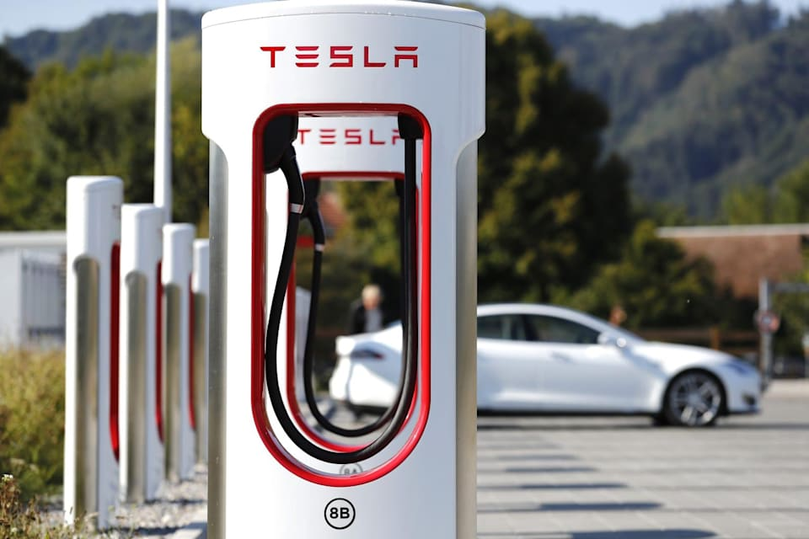

# **2.11 SAFETY AND HEALTH NORMS FOLLOWED**

First, Tesla rolled out an over-the-air update to the air suspension that will result in higher ground clearance at maximum speeds. To be accurate, this is about minimising the chances of underbody impact damage, not improving safety. Tesla has claimed that the theoretical probability of a fire injury is already really very small and the actual number till now is zero. Another software update that gives the driver direct control of the air suspension ride height transitions is also rolled out, and many more such software updates are rolled out frequently to enhance the safety features.

Second, they have requested that the National Highway Traffic Safety Administration to conduct a full investigation into the fire incidents at the earliest. They said that it is almost impossible, if something would come out that would result in a materialistic improvement in occupant fire safety, and if came, they will immediately apply that change to new cars and offer it as a free upgrade to all the existing ones. They are confident that the incidence of fires is far lower than the normal combustion cars and that there have been no resulting injuries, this did not at first seem like a good use of NHTSA’s time compared to the hundreds of gasoline fire deaths per year that warrant their attention. However, there is a larger issue at stake: if a false perception about the safety of electric cars is not identified, it will delay the beginning of sustainable transport and eventually increase the risk of global climate change, with a disastrous consequence worldwide. That cannot be allowed to happen.

Third, to emphasise on how strongly they believe about the low risk of fire in their cars, they will reform their warranty policy to cover damage due to a fire, even if due to driver error. Unless an owner purposely tries to destroy the car, they are covered. Their goal mainly is to eliminate any concern about the cost of such an event and ensure that over time the Tesla cars has the lowest insurance cost of any car at their price point. Either their belief in the safety of their car is correct and this is a minor cost or else they are wrong in which case the right thing is for Tesla to bear the cost rather than the owner.

All of these actions are taken in order to make clear the believe they have in their product and to eliminate any misperceptions regarding the integrity of their technology and the safety of their cars.

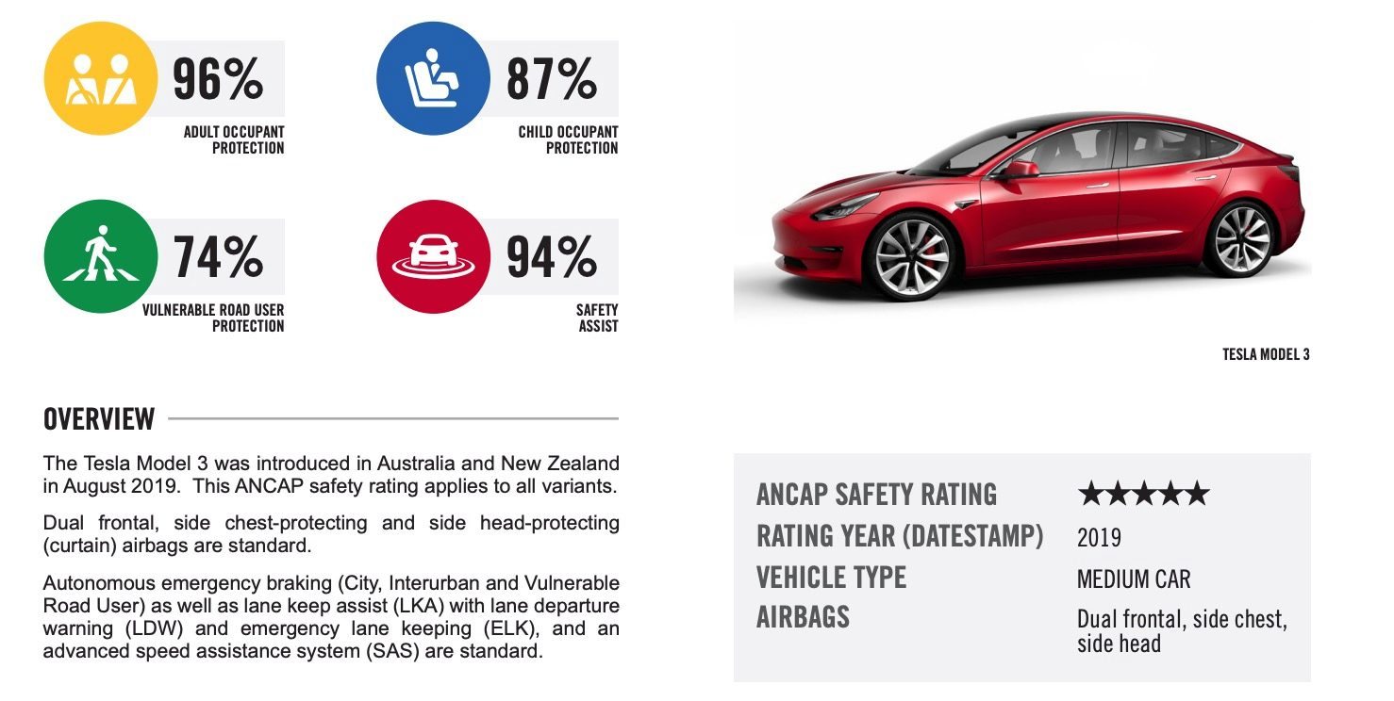

# **3 LEARNING FROM INDUSTRIAL ORIENTATION**

# **4 REFERENCES**