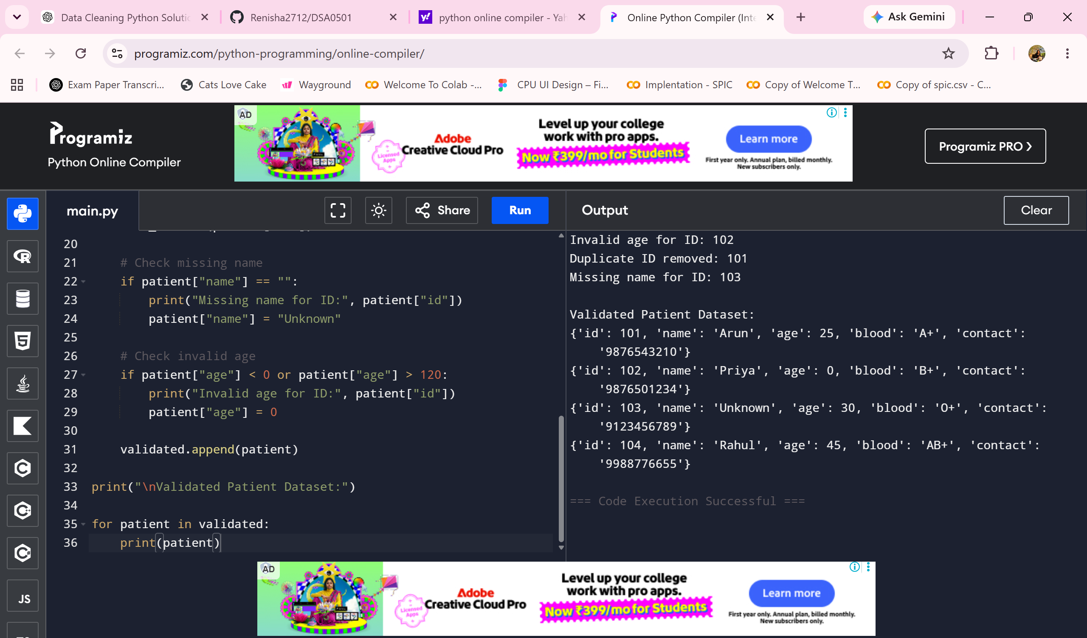
Patients = [
{"id": 101, "name": "Arun", "age": 25, "blood": "A+", "contact": "9876543210"},
{"id": 102, "name": "Priya", "age": -5, "blood": "B+", "contact": "9876501234"},
{"id": 101, "name": "Arun", "age": 25, "blood": "A+", "contact": "9876543210"},
{"id": 103, "name": "", "age": 30, "blood": "O+", "contact": "9123456789"},
{"id": 104, "name": "Rahul", "age": 45, "blood": "AB+", "contact": "9988776655"}
]

validated = []
seen_ids = set()

for patient in patients:

# Remove duplicate patient IDs
if patient["id"] in seen_ids:
print("Duplicate ID removed:", patient["id"])
continue

seen_ids.add(patient["id"])

# Check missing name
if patient["name"] == "":
print("Missing name for ID:", patient["id"])
patient["name"] = "Unknown"

# Check invalid age
if patient["age"] < 0 or patient["age"] > 120:
print("Invalid age for ID:", patient["id"])
patient["age"] = 0

validated.append(patient)

print("\nValidated Patient Dataset:")

for patient in validated:
print(patient)

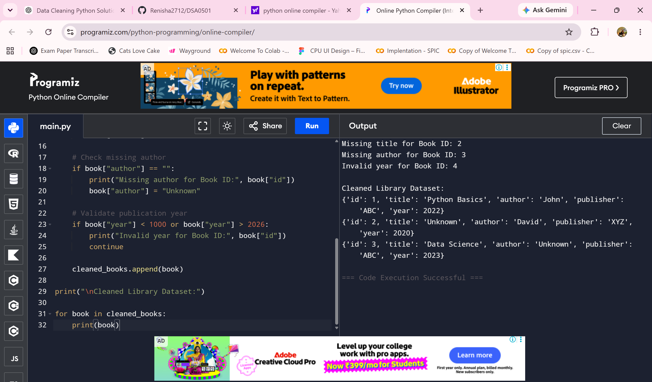

2. Library Database Preparation
books = [
{"id": 1, "title": "Python Basics", "author": "John", "publisher": "ABC", "year": 2022},
{"id": 2, "title": "", "author": "David", "publisher": "XYZ", "year": 2020},
{"id": 3, "title": "Data Science", "author": "", "publisher": "ABC", "year": 2023},
{"id": 4, "title": "Machine Learning", "author": "Sam", "publisher": "XYZ", "year": 2030}
]

cleaned_books = []

for book in books:

# Check missing title
if book["title"] == "":
print("Missing title for Book ID:", book["id"])
book["title"] = "Unknown"

# Check missing author
if book["author"] == "":
print("Missing author for Book ID:", book["id"])
book["author"] = "Unknown"

# Validate publication year
if book["year"] < 1000 or book["year"] > 2026:
print("Invalid year for Book ID:", book["id"])
continue

cleaned_books.append(book)

print("\nCleaned Library Dataset:")

for book in cleaned_books:
print(book)

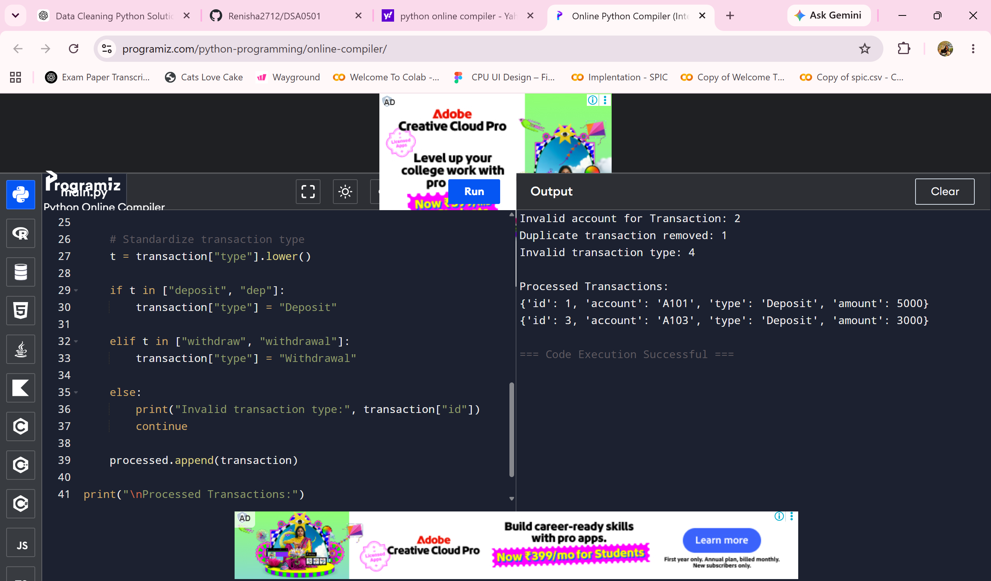3. Banking Transaction Analysis
transactions = [
{"id": 1, "account": "A101", "type": "deposit", "amount": 5000},
{"id": 2, "account": "", "type": "withdraw", "amount": 2000},
{"id": 1, "account": "A101", "type": "deposit", "amount": 5000},
{"id": 3, "account": "A103", "type": "DEP", "amount": 3000},
{"id": 4, "account": "A104", "type": "wrong", "amount": 1000}
]

processed = []
seen_ids = set()

for transaction in transactions:

# Remove duplicate transaction IDs
if transaction["id"] in seen_ids:
print("Duplicate transaction removed:", transaction["id"])
continue

seen_ids.add(transaction["id"])

# Check blank account number
if transaction["account"] == "":
print("Invalid account for Transaction:", transaction["id"])
continue

# Standardize transaction type
t = transaction["type"].lower()

if t in ["deposit", "dep"]:
transaction["type"] = "Deposit"

elif t in ["withdraw", "withdrawal"]:
transaction["type"] = "Withdrawal"

else:
print("Invalid transaction type:", transaction["id"])
continue

processed.append(transaction)

print("\nProcessed Transactions:")

for transaction in processed:
print(transaction)

