

INTERNSHIP REPORT

An Internship Report Submitted to
DR. VISHWANATH KARAD MIT WORLD PEACE UNIVERSITY

Submitted by,
Renish Lale (1262240103)

Under the supervision of
Mr. Vinay Sabnis
and
Prof. Yogesh Gaikwad

Department of Polytechnic and Skill Development
Dr VK MIT World Peace University, Kothrud, Pune-411038
Period from 3rd June 2026 to 17th July 2026

Department of Polytechnic and Skill Development, Pune Integrated B. Tech Computer Engineering

Weekly Internship Report

Course Title: Industrial Internship (INI)
Name of student: Renish Mangesh Lale
Name of Academic Mentor: Mr. Yogesh Gaikwad
Course Outcomes:
∙ Demonstrate the technical knowledge by applying them, as the case.
∙ Develop professional communication skills and interpersonal skills.
∙ Exhibit the work done
∙ Working in a team
∙ Understand professional responsibilities and ethics.
∙ Collect and organize data into meaningful information.

Name of Company: Arixel Tech
Name of Industry Mentor: Vinay Sabnis
Duration: 3rd June – 17th July
Role: DevOps Intern

Week 1 (2nd June – 7th June):
Introduced to project management tools such as Jenkins, GitLab, Zoho Projects, and Jira, and learned their basic features and uses.

Week 2 (8th June – 14th June):
Prepared and delivered presentations explaining various project management tools to improve understanding and communication.

Week 3 (15th June – 21st June):
Studied application security tools and gained an understanding of their role in software security.

Week 4 (22nd June – 28th June):
Created presentations and explored application security concepts through practical discussions.

Week 5 (29th June – 5th July):
Learned the fundamentals of DevSecOps and its importance in secure software development.

Week 6 (6th July – 12th July):
Followed the GitLab learning roadmap. Learned GitLab basics and CI/CD concepts.

Week 7 (13th July – 17th July):
Successfully created GitLab CI/CD pipelines and learned Docker containerization basics.

Industry Mentor Comment:
During his internship, Renish performed the tasks assigned to him with sincerity and dedication. He maintained a professional attitude, demonstrated a willingness to learn, and worked well with the team throughout his tenure. We appreciate his efforts during the internship and wish him every success in his future academic and professional endeavors.

Final Summary:
During my internship, I gained practical knowledge of project management tools, DevSecOps, GitLab, CI/CD pipelines, and Docker. This experience improved my understanding of software development workflows, automation, and secure development practices.
CERTIFICATE OF COMPLETION

CERTIFICATE
This is to certify that the Internship Report entitled

Summer Internship Report at Arixel Tech Pvt. Ltd

Submitted by

Renish Lale (1262240103)

in partial fulfillment of requirement of an Internship at Arixel Tech Pvt. Ltd., is a Bonafide record of the work carried out by him during the period from 3rd June 2026 to 17th July 2026. He has worked under the supervision of Mr. Vinay Sabnis and Prof. Yogesh Gaikwad He has fulfilled the requirement of the submission of the Internship report for Third Year Computer Science Engineering as per the syllabus prescribed by the MIT World Peace University, Pune.


Name | Name | Name
Mr. Vinay Sabnis  Company Supervisor | Prof. Yogesh Gaikwad  Mentor | Prof. Vilas Rathod  Internship Coordinator

Dr Jyoti Mante
Program Head
CSE & AIDS

Dr Nitin Khedkar
Director Department of Polytechnic & Skill Development
AKNOWLEDGEMENT

I would like to thank Arixel Tech Pvt. Ltd., for giving me the opportunity to do an internship within the organization.
I am also grateful to internship coordinator Prof Vilas Rathod and Programme Head for facilitating and supporting this internship program.
I am thankful to my college mentor, Prof. Yogesh Gaikwad, for his continuous support and guidance during the internship. Special thanks to Mr. Vinay Sabnis for his timely help and technical mentorship throughout the internship.
I am also thankful to all members of Arixel Tech Pvt. Ltd. for creating a professional and enriching work environment.

TABLE OF CONTENTS

1. Company Profile / Introduction of Company
2. Department Worked In / Jobs Performed
3. Annexure 2 – Mid-Term Presentation
4. Analysis / Result
5. Observations & Challenges
6. Conclusion

Company Profile

ArixelTech is a Pune-based IT services and consulting company specializing in DevSecOps, cloud engineering, cybersecurity, and IT staff augmentation. The company helps organizations build secure, scalable, and efficient technology solutions by combining modern DevOps practices with security-first methodologies.
ArixelTech provides services in DevSecOps consulting, CI/CD pipeline implementation, cloud and infrastructure security, Salesforce and ServiceNow solutions, and IT resource augmentation. The company focuses on delivering high-quality technology solutions that improve software development, deployment, and operational efficiency.
The organization follows modern software development practices and leverages industry-standard tools such as GitLab, Jenkins, Docker, and security scanning solutions to support secure application delivery and continuous integration/continuous deployment (CI/CD).
Core Services: DevSecOps Consulting, Cloud Engineering, Cybersecurity, CI/CD Pipeline Automation, IT Staff Augmentation, Salesforce & ServiceNow Solutions, and AI Security & Automation.
2. Department Worked In / Jobs Performed

During the internship, I worked as a DevOps Intern in the DevOps Department.
My primary responsibility was to learn and implement DevOps practices using industry-standard tools. I gained hands-on experience with GitLab, CI/CD pipelines, DevSecOps concepts, Docker, and project management tools while working under the guidance of the technical team.
Daily Tasks & Learning:
- Week 1: Introduced to project management tools such as Jenkins, GitLab, Zoho Projects, and Jira, and learned their basic features and uses.
- Week 2: Prepared and delivered presentations explaining various project management tools to improve understanding and communication.
- Week 3: Studied application security tools and gained an understanding of their role in software security.
- Week 4: Created presentations and explored application security concepts through practical discussions.
- Week 5: Learned the fundamentals of DevSecOps and its importance in secure software development.
- Week 6: Followed the GitLab learning roadmap. Learned GitLab basics and CI/CD concepts.
- Week 7: Successfully created GitLab CI/CD pipelines and learned Docker containerization basics.

3. Annexure 2 – Mid-Term Presentation

🛡️ Enterprise DevSecOps Disaster Recovery & Deployment Platform
- A web-based platform designed to monitor infrastructure, track CI/CD pipelines, manage backup operations, and simulate automated disaster recovery workflows. It provides a centralized console for monitoring system health and improving application resilience.
- 🚀 Features
- 🖥️ Infrastructure and cluster node monitoring
- 🔄 Simulate chaos/failover scenarios and trigger recovery
- 📊 Track RTO and RPO for disaster recovery operations
- ⚙️ Monitor GitLab CI/CD pipeline status
- 💾 Manage backup snapshots and retention policies
- 🐳 Monitor Docker and container-based services
- 🔐 Integrate DevSecOps security scanning and audit logs
- 📋 Maintain recovery and system activity logs
- 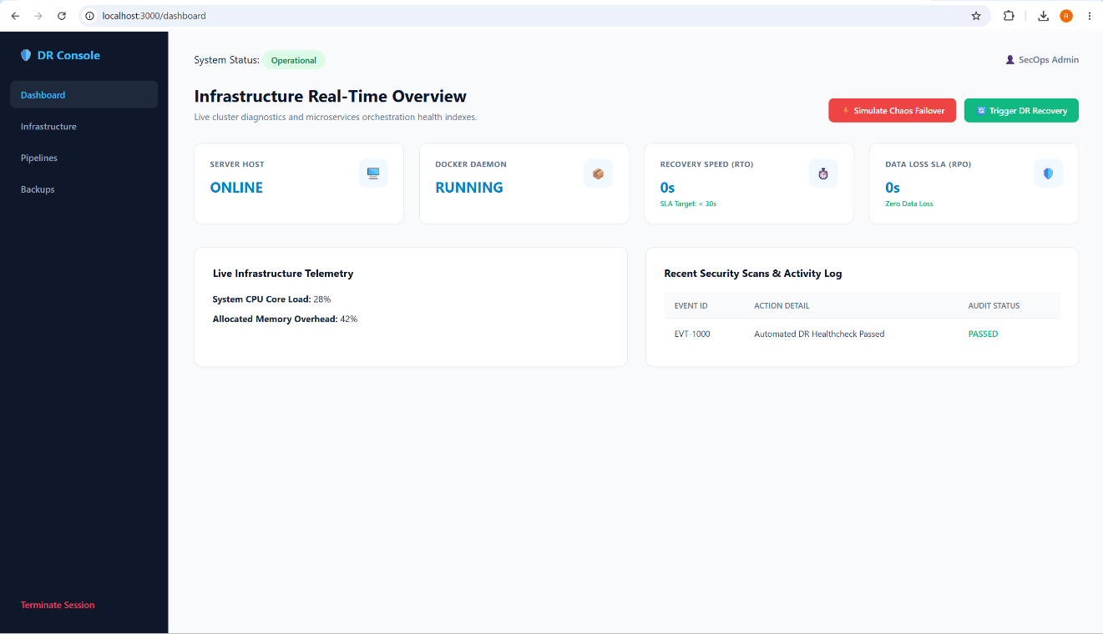

4. Analysis / Result

The outcome of the internship project was a functional Enterprise DevSecOps Disaster Recovery & Deployment Platform designed to provide a centralized view of infrastructure health, CI/CD pipelines, backup operations, and disaster recovery workflows. The platform enables users to monitor system status, track GitLab pipelines, view infrastructure nodes, manage backup snapshots, and simulate failover and recovery scenarios.
The application provides a clean and responsive dashboard interface with separate modules for Infrastructure, Pipelines, and Backups. It also includes disaster recovery features such as chaos failover simulation, recovery triggering, RTO/RPO tracking, health monitoring, and activity logging. The project demonstrates the practical integration of DevOps, DevSecOps, CI/CD, containerization, and disaster recovery concepts in a single platform.
Key Features:
- Clean and professional DevOps dashboard
- Infrastructure and node health monitoring
- GitLab CI/CD pipeline tracking
- Backup and snapshot management

GitLab Repository: https://github.com/Renishlale/Internship-project

5. Observations & Challenges
Challenges Faced:

1. Understanding DevOps Tools and Workflows:
Initially, understanding the purpose and workflow of tools such as GitLab, Jenkins, Jira, and other project management tools was challenging. Through practical learning and continuous exploration, I developed a better understanding of how these tools support software development and DevOps processes.

2. Configuring and Troubleshooting GitLab CI/CD Pipelines:
Creating and executing CI/CD pipelines required understanding pipeline stages, jobs, runners, and configuration files. Initial errors in pipeline configuration and execution helped me understand the importance of proper YAML syntax, job dependencies, and troubleshooting failed pipelines.

3. Integrating DevSecOps Practices into Development Workflows:
Understanding how security tools such as SAST, DAST, dependency scanning, and secret detection are integrated into CI/CD pipelines was a technical challenge. Studying application security tools and DevSecOps practices helped me understand how security can be included throughout the software development lifecycle.

4. Understanding Docker and Container-Based Deployment:
Learning about Docker, containers, images, and containerized application deployment required understanding a new deployment environment. Creating and managing containers helped me understand how applications can be packaged and deployed consistently across different environments.
Observations:

1. Automation Improves Development Efficiency:
Working with GitLab CI/CD demonstrated how automated pipelines can reduce manual effort and provide consistent build, testing, security scanning, and deployment workflows.

2. Security Should Be Integrated into the Development Lifecycle:
The study of DevSecOps and application security tools showed that security testing should be integrated into the development process rather than performed only at the end of development.

3. Practical Experience Reinforces Technical Concepts:
Hands-on experience with GitLab, CI/CD pipelines, Docker, DevSecOps tools, and disaster recovery concepts helped strengthen my understanding beyond theoretical learning.

4. Disaster Recovery Requires Automation and Monitoring:
While developing the Disaster Recovery Platform, I observed that monitoring, backups, automated recovery workflows, and metrics such as RTO and RPO are important for maintaining system availability and reducing downtime.

6. Conclusion

The internship at Arixel Tech was a valuable learning experience that helped me understand modern DevOps practices and industry workflows. During the eight-week internship, I gained practical knowledge of project management tools, application security, DevSecOps, GitLab, CI/CD pipelines, and Docker.
This internship enhanced my understanding of software development automation, secure development practices, and continuous integration/continuous deployment (CI/CD). Working with tools such as GitLab, Jenkins, Jira, and Docker provided me with hands-on exposure to industry-standard technologies and DevOps methodologies.
In addition to technical knowledge, I improved my communication, teamwork, presentation, and problem-solving skills through regular learning sessions and technical presentations. The internship also strengthened my confidence in adapting to new technologies and working in a professional environment.
Overall, this internship has provided a strong foundation in DevOps and DevSecOps concepts and has motivated me to continue developing my technical skills for future academic and professional opportunities. I am grateful to my mentors and the entire Arixel Tech team for their guidance, support, and encouragement throughout the internship.

Annexure – Internship Certificate
The internship certificate issued by Arixel Tech Pvt. Ltd. is attached below:
