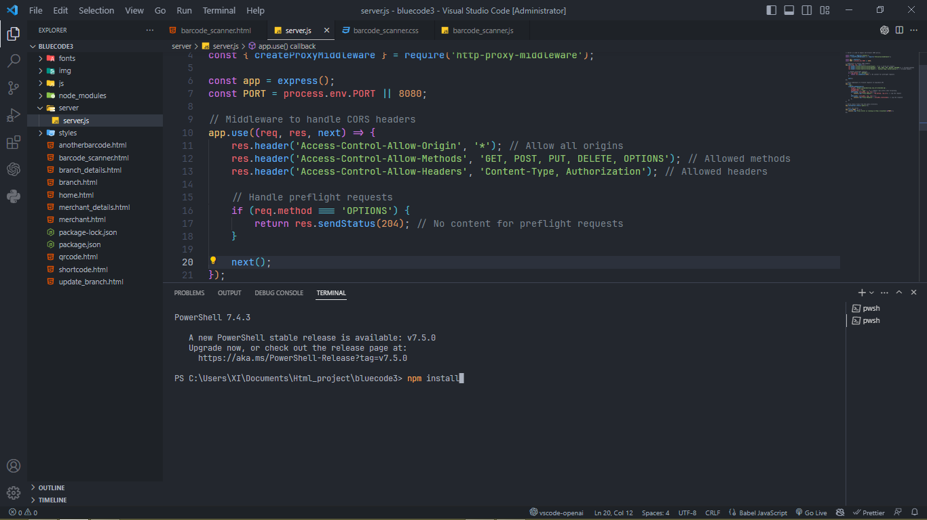

==========================================================

Step 1:

On the terminal, install node package manager (npm) using the command npm install to install all necessary dependencies included in the package.json file. 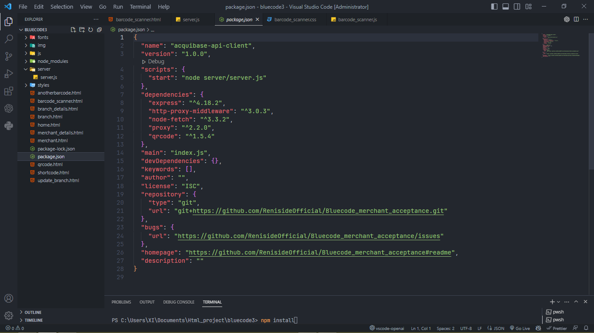

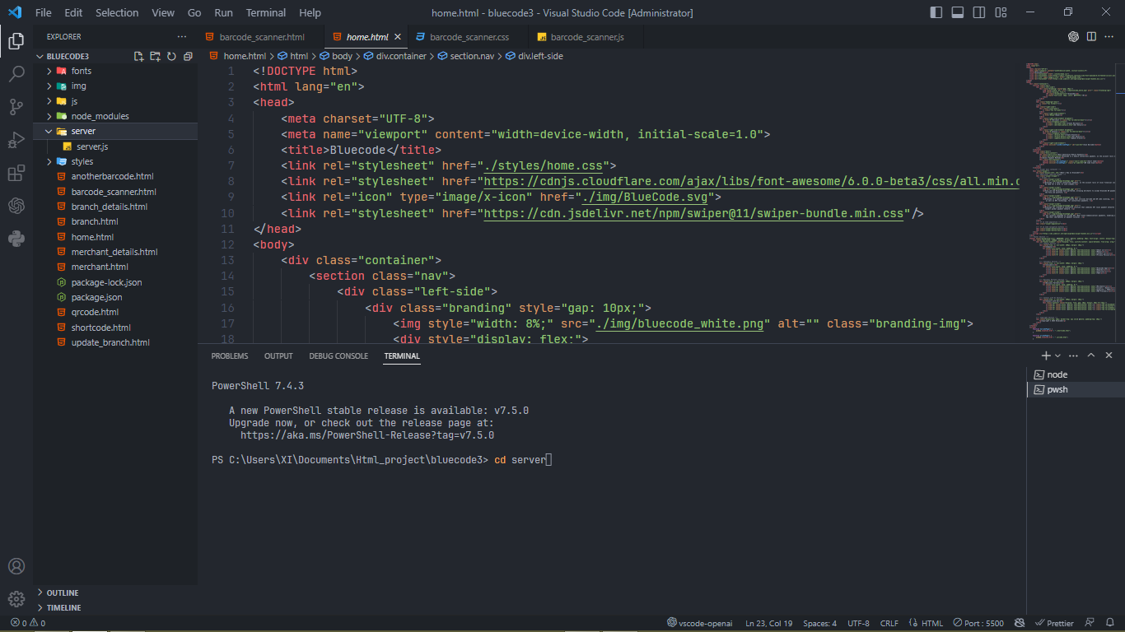

==========================================================

Step 2:

Move into the server folder using this command on the terminal

cd server, after that enable the server.js file in the folder using this command node server.js so as to listen for api request on the Port inorder to bypass CORS web browser policy. You should get this message “Proxy server is running on <http://localhost:8080>”

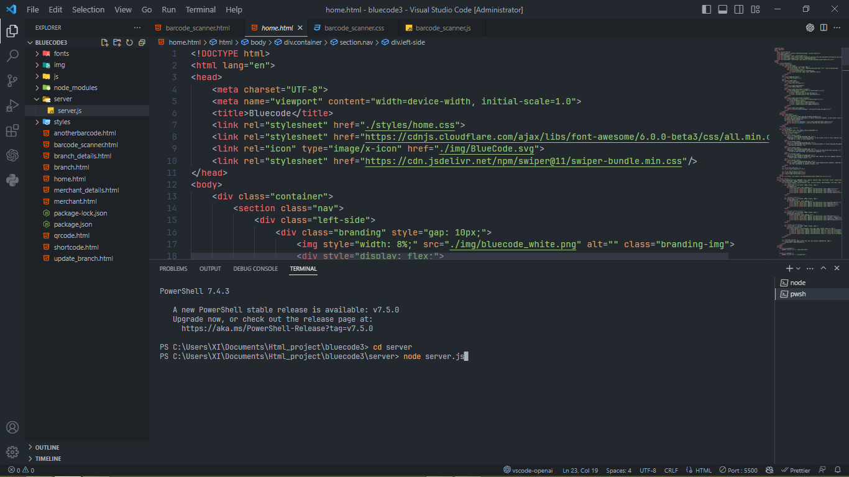

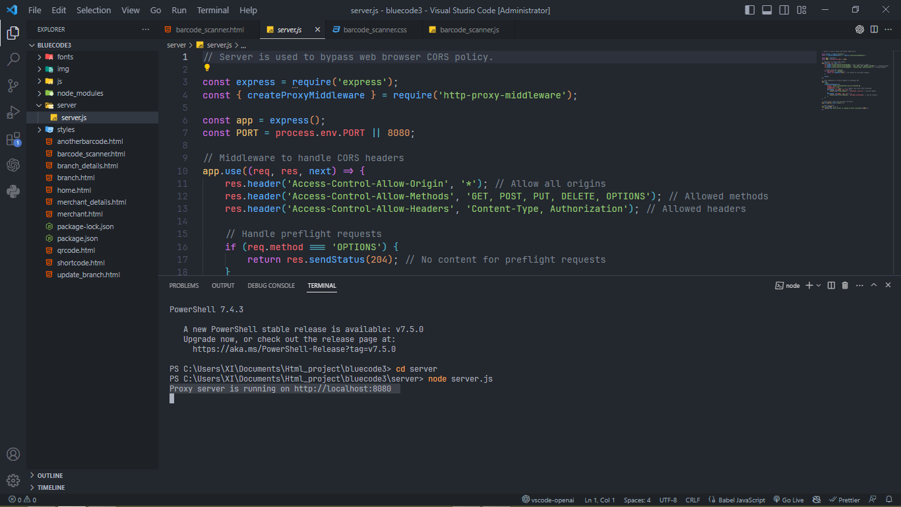

==========================================================

Step 3:

Right click on the code and select “open with Live Server” to run it on the default web browser.

