Renivet Corporate Order Current State
Current UI, features, document chain, required flow, and implementation gaps
Prepared for product, operations, finance, and engineering alignment. This report describes what is currently implemented in the repository, what the current document previews show, and what is still required for a dependable corporate procurement workflow.
Report detail | Value
Repository reviewed | C:\Personal Projects\renivet-marketplace
Review date | 06 October 2026
Scope | Corporate ordering, RFQ, payment, fulfilment, finance, invoices, and operational documents
Evidence used | Current React/Next.js routes and components plus rendered PDF previews stored in the repository

Executive conclusion: Renivet already has the foundations of a complete corporate ordering system. The strongest implemented areas are the multi-step self-service order flow, the newer RFQ and quote workflow, payment handling, admin operations, and a broad corporate document chain. The main work remaining is operational hardening: make the primary corporate journey unambiguous, close edge cases around approvals and document issuance, confirm permissions and notifications end to end, and define a single source of truth for status and finance reconciliation.

1 Current state at a glance
The current system contains two overlapping buyer experiences. The legacy self-service flow is a five-step configurable garment ordering journey. The newer corporate procurement surface is a dashboard-led RFQ, quote, purchase order, payment, fulfilment, and finance journey. Both are present in the repository and are linked from the corporate landing surface.
Area | Implemented today | Current-state assessment
Buyer entry | Corporate procurement landing page, corporate orders page, profile corporate dashboard, legacy self-service route | Implemented, but two journeys can confuse users unless one is clearly designated as primary.
Order capture | Company/contact, delivery, quantity, product configuration, colours, branding, employee size sheet, artwork, notes | Strong for configured apparel orders.
RFQ and quote | RFQ form with attachments, admin quote preparation, revisions, buyer approval or revision request | Implemented in the newer platform flow.
Purchase order | Buyer PO upload and admin/direct PO creation paths | Implemented; needs clear approval and exception rules.
Payments | Razorpay advance, balance, requested payment, full upfront, payment confirmations, receipt vouchers | Implemented; reconciliation and failure handling need explicit operating procedures.
Production and fulfilment | QC gate, status updates, shipment workspace, dispatch and delivered states, replacement requests | Implemented across admin/brand workspaces.
Finance documents | Proforma, customer tax invoice, vendor PO, brand tax invoice, delivery challan, receipt voucher, settlement statement, order summary | Broad document coverage; sequence and ownership must be enforced consistently.

2 Current corporate UI inventory
Screen or route | What it provides | Primary users
/corporate | Corporate catalog, RFQ entry, corporate dashboard link, legacy self-service link | Buyer
/corporate-orders | Legacy five-step order flow: Company, Product, Branding, Employee Sizes, Summary | Buyer
/profile/corporate | Dashboard metrics for requests, quotes, orders, approved quotes, payments, deliveries; quote review and order setup | Buyer
/profile/corporate/request-quote | Company/contact, requirements, quantity, budget, date, procurement mode, preferences, description, attachments | Buyer
/profile/corporate/self-service | Self-service flow entry from the corporate dashboard | Buyer
/dashboard/general/corporate | Corporate command center for RFQs, tasks, reports, finance, and executive views | Renivet admin
/dashboard/general/corporate-orders | Corporate orders table, order detail, document chain, payment ledger, QC, shipment workspace | Renivet operations/admin
/dashboard/brands/{brandId}/corporate-orders | Brand-side corporate orders workspace | Supplier brand

Code evidence: the route and component inventory above is based on the current source tree under src/app, src/components/corporate-platform, src/components/corporate-orders, src/components/dashboard/general/corporate-orders, and src/components/profile/general.

3 End to end corporate order flow
The intended end-to-end flow can be represented as follows. The current implementation supports the major states, but the handoffs should be treated as controlled transitions with role ownership, mandatory data, and document prerequisites.
Step | Buyer and system action | Current implementation | Required control
1. Discover | Buyer opens corporate surface and chooses catalog, RFQ, or self-service. | Corporate landing page links all three paths. | Declare one recommended path for new buyers and explain when self-service is appropriate.
2. Submit requirement | Buyer enters company/contact, quantity, delivery date, use case, budget, preferences, description, and files. | RFQ form captures these fields and accepts PDF, PPT, XLSX, images, and ZIP attachments within 50 MB. | Validate required fields, attachment safety, PII handling, and delivery-date feasibility.
3. Prepare quote | Admin reviews RFQ, selects supplier/product inputs, sets cost/tax/advance, and creates a quote. | Admin RFQ queue supports manual quote preparation and revisions. | Keep quote calculation auditable and lock commercial terms after buyer approval.
4. Buyer decision | Buyer approves quote, requests revision, or proceeds through PO/payment route. | Buyer dashboard exposes quote decisions and purchase-order upload. | Define expiry, revision limits, approval authority, and audit history.
5. Order release | System creates order after accepted quote plus PO or required payment condition. | Purchase-order and payment mutations are present; finance queue supports order release. | Use a single release gate so no production starts without approved commercial evidence.
6. Advance and receipt | Buyer pays advance or full amount; receipt voucher is generated. | Razorpay flows, payment confirmation, balance links, and receipt voucher are implemented. | Handle failed, duplicate, delayed, and unmatched payments with reconciliation ownership.
7. Supplier fulfilment | Vendor PO, production, QC, shipment, dispatch, and delivery are tracked. | Document chain, QC review, status timeline, and shipment workspace are present. | Make QC approval and dispatch prerequisites explicit and enforce role permissions.
8. Final billing | Customer tax invoice is issued; balance is collected where applicable. | Tax invoice, balance payment link, payment status, and paid-in-full variant exist. | Define issue timing, place-of-supply, tax identity, credit/adjustment handling, and reissue policy.
9. Settlement | Supplier settlement is produced after delivery and finance checks. | Settlement statement includes commission, GST on commission, TCS, TDS, and net remittance. | Tie settlement to delivery confirmation, final invoice, returns/replacements, and payout status.

4 Current features by capability

Buyer and company data
- Corporate profile and company snapshot
- Company name, contact person, email, phone, GSTIN, delivery address
- Employee count and employee size-sheet upload
- Customer notes and payment preference

Product and customization
- Product type, GSM, fabric composition, colours
- Logo placement, print method, artwork upload
- Custom colours and extra charge rules
- Quantity and configured quote summary

Commercial workflow
- RFQ creation and attachments
- Admin manual quote creation
- Quote revision history and buyer decision
- Purchase-order upload and direct admin order creation
- Partial advance or full upfront payment options

Operations
- Corporate order status timeline
- Quality-control submission and approve/reject actions
- Ready for dispatch, dispatched, delivered, and replacement flows
- Shipment workspace and dispatch details
- Brand-side corporate order workspace

Finance and documents
- Proforma invoice
- Customer tax invoice
- Vendor purchase order
- Receipt voucher
- Delivery challan
- Settlement statement
- Corporate order summary
- Payment ledger and balance payment links

5 Current screens and document evidence
The following captures are rendered from current repository previews. They are representative artifacts of the present document chain and should be used as the baseline for product, finance, and operations sign-off.
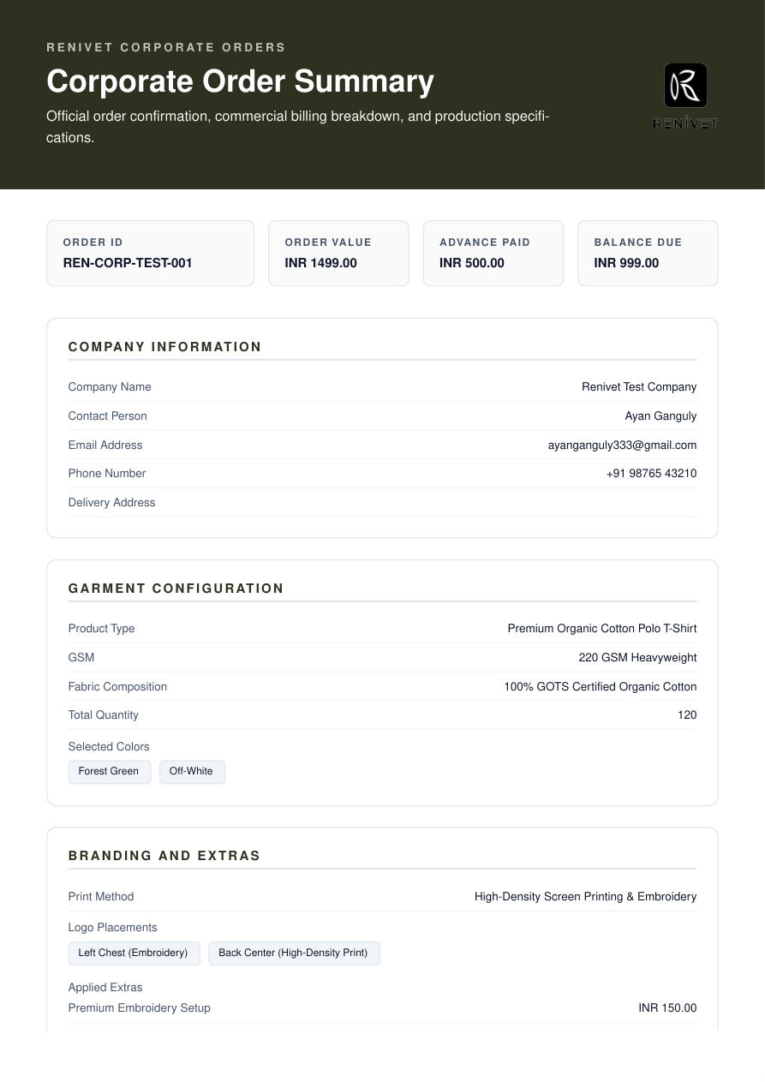
Figure 1. Corporate order summary showing company information, garment configuration, branding/extras, order value, advance paid, and balance due.
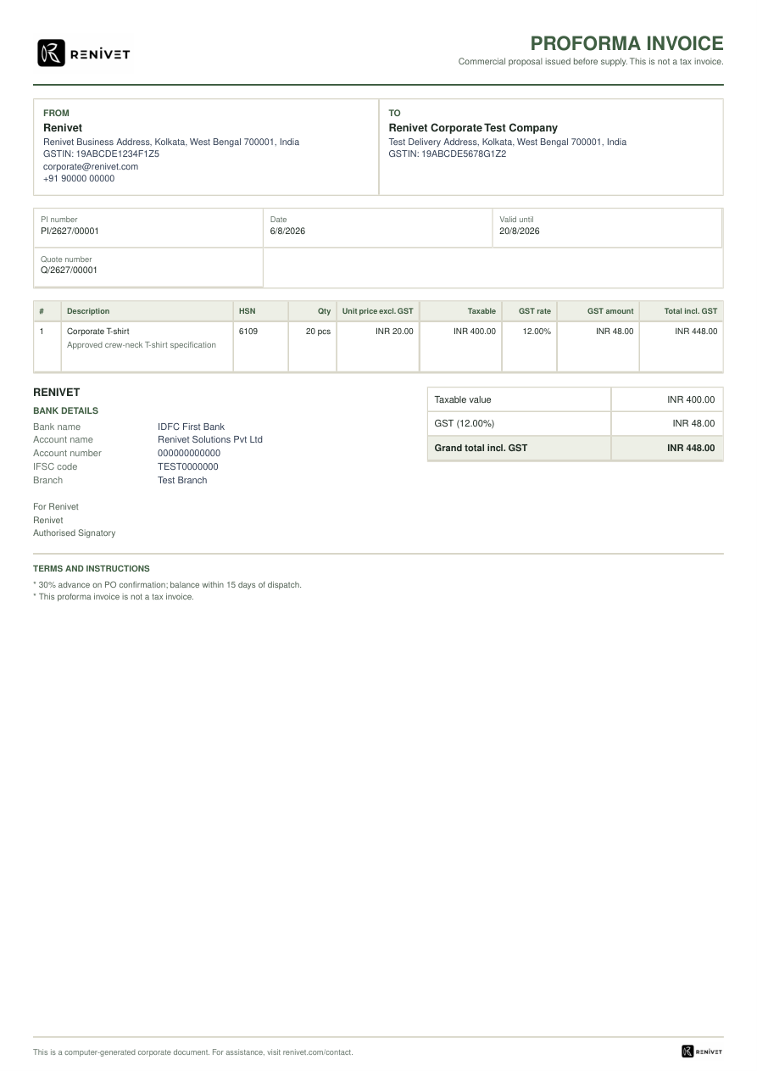
Figure 2. Proforma invoice showing buyer/seller, quote reference, taxable value, GST, advance terms, and validity.

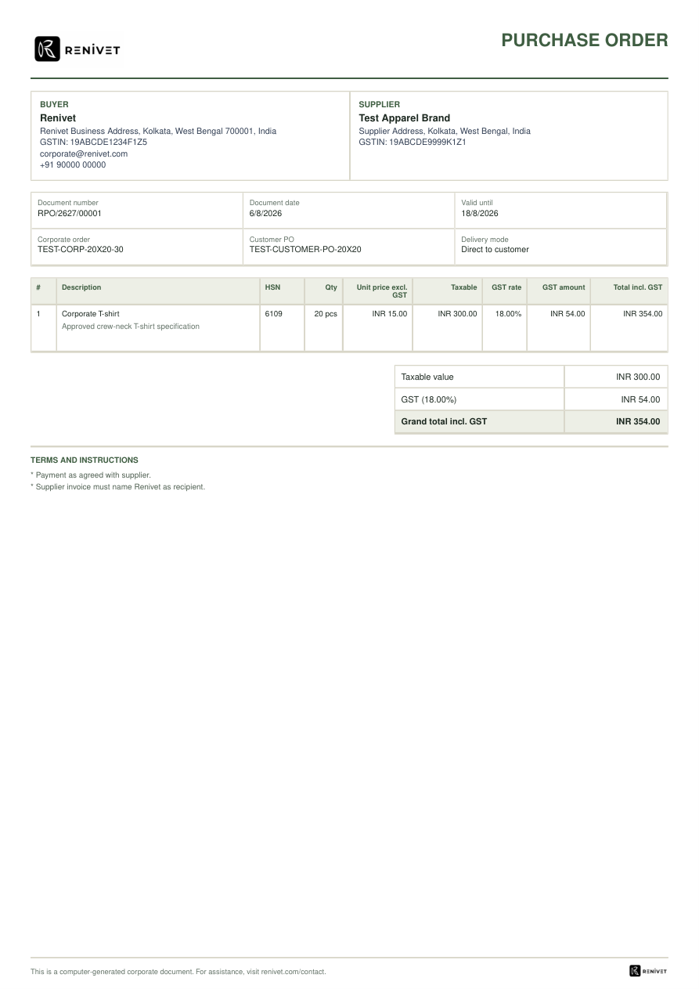
Figure 3. Renivet purchase order showing buyer, supplier, corporate order, customer PO, delivery mode, item, tax, and terms.
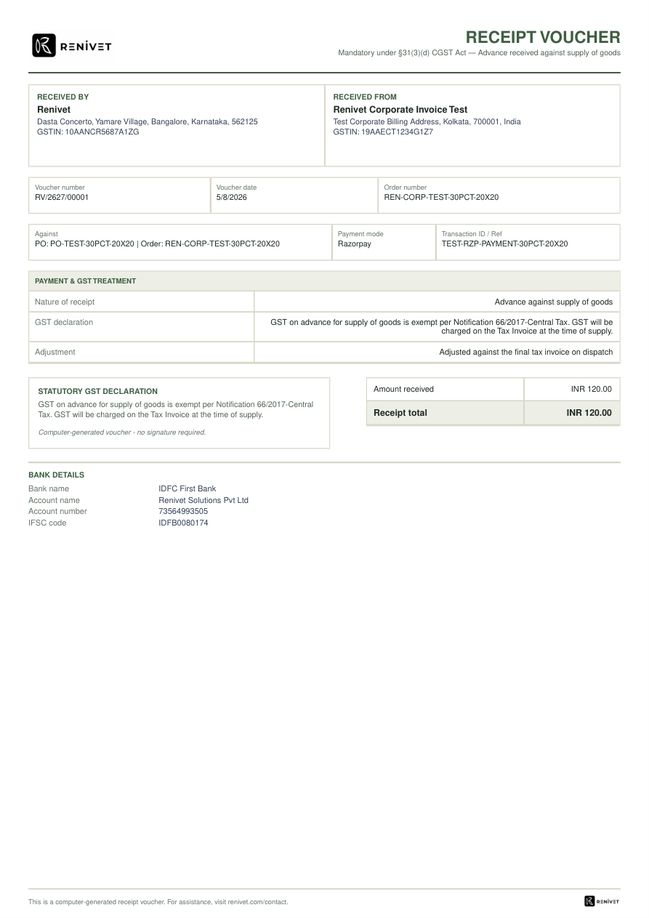
Figure 4. Receipt voucher showing advance received, payment reference, GST treatment, receipt total, and bank details.

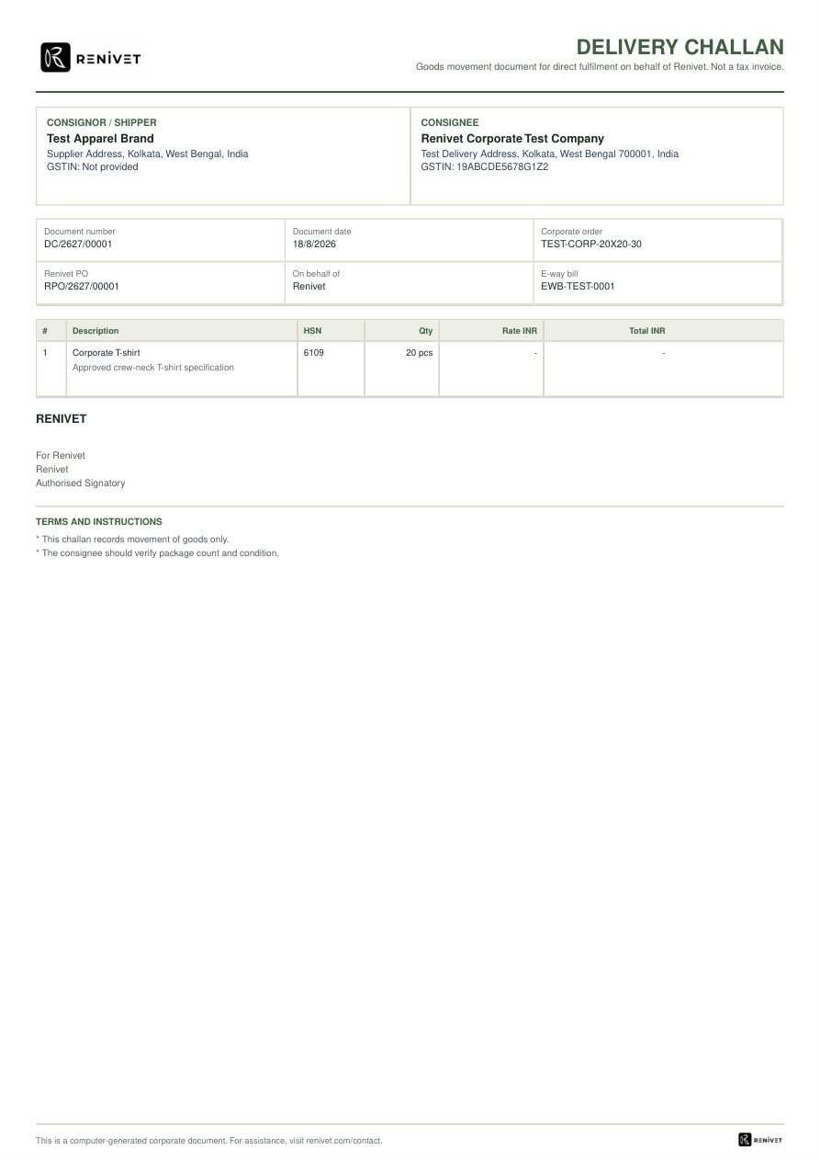
Figure 5. Delivery challan showing consignor, consignee, Renivet PO, e-way bill reference, goods movement, and terms.
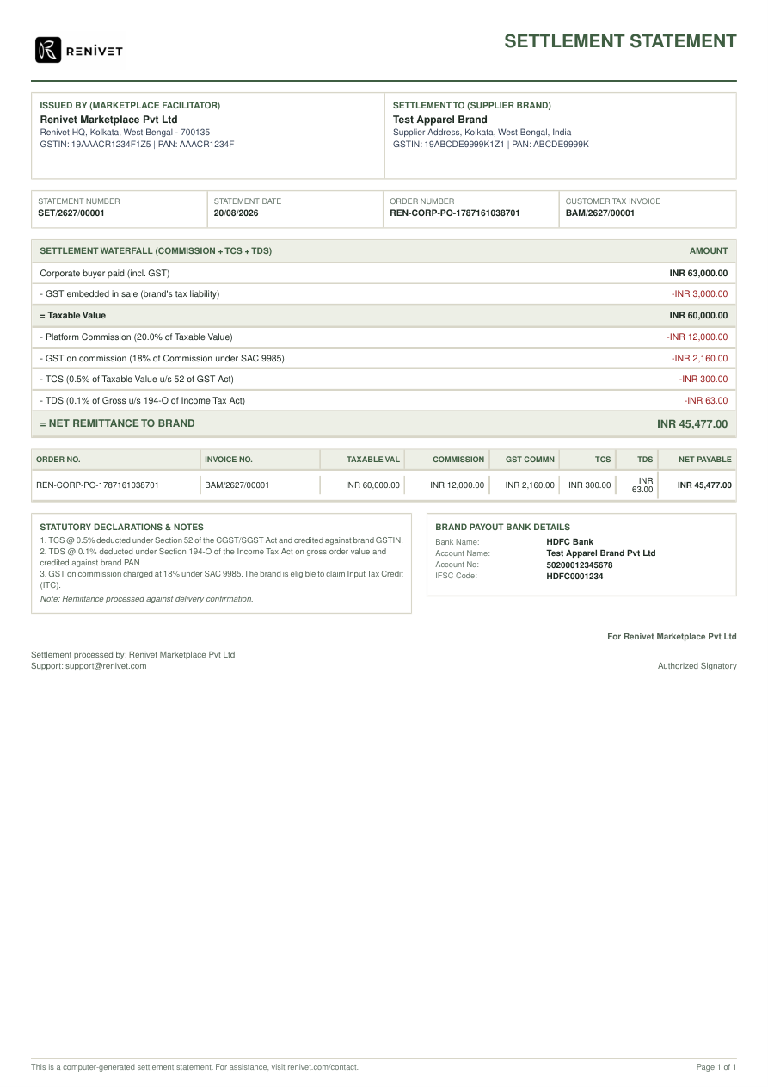
Figure 6. Settlement statement showing gross collection, embedded GST, platform commission, GST on commission, TCS, TDS, and net remittance.

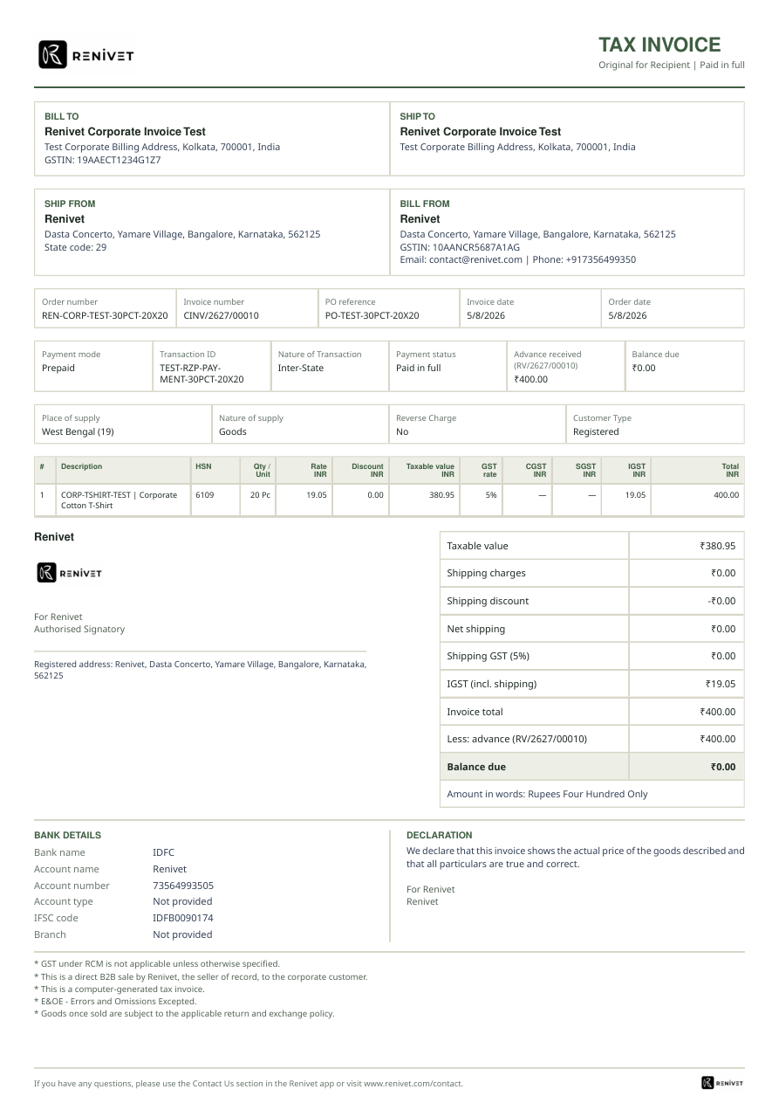
Figure 7. Customer tax invoice marked paid in full, including advance received, balance due, place of supply, GST breakup, QR, and declarations.

6 Document chain and ownership
Document | Purpose | Likely issuer | Trigger or prerequisite | Current evidence
Proforma invoice | Commercial proposal before supply; not a tax invoice | Renivet / corporate finance | Approved quote or advance/order setup | Rendered preview available
Customer purchase order | Buyer authorization and scope | Corporate buyer | Buyer chooses PO route | Upload and admin creation paths present
Receipt voucher | Evidence of advance/payment received | Renivet | Payment confirmation | Rendered preview available
Vendor purchase order | Instruction to supplier brand | Renivet | Order release and supplier details | Rendered preview available
Brand tax invoice | Supplier invoice into Renivet process | Supplier brand | Supplier fulfilment and invoice upload | Review and validation form present
Delivery challan | Goods movement document for direct fulfilment | Renivet / operations | Dispatch route requires goods-movement document | Rendered preview available
Customer tax invoice | Final customer tax invoice | Supplier brand or Renivet depending configured flow | Supply/invoice issuance condition | Paid-in-full and tax invoice previews available
Settlement statement | Supplier payout and deduction reconciliation | Renivet finance | Delivery/final billing and settlement checks | Rendered preview available

7 What is required for a production-ready corporate flow
The current implementation is feature-rich, but a production-ready operating model requires explicit business rules and controls around the flow. The requirements below are the minimum set to make the journey predictable for buyers, operations, suppliers, and finance.
Priority | Requirement | Why it is required | Acceptance signal
P0 | Choose and declare the primary buyer journey | Two corporate experiences currently coexist. | Landing page clearly recommends RFQ or self-service based on use case.
P0 | Define the order-release gate | Prevents production before quote, PO/payment, and required data are approved. | Every released order has an auditable commercial basis.
P0 | Lock quote snapshot after approval | Protects price, tax, quantity, customization, delivery, and terms. | Order snapshot cannot silently diverge from approved quote.
P0 | Enforce document prerequisites by state | Prevents missing or premature proforma, receipt, PO, challan, tax invoice, and settlement records. | Invalid document transitions are blocked with clear messages.
P0 | Complete role and permission matrix | Buyer, admin, finance, operations, and brand actions must be separated. | Unauthorized download, edit, approval, or issuance is denied and audited.
P1 | Create finance reconciliation runbook | Payment provider events, receipt vouchers, balance payments, refunds, and settlements need operational ownership. | Finance can reconcile every payment to order, customer, and document.
P1 | Define tax and place-of-supply rules | Corporate invoices include GST, HSN, CGST/SGST/IGST, GSTIN, and state logic. | Valid tax output is generated for intra-state and inter-state cases.
P1 | Define notification matrix | Buyers and internal teams need predictable updates at RFQ, quote, payment, QC, dispatch, delivery, and invoice events. | Each state has an owner, channel, template, retry, and audit record.
P1 | Add exception handling for revisions/cancellations/replacements | Real orders change after approval or production. | Every exception has eligibility, approval, financial adjustment, and audit trail.
P2 | Add reporting and SLA metrics | Operations need visibility into quote aging, production aging, payment aging, and fulfilment aging. | Admin reports show open work by owner and due date.

8 Gap assessment
Gap | Observed current state | Impact | Recommended next action
Journey overlap | Landing surface exposes both newer procurement and legacy self-service. | Buyer uncertainty and inconsistent data capture. | Set decision rules and label legacy flow as self-service where appropriate.
UI evidence and QA | Repository contains rendered document previews; live authenticated page screenshots are not part of the current evidence set. | Stakeholders cannot sign off all role-specific UI states from one artifact. | Capture authenticated buyer, admin, finance, and brand screenshots in the release QA pack.
Document lifecycle | Document chain is broad and components expose issue/download actions. | Risk of premature, missing, or duplicated documents without a central state machine. | Map each document to state, owner, issuer, number sequence, and reversal policy.
Finance edge cases | Payment and settlement features exist. | Failed, duplicate, partial, refunded, or unmatched payments may require manual intervention. | Add reconciliation statuses and finance exception queue rules.
Tax identity completeness | Corporate tax data, GSTIN, place of supply, and supplier identity are represented. | Invalid or incomplete tax output can block billing. | Make identity completeness a hard gate before issue.
Operational ownership | Admin task center, QC, shipment, and status timeline exist. | Work can stall if task ownership and SLA are not explicit. | Require owner, due date, escalation, and completion evidence for operational tasks.

9 Recommended target workflow
The recommended operating model keeps the existing capabilities but presents them as one controlled lifecycle. The most important decision is to make the RFQ route the default for managed corporate procurement, while retaining self-service for repeatable configured apparel orders.
Lifecycle state | Owner | Required data | Allowed next states
Draft RFQ | Buyer | Company/contact, quantity, delivery need, use case | Submitted or abandoned
Submitted RFQ | Buyer / admin | Description, attachments, preferences | Under review
Quote prepared | Admin / procurement | Supplier, product, cost, tax, advance, terms, expiry | Revision requested or sent to buyer
Quote approved | Buyer approver | Approval record, approved commercial snapshot | PO/payment pending
Order released | Finance / operations | PO or payment condition, customer snapshot, supplier assignment | In production
In production | Supplier / operations | Vendor PO, artwork, employee sizes, delivery plan | QC pending
QC approved | QC / operations | QC evidence and approval | Ready for dispatch
Dispatched | Operations / supplier | Challan or shipment record, dispatch date | Delivered or exception
Delivered | Operations | Delivery confirmation, replacements if any | Final invoice and settlement
Settled | Finance | Final invoice, receipts, deductions, payout confirmation | Closed

10 Evidence-backed implementation inventory
Repository area | Evidence found
Buyer corporate platform | src/components/corporate-platform/customer-corporate-dashboard.tsx, request-quote-form.tsx, corporate-tabs.tsx
Legacy order journey | src/components/corporate-orders/corporate-order-page.tsx with five-step flow and uploads
Admin platform | admin-rfq-queue.tsx, admin-finance-queue.tsx, admin-task-center.tsx, admin-report-center.tsx
Order operations | corporate-order-detail.tsx and corporate-document-chain-panel.tsx
Document templates | src/components/pdf/corporate-commercial-document-template.tsx, corporate-tax-invoice-template.tsx, corporate-settlement-statement-template.tsx, corporate-receipt-voucher-template.tsx, corporate-order-summary-template.tsx
API document routes | src/app/api/corporate-orders/[id]/... routes for invoice, summary, receipt, vendor PO, challan, settlement, and fulfilment order
Rendered previews | output/pdf/*.pdf and tmp/corp-docs-png/*.png used in this report

11 Suggested next delivery sequence
- P0: Confirm the primary buyer journey and document the decision rules on the landing page.
- P0: Implement or verify the single order-release gate and quote snapshot locking.
- P0: Complete role/permission and document-prerequisite QA across buyer, admin, finance, operations, and brand roles.
- P1: Create the finance reconciliation and tax-identity runbooks, including failure and reversal cases.
- P1: Capture authenticated screenshots and add them to the release evidence pack.
- P2: Add SLA dashboards, quote aging, payment aging, production aging, and settlement aging reports.

Appendix A Report assumptions and limitations
This report describes the implementation visible in the repository and the rendered document previews available at review time. It does not assert that every external integration, production environment permission, notification delivery, or live database record has been exercised. Those items should be validated in authenticated staging QA before production sign-off.
The invoice and corporate document previews contain test or sample identities and values. They are included to show current document structure and coverage, not as legally final production samples.

