LUXECART E-COMMERCE WEBSITE
Project Report Submitted to
MANONMANIAM SUNDARANAR UNIVERSITY
In partial fulfillment of the requirements for the award of the degree of Bachelor of Science in Information Technology
Submitted by
RENJITH R
Register Number: 20213066110011111
System used for development
Acer Aspire 7
512 GB Storage
Department of Information Technology
Lekshmipuram College of Arts and Science
Neyyoor - 629802
April 2026

BONAFIDE CERTIFICATE
This is to certify that the project report entitled "LUXECART E-COMMERCE WEBSITE" is the bonafide work carried out by Renjith R, Register Number 20213066110011111, in partial fulfillment of the degree requirements of the Department of Information Technology, Lekshmipuram College of Arts and Science, Neyyoor, during the academic year 2025-2026.
This work has not previously formed the basis for the award of any degree, diploma, or similar title in this or any other institution.
Project Guide | Head of the Department
Name: ______________________  Signature: __________________ | Name: ______________________  Signature: __________________
Place: Neyyoor
Date: __________________

DECLARATION
I hereby declare that the project report entitled "LUXECART E-COMMERCE WEBSITE" is a record of the original work done by me under the guidance of the project guide and that this report has not been submitted elsewhere for the award of any degree or diploma.
Name of the Candidate: Renjith R
Register Number: 20213066110011111
Department: Information Technology
College: Lekshmipuram College of Arts and Science, Neyyoor
Signature: __________________
Date: __________________

ACKNOWLEDGEMENT
I thank the Almighty for the strength and guidance given to complete this project successfully. I express my sincere gratitude to the management and faculty members of Lekshmipuram College of Arts and Science, Neyyoor, for providing the academic support and facilities required for this work.
I offer my heartfelt thanks to the Head of the Department and my project guide for their encouragement, valuable suggestions, and continuous support throughout the development of this project.
I also thank my friends and family members for their motivation and support during the analysis, design, implementation, testing, and documentation of this project.
RENJITH R

ABSTRACT
LuxeCart E-Commerce Website is a full-stack shopping platform designed to serve both customer users and store administrators through a single integrated application. The customer side of the system allows product browsing, category filtering, search, cart management, wishlist handling, address entry, checkout, order history viewing, account management, and support ticket submission. The administrator side provides product control, section management, support monitoring, user tracking, order review, and sales overview.
The project is implemented using Angular and TypeScript for the frontend, Bootstrap for responsive user interface design, Node.js with Express for backend services, and MySQL for relational data storage. The application is organized into reusable frontend components and backend API modules so that catalog, account, order, and support workflows remain maintainable and scalable.
This project demonstrates the practical use of modern web technologies in building a real commerce workflow that supports browsing, ordering, storage, validation, reporting, and administration in a structured way. It also provides a strong base for future extensions such as live payment gateway integration, delivery tracking, invoice generation, and production deployment.

CONTENTS
1. INTRODUCTION
1.1 Overview of the System
1.2 Specific Objectives
2. SYSTEM STUDY AND ANALYSIS
2.1 Existing System
2.2 Proposed System
3. SYSTEM SPECIFICATION
3.1 Hardware Requirement
3.2 Software Requirement
3.3 Software Profile
4. SYSTEM DESIGN
4.1 Data Flow Diagram
4.2 ER Diagram
4.3 Database Design
5. IMPLEMENTATION
6. SYSTEM TESTING
7. APPENDIX
7.1 Sample Coding
7.2 Output Screens
8. CONCLUSION
9. FUTURE ENHANCEMENT
10. BIBLIOGRAPHY

1. INTRODUCTION

1.1 Overview of the System
LuxeCart is a web-based e-commerce system developed to provide a rich shopping experience for customers and a structured administration panel for store management. The application supports browsing products by category, searching the catalog, viewing product cards, placing orders, reviewing order history, and raising support tickets.
On the administration side, the project provides a separate admin login flow and multiple admin pages for dashboard monitoring, products, orders, store sections, support box, users, account handling, and stock visibility. This makes the project suitable for demonstration as a complete academic full-stack software system.

1.2 Specific Objectives
- To build a full-stack e-commerce website using Angular, Express.js, and MySQL.
- To provide customer sign-up, sign-in, password recovery, and account management.
- To implement product search, category browsing, saved items, and cart handling.
- To create a checkout module with delivery details and card-payment validation.
- To store orders, order items, customer accounts, support tickets, and card summaries in MySQL.
- To build a separate admin login and multi-page admin control center.
- To create a responsive UI suitable for desktop browsing and project demonstration.

2. SYSTEM STUDY AND ANALYSIS

2.1 Existing System
Many basic online shopping systems provide limited product browsing and weak integration between shopping, order tracking, and administration. Older systems frequently use static listings, basic forms, and manual record handling. Support requests and user account tracking are often managed separately, making the workflow inefficient.
Common drawbacks in existing systems are:
- Limited category filtering and weak catalog discovery.
- No proper admin workspace for products, orders, users, and support.
- Poor checkout validation and weak order-history visibility.
- Lack of customer-account and support-ticket storage in a connected system.
- Weak visual design and limited responsiveness.

2.2 Proposed System
The proposed LuxeCart E-Commerce Website provides a modern shopping portal together with a complete admin workspace. Customers can search products, view categories, manage carts, place orders, see previous purchases, and submit support tickets. Administrators can log in separately and manage products, sections, users, support requests, order visibility, and performance-related summaries.
Main advantages of the proposed system:
- Integrated customer and admin workflows in one project.
- Multiple store sections and category-focused product display.
- Checkout with cash-on-delivery and card-payment support.
- Masked card detail storage for order reference.
- Support-ticket and customer-account persistence in the database.
- Admin pages for dashboard, products, orders, users, stock, and support box.
- Responsive frontend and meaningful toast feedback.

3. SYSTEM SPECIFICATION

3.1 Hardware Requirement
Component | Specification
System Name | Acer Aspire 7
Storage Capacity | 512 GB
RAM | 8 GB or above recommended
Display | 15.6-inch Full HD display
Input Devices | Keyboard, touchpad, mouse

3.2 Software Requirement
Software Item | Technology Used
Operating System | Windows 11
Frontend | Angular 21 with TypeScript
Styling / UI | Bootstrap 5.3.8, Bootstrap Icons, custom CSS
Backend | Node.js and Express 5.2.1
Database | MySQL 8.0
IDE | Visual Studio Code
Version Control | Git and GitHub
Testing / Build | npm, Angular CLI, browser-based verification

3.3 Software Profile
The project uses a layered architecture. The Angular frontend handles all visual presentation and user interactions. The Express backend provides API endpoints for products, orders, accounts, support, and admin operations. MySQL acts as the persistent relational storage layer.
The frontend contains pages for home, checkout, account, support, orders, sign-in, sign-up, product views, and separate admin pages. The backend contains database setup, seed logic, route processing, validation, and response handling. Together, these modules deliver a working commerce platform suitable for academic submission and demonstration.

4. SYSTEM DESIGN

4.1 Data Flow Diagram
The data flow of the system begins when a customer or administrator interacts with the frontend. Requests are passed to the backend API, validated, and then stored in or retrieved from the MySQL database. The processed response is returned to the frontend for visual display.
1. Customer/Admin enters details through the frontend interface.
2. Frontend sends request to backend API.
3. Backend validates and processes the request.
4. MySQL stores or returns the related data.
5. Frontend displays the final result to the user.
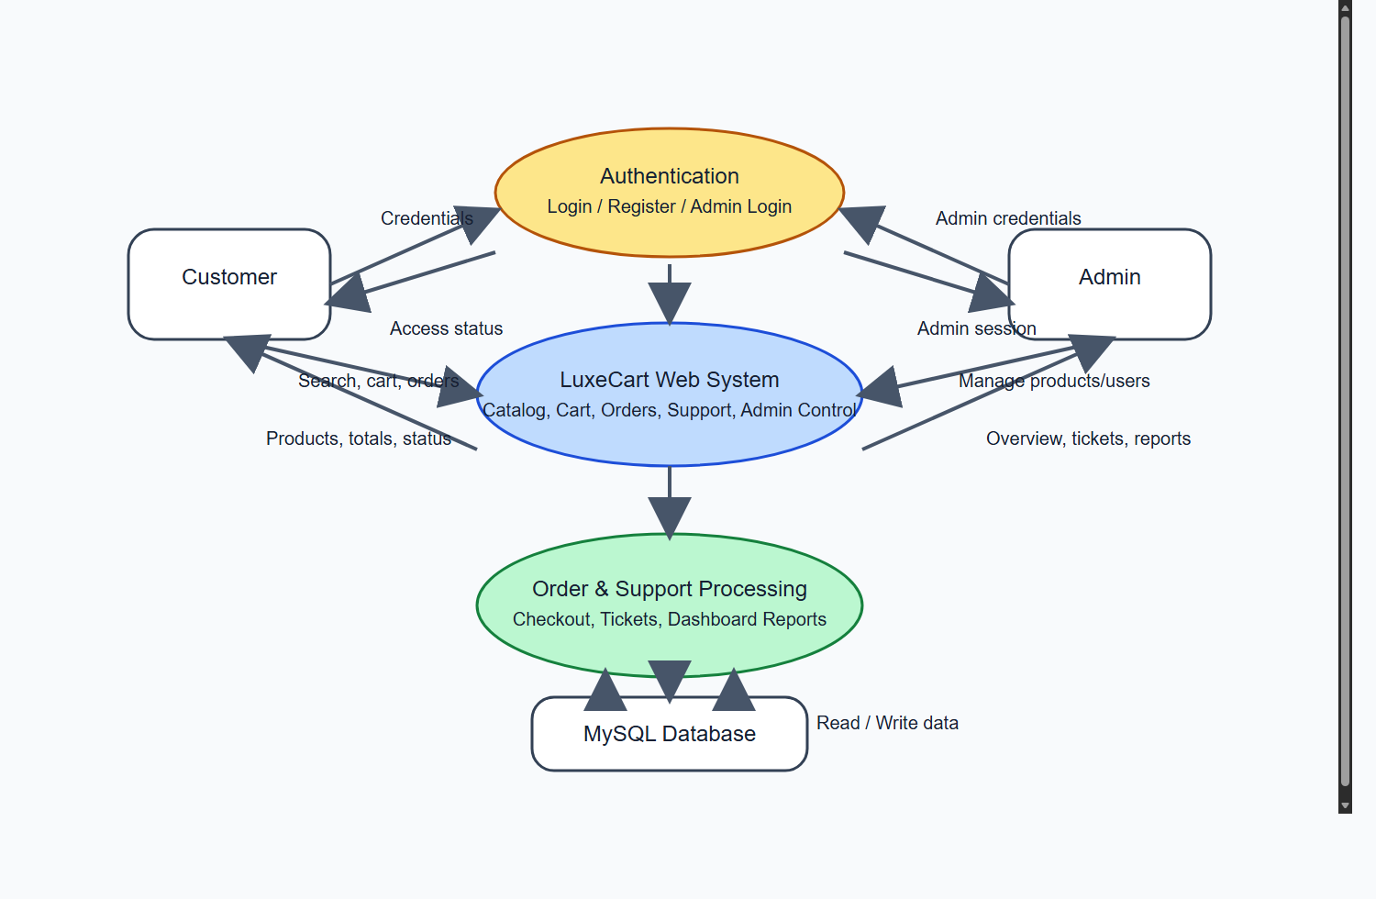
Figure 1. Data Flow Diagram of LuxeCart E-Commerce Website

4.2 ER Diagram
The ER diagram shows the relationship between store sections, products, customer accounts, orders, order items, support tickets, admin accounts, and card details. It helps explain the database design used to manage records in a normalized and structured manner.
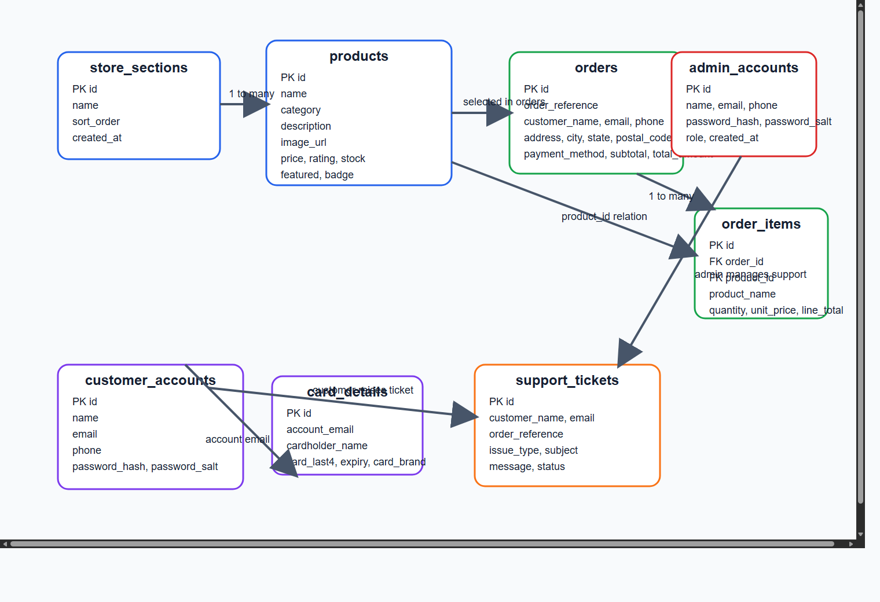
Figure 2. ER Diagram of the Project Database

4.3 Database Design
Table Name | Purpose | Important Fields
store_sections | Stores store section names and order of display. | id, name, sort_order, created_at
products | Stores product catalog information. | id, name, category, description, image_url, price, stock, rating
orders | Stores customer order summary and delivery details. | id, order_reference, customer_name, email, payment_method, total_amount, status
order_items | Stores item-level details for each order. | id, order_id, product_id, product_name, quantity, unit_price
support_tickets | Stores customer support requests and replies. | id, customer_name, email, issue_type, subject, status, admin_response
admin_accounts | Stores admin credentials and role details. | id, name, email, phone, password_hash, role
customer_accounts | Stores customer sign-up and login data. | id, name, email, phone, password_hash, password_hint
card_details | Stores safe masked card-summary details for card payments. | id, account_email, cardholder_name, card_last4, expiry, card_brand

5. IMPLEMENTATION
Implementation is the stage where the system design is converted into a working application. The LuxeCart project is implemented using Angular in the frontend and Express.js in the backend. MySQL is used as the storage engine for sections, products, orders, support tickets, accounts, and masked card summaries.

5.1 Customer Module
The customer module contains pages for browsing products, filtering by category, searching products, adding items to cart, saving items, viewing account details, placing orders, reviewing previous orders, and submitting support requests.

5.2 Checkout Module
The checkout module validates name, phone, address, city, state, postal code, payment method, and card details before placing the order. Card-based orders store only masked card detail information for safe record keeping.

5.3 Admin Module
The admin module contains a separate admin login page and multiple control pages such as dashboard, products, orders, accounts, users, out-of-stock, and support box. It is designed to help the store administrator manage daily operations from one control center.

5.4 Database and Seed Module
Database tables are created and updated from the backend. Seed logic is used to populate section and product data for demonstration. The project also supports product image updates, INR price display, toast feedback, and data refresh flows.

6. SYSTEM TESTING
Testing ensures the correctness, efficiency, usability, and reliability of the software. The project was tested through both customer-side and admin-side workflows.

6.1 Unit Testing
- Login and sign-up form validation
- Checkout validation for payment details
- Product form validation in admin pages
- Support form validation

6.2 Integration Testing
- Frontend and backend API communication
- Backend and MySQL database storage
- Customer account to orders data flow
- Support ticket creation and admin visibility

6.3 System Testing
End-to-end testing covered browsing, add-to-cart, checkout, order placement, customer sign-in, support request submission, admin login, and admin management workflows.

6.4 Validation Testing
Input validation and toast messages were verified for success and failure cases, including login, logout, account creation, support submission, and payment validation.

6.5 User Interface Testing
The customer pages and admin pages were checked for readability, responsive layout behavior, proper button interactions, and meaningful page-level user feedback.

6.6 Build Verification
The frontend was compiled using the Angular build command and verified successfully. This confirmed that the templates, styles, and TypeScript modules compile into a production build.

7. APPENDIX

7.1 Sample Coding
Sample 1: Root development scripts
{
"scripts": {
"dev": "concurrently "npm --prefix backend run dev" "npm --prefix frontend start"",
"dev:frontend": "npm --prefix frontend start",
"dev:backend": "npm --prefix backend run dev",
"build": "npm --prefix frontend run build"
}
}
Sample 2: Angular INR price display
<strong>{{ product.price | currency:'INR':'symbol':'1.0-0' }}</strong>
<small>M.R.P. {{ listPrice | currency:'INR':'symbol':'1.0-0' }}</small>
Sample 3: Orders table structure
CREATE TABLE orders (
id INT NOT NULL AUTO_INCREMENT PRIMARY KEY,
order_reference VARCHAR(32) NULL UNIQUE,
customer_name VARCHAR(120) NOT NULL,
email VARCHAR(140) NOT NULL,
phone VARCHAR(40) NOT NULL,
address_line VARCHAR(255) NOT NULL,
city VARCHAR(80) NOT NULL,
state VARCHAR(80) NOT NULL,
postal_code VARCHAR(20) NOT NULL,
payment_method VARCHAR(60) NOT NULL,
total_amount DECIMAL(10, 2) NOT NULL
);
Sample 4: Backend order API concept
app.post('/api/orders', async (request, response, next) => {
// validate checkout data
// insert order into orders table
// insert order items into order_items table
// store masked card details if payment is card based
// return confirmation to frontend
});

7.2 Output Screens
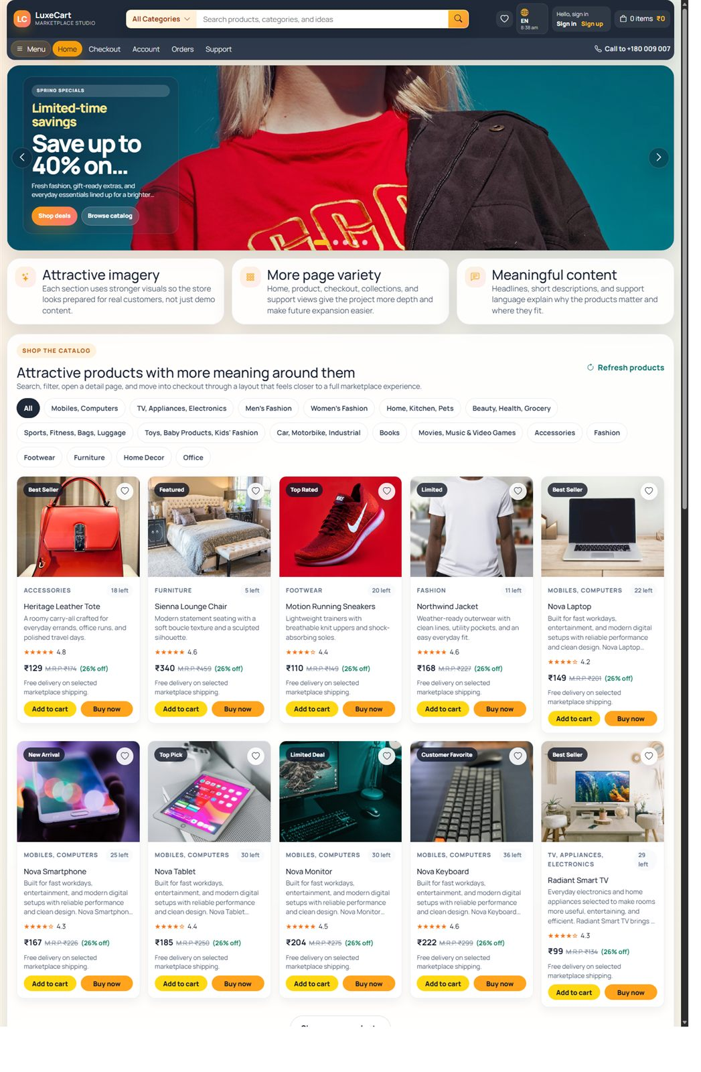
Figure 3. Customer Home Page
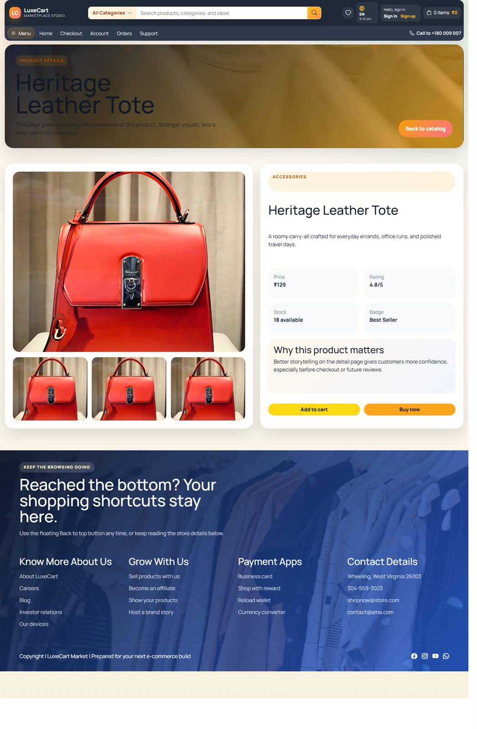
Figure 4. Product Listing and Catalog View
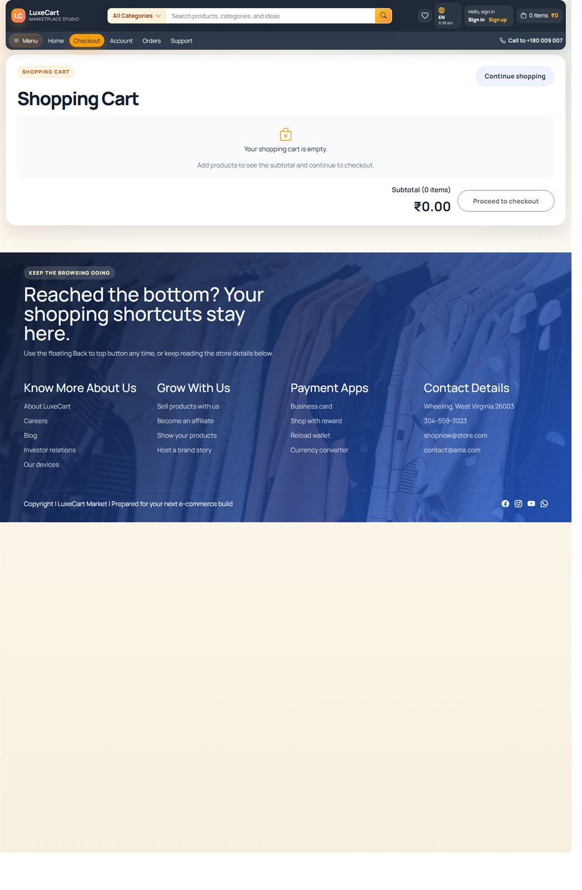
Figure 5. Checkout Page
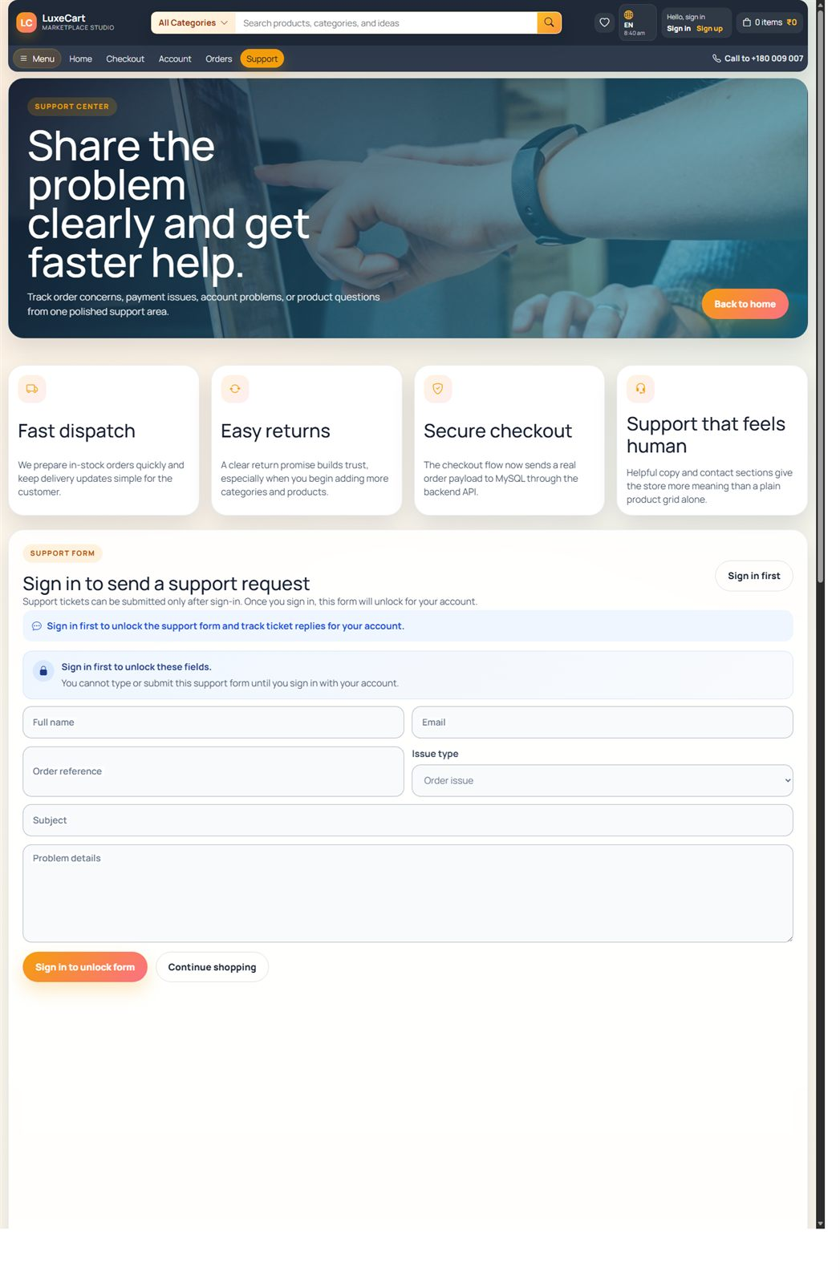
Figure 6. Support Page
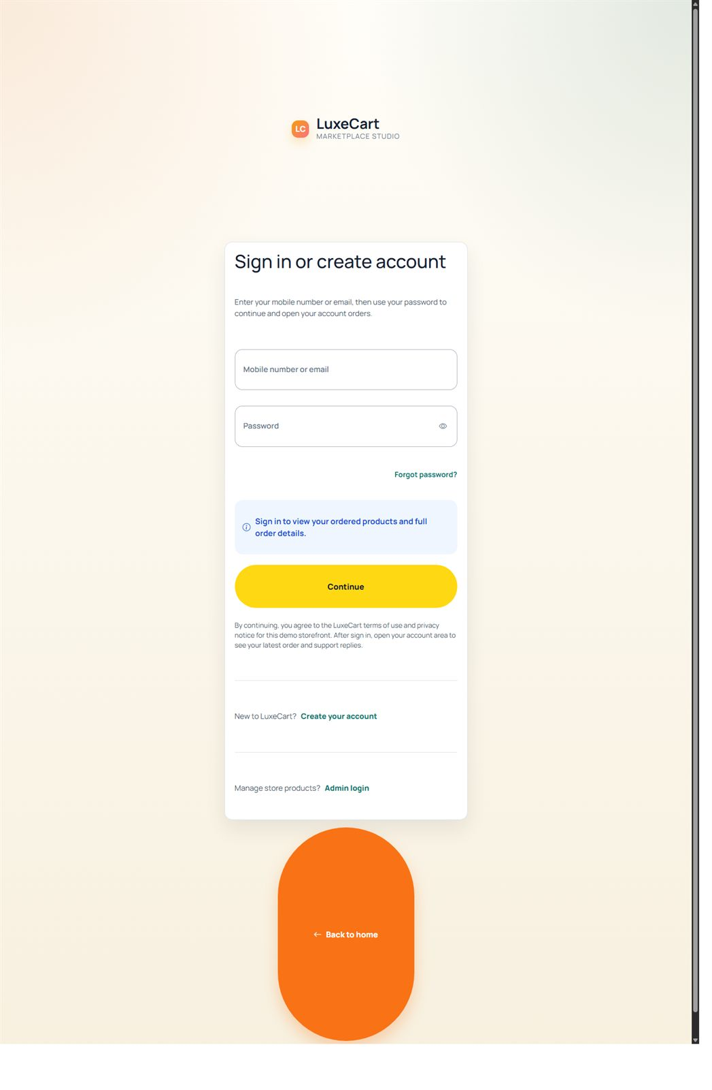
Figure 7. Customer Sign In and Ordered Products Access
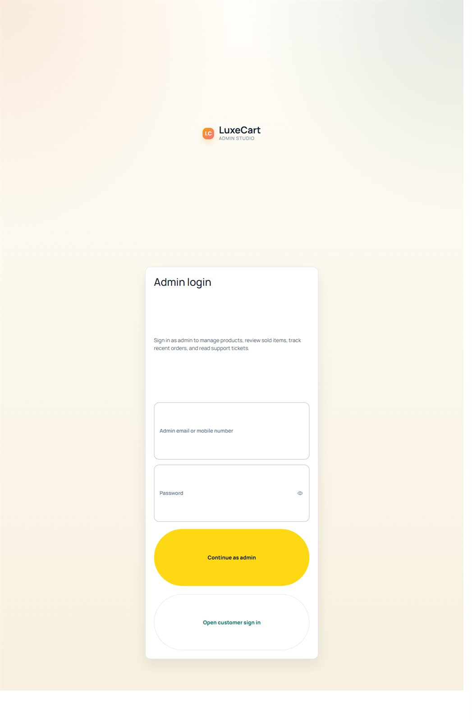
Figure 8. Admin Login Page

8. CONCLUSION
The LuxeCart E-Commerce Website successfully demonstrates the design and implementation of a complete web-based shopping system. The project supports customer browsing, ordering, account handling, support activity, and a separate admin workspace through one integrated software solution.
This project applies important software engineering concepts such as layered architecture, data validation, API communication, database normalization, reusable UI design, and structured testing. As an academic project, it provides both technical depth and practical demonstration value.

9. FUTURE ENHANCEMENT
- Real payment gateway integration using Razorpay or Stripe
- Shipment and delivery tracking
- Invoice generation in PDF format
- Email and SMS notifications
- Product reviews and ratings
- Recommendation engine for customers
- Improved analytics for admin users
- Cloud deployment and CI/CD automation
- Enhanced security and access controls

10. BIBLIOGRAPHY
Angular Documentation - https://angular.dev
Express.js Documentation - https://expressjs.com
MySQL Documentation - https://dev.mysql.com/doc
Bootstrap Documentation - https://getbootstrap.com
Node.js Documentation - https://nodejs.org
GitHub Documentation - https://docs.github.com
Software Engineering references by Ian Sommerville and Roger S. Pressman

