7.3 FEASIBILITY STUDY
A detailed feasibility study was carried out to evaluate whether the LuxeCart E-Commerce Website can be developed, demonstrated, maintained, and extended within the available academic time frame and resource limits. The study confirms that the project is practical as a software engineering submission because the selected tools, hardware, and programming stack are available and well suited to the required scope.
7.3.1 Technical Feasibility
The project is technically feasible because it is built on a standard web stack that can be installed and executed on a normal student development machine without specialized infrastructure.
- Angular is suitable for building a modern storefront because it supports component-based UI development, form handling, and structured client-side state.
- Express.js is appropriate for the backend because it allows the API to be organized clearly around routes for products, orders, accounts, and support tickets.
- MySQL is technically suitable because the project requires relational storage, transaction support, referential integrity, and reporting through grouped queries.
- Bootstrap makes the interface development process faster by providing responsive layout utilities, form components, and grid helpers that reduce repetitive CSS work.
- The project already contains a working optional PHP mirror backend, which proves that the frontend can communicate with more than one API implementation if needed.
From a technical point of view, the project does not depend on rare libraries or advanced hardware. The chosen stack is stable, understandable, and appropriate for an academic commerce application.
7.3.2 Economic Feasibility
The project is economically feasible because it uses common open-source tools and does not require licensing cost for the software used in development, testing, or demonstration.
- Angular, Node.js, Express.js, Bootstrap, and MySQL are all freely available for educational development.
- The project runs locally on an existing laptop and does not require paid hosting during the development phase.
- The database and seeded catalog can be created from a single SQL schema file, reducing setup time and maintenance effort.
- The interface design uses reusable components, which lowers future enhancement cost because the same building blocks can be reused across multiple pages.
- The admin dashboard reduces manual tracking effort by collecting product, order, and support information in one workspace, which reflects good operational value.
Because the solution can be built and demonstrated using already available software and hardware resources, the overall economic burden of the project remains low while the academic and practical value remains high.
7.3.3 Operational Feasibility
Operational feasibility focuses on whether the intended users can actually work with the system once it has been implemented. LuxeCart is operationally feasible because both customer and admin flows are designed around familiar e-commerce behavior.
- Customers can browse products, view details, add items to cart, and place orders through patterns that closely match real online shopping websites.
- The account module uses simple sign-up, sign-in, and password reset interactions that are understandable to first-time users.
- Support ticket creation is guided by issue type, subject, and order reference, which keeps the workflow easy to follow while still enforcing validity.
- Administrators receive a grouped dashboard with recent orders, product status, support tickets, and customer data rather than having to open multiple disconnected screens.
- Role-based admin handling helps the system behave in a predictable manner because privileged actions can be separated from normal operational activity.
The project is operationally feasible because the user interaction patterns are familiar, the screens are task-oriented, and the information flow is designed to reduce confusion for both customers and store operators.
7.3.4 Schedule Feasibility And Risk Review
Schedule feasibility was considered by dividing the project into clear work units such as schema design, backend route implementation, storefront layout, checkout logic, support workflows, and admin management.
- The frontend and backend were developed in parallel using a service-based interface contract, which reduced waiting time between modules.
- Seed data and runtime migration logic made it easier to test the full application without depending on external production data.
- The main risk areas were legacy save behavior in Word automation, stock validation edge cases, and consistency between customer and admin flows.
- These risks were handled by using direct XML report generation for documentation and by keeping the business rules inside centralized backend routes.
- The project scope remained manageable because advanced features such as live payments and delivery APIs were documented as future work instead of being forced into the initial academic version.
The schedule was realistic for an academic development cycle, and the identified risks were manageable. This supports the conclusion that the project is feasible not only in theory but also in actual implementation practice.

7.4 INPUT DESIGN
Input design in LuxeCart focuses on making every user entry point clear, validated, and safe. The system handles inputs from customers, administrators, and database setup scripts, so each form and endpoint is designed to reduce ambiguity and prevent invalid data from entering the application.
7.4.1 Customer Account Inputs
The customer account module accepts registration, sign-in, profile update, and password reset input. These input screens are designed to collect only the data that is necessary for identity and account continuity.
- Registration collects name, email, mobile number, password, and password hint so that the account has both identity and recovery data.
- Sign-in accepts either email or phone as the identifier, which improves convenience for the customer.
- Profile editing requires the current password before saving account changes, which improves trust and prevents accidental unauthorized updates.
- Password reset uses the previously stored password hint, allowing a simple academic recovery workflow without requiring email services.
- Validation rules ensure that name length, email structure, phone format, and password length remain consistent before data is sent to the backend.
These customer account inputs were chosen to balance convenience and control. The forms remain simple for the user while still giving the system enough data to manage identity and recovery.
7.4.2 Product Selection And Cart Inputs
Catalog interaction is also treated as an input design problem because the system must interpret product selection, quantity changes, saved items, and wishlist actions correctly.
- Category selection helps the user filter the storefront without typing long search phrases.
- Search input narrows the visible catalog and improves discovery speed, especially when the product list grows.
- Cart quantity controls prevent values from exceeding available stock and give immediate feedback when a product is low in stock.
- Buy-now flow captures a focused checkout intent by sending a direct product selection into the checkout stage.
- Saved items and wishlist actions preserve intent even when the customer is not yet ready to purchase.
The input design for product interaction supports natural shopping behavior and keeps the number of clicks low while still enforcing stock-aware rules.
7.4.3 Checkout And Support Inputs
The checkout form is one of the most important input areas in the system because it combines delivery data, payment choice, and order items into a single transaction request.
- Checkout collects customer name, email, mobile number, full delivery address, city, state, postal code, payment method, notes, and item details.
- Card-based orders accept only masked snapshot values such as cardholder name, last four digits, expiry, and card brand. Full card number and CVV are not persisted.
- The support form requires a valid order reference, which makes sure that customer support activity is tied to a real order.
- Issue type, subject, and detailed message make it easier for the admin to understand the request and respond meaningfully.
- Input validation occurs both in the Angular forms and in the backend API so that invalid data is stopped even if client-side validation is bypassed.
Checkout and support inputs are designed for accuracy because both processes have direct business impact. The design therefore emphasizes completeness, validation, and traceability.
7.4.4 Admin Inputs
Administrative inputs must support catalog control and operational maintenance. Admin users therefore receive focused forms for sections, products, support replies, and sub-admin management.
- Product forms capture name, category, description, image URL or upload, price, rating, stock, badge, and featured state.
- Section management allows the admin to create, rename, and remove storefront categories in a controlled way.
- Support reply input lets the admin update ticket status and provide a response in the same working area.
- Sub-admin creation captures identity, contact details, and password values for controlled staff expansion.
- Protected admin requests are sent with a session token so that restricted inputs cannot be applied without authorization.
The admin input design focuses on clarity and operational safety. Each form is centered on one business task, which reduces the risk of accidental misuse and supports day-to-day management.

7.5 OUTPUT DESIGN
Output design ensures that the information generated by the application is clear, useful, and relevant to the person viewing it. In LuxeCart, outputs are not limited to printed reports; they include on-screen product cards, confirmation messages, support status displays, dashboard metrics, and database-backed summaries.
7.5.1 Storefront Outputs
The customer-facing storefront produces visual outputs that help users understand products and categories quickly without needing technical knowledge.
- Hero banners highlight seasonal or promotional categories and provide immediate navigation direction from the homepage.
- Product cards show name, price, rating, badge, image, and stock-aware context so that customers can compare items rapidly.
- Product detail screens expand the output by showing a larger description, stronger visual focus, and clearer purchase actions.
- Category sections and promotional boards help the homepage look like a real marketplace instead of a static list of sample records.
- Toast feedback messages provide immediate output when a user signs in, updates an account, adds to cart, or submits support information.
These storefront outputs were designed to improve the shopping experience by combining presentation, clarity, and quick decision support.
7.5.2 Order And Checkout Outputs
Order-related outputs must confirm that the system processed the purchase correctly and preserve a reliable record for later reference.
- The checkout summary displays item count, subtotal, delivery fee, and final total so that the customer sees the exact financial breakdown before ordering.
- Order confirmation output returns order reference, customer name, total amount, and estimated delivery information.
- Orders history output groups previous purchases in a readable form so that the customer can re-check older activity without contacting support.
- Recent ordered products output makes it easier to revisit previously purchased items and improves continuity after repeat purchases.
- Order detail modals show address, payment method, item lines, quantity, and cost data in a customer-friendly layout.
Checkout and order outputs focus on trust. They confirm that the transaction was recorded correctly and they provide enough detail for later review or support follow-up.
7.5.3 Support Outputs
Support outputs help customers understand the current status of their requests and help administrators decide what action must be taken next.
- Support submission outputs confirm ticket creation and show the initial status as open.
- Customer support history output groups previous requests and displays the latest admin response or system status explanation.
- Ticket status labels such as open, in progress, resolved, and closed provide an immediate understanding of the request lifecycle.
- Order-linked support output helps both the user and the admin identify which purchase the problem belongs to.
- Admin response output reduces uncertainty because the customer can view a concrete message instead of a silent status flag.
Support output design helps convert a potentially confusing after-sales process into a traceable and transparent workflow.
7.5.4 Admin Outputs
The admin workspace produces outputs that are more analytical than the customer side because the store operator needs summarized operational information.
- Overview cards display product count, inventory units, low-stock count, order count, sold units, revenue, and open ticket count.
- Recent orders output helps the admin review the latest business activity without manually searching the database.
- Top product output shows the strongest performers based on units sold and revenue contribution.
- Out-of-stock and low-stock outputs help the store operator plan replenishment and reduce missed sales opportunities.
- Customer-user output combines account, order, and support activity so that the admin can understand user engagement at a glance.
Admin outputs transform raw transactional data into operational insight. This is important because the value of the system depends not only on selling products but also on supporting store management decisions.

7.11 USER MANUAL
A practical project report should also explain how the system can be used. The following user manual summary describes how LuxeCart can be installed, started, and operated from both the customer side and the admin side.
7.11.1 Installation And Startup
The project can be set up locally through a sequence of straightforward development steps.
- Create the MySQL database using the provided schema file in backend/database/schema.sql.
- Configure backend environment variables using the supplied .env example file.
- Run the root development script so that the frontend and Express backend start together.
- Verify API availability using the health route before testing advanced workflows.
- Optionally point the frontend to the PHP mirror backend when alternate API execution is required.
Startup was intentionally kept simple so that the academic evaluator can recreate the project environment without a long deployment procedure.
7.11.2 Customer Operation Steps
The customer workflow begins at the storefront and can continue through account creation, ordering, and support.
- Open the homepage and browse highlighted categories or search directly for a product.
- Select a product to open the detail page and review price, stock, and description.
- Add the product to cart or proceed through the buy-now path.
- Sign up or sign in when account continuity is required for orders and support access.
- Complete the checkout form, place the order, and then review the order reference in the confirmation screen.
These steps reflect the normal customer journey and show that the application supports the complete shopping flow from discovery to confirmation.
7.11.3 Admin Operation Steps
The admin workflow is oriented around control, monitoring, and response rather than browsing and purchase.
- Sign in using the admin login form with a valid email or mobile number and password.
- Review the overview dashboard to understand recent orders, revenue, ticket status, and stock position.
- Create or update products and store sections as required by catalog planning.
- Inspect customer orders and user activity when operational follow-up is needed.
- Respond to support tickets and maintain sub-admin accounts according to role permissions.
The admin sequence shows that LuxeCart is capable of supporting real management tasks and not only the customer-facing sales path.
7.11.4 Maintenance Suggestions
Because the project can be extended later, it is useful to document the maintenance habits that support long-term reliability.
- Back up the MySQL database before large catalog updates or schema changes.
- Review low-stock output regularly to avoid customer disappointment during ordering.
- Keep image URLs and product badges consistent so that the storefront remains visually clear.
- Monitor admin account usage and remove unused staff access when no longer needed.
- Use build verification after major frontend edits to ensure that the application remains deployment-ready.
These maintenance practices support continued academic demonstration and provide a realistic bridge toward future production-oriented improvement.

7.12 SCREEN DESCRIPTION AND OBSERVATIONS
Screens are an important part of documentation because they translate technical design into visible user experience. The following observations explain how the major LuxeCart pages support the business flow of the application.
7.12.1 Home And Product Screens
The home page and product detail page represent the sales-first identity of the application and therefore combine both visual storytelling and practical product discovery.
- The home screen uses banner sections, category groups, and promotional blocks to make the storefront feel active and marketplace-oriented.
- The catalog output on the home area supports direct browsing while also guiding the user toward more focused product exploration.
- The product detail screen expands the selected product and presents a stronger purchase context through stock and price visibility.
- Color, typography, and card layout work together to create an interface that feels more complete than a minimal form-based demo.
- These screens are important because they establish trust before the user reaches checkout.
The storefront screens show that user interface design can support both visual appeal and commercial clarity at the same time.
7.12.2 Checkout And Orders Screens
Checkout and orders screens focus less on discovery and more on confidence, review, and continuity.
- The checkout page groups cart review and delivery information in a way that reduces last-step confusion.
- Order totals are shown clearly so that the customer understands the cost structure before confirming the purchase.
- The saved-address idea supports repeat orders and demonstrates continuity in customer interaction design.
- Orders history and order detail views help customers verify that the system has preserved their transaction records correctly.
- These screens are especially important because they represent the point at which business trust is either reinforced or lost.
The order-related screens provide structure, memory, and accountability, which are essential qualities in any e-commerce application.
7.12.3 Support And Account Screens
Account and support screens extend the system beyond a single sale and make the application feel more like a maintained service platform.
- The account screen keeps profile management and password actions together so that identity maintenance remains simple.
- Password-hint based recovery is practical for an academic system that does not yet depend on external mail services.
- The support page combines FAQ-like guidance, issue submission, and ticket history in a way that encourages clear communication.
- Status labels and visible admin responses improve transparency during after-sales service interactions.
- These screens show that user care continues after the order is placed, which is an important design quality.
Account and support screens strengthen the perception that LuxeCart is a complete customer-facing system rather than only a shopping catalogue.
7.12.4 Admin Dashboard Screens
The admin screens translate raw business data into manageable operational views and therefore play a different role from the customer pages.
- The overview dashboard makes store performance visible through compact metric cards and recent activity panels.
- Catalog maintenance screens support direct business action by allowing the admin to adjust sections, products, and stock-related details.
- User and order monitoring areas improve accountability by linking account activity with purchase and support history.
- Support management within the same workspace reduces switching cost when the admin needs to resolve customer issues.
- The overall admin experience demonstrates that the project includes management depth and not only a polished public storefront.
These dashboard screens are strong evidence that the system was designed with both operational control and customer experience in mind.

7.13 RESULT ANALYSIS AND LIMITATIONS
Result analysis helps explain what the project has achieved, what boundaries remain, and why the current implementation still has value as a software engineering submission. LuxeCart performs well as a structured commerce project because it demonstrates a meaningful combination of interface design, API logic, relational storage, and operational dashboards.
7.13.1 Achievements Of The Project
The project achieves a wide range of functional objectives for a student e-commerce system.
- It provides a customer-facing storefront with category browsing, product detail, cart, and checkout features.
- It includes customer account creation, profile update, password reset, order history, and support continuity.
- It demonstrates backend logic for validation, order transactions, stock updates, session handling, and reporting.
- It provides a dedicated admin workspace rather than limiting management to direct database manipulation.
- It maintains a relational database design that supports present functionality and future extension.
These achievements confirm that the project delivers more than a static UI. It behaves like an integrated commerce system with both technical and operational value.
7.13.2 Academic Value
From an academic point of view, LuxeCart provides a strong project base because it touches multiple areas of software engineering and web application design.
- It demonstrates layered architecture by separating presentation logic, service interaction, backend routes, and database design.
- It shows how validation should exist on both the frontend and backend for stronger reliability.
- It reflects database normalization and transaction handling in a way that is relevant to commerce-oriented applications.
- It documents user roles, security boundaries, and operational reporting, which are important enterprise design concepts.
- It produces an end product that can be explained both from the user perspective and from the implementation perspective.
The project therefore serves as a complete academic demonstration case rather than only a narrow programming exercise.
7.13.3 Present Limitations
Every academic project has a controlled scope, and LuxeCart is no exception. The current version is intentionally limited in areas that would normally require external service integration or broader infrastructure.
- Real payment gateway processing is not yet connected, so card payment remains a simulated academic workflow.
- Delivery tracking and courier integration are not yet available in the current version.
- The deployment model is still local-development oriented rather than cloud-production oriented.
- Advanced search, recommendation intelligence, and real image storage optimization are not yet implemented.
- Legacy document export behavior in the office environment remains limited for old .doc conversion, even though the final docx output is complete.
These limitations do not reduce the academic usefulness of the project. Instead, they define a realistic future roadmap while keeping the present implementation manageable and demonstrable.
7.13.4 Readiness For Future Enhancement
Although the current implementation is academic in scope, the architecture already contains useful foundations for future extension.
- The service layer and typed models make it easier to add new pages and workflows without rewriting the full application structure.
- The admin dashboard already provides a place where advanced analytics and reporting widgets can be added later.
- The relational schema can be extended to include reviews, coupons, shipment records, and invoice references.
- Because the project already has clear customer and admin roles, stronger authentication methods can be layered in later without redesigning the entire UI.
- The presence of an optional PHP mirror backend shows that the frontend is not permanently locked to a single server technology.
This makes LuxeCart a strong foundation project. It is complete enough for submission today and flexible enough for meaningful future development tomorrow.

7.14 SECURITY DESIGN AND CONTROL
Security design in LuxeCart is intentionally practical. The project is academic in scope, but it still demonstrates how a commerce application should protect access, validate input, and limit the storage of sensitive information.
7.14.1 Authentication Control
Authentication is the first layer of protection in the system because it controls who can access personal account data and who can enter the admin workspace.
- Customer account actions are tied to verified identity data such as email, phone, password, and password hint values.
- Admin actions are separated from customer actions through dedicated login routes and protected session checks.
- Protected requests are linked to a session token so that product updates and support responses cannot be sent anonymously.
- Password change and profile update flows require proof of the current password before changes are saved.
- Expired or invalid admin sessions are rejected by the backend before restricted business operations are allowed.
Authentication control is therefore more than a login screen. It is the mechanism that separates general browsing from protected account and management operations.
7.14.2 Data Validation Control
Validation control protects the application from invalid or incomplete data and helps maintain database quality.
- Frontend validation improves usability by showing issues early while the user is still working with the form.
- Backend validation protects the database even if the client side is bypassed or manipulated.
- Email and phone values are normalized before storage so that duplicate handling remains consistent.
- Order placement validates item lists, payment method values, and stock quantities before any transaction is committed.
- Support routes validate order-reference ownership so that unrelated customer tickets cannot be submitted against random orders.
Validation control is one of the strongest security-related design choices in the project because it protects both correctness and trust.
7.14.3 Sensitive Data Handling
Payment-related data requires special care even in an academic system, which is why LuxeCart limits what is stored and how it is used.
- Only masked card snapshot details are stored, such as cardholder name, last four digits, expiry, and brand.
- Full card number and CVV values are intentionally not persisted in the database.
- Support tickets and account records are kept separate from raw payment details to reduce unnecessary exposure.
- Password values are stored in hashed form along with salt values rather than in plain text.
- Runtime database design is structured so that sensitive values can be controlled by table purpose and route purpose.
This approach reflects a clear design principle: store only what is necessary, protect what is sensitive, and keep concerns separated.
7.14.4 Operational Control Measures
Operational control includes the runtime practices that help the system stay predictable and safe during use.
- Low-stock checks stop overselling and preserve the accuracy of order commitments.
- Role-aware admin management reduces the risk of high-impact actions being performed by every operational user.
- Audit-friendly timestamps on account and support records improve traceability during review.
- The health endpoint and build verification step make it easier to catch deployment or runtime issues before demonstration.
- The separation of customer, support, order, and admin modules reduces the chance of one workflow corrupting another.
Security in LuxeCart is therefore both technical and operational. It includes validation rules, storage decisions, role boundaries, and routine control checks.

7.15 ORDER LIFECYCLE ANALYSIS
The order lifecycle is a useful way to study how the different LuxeCart modules cooperate. A successful order touches the storefront, the checkout form, the backend transaction layer, the database, the customer order history, and the admin dashboard.
7.15.1 Product Selection Stage
The lifecycle begins when the customer identifies a product of interest through browsing, filtering, or search.
- The customer can discover items through banners, category sections, and product cards.
- Product detail pages provide the deeper context that supports a purchase decision.
- Wishlist and save-for-later behavior allow interest to be preserved even before checkout begins.
- Cart updates keep track of quantity choices and respect stock-aware limits.
- This stage is important because every later commerce action depends on accurate product selection.
Product selection is not only a visual stage. It is the point where user intention becomes structured cart data.
7.15.2 Checkout Validation Stage
Once products are selected, the lifecycle moves into checkout where user identity, delivery data, and payment choice are gathered and verified.
- Customer name, email, phone, address, city, state, postal code, and payment method are validated before the order is accepted.
- The checkout module supports both cart-based and buy-now based entry paths.
- Masked card snapshots are validated if card payment is selected.
- The order request is not allowed to continue when the cart contains invalid product identifiers or quantities.
- This stage ensures that downstream transaction logic receives a clean and meaningful payload.
Checkout validation acts as the business gatekeeper for the order lifecycle. It protects both the user and the system from incomplete transaction requests.
7.15.3 Transaction Processing Stage
The backend transaction stage is where the shopping intent becomes a committed business record.
- The backend starts a transaction and locks the affected product rows before finalizing the order.
- Product availability is checked again at the database level to avoid stale cart assumptions.
- Order header data and order-item lines are inserted in a coordinated sequence.
- Stock values are updated only after the transaction has verified that all selected quantities are valid.
- A customer-friendly order reference is generated so that later review and support workflows remain simple.
This processing stage is the heart of the e-commerce system because it converts a UI event into a durable, validated, and traceable order record.
7.15.4 Post-Order Continuity Stage
The order lifecycle does not end at insertion. After the transaction succeeds, the data must remain visible and useful in related parts of the system.
- The confirmation screen presents the order reference and estimated delivery information to the customer.
- The order history screen allows the same customer to re-open the transaction later.
- Recent ordered product views improve repeat interaction and support future shopping behavior.
- The admin dashboard incorporates the new order into revenue, quantity, and recent-activity metrics.
- If a problem appears later, the support workflow can use the same order reference to keep the issue grounded in a verified purchase.
The order lifecycle therefore extends across multiple modules, showing how one action can influence visibility, reporting, and customer service at the same time.

7.16 SUPPORT AND CUSTOMER SERVICE WORKFLOW
Support handling is a major quality indicator for any commerce system. LuxeCart treats support as a structured workflow instead of as a simple contact form, which makes the application feel more realistic and operationally useful.
7.16.1 Ticket Creation Workflow
Support begins when the customer decides that an order-related or account-related issue requires formal follow-up.
- The support form collects customer identity, order reference, issue type, subject, and detailed message.
- Validation ensures that the order reference belongs to the same customer email before the ticket is created.
- The issue type field improves routing clarity because the admin can quickly understand whether the case involves payment, order, or product questions.
- The message field encourages more detailed problem reporting, which reduces follow-up ambiguity.
- The ticket is created with an initial status so that the customer immediately knows the request has entered the system.
Ticket creation is designed to be easy for the user while still preserving the information quality needed for real follow-up.
7.16.2 Customer Visibility Workflow
Once a ticket exists, the customer should be able to track what is happening rather than sending repeated follow-up messages.
- The support history view shows previous tickets and their latest status.
- Admin responses are surfaced directly so that customers do not need a separate communication channel for every update.
- Status wording such as open, in progress, resolved, and closed helps the customer interpret the lifecycle clearly.
- Order-linked ticket display makes it easier to remember which purchase the issue belongs to.
- This visibility lowers uncertainty and improves confidence in the service side of the application.
A visible support history turns customer service into a trackable workflow and reinforces trust after the purchase stage.
7.16.3 Admin Resolution Workflow
The administrator needs a support workflow that is efficient enough to handle multiple tickets while still preserving context.
- Ticket filtering allows the admin to focus on open or in-progress issues quickly.
- Reply drafting within the admin workspace reduces context switching and keeps the response process organized.
- Status change controls let the admin mark a request as active, resolved, or closed depending on its current state.
- The link between ticket and order reference makes it easier to inspect related purchase data during investigation.
- Updated timestamps help the admin understand which issues have recent activity and which are becoming stale.
The admin resolution workflow helps the support process remain structured rather than reactive, which is important for store professionalism.
7.16.4 Customer Service Value
From a project perspective, the support workflow adds a major layer of realism because post-purchase care is part of actual commerce operations.
- The support module shows that the project accounts for problems, not only successful purchases.
- It gives the admin a service responsibility beyond catalog maintenance and revenue review.
- It gives the customer a formal escalation path instead of leaving order issues unresolved.
- It connects operational status, timestamps, and communication into one manageable dataset.
- It demonstrates that the system design considers customer satisfaction as part of the full business cycle.
For these reasons, the support workflow is one of the strongest indicators that LuxeCart is a complete project report subject rather than a narrow UI exercise.

7.17 ADMIN REPORTING AND BUSINESS INSIGHT
Reporting turns raw data into decision support. LuxeCart includes an admin overview that does more than list records; it summarizes commercial activity in a way that helps the operator understand the present condition of the store.
7.17.1 Revenue And Order Insight
Revenue and order metrics help the admin understand whether store activity is increasing and which areas deserve attention.
- Order count provides a direct measure of transaction volume.
- Sold-unit aggregation shows how many individual items moved through the system.
- Revenue calculation summarizes the financial outcome of completed purchases.
- Recent-order panels help the admin connect numeric totals with specific customers and purchase times.
- These outputs are useful because they transform ordinary transactional rows into business visibility.
Revenue insight is important not only for performance measurement but also for identifying whether the rest of the management process is functioning effectively.
7.17.2 Product Performance Insight
Product reporting is necessary because the admin must know which items are selling well, which are underperforming, and which are approaching stock risk.
- Top-product output shows which products contribute most strongly to unit movement and revenue.
- Low-stock and out-of-stock outputs prevent the admin from relying on memory or manual checking alone.
- Recent ordered product output reveals which categories are currently active in the store.
- Badge and featured status can be used to support promotional visibility in combination with stock information.
- This insight helps connect inventory planning with storefront presentation.
Product insight is therefore both commercial and operational. It helps the admin align what customers see with what the store can actually fulfil.
7.17.3 Customer Activity Insight
Customer-related reporting makes it easier to understand who is engaging with the system and what type of follow-up might be required.
- Customer-user views combine account presence, order count, ticket count, and spending levels.
- Recent activity timestamps help the admin identify engaged users and dormant users.
- Linking account, order, and support behavior gives a fuller picture than viewing each dataset separately.
- Customer summaries can also reveal whether support activity is concentrated around a particular order pattern.
- This insight supports better service prioritization and store review.
Customer reporting adds depth to the dashboard because it shows the human side of business activity instead of only product and revenue totals.
7.17.4 Operational Decision Value
The true value of reporting lies in how it supports action rather than only presentation.
- A low-stock count can lead directly to replenishment planning.
- A rising ticket count can indicate that a product description, checkout rule, or order process needs improvement.
- Recent order patterns can influence which categories deserve homepage emphasis.
- Sub-admin and support workload can be understood better when recent activity is visible in one place.
- Because the overview is built from live data, it gives a meaningful academic demonstration of dashboard thinking.
This section shows that the admin dashboard is not decorative. It is an applied reporting feature with real operational meaning.

7.18 DATA DICTIONARY AND FIELD EXPLANATION
A data dictionary helps clarify what each field represents and why it exists. This is especially useful in commerce projects where multiple modules rely on shared names, identifiers, and status values.
7.18.1 Product And Section Fields
Catalog-related fields support display, classification, and operational stock control.
- Section name identifies the marketplace grouping used in browsing and administration.
- Product name is the customer-facing identity of the item and must remain descriptive and unique enough for recognition.
- Description explains product purpose and creates a better selling context in the detail view.
- Price represents the selling amount shown to the customer and used in order calculations.
- Stock represents the number of units currently available for purchase.
These fields combine presentation value with operational meaning, which is why they are central to both the storefront and the admin panel.
7.18.2 Order Fields
Order fields are designed to preserve both transaction meaning and customer traceability.
- Order reference is the public-facing identifier used by customers and support workflows.
- Customer name, email, and phone identify who placed the order and how they can be contacted if necessary.
- Address line, city, state, and postal code define where the purchase should be delivered.
- Subtotal, delivery fee, and total amount explain how the final order value was formed.
- Status shows the current processing state of the order in business terms.
Together these fields turn a purchase action into a complete and reviewable order record.
7.18.3 Account And Support Fields
Identity and support fields support continuity, recovery, and service communication.
- Customer email and phone are treated as identity anchors for registration and sign-in logic.
- Password hint is used as a lightweight recovery mechanism for the academic version of the project.
- Admin role defines whether the user acts as main admin or sub-admin in the management workflow.
- Issue type and subject make support tickets easier to classify and respond to.
- Admin response and updated timestamps help document the lifecycle of customer service communication.
These fields show that the application was designed for continuity and operational follow-up, not only one-time browsing.
7.18.4 Payment Snapshot Fields
Payment snapshot fields are intentionally limited because the system avoids storing full sensitive card data.
- Cardholder name helps identify the saved masked payment record in a user-friendly way.
- Last four digits support recognition without exposing the full account number.
- Expiry value supports limited academic validation for card-style checkout simulation.
- Card brand helps distinguish generic payment types when multiple saved snapshots exist.
- Updated timestamps allow the system to retain the most recent masked snapshot context.
This limited data dictionary demonstrates a good security principle: keep enough information for usability, but avoid storing what is unnecessarily sensitive.

7.19 DETAILED USER SCENARIOS
User scenarios help explain how the system behaves in realistic situations. They are useful in project documentation because they connect technical modules with human goals and expected outcomes.
7.19.1 Scenario One - New Customer Purchase
A new customer visits the site, explores products, creates an account, and places a first order.
- The customer uses the homepage and category sections to find a product of interest.
- The product detail page is used to review the description, stock, and purchase actions.
- The customer signs up, which creates a reusable identity for future orders and support.
- Checkout is completed with address and payment method information.
- The system responds with a confirmation view and order reference.
This scenario shows how LuxeCart supports a complete first-time shopping journey without requiring manual intervention.
7.19.2 Scenario Two - Returning Customer Support Request
A returning customer signs in, checks a previous order, and submits a support request related to that order.
- The customer signs in using the existing account credentials.
- The orders page is used to identify the correct order reference.
- The support form accepts the order reference and issue details.
- The backend verifies that the supplied order belongs to that customer identity.
- The customer later returns to the support history screen to review the latest admin response.
This scenario demonstrates how account continuity and order traceability improve post-purchase service quality.
7.19.3 Scenario Three - Admin Catalog Update
The main admin signs in, reviews the dashboard, and updates the visible catalog based on stock and presentation needs.
- The admin enters the dashboard and checks current order, revenue, and stock summary information.
- A low-stock product is identified and reviewed through catalog management screens.
- A new product or updated category arrangement is added to improve the storefront offering.
- The storefront reflects the change without requiring manual database edits from outside the system.
- The admin can then review whether the updated catalog is visible to customers as expected.
This scenario shows the operational value of the admin module as a real management environment rather than only a hidden maintenance page.
7.19.4 Scenario Four - Support Resolution And Follow-Up
An admin receives a ticket, reviews the related order context, updates the ticket, and closes the issue after response.
- The admin filters open tickets in the support area of the dashboard.
- The order reference is used to understand the original purchase context.
- A reply is drafted and the status is moved to in progress or resolved depending on the action taken.
- The customer later sees the updated status and admin response in the support history view.
- The ticket can eventually be closed once the issue is no longer active.
This scenario demonstrates that LuxeCart supports not only purchase creation but also service resolution and lifecycle closure.

7.20 DEPLOYMENT AND MAINTENANCE PLANNING
Although LuxeCart is presented as an academic project, deployment and maintenance planning are still important because they show whether the project could evolve into a more production-oriented system.
7.20.1 Local Deployment Model
The current system is designed to run comfortably in a local development environment for demonstration and evaluation.
- The Angular frontend runs through the standard development server.
- The Express backend runs independently and connects to MySQL through environment-controlled settings.
- The root development script allows both layers to start together for convenience.
- Schema setup is reproducible through one SQL file, reducing environment mismatch during testing.
- This local deployment model is appropriate for project review, viva demonstration, and classroom evaluation.
The local model is intentionally straightforward because academic usability is more important than complex deployment automation at this stage.
7.20.2 Production-Oriented Changes
If LuxeCart were to move beyond the academic stage, several deployment-related changes would be recommended.
- A production build of the Angular application should be served from a proper web server or CDN-backed environment.
- The backend should use stronger environment separation and managed secrets for credentials and admin defaults.
- A hosted relational database with automated backup policies would improve recovery readiness.
- Media assets should move from placeholder-style hosting to controlled storage with optimization.
- Monitoring, logging, and rate limiting should be added to improve operational observability and protection.
These recommendations show that the project architecture can move forward in a structured way even though the present version remains education-focused.
7.20.3 Maintenance Responsibilities
Maintenance planning identifies what must be reviewed regularly after the initial implementation is complete.
- Catalog content should be reviewed for outdated prices, stock mismatches, and broken image references.
- Customer support queues should be checked to make sure tickets do not remain unresolved for long periods.
- Admin account records should be reviewed to remove unused access and preserve operational safety.
- Database backups and restore checks should be scheduled to protect transaction history.
- Frontend build verification should be repeated after significant UI or service-layer modifications.
Maintenance planning supports long-term stability and prevents the project from degrading after the initial demonstration phase.
7.20.4 Long-Term Sustainability
A project becomes sustainable when its structure supports future change without requiring complete redesign.
- The component-based Angular structure makes interface growth manageable.
- The service-layer API abstraction keeps HTTP logic separated from display logic.
- The relational schema can be extended carefully through new tables and fields without collapsing existing workflows.
- The admin workspace already gives a central place where new operational features can be surfaced later.
- The documentation itself now reflects a more complete report model, which supports future project handover and evaluation.
This sustainability view confirms that LuxeCart is not only functional in the present but also organized for thoughtful future development.

7.14 DIAGRAMS AND USER INTERFACE FIGURES
This section contains the major system diagrams and customer or admin user interface captures used in the LuxeCart project documentation. The purpose of these pages is to visually document the actual working screens and analysis diagrams in the same detailed style expected in a full project report.

7.14.1 Architecture Diagram
Overall system architecture showing the Angular frontend, Express API, MySQL database, and supporting admin and customer flows.
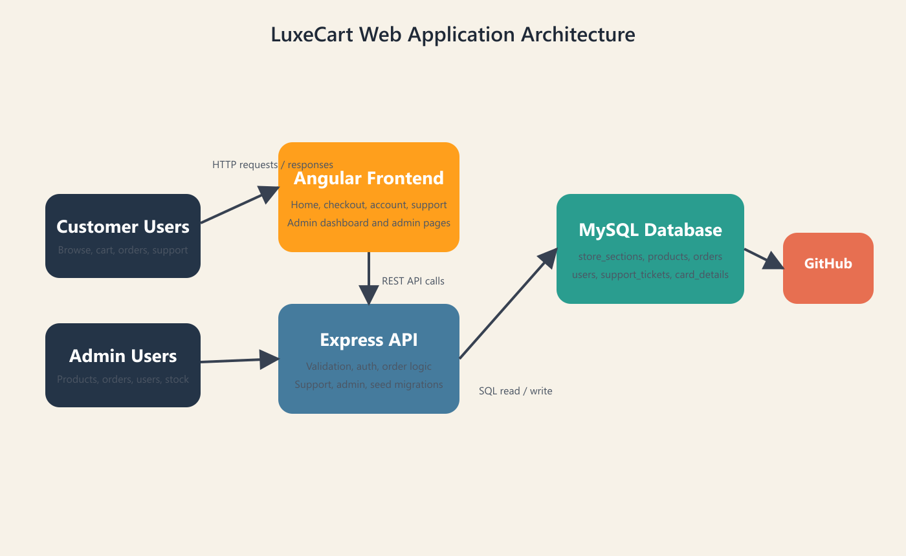

7.14.2 DFD Level 0
High-level data flow diagram describing the interaction between customers, administrators, the application, and the main data stores.
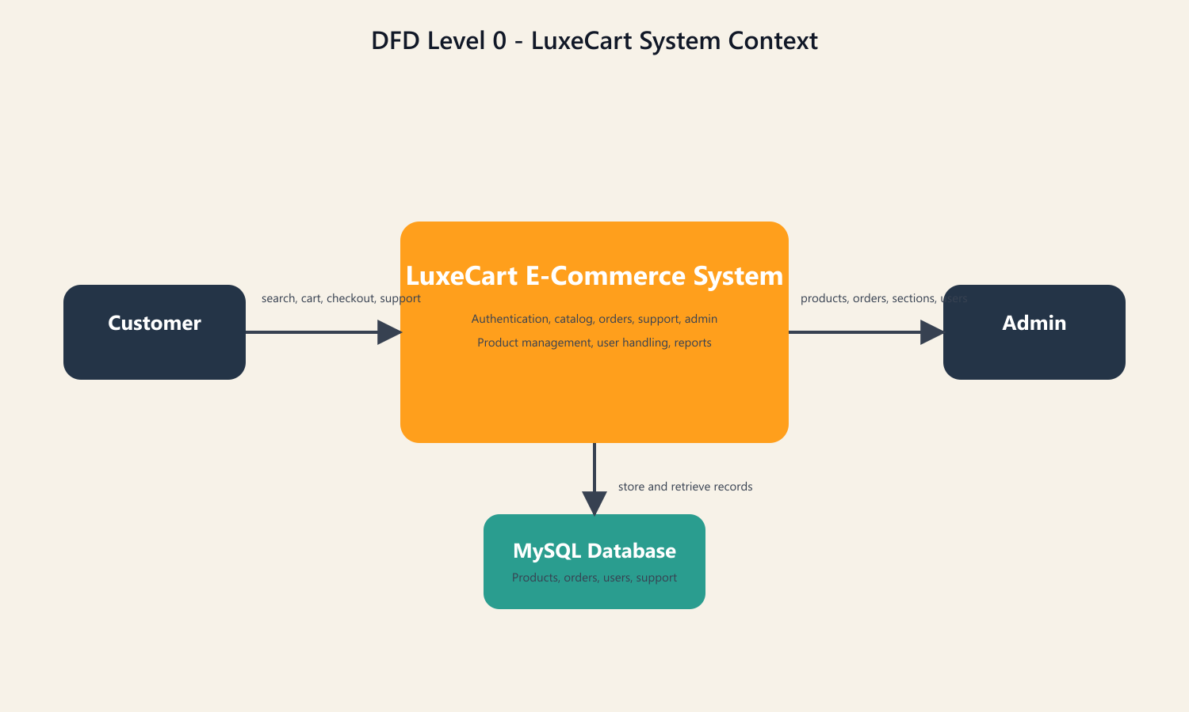

7.14.3 DFD Level 1
Expanded data flow diagram that breaks the core commerce process into account, catalog, order, and support activities.
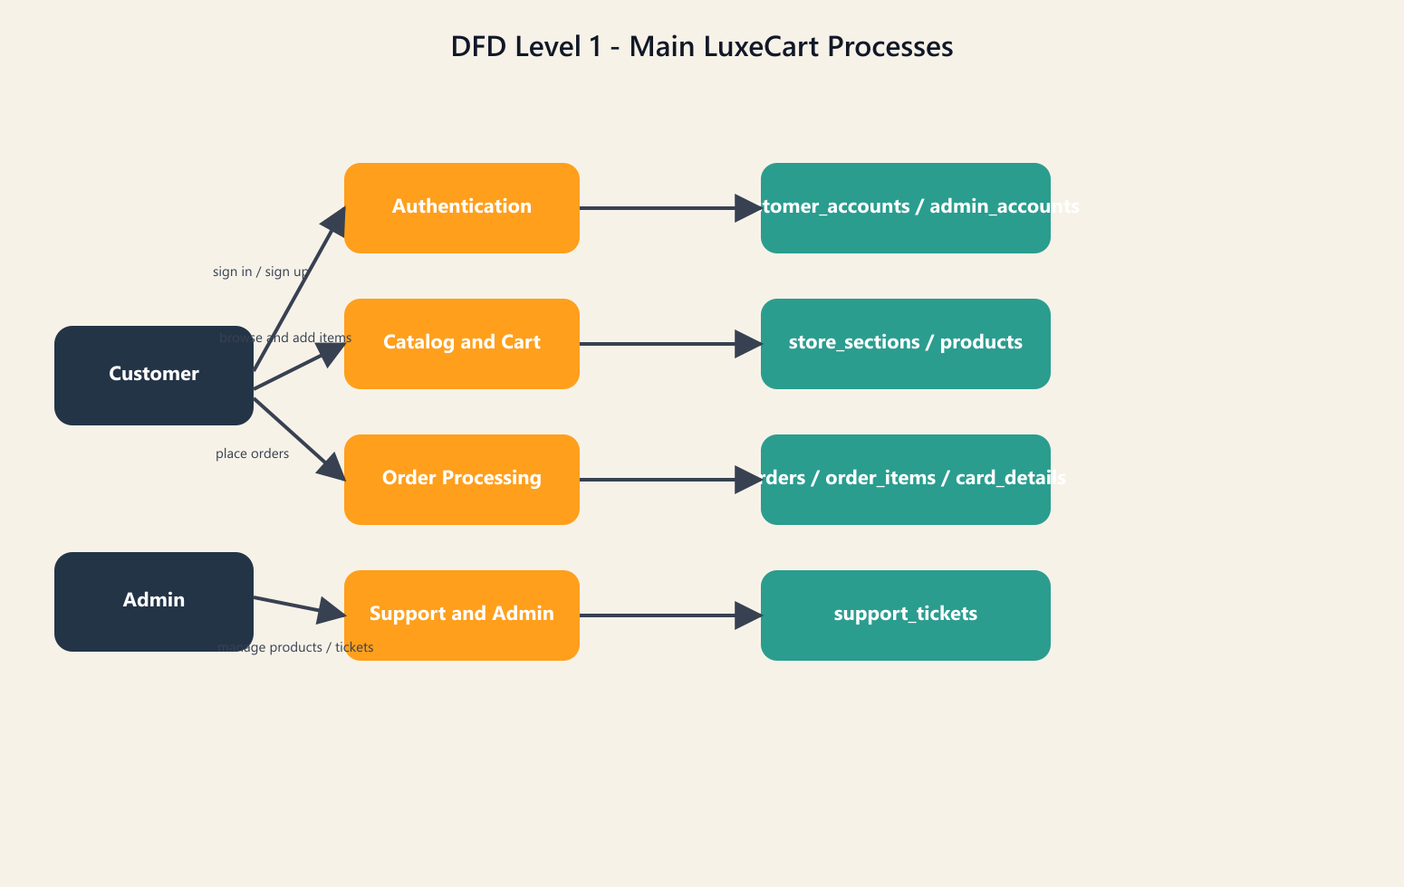

7.14.4 DFD Level 2
Detailed flow diagram illustrating validation and transactional actions during checkout and admin control processes.
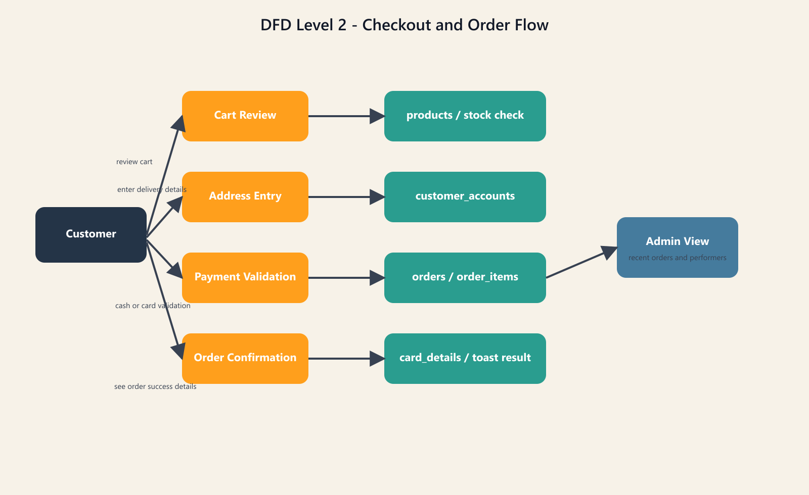

7.14.5 Security Diagram
Diagram describing authentication, protected admin routes, masked card storage, and validation boundaries in the project.
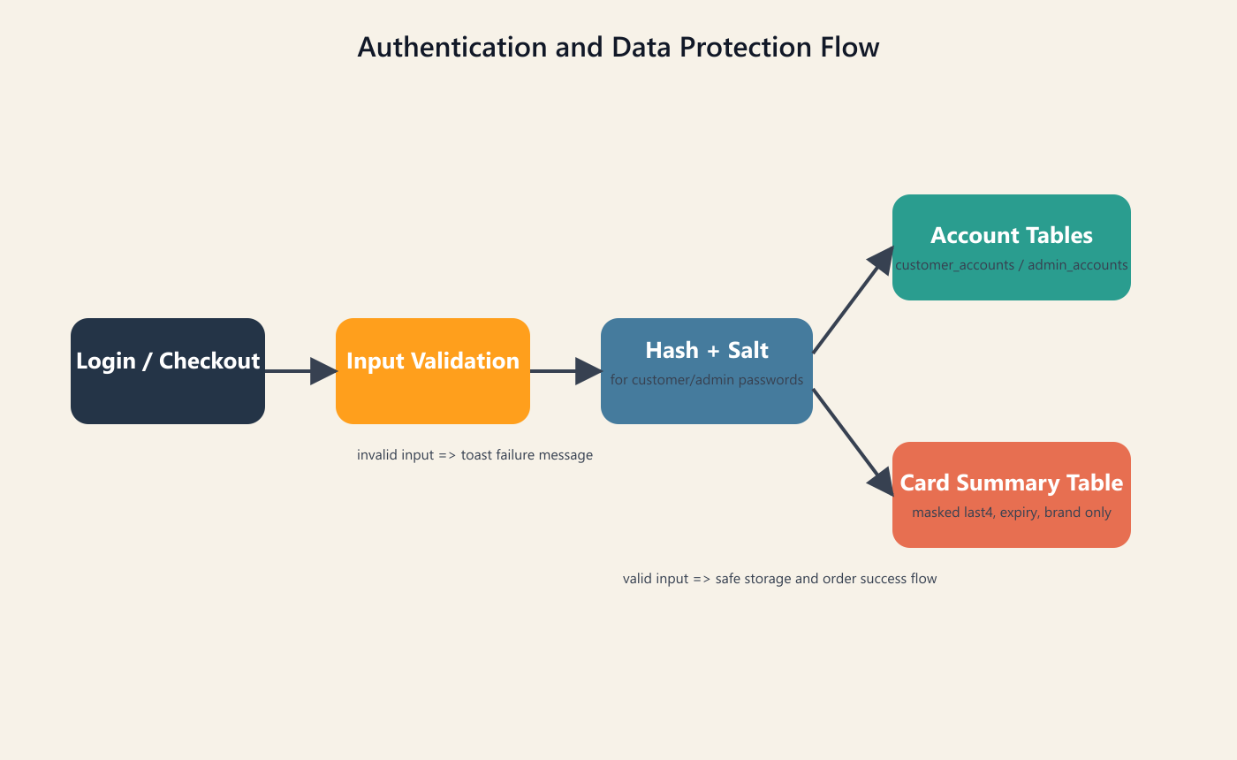

7.14.6 ER Diagram
Entity relationship diagram showing the major database tables used by LuxeCart and their relationships.
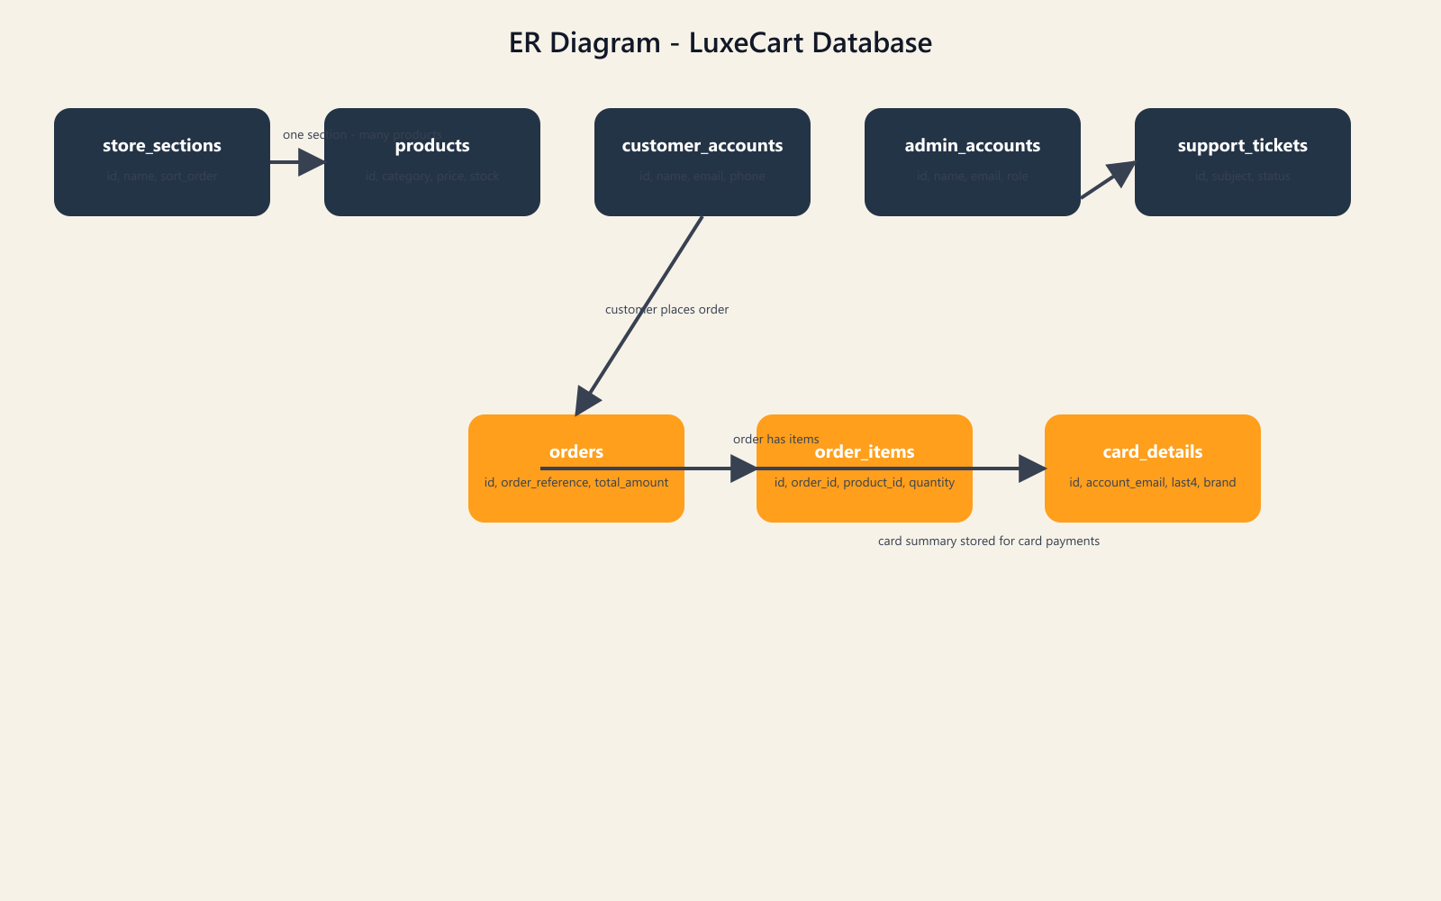

7.14.7 Home Page
Main storefront homepage with promotional content, category-driven discovery, and featured marketplace sections.
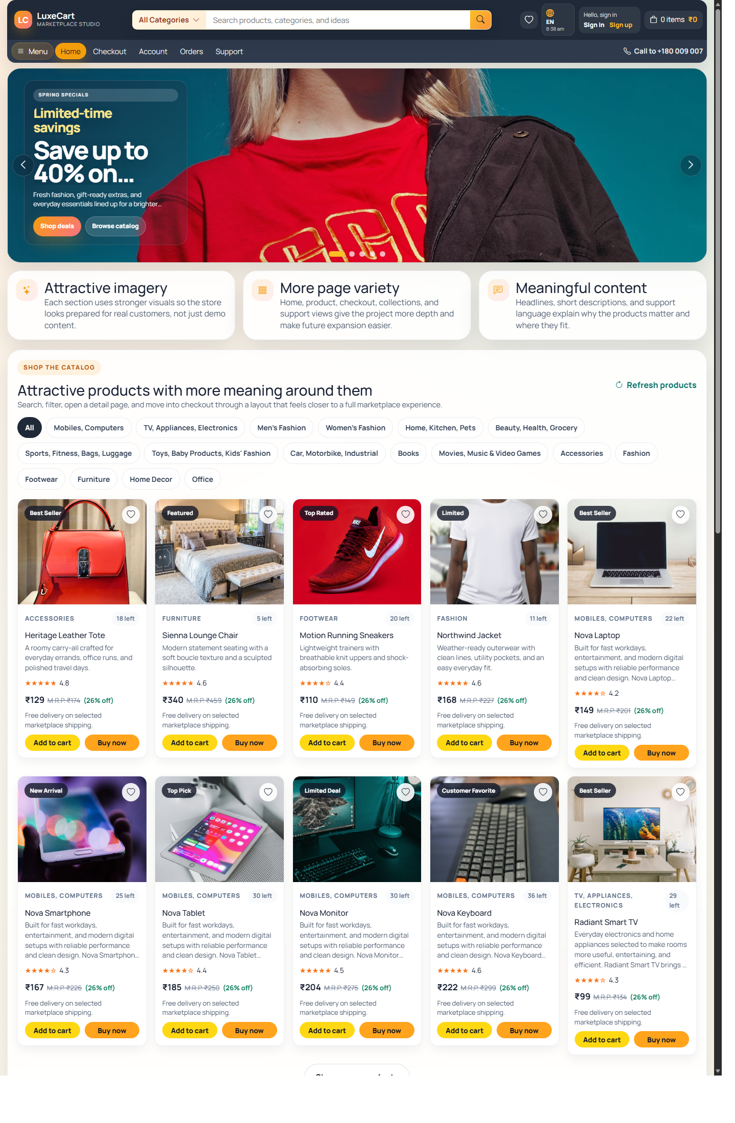

7.14.8 Product Detail Page
Detailed product page showing item presentation, pricing, stock, and primary purchase actions.
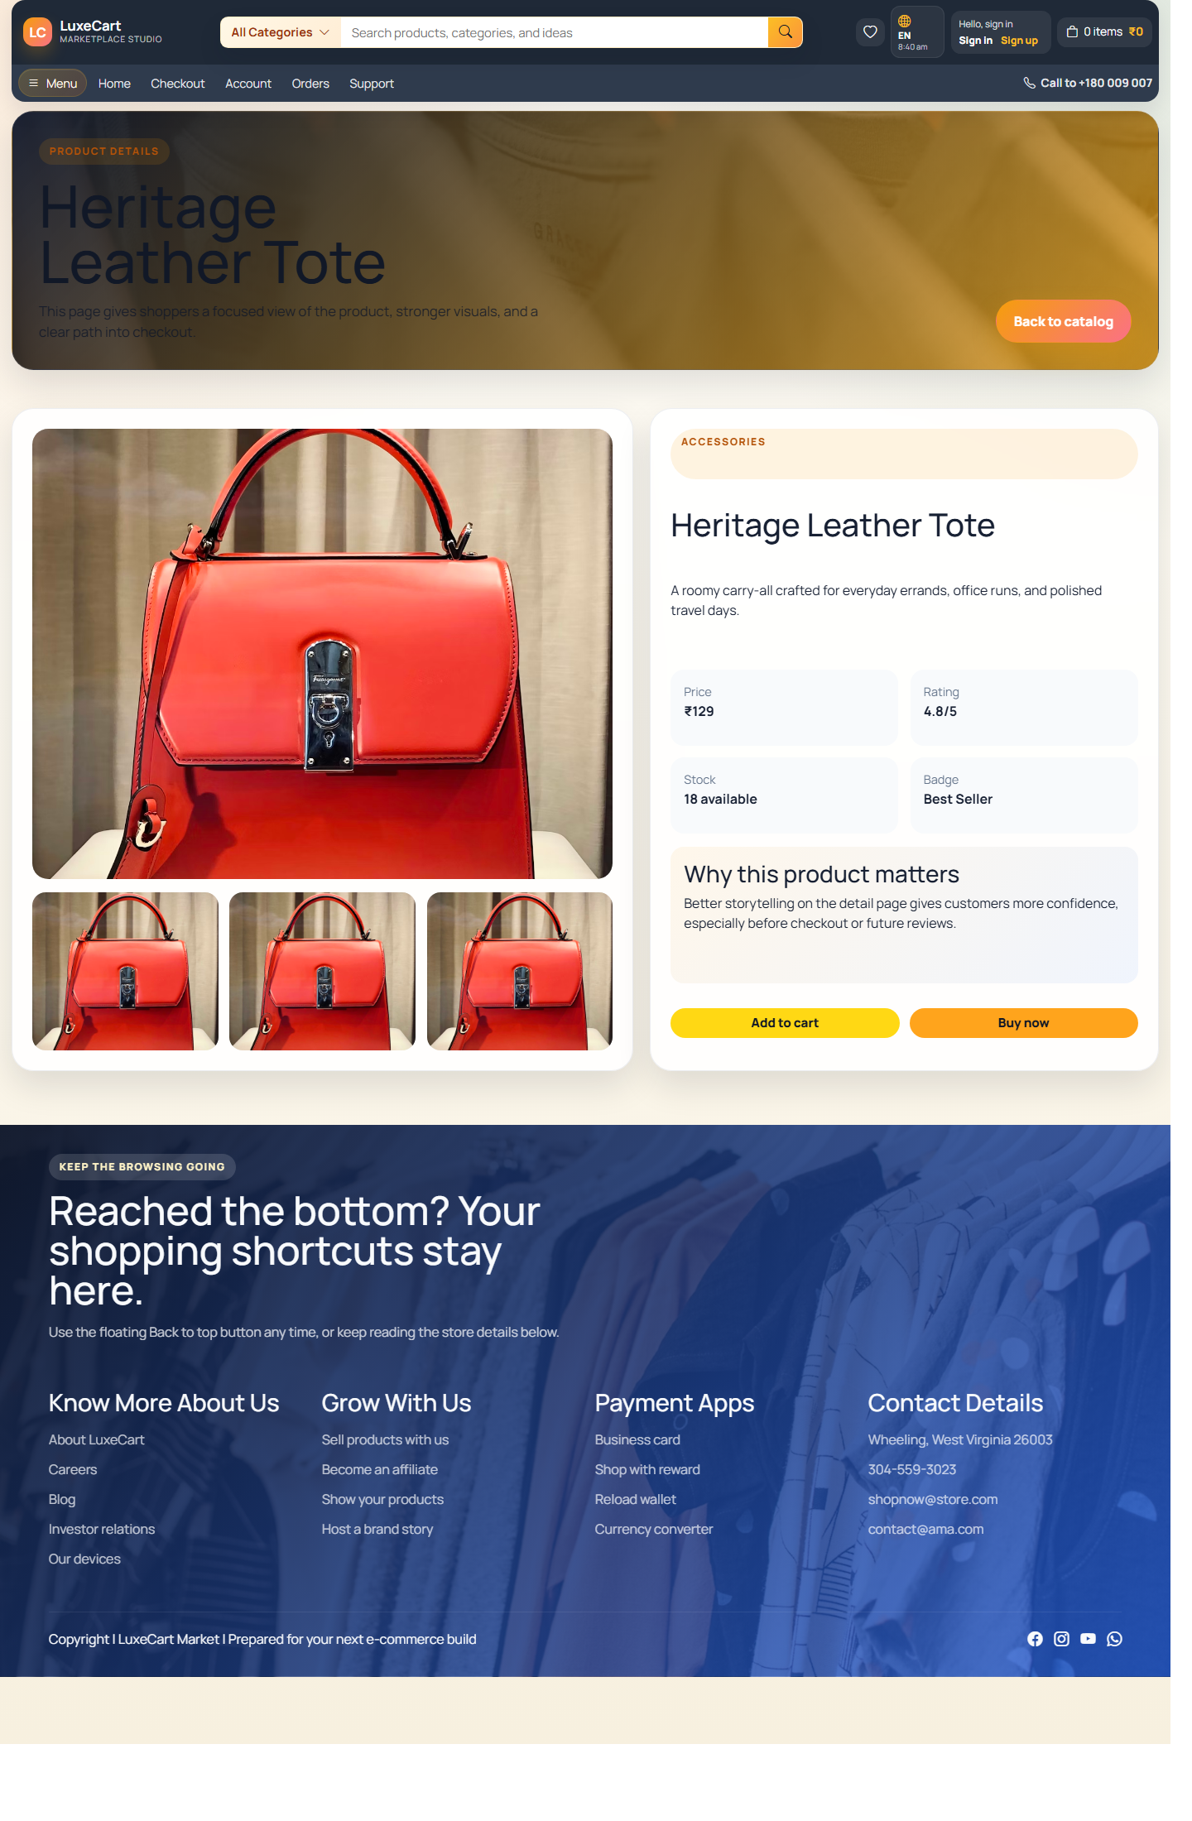

7.14.9 Checkout Page
Checkout screen combining cart review, address details, payment method selection, and order summary.
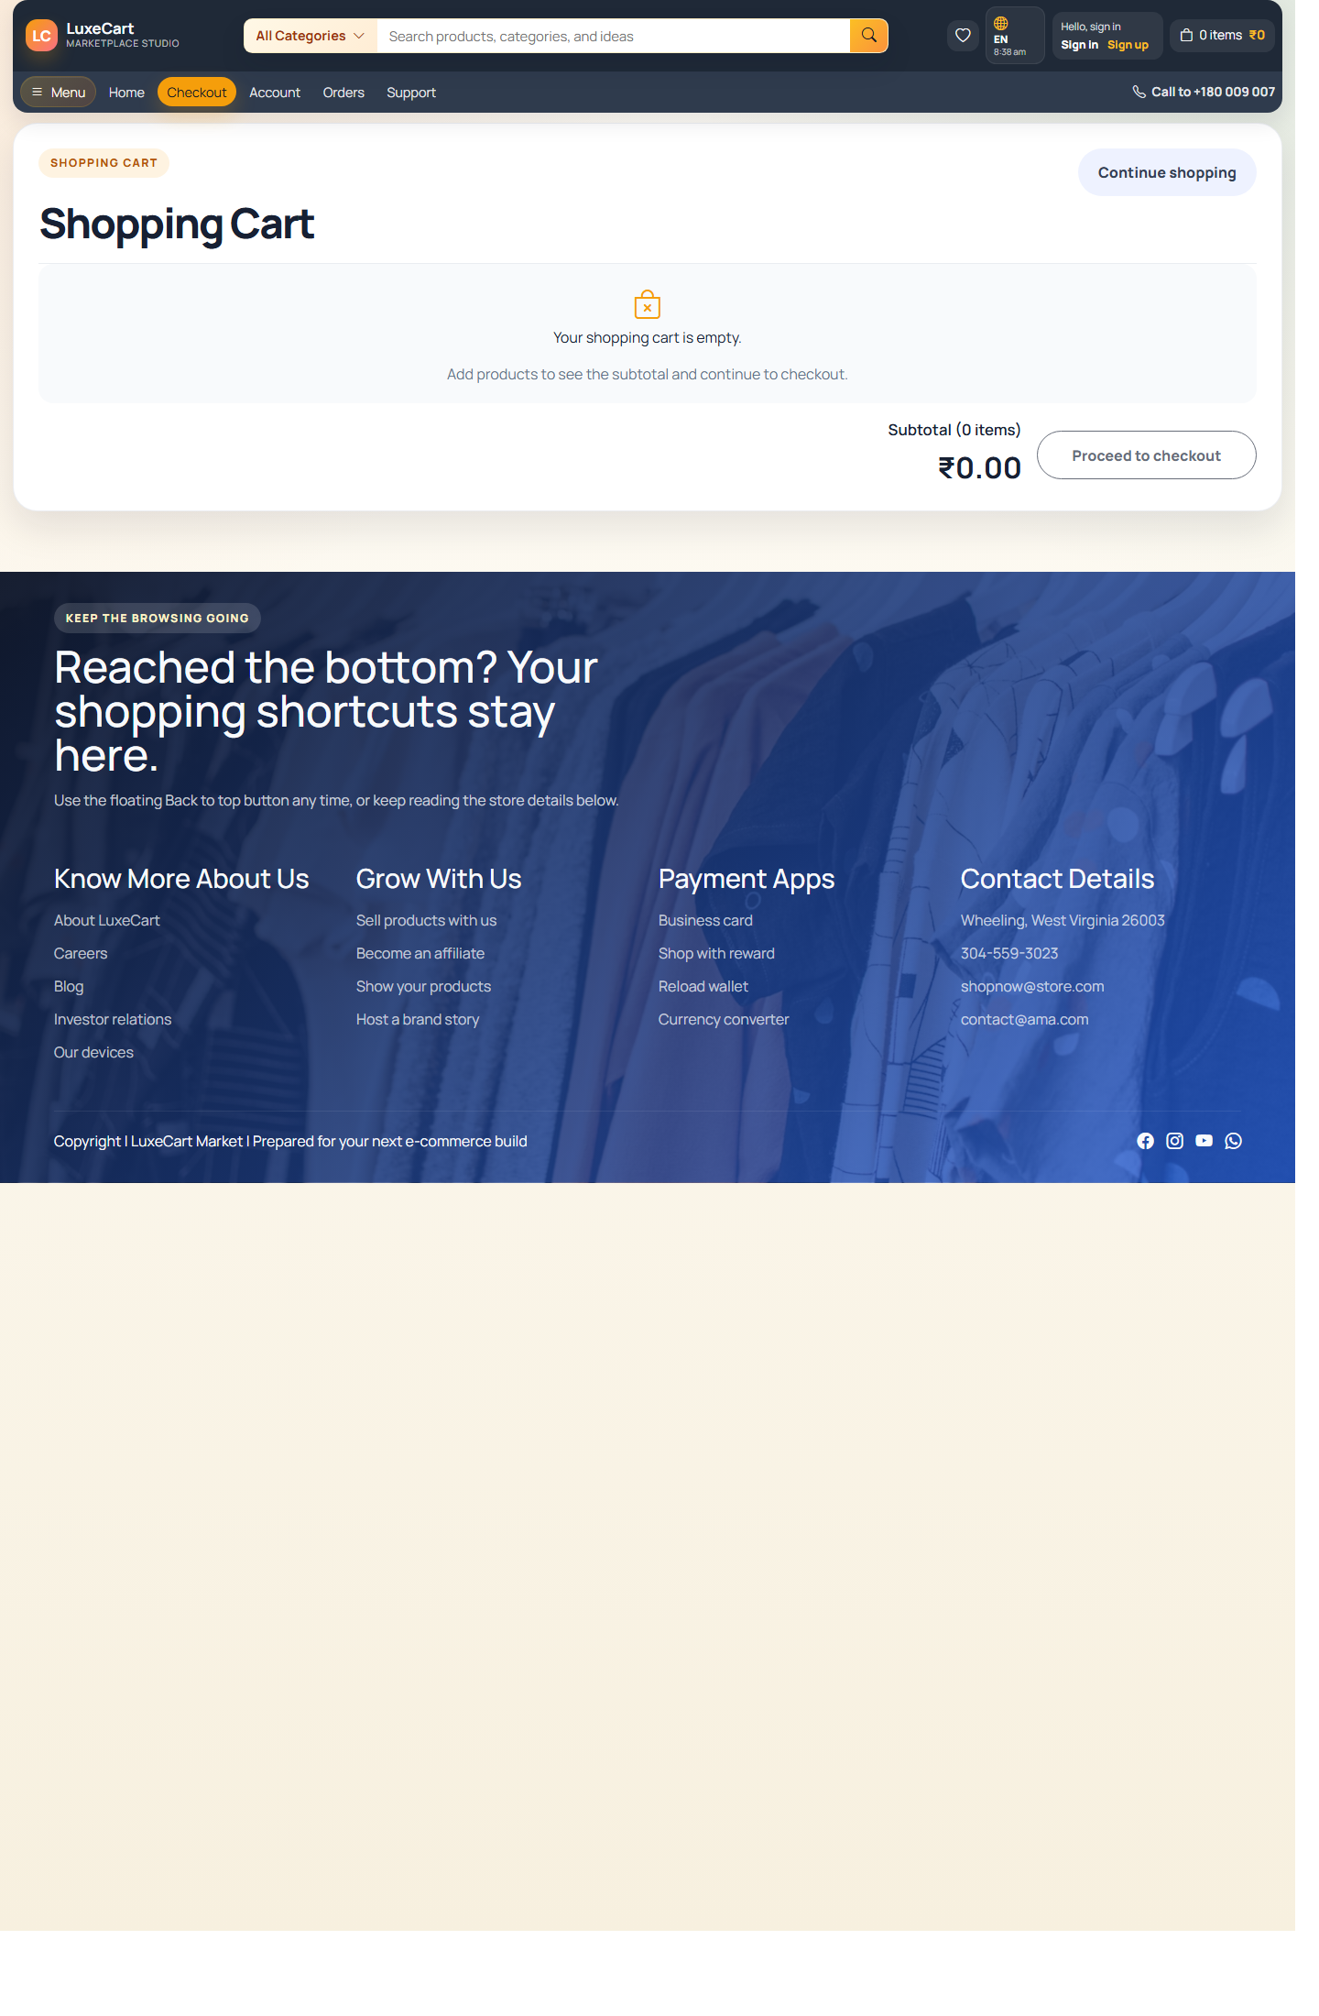

7.14.10 Support Page
Support interface used for order-related help requests, issue tracking, and response visibility.
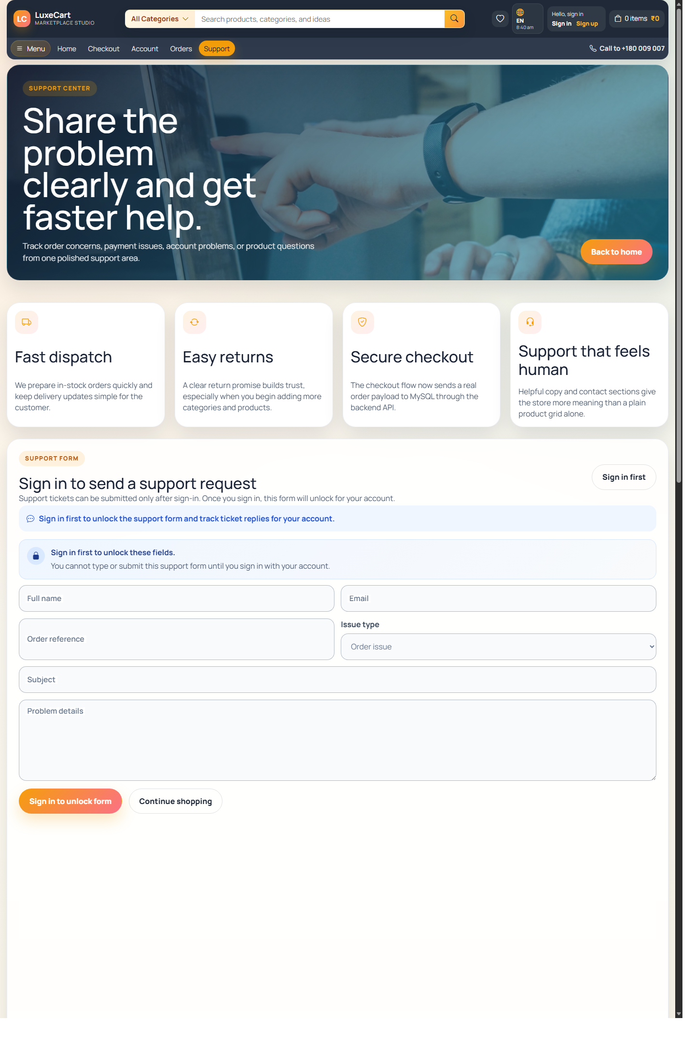

7.14.11 Orders Page
Customer orders page showing order history, detail access, and purchase continuity features.
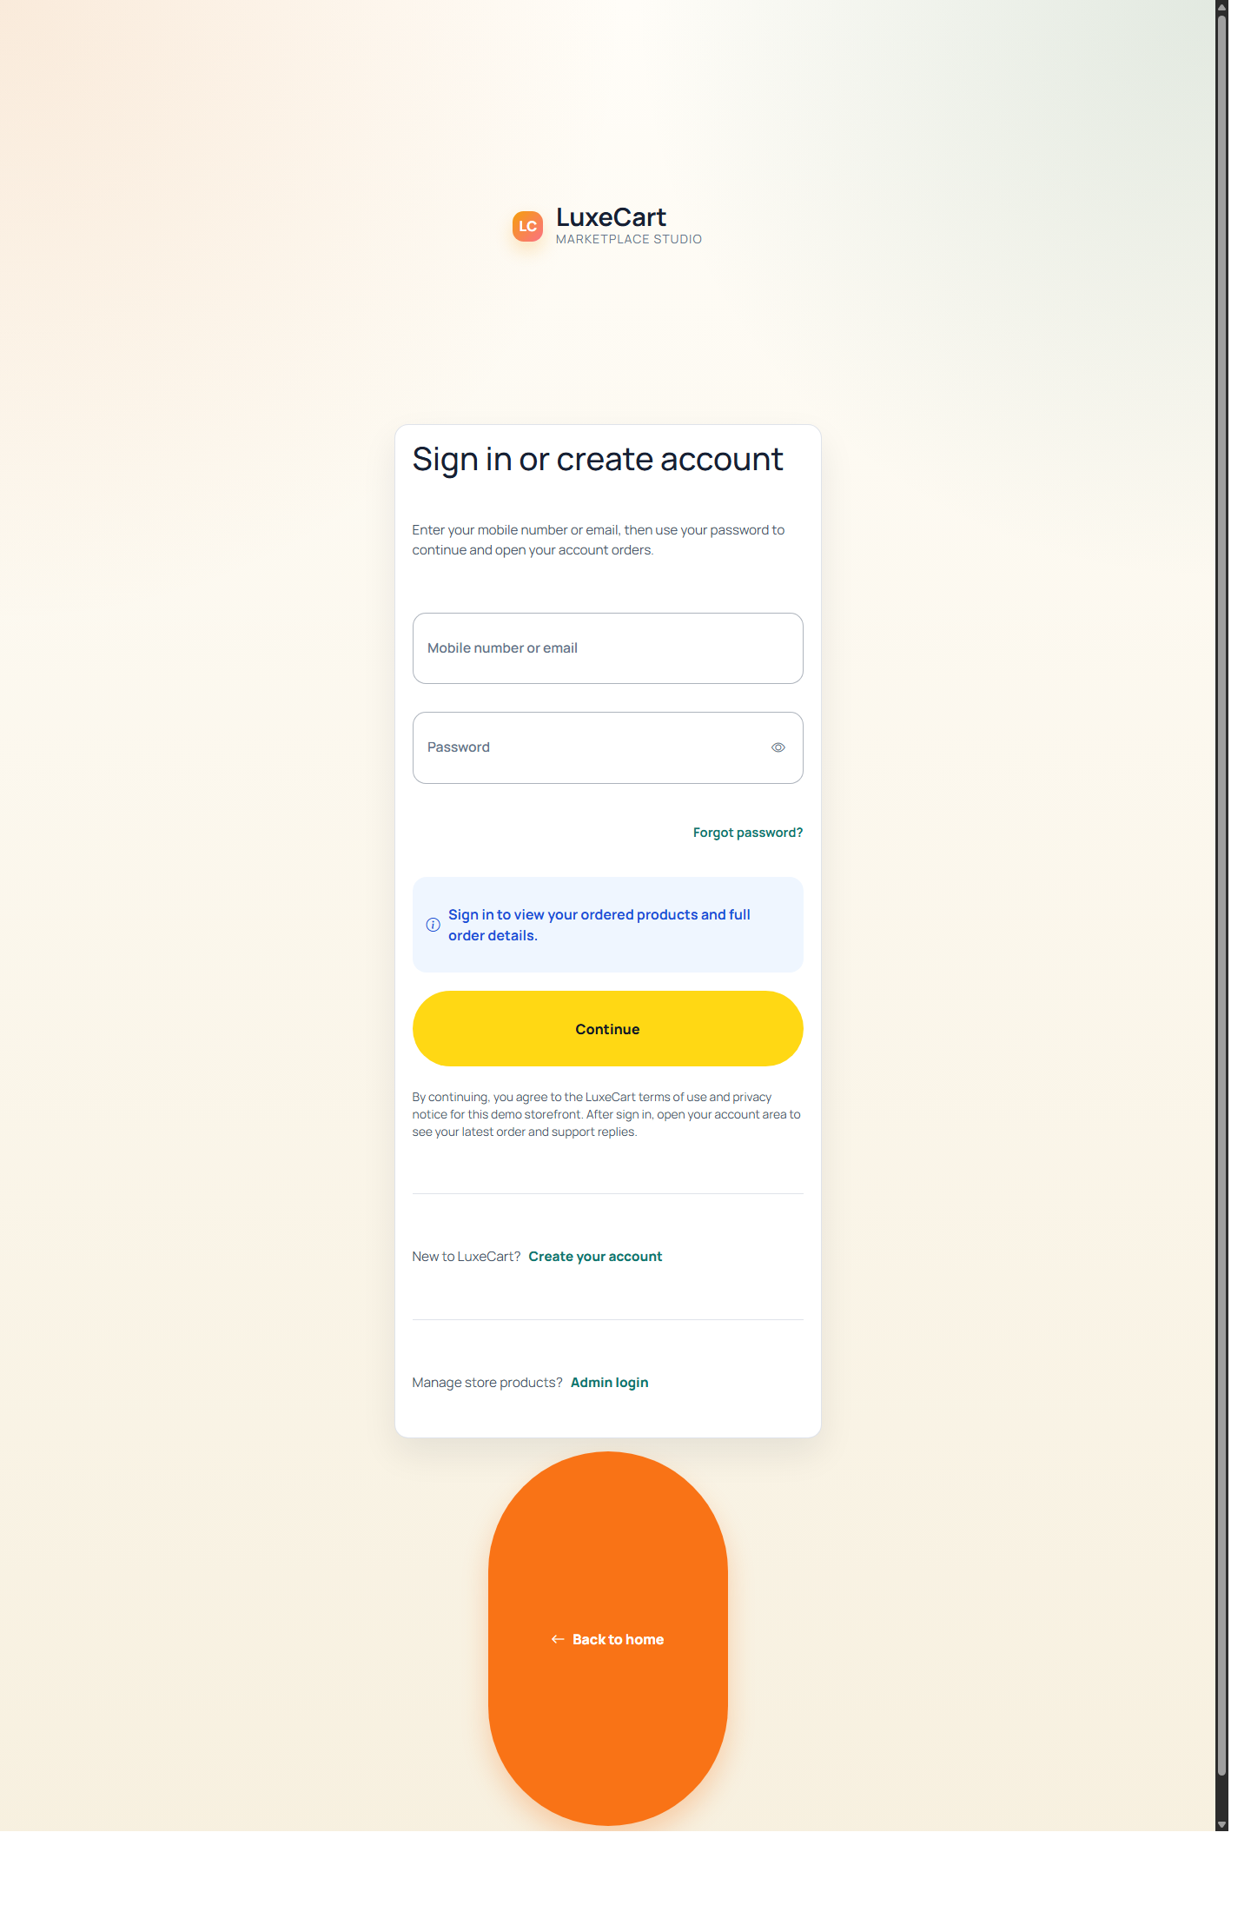

7.14.12 Admin Dashboard
Administrative dashboard with overview metrics, catalog maintenance, support management, and order monitoring.
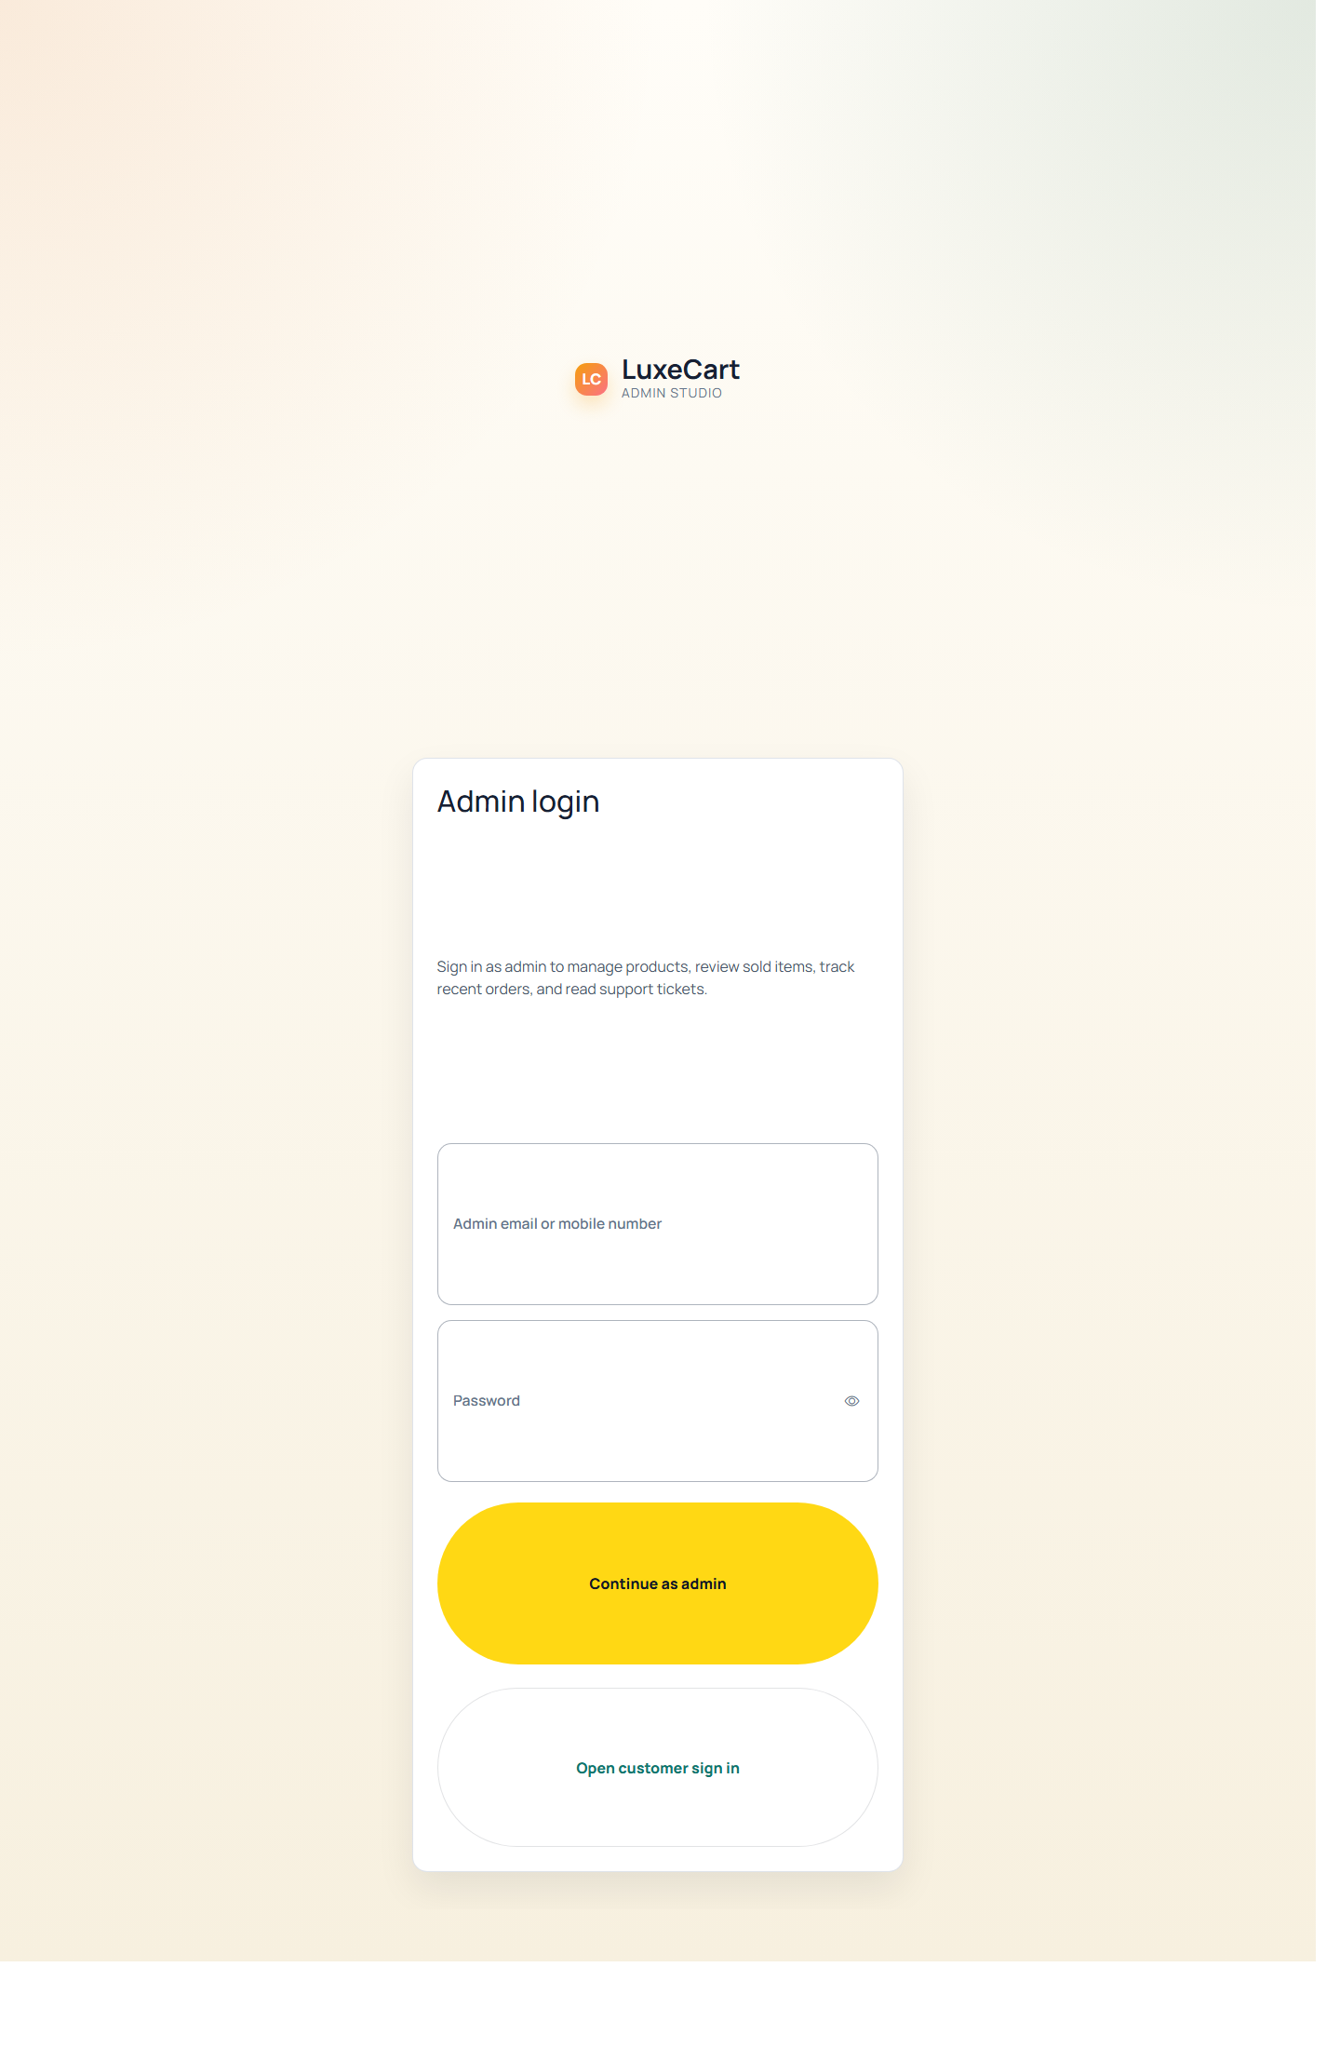

7.14.13 Home Hero And Banner View
Additional home interface capture highlighting top promotional presentation areas.
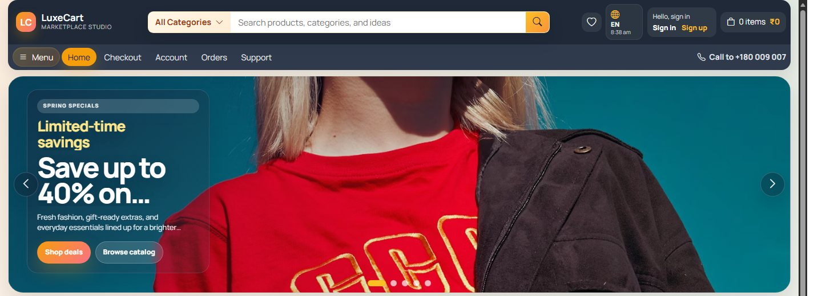

7.14.14 Product Detail Additional View
Additional product interface capture showing more detail from the customer presentation flow.
