LEKSHMIPURAM COLLEGE OF ARTS AND SCIENCE

Department of MSc Information Technology

PROJECT REPORT

ON

LuxeCart – Full-Stack E-Commerce Marketplace

( Angular | Node.js | PHP | HTML | CSS | JavaScript | MySQL )

Submitted in partial fulfillment of the requirements for the degree of
Master of Science in Information Technology

Submitted by

RENJITH R
Roll No: 8072178664

Academic Year: 2024 – 2026

April 2026

ABSTRACT
LuxeCart is a fully functional, full-stack e-commerce marketplace web application developed using Angular (TypeScript) for the frontend, Node.js and PHP for backend services, and MySQL as the relational database. The platform replicates the core experience of a modern online marketplace, supporting product browsing, a dynamic shopping cart, user authentication, order placement, account management, customer support ticketing, and a comprehensive admin control panel.

The system supports two distinct user roles — customers and administrators — each with dedicated interfaces and permission levels. The admin panel provides real-time store metrics, full product CRUD management, order tracking, customer account oversight, and support ticket handling. Sub-admin accounts can be created to delegate store management tasks.

This report documents the complete software development lifecycle of LuxeCart, covering the problem statement, objectives, system analysis, design, implementation with source code, data flow diagrams, ER diagram, testing, sample output screenshots, and future enhancement scope.

1. SYNOPSIS
The rapid growth of internet usage and digital commerce has transformed the way people shop globally. Traditional brick-and-mortar retail has steadily shifted to online platforms where customers can browse, compare, and purchase products from the comfort of their homes. Building a full-featured e-commerce platform that handles product management, user accounts, order processing, and admin oversight requires a well-integrated and robust technology stack.

LuxeCart is designed as a complete marketplace solution. It allows users to register, sign in, browse a categorised product catalog, manage a shopping cart, place orders, track their order history, manage account details, and raise support tickets. On the administrative side, it provides a powerful admin dashboard to manage products, monitor orders, handle customer accounts, and respond to support requests.

The system is built using Angular for the client-side Single Page Application (SPA), Node.js for the primary API layer, PHP for specific backend operations, and MySQL as the persistent data store. HTML5 and CSS3 are used for markup and styling, with JavaScript powering dynamic behavior. This multi-technology approach reflects real-world enterprise web development practices and provides exposure to full-stack architecture, RESTful APIs, relational database design, and modern frontend frameworks.

2. INTRODUCTION

2.1 Project Profile
LuxeCart – Marketplace Studio is a web-based e-commerce platform that enables customers to shop across multiple product categories including Mobiles & Computers, TV & Electronics, Men's and Women's Fashion, Home & Kitchen, Books, Sports, Footwear, Furniture, and more. The application provides a seamless shopping experience from product discovery all the way to order confirmation.

The platform includes a dedicated Admin Studio panel through which store administrators can manage the entire product catalog, track orders and revenues, manage customer accounts, and handle support tickets. Sub-admin accounts can be created to delegate store management tasks to staff members.

2.2 Purpose of the Project
The primary purpose of LuxeCart is to demonstrate the development of a production-grade, full-stack e-commerce web application as part of the MSc IT final year project. The project showcases the integration of modern frontend frameworks with backend API services and relational database management in a practical, real-world context.

From the customer perspective, LuxeCart makes product discovery, comparison, and purchasing simple and intuitive. From the business perspective, the admin panel provides complete visibility into store performance, inventory health, and customer activity — enabling data-driven decisions.

2.3 Scope of the Project
The scope of LuxeCart covers the following functional areas:
- Customer-facing storefront with product catalog, category filters, and search
- User registration and authentication (sign-up, sign-in, password reset)
- Shopping cart with quantity controls, delete, and save-for-later
- Checkout and order placement with MySQL persistence
- Order history and order detail tracking per user account
- Account management: profile edit, password change
- Wishlist and recently viewed product tracking
- Customer support ticket submission and status tracking
- Admin dashboard with live sales, revenue, and inventory metrics
- Admin product management: add, edit, delete products and store sections
- Admin order review and best-seller tracking
- Admin user management with activity summary and account lookup
- Out-of-stock inventory watch with restock recommendations
- Support inbox with ticket status workflow (Open → In Progress → Resolved → Closed)
- Sub-admin account creation and access management

2.4 Web Application Architecture
LuxeCart follows the standard three-tier web application architecture. The client browser communicates with the web server via HTTP requests. The Angular SPA runs in the browser, making API calls to the Node.js/PHP backend. The backend processes business logic and interacts with the MySQL database to retrieve or persist data, then returns responses in JSON format to the frontend.

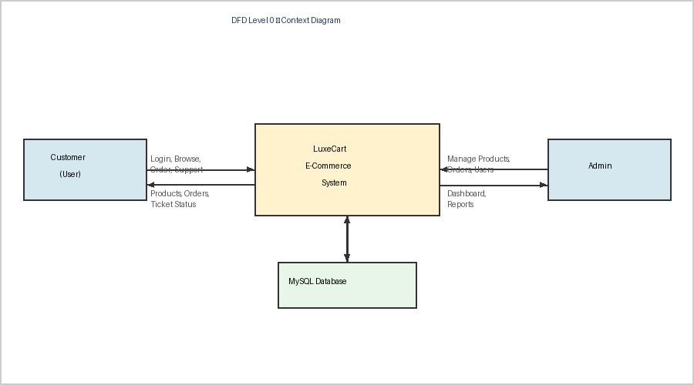
Fig 2.1 – Web Application Architecture (Context Diagram)

2.5 Objectives of the Project
- To design and develop a complete, database-backed e-commerce web application using modern technologies
- To implement secure user authentication with role-based access control for customers and admins
- To build a fully functional product catalog with categories, badges, ratings, and inventory tracking
- To enable seamless order placement, cart management, and order history for customers
- To provide a comprehensive admin control panel for real-time store management
- To implement a customer support ticket system with status tracking and admin responses
- To apply software engineering best practices including modular architecture and clean code

2.6 Organization Profile
This project was developed as part of the MSc Information Technology final year program at Lekshmipuram College of Arts and Science. The college provides a strong foundation in computer science, software development, and information systems, equipping students with practical skills relevant to the modern IT industry.

The project was individually developed by Renjith R (Roll No: 8072178664) under the guidance of the Department of MSc Information Technology, academic year 2024–2026.

3. SYSTEM ANALYSIS
System analysis is the process of gathering and interpreting facts, diagnosing problems, and recommending improvements to a system. It involves intensive communication between system users and developers to understand both the current state and the desired future state. The system is studied in detail and all inputs, outputs, and processes are identified and analyzed to recommend an optimal solution.

3.1 Existing System
Prior to LuxeCart, there was no dedicated integrated full-stack e-commerce solution that combined all marketplace functions — product browsing, cart management, order placement, customer support, and admin management — into a single unified and database-backed system.

Disadvantages of the existing approach:
- No real-time data persistence — cart and order data lost on page reload
- No proper user authentication — pages accessible without login
- No admin control panel to manage products, orders, or customers
- No support system for resolving customer issues
- No inventory tracking or alerts for low/zero stock items
- Static product data — not connected to a live database
- Not scalable for a growing product catalog or user base

3.2 Proposed System
LuxeCart addresses all shortcomings by delivering a complete, database-backed, multi-role e-commerce system with the following improvements:
- Full user authentication with sign-up, sign-in, password management, and session handling
- MySQL-backed persistence for all users, products, orders, cart data, wishlists, and support tickets
- A powerful admin panel with dashboard analytics and full CRUD operations on all entities
- Real-time inventory monitoring with low-stock and out-of-stock alerts
- A customer support system with ticket creation, status workflow, and admin reply capability
- Wishlist and recently viewed product tracking for a personalised experience
- Sub-admin role support for delegated store management

Advantages of the proposed system:
- Secure, role-based access control — customers and admins see only what is appropriate for their role
- Scalable product catalog with store sections, category filters, and badge labelling
- Accurate order tracking linked to individual user accounts with order reference numbers
- Responsive, clean UI built with Angular and modern CSS
- Modular Angular component architecture for easy maintenance and extensibility

3.3 Problem of Existing System
In the absence of a dedicated system, managing an e-commerce store manually is time-consuming and error-prone. Orders cannot be tracked reliably, inventory gets out of sync, and customers have no way to raise support issues or view their order history online. Store admins have no visibility into sales performance, best-selling products, or customers requiring attention. These operational inefficiencies directly impact customer satisfaction and business growth.

3.4 Feasibility Study
A feasibility study was conducted before development to determine whether the proposed system is practical to build within the available time, budget, and technical resources.
3.4.1 Technical Feasibility
All technologies used in LuxeCart — Angular, Node.js, PHP, MySQL, HTML, CSS, and JavaScript — are widely adopted, well-documented, and freely available. The development machine meets all software requirements. Visual Studio Code provides a capable IDE with Angular and Node.js support. The project is fully technically feasible.
3.4.2 Economic Feasibility
The entire project was developed using free and open-source technologies. No paid software licenses, cloud services, or additional hardware was required. Development was carried out on the student's personal computer with freely available tools. The project is economically feasible at zero cost.
3.4.3 Operational Feasibility
The system is designed with an intuitive user interface that requires minimal training for customers. The admin panel is structured logically with clear navigation. All operations are guided with descriptive labels, inline error messages, and confirmation steps. The application is operationally feasible for both technical and non-technical users.

4. SYSTEM REQUIREMENTS

4.1 Hardware Requirements

Component | Minimum Requirement | Recommended
Processor | Intel Core i3 / AMD Ryzen 3 | Intel Core i5 or above
RAM | 4 GB | 8 GB or above
Storage | 20 GB free space | 50 GB SSD
Display | 1280 x 720 resolution | 1920 x 1080 Full HD
Network | Broadband Internet | High-speed broadband

4.2 Software Requirements

Category | Technology / Tool | Purpose
Frontend Framework | Angular 17+ (TypeScript) | Component-based SPA development
Markup & Styling | HTML5, CSS3, JavaScript | Structure and responsive design
Backend Runtime | Node.js | REST API and server-side logic
Backend Scripting | PHP | Server-side scripting and DB operations
Database | MySQL | Relational data persistence
Development IDE | Visual Studio Code | Code editing and debugging
Version Control | Git | Source code management
Browser | Chrome / Firefox / Edge | Application testing and use
Package Manager | npm | Angular and Node.js dependency management
API Testing | Postman | REST API testing and validation

4.3 Technology Descriptions
Angular
Angular is a TypeScript-based open-source web framework developed by Google. It provides a component-based architecture for building scalable Single Page Applications. Angular's two-way data binding, dependency injection, reactive forms, and Angular Router are core features used throughout LuxeCart.
Node.js
Node.js is a JavaScript runtime built on Chrome's V8 engine. It enables server-side JavaScript execution and is ideal for building fast, scalable RESTful API services. Node.js handles all API requests in LuxeCart including authentication, product data, orders, and admin operations.
PHP
PHP is a widely-used server-side scripting language well-suited for web development and MySQL database interaction. PHP scripts in LuxeCart handle specific data processing tasks and database operations that complement the Node.js API layer.
MySQL
MySQL is an open-source relational database management system. It provides structured, persistent storage for all LuxeCart data including users, products, orders, cart items, support tickets, and wishlists. MySQL supports ACID transactions ensuring data integrity during checkout and order operations.

5. SYSTEM DESIGN

5.1 System Architecture
LuxeCart follows a three-tier architecture consisting of the Presentation Layer (Angular SPA running in the browser), the Business Logic Layer (Node.js REST API and PHP scripts running on the web server), and the Data Layer (MySQL database). The Angular frontend communicates with the backend via HTTP API calls, sending and receiving JSON payloads. The backend handles business rules, authentication, and database queries.

5.2 Data Flow Diagrams
DFD Level 0 – Context Diagram
The context diagram shows the highest-level view of the system. Two external entities — the Customer (User) and the Admin — interact with the central LuxeCart system. The system in turn reads from and writes to the MySQL database.

Fig 5.1 – DFD Level 0 (Context Diagram)
DFD Level 1 – Main System Processes
Level 1 breaks the central system into its eight main processes: Authentication, Product Catalog, Cart & Checkout, Order Management, Account Management, Support System, Wishlist, and Admin Control. Each process interacts with the MySQL database and receives input from either the User or the Admin entity.

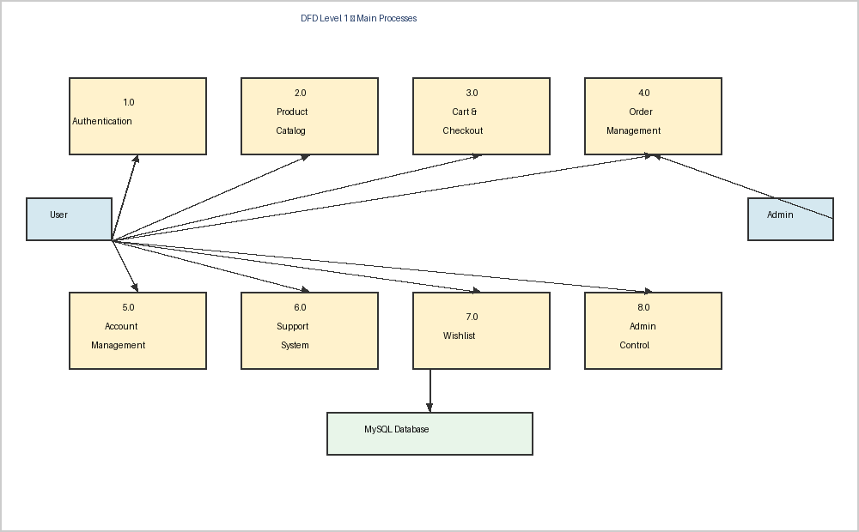
Fig 5.2 – DFD Level 1 (Main Processes)
DFD Level 2 – Cart & Checkout Process
Level 2 drills into the Cart & Checkout process. The flow begins with verifying the user is signed in, then displays cart items, allows quantity updates and save-for-later actions, and proceeds to checkout where the order is saved to the database.

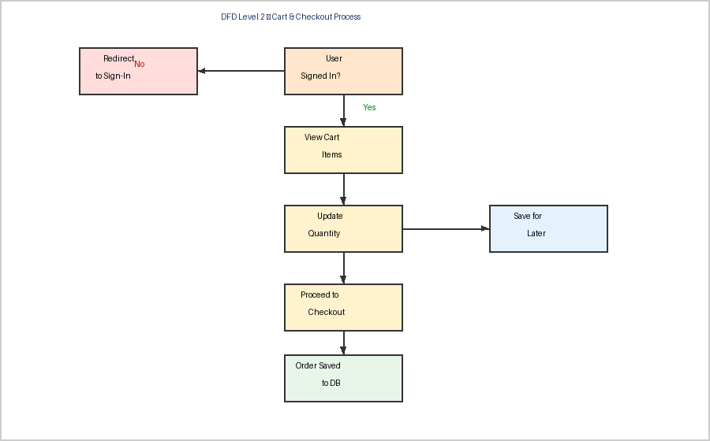
Fig 5.3 – DFD Level 2 (Cart & Checkout Process)

5.3 ER Diagram
The Entity-Relationship diagram shows the database schema for LuxeCart. The eight main entities — USERS, PRODUCTS, SECTIONS, CART_ITEMS, ORDERS, ORDER_ITEMS, SUPPORT_TICKETS, and WISHLIST — are connected through foreign key relationships. Users are central to the schema, linked to orders, cart items, support tickets, and wishlists.

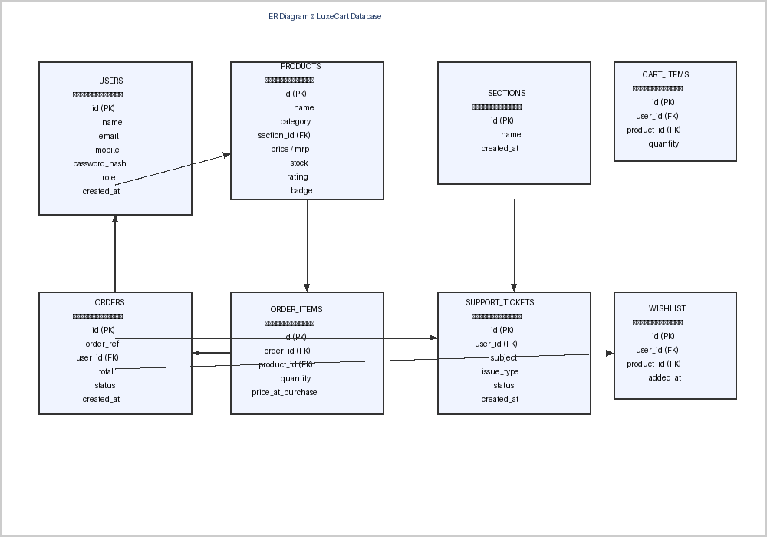
Fig 5.4 – ER Diagram (LuxeCart Database)

5.4 Module Design

Module | Description
Authentication | User sign-up, sign-in, password reset, session management, admin login
Home Page | Hero banner, product catalog grid, category filters, promo boards, wishlist section, recently viewed
Product Detail | Full product view, image, description, price, stock, rating, add to cart / buy now
Cart & Checkout | Cart items, quantity stepper, delete, save for later, subtotal, proceed to checkout, order placement
Orders | Order history list, full order detail view, order reference, status, total, items
Account | Profile edit (name, mobile), password change, email display (locked)
Support | Ticket submission form, ticket status list, FAQ section
Admin Dashboard | Live metrics, best-selling products list, store and ticket summaries
Admin Products | Section management, product CRUD popup, search & filter, 281 products across 17 sections
Admin Orders | Latest orders, top-selling products, normal/full detail toggle
Admin Accounts | Main/sub-admin management, create sub-admin form
Admin Users | Customer directory, activity filter chips, order history per user, delete user
Admin Out of Stock | Zero-stock product list, full detail with restock recommendation
Admin Support Box | Ticket inbox, status tabs (Open/In Progress/Resolved/Closed), link to order details

5.5 Database Design

Table | Primary Key | Key Foreign Keys | Description
users | id | – | Customer and admin accounts (name, email, mobile, password_hash, role)
products | id | section_id → sections | Product catalog (name, price, mrp, stock, rating, badge, image_url)
sections | id | – | Store category sections (Mobiles, Fashion, Books, etc.)
cart_items | id | user_id → users, product_id → products | Shopping cart state per user with quantity and saved_for_later flag
orders | id | user_id → users | Order header (order_ref, total, status, created_at)
order_items | id | order_id → orders, product_id → products | Line items per order (quantity, price_at_purchase)
support_tickets | id | user_id → users | Customer support requests (subject, issue_type, order_ref, status)
wishlist | id | user_id → users, product_id → products | User wishlist records

6. IMPLEMENTATION

6.1 Frontend Implementation – Angular
The Angular application is structured into page components and shared components. Each page — Home, Checkout, Account, Orders, Support, Sign-In, Sign-Up, Admin — is an Angular component with its own HTML template, TypeScript class, and CSS stylesheet. Angular's component-based architecture enables reusability and separation of concerns throughout the codebase.

Key Angular features used in LuxeCart:
- Component-based architecture with clear separation of concerns per page and feature
- Angular Router for client-side navigation between all pages without full page reload
- NgModel and reactive forms for form handling, validation, and error display
- @Input and @Output decorators with EventEmitter for parent-child component communication
- Angular Services for shared state management (cart, auth state, product data)
- *ngIf and *ngFor structural directives for conditional and list rendering
- Signal-based reactive state management for real-time UI updates
- Angular Signals and computed values for derived state

6.2 Backend Implementation – Node.js & PHP
The Node.js backend exposes RESTful API endpoints for all major operations. PHP scripts handle specific data processing tasks and MySQL interactions. The two backend layers work together to serve the Angular frontend with all required data.

Key REST API endpoints implemented:
- POST /api/auth/signup — User registration with password hashing
- POST /api/auth/signin — Authentication with credential validation and session creation
- GET /api/products — Product catalog retrieval with optional section and category filters
- POST /api/cart — Add item to cart for authenticated user
- PUT /api/cart/:id — Update cart item quantity
- DELETE /api/cart/:id — Remove item from cart
- POST /api/orders/checkout — Order placement with inventory deduction
- GET /api/orders/:userId — Order history retrieval per user
- POST /api/support — Support ticket submission
- GET /api/admin/dashboard — Aggregated metrics for admin dashboard
- GET /api/admin/users — All customer accounts for admin view
- POST /api/admin/products — Add new product to catalog
- PUT /api/admin/products/:id — Edit existing product
- DELETE /api/admin/products/:id — Remove product from catalog

6.3 Database Implementation – MySQL
MySQL stores all persistent application data. The database is designed with proper foreign key constraints to maintain referential integrity. Indexes are applied on frequently queried columns such as user_id, product_id, and order_ref. Transactions are used during checkout to ensure stock deduction and order creation happen atomically.

7. SOURCE CODE

7.1 Sign-In Page Component (TypeScript)
The SignInPageComponent handles user login via mobile number or email and password. It uses Angular's EventEmitter pattern to communicate with the parent app component.

import { CommonModule } from '@angular/common';
import { Component, EventEmitter, Input, Output } from '@angular/core';
import { FormsModule, NgForm } from '@angular/forms';
import { AuthForm, AuthPasswordResetPayload } from '../../models/storefront.model';

@Component({
selector: 'app-sign-in-page',
imports: [CommonModule, FormsModule],
templateUrl: './sign-in-page.component.html'
})
export class SignInPageComponent {
@Input({ required: true }) form!: AuthForm;
@Input() errorMessage = '';
@Input() successMessage = '';
@Output() submitForm = new EventEmitter<void>();
@Output() openSignUp = new EventEmitter<void>();
@Output() openAdmin = new EventEmitter<void>();
@Output() backHome = new EventEmitter<void>();

showSignInPassword = false;

handleSubmit(form: NgForm): void {
if (form.invalid || !this.isIdentifierValid(this.form.identifier)) {
return;
}
this.submitForm.emit();
}

isIdentifierValid(id: string): boolean {
const emailOk = /^[^\s@]+@[^\s@]+\.[^\s@]+$/.test(id);
const phoneOk = /^[0-9]{10}$/.test(id);
return emailOk || phoneOk;
}
}

7.2 Home Page Component (TypeScript)
The HomePageComponent is the main storefront. It receives all product data, hero slides, wishlist, and category state through @Input bindings and emits user actions upward to the parent via @Output EventEmitters.

import { CommonModule } from '@angular/common';
import { Component, EventEmitter, Input, Output } from '@angular/core';
import { Product } from '../../models/product.model';
import { HeroAction, HeroSlide, PromoBoard } from '../../models/storefront.model';

@Component({
selector: 'app-home-page',
imports: [CommonModule, /* child components */],
templateUrl: './home-page.component.html',
styleUrl: './home-page.component.css'
})
export class HomePageComponent {
@Input({ required: true }) heroSlides!: HeroSlide[];
@Input({ required: true }) allProducts!: Product[];
@Input({ required: true }) categories!: string[];
@Input({ required: true }) selectedCategory!: string;
@Input({ required: true }) wishlistProducts!: Product[];
@Input() showWishlistSection = false;
@Input({ required: true }) bestSellerProducts!: Product[];

@Output() heroAction = new EventEmitter<HeroAction>();
@Output() shopCategory = new EventEmitter<string>();
@Output() refreshProducts = new EventEmitter<void>();
@Output() addToCart = new EventEmitter<Product>();
@Output() toggleWishlist = new EventEmitter<Product>();
@Output() openProduct = new EventEmitter<Product>();
}

7.3 Checkout Page Component (TypeScript)
The CheckoutPageComponent manages the shopping cart and order placement flow. It receives cart items, totals, and checkout stage as inputs, and emits order submission and navigation events.

import { Component, EventEmitter, Input, Output } from '@angular/core';
import { CartItem, CheckoutForm, CheckoutStage } from '../../models/storefront.model';

@Component({
selector: 'app-checkout-page',
templateUrl: './checkout-page.component.html'
})
export class CheckoutPageComponent {
@Input({ required: true }) stage!: CheckoutStage;
@Input({ required: true }) cart!: CartItem[];
@Input({ required: true }) cartSubtotal!: number;
@Input({ required: true }) cartTotal!: number;
@Input({ required: true }) deliveryFee!: number;
@Input({ required: true }) checkoutItemCount!: number;
@Input({ required: true }) orderSubmitting!: boolean;

@Output() submitOrder = new EventEmitter<void>();
@Output() increaseQuantity = new EventEmitter<number>();
@Output() decreaseQuantity = new EventEmitter<number>();
@Output() deleteFromCart = new EventEmitter<number>();
@Output() saveForLater = new EventEmitter<number>();
@Output() backHome = new EventEmitter<void>();
}

7.4 Admin Dashboard (TypeScript – Key Logic)
The Admin page loads all store metrics on initialization and displays them in the dashboard. It supports navigation between sub-sections and manages product CRUD operations through modal popups.

@Component({ selector: 'app-admin-page', ... })
export class AdminPageComponent implements OnInit {
activeTab: AdminTab = 'dashboard';
dashboardMetrics!: DashboardMetrics;
products: Product[] = [];
orders: Order[] = [];
users: User[] = [];
supportTickets: SupportTicket[] = [];

ngOnInit(): void {
this.loadDashboard();
}

loadDashboard(): void {
this.http.get<DashboardMetrics>('/api/admin/dashboard')
.subscribe(data => this.dashboardMetrics = data);
}

addProduct(product: NewProduct): void {
this.http.post('/api/admin/products', product)
.subscribe(() => this.loadProducts());
}

deleteProduct(id: number): void {
this.http.delete('/api/admin/products/' + id)
.subscribe(() => this.loadProducts());
}
}

8. PAGE DESCRIPTIONS & FEATURES

8.1 Sign-In Page
Allows users to authenticate using mobile number or email and password. Includes Forgot Password with password hint recovery, links to Sign-Up and Admin Login.

8.2 Sign-Up Page
New users register with full name, 10-digit mobile number, email, password (min 6 chars), and a password hint. Requires agreement to Terms of Use and Privacy Policy.

8.3 Home Page
Main storefront featuring: rotating hero banner carousel, product catalog grid with category filters and badge labels (Best Seller, Featured, Top Rated, New Arrival, Limited Deal, Customer Favorite), Wishlist section, promo boards (Wireless Tech, Finds for Home, etc.), and Related to Items You've Viewed section.

8.4 Shopping Cart
Displays all cart items with image, name, price, stock status, and quantity stepper. Supports Delete and Save for Later. Shows subtotal and Proceed to Checkout button.

8.5 Account Page
Allows profile edit (name, mobile) and password change. Email is shown as read-only. Password reset via current password or password hint is supported.

8.6 Orders Page
Lists all orders per signed-in user with order reference (LC-XXXXXX), item count, date, status (Confirmed), and total amount. Full order detail view available per order.

8.7 Support Page
Logged-in support form pre-filled with user name and email. Allows issue type selection, order reference, subject, and problem details. All submitted tickets and their current status/admin replies are shown below the form. FAQ section provided.

8.8 Admin Dashboard
Live metrics: Total Products (281), Inventory Units (10,334), Orders Placed (16), Sold Units (43), Revenue (₹5,777.80), Low Stock Items (4). Best-Selling Products panel with units sold and revenue per product.

8.9 Admin Products
All 281 products grouped by 17 store sections. Quick Actions: section filter, product search, Add New Product button (popup form), Add or Edit Sections. Each product card shows stock, price, rating, and Edit/Delete buttons.

8.10 Admin Orders
Latest orders list with Normal/Full Detail toggle. Best Performers panel showing top-sold products. Each order shows customer email, item count, total, date, and status.

8.11 Admin Accounts
Main admin and sub-admin access management. Shows signed-in role, total admin count (2), main admin count (1), and sub-admin count (1). Add New Sub-Admin form with name, email, mobile, and password.

8.12 Admin Users
Searchable customer directory with filter chips: All Users (5), Account Only (1), Orders Only (3), Mixed Activity (1), Open Tickets (1). Each user card shows order count, support count, total spend, and links to view account or delete user.

8.13 Admin Out of Stock
Lists products with zero inventory. Full Detail view shows complete product card with Restock Recommendation section. Supports Normal and Full Detail toggle views.

8.14 Admin Support Box
Customer ticket inbox with tabs: All (1), Open (1), In Progress (0), Resolved (0), Closed (0). Each ticket shows customer name/email, issue type, status badge, message, and order reference. Direct link to order details.

9. TESTING

9.1 Testing Strategy
LuxeCart was tested using manual functional testing, integration testing, and user acceptance testing. Each module was tested independently before end-to-end integration testing. Test cases covered both positive (happy path) and negative (error/edge) scenarios.

9.2 Test Cases

TC ID | Module | Test Description | Expected Result | Status
TC-001 | Sign-Up | Register with valid all details | Account created, home redirect | Pass
TC-002 | Sign-Up | Register with duplicate email | Duplicate email error shown | Pass
TC-003 | Sign-In | Login with correct credentials | Session set, home loaded | Pass
TC-004 | Sign-In | Login with wrong password | Error message displayed | Pass
TC-005 | Sign-In | Login with 10-digit mobile number | Authentication successful | Pass
TC-006 | Cart | Add product to cart | Item in cart with correct price | Pass
TC-007 | Cart | Increase item quantity | Subtotal updates correctly | Pass
TC-008 | Cart | Delete item from cart | Item removed, subtotal updated | Pass
TC-009 | Cart | Save item for later | Item moved to saved list | Pass
TC-010 | Checkout | Place order as signed-in user | Order saved, confirmation shown | Pass
TC-011 | Checkout | Checkout as guest (not signed in) | Prompted to sign in first | Pass
TC-012 | Orders | View order history | All user orders listed correctly | Pass
TC-013 | Account | Edit name and mobile number | Profile updated in database | Pass
TC-014 | Account | Change password correctly | Password updated successfully | Pass
TC-015 | Account | Change password with wrong current | Error message displayed | Pass
TC-016 | Support | Submit support ticket | Ticket saved, appears in list | Pass
TC-017 | Wishlist | Heart / un-heart a product | Product added/removed from wishlist | Pass
TC-018 | Admin | Admin login with credentials | Admin dashboard loaded | Pass
TC-019 | Admin Products | Add new product via popup | Product appears in catalog | Pass
TC-020 | Admin Products | Delete product | Product removed from catalog | Pass
TC-021 | Admin Orders | View latest orders | All orders displayed correctly | Pass
TC-022 | Admin Users | View all customer accounts | All 5 users shown with details | Pass
TC-023 | Admin Users | Filter by Open Tickets | Only users with open tickets shown | Pass
TC-024 | Out of Stock | View zero-stock list | Out-of-stock items listed correctly | Pass
TC-025 | Admin Accounts | Create sub-admin account | Sub-admin created, count updated | Pass

10. SAMPLE OUTPUT
The following screenshots show the actual running application captured from the local development server at localhost:4200.

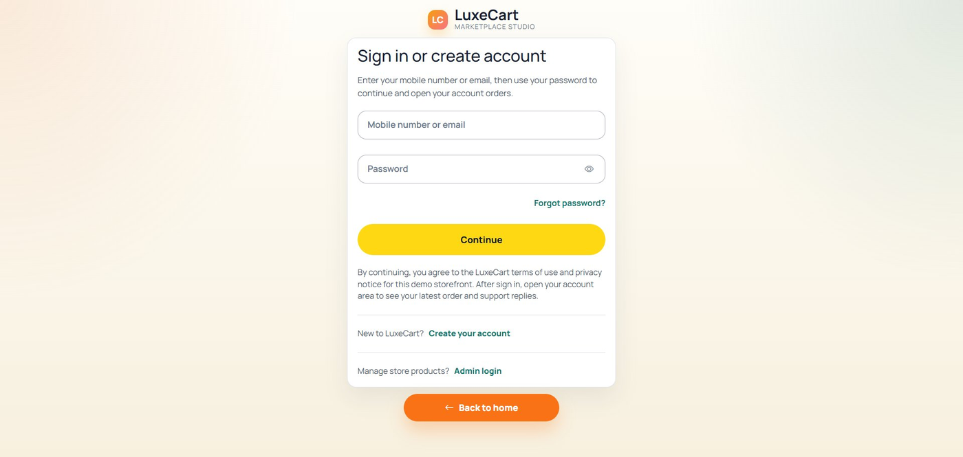
Fig 10.1 – Sign-In Page
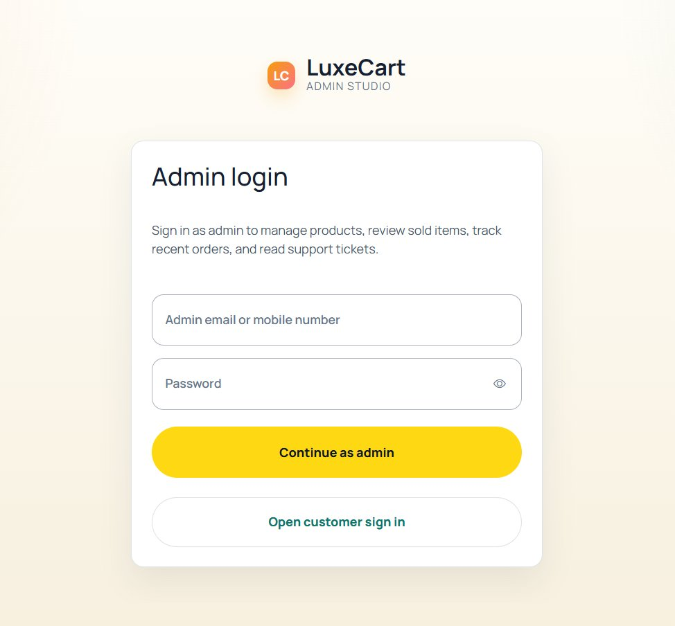
Fig 10.2 – Sign-Up / Create Account Page
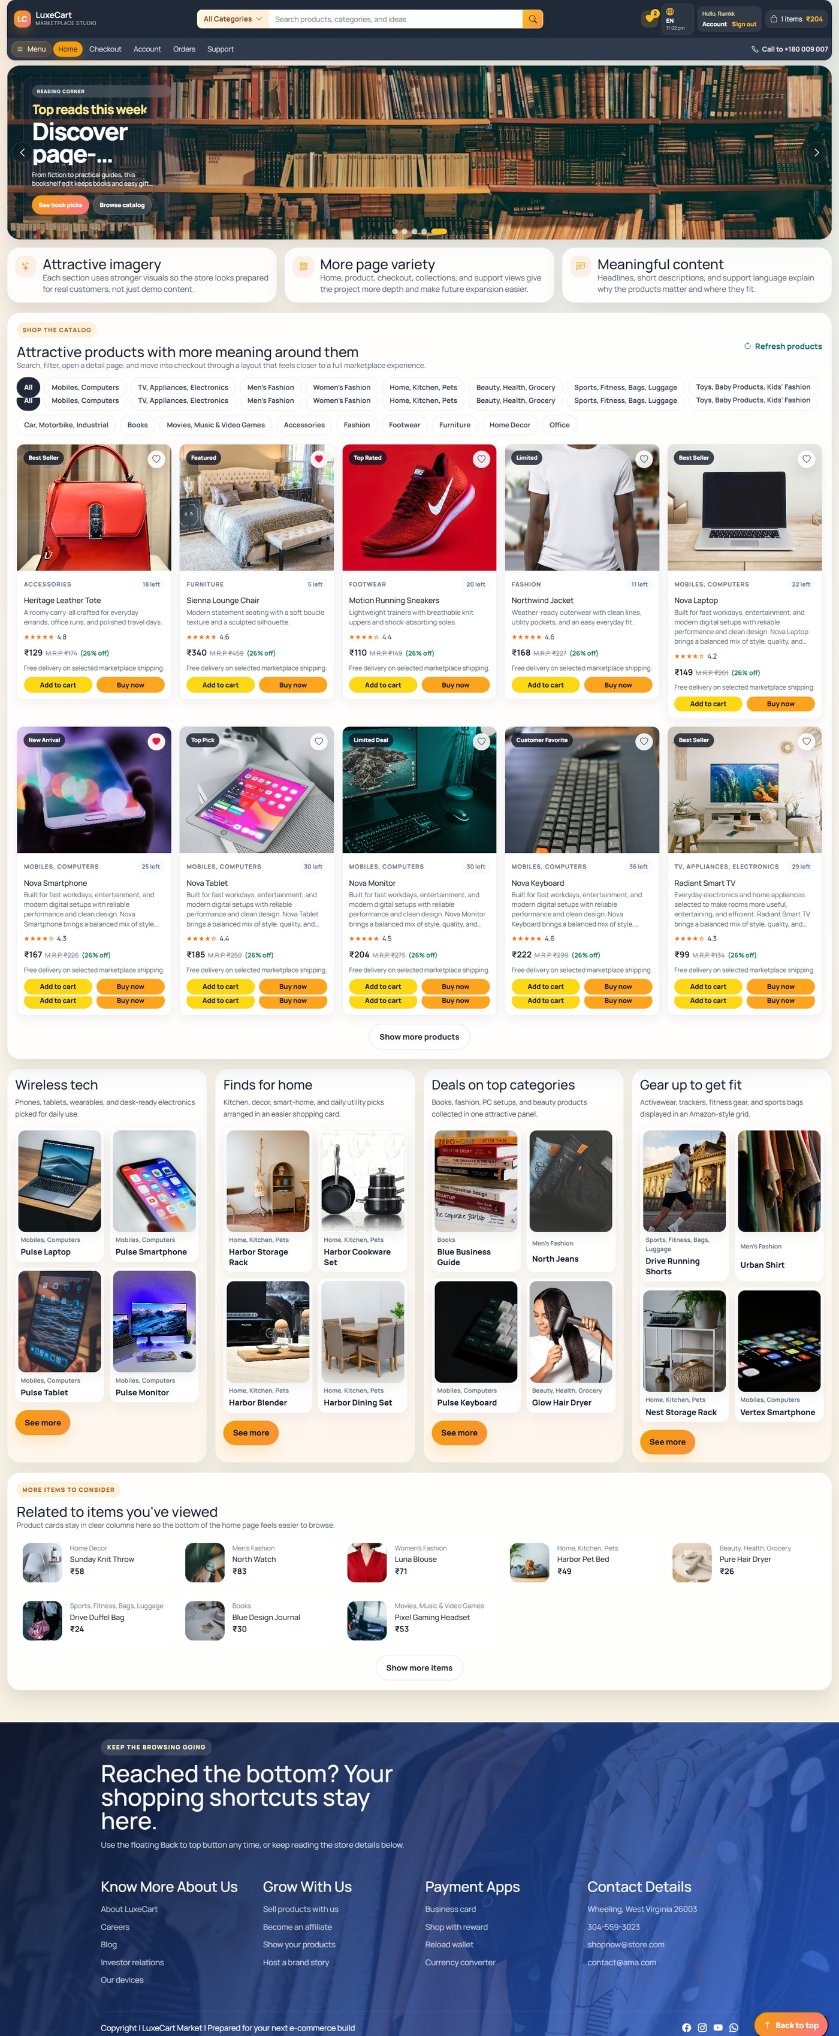
Fig 10.3 – Home Page (Full View)
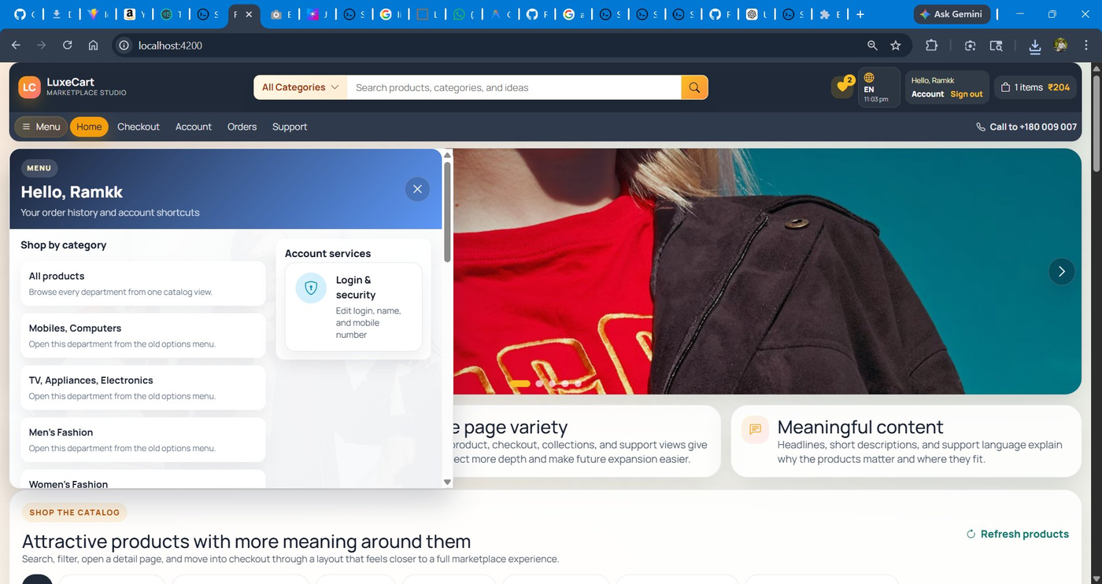
Fig 10.4 – Home Page – Menu Panel
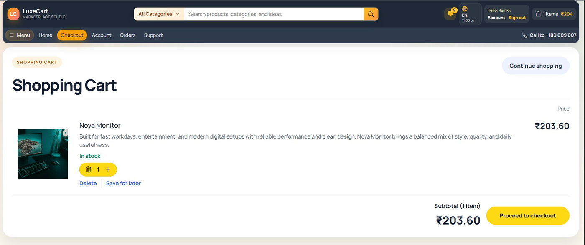
Fig 10.5 – Shopping Cart Page
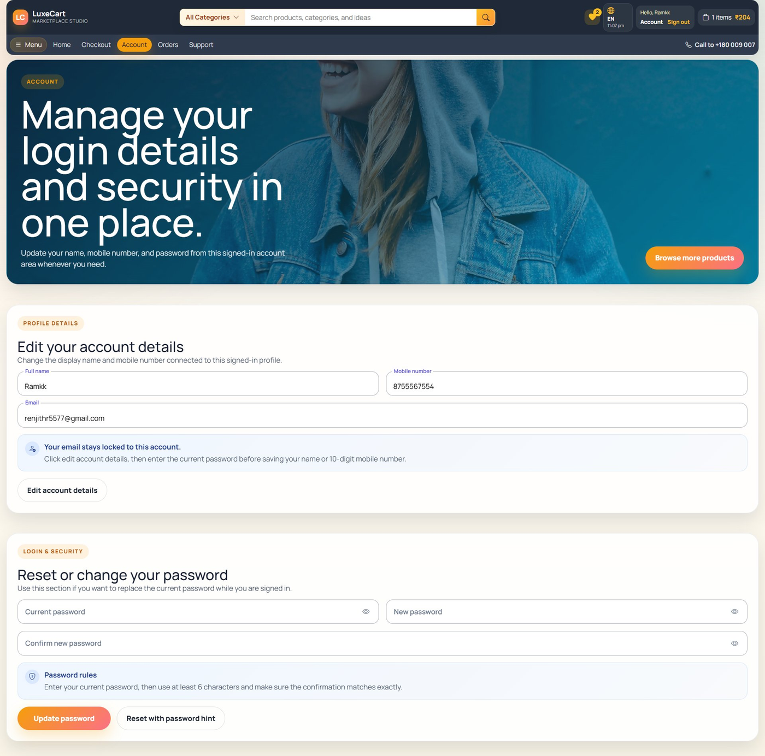
Fig 10.6 – Account Management Page
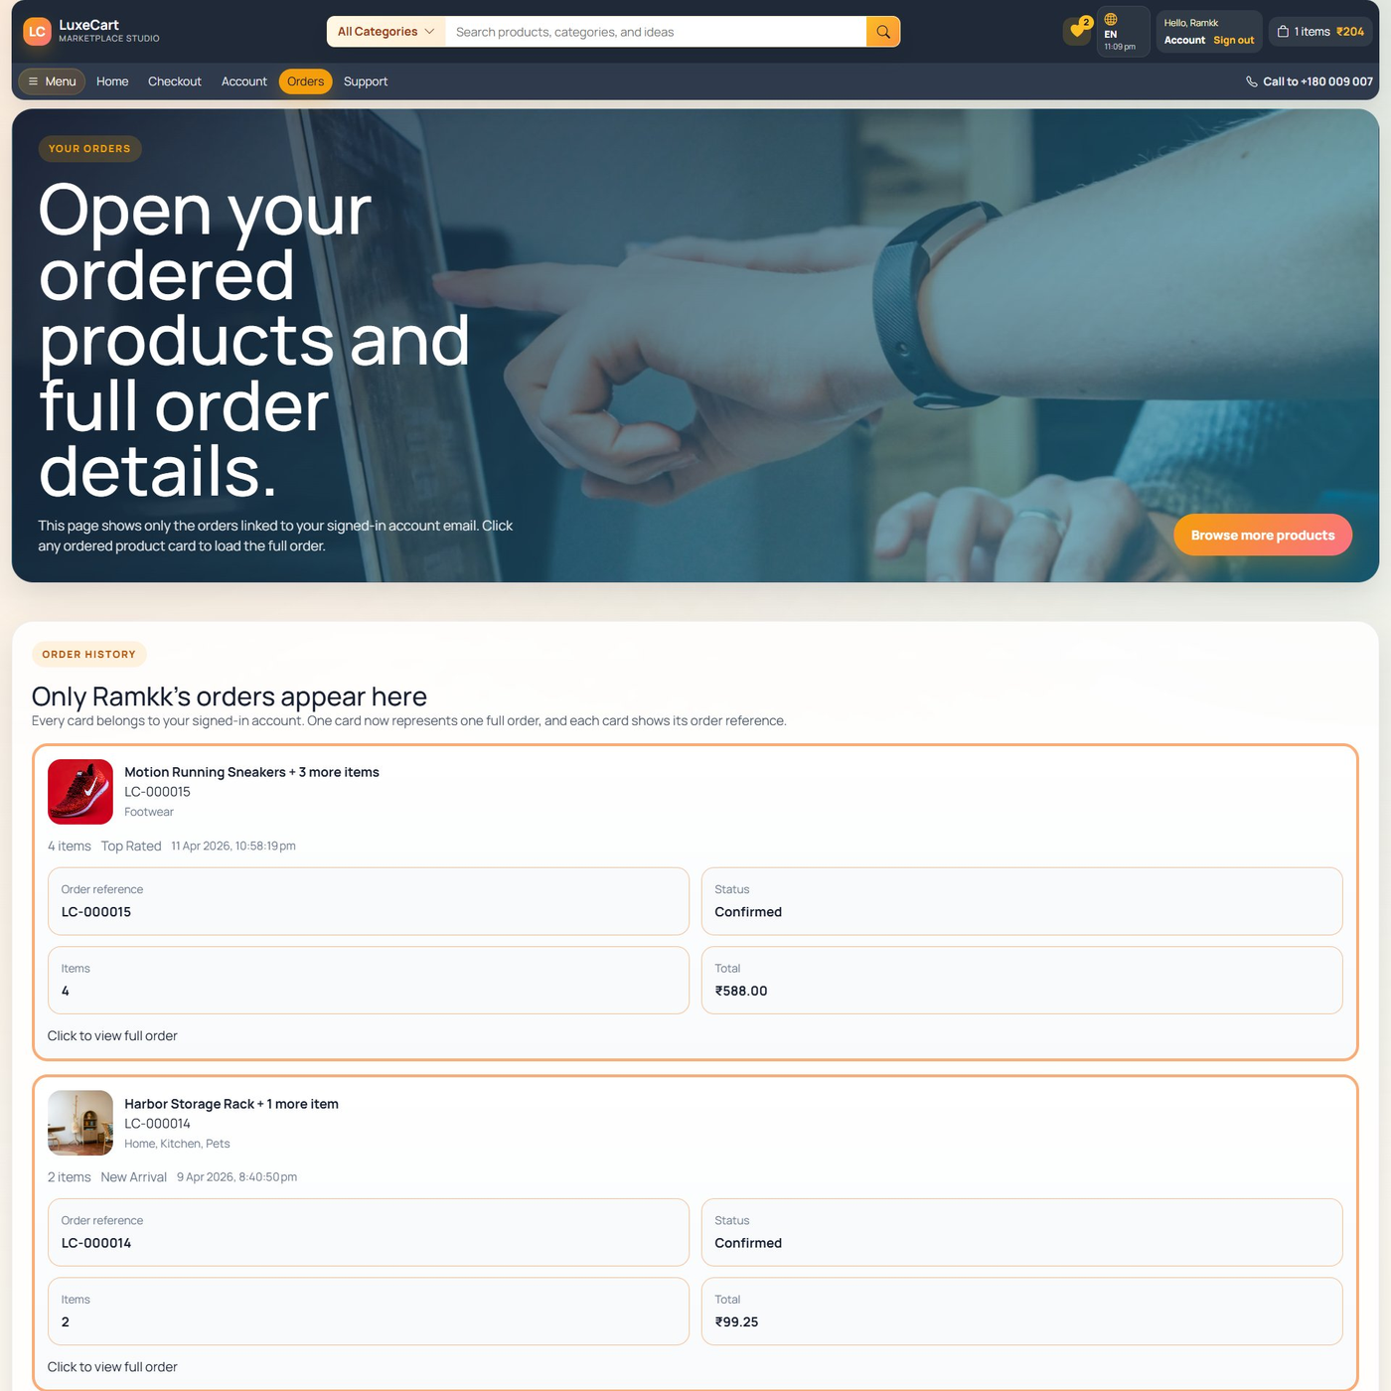
Fig 10.7 – Orders Page
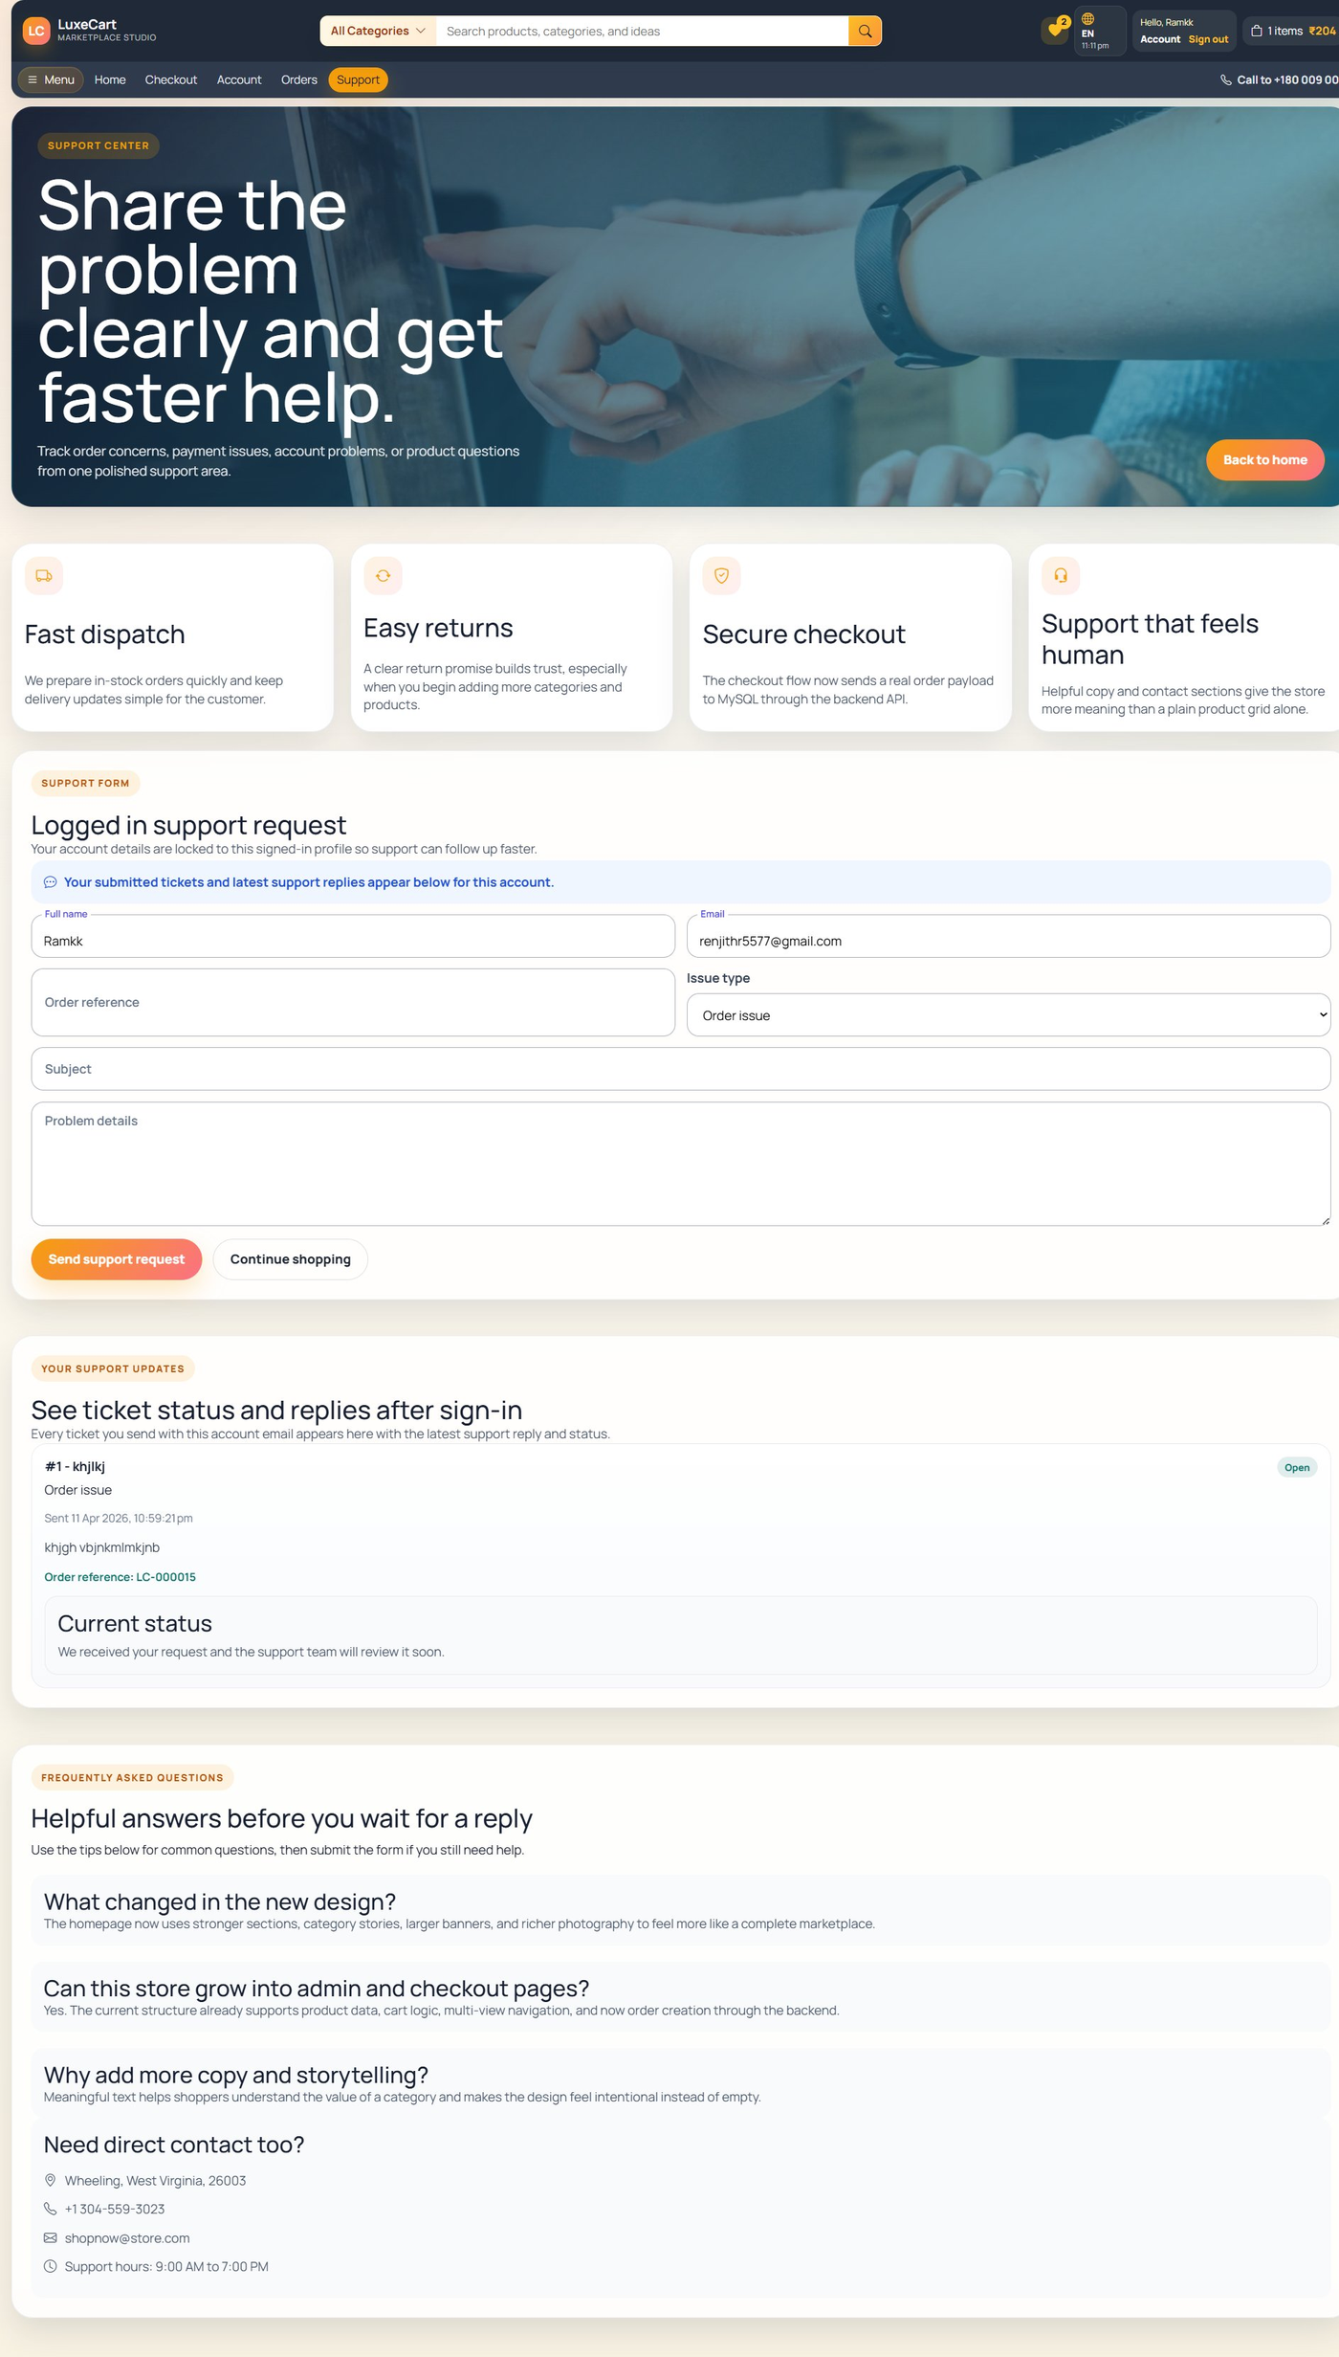
Fig 10.8 – Support Page
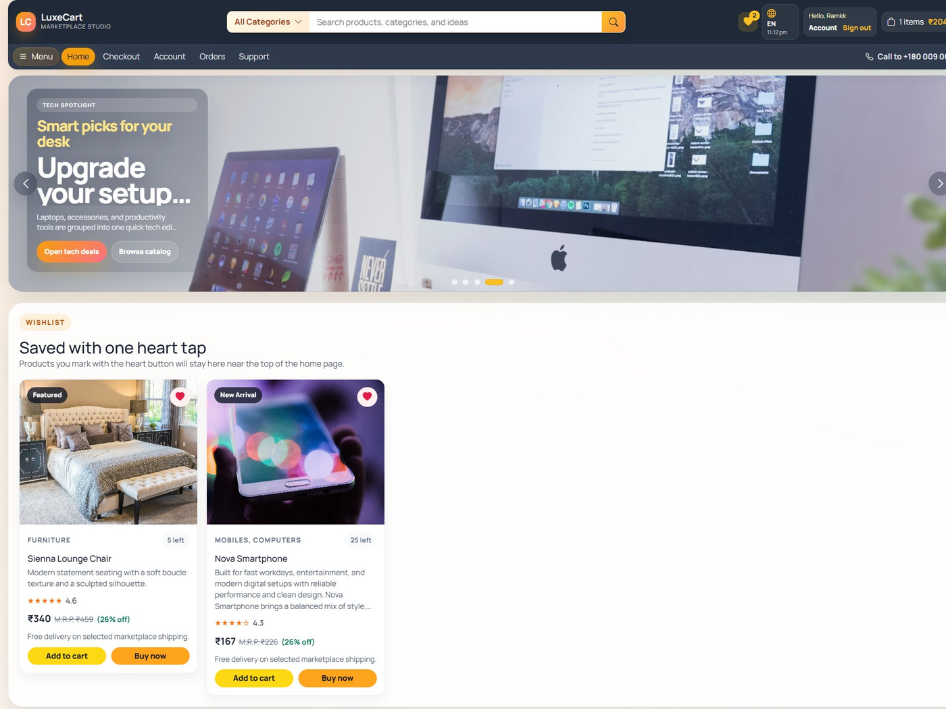
Fig 10.9 – Home Page – Wishlist Section
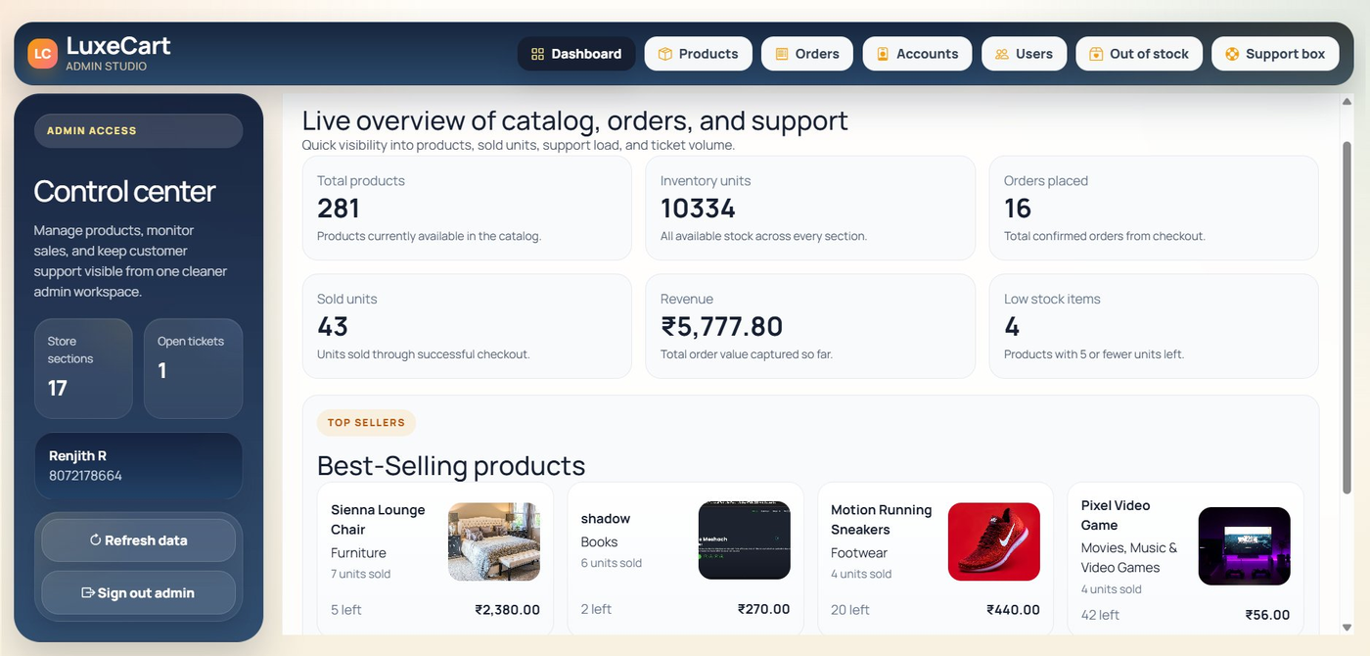
Fig 10.10 – Admin Login Page
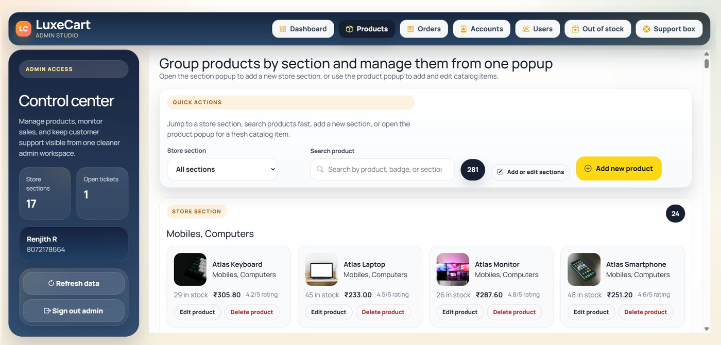
Fig 10.11 – Admin Dashboard
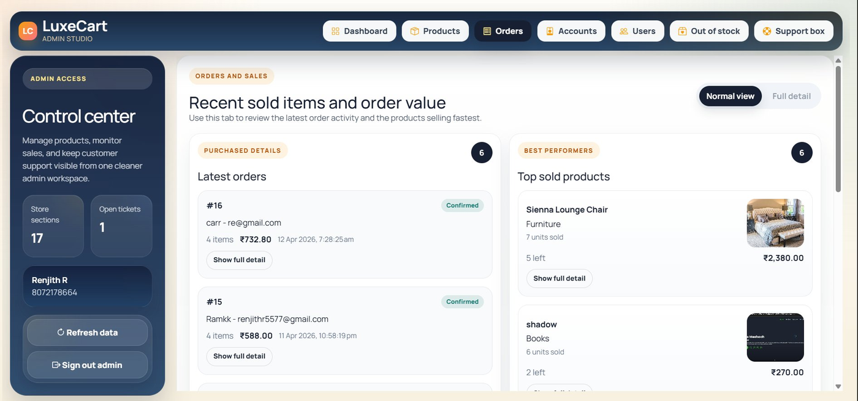
Fig 10.12 – Admin Products Page
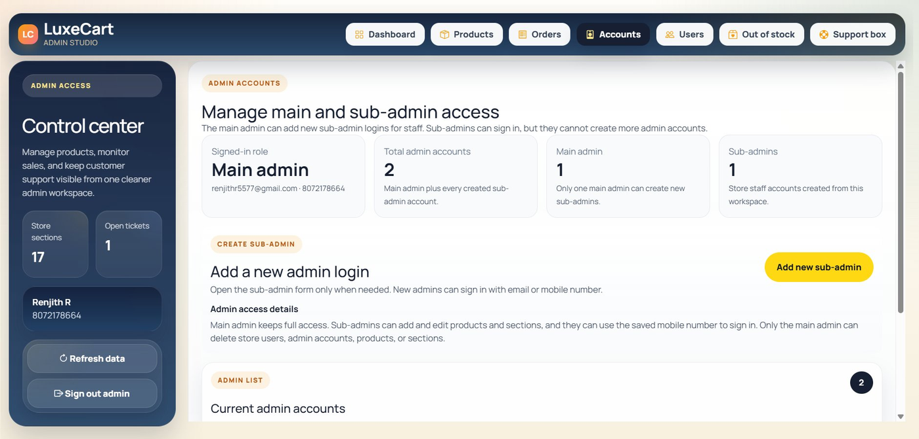
Fig 10.13 – Admin Orders Page
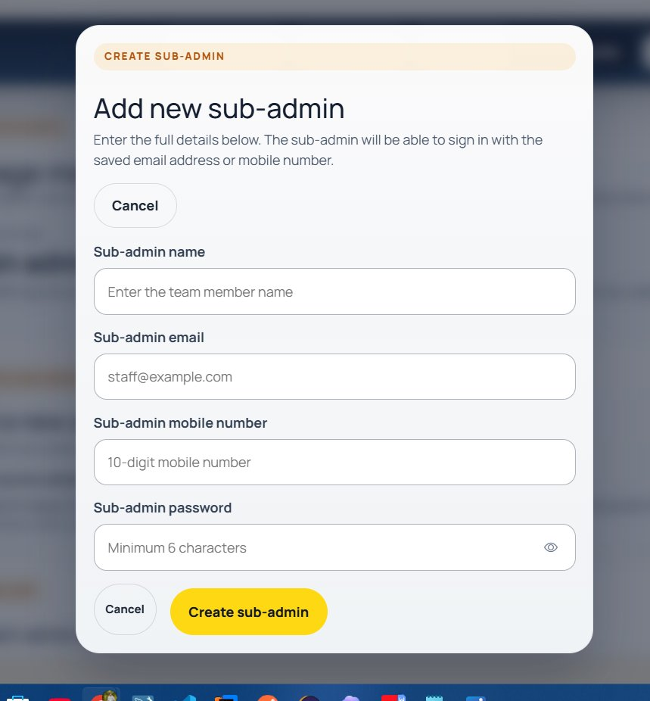
Fig 10.14 – Admin Accounts Page
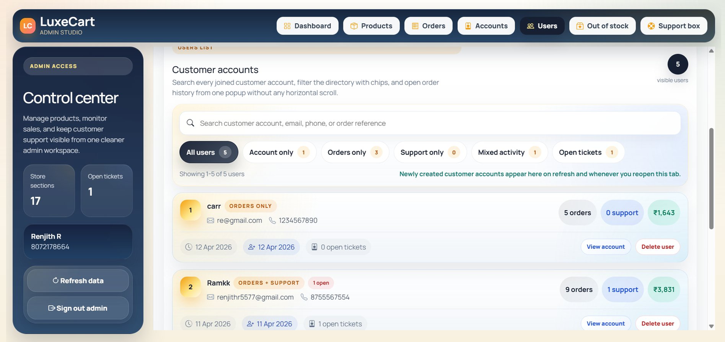
Fig 10.15 – Admin – Add Sub-Admin Form
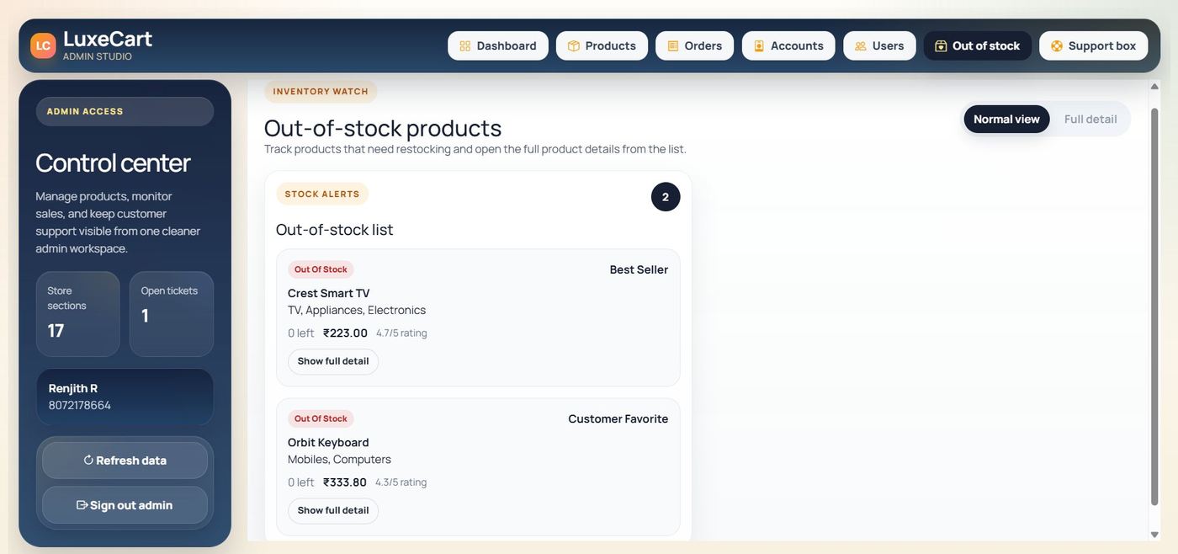
Fig 10.16 – Admin Users Page
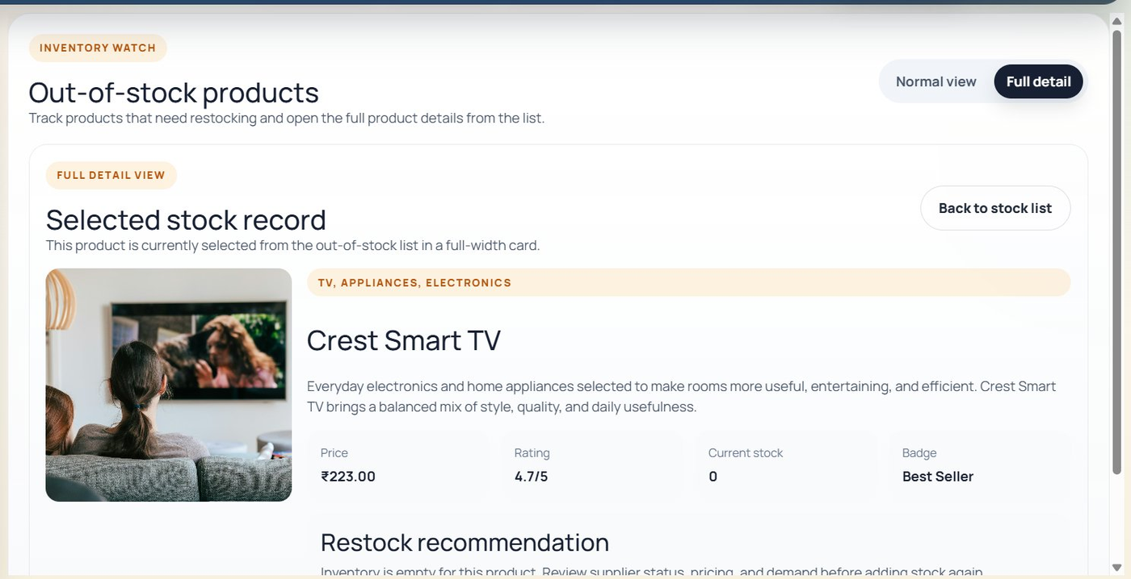
Fig 10.17 – Admin Out of Stock Page
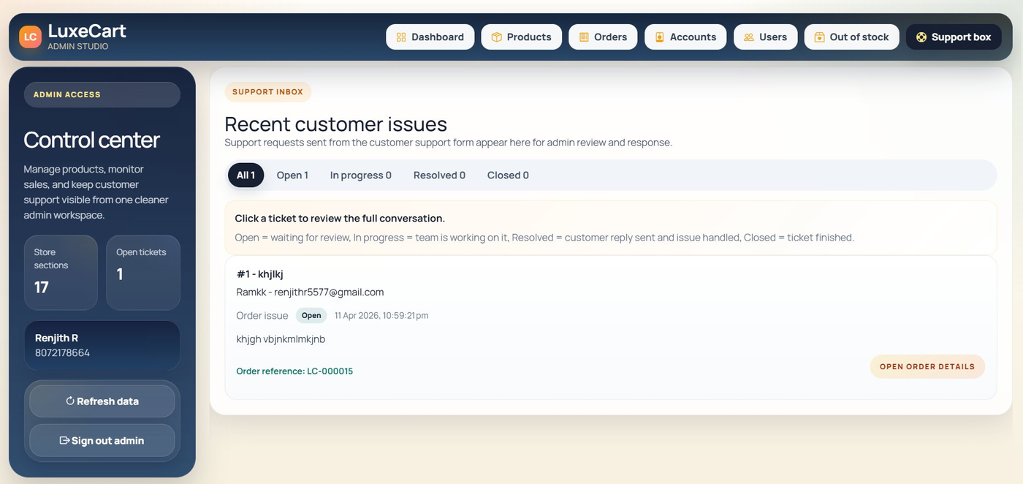
Fig 10.18 – Admin Support Box

11. CONCLUSION
The LuxeCart E-Commerce Marketplace project has been successfully designed, developed, and tested. The application delivers a complete, full-stack online shopping platform with a rich customer-facing storefront and a powerful admin management studio, meeting all defined project objectives.

The project demonstrates the practical application of modern web development technologies — Angular, Node.js, PHP, HTML5, CSS3, JavaScript, and MySQL — in building a scalable, database-backed web application. Angular's component-based architecture ensures the frontend is modular and maintainable. The RESTful backend design ensures clean separation of concerns and easy extensibility.

LuxeCart successfully implements all planned features: user authentication, product catalog, shopping cart, order management, wishlist, customer support, admin dashboard, product CRUD, user management, inventory monitoring, and support ticket handling. The admin panel provides real-time visibility into store performance, making it a genuinely useful business management tool.

This project has provided valuable hands-on experience in full-stack web development, relational database design, REST API development, Angular component architecture, and UI/UX implementation — skills that are directly relevant to professional software development careers.

12. FUTURE ENHANCEMENTS
The following enhancements are planned for future development iterations of LuxeCart:

- Payment Gateway Integration — Integrate Razorpay or Stripe for real online payment processing
- Email Notifications — Automated order confirmation, shipment updates, and support reply emails
- Product Reviews & Ratings — Allow customers to leave verified purchase reviews with star ratings
- Advanced Search & Filters — Price range sliders, multi-category selection, and sort options
- Coupon & Discount Engine — Promo code support with configurable percentage or fixed discounts
- Address Book — Multiple saved delivery addresses per user account for faster checkout
- Real-time Order Tracking — Shipment status milestones (Confirmed → Packed → Shipped → Delivered)
- Mobile Application — React Native or Flutter cross-platform mobile app using the existing REST API
- Analytics Dashboard — Revenue trend charts, conversion rate metrics, and user growth graphs
- AI Product Recommendations — Machine learning-based personalised product suggestions per user
- Multi-language Support — i18n (internationalisation) for Tamil, Hindi, and other regional languages
- Progressive Web App (PWA) — Offline browsing capability and home screen installation support
- Seller Portal — Allow third-party sellers to list and manage their own products

BIBLIOGRAPHY

Books
- Yakov Fain and Anton Moiseev, Angular Development with TypeScript, Second Edition, Manning Publications, 2019.
- Ethan Brown, Web Development with Node and Express, Second Edition, O'Reilly Media, 2019.
- Paul DuBois, MySQL Cookbook, Fourth Edition, O'Reilly Media, 2014.
- David Flanagan, JavaScript: The Definitive Guide, Seventh Edition, O'Reilly Media, 2020.
- Luke Welling and Laura Thomson, PHP and MySQL Web Development, Fifth Edition, Addison-Wesley, 2016.
- Jon Duckett, HTML and CSS: Design and Build Web Sites, John Wiley & Sons, 2011.

Online References
- https://angular.io/docs — Angular Official Documentation
- https://nodejs.org/en/docs — Node.js Official Documentation
- https://dev.mysql.com/doc — MySQL Reference Manual
- https://www.php.net/manual — PHP Official Manual
- https://developer.mozilla.org — MDN Web Docs (HTML, CSS, JavaScript)
- https://www.w3schools.com — Web Technology Reference and Tutorials
- https://getbootstrap.com/docs — Bootstrap CSS Framework Docs
- https://git-scm.com/doc — Git Version Control Documentation

