LUXECART E-COMMERCE WEBSITE
Project Report Submitted to

MANONMANIAM SUNDARANAR UNIVERSITY
In partial fulfillment of the requirements for the award of the degree of
Master of Science
in
Information Technology

Submitted by

RENJITH R | 20213066110011111

Under the guidance of

Prof. C. RAJESH M.C.A., M.Phil.

LEKSHMIPURAM COLLEGE OF ARTS AND SCIENCE

NEYYOOR – 629802

APRIL - 2026
DEPARTMENT OF INFORMATION TECHNOLOGY

LEKSHMIPURAM COLLEGE OF ARTS AND SCIENCE

NEYYOOR – 629802

BONA FIDE CERTIFICATE

This is to certify that the project report entitled “LuxeCart – Full-Stack E-Commerce Marketplace” submitted by RENJITH R in partial fulfilment of the requirements for the award of the degree of Master of Science in Information Technology of Manonmaniam Sundaranar University is a bona fide record of the work carried out by her under my guidance and supervision during April 2026. Further, I certify that this project report or any part thereof has not been submitted elsewhere for the award of any other degree, diploma, or similar qualification, to the best of my knowledge.

Project Guide Head of the Department

Place: NEYYOOR Examiners
Date: 1.
2.

DECLARATION

DECLARATION

I hereby declare that this dissertation entitled “LUXECART – FULL-STACK E-COMMERCE MARKETPLACE” is a bonafide record of the work carried out by me at Lekshmipuram College of Arts and Science, Neyyoor, in partial fulfillment of the requirements for the award of the degree of Master of Science in Information Technology of Manonmaniam Sundaranar University, Tirunelveli. I further declare that this report or any part thereof has not been submitted elsewhere for the award of any other degree or diploma.

Name of the Candidate Reg. No. Signature

RENJITH R | 20213066110011111

Place: Neyyoor
Date:

ACKNOWLEDGEMENT

ACKNOWLEDGEMENT

I express my sincere gratitude to all those who have helped me in making this project a success. At the outset, I thank the Almighty God for blessing me with good health and bestowing upon me the strength and ability required to complete this course successfully.
I wish to express my heartfelt gratitude to the Principal of Lekshmipuram College of Arts and Science, Neyyoor, for the encouragement and support extended to me during the course of my M.Sc. Information Technology programme. I also express my sincere thanks to the Head of the Department for the guidance and support provided for the successful completion of my project.
I express my deep gratitude and thanks to my Project Guide for the constant guidance, kind cooperation, and encouragement extended to me throughout the course of this project. I also extend my thanks to all the staff members of the Department who helped me at various stages in completing this work successfully.
Finally, I extend my sincere thanks to my family members and friends for their constant encouragement, love, affection, and moral support, which I can never repay.

RENJITH R

ABSTRACT

ABSTRACT

LuxeCart E-Commerce Website is a full-stack shopping platform designed to serve both customer users and store administrators through a single integrated application. The customer side of the system allows product browsing, category filtering, search, cart management, wishlist handling, address entry, checkout, order history viewing, account management, and support ticket submission. The administrator side provides product control, section management, support monitoring, user tracking, order review, and sales overview.
The project is implemented using Angular and TypeScript for the frontend, Bootstrap for responsive user interface design, Node.js with Express for backend services, and MySQL for relational data storage. The application is organized into reusable frontend components and backend API modules so that catalog, account, order, and support workflows remain maintainable and scalable.
This project demonstrates the practical use of modern web technologies in building a real commerce workflow that supports browsing, ordering, storage, validation, reporting, and administration in a structured way. It also provides a strong base for future extensions such as live payment gateway integration, delivery tracking, invoice generation, and production deployment.

CONTENTS

CONTENTS

1. INTRODUCTION
1.1 Overview of the System
1.2 Specific Objectives

2. SYSTEM STUDY AND ANALYSIS
2.1 Existing System
2.2 Proposed System

3. SYSTEM SPECIFICATION
3.1 Hardware Requirement
3.2 Software Requirement
3.3 Software Profile

4. SYSTEM DESIGN
4.1 Data Flow Diagram
4.2 ER Diagram
4.3 Database Design

5. IMPLEMENTATION

6. SYSTEM TESTING

7. APPENDIX
7.1 Sample Coding
7.2 Output Screens

8. CONCLUSION

9. FUTURE ENHANCEMENT

10. BIBLIOGRAPHY

INTRODUCTION

INTRODUCTION

1.1 Overview of the System
LuxeCart is a web-based e-commerce system developed to provide a rich shopping experience for customers and a structured administration panel for store management. The application supports browsing products by category, searching the catalog, viewing product cards, placing orders, reviewing order history, and raising support tickets.
On the administration side, the project provides a separate admin login flow and multiple admin pages for dashboard monitoring, products, orders, store sections, support box, users, account handling, and stock visibility. This makes the project suitable for demonstration as a complete academic full-stack software system.
1.2 Specific Objectives
- To build a full-stack e-commerce website using Angular, Express.js, and MySQL.
- To provide customer sign-up, sign-in, password recovery, and account management.
- To implement product search, category browsing, saved items, and cart handling.
- To create a checkout module with delivery details and card-payment validation.
- To store orders, order items, customer accounts, support tickets, and card summaries in MySQL.
- To build a separate admin login and multi-page admin control center.
- To create a responsive UI suitable for desktop browsing and project demonstration.

SYSTEM STUDY AND ANALYSIS

SYSTEM STUDY AND ANALYSIS

2.1 Existing System

Many basic online shopping systems provide limited product browsing and weak integration between shopping, order tracking, and administration. Older systems frequently use static listings, basic forms, and manual record handling. Support requests and user account tracking are often managed separately, making the workflow inefficient.

Common drawbacks in existing systems are:

Limited category filtering and weak catalog discovery.

No proper admin workspace for products, orders, users, and support.

Poor checkout validation and weak order-history visibility.

Lack of customer-account and support-ticket storage in a connected system.

Weak visual design and limited responsiveness.

2.2 Proposed System

The proposed LuxeCart E-Commerce Website provides a modern shopping portal together with a complete admin workspace. Customers can search products, view categories, manage carts, place orders, see previous purchases, and submit support tickets. Administrators can log in separately and manage products, sections, users, support requests, order visibility, and performance-related summaries.

Main advantages of the proposed system:

Integrated customer and admin workflows in one project.

Multiple store sections and category-focused product display.

Checkout with cash-on-delivery and card-payment support.

Masked card detail storage for order reference.

Support-ticket and customer-account persistence in the database.

Admin pages for dashboard, products, orders, users, stock, and support box.

Responsive frontend and meaningful toast feedback.

SYSTEM SPECIFICATION

3. SYSTEM SPECIFICATION

3.1 Hardware Requirement
Component | Specification
System Name | Acer Aspire 7
Storage Capacity | 512 GB
RAM | 8 GB or above recommended
Display | 15.6-inch Full HD display
Input Devices | Keyboard, touchpad, mouse

3.2 Software Requirement
Software Item | Technology Used
Operating System | Windows 11
Frontend | Angular 21 with TypeScript
Styling / UI | Bootstrap 5.3.8, Bootstrap Icons, custom CSS
Backend | Node.js and Express 5.2.1
Database | MySQL 8.0
IDE | Visual Studio Code
Version Control | Git and GitHub
Testing / Build | npm, Angular CLI, browser-based verification

3.3 Software Profile

The project uses a layered architecture. The Angular frontend handles all visual presentation and user interactions. The Express backend provides API endpoints for products, orders, accounts, support, and admin operations. MySQL acts as the persistent relational storage layer.
The frontend contains pages for home, checkout, account, support, orders, sign-in, sign-up, product views, and separate admin pages. The backend contains database setup, seed logic, route processing, validation, and response handling. Together, these modules deliver a working commerce platform suitable for academic submission and demonstration.

SYSTEM DESIGN
4.SYSTEM DESIGN

4.1 Data Flow Diagram

The data flow of the system begins when a customer or administrator interacts with the frontend. Requests are passed to the backend API, validated, and then stored in or retrieved from the MySQL database. The processed response is returned to the frontend for visual display.
- Customer/Admin enters details through the frontend interface.
- Frontend sends request to backend API.
- Backend validates and processes the request.
- MySQL stores or returns the related data.
- Frontend displays the final result to the user.

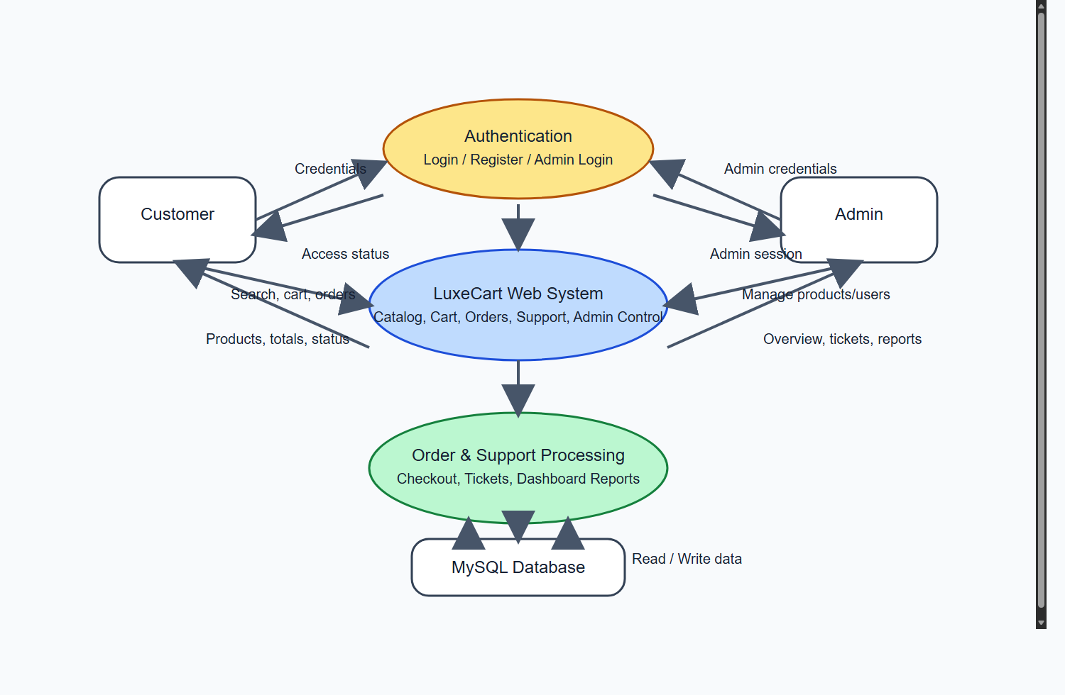

Figure 1. Data Flow Diagram of LuxeCart E-Commerce Website

4.2 ER Diagram
The ER diagram shows the relationship between store sections, products, customer accounts, orders, order items, support tickets, admin accounts, and card details. It helps explain the database design used to manage records in a normalized and structured manner.
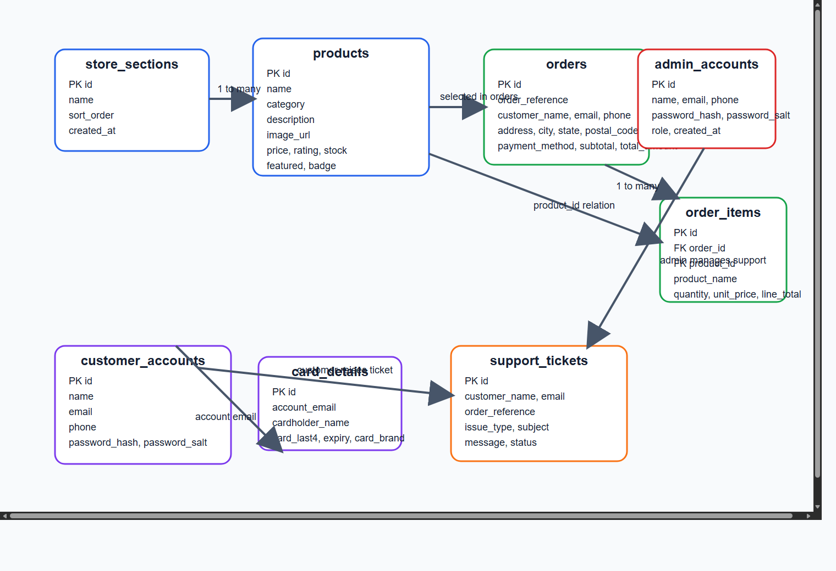
Figure 2. ER Diagram of the Project Database

4.3 Database Design
Table Name | Purpose | Important Fields
store_sections | Stores store section names and order of display. | id, name, sort_order, created_at
products | Stores product catalog information. | id, name, category, description, image_url, price, stock, rating
orders | Stores customer order summary and delivery details. | id, order_reference, customer_name, email, payment_method, total_amount, status
order_items | Stores item-level details for each order. | id, order_id, product_id, product_name, quantity, unit_price
support_tickets | Stores customer support requests and replies. | id, customer_name, email, issue_type, subject, status, admin_response
admin_accounts | Stores admin credentials and role details. | id, name, email, phone, password_hash, role
customer_accounts | Stores customer sign-up and login data. | id, name, email, phone, password_hash, password_hint
card_details | Stores safe masked card-summary details for card payments. | id, account_email, cardholder_name, card_last4, expiry, card_brand

IMPLEMENTATION

5. IMPLEMENTATION

Implementation is the stage where the system design is converted into a working application. The LuxeCart project is implemented using Angular in the frontend and Express.js in the backend. MySQL is used as the storage engine for sections, products, orders, support tickets, accounts, and masked card summaries.

5.1 Customer Module
The customer module contains pages for browsing products, filtering by category, searching products, adding items to cart, saving items, viewing account details, placing orders, reviewing previous orders, and submitting support requests.

5.2 Checkout Module
The checkout module validates name, phone, address, city, state, postal code, payment method, and card details before placing the order. Card-based orders store only masked card detail information for safe record keeping.

5.3 Admin Module
The admin module contains a separate admin login page and multiple control pages such as dashboard, products, orders, accounts, users, out-of-stock, and support box. It is designed to help the store administrator manage daily operations from one control center.

5.4 Database and Seed Module
Database tables are created and updated from the backend. Seed logic is used to populate section and product data for demonstration. The project also supports product image updates, INR price display, toast feedback, and data refresh flows.

SYSTEM TESTING

6. SYSTEM TESTING

Testing ensures the correctness, efficiency, usability, and reliability of the software. The project was tested through both customer-side and admin-side workflows.
6.1 Unit Testing
- Login and sign-up form validation
- Checkout validation for payment details
- Product form validation in admin pages
- Support form validation

6.2 Integration Testing
- Frontend and backend API communication
- Backend and MySQL database storage
- Customer account to orders data flow
- Support ticket creation and admin visibility

6.3 System Testing
End-to-end testing covered browsing, add-to-cart, checkout, order placement, customer sign-in, support request submission, admin login, and admin management workflows.

6.4 Validation Testing
Input validation and toast messages were verified for success and failure cases, including login, logout, account creation, support submission, and payment validation.

6.5 User Interface Testing
The customer pages and admin pages were checked for readability, responsive layout behavior, proper button interactions, and meaningful page-level user feedback.

6.6 Build Verification
The frontend was compiled using the Angular build command and verified successfully. This confirmed that the templates, styles, and TypeScript modules compile into a production build.

APPENDIX

7. APPENDIX

7.1 Sample Coding

Sample 1: Root development scripts
{
"scripts": {
"dev": "concurrently \"npm --prefix backend run dev\" \"npm --prefix frontend start\"",
"dev:frontend": "npm --prefix frontend start",
"dev:backend": "npm --prefix backend run dev",
"build": "npm --prefix frontend run build"
}
}

Sample 2: Angular INR price display
<strong>{{ product.price | currency:'INR':'symbol':'1.0-0' }}</strong>
<small>M.R.P. {{ listPrice | currency:'INR':'symbol':'1.0-0' }}</small>

Sample 3: Orders table structure
CREATE TABLE orders (
id INT NOT NULL AUTO_INCREMENT PRIMARY KEY,
order_reference VARCHAR(32) NULL UNIQUE,
customer_name VARCHAR(120) NOT NULL,
email VARCHAR(140) NOT NULL,
phone VARCHAR(40) NOT NULL,
address_line VARCHAR(255) NOT NULL,
city VARCHAR(80) NOT NULL,
state VARCHAR(80) NOT NULL,
postal_code VARCHAR(20) NOT NULL,
payment_method VARCHAR(60) NOT NULL,
total_amount DECIMAL(10, 2) NOT NULL
);

Sample 4: Backend order API concept
app.post('/api/orders', async (request, response, next) => {
// validate checkout data
// insert order into orders table
// insert order items into order_items table
// store masked card details if payment is card based
// return confirmation to frontend
});

7.2 Output Screenshots

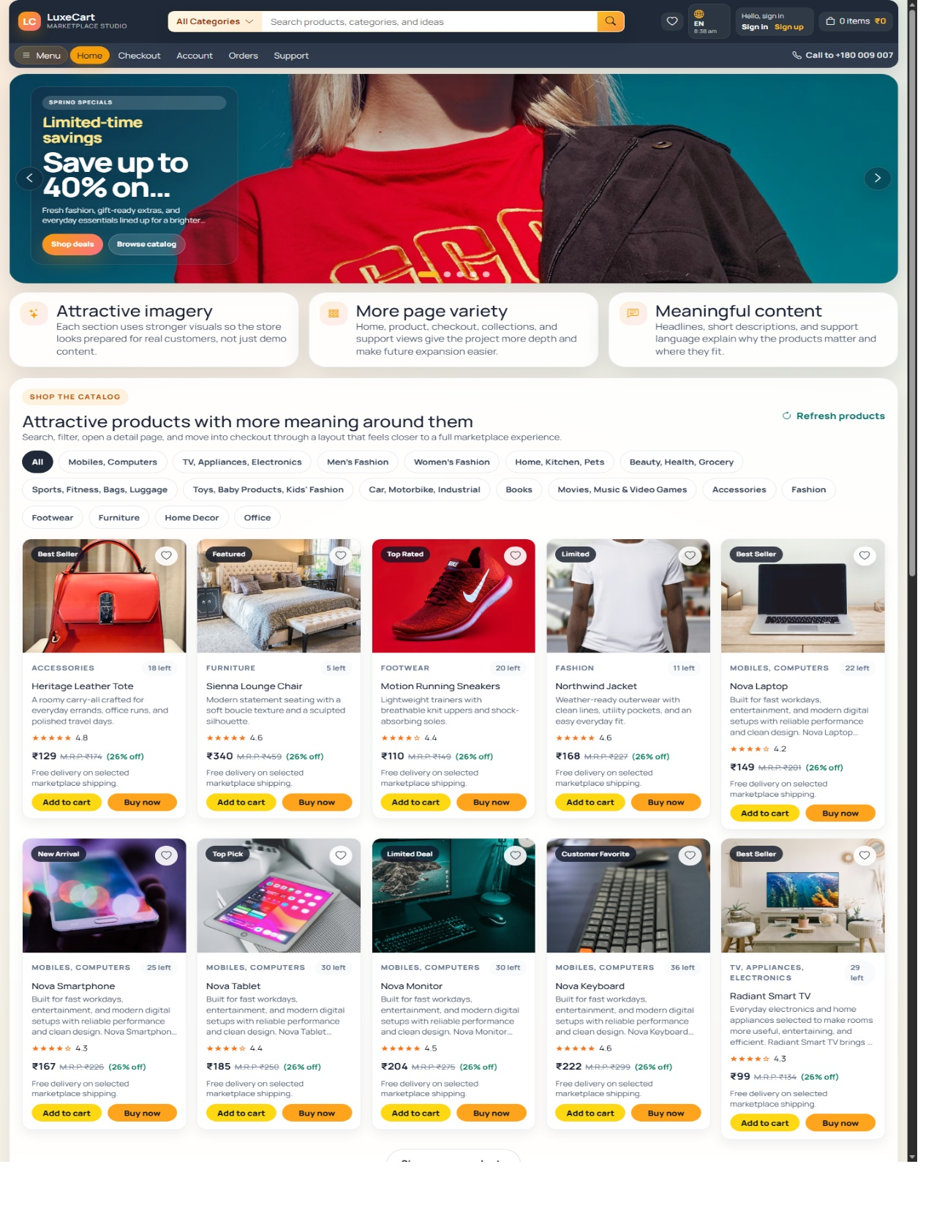
Customer Home Page
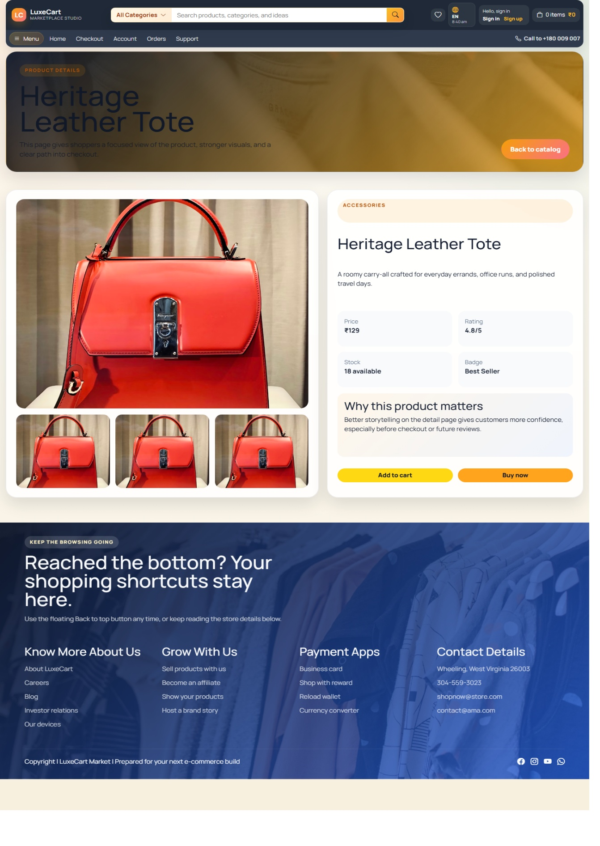
Product Listing and Catalog View
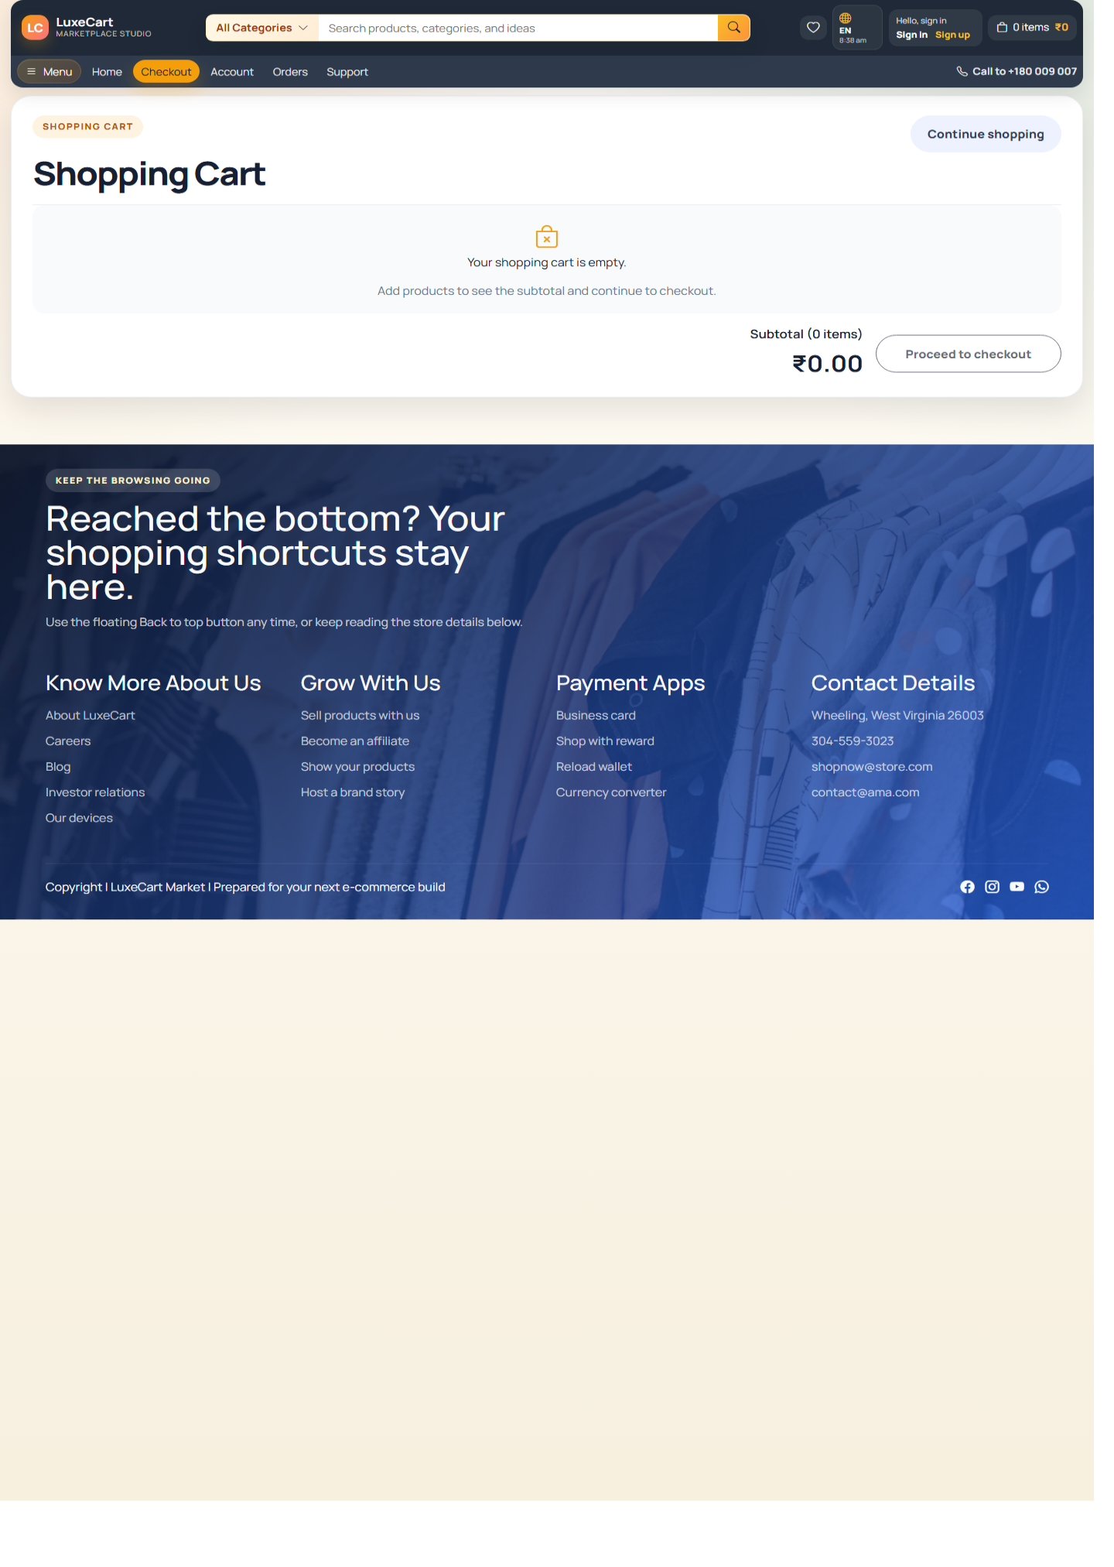
Checkout Page
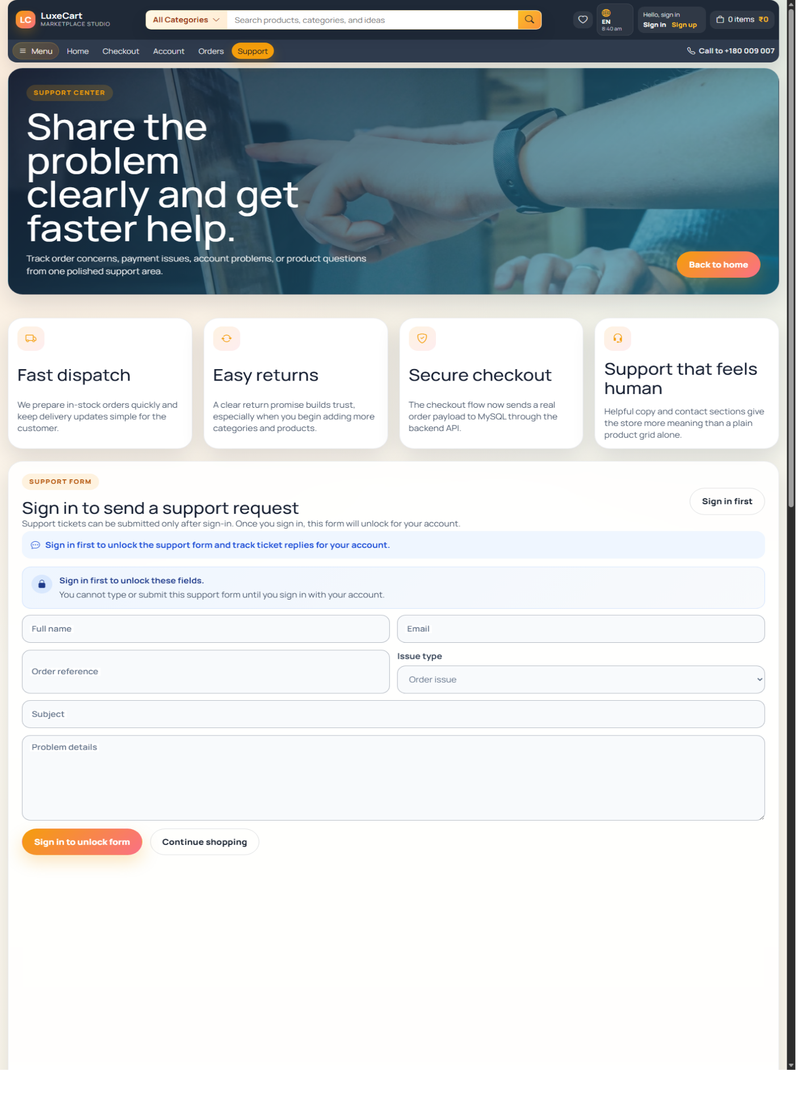
Support Page
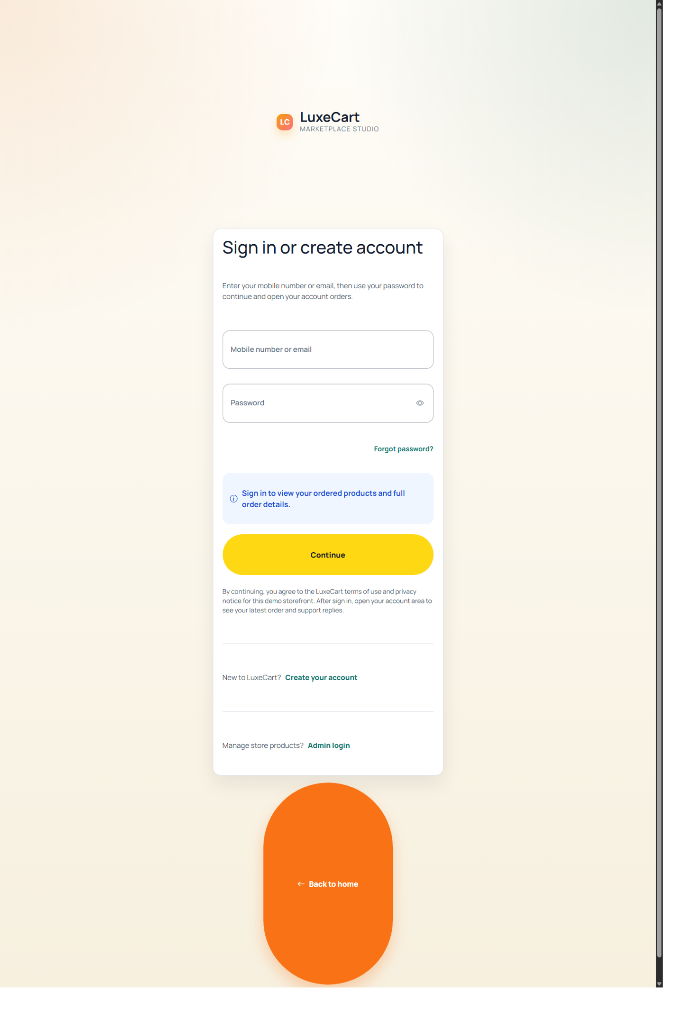
Customer Sign In and Ordered Products Access
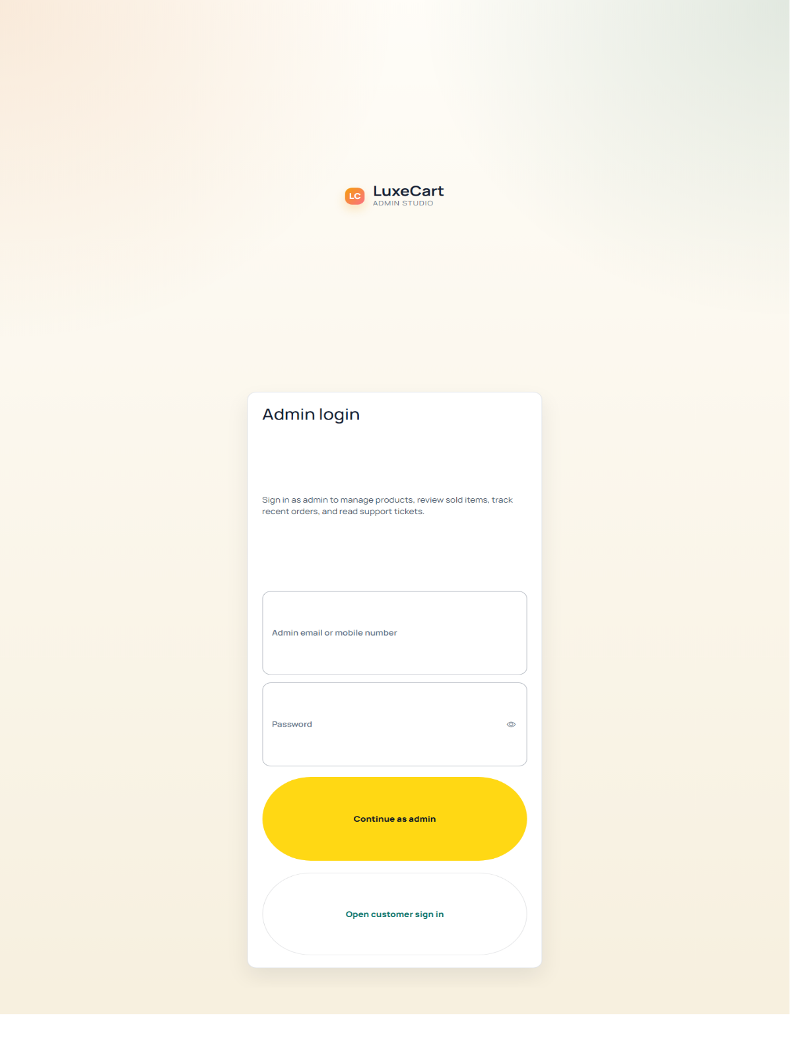

CONCLUSION

8. CONCLUSION
The LuxeCart E-Commerce Website successfully demonstrates the design and implementation of a complete web-based shopping system. The project supports customer browsing, ordering, account handling, support activity, and a separate admin workspace through one integrated software solution.
This project applies important software engineering concepts such as layered architecture, data validation, API communication, database normalization, reusable UI design, and structured testing. As an academic project, it provides both technical depth and practical demonstration value.

FUTURE ENHANCEMENTS

9. FUTURE ENHANCEMENTS
- Real payment gateway integration using Razorpay or Stripe
- Shipment and delivery tracking
- Invoice generation in PDF format
- Email and SMS notifications
- Product reviews and ratings
- Recommendation engine for customers
- Improved analytics for admin users
- Cloud deployment and CI/CD automation
- Enhanced security and access controls

BIBLIOGRAPHY

10. BIBLIOGRAPHY
- Angular Documentation - https://angular.dev
- Express.js Documentation - https://expressjs.com
- MySQL Documentation - https://dev.mysql.com/doc
- Bootstrap Documentation - https://getbootstrap.com
- Node.js Documentation - https://nodejs.org
- GitHub Documentation - https://docs.github.com
- Software Engineering references by Ian Sommerville and Roger S. Pressman

