PROGRAMMABLE LOGIC CONTROLLERS
✅ 1. PLC Fundamentals (Core Concepts)
- What is a PLC?
▸ Definition & role in automation
▸ Advantages over hard-wired relay logic
- PLC Architecture
▸ CPU (control + scan cycle)
▸ Memory (program memory, data table, I/O image table)
▸ Input modules (digital/analog)
▸ Output modules (digital/analog)
▸ Power supply
- PLC Scan Cycle
▸ Input scan → Program execution → Output update
▸ Relation to continuous loops in software
- PLC Programming Languages (overview)
▸ Ladder Diagram (main focus)
▸ Mention of others: FBD, ST, IL, SFC (just awareness)

✅ 2. Ladder Logic Essentials (Main Exam Meat)
- Contacts and Coils
▸ Normally Open (XIC)
▸ Normally Closed (XIO)
▸ Output Coil (OTE)
▸ Latch (OTL) and Unlatch (OTU)
- Logical Operations
▸ AND (series contacts)
▸ OR (parallel contacts)
▸ NOT (using NC contacts)
- Internal Memory Bits
▸ How to use internal relays (B3, M bits) for intermediate logic
- Basic Programs
▸ Start/Stop motor latch circuit
▸ Simple interlock (two conditions must be true)
✅ 3. Timers (Time-Based Control)
- On-Delay Timer (TON)
- Off-Delay Timer (TOF)
- Retentive Timer (RTO)
- Timer Reset (RES)
(Know their use-cases and how to wire them in ladder logic)

✅ 4. Counters (Count-Based Control)
- Count Up (CTU)
- Count Down (CTD)
- Counter Reset (RES)
(Be able to create simple counting circuits)

✅ 5. Data Handling & Math
- Comparison Instructions
▸ Greater Than (GRT)
▸ Less Than (LES)
▸ Equal (EQU)
- Math Instructions
▸ ADD, SUB, MUL, DIV
▸ Scaling analog inputs (basic understanding)
- Move Instruction (MOV)
▸ Copy data between memory locations

✅ 6. Program Structuring Techniques
- Sequencing (step-by-step control, e.g. washing machine cycle)
- Subroutines / JSR (jump to subroutine)
- State machines (using memory bits to track steps)

✅ 7. Troubleshooting & Simulation
- Diagnostics
▸ Going online with PLC software
▸ Forcing I/O (know concept)
▸ Monitoring and interpreting real-time values
- Common Faults
▸ Inputs not wired or misaddressed
▸ Timers/counters not resetting as expected
- Simulation Practice (you already reached this in class)
▸ Start/Stop motor latch
▸ Traffic light (timers)
▸ Bottle filling/counting (counters)
▸ Door interlock (AND/OR logic)

✅ 8. Extra (If Time Allows / Bonus Points)
- Analog I/O handling (4–20 mA sensors, scaling raw values)
- Safety interlocks (why certain conditions must be enforced before outputs energize)

✨ Your Study Priority
If time is tight, focus in this order:
Ladder Logic Basics → Timers → Counters → Comparisons/Math → Structuring → Troubleshooting/Simulation.

💡 Practical Tip
✅ Spend most of your time in a simulator (OpenPLC or LogixPro).
✅ Build small circuits for each topic.
✅ Write tiny notes after each topic with a quick ladder snippet.

✅ 9. Minor Topic Additions for a Full House 🏡
Data Addressing & Naming Conventions: Understand how different PLC brands label inputs, outputs, timers, and internal bits (e.g., I:1/0, O:2/1, M0.0), so you can read and write ladder logic accurately.
Basic Error Handling & Safety Chains: Learn how to use latches/unlatches or fault bits to flag abnormal conditions, and design safety interlocks (like E-stops) that override all other logic when triggered.
PLC Operating Modes: Know the difference between RUN, PROG/STOP, and REMOTE modes, and how each affects program execution and editing.
Troubleshooting Scenarios: Be ready to diagnose practical issues (e.g., motor not starting despite input signal, counters double-counting) by tracing logic, wiring, and I/O behavior.

✨ WHAT IS A PLC?
PLCs are a specialized industrial computer that controls and automates processes in various industries.
PLCs are designed to be rugged, reliable, and easily programmed to monitor and control machines and processes.
A Programmable Logic Controller (PLC) is basically a rugged, specialized industrial computer built to run automation tasks. Rugged means they can operate in harsh environments.
👉 It takes in signals from sensors and switches, processes them according to a stored program, and then sends commands to outputs like motors, valves, or lights.

Key real-world use cases:
- Controlling machines on a factory assembly line.
- Managing amusement ride rollercoasters as they twist and turn.
- Automating food-processing machinery that mix ingredients for your favorite snack.

Why PLCs instead of normal PCs?
Designed to Handle Digital & Analog I/O:
PLCs have built-in I/O modules to directly handle digital and analog signals from industrial devices, while regular PCs need extra hardware and software, making them slower and harder to use for real-time control.

Survive Extreme Temperatures:
PLCs are rugged and built to survive extreme temperatures, while regular PCs can't handle the heat—or the cold—of harsh industrial environments.

Immune to Electrical Noise:
PLCs are built to resist electrical noise from heavy machinery, while regular PCs can glitch or fail in such interference-heavy environments.

Resist Vibration and Impact:
PLCs are designed with sturdy, shock-resistant casings and components, enabling them to withstand vibrations, impacts, and rough handling while regular PCs are too fragile and prone to hardware failures under physical stress.
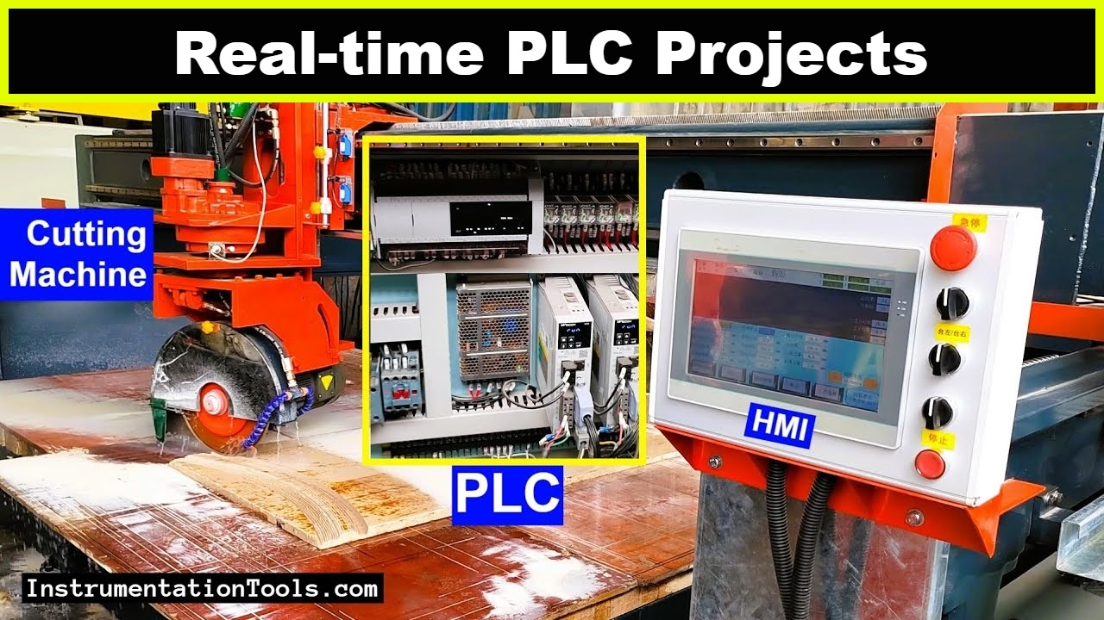
🧠 Core Sections of a PLC
CPU (Central Processing Unit)
The PLC’s “brain.”
Contains a microprocessor, memory chips, and circuits for control logic, monitoring, and communication.
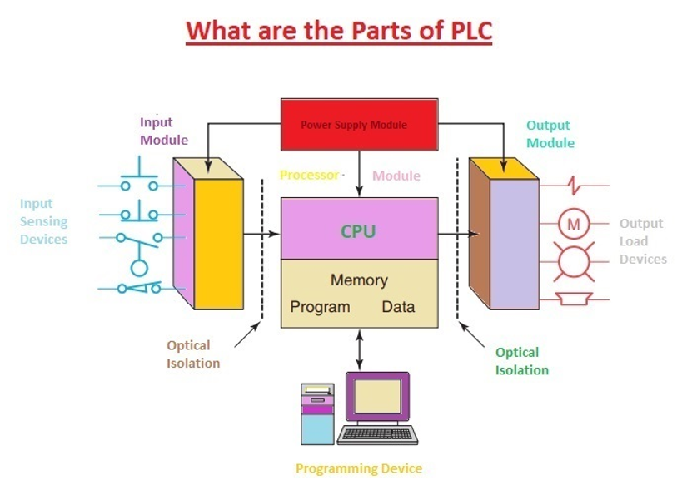
I/O Interface System
The PLC’s “nerves.”
Accepts input signals (from field devices: sensors, switches)
Drives output signals (to actuators: motors, lamps, relays)

